Living Robots with EV3

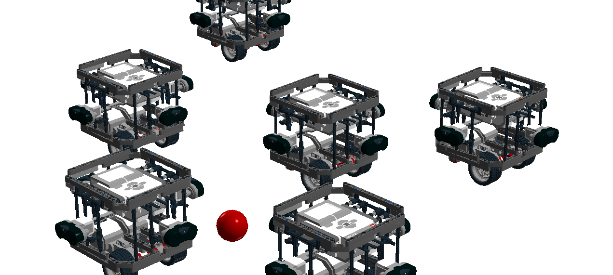
Using the EV3 programming environment

Version 0.4

Juan Antonio Breña Moral

10-May-2015

Table of Contents
Chapter 3: Sensors 5
Introduction 5
The Scientific method 6
Observe the world with sensors 6
Design hypotheses 9
Develop predictions 9
Test predictions 10
Create a theory 10
Exteroceptors sensors in EV3 11
Introduction 11
EV3 Infrared Sensor 14
EV3 Touch sensor 17
EV3 Light sensor 19
Proprioceptors sensors in NXT 21
Introduction 21
EV3 Gyro sensor 22
EV3 Motor sensor features 24
Data-logging 25
Introduction 25
Continous vs Discrete signals 26
Combining ideas 28
Behaviours 28
Summary 29
Exercises 30
Exercise 1: Build a Sumobot 30
Exercise 2: Follow a leader 31
References 32
General 32
EV3 Programming 32
Providers 32
About the author 33
Courses 33
Robots 33
Software 35

Illustration Index
Illustration 1: Human senses 5
Illustration 2: EV3 with a light sensor connected 6
Illustration 3: Retrive sun data in a period of time (One Week) 7
Illustration 4: Retrive sun data in a period of time (One Week) V2 7
Illustration 5: EV3 rechargable battery 8
Illustration 6: EV3 power adapter 8
Illustration 7: 31313 Lego Mindstorms EV3 Kit 11
Illustration 8: 45544 Education EV3 Core set 12
Illustration 9: EV3 Firmware version 13
Illustration 10: EV3 Monitor 13
Illustration 11: EV3 Infrared sensor 14
Illustration 12: EV3 Infrared sensor / Example 1 15
Illustration 13: EV3 Infrared sensor / Example 2 15
Illustration 14: EV3 Infrared sensor / Example 3 16
Illustration 15: EV3 Touch sensor 17
Illustration 16: EV3 Touch sensor / Example 1 17
Illustration 17: EV3 Touch sensor / Example 2 18
Illustration 18: EV3 Touch sensor / Example 3 18
Illustration 19: EV3 Light Sensor 19
Illustration 20: EV3 Light Sensor / Example 1 20
Illustration 21: EV3 Light sensor / Example 2 20
Illustration 22: EV3 Gyro sensor 22
Illustration 23: EV3 Gyro sensor / Example 1 23
Illustration 24: EV3 large motor 24
Illustration 25: EV3 large motor / Example 1 24
Illustration 26: LME 25
Illustration 27: Monitoring a EV3 Sensor 26
Illustration 28: A discrete signal from a EV3 Sensor 26
Illustration 29: A continous signal from a EV3 Sensor 27
Illustration 30: Program example using behaviours 28
Illustration 31: A simple SumoRobot 30
Illustration 32: EV3 IR Beacon 31

Version Control

0.1 | 10/05/2014 | Initial version
0.2 | 22/03/2015 | Adding examples to use with the EV3 programming environment
0.3 | 29/03/2015 | Adding:  EV3 Gyro sensor  Exercises
0.4 | 10/05/2015 | Adding the exercise “Follow a leader”  Adding the Scientific method

Chapter 3: Sensors

Introduction
Human being has 5 senses to measure signals from the environment to interact with the world. The senses are: sight, hearing, taste, smell and touch.

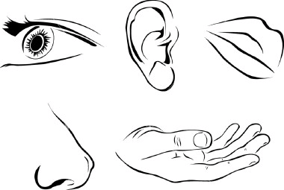Illustration 1: Human senses
In robotics, it is possible to add sensors in your robots to get data from environment or internal state of that creation to intereact. Robots built with a EV3 has the opportunity to use 4 sensors connected to the brick. If you classify the nature of the information which sensors measure, you have 2 groups:

- “exteroceptors” for the measurement of its environmental (external, from the robot point of view) parameters.
- “proprioceptors” for the measurement of the robot’s (internal) parameters

Exteroceptors sensors
Exteroceptors are sensors that measure the positional or force-type interaction of the robot with its environment.

Proprioceptors sensors
Proprioception in robotics means sensing the internal state of the robot or a part of it . For example the posture of a mechanical manipulator, leg or other jointed mechanism or the battery level.

The Scientific method
The scientific method is an ongoing process, which usually begins with observations about the natural world. Human beings are naturally inquisitive, so they often come up with questions about things they see or hear and often develop ideas (hypotheses) about why things are the way they are. The best hypotheses lead to predictions that can be tested in various ways, including making further observations about nature. In general, the strongest tests of hypotheses come from carefully controlled and replicated experiments that gather empirical data. Depending on how well the tests match the predictions, the original hypothesis may require refinement, alteration, expansion or even rejection. If a particular hypothesis becomes very well supported a general theory may be developed.

To understand the idea, we will explain the whole process with the following example:

“Morning is the most enlightened moment in the flat”

Observe the world with sensors
The long path to develop a theory it is necessary to retrieve data from the environment.
Use the brick to retrieve data to study. In this case, use the light sensor to store information about the light. Design an Experiment to retrive data to study. EV3 has a feature to store information. Use data logging features to store information.

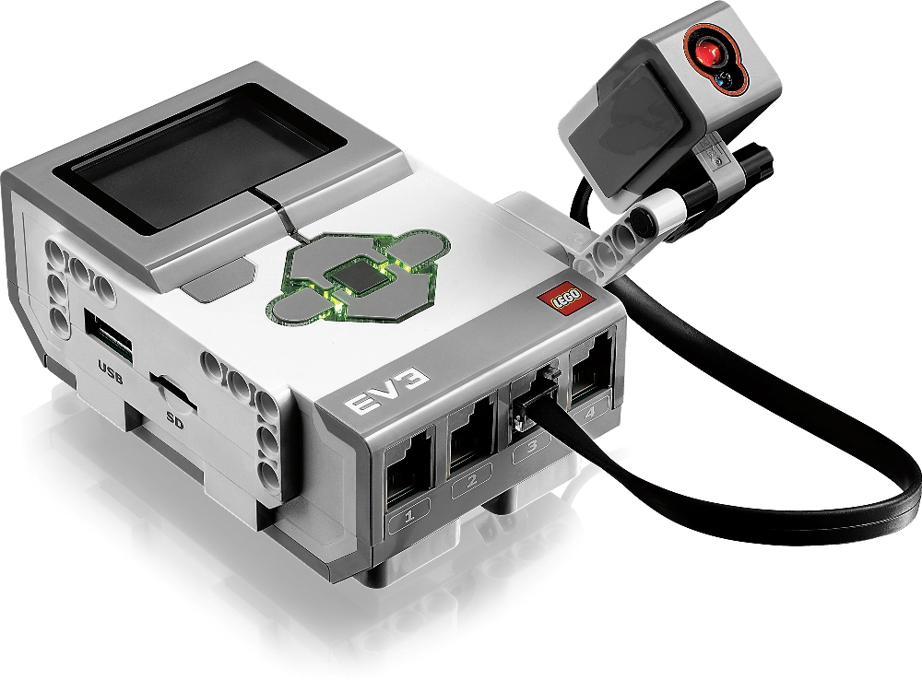Illustration 2: EV3 with a light sensor connected
The experiment
Design an experiment to store light data for a determinate period of time, in this case a week.

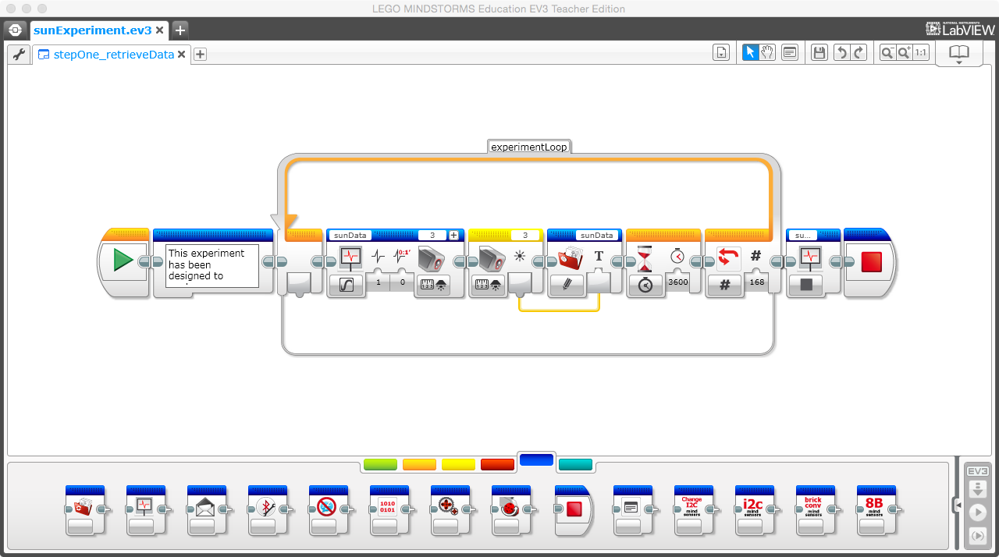Illustration 3: Retrive sun data in a period of time (One Week)
Another alternative about the same experiment:

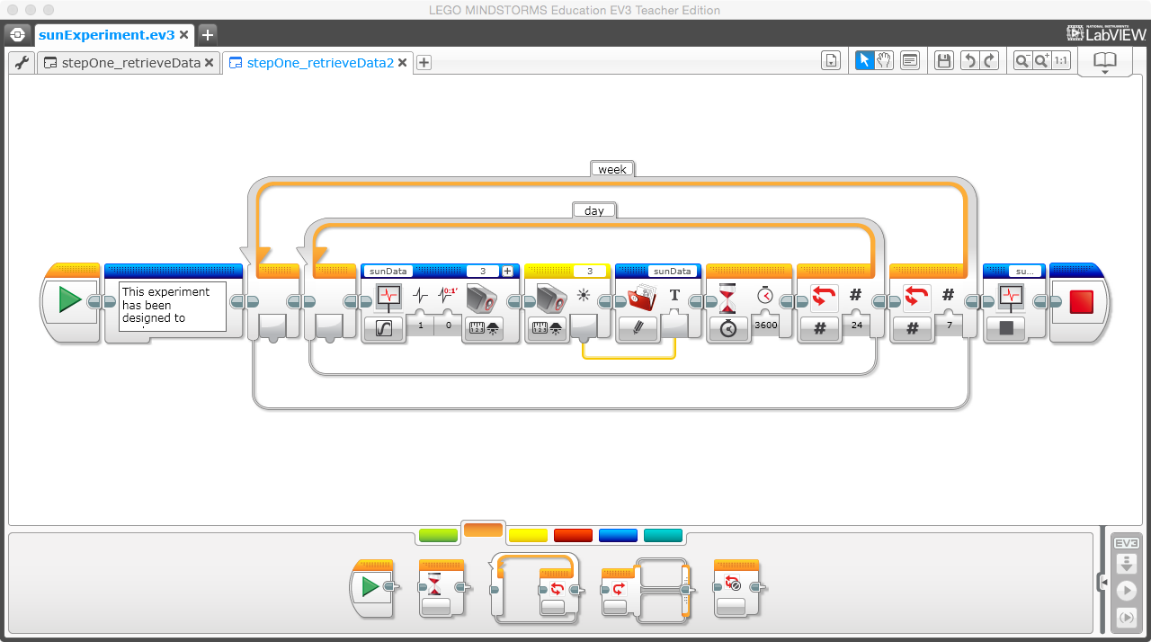Illustration 4: Retrive sun data in a period of time (One Week) V2
Execute the experiment with your EV3 brick. Remember that this experiment is longer so, try to use the EV3 battery connected to the power adapter. Begin the experiment a monday at 0:00 Am.

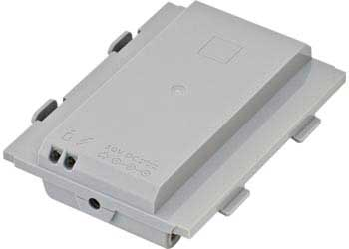Illustration 5: EV3 rechargable battery | 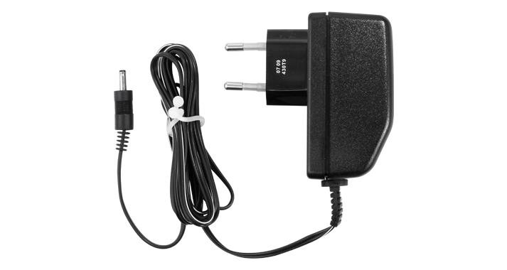Illustration 6: EV3 power adapter

Once you have the data stored in the system. Tabulate data in a spreadsheet to study.

Design hypotheses
Using data tabulated, establish a number of hypotheses.

- The moment with more light is 10 am
- The moment with more light is 11 am
- The moment with more light is 12 am

Develop predictions
Using the hypotheses formulated, develop predictions:

- At 10am the light value will be: x
- At 11am the light value will be: y
- At 12am the light value will be: z

Test predictions
Once, you have fixed your predictions, execute a new experiment in a period of time.
Store information only in the hours predicted in the next 2 weeks to validate your predictions.

Note: store data for 10Am, 11Am & 12am

Create a theory
Once, you have data about predictions, confirm that the best prediction is the second one:

“At 11am, the flat receive the most quantity of light in the day.”

Exteroceptors sensors in EV3

Introduction
In the market, Lego Mindstorms for EV3 has 2 kits in the market:

31313
The set includes the following exteroceptor sensors:

- Infrared sensor x1
- Touch sensor x1
- Light sensor x1

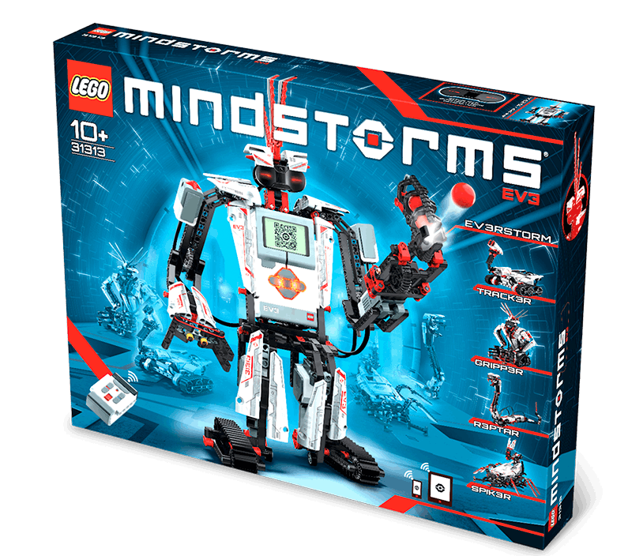Illustration 7: 31313 Lego Mindstorms EV3 Kit

45554
The set includes the following exteroceptor sensors:

- Ultrasonic sensor x1
- Touch sensor x2
- Light sensor x1
- Gyro sensor x1

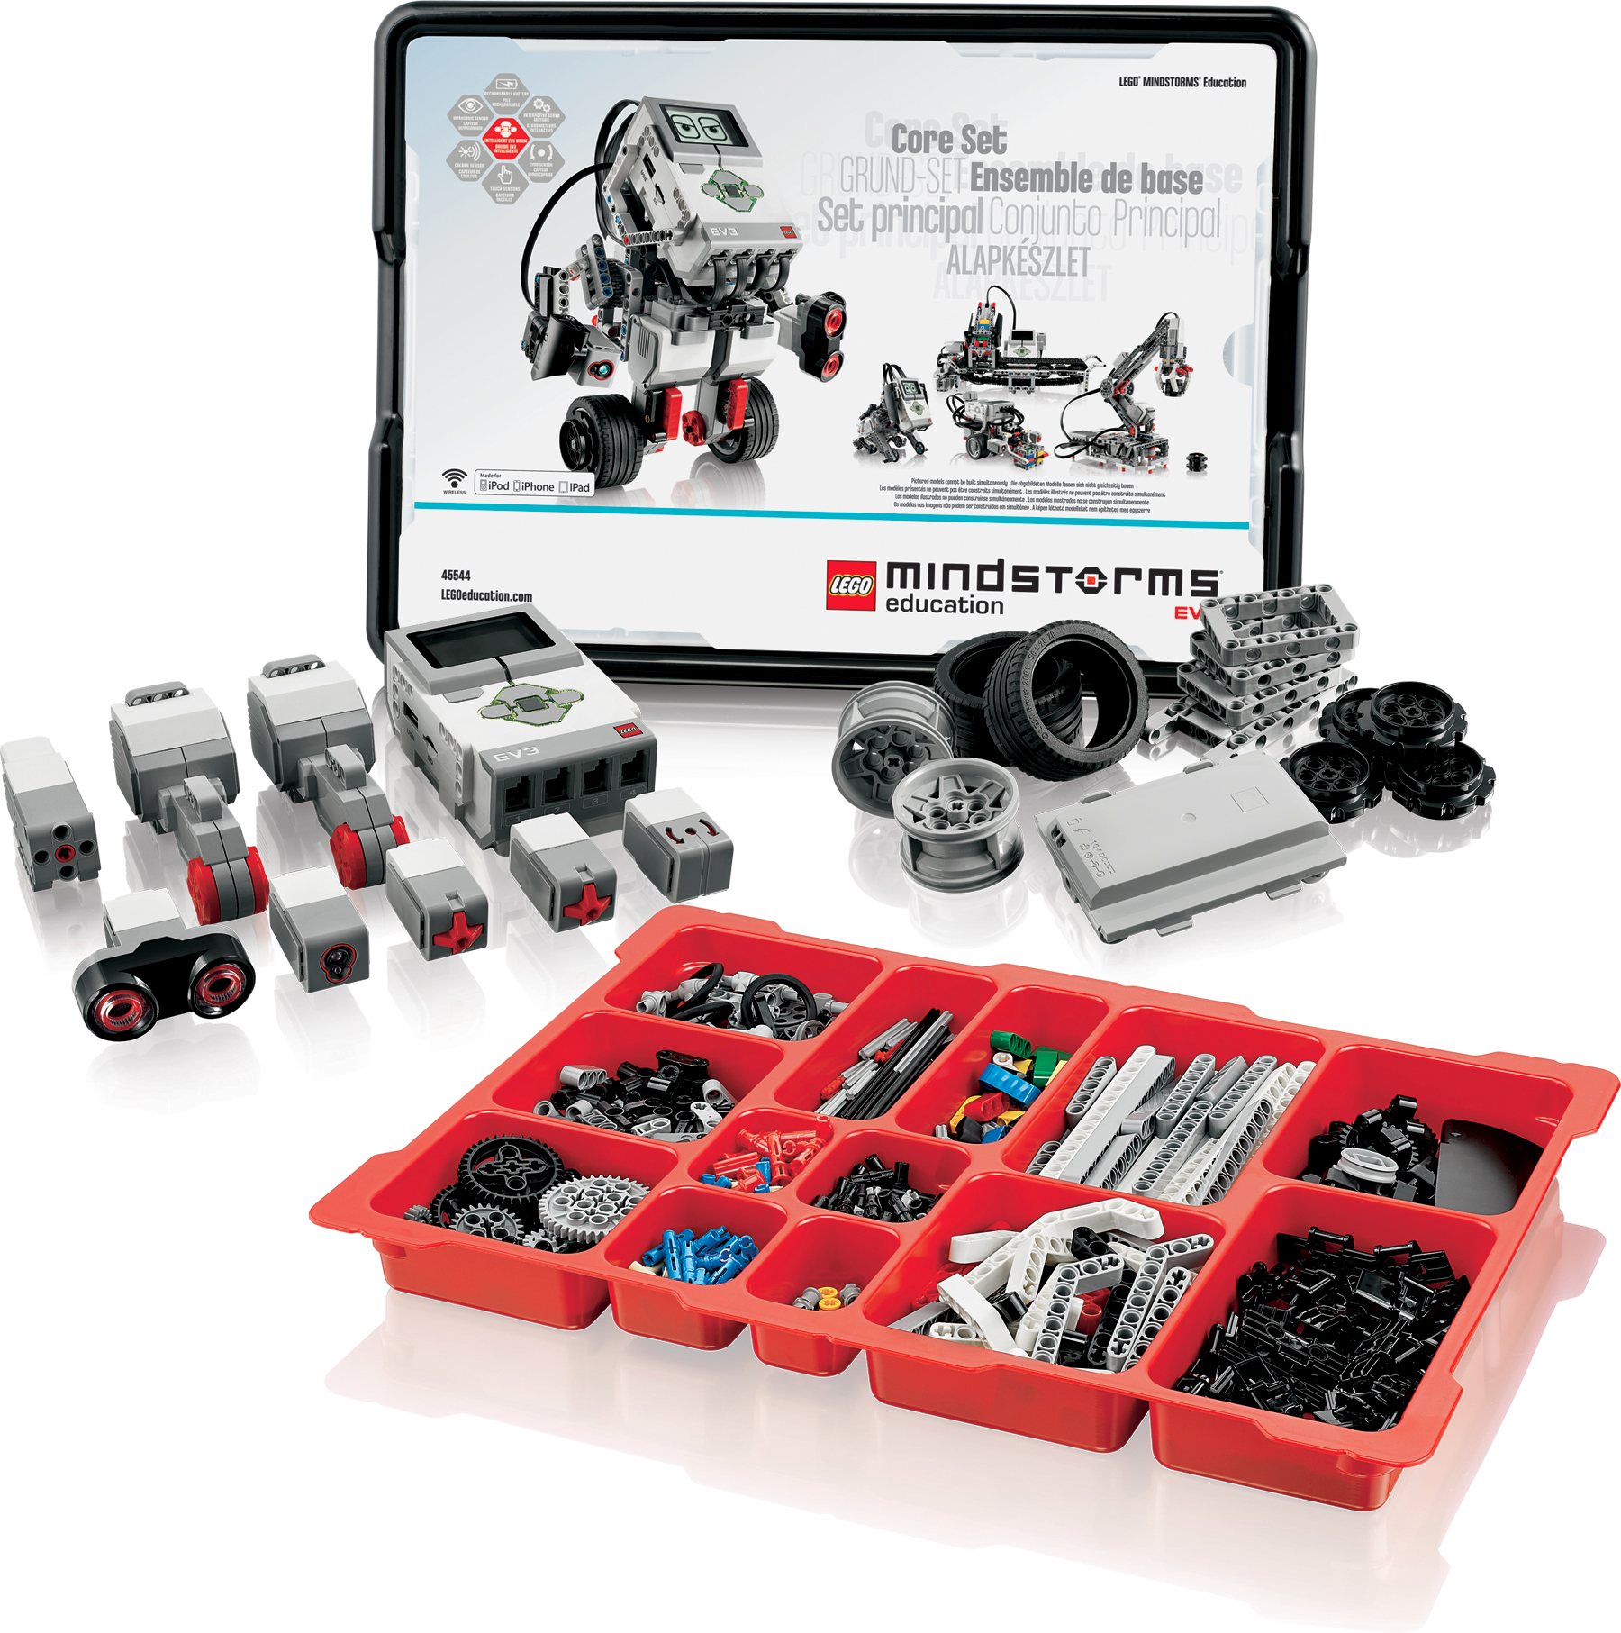Illustration 8: 45544 Education EV3 Core set
Besides, in the market exist others exteroceptor sensors from Lego education, Mindsensors, Dexter Laboratories and HiTechnics.

Update the firmware
To begin developing, it is necessary to update the firmware to get latest version. If you develop using EV3 language, download latest IDE and update the firmware. At the moment of this writing (2015/03/29), last firmware is 1.07E

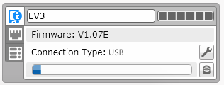Illustration 9: EV3 Firmware version
Analyze sensor data
In order to develop good software to robots, it is necessary to study in details sensors connected to your EV3 brick. To analyze data, use the monitor included in the EV3 IDE.

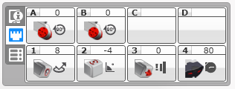Illustration 10: EV3 Monitor

EV3 Infrared Sensor
The digital EV3 Infrared Seeking Sensor detects proximity to the robot and reads signals emitted by the EV3 Infrared Beacon.

Some features about this sensor:
- Proximity measurement of approximately 50-70 cm
- Working distance from the beacon of up to two meters
- Supports four signal channels
- Receives IR remote commands

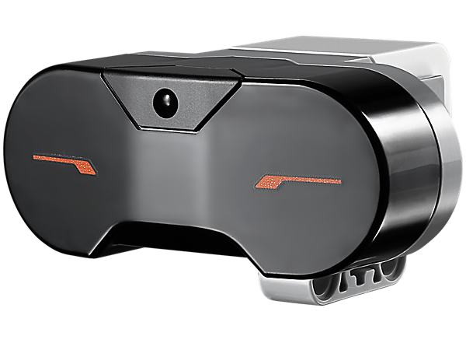Illustration 11: EV3 Infrared sensor

How to use the sensor
Example 1: Show in the display the value of a Infrared sensor.

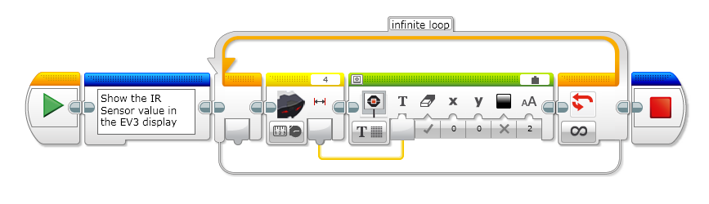Illustration 12: EV3 Infrared sensor / Example 1
Example2: Use a Infrared Sensor in a if statement.

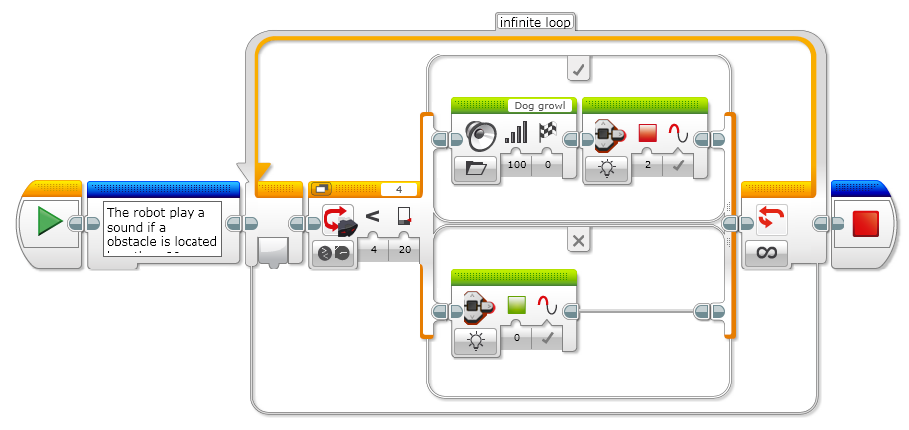Illustration 13: EV3 Infrared sensor / Example 2

Example3: Play sounds with the help of a IR Sensor.

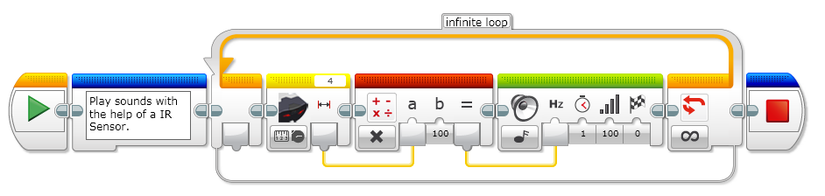Illustration 14: EV3 Infrared sensor / Example 3

EV3 Touch sensor
The analog EV3 Touch Sensor is a simple but exceptionally precise tool that detects when its front button is pressed or released and is able to count single and multiple presses.

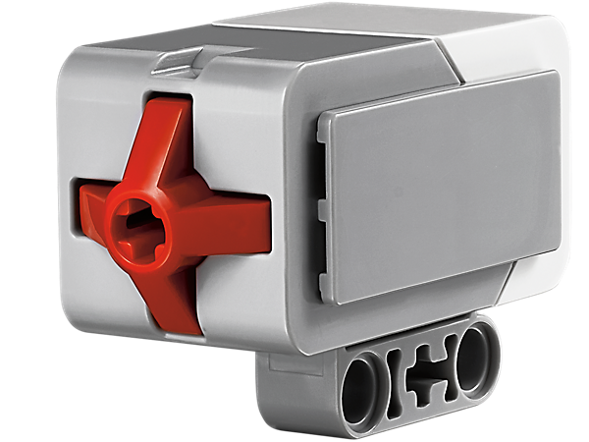Illustration 15: EV3 Touch sensor
How to use the sensor
Example 1: Show the state from a Touch sensor in the EV3 display

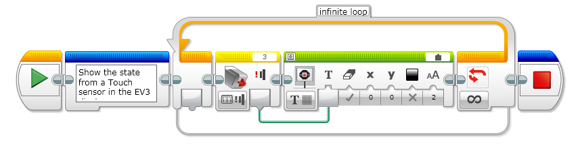Illustration 16: EV3 Touch sensor / Example 1

Example 2: Example to show how to use a IF statement using a Touch Sensor

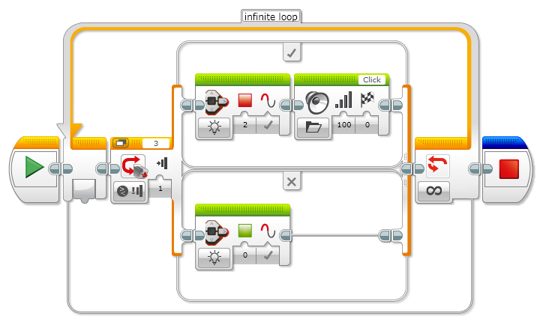Illustration 17: EV3 Touch sensor / Example 2
Example 3: Show the raw value from a Sensor port in the EV3 display

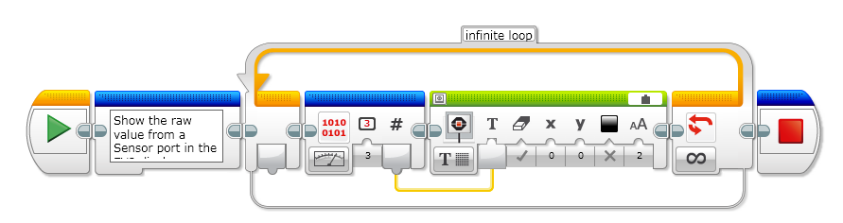Illustration 18: EV3 Touch sensor / Example 3

EV3 Light sensor
The digital EV3 Color Sensor distinguishes between eight different colors. It also serves as a light sensor by detecting light intensities. Students can build color sorting and line-following robots, experiment with light reflection of different colors, and gain experience with a technology that is widely used in industries like recycling, agriculture and packaging.The sensor measures reflected red light and ambient light, from darkness to very bright sunlight. It is capable of detecting eight colors. It cantell the difference between color or black and white, or between blue, green, yellow, red, white and brown.

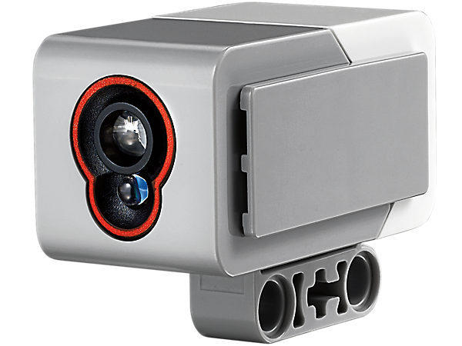Illustration 19: EV3 Light Sensor
The range of values for a light sensor measuring the reflected light intensity are:

- Minimum: 0, Black
- Maximum: 100, White

How to use the sensor
Example 1: Measure the reflected light intensity from the EV3 light sensor.

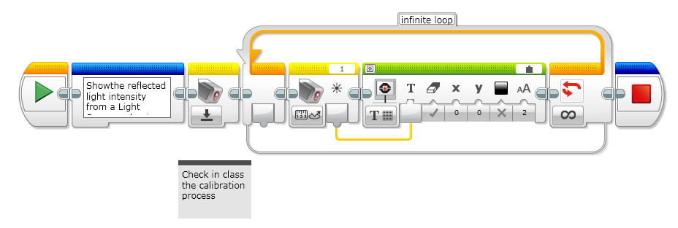Illustration 20: EV3 Light Sensor / Example 1
Example 2: Calibrate the sensor .

A Sumo ring has the floor with color black, so a good technique is to calibrate the sensor the minimum value.

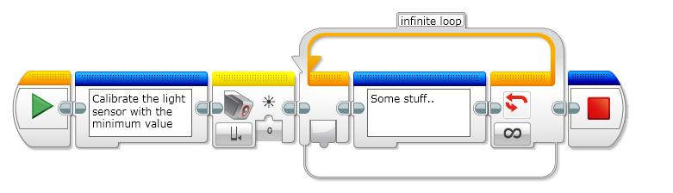Illustration 21: EV3 Light sensor / Example 2

Proprioceptors sensors in NXT

Introduction
Once you have discovered how to use EV3 sensors to get data from the world, it is necessary to discover other kind of sensors used to measure internal state of your own robot.

EV3 Gyro sensor
The digital EV3 Gyro Sensor measures the robot’s rotational motion and changes in its orientation.

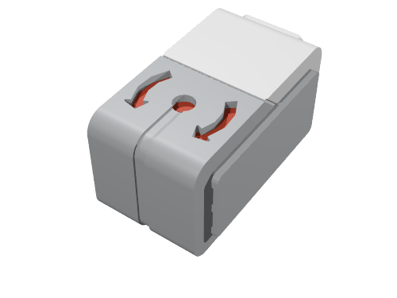Illustration 22: EV3 Gyro sensor
The EV3 User Guide provides this warning about using the Gyro Sensor: "Note: The sensor must be completely motionless while being plugged into the EV3 Brick. If the Gyro Sensor is attached to a robot, the robot should be held motionless in its starting position as the Gyro Sensor is plugged into the EV3 Brick." This is required when using Port View or On Brick Programming. If using using the EV3-G software, alternatively rather than unplugging the gyro to cure your drift problem, try changing the gyro block mode from angle to rate or angle & rate while the robot is stationary. It takes a second or two to reset and zero out any offset but seems to cure the drift problem if the robot is immobile during the mode change. Also, to reduce errors make sure your gyro sensor is oriented absolutely perpendicular to the plane of rotation to reduce or eliminate any cross-axis sensitivity. Technical Background Looking through the EV3 firmware and hardware documentation it seems the EV3 gyro sensor uses a Z-axis integrated dual-mass, vibratory MEMS rate gyroscope which was designed for high performance game controllers and audio-video remote controllers which require wide dynamic range motion processing, high impact shock resistance, and low cost. It features a primary output with a full-scale range of ±2,000°/sec to track the widest range of physical motions, as required by fast-motion gaming; and a secondary output with a full-scale range of ±440°/sec, for tracking slower motions, such as required in pointing applications. The fast primary output (±2,000°/sec) is not supported in EV3 View and Datalog apps, but seems to be implemented somewhat in the firmware but not with the EV3 gyro block which supports only three of the five modes implemented in the firmware. The slower secondary output (±440°/sec) is fully supported by EV3-G, View and Datalog apps. The Z-axis gyroscope is controlled by a small 8-bit microcontroller which does all the Analog-to-Digital conversion of both the fast primary 2000°/s channel and the slower secondary 440°/s rate channels and the temperature compensation. It also provides all the I²C communications and the EV3 sensor auto-ID functions with the host EV3 brick.
Gyroscope Features:
- Two separate outputs per axis for high-speed gaming applications and lower-speed menu navigation: 2000°/s full scale range (high-speed gaming) 440°/s full scale range (pointing) • Low bias drift over temperature • On-chip temperature sensor
- Temperature sensor Integrated amplifiers & low-pass filters.
- Dual-mass, vibratory MEMS gyroscope offers superior vibration rejection over a wide frequency range. The dual-mass design inherently rejects any signal caused by linear acceleration.
- 10,000 g shock tolerance The Rate-Out of the gyro is not ratiometric to the supply voltage. The scale factor is calibrated at the chip foundry and is nominally independent of supply voltage.

Example1: Turn your robot using a EV3 Gyro sensor.

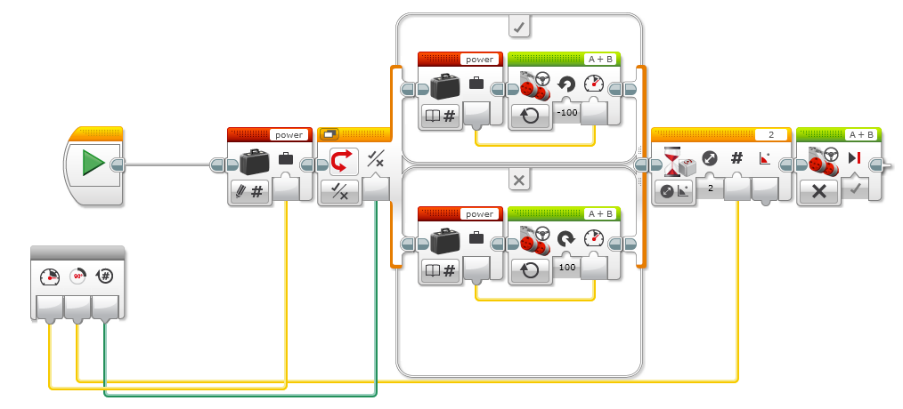Illustration 23: EV3 Gyro sensor / Example 1

EV3 Motor sensor features
A EV3 large motor has an internal encoder to know in what state is the motor.

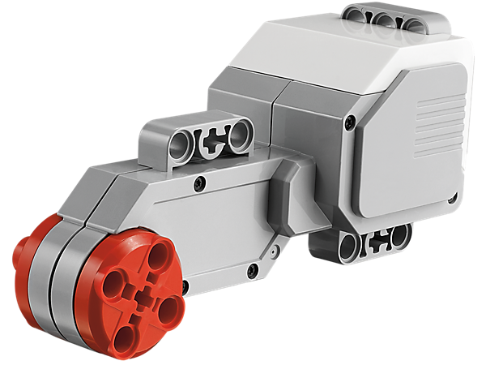Illustration 24: EV3 large motor
How to get state of the motor?

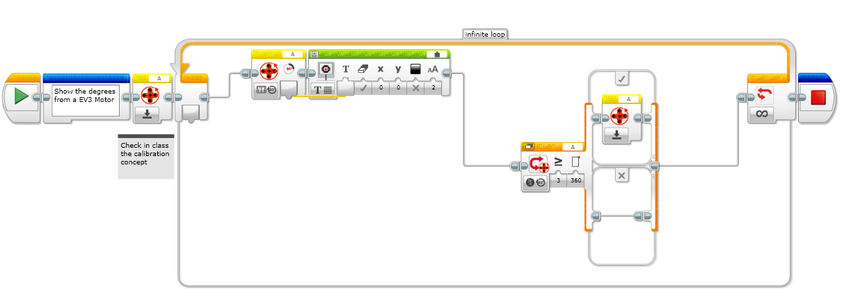Illustration 25: EV3 large motor / Example 1

Data-logging

Introduction
Data-logging is a great featured included in LME.
Download environment to develop the EV3 brick here:
https://education.lego.com/en-us/educationdownloads/productpage?AccessLink=9ab94e02-33e4-48df-abce-26b708c50cfb

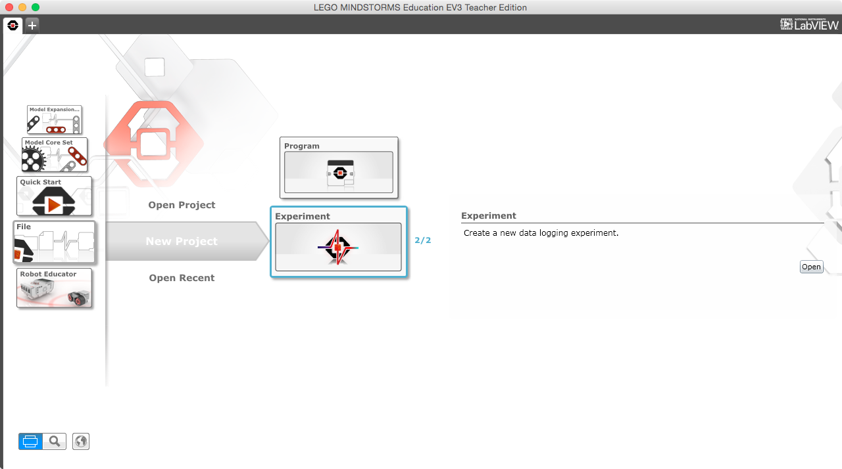Illustration 26: LME

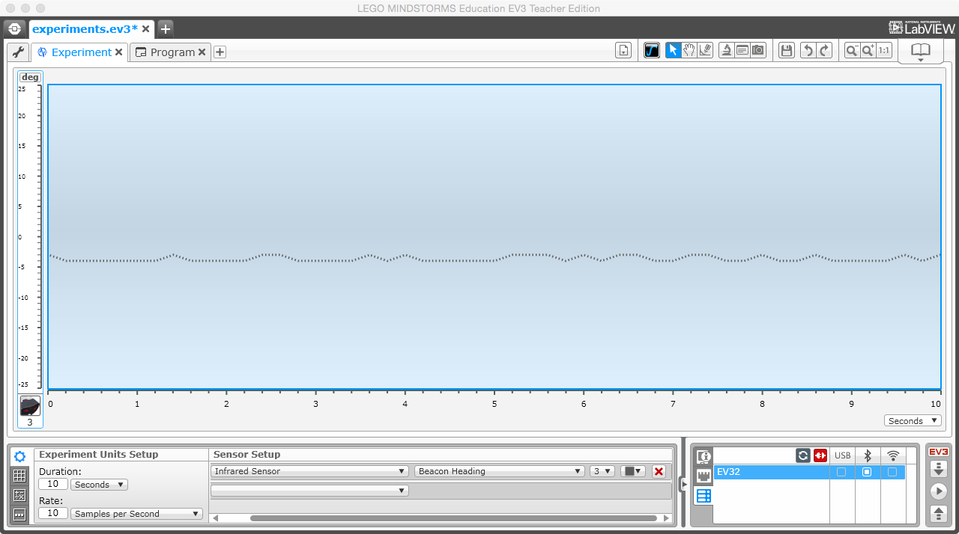Illustration 27: Monitoring a EV3 Sensor

Continous vs Discrete signals

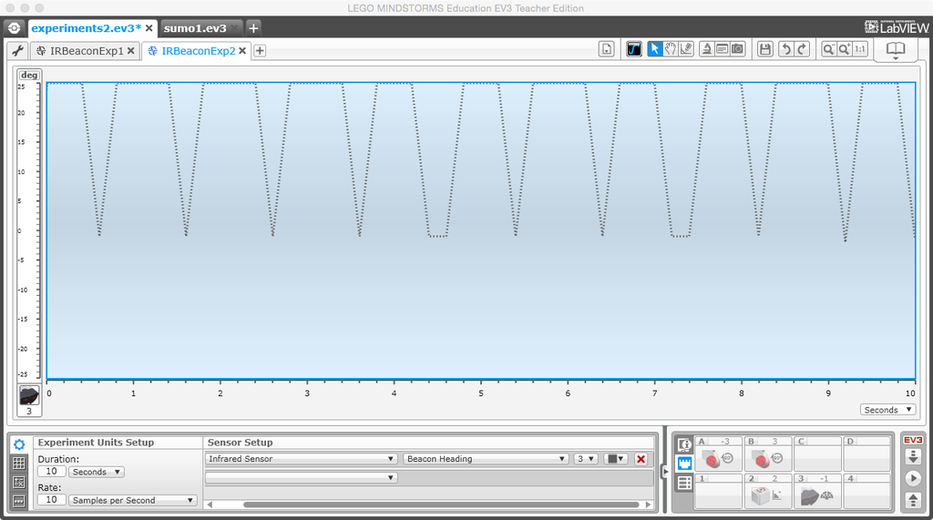Illustration 28: A discrete signal from a EV3 Sensor

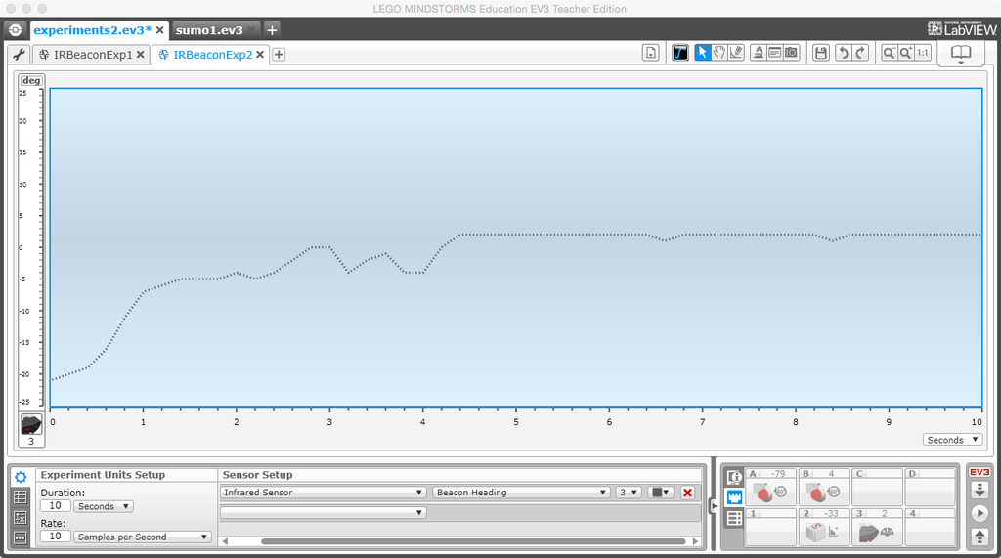Illustration 29: A continous signal from a EV3 Sensor

Combining ideas

Behaviours

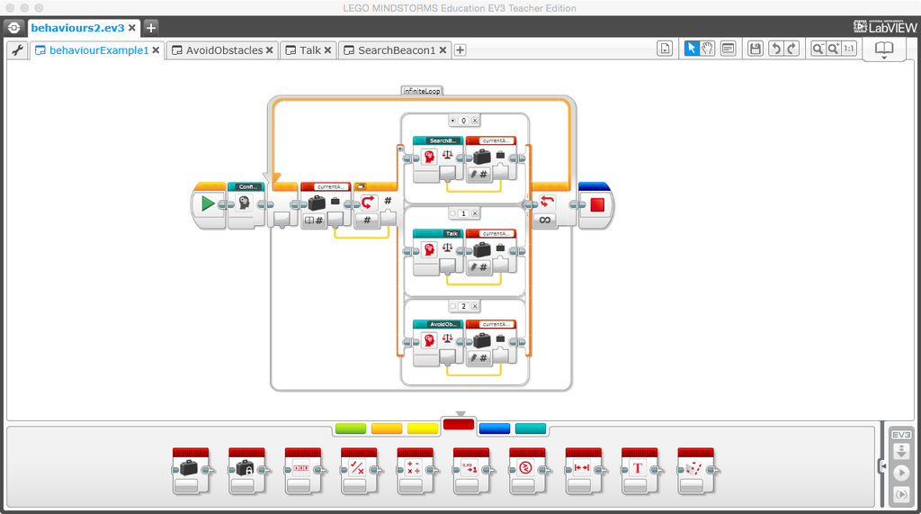Illustration 30: Program example using behaviours

Summary
In this chapter you learnt how to use sensors with your EV3 robot. Besides you learnt that exist a classification to differenciate sensors which his goal is to measure internal data and other kind of sensor which measure data from environment.

Exercises
If you read carefully this chapter you could do the following exercises:

Exercise 1: Build a Sumobot
Build a easy logic using 3 sensors:

  - Color sensor
  - Infrared sensor
  - Gyro sensor

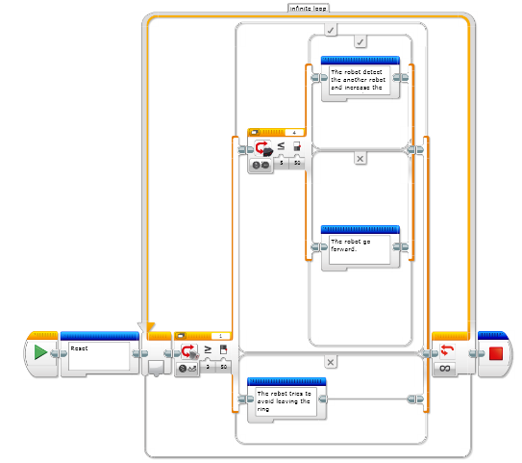Illustration 31: A simple SumoRobot

Exercise 2: Follow a leader
Lego mindstorms has a new hardware to interact with the world, the IR beacon. Try to develop a program to follow a beacon.

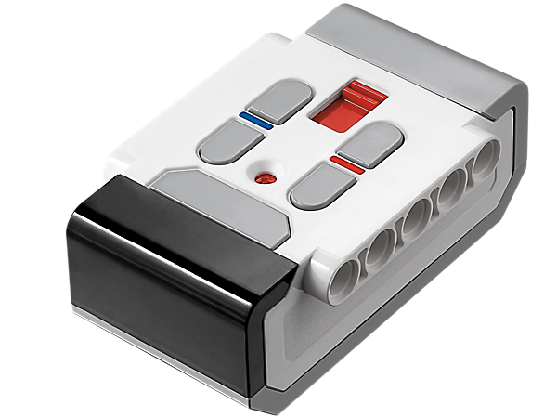Illustration 32: EV3 IR Beacon

References

General
http://en.wikipedia.org/wiki/Sensor
http://i.cmpnet.com/eetimes/news/09/09/1567chart_pg31.gif
http://www.seattlerobotics.org/encoder/jul97/basics.html
http://en.wikipedia.org/wiki/Autonomous_robot
http://en.wikipedia.org/wiki/Global_Positioning_System
http://en.wikipedia.org/wiki/Scientific_method

EV3 Programming
https://sites.google.com/site/gask3t/lego-ev3/the-missing-commentaries/ev3-beyond-basics-exercises-12-18

Providers
https://education.lego.com/en-gb/products
http://www.mindsensors.com/
https://www.hitechnic.com/
http://www.dexterindustries.com/

About the author


Juan Antonio Breña Moral is a STEAM teach and roboticist.
The participates in open source projects about robotics (For example: LeJOS project or ROS). In 2013, he founded the educational project I Love Neutrinos, an annual STEAM program using the platform Lego Mindstorms.

Courses
Courses about mobile robots:

Years | Name | Description
2013-Now | I Love Neutrinos | An annual STEAM course.  http://iloveneutrinos.com/
2009-2013 | PEAC | An annual course for students with high IQ. In the course, I managed contents about social skills and Science & Tecnology.  http://www.educa2.madrid.org/web/peac
2009-2012 | CRE | An annual course about educative robots using Lego Mindstorms.  http://iesmachado.org/web%20insti/info/img/OfertaCursoRobotica.pdf

Robots
My favorite creations in the time:

Year | Name | Description | Picture
2014 | Brity V2 | This model has been used in the ebook “Living Robots with EV3”  The main components of this robot are: an EV3 Brick, 2D LIDAR & Arduino. | 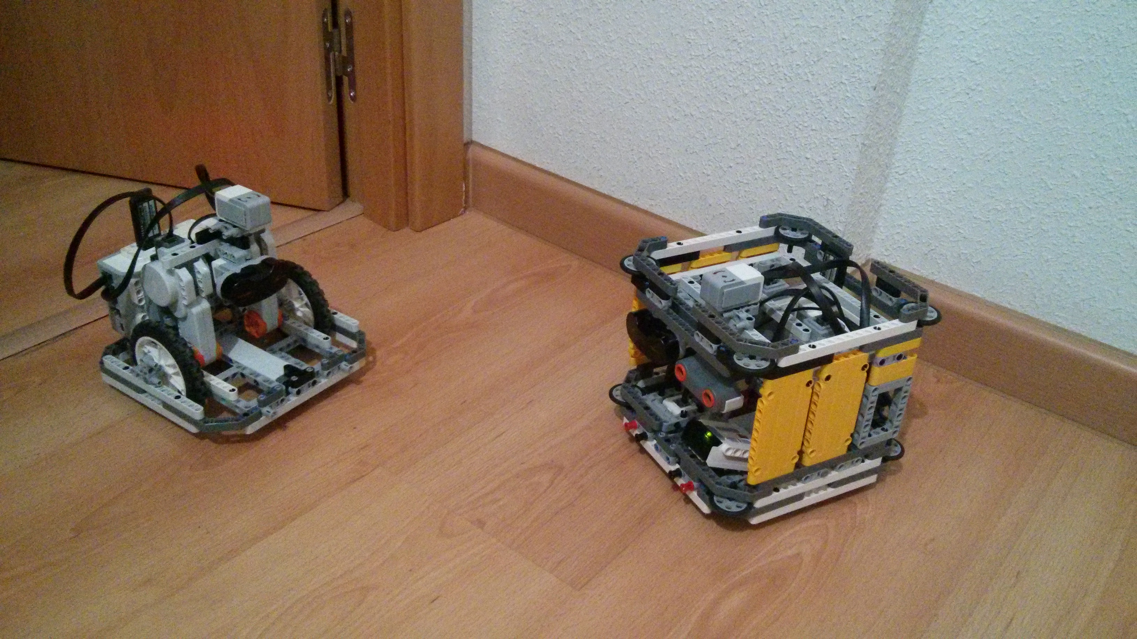
2012 | ROS Robot | This model was built to test the ROS package with LeJOS.  This huge robot used a notebook with Linux to run ROS and a NXT Brick with LeJOS NXJ.  https://www.youtube.com/watch?v=YlqptE8LHc0 | 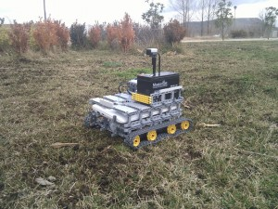
2010 | LeJOS NXT RC CAR V2 | This model replaced the old RC platform with a better structure to operate in a autonomous way.  https://www.youtube.com/watch?v=ZJN38XfvmPo | 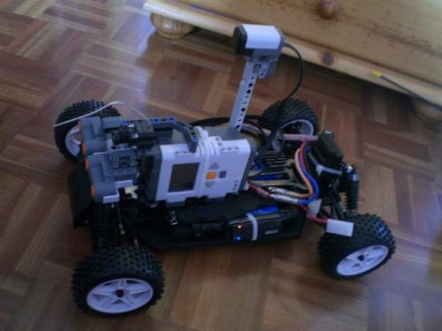
2010 | TurtleNXT | This educative used in a course was very useful to test the sensor NXTCam. In a room several NXT robots operated in a project named: Jungle Project.  https://www.youtube.com/watch?v=BbWRlLukn3M | 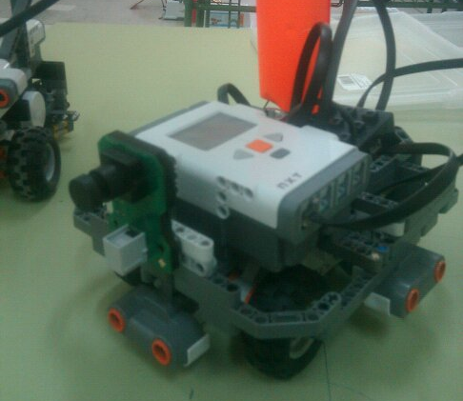
2009 | LeJOS NXT RC CAR | This is the first attempt to develop an autonomous robot with Lego Mindstorms. I combined a RC Car with NXT Brick using the Motor Controller from Lattebox.  https://www.youtube.com/watch?v=Xm6khrdnATo | 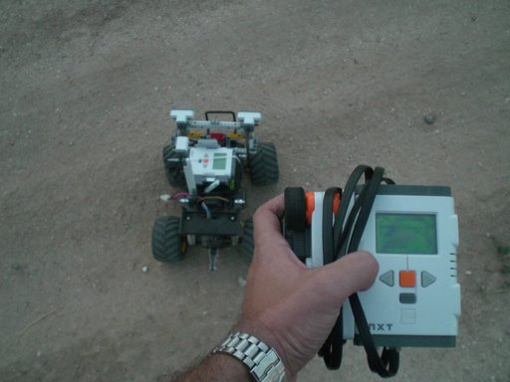

Software
Main pieces of code which I have participated in robotics:

Year | Name | Description | Picture
2012 | ROS support for LeJOS | Using ROSJava, Lawrie and me developed the ROS support for LeJOS project.  http://wiki.ros.org/nxt_lejos | 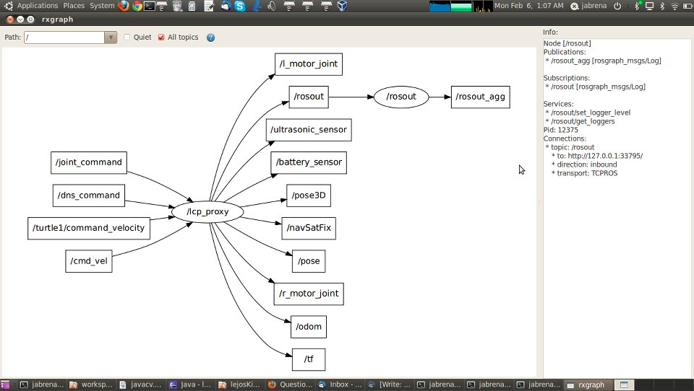

Further information:
http://juanantonio.info/lejos-ebook/
http://www.iloveneutrinos.com/
@juanantoniobm

