FLL Student Challenge

Instructions:
This document will be used by the student to design the solution for their challenge. Check the challenge and write the way to solve the problem.

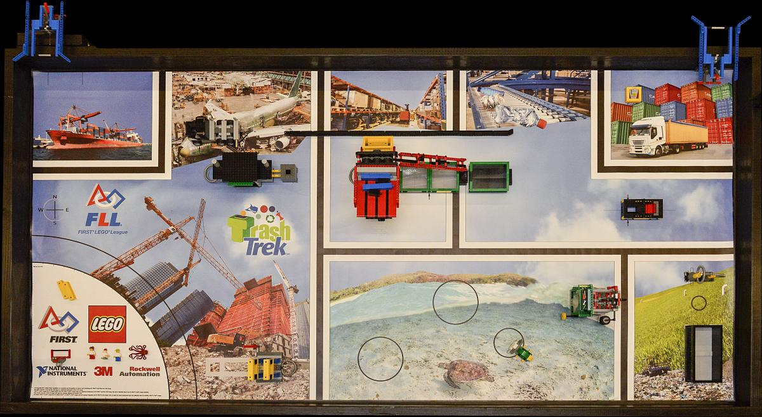Illustration 1: FLL Trash Trek 2015

Preliminar questions:

Name of the challenge:
DIEGO’S ANSWER:
Scrap Cars.

Where is the objects to interact in the map?
DIEGO’S ANSWER:
The objects to interact in the map (in my misión) are in the right and in the middle.

Idea to solve:
DIEGO’S ANSWER:
My idea is to use one or two color sensors that detect when the black line splits. When they detect that, they should make the robot stop. Once stopped, the robot would release the car engine. Ideal for transporting the car engine is this piece, because as you put the car engine, it will go to the middle. Then the robot lets fall the car engine and ready.
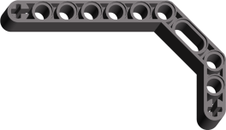

We will only use a unique Light Sensor in the whole FLL challenge.

What motors will you use:
DIEGO’S ANSWER:
I will use this combination of motors:
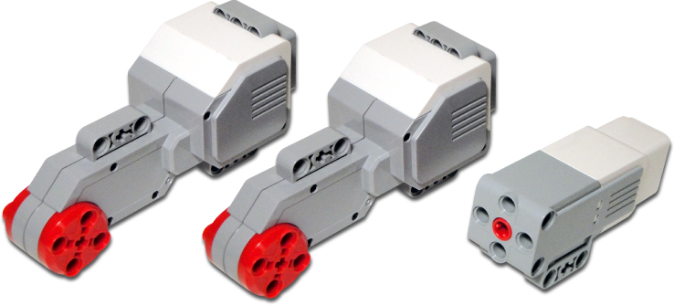

What sensors will you use:
DIEGO’S ANSWER:
I will use a gyroscope sensor and a color sensor.

- EV3 Gyro Sensor
- EV3 Light Sensor

It is possible to combine your challenge with another one?
[DISCUSS IN TEAM IN CLASS]
DIEGO’S ANSWER:
Yes, with the composting one.

Improvements:

- Design in LDD the robot's prototype.
  - Include a design for a possible arm
- Convert the description of your solution into physical measures
  - Example

- Go straight 3 rotations
- Stop
- Turn 90 degrees
- Stop
- Go straight 3 rotations
- etc...

- Develop a program to follow a black line using a unique light sensor

