ILN // Module 1 : Renewables energies // Practical exercises

Theory Part // Electrical engineering

- Learning the concepts: Voltage, Current & Wattage

To use the Energy meter sensor, it is necessary to learn some electrical concepts about the Voltage, Current & Wattage.

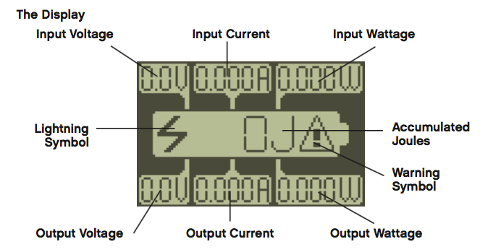Illustration 1: The display

Voltage
Voltage, electric potential difference, electric pressure or electric tension (denoted ∆V or ∆U) is the difference in electric potential energy between two points per unit electric charge. The voltage between two points is equal to the work done per unit of charge against a static electric field to move the charge between two points and is measured in units of volts (a joule per coulomb).

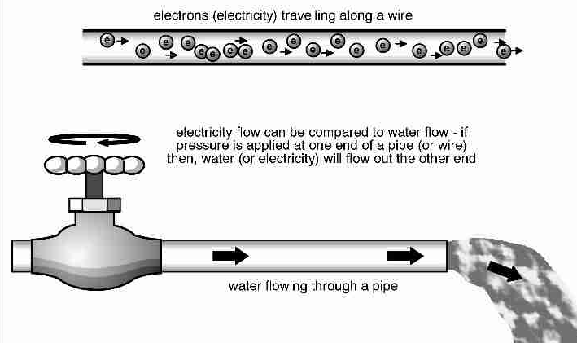Illustration 2: Electrical analogy with the water

Volt, formally, is defined as the potential difference across a conductor when a current of one ampere dissipates one watt of power. This definition is not very helpful to consumers. Using a water-in-pipes analogy, volts is analogous to water "pressure" in the electrical system. Having higher "pressure" in a pipe (or electrical conductor) means that conductor is capable of delivering more energy to the user.
Just as a 10 gpm flow rate of water through a pipe provides half the amount of water as a 20 gpm flow rate, 10 amps of current in a conductor provides half the energy as 20 amps of current.

Current
Amps, as we discussed above, is a measure total current flow (or "gallons per minute" or "gpm" using the popular water analogy) available from an electrical service.

Wattage
Watts is a measure of the amount of electricity being used - a rate of electrical power consumption. Most people use a very simple mathematical formula to determine how many watts an electrical circuit can carry or how many watts an electrical device will require:
- Watts = Volts x Amps
This formula shows how Watts relates to Volts and Amps. You can rearrange this equation using simple algebra or you can re-write it using Ohm's law. (Ohms is a measure of electrical resistance, which also measures the heat that will be generated in a wire carrying a given current.)
- Amps = Volts / Ohms
Given those two equations just cited, we can also write:
- Watts = Volts x (Volts / Ohms),
which lets us also write Watts as:
- Watts = Volts 2 / Ohms

Exercise 1 // Electrical engineering

- Learn to use Energy meter sensor

Introduction
The Energy Meter is part of the Renewable Energy Add-On Set. If you connect the Energy Meter to a sensor port on the EV3 Brick, the meter can provide data about the electrical energy storage, input, and consumption of the electrical components connected to it.

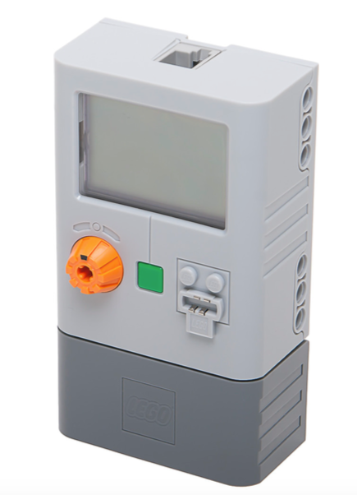Illustration 3: Energy meter sensor

The display
Energy meter show the following information in the LCD display:

Illustration 4: The display
The Energy Meter provides seven kinds of Numeric data:

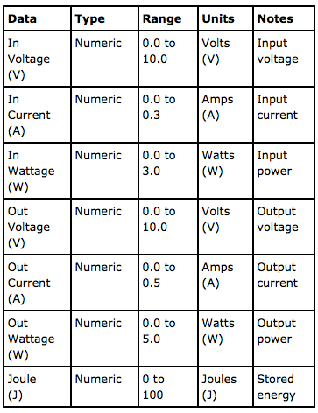Illustration 5: Information provided by the Energy Meter

Technical Specifications
At least 1 J of energy must be stored before power can be drawn from the Energy Meter

Input voltage .................................................................. 0.0 - 9.9 V
Input current ...................................................................0.000 - 0.200 A
Input wattage ............................................................... P = V x I
Output voltage .......................................................... 0.0 - 9.9 V
Output current ........................................................... 0.000 - 0.450 A
Output wattage ....................................................... P = V x I
Accumulated joules .................................... 0 - 100 J
Energy Storage ....................................................... 150mAh

Where to use the sensor

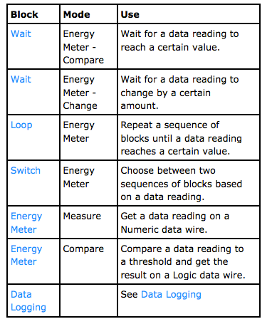Illustration 6: Available blocks to use this sensor

- Practice: 1: Connect the Energy Meter with a Motor

Connect to the energy meter a Lego E-Motor to generate an amount of energy. Learn to read the display.

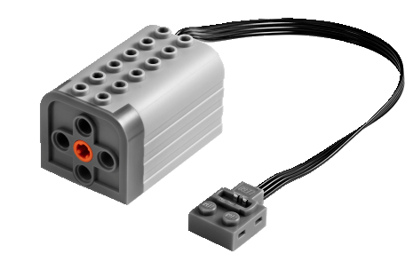Illustration 7: Lego E-motor

- Practice: 2: Connect the Energy Meter with EV3

Use the port view to read values from the sensor Energy meter

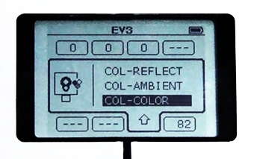Illustration 8: EV3 Port view

- Practice: 3: Show the amount of energy stored in the Energy meter

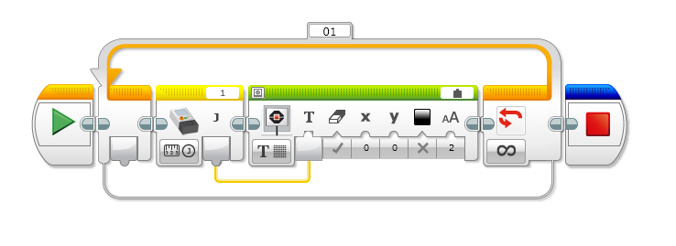Illustration 9: EV3 Program example
- Practice: 4: Play an alert sound when the Energy meter stores 50J

Extra // Homework

- Homework1: Create a Hand Generator

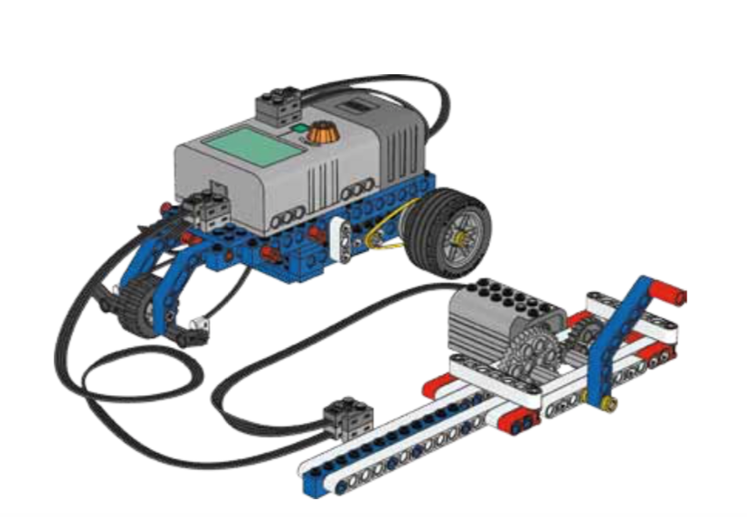

Ideas:
http://www.mocpages.com/moc.php/285654
https://www.youtube.com/watch?v=XCoVoF3sgo0

