Introduction to Robotics
Juan Antonio Breña Moral

1. Educational Goals
The goals once the student finishes the exercises are:

- Introduction to educational robots
- Introduction to Lego Mindstorms ecosystem
- Introduction to graphical programming environment
- Introduction to Motors
- Introduction to Sensors
- Introduction to graphical programming with Lego Mindstorms EV3

1. Educational Software
To develop educational software for Lego Mindstorms robots, it is necessary to download the software from the following address:
http://www.lego.com/es-es/mindstorms/downloads/download-software

1.1 Exercise: Install the software to develop robots
Install in your computer the software.

2. The brick
Lego Mindstorms is a Lego product line designed to create educational robots. In the third generation, Lego Mindstorms EV3, the product has a rechargeable battery.

2.1 Exercise: Recharge the battery of your EV3 brick
Extract the battery from your EV3 Brick to recharge the battery.

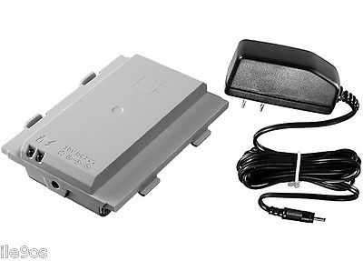Illustration 1: EV3 Brick battery
When the battery has a green led, this is the moment to stop recharging the battery.

2.2 Turn on the brick
Turn on the brick and connect some motors and sensors.
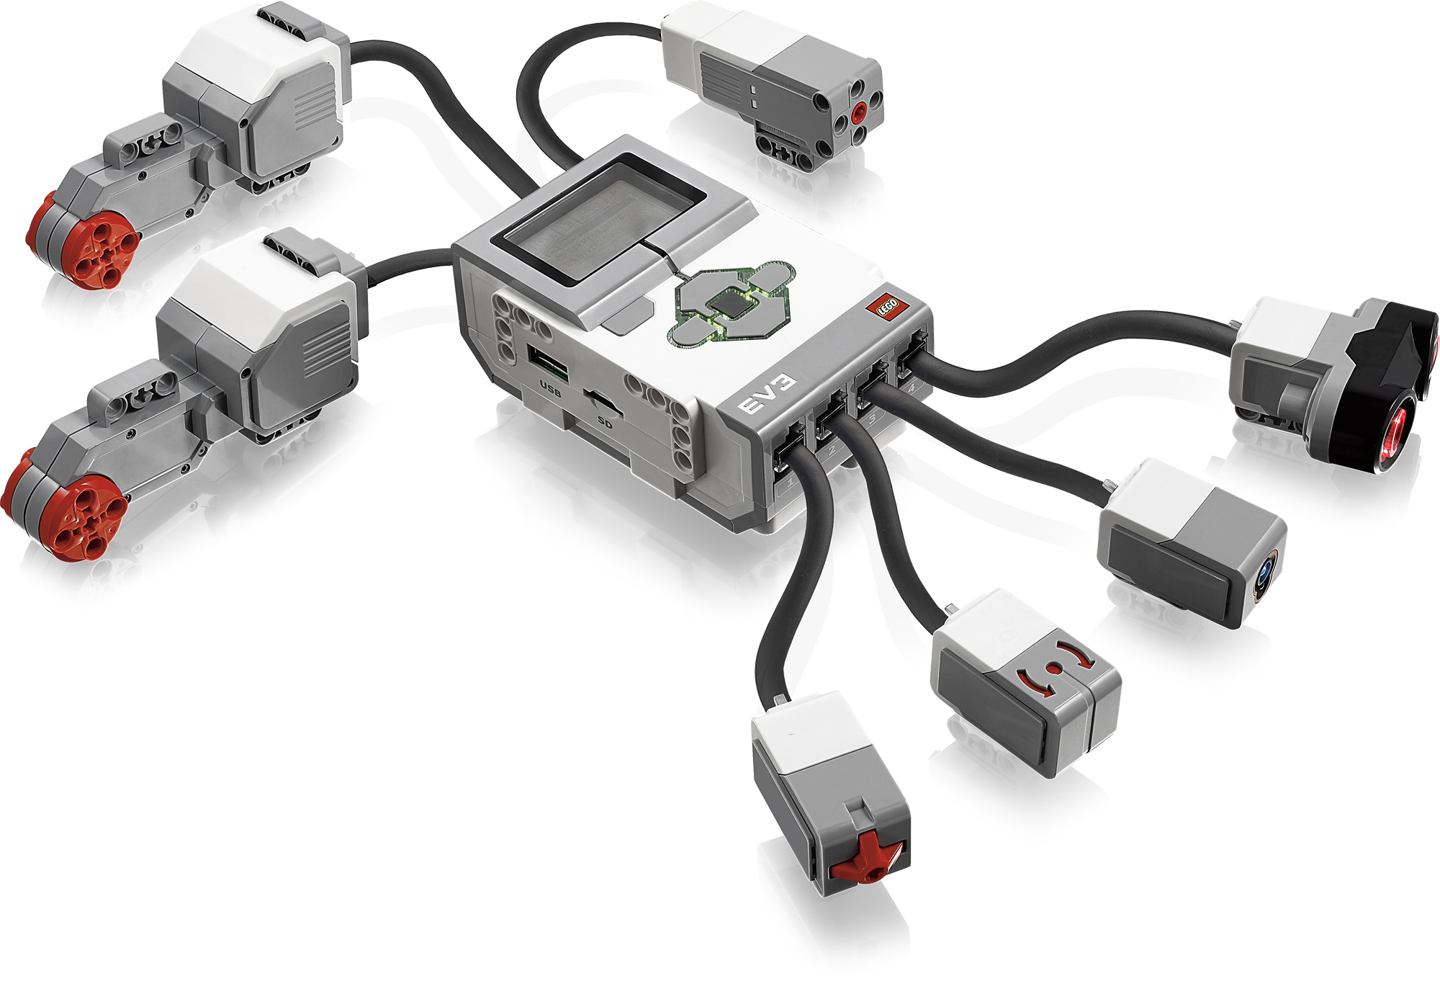Illustration 2: EV3 Brick with Sensors and Actuators connected

2.3 Exercise: Learn to use the EV3 Menu
Turn on the EV3 Brick and connect 2 motors in the part for actuators (Output ports: A, B, C, D) and learn to use the menu options. Search the option menu: Motor Control. Try to interact with the motors with the buttons.

- Question:
  - In what motor port, does the robot ask you to connect the motors?

2.4 Exercise: Learn to use sensors
Turn on the EV3 Brick and connect a IR Sensor in the part for sensors (Input ports: 1, 2, 3, 4) and learn to use the menu options. Search the option menu: Port view & Port Datalog

- Question:
  - Why change the values in the view “port view”?
  - What is the value x in the view “port datalog”?
  - What is the maximum value measured on a EV3 IR Sensor?

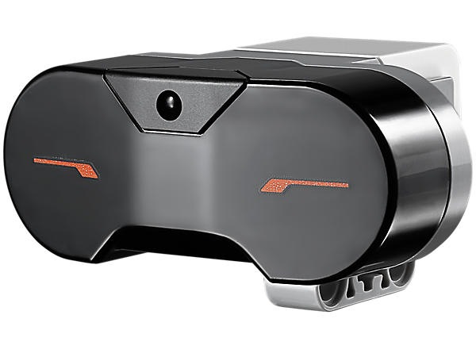Illustration 3: EV3 IR Sensor

