FLL Student Challenge

Instructions:
This document will be used by the student to design the solution for their challenge. Check the challenge and write the way to solve the problem.

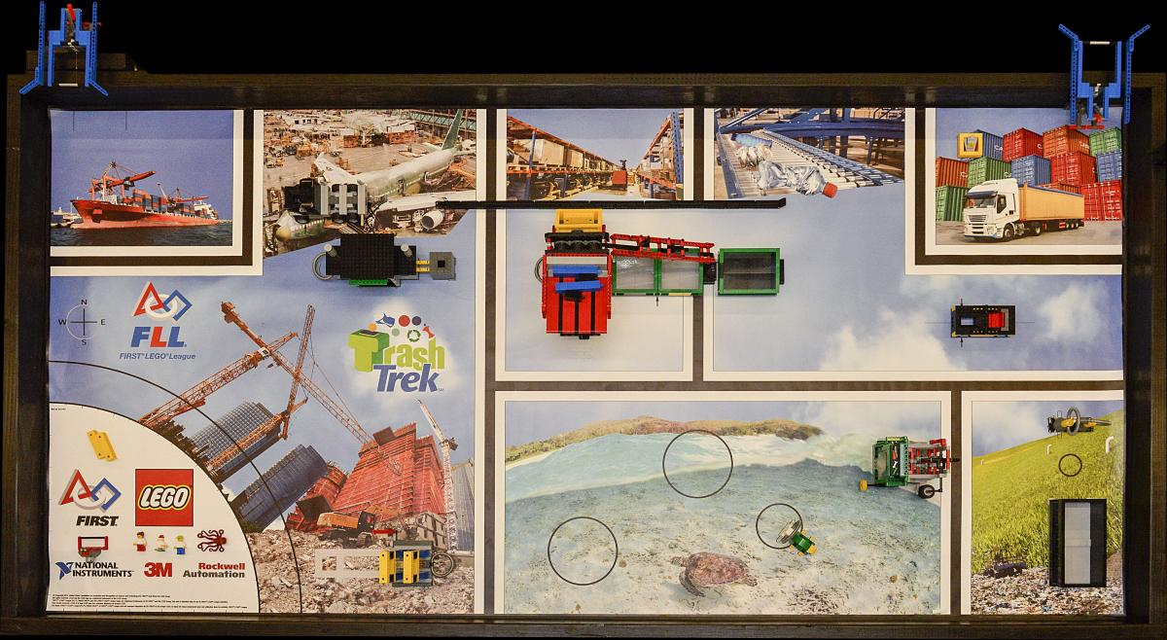Illustration 1: FLL Trash Trek 2015

Preliminar questions:

Name of the challenge:
STUDENT ANSWER:

Where is the objects to interact in the map?
STUDENT ANSWER:

Idea to solve:
STUDENT ANSWER:

What motors will you use:
STUDENT ANSWER:

What sensors will you use:
STUDENT ANSWER:

It is possible to combine your challenge with another one?
[DISCUSS IN TEAM IN CLASS]
STUDENT ANSWER:

