lvm

[root@mysql ~]# yum install -y lvm2 #安装lvm
[root@mysql ~]# pvcreate /dev/sda7 #创建物理卷
Physical volume "/dev/sda7" successfully created
[root@mysql ~]# vgcreate myvg /dev/sda7 #创建卷组
Volume group "myvg" successfully created
[root@mysql ~]# lvcreate -L 1G -n mydata myvg #创建逻辑卷
Logical volume "mydata" created
[root@mysql ~]# lvs #查看逻辑卷
LV VG Attr LSize Pool Origin Data% Move Log Cpy%Sync Convert
mydata myvg -wi-a---- 1.00g
[root@mysql ~]# mkfs.ext4 /dev/myvg/mydata #格式化
mke2fs 1.41.12 (17-May-2010)
文件系统标签=
操作系统:Linux
块大小=4096 (log=2)
分块大小=4096 (log=2)
Stride=0 blocks, Stripe blocks
65536 inodes, 262144 blocks
13107 blocks (5.00%) reserved for the super user
第一个数据块=0
Maximum filesystem blocks=268435456
8 block groups
32768 blocks per group, 32768 fragments per group
8192 inodes per group
Superblock backups stored on blocks:
32768, 98304, 163840, 229376
正在写入inode表: 完成
Creating journal (8192 blocks): 完成
Writing superblocks and filesystem accounting information: 完成
This filesystem will be automatically checked every 33 mounts or
180 days, whichever comes first. Use tune2fs -c or -i to override.
5.挂载设置
[root@mysql ~]# mkdir /mydata #创建挂载目录
[root@mysql ~]# vim /etc/fstab #修改挂载配置文件
#新增一行
/dev/myvg/mydata /mydata ext3 defaults 0 0
[root@mysql ~]# mount -a #挂载
[root@mysql ~]# mount #查看所有挂载
/dev/sda2 on / type ext4 (rw)
proc on /proc type proc (rw)
sysfs on /sys type sysfs (rw)
devpts on /dev/pts type devpts (rw,gid=5,mode=620)
tmpfs on /dev/shm type tmpfs (rw)
/dev/sda1 on /boot type ext4 (rw)
/dev/sda3 on /data type ext4 (rw)
none on /proc/sys/fs/binfmt_misc type binfmt_misc (rw)
/dev/mapper/myvg-mydata on /mydata type ext4 (rw)

下载地址

----下载网址----
http://dev.mysql.com/downloads/mysql/

----源码下载----
wget http://dev.mysql.com/get/Downloads/MySQL-5.6/mysql-5.6.19.tar.gz/from/ftp://ftp.ntu.edu.tw/pub/MySQL/

wget http://dev.mysql.com/get/Downloads/MySQL-5.6/mysql-5.6.20.tar.gz/from/ftp://ftp.ntu.edu.tw/pub/MySQL/

----rpm下载----
wget http://dev.mysql.com/get/Downloads/MySQL-5.6/MySQL-5.6.19-1.el6.x86_64.rpm-bundle.tar/from/ftp://ftp.ntu.edu.tw/pub/MySQL/

源码安装-MYSQL
http://cdn.mysql.com/Downloads/MySQL-5.6/MySQL-5.6.20-1.el6.x86_64.rpm-bundle.tar

1.使用Yum安装依赖软件包

# yum install -y gcc gcc-c++ autoconf automake bison zlib* \
libxml* ncurses-devel libtool-ltdl-devel* openssl openssl-devel

2.安装cmake
# yum install -y cmake

3.解压缩并编译安装MySQL源码包
# wget http://downloads.skysql.com/archives/mysql-5.5/mysql-5.5.27.tar.gz

# tar xzvf mysql-5.5.27.tar.gz
# cd mysql-5.5.27

配置编译
（参考:http://dev.mysql.com/doc/refman/5.5/en/source-configuration-options.html）
cmake -DCMAKE_INSTALL_PREFIX=/usr/local/mysql \
-DSYSCONFDIR=/usrl/local/mysql/etc \
-DMYSQL_DATADIR=/usr/local/mysql/data \
-DMYSQL_TCP_PORT=3306 \
-DMYSQL_UNIX_ADDR=/tmp/mysql.sock \
-DMYSQL_USER=mysql \
-DDEFAULT_CHARSET=utf8 \
-DDEFAULT_COLLATION=utf8_general_ci \
-DWITH_EXTRA_CHARSETS=all \
-DWITH_READLINE=1 \
-DWITH_SSL=system \
-DWITH_EMBEDDED_SERVER=1 \
-DENABLED_LOCAL_INFILE=1 \
-DWITH_MYISAM_STORAGE_ENGINE=1 \
-DWITH_MEMORY_STORAGE_ENGINE=1 \
-DWITH_INNOBASE_STORAGE_ENGINE=1

配置编译报错：
CMake Error at cmake/ssl.cmake:83 (MESSAGE):
Cannot find appropriate system libraries for SSL. Use WITH_SSL=bundled to
enable SSL support

处理方法：
# yum install -y openssl openssl-devel
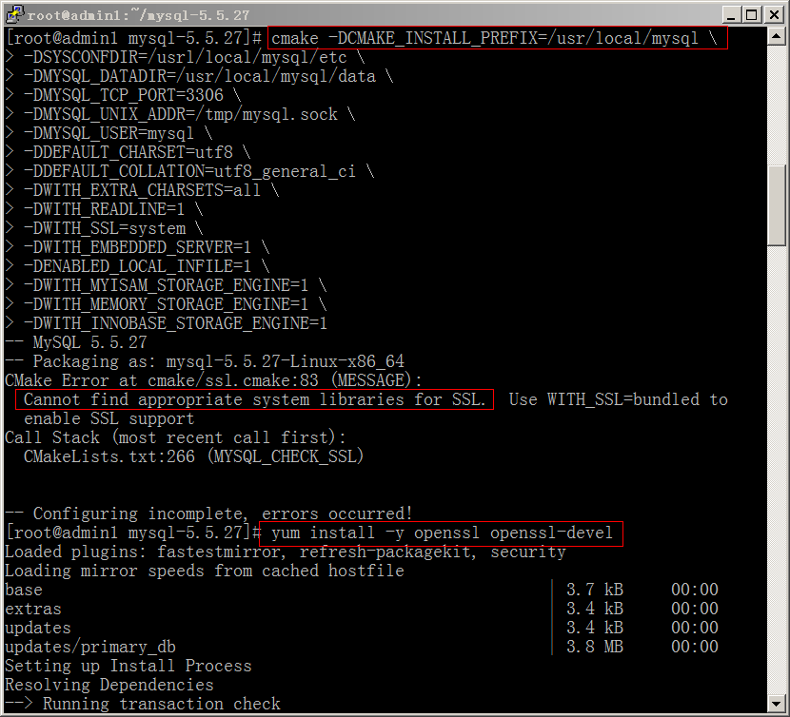

安装
# make
# make install

注意事项：
重新编译时，需要清除旧的对象文件和缓存信息。

# make clean
# rm -f CMakeCache.txt

4.添加mysql用户及用户组并修改目录所有权限
[root@ttt mysql]# useradd mysql
[root@ttt mysql]# passwd mysql
[root@ttt mysql]# chown -R mysql /usr/local/mysql
[root@ttt mysql]# chgrp -R mysql /usr/local/mysql

5.安装基础数据库并复制示例配置文件
# cd /usr/local/mysql
# chmod +x scripts/*
[root@ttt mysql]# ./scripts/mysql_install_db --basedir=/usr/local/mysql \
--datadir=/usr/local/mysql/data --user=mysql //初始化数据库

# cp /usr/local/mysql/support-files/my-medium.cnf /etc/my.cnf

[root@ttt ~]# export PATH=$PATH:/usr/local/mysql/bin //全局宣告mysql命令的路径
[root@ttt ~]# echo "PATH=$PATH:/usr/local/mysql/bin" >> /etc/profile //写入开机启动文件
[root@myttt ~]# su - mysql
[mysql@myttt ~]$ echo "PATH=$PATH:/usr/local/mysql/bin" >> .bash_profile

6.注册mysql系统服务并启动mysql

[root@ttt mysql]# chmod 755 support-files/mysql.server
[root@ttt mysql]# ls -l support-files/mysql.server
-rwxr-xr-x 1 mysql mysql 10650 6月 22 19:21 support-files/mysql.server
[root@ttt mysql]# cp support-files/mysql.server /etc/init.d/mysql
[root@ttt mysql]# chown root.root /etc/init.d/mysql
[root@ttt mysql]# chkconfig --add mysql
[root@ttt mysql]# chkconfig --level 35 mysql on
[root@ttt mysql]# chkconfig --list mysql
mysql 0:关闭 1:关闭 2:启用 3:启用 4:启用 5:启用 6:关闭
[root@ttt mysql]# service mysql start
Starting MySQL... [确定]
[root@ttt mysql]# netstat -ltu |grep mysql
tcp 0 0 *:mysql *:* LISTEN
[root@ttt mysql]# ps -ef | grep mysql
root 15492 1 0 21:00 pts/0 00:00:00 /bin/sh /usr/local/mysql/bin/mysqld_safe
--datadir=/usr/local/mysql/data --pid-file=/usr/local/mysql/data/ttt.pid
mysql 15744 15492 0 21:00 pts/0 00:00:00 /usr/local/mysql/bin/mysqld --
basedir=/usr/local/mysql --datadir=/usr/local/mysql/data --plugin-
dir=/usr/local/mysql/lib/plugin --user=mysql --log-error=/usr/local/mysql/data/ttt.err
--pid-file=/usr/local/mysql/data/ttt.pid --socket=/tmp/mysql.sock --port=3306
root 15896 1098 0 21:10 pts/0 00:00:00 grep mysql

7.安装完成，启动mysql数据库，进入测试

[root@ttt ~]# mysql -u root
Welcome to the MySQL monitor. Commands end with ; or \g.
Your MySQL connection id is 3
Server version: 5.5.27-log Source distribution

Copyright (c) 2000, 2011, Oracle and/or its affiliates. All rights reserved.

Oracle is a registered trademark of Oracle Corporation and/or its
affiliates. Other names may be trademarks of their respective
owners.

Type 'help;' or '\h' for help. Type '\c' to clear the current input statement.

mysql> show databases;
+--------------------+
| Database |
+--------------------+
| information_schema |
| mysql |
| performance_schema |
| test |
+--------------------+
4 rows in set (0.00 sec)

mysql> use mysql
Database changed
mysql> show tables;
+---------------------------+
| Tables_in_mysql |
+---------------------------+
| columns_priv |
| db |
| event |
| func |
| time_zone_name |
| time_zone_transition |
| time_zone_transition_type |
| user |
+---------------------------+
24 rows in set (0.00 sec)

mysql>

8.修改mysql数据库root密码并删除本机匿名连接的空密码帐号
1>
[root@ttt ~]# mysqladmin -u root password '123456' --给“root”用户设置一个密码

2>
[root@ttt ~]# mysql -u root -p
mysql> use mysql; //选择默认数据库mysql
Database changed
mysql> update mysql.user set password=password("111111") where user = 'root';
//修改root密码
mysql> delete from user where password=""; //不允许root密码为空
mysql> flush privileges;
mysql> quit
Bye

忘记密码：
[root@mysql-1 ~]# service mysqld stop
[root@mysql-1 ~]# mysqld_safe --skip-grant-tables&
[root@mysql-1 ~]# mysql -u root mysql
mysql> update mysql.user set password=password('123456') where user = 'root';
mysql> FLUSH PRIVILEGES;
mysql> exit

9.其他设置
下面这行把myslq的库文件链接到系统默认的位置，这样你在编译类似PHP等软件时可以不用指定mysql的库文件地址。
ln -s /usr/local/mysql/include/mysql /usr/include/mysql

10. 配置防火墙
[root@ttt ~]# vi /etc/sysconfig/iptables
添加：
-A INPUT -m state --state NEW -m tcp -p tcp --dport 3306 -j ACCEPT
[root@ttt ~]# service iptables restart --刷新防火墙配置
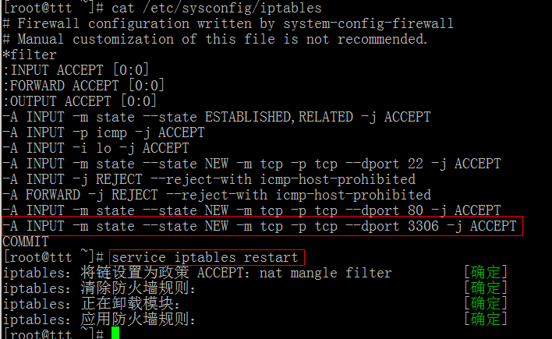

11.关闭selinux
打开/etc/selinux/config，把SELINUX=enforcing改为SELINUX=disabled后存盘退出重启机器。

12.客户端链接
mysql> delete from user where host="localhost"; ----删除root只准本地连接的限制
Query OK, 1 row affected (0.00 sec)

mysql> select host, user from user; ----查看权限
+-----------+------+
| host | user |
+-----------+------+
| % | root |
| 127.0.0.1 | root |
| ::1 | root |
+-----------+------+
3 rows in set (0.00 sec)

mysql> FLUSH PRIVILEGES;
Query OK, 0 rows affected (0.00 sec)

mysql> grant all privileges on *.* to 'root'@'%' identified by 'root' with grant option;
----授予root用户任何IP都可连接的权限
Query OK, 0 rows affected (0.00 sec)

mysql> FLUSH PRIVILEGES;
Query OK, 0 rows affected (0.00 sec)

mysql> quit
Bye
[root@mysql-1 init.d]# service iptables stop
iptables：将链设置为政策 ACCEPT：filter [确定]
iptables：清除防火墙规则：[确定]
iptables：正在卸载模块：[确定]

卸载
http://www.360doc.com/content/14/0126/10/15109633_348050899.shtml

# yum install mysql-community-server
# yum remove mysql-community-server

# rpm -qa|grep -i mysql
# rpm -ev mysql-xxx

卸载后/var/lib/mysql中的/etc/my.cnf会重命名为my.cnf.rpmsave，/var/log/mysqld.log 会重命名为/var/log/mysqld.log.rpmsave，如果确定没用后就手工删除

RPM安装-环境检查
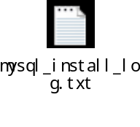

检查MySQL已安装的rpm包
sudo rpm -qa| grep mysql

[root@mysql-t ~]# rpm -qi mysql
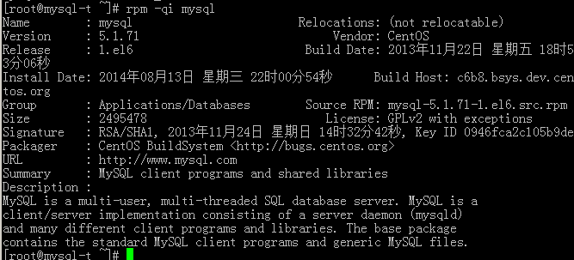

删除所有的安装包
sudo rpm -e mysql-community-common-5.6.17-4.el6.x86_64
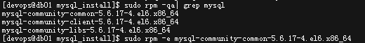

rpm -e --nodeps package_name ----不考虑依赖包

安装
下载
http://dev.mysql.com/downloads/mysql/
或 登陆管理系统
wget http://dev.mysql.com/get/Downloads/MySQL-5.6/MySQL-5.6.19-1.el6.x86_64.rpm-bundle.tar/from/ftp://ftp.ntu.edu.tw/pub/MySQL/
----rpm下载
$ scp MySQL-5.6.19-1.el6.x86_64.rpm-bundle.tar db01:~ ----传送到要安装的机器

# chmod +x MySQL-5.6.19-1.el6.x86_64.rpm-bundle.tar
# mkdir mysql_install
# tar xvf MySQL-5.6.19-1.el6.x86_64.rpm-bundle.tar -C mysql_install
# cd mysql_install/

解压后安装
[devops@db01 mysql_install]$ sudo rpm -ivh MySQL-*
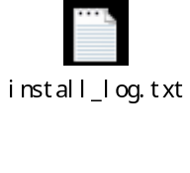

初始化数据库
# /usr/bin/mysql_install_db

启动
# /etc/rc.d/init.d/mysql status (#service mysql status ) ----查看运行状态
####(# cp /usr/share/mysql/mysql.server /etc/init.d/mysql)
[devops@db01 ~]$ sudo /etc/init.d/mysql start (#service mysql start )
Starting MySQL.. SUCCESS!

为msyql设置root密码

命令如下：
# mysql -u root -p
会提示输入密码，初始root密码保存在'/root/.mysql_secret'文件中
接着输入mysql>SET PASSWORD = PASSWORD('111111');
或：SET PASSWORD FOR user = PASSWORD('some password')

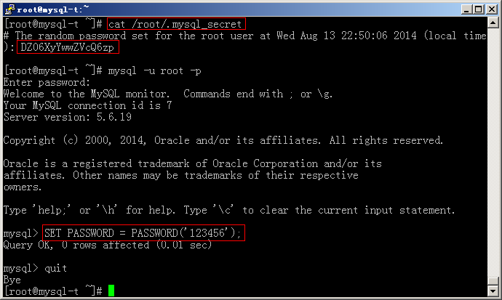

MySQL的默认安装位置

/var/lib/mysql #数据库文件
/usr/share/mysql #命令及配置文件
/usr/bin #相关命令目录(mysqladmin、mysqldump等命令)
/etc/init.d/mysql #启动脚本
/usr/my.cnf #my.cnf 的默认位置
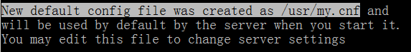

[root@mysql-t mysql]# pwd
/usr/share/mysql
[root@mysql-t mysql]# find / -name "my.cnf"
/usr/share/mysql-test/suite/federated/my.cnf
/usr/share/mysql-test/suite/ndb_rpl/my.cnf
/usr/share/mysql-test/suite/ndb/my.cnf
/usr/share/mysql-test/suite/ndb_big/my.cnf
/usr/share/mysql-test/suite/ndb_binlog/my.cnf
/usr/share/mysql-test/suite/rpl_ndb/my.cnf
/usr/share/mysql-test/suite/ndb_team/my.cnf
/usr/share/mysql-test/suite/rpl/extension/bhs/my.cnf
/usr/share/mysql-test/suite/rpl/my.cnf
/usr/my.cnf
[root@mysql-t mysql]#

配置
# cp /usr/my.cnf /etc/my.cnf

[devops@db01 ~]$ cat /etc/my.cnf
[client]
socket=/dbfiles/data/mysql.sock

[mysqld]
#General server parameters
datadir = /dbfiles/data
tmpdir= /dbfiles/temp
port = 3306
server_id = 91
bind_address=172.24.50.2
character_set_server='utf8'

# InnoDB specific parameters
innodb_undo_directory= /dbfiles/undologs
innodb_buffer_pool_size = 2048M
innodb_file_per_table=ON
innodb_flush_log_at_trx_commit=1

# Transaction behavior
autocommit=OFF
transaction-isolation=READ-COMMITTED

# Memory sizes
join_buffer_size = 128M
sort_buffer_size = 8M
read_rnd_buffer_size = 8M

# Miscellaneous parameters
sql_mode=NO_ENGINE_SUBSTITUTION,STRICT_TRANS_TABLES,NO_AUTO_CREATE_USER
default_storage_engine=InnoDB

# Enables binary logging
relay_log=/dbfiles/logs/mysql-relay-bin.log
binlog_format=ROW
log_bin=/dbfiles/logs/binlog.log
sync_binlog=1
gtid_mode=ON
log_slave_updates=ON
enforce_gtid_consistency=ON

# Disabling symbolic-links is recommended to prevent assorted security risks
symbolic-links=0

查看版本
$ mysql --version
mysql> SELECT VERSION();
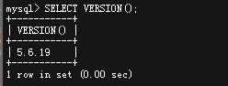

配置权限

恢复root的localhost登录权限
mysql> GRANT ALL PRIVILEGES ON *.* TO 'root'@'localhost' ;
mysql> update mysql.user set password=password('111111') where user = 'root' and host = 'localhost';

查看生产库中platform用户的权限
mysql> SHOW GRANTS FOR platform;
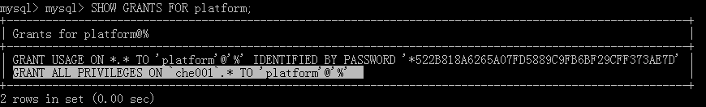

给新库配置权限
mysql> SHOW GRANTS FOR platform;
mysql> GRANT USAGE ON *.* TO 'platform'@'%' IDENTIFIED BY 'platform' WITH GRANT OPTION;
flush privileges;
mysql> GRANT ALL PRIVILEGES ON `che001`.* TO 'platform'@'%' ;
----授予platform用户在任何机器上都有使用che001数据库的任何权限(如果没有此用户，则会自动创建)。

//修改密码
mysql> select user,password,host from mysql.user;
mysql> update mysql.user set password=password('platform') where user = 'platform' and host = 'localhost';

自启动配置
[root@mysql-t ~]# chkconfig --list|grep mysqld
[root@mysql-t ~]# chkconfig --level 35 mysqld on
[root@mysql-t ~]# chkconfig --list|grep mysqld
mysqld 0:off 1:off 2:on 3:on 4:on 5:on 6:off

刷新权限表
mysql> flush privileges;
Query OK, 0 rows affected (0.02 sec)

创建用户
mysql> create user platform;

添加密码
mysql> update mysql.user set password=password('platform') where user = 'platform';
mysql> select user,password,host from mysql.user;

MYSQL主从复制配置

主机：192.168.56.102（A） 192.168.2.1
主机：192.168.56.103（B） 192.168.2.2

配置主服务器

master库配置：
# vi /etc/my.cnf
A机配置：
[mysqld]

server-id = 1
datadir = /usr/local/mysql/data
pid-file=/var/run/mysqld/mysqld.pid
log-bin=/var/log/mysql/mysql-bin.log

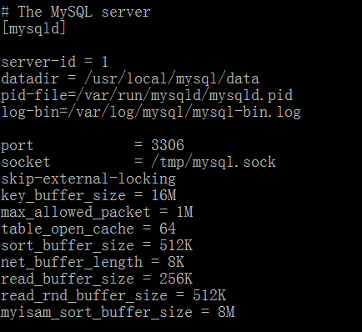
# service mysql restart ----重启
mysql> show master status\G ----查看主服务器状态
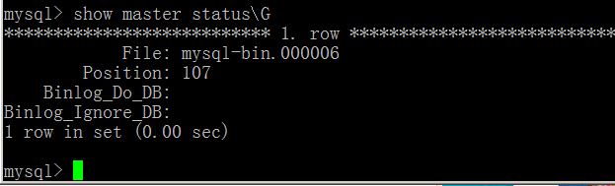

授权给从数据库服务器
mysql> create user repl_user;
mysql> update mysql.user set password=password('1234') where user = 'repl_user';
mysql> GRANT REPLICATION SLAVE ON *.* to 'repl_user'@'192.168.56.103' IDENTIFIED BY '1234';
Query OK, 0 rows affected (0.00 sec)
mysql> flush privileges; ----刷新权限表
mysql> select user,host,password from mysql.user;

Slave库配置

# vi /etc/my.cnf
[mysqld]

server-id = 2
relay-log=slave-relay-bin
relay-log-index=slave-relay-bin.index
datadir = /usr/local/mysql/data
pid-file=/var/run/mysqld/mysqld.pid

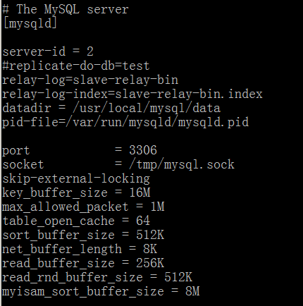

查看server-id
mysql> show variables like 'server_id';
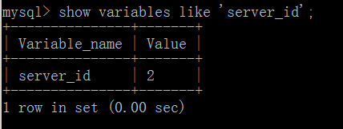

mysql> reset slave; //重置SLAVE配置
mysql> change master to master_host='192.168.56.102', \
master_port=3306,master_user='repl_user',master_password='1234';
Query OK, 0 rows affected (0.04 sec)

mysql> start slave; //启动从数据库；
mysql> SHOW SLAVE STATUS\G //检查从库状态；

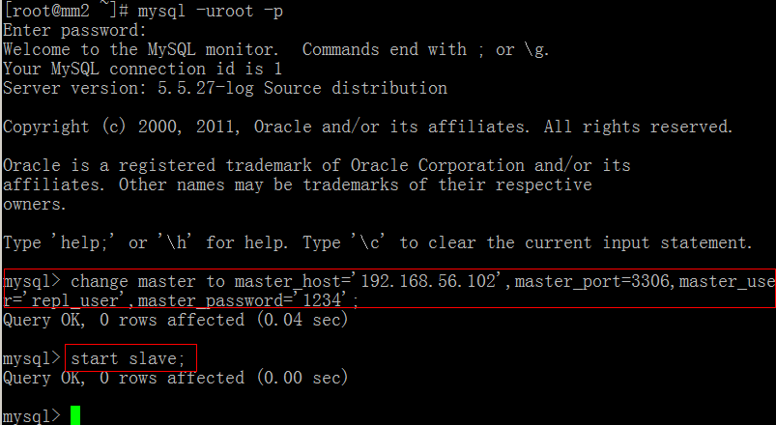
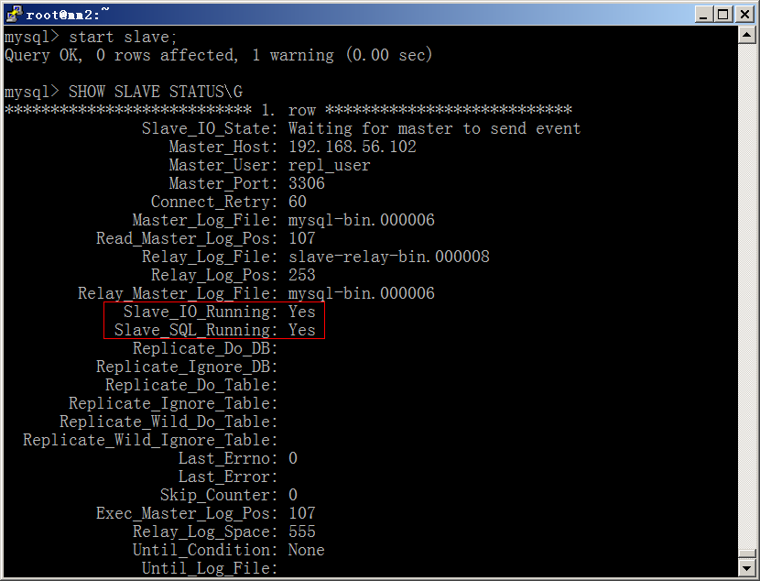

Error

ERROR 1045 (28000)
[root@db01 devops]# mysql -u root -p
[root@db01 devops]# /etc/init.d/mysql stop
Shutting down MySQL.. SUCCESS!

[root@db01 devops]# /usr/bin/mysqld_safe --user=mysql --skip-grant-tables --skip-networking &
[1] 6298
[root@db01 devops]# 140813 15:38:42 mysqld_safe Logging to '/var/lib/mysql/db01.err'.
140813 15:38:42 mysqld_safe Starting mysqld daemon with databases from /var/lib/mysql

[root@db01 devops]# mysql -u root mysql
mysql> update mysql.user set password=password("123456") where user = 'root';
mysql> flush privileges; ----刷新权限表
mysql> quit
Bye
[devops@db01 ~]$ sudo /etc/init.d/mysql restart
Starting MySQL.. SUCCESS!
[devops@db01 ~]$ mysql -uroot -p123456

ERROR 1820 (HY000):
mysql> SELECT VERSION();
ERROR 1820 (HY000): You must SET PASSWORD before executing this statement
mysql> SET PASSWORD = PASSWORD('123456'); 必须重新设置一个密码。
Query OK, 0 rows affected (0.00 sec)

mysql> SELECT VERSION();
+-----------+
| VERSION() |
+-----------+
| 5.6.19 |
+-----------+
1 row in set (0.00 sec)

mysql>

Starting MySQL.******updating PID file
错误
解决方法：（给datadir目录合适的权限）
[root@mysql-t mysql]# chown -R mysql:mysql /var/lib/mysql
[root@mysql-t mysql]# chmod -R 755 /var/lib/mysql
[root@mysql-t init.d]# cd /var/run/
[root@mysql-t run]# ll
[root@mysql-t run]# chmod -R 775 /var/run/mysqld/
[root@mysql-t run]# chown -R mysql:mysql /var/run/mysqld/
[root@mysql-t mysql]# service mysqld start



ERROR 1018 (HY000):
解决办法：
[root@mysql-t mysql]# chmod -R 755 /var/lib/mysql/test
[root@mysql-t mysql]# chown -R mysql.mysql /var/lib/mysql/test
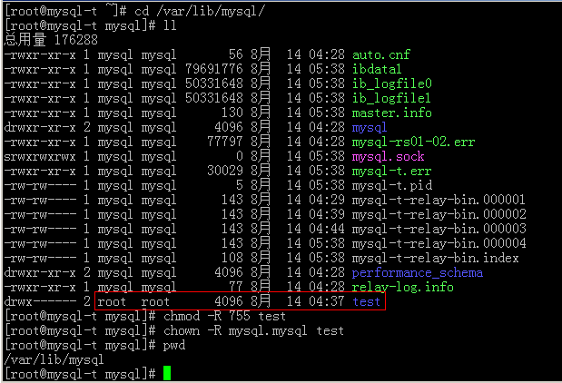
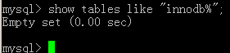

Last_IO_Errno: error 1236
mysql> stop slave;
mysql> reset slave;
mysql> change master to master_host='192.168.56.102', \
master_port=3306,master_user='repl_user',master_password='1234';
mysql> slave start;
mysql> SHOW SLAVE STATUS\G

错误：Slave_SQL_Running: No
Slave_SQL_Running: No
1.程序可能在slave上进行了写操作
2.也可能是slave机器重起后，事务回滚造成的.
一般是事务回滚造成的：
解决办法：
mysql> slave stop;
mysql> set GLOBAL SQL_SLAVE_SKIP_COUNTER=1;
mysql> slave start;

解决办法二
首先停掉Slave服务：slave stop
到主服务器上查看主机状态：记录File和Position对应的值
进入master
mysql> show master logs;
+------------------+-----------+
| Log_name | File_size |
+------------------+-----------+
| MySQL-bin.000001 | 117 |
| MySQL-bin.000002 | 117 |
| MySQL-bin.000003 | 117 |
| MySQL-bin.000004 | 117 |
| MySQL-bin.000005 | 117 |
| MySQL-bin.000006 | 117 |
| MySQL-bin.000007 | 117 |
| MySQL-bin.000008 | 117 |
| MySQL-bin.000009 | 117 |
| MySQL-bin.000010 | 117 |
| MySQL-bin.000011 | 117 |
| MySQL-bin.000012 | 826 |
| MySQL-bin.000013 | 7062 |
| MySQL-bin.000014 | 13900 |
+------------------+-----------+
14 rows in set (0.00 sec)

然后到slave服务器上执行手动同步：

mysql> change master to master_host='192.168.4.200',master_user='tongbu',
master_password='123456',master_log_file='MySQL-bin.0000014',master_log_pos=139000;
1 row in set (0.00 sec)
mysql> show slave status\G;
*************************** 1. row ***************************
........
Slave_IO_State: Waiting for master to send event
Master_Host: 192.168.4.200
Master_User: tongbu
Master_Port: 3306
Connect_Retry: 30
Master_Log_File: MySQL-bin.000014
Read_Master_Log_Pos: 13900
Relay_Log_File: relay-bin.000173
Relay_Log_Pos: 235
Relay_Master_Log_File: MySQL-bin.000014
Slave_IO_Running: Yes
Slave_SQL_Running: Yes
Replicate_Do_DB: zhubao,HyDatabase,zentao,collect
..........
手动同步需要停止master的写操作！

Last_IO_Error: error connecting
Last_IO_Error: error connecting to master 'repl@172.24.50.9:3306' - retry-time: 60 retries: 2

此错误是由于密码设置不正确导致

处理方法：
mysql> stop slave;
Query OK, 0 rows affected (0.16 sec)

mysql> reset slave;
Query OK, 0 rows affected (0.45 sec)

mysql> change master to master_host='172.24.50.9', \
master_port=3306,master_user='repl',master_password='replwd';
Query OK, 0 rows affected, 2 warnings (0.99 sec)

mysql> start slave;
Query OK, 0 rows affected (0.08 sec)

Last_IO_Error: ...UUID
Last_IO_Error: Fatal error: The slave I/O thread stops because master and slave have equal MySQL server UUIDs; these UUIDs must be different for replication to work.

解决办法：
原因在于，拷贝整个data目录，把auto.cnf文件也拷贝过来了，里面记录了数据库的uuid，每个库的uuid应该是不一样的。
[auto]
server-uuid=6dcee5be-8cdb-11e2-9408-90e2ba2e2ea6
解决办法，按照这个16进制格式，随便改下，重启mysql即可。
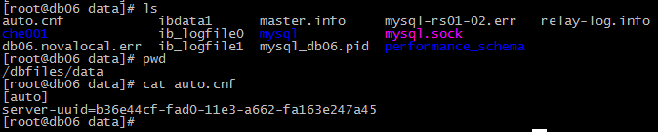

Last_IO_Error:....GLOBAL.GTID_MODE OFF
Last_IO_Error: The slave IO thread stops because the master has @@GLOBAL.GTID_MODE ON and this server has @@GLOBAL.GTID_MODE OFF
解决办法：
# service mysql stop
# vi /etc/my.cnf
添加： gtid_mode=ON
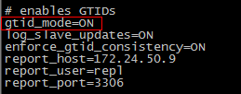
# service mysql start

Last_IO_Error:..Error_code: 1062...end_log_pos 63620

http://www.docin.com/p-702596803.html

http://wenku.baidu.com/link?url=Z3An_JjLAD5fnc4FfS-C0AKVQr0YUokLvSo0F8gkE6WB4L2WHXKDVF4bn8XDTPlSv2-Xgq7p-Q951byxSRMX16jnnxFezXCfnErwIDHHExK

mysql> show global variables like "%GTID%"\G

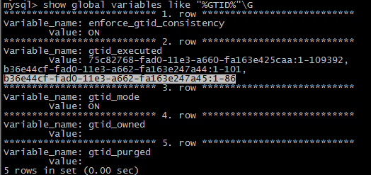
mysql> reset master; ----在slave上执行；
mysql> stop slave;
mysql> reset slave;
mysql> show global variables like "%GTID%";
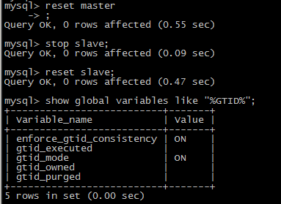

mysql> start slave;
mysql> show global variables like "%GTID%";
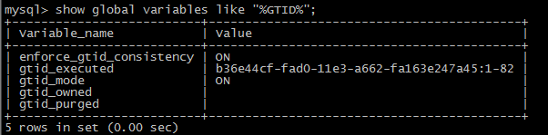
mysql> SHOW SLAVE STATUS\G
还报同样的错误！！！

mysql> stop slave;
mysql> reset slave;
mysql> show master status\G ----master中执行
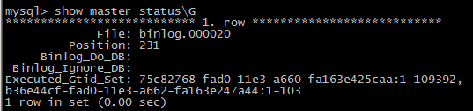
mysql> change master to master_host='172.24.50.9', master_port=3306,master_user='repl',\
master_password='replwd',master_log_file='binlog.000020',master_log_pos=231; ----slave中执行
mysql> start slave;
mysql> show slave status\G
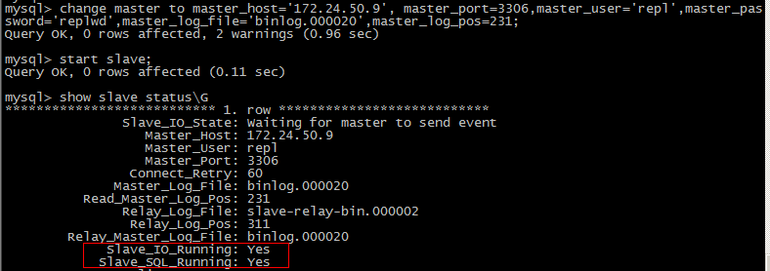
正常！！

重置密码
[root@db01 devops]# /etc/init.d/mysql stop
[root@db01 devops]# /usr/bin/mysqld_safe --user=mysql --skip-grant-tables --skip-networking &
[root@db01 devops]# mysql -u root mysql
mysql> update mysql.user set password=password("111111") where user = 'root';
mysql> flush privileges; ----刷新权限表

测试机上主从配置
主：inet addr:172.24.50.9
从：inet addr:172.24.50.10

1、关闭数据库，恢复数据（主从数据一致）
# service mysql stop
# cp -r dbfiles/* /dbfiles/
# cd /dbfiles
# chown -R mysql:mysql backup/ data/ logs/ temp/ undologs/
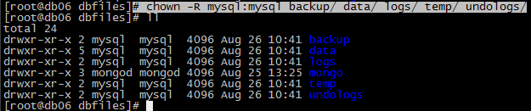

2、主库my.cnf配置：



3、权限配置
mysql> select user,host,password from mysql.user;
mysql> update mysql.user set password=password('replpw') where user = 'repl';
mysql> GRANT REPLICATION SLAVE ON *.* to 'repl'@'%' IDENTIFIED BY 'replwd';
mysql> flush privileges;
mysql> select * from mysql.user where user='repl'\G
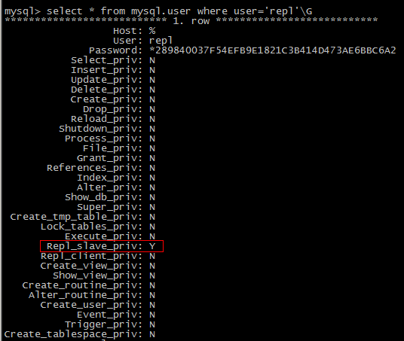

从库配置：

mysql> stop slave;
mysql> reset slave;
mysql> change master to master_host='172.24.50.9', master_port=3306,master_user='repl',master_password='replwd';

mysql> start slave;
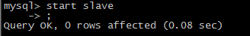

mysql> SHOW SLAVE STATUS\G //检查从库状态；
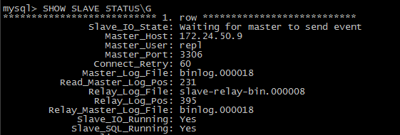
mysql> SHOW master STATUS\G //检查主库状态；
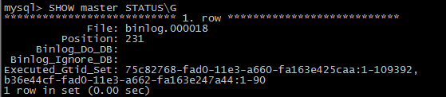

测试
主库：
创建一个表：
mysql> create table name (id int(3) auto_increment not null primary key,xm char(8),xb char(2),csny date);
插入3条数据
mysql> insert into name values('1','张三','男','1988-1-10');
mysql> insert into name values('2','李四','男','1988-2-10');
mysql> insert into name values('3','陆宇','男','1988-3-10');

mysql> show master status\G
mysql> select * from name;

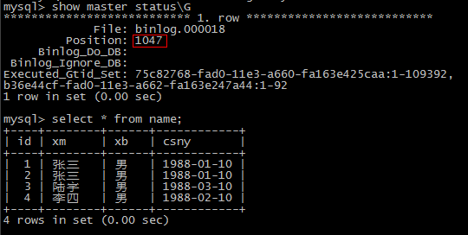

从库：
mysql> show slave status\G
mysql> select * from name;
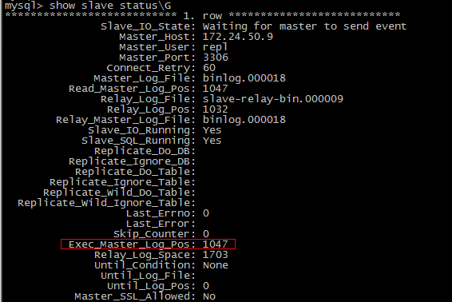

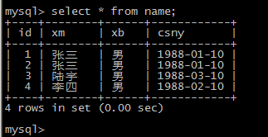

> mysql -uplatform -pplatform che001

> GRANT USAGE ON *.* TO 'platform'@'%' IDENTIFIED BY 'platform';
> GRANT ALL PRIVILEGES ON `che001`.* TO 'platform'@'%' ;

mysql -uplatform -pplatform che001

