WP
CovertChannel
题目截图
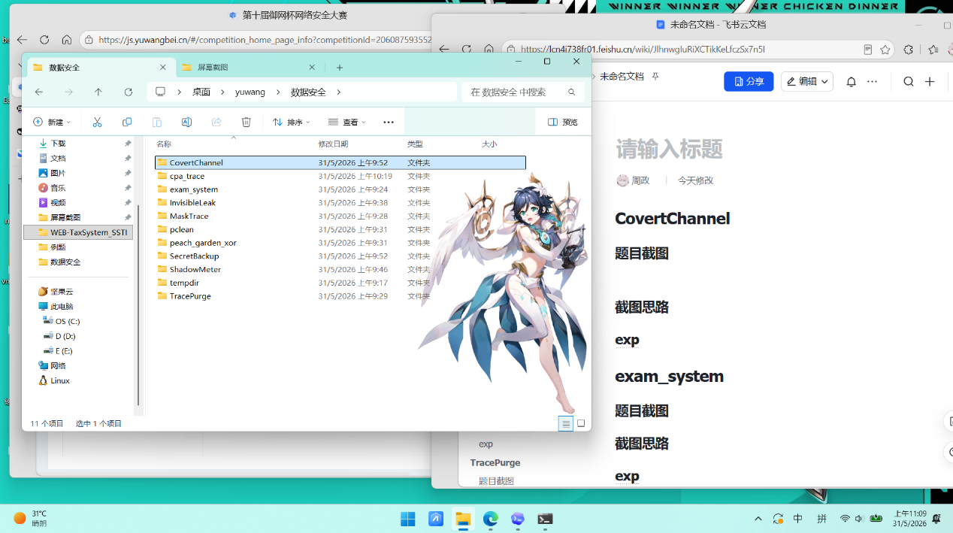

解题思路
- 题目压缩后是一个 pcapng 流量，用wireshark打开后发现是 10.10.20.33 发送了大量异常 ICMP 和 DNS 请求。真正的外泄链路是：

ICMP -> 45.76.188.23 的 IP.ttl 只取 0/1，按比特流还原出十六进制密文和提示语。
DNS TXT secret.exfil-cdn.com. 返回 Base64 字符串，解码后就是 AES-128 的密钥。
用 AES-ECB 解密还原最终 flag。
- 先过滤出两条关键流量：
- 10.10.20.33 -> 45.76.188.23 的 ICMP Echo Request
- 10.10.20.1 -> 10.10.20.33 中 secret.exfil-cdn.com. 的 DNS TXT 响应
- ICMP 这条流的 984 个包里，IP.ttl 只有 0 和 1，按 bit 拼接；DNS TXT 响应内容是 TW9yZVNlY3VyZUFlczEyOA==，Base64 解码后得到密钥MoreSecureAes128。
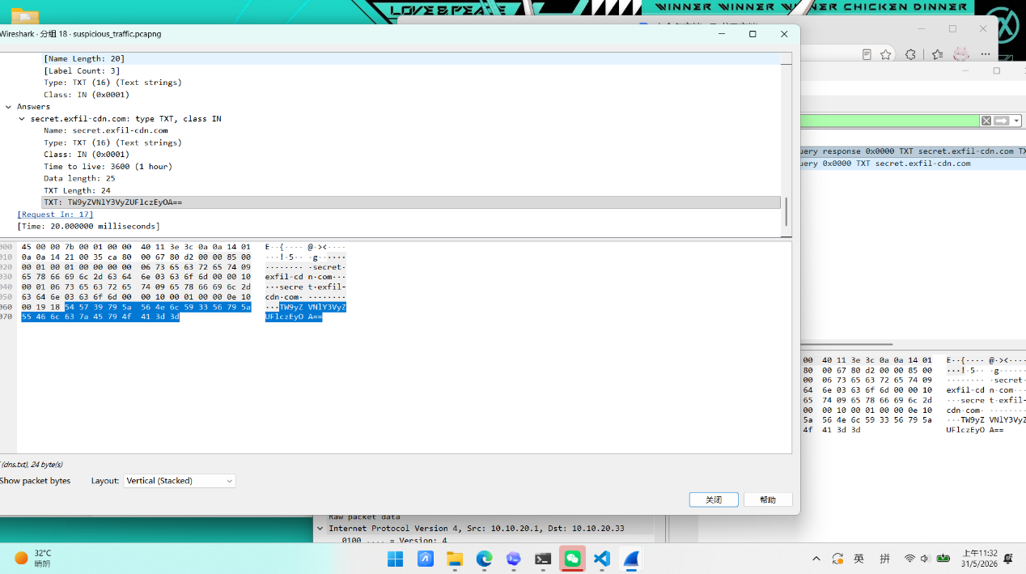
- 具体在wireshark在查看ip.src == 10.10.20.33 && ip.dst == 45.76.188.23 && icmp.type == 8流量，发现ttl只有0和1，TTL 一般是 64、128、255正常，所以把它当成二进制位按 8 bit 还原后得到：
Plain Text
60226d3cd3cf345df0baa3c8dec0d9d225b3ff91634498db4f5a7d4452dd1a2c208d4efc9da73eb8884fb69c3b1202c5|AES-ECB, key is in DNS TXT
- 还原的后面提示有 AES-ECB, key is in DNS TXT，这是AES-ECB、密钥 MoreSecureAes128 解密前面的十六进制密文即可得到 flag。
Plain Text
flag{5f356e09a565c656c6d8ae31f7973452}
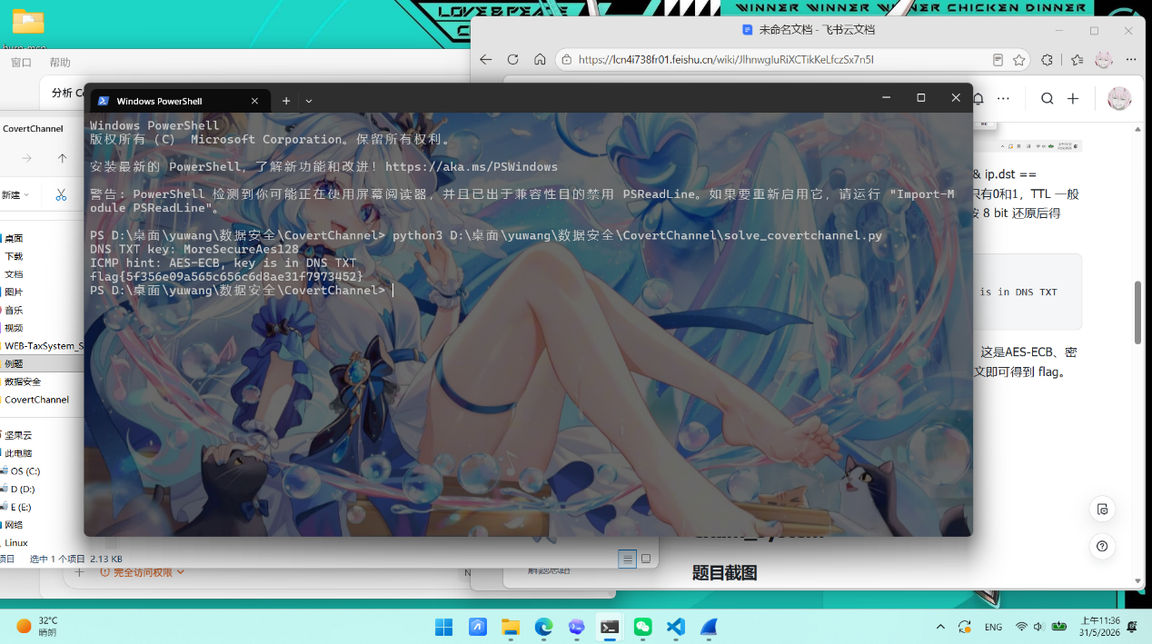

exp
Python
from __future__ import annotations
from base64 import b64decode
from pathlib import Path
from Crypto.Cipher import AES
from scapy.all import DNS, ICMP, IP, UDP, rdpcap
BASE_DIR = Path(__file__).resolve().parent
DEFAULT_PCAP = (
BASE_DIR / "extracted" / "tempdir" / "MISC附件" / "suspicious_traffic.pcapng"
)
TXT_DOMAIN = b"secret.exfil-cdn.com."
SRC_HOST = "10.10.20.33"
ICMP_EXFIL_DST = "45.76.188.23"
def load_packets(pcap_path: Path):
return rdpcap(str(pcap_path))
def extract_dns_txt_key(packets) -> bytes:
for pkt in packets:
if (
IP in pkt
and UDP in pkt
and DNS in pkt
and pkt[IP].src == "10.10.20.1"
and pkt[DNS].qr == 1
and pkt[DNS].qd
and pkt[DNS].qd.qname == TXT_DOMAIN
):
return b64decode(pkt[DNS].an.rdata[0])
raise ValueError("DNS TXT key not found")
def extract_icmp_ttl_message(packets) -> str:
bits = []
for pkt in packets:
if (
IP in pkt
and ICMP in pkt
and pkt[IP].src == SRC_HOST
and pkt[IP].dst == ICMP_EXFIL_DST
and pkt[ICMP].type == 8
):
bits.append(str(pkt[IP].ttl))
if not bits:
raise ValueError("ICMP covert channel not found")
bitstream = "".join(bits)
data = bytes(int(bitstream[i : i + 8], 2) for i in range(0, len(bitstream), 8))
return data.decode()
def decrypt_flag(ciphertext_hex: str, key: bytes) -> str:
ciphertext = bytes.fromhex(ciphertext_hex)
plaintext = AES.new(key, AES.MODE_ECB).decrypt(ciphertext)
return plaintext.rstrip(b"\n").decode()
def solve(pcap_path: Path = DEFAULT_PCAP) -> str:
packets = load_packets(pcap_path)
key = extract_dns_txt_key(packets)
ttl_message = extract_icmp_ttl_message(packets)
ciphertext_hex, hint = ttl_message.split("|", 1)
if hint.strip() != "AES-ECB, key is in DNS TXT":
raise ValueError(f"Unexpected hint: {hint}")
flag = decrypt_flag(ciphertext_hex, key)
print(f"DNS TXT key: {key.decode()}")
print(f"ICMP hint: {hint}")
print(flag)
return flag
if __name__ == "__main__":
solve()
exam_system
题目截图
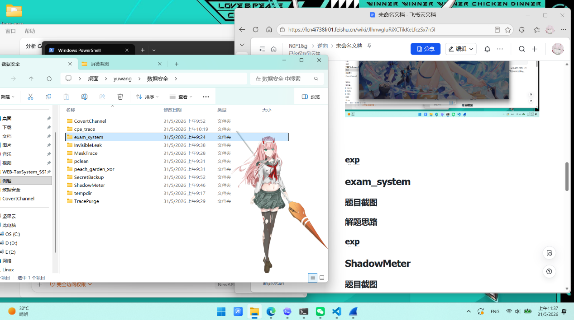
解题思路

- 解压出有SQLite 数据库备份和一份《安全审计规范》md。
- 先看审计规范里，找幽灵账户和排除幽灵账户的所有访问日志再对剩下的每条日志判违规类型
- 幽灵账户：idcard 或 phone 任一校验不通过的用户。
- 违规类型：
- 1：用户状态为 inactive 但仍有访问记录
- 2：访问时间不在 09:00:00-18:00:00 内
- 3：用户角色对该 API 没有访问权限
- 若同一条日志同时命中多种违规类型，只记录最小的类型编号。
其中身份证需要做这几项校验：
- 格式必须是 17 位数字 + 1 位数字或 X
- 出生日期字段必须能解析为合法日期 YYYYMMDD
- 最后一位校验码要满足加权校验规则，权重为 7,9,10,5,8,4,2,1,6,3,7,9,10,5,8,4,2
手机号校验规则是必须恰好为 11 位数字，前 3 位必须属于题目给定的合法号段集合
- 接下来写脚本把所有违规日志按日志 id 升序写成：日志ID-类型编号再用英文逗号连接
算出幽灵账户用户 ID：
Plain Text
3,12,16,31,34,40,43,44,63,68,72,78,80,85,88,92,112,128,132,133,134,151,160,165,172,179,186,188,192,195
违规记录串：
Plain Text
14728-3,24311-1,30736-1,38039-2,40118-2,41610-1,47445-3,60354-2,76513-1
再用md5在线网站https://www.sojson.com/encrypt_md5.html做 MD5加密，外面套上 flag{}
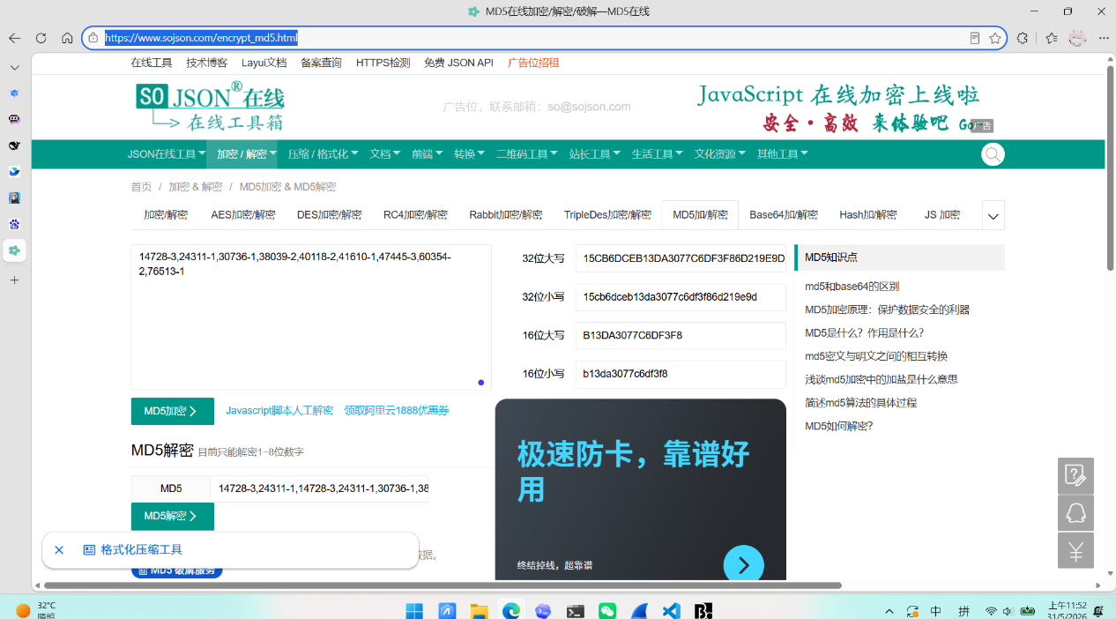

Plain Text
flag{15cb6dceb13da3077c6df3f86d219e9d}
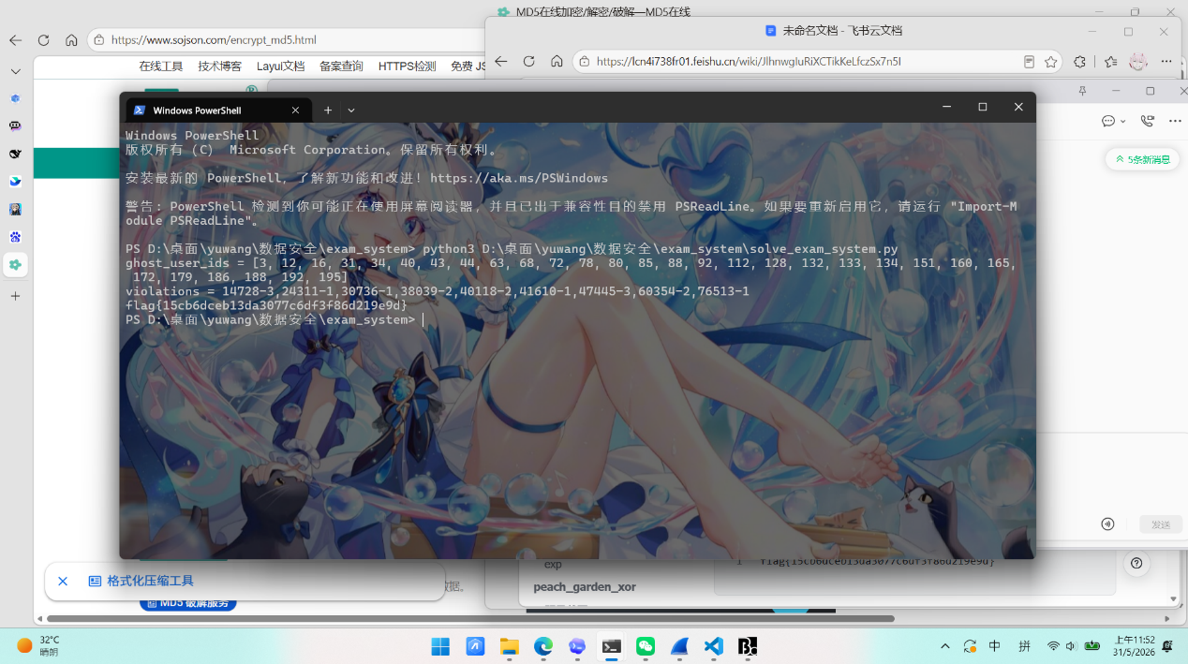

exp
Python
import datetime as dt
import hashlib
import re
import sqlite3
from pathlib import Path
BASE_DIR = Path(__file__).resolve().parent
DB_CANDIDATES = [
BASE_DIR / "tempdir" / "payload" / "exam_system的附件" / "exam_system.db",
BASE_DIR / "exam_system.db",
Path(r"C:\temp\exam_tmp\exam_system.db"),
]
PHONE_PREFIXES = {
"130", "131", "132", "133", "134", "135", "136", "137", "138", "139",
"140", "145", "146", "147", "148", "149", "150", "151", "152", "153",
"155", "156", "157", "158", "159", "166", "167", "171", "172", "173",
"174", "175", "176", "177", "178", "180", "181", "182", "183", "184",
"185", "186", "187", "188", "189", "190", "191", "193", "195", "196",
"198", "199",
}
IDCARD_WEIGHTS = [7, 9, 10, 5, 8, 4, 2, 1, 6, 3, 7, 9, 10, 5, 8, 4, 2]
IDCARD_CHECKSUM = {
0: "1",
1: "0",
2: "X",
3: "9",
4: "8",
5: "7",
6: "6",
7: "5",
8: "4",
9: "3",
10: "2",
}
def valid_phone(phone: str) -> bool:
return bool(re.fullmatch(r"\d{11}", phone)) and phone[:3] in PHONE_PREFIXES
def valid_idcard(idcard: str) -> bool:
if not re.fullmatch(r"\d{17}[\dX]", idcard):
return False
try:
dt.datetime.strptime(idcard[6:14], "%Y%m%d")
except ValueError:
return False
total = sum(int(num) * weight for num, weight in zip(idcard[:17], IDCARD_WEIGHTS))
return IDCARD_CHECKSUM[total % 11] == idcard[-1]
def find_db_path() -> Path:
for candidate in DB_CANDIDATES:
if candidate.exists():
return candidate
raise FileNotFoundError("Could not locate exam_system.db")
def main() -> None:
conn = sqlite3.connect(find_db_path())
cur = conn.cursor()
users = {
row[0]: {
"username": row[1],
"idcard": row[4],
"phone": row[5],
"role_id": row[6],
"status": row[7],
}
for row in cur.execute("SELECT * FROM users")
}
permissions = {
(row[1], row[2]): row[3]
for row in cur.execute("SELECT * FROM api_permissions")
}
ghost_users = {
user_id
for user_id, user in users.items()
if not valid_idcard(user["idcard"]) or not valid_phone(user["phone"])
}
violations = []
for log_id, user_id, api_endpoint, access_time in cur.execute(
"SELECT id, user_id, api_endpoint, access_time FROM access_logs ORDER BY id"
):
if user_id in ghost_users:
continue
user = users[user_id]
violation_types = []
if user["status"] == "inactive":
violation_types.append(1)
access_clock = access_time.split()[1]
if access_clock < "09:00:00" or access_clock > "18:00:00":
violation_types.append(2)
if permissions.get((user["role_id"], api_endpoint), 0) != 1:
violation_types.append(3)
if violation_types:
violations.append(f"{log_id}-{min(violation_types)}")
joined = ",".join(violations)
flag = hashlib.md5(joined.encode()).hexdigest()
print("ghost_user_ids =", sorted(ghost_users))
print("violations =", joined)
print(f"flag{{{flag}}}")
if __name__ == "__main__":
main()
ShadowMeter
题目截图
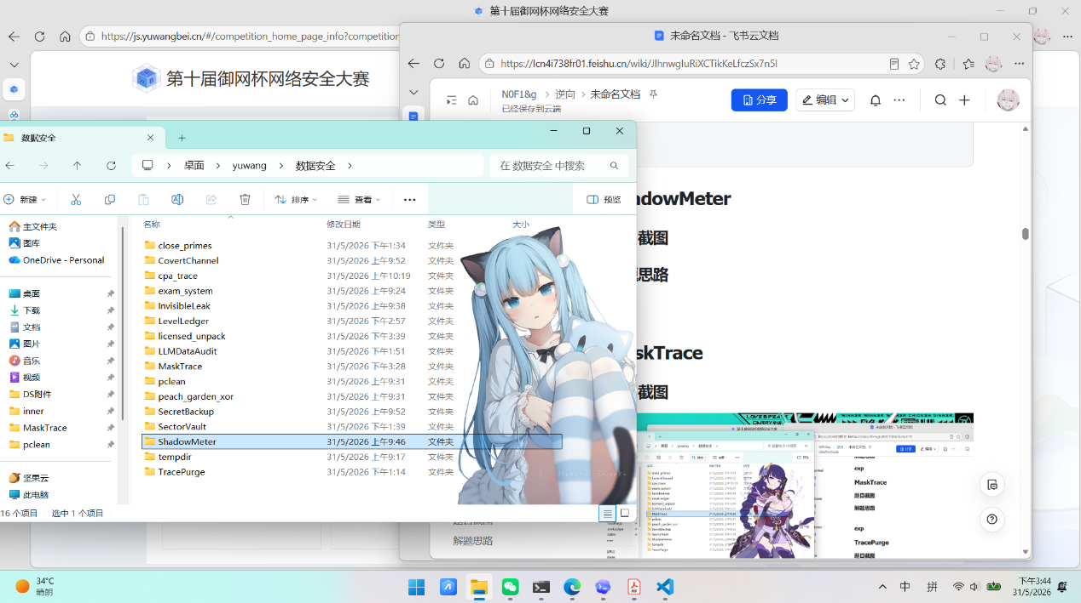
解题思路
- 解压发现access.log有大量来自 172.25.0.1 的请求，部分带有 User-Agent DataMeterAgent/3.4 (perf-collector)。同时在 error.log 中发现对 /admin/login.php 的暴力破解：
Plain Text
username=admin_ops&password=Admin%40Pa%24%24w0rd
- 解码后为 Admin@Pa$$w0rd，登录成功返回 {"token":"ops-internal-8dd18cfd"}。
- 再看error.log 启用了 mod_dumpio 的 trace7 级别日志，完整记录了 HTTP 请求和响应的原始字节。攻击者使用 /collect/report.php 将 70 个 base64 分片外传，每个分片包含 app=portal&env=prod&job=SM-20260507-17&seq=N&note=...&sign=...。
- 发现：/admin/debug.php 的 POST 请求体中包含加密密钥
Plain Text
op=peek_export_keyf&token=meter_report&key=SM-20260507-17%3Ameter%3Areport
URL 解码后密钥为 SM-20260507-17:meter:report。
- 从 error.log 提取所有 SM job 的 note 值，URL 解码后按 seq 顺序拼接，一次性 base64 解码。还原后的 ZIP 大小为 10601 字节，包含 3 个文件：export.csv、manifest.json、readme.txt。
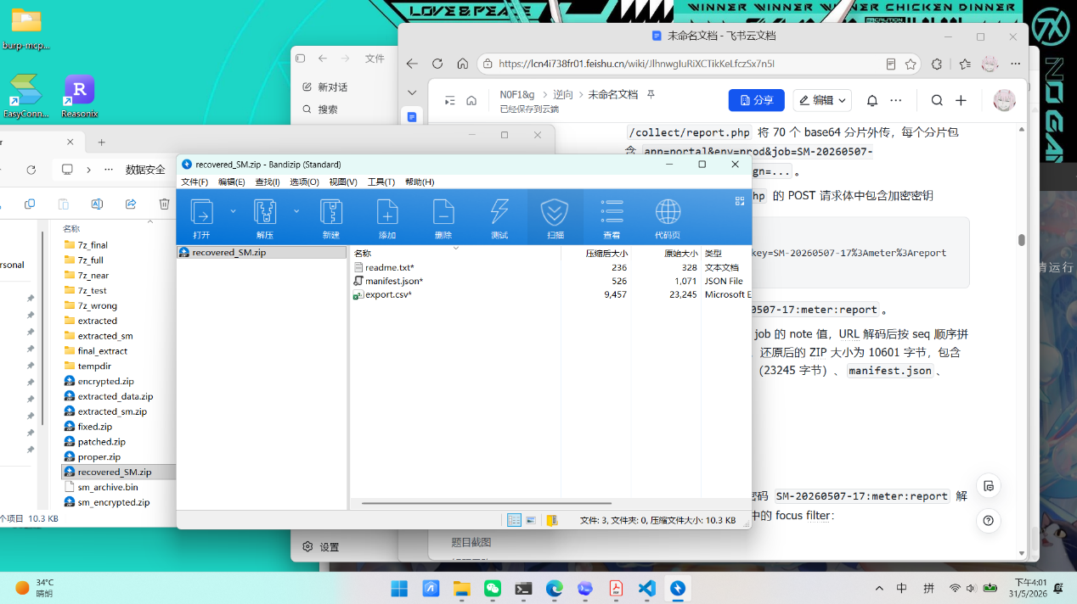
- 使用 pyzipper以密码 SM-20260507-17:meter:report 解密。根据 manifest.json 中的 focus filter：
JSON
{
"app": "portal",
"metric_name": "secure.checkpoint",
"user_id": "ADMIN_OPS"
}
在 export.csv 中筛选到唯一匹配的记录查询portal，找到匹配的发现tg_c1b50d61ac8b81fac5ab3ea499056c0a，去掉 tg_ 前缀就是 flag。

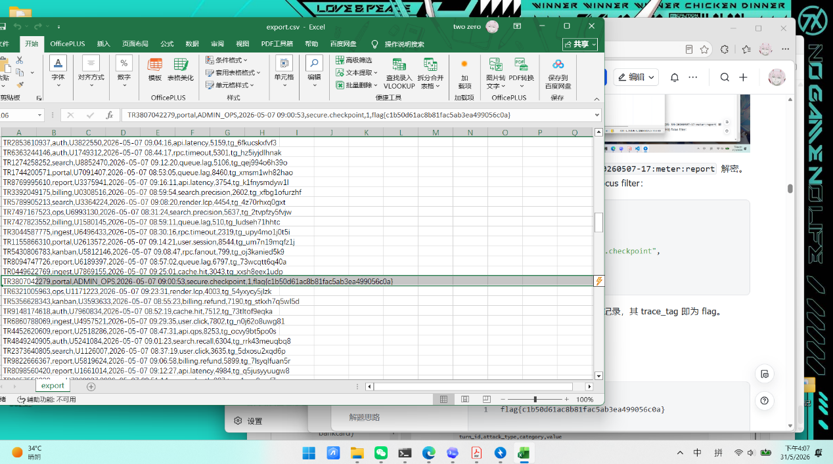

Plain Text
flag{c1b50d61ac8b81fac5ab3ea499056c0a}
exp
Python
#!/usr/bin/env python3
"""ShadowMeter solve — 从 error.log 还原被外传的审计数据"""
import re, os, sys, tempfile, subprocess, json
BASE = os.path.dirname(os.path.abspath(__file__))
LOG = os.path.join(BASE, "3_ShadowMeter", "extracted", "ShadowMeter附件", "error.log")
if not os.path.exists(LOG):
print(f"未找到 error.log，预期路径: {LOG}")
print("请将 error.log 放在脚本同目录下，或修改 LOG 变量路径")
sys.exit(1)
# ── 1. 行状态机：按 [client:port] 追踪每个 TCP 连接的 POST body ──
connections = {} # client_port → {"job":"", "seq":"", "note":"", "body_len":0}
collect = [] # 收集到的 SM 条目
with open(LOG, errors="replace") as f:
for line in f:
# 提取 client:port 例: [client 172.25.0.1:60118]
m = re.search(r"\[client ([\d.]+:\d+)\]", line)
if not m:
continue
host = m[1]
# dumpio_in 标记 HTTP 请求行和请求体
if "dumpio_in (data-HEAP):" in line:
# 一个 POST 请求开始了
if "POST " in line:
connections[host] = {"body": "", "expect": 0, "job": "", "seq": ""}
elif "Content-Length:" in line:
cl = re.search(r"Content-Length: (\d+)", line)
if cl and host in connections:
connections[host]["expect"] = int(cl[1])
elif host in connections and connections[host]["expect"] > 0:
# 提取请求体中的数据 (app=... 形式)
payload = line.split("dumpio_in")[-1]
payload = re.sub(r".*?\(data-HEAP\):\s*", "", payload).strip()
payload = payload.replace("\\r\\n", "").replace("\\n", "")
if payload and "job=SM-20260507-17" in payload:
conn = connections[host]
conn["body"] += payload
# 判断是否收齐 (根据 Content-Length)
if len(conn["body"]) >= conn["expect"]:
body = conn["body"][:conn["expect"]]
# 手工提取 note、seq
note_m = re.search(r"note=([^&]+)", body)
seq_m = re.search(r"seq=(\d+)", body)
if note_m and seq_m:
collect.append({
"seq": int(seq_m[1]),
"note_enc": note_m[1] # URL 编码的 base64
})
del connections[host]
# 合并重复 seq（取第一次出现的）
seen = set()
deduped = []
for e in collect:
if e["seq"] not in seen:
seen.add(e["seq"])
deduped.append(e)
collect = deduped
collect.sort(key=lambda x: x["seq"])
print(f"共收集 {len(collect)} 个分片 (seq {collect[0]['seq']}~{collect[-1]['seq']})")
# ── 3. 还原 ZIP: 逐个 URL 解码 → 去 padding → 拼接 → 加 padding → 一次解码 ──
import urllib.parse
pieces = []
for entry in collect:
raw = urllib.parse.unquote(entry["note_enc"])
raw = raw.rstrip("=") # 去掉本来的 padding
pieces.append(raw)
big_b64 = "".join(pieces)
# 补回最终的 padding
pad = 4 - len(big_b64) % 4
if pad != 4:
big_b64 += "=" * pad
import base64
zip_data = base64.b64decode(big_b64)
# 写入临时文件
tmp = tempfile.NamedTemporaryFile(delete=False, suffix=".zip")
tmp.write(zip_data)
tmp.close()
print(f"ZIP还原完成 ({len(zip_data)} bytes)")
# ── 4. 用 7z 命令行解密 ──
out_dir = tempfile.mkdtemp()
pwd = "SM-20260507-17:meter:report"
_7z = r"C:\Program Files\7-Zip\7z.exe"
rc = subprocess.call([
_7z, "x", f"-p{pwd}", f"-o{out_dir}",
tmp.name
], stdout=subprocess.DEVNULL, stderr=subprocess.DEVNULL)
os.unlink(tmp.name) # 删除临时 ZIP
# ── 5. 读取 CSV 和 manifest ──
csv_path = os.path.join(out_dir, "export.csv")
mft_path = os.path.join(out_dir, "manifest.json")
if not os.path.exists(csv_path):
print("失败请检查密码")
sys.exit(1)
with open(csv_path, encoding="utf-8", errors="replace") as f:
csv_lines = f.read().strip().split("\n")
with open(mft_path, encoding="utf-8", errors="replace") as f:
manifest = json.load(f)
# ── 6. 按 manifest.focus.filter 定位 ──
flt = manifest["focus"]["filter"]
print(f"过滤条件: app={flt['app']} metric={flt['metric_name']} user={flt['user_id']}")
# 解析 CSV 列名: trace_id,app,user_id,event_time,metric_name,value,trace_tag
header = csv_lines[0].split(",")
col_idx = {name: i for i, name in enumerate(header)}
for row in csv_lines[1:]:
cols = row.split(",")
if len(cols) < len(header):
continue
if (cols[col_idx["app"]] == flt["app"]
and cols[col_idx["user_id"]] == flt["user_id"]
and cols[col_idx["metric_name"]] == flt["metric_name"]):
tag = cols[col_idx["trace_tag"]]
flag = tag.split("flag{")[1].rstrip("}") if "flag{" in tag else tag.replace("tg_", "")
print(f"\nflag{{{flag}}}")
break
# 清理
import shutil
shutil.rmtree(out_dir, ignore_errors=True)
MaskTrace
题目截图
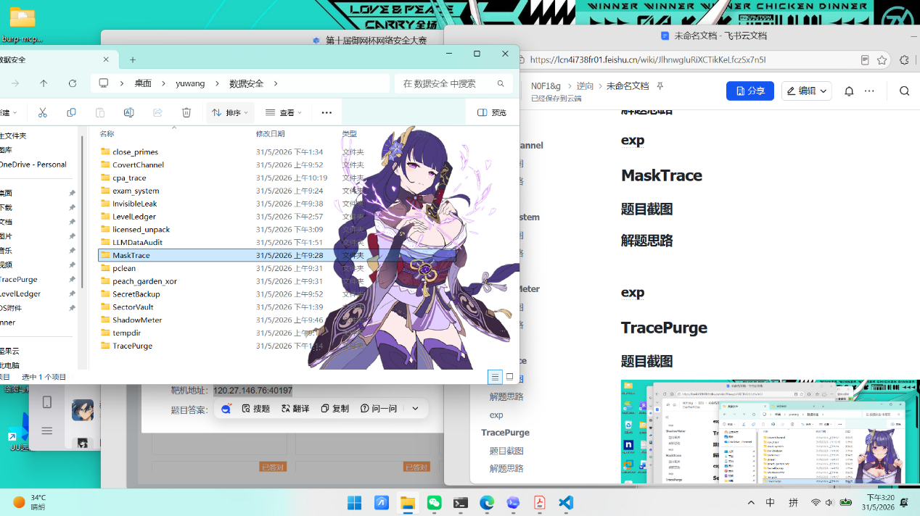
解题思路
- 解压后有 user_export.sql 和字段脱敏规范，要求只保留 status=active 的记录，逐字段做合法性校验与脱敏，导出指定表头的 UTF-8 CSV，再上传到校验平台拿 flag。核心就是把 SQL 导入内存后按规范实现一套严格的数据清洗流水线。
- 先读取 脱敏规范.md，再把 user_export.sql)直接导入 SQLite。规则有
- 只导出 status='active'，并按 id ASC 排序。
- password 做原文 MD5。
- idcard 要校验 18 位格式、真实生日和身份证校验位。
- phone / bankcard 先归一化后再判合法性。
- birthday 按参考日 2026-05-01 计算十年年龄段。
- 非法字段不丢行，直接写成 INVALID。
- 靶机文件给的官方 example.csv 只给了前 40 行样例；用它对照本地脚本前缀输出，可以快速确认规则实现是否一致。
- 按要求写对应的脚本，把输出的masktrace_answer.csv提交上去,获得flag
Plain Text
flag{eb463fa3858c3be11675e96664e615dc}
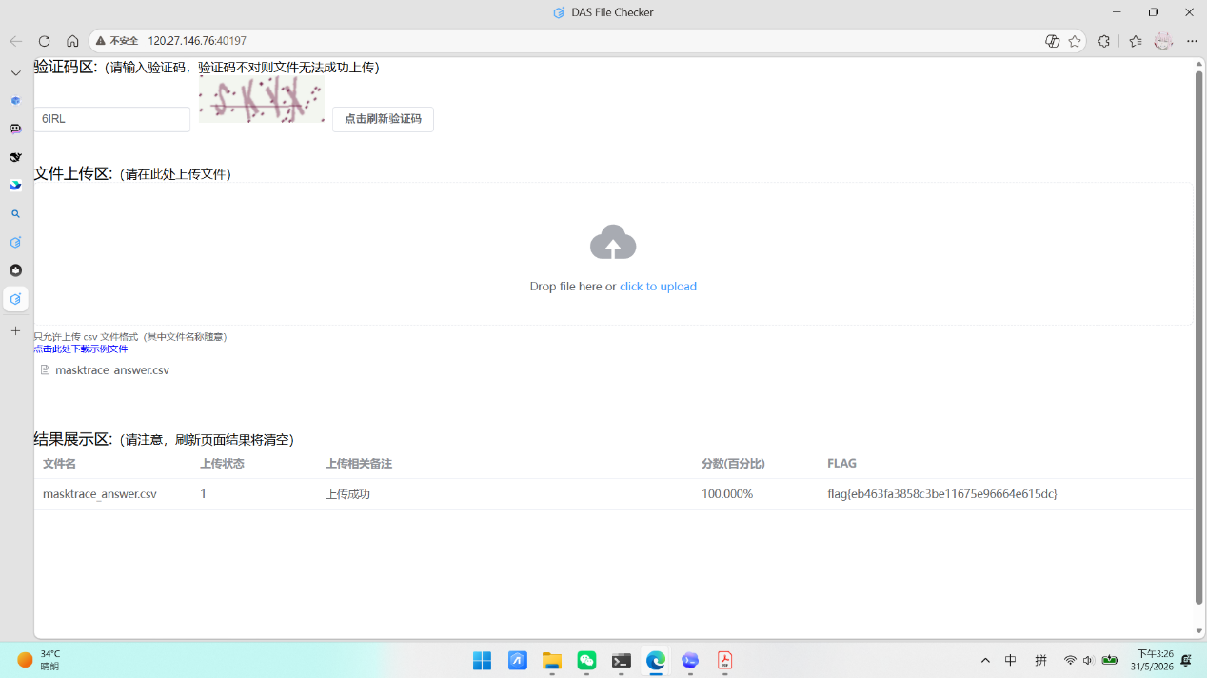

exp
Python
import argparse
import csv
import hashlib
import ipaddress
import re
import sqlite3
import time
from datetime import date, datetime
from pathlib import Path
HEADER = [
"id",
"username",
"password",
"name",
"idcard",
"phone",
"email",
"bankcard",
"address",
"ip",
"birthday",
]
PHONE_PREFIXES = {
"134",
"135",
"136",
"137",
"138",
"139",
"147",
"148",
"150",
"151",
"152",
"157",
"158",
"159",
"172",
"178",
"182",
"183",
"184",
"187",
"188",
"195",
"198",
"130",
"131",
"132",
"140",
"145",
"146",
"155",
"156",
"166",
"167",
"171",
"175",
"176",
"185",
"186",
"196",
"133",
"149",
"153",
"173",
"174",
"177",
"180",
"181",
"189",
"190",
"191",
"193",
"199",
}
IDCARD_WEIGHTS = [7, 9, 10, 5, 8, 4, 2, 1, 6, 3, 7, 9, 10, 5, 8, 4, 2]
IDCARD_CHECK_MAP = "10X98765432"
EMAIL_RE = re.compile(
r"^[a-z0-9](?:[a-z0-9_%+\-]*(?:\.[a-z0-9_%+\-]+)*)?@"
r"[a-z0-9](?:[a-z0-9\-]{0,61}[a-z0-9])?"
r"(?:\.[a-z0-9](?:[a-z0-9\-]{0,61}[a-z0-9])?)+$"
)
CHINESE_RE = re.compile(r"[\u4e00-\u9fff]+")
REFERENCE_DAY = date(2026, 5, 1)
BASE_DIR = Path(__file__).resolve().parent
def resolve_path(path_str: str) -> Path:
path = Path(path_str)
if path.is_absolute():
return path
if path.exists():
return path.resolve()
return BASE_DIR / path
def clean_text(value: str) -> str:
return value.strip()
def mask_like_username(value: str) -> str:
value = clean_text(value)
if len(value) <= 1:
return "*" * len(value)
if len(value) == 2:
return value[0] + "*"
return value[0] + ("*" * (len(value) - 2)) + value[-1]
def md5_lower(value: str) -> str:
return hashlib.md5(clean_text(value).encode("utf-8")).hexdigest()
def mask_name(value: str) -> str:
value = clean_text(value)
if len(value) < 2 or not CHINESE_RE.fullmatch(value):
return "INVALID"
if len(value) == 2:
return value[0] + "*"
return value[0] + ("*" * (len(value) - 2)) + value[-1]
def valid_idcard(value: str) -> bool:
if not re.fullmatch(r"\d{17}[\dX]", value):
return False
try:
datetime.strptime(value[6:14], "%Y%m%d")
except ValueError:
return False
checksum = sum(int(num) * weight for num, weight in zip(value[:17], IDCARD_WEIGHTS))
return IDCARD_CHECK_MAP[checksum % 11] == value[-1]
def mask_idcard(value: str) -> str:
value = clean_text(value).upper()
if not valid_idcard(value):
return "INVALID"
return "******" + value[6:10] + "********"
def normalize_phone(value: str) -> str:
digits = re.sub(r"\D", "", clean_text(value))
if digits.startswith("0086") and len(digits) == 15:
digits = digits[4:]
elif digits.startswith("86") and len(digits) == 13:
digits = digits[2:]
return digits
def mask_phone(value: str) -> str:
digits = normalize_phone(value)
if len(digits) != 11 or not digits.isdigit() or digits[:3] not in PHONE_PREFIXES:
return "INVALID"
return digits[:3] + "****" + digits[7:]
def mask_email(value: str) -> str:
value = clean_text(value).lower()
if not EMAIL_RE.fullmatch(value):
return "INVALID"
local, domain = value.split("@", 1)
return f"{mask_like_username(local)}@{domain}"
def normalize_bankcard(value: str) -> str:
return re.sub(r"\D", "", clean_text(value))
def mask_bankcard(value: str) -> str:
digits = normalize_bankcard(value)
if not digits.isdigit() or not 16 <= len(digits) <= 19:
return "INVALID"
return digits[:6] + ("*" * (len(digits) - 10)) + digits[-4:]
def mask_address(value: str) -> str:
value = clean_text(value)
idx = value.find("号")
if idx == -1:
return "INVALID"
return value[:idx] + "***"
def mask_ip(value: str) -> str:
value = clean_text(value)
try:
ip = ipaddress.IPv4Address(value)
except ipaddress.AddressValueError:
return "INVALID"
parts = str(ip).split(".")
return ".".join(parts[:3] + ["*"])
def parse_birthday(value: str) -> date | None:
value = clean_text(value)
for fmt in ("%Y-%m-%d", "%Y/%m/%d"):
try:
return datetime.strptime(value, fmt).date()
except ValueError:
continue
return None
def mask_birthday(value: str) -> str:
birthday = parse_birthday(value)
if birthday is None or birthday > REFERENCE_DAY:
return "INVALID"
age = REFERENCE_DAY.year - birthday.year
if (REFERENCE_DAY.month, REFERENCE_DAY.day) < (birthday.month, birthday.day):
age -= 1
if age < 0:
return "INVALID"
lower = (age // 10) * 10
return f"{lower}-{lower + 9}"
def load_active_rows(sql_path: Path) -> list[sqlite3.Row]:
conn = sqlite3.connect(":memory:")
conn.row_factory = sqlite3.Row
conn.executescript(sql_path.read_text(encoding="utf-8"))
rows = conn.execute(
"""
SELECT id, username, password, name, idcard, phone, email, bankcard, address, ip, birthday
FROM user_export
WHERE status = 'active'
ORDER BY id ASC
"""
).fetchall()
conn.close()
return rows
def transform_row(row: sqlite3.Row) -> list[str]:
return [
str(row["id"]),
mask_like_username(row["username"]),
md5_lower(row["password"]),
mask_name(row["name"]),
mask_idcard(row["idcard"]),
mask_phone(row["phone"]),
mask_email(row["email"]),
mask_bankcard(row["bankcard"]),
mask_address(row["address"]),
mask_ip(row["ip"]),
mask_birthday(row["birthday"]),
]
def write_csv(rows: list[list[str]], output_path: Path) -> None:
with output_path.open("w", encoding="utf-8", newline="") as handle:
writer = csv.writer(handle)
writer.writerow(HEADER)
writer.writerows(rows)
def compare_csv(expected_path: Path, actual_path: Path) -> int:
with expected_path.open(encoding="utf-8", newline="") as expected_handle:
expected_rows = list(csv.reader(expected_handle))
with actual_path.open(encoding="utf-8", newline="") as actual_handle:
actual_rows = list(csv.reader(actual_handle))
mismatches = 0
limit = min(len(expected_rows), len(actual_rows))
for index in range(limit):
if expected_rows[index] != actual_rows[index]:
mismatches += 1
print(f"Line {index + 1} mismatch")
print(" expected:", expected_rows[index])
print(" actual :", actual_rows[index])
if len(expected_rows) != len(actual_rows):
print(f"Row count differs: expected {len(expected_rows)}, actual {len(actual_rows)}")
return mismatches
def fetch_captcha(base_url: str, save_path: Path) -> str:
import requests
session = requests.Session()
session.get(f"{base_url}/api/captcha", timeout=30)
response = session.get(f"{base_url}/api/captcha?ts={int(time.time() * 1000)}", timeout=30)
response.raise_for_status()
save_path.write_bytes(response.content)
return session.cookies.get("session", "")
def submit_csv(base_url: str, csv_path: Path, captcha: str, session_cookie: str) -> dict:
import requests
session = requests.Session()
if session_cookie:
session.cookies.set("session", session_cookie)
with csv_path.open("rb") as handle:
response = session.post(
f"{base_url}/api/upload",
files={"file": (csv_path.name, handle, "text/csv")},
data={"captcha": captcha},
timeout=60,
)
response.raise_for_status()
payload = response.json()
if payload.get("state") == -1:
raise RuntimeError(payload.get("reason", "upload failed"))
key = payload["key"]
for _ in range(180):
status = session.get(f"{base_url}/api/status/{key}", timeout=30)
status.raise_for_status()
result = status.json()
if result.get("state") == 1:
return result
time.sleep(2)
raise TimeoutError("submission did not finish within the polling window")
def main() -> None:
parser = argparse.ArgumentParser(description="Solve the MaskTrace data masking challenge.")
parser.add_argument("--sql", default=r"payload\MaskTrace附件\user_export.sql", help="Path to user_export.sql")
parser.add_argument("--output", default="masktrace_answer.csv", help="Path to the output CSV file")
parser.add_argument(
"--compare",
default="",
help="Optional path to a reference CSV for comparison",
)
parser.add_argument(
"--base-url",
default="http://120.27.146.76:40197",
help="Checker platform base URL",
)
parser.add_argument(
"--fetch-captcha",
action="store_true",
help="Fetch a fresh captcha image and save its session cookie",
)
parser.add_argument(
"--captcha-path",
default="captcha.png",
help="Where to save the fetched captcha image",
)
parser.add_argument(
"--session-cookie-path",
default="session_cookie.txt",
help="Where to save or load the checker session cookie",
)
parser.add_argument(
"--submit",
action="store_true",
help="Submit the generated CSV to the checker platform",
)
parser.add_argument(
"--captcha",
default="",
help="Captcha text used when submitting the CSV",
)
args = parser.parse_args()
sql_path = resolve_path(args.sql)
output_path = resolve_path(args.output)
captcha_path = resolve_path(args.captcha_path)
session_cookie_path = resolve_path(args.session_cookie_path)
rows = [transform_row(row) for row in load_active_rows(sql_path)]
write_csv(rows, output_path)
print(f"Wrote {len(rows)} active rows to {output_path}")
if args.compare:
mismatches = compare_csv(resolve_path(args.compare), output_path)
if mismatches:
print(f"Comparison finished with {mismatches} mismatches")
else:
print("Comparison finished with no mismatches")
if args.fetch_captcha:
session_cookie = fetch_captcha(args.base_url, captcha_path)
session_cookie_path.write_text(session_cookie, encoding="utf-8")
print(f"Saved captcha image to {captcha_path}")
print(f"Saved session cookie to {session_cookie_path}")
if args.submit:
if not args.captcha:
raise SystemExit("--submit requires --captcha")
session_cookie = ""
if session_cookie_path.exists():
session_cookie = session_cookie_path.read_text(encoding="utf-8").strip()
result = submit_csv(args.base_url, output_path, args.captcha, session_cookie)
print(result)
if __name__ == "__main__":
main()

TracePurge
题目截图
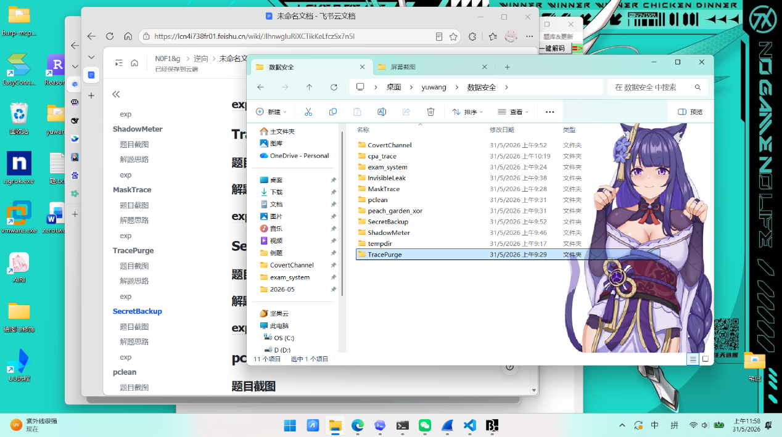
解题思路
- 解压发现有外部泄露样本、内部导出日志、外发检测日志和客户索引，看事件响应说明.md，export_log.csv 表示导出任务有没有成功，transfer_log.csv 表示导出的文件有没有外发
- 再从export_log.csv 和 transfer_log.csv 找 status=success 且 event=external_upload 的任务。
- 找到EX20260508004 / CRM-20260508-D4 是 success + external_upload
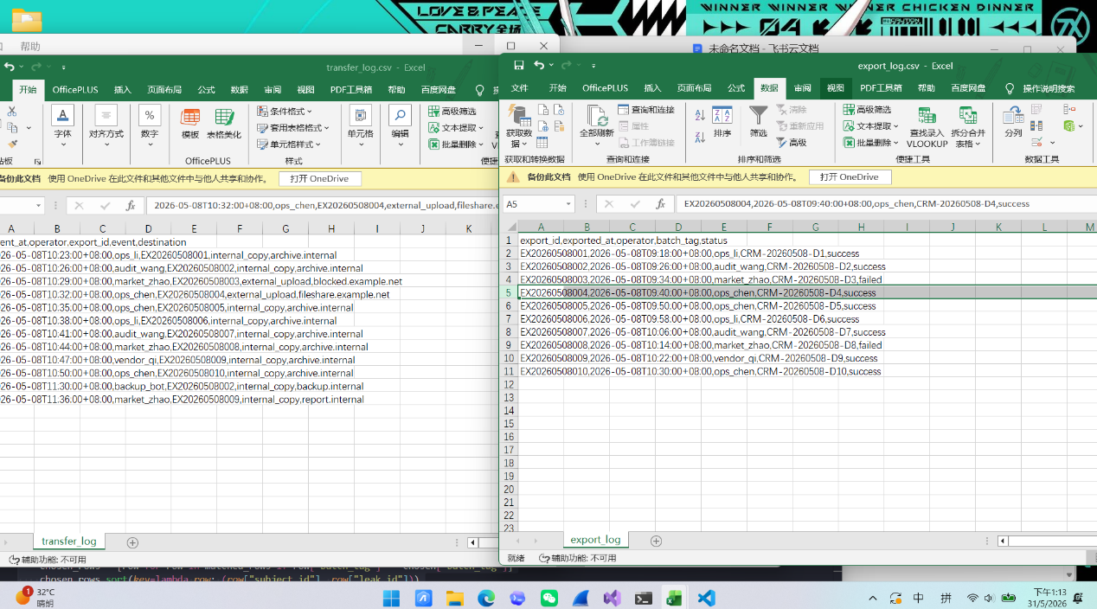
- leak_sample.csv 中绝大多数样本的 batch_tag 也都是 CRM-20260508-D4，共有 1540 行，所以本次事件对应的内部导出任务就是：
Plain Text
export_id = EX20260508004
operator = ops_chen
batch_tag = CRM-20260508-D4
- 再只保留 D4 这批泄露样本，现在先把样本缩到这一个批次。预期是 1540。
- 按题面规则把样本匹配到客户主体
匹配顺序：
- 如果 email 非空，算 sha256(lower(strip(email)))
- 去 customer_index.csv 里对 email_hash
- 如果没命中，或者样本 email 本来就是空，再用 name + phone_mask
- name + phone_mask 必须唯一命中，否则丢弃
- 匹配失败的样本不写入结果
- 对同一主体去重，题目要求：同一个 subject_id 只能出现一次，如果多个 leak_id 都映射到同一个主体，只保留字典序最小的那个 leak_id
所以要先按 subject_id, leak_id 排序，再对 subject_id 做 setdefault 式保留第一条。
- 从匹配到的客户主体行里取：
- erase_requested == true -> PURGE
- 否则 risk == high -> NOTIFY
- 否则 MONITOR
- 生成 response_plan.csv
输出格式固定：leak_id,subject_id,export_id,operator,action
其中：
- export_id 全部写 EX20260508004
- operator 全部写 ops_chen
最终生成 1200 行提交数据。
- 将生成的 response_plan.csv 上传到平台，返回满分，获得flag
Plain Text
flag{040ae9835b39f202ec65245e1c483004}
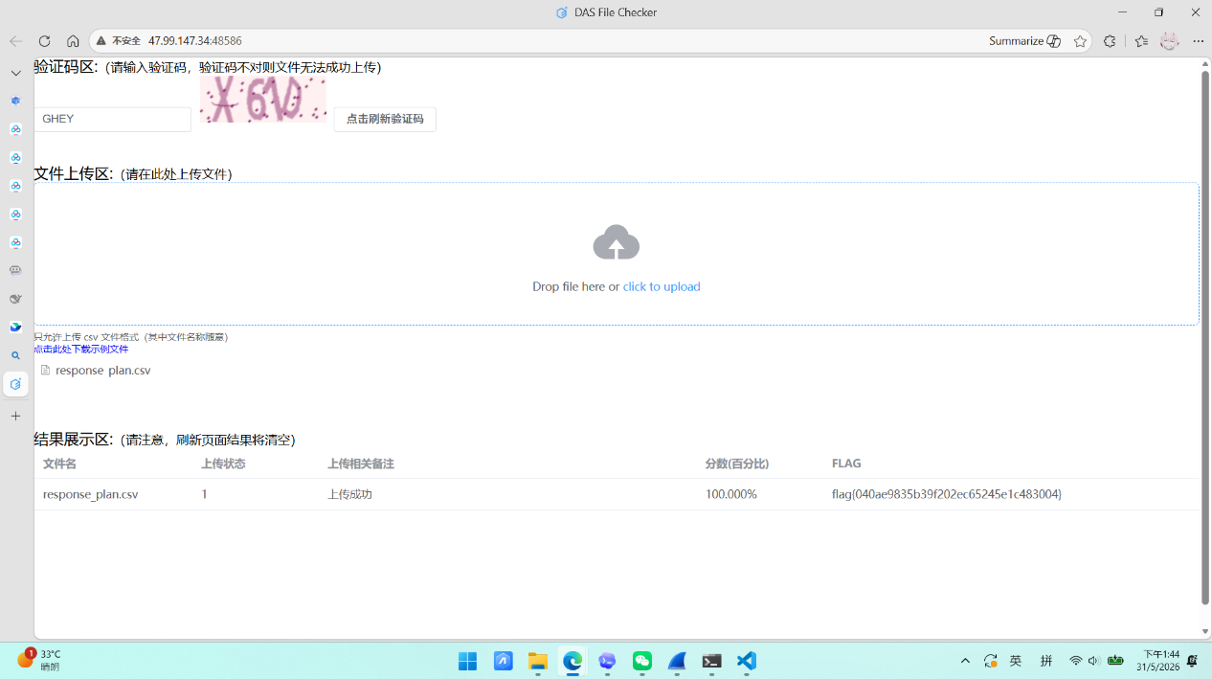

exp
Python
import csv
import hashlib
from collections import Counter, defaultdict
from pathlib import Path
SCRIPT_DIR = Path(__file__).resolve().parent
def resolve_base() -> Path:
candidates = [
SCRIPT_DIR / "tempdir" / "tracepurge" / "inner" / "TracePurge附件",
SCRIPT_DIR / "tempdir" / "inner" / "TracePurge附件",
]
for candidate in candidates:
if candidate.exists():
return candidate
raise FileNotFoundError(
"Could not find extracted challenge files under tempdir. "
"Expected one of: "
+ ", ".join(str(path) for path in candidates)
)
BASE = resolve_base()
def read_csv(name: str) -> list[dict[str, str]]:
with (BASE / name).open("r", encoding="utf-8", newline="") as fh:
return [{k: (v or "").strip() for k, v in row.items()} for row in csv.DictReader(fh)]
def sha256_hex(value: str) -> str:
return hashlib.sha256(value.strip().lower().encode("utf-8")).hexdigest()
def action_for(row: dict[str, str]) -> str:
if row["erase_requested"] == "true":
return "PURGE"
if row["risk"] == "high":
return "NOTIFY"
return "MONITOR"
def main() -> None:
export_rows = read_csv("export_log.csv")
transfer_rows = read_csv("transfer_log.csv")
leak_rows = read_csv("leak_sample.csv")
customer_rows = read_csv("customer_index.csv")
email_map: dict[str, list[dict[str, str]]] = defaultdict(list)
name_phone_map: dict[tuple[str, str], list[dict[str, str]]] = defaultdict(list)
for row in customer_rows:
if row["email_hash"]:
email_map[row["email_hash"]].append(row)
name_phone_map[(row["name"], row["phone_mask"])].append(row)
debug_rows: list[dict[str, str]] = []
matched_rows: list[dict[str, str]] = []
for row in leak_rows:
subject = None
match_method = ""
email = row["email"]
if email:
hits = email_map.get(sha256_hex(email), [])
if len(hits) == 1:
subject = hits[0]
match_method = "email_hash"
if subject is None:
hits = name_phone_map.get((row["name"], row["phone_mask"]), [])
if len(hits) == 1:
subject = hits[0]
match_method = "name_phone"
debug_rows.append(
{
"leak_id": row["leak_id"],
"batch_tag": row["batch_tag"],
"subject_id": "" if subject is None else subject["subject_id"],
"match_method": match_method,
}
)
if subject is not None:
matched_rows.append(
{
"leak_id": row["leak_id"],
"batch_tag": row["batch_tag"],
"subject_id": subject["subject_id"],
"erase_requested": subject["erase_requested"],
"risk": subject["risk"],
"action": action_for(subject),
"match_method": match_method,
}
)
transfers_by_export: dict[tuple[str, str], list[dict[str, str]]] = defaultdict(list)
for row in transfer_rows:
transfers_by_export[(row["export_id"], row["operator"])].append(row)
leak_count_by_batch = Counter(row["batch_tag"] for row in leak_rows)
matched_count_by_batch = Counter(row["batch_tag"] for row in matched_rows)
print("=== Candidate exports ===")
for export in export_rows:
key = (export["export_id"], export["operator"])
transfers = transfers_by_export.get(key, [{}])
for transfer in transfers:
print(
export["export_id"],
export["batch_tag"],
export["operator"],
export["status"],
transfer.get("event", ""),
transfer.get("destination", ""),
leak_count_by_batch.get(export["batch_tag"], 0),
matched_count_by_batch.get(export["batch_tag"], 0),
)
print("\n=== Leak sample counts by batch ===")
for batch_tag, count in leak_count_by_batch.most_common():
print(batch_tag, count, matched_count_by_batch.get(batch_tag, 0))
print("\n=== First 80 matched-debug rows ===")
for row in debug_rows[:80]:
print(row)
print("\n=== Action summary by batch ===")
action_summary: dict[str, Counter] = defaultdict(Counter)
for row in matched_rows:
action_summary[row["batch_tag"]][row["action"]] += 1
for batch_tag in sorted(action_summary):
print(batch_tag, dict(action_summary[batch_tag]))
candidates = []
for export in export_rows:
key = (export["export_id"], export["operator"])
for transfer in transfers_by_export.get(key, []):
if export["status"] == "success" and transfer.get("event") == "external_upload":
candidates.append(
{
"export_id": export["export_id"],
"operator": export["operator"],
"batch_tag": export["batch_tag"],
"destination": transfer.get("destination", ""),
"sample_count": leak_count_by_batch.get(export["batch_tag"], 0),
"matched_sample_count": matched_count_by_batch.get(export["batch_tag"], 0),
}
)
candidates.sort(key=lambda row: (row["sample_count"], row["matched_sample_count"]), reverse=True)
chosen = candidates[0]
print("\n=== Chosen incident export ===")
print(chosen)
chosen_rows = [row for row in matched_rows if row["batch_tag"] == chosen["batch_tag"]]
chosen_rows.sort(key=lambda row: (row["subject_id"], row["leak_id"]))
deduped: dict[str, dict[str, str]] = {}
for row in chosen_rows:
deduped.setdefault(row["subject_id"], row)
response_rows = []
for subject_id, row in deduped.items():
response_rows.append(
{
"leak_id": row["leak_id"],
"subject_id": subject_id,
"export_id": chosen["export_id"],
"operator": chosen["operator"],
"action": row["action"],
}
)
response_rows.sort(key=lambda row: (row["leak_id"], row["subject_id"]))
output_path = SCRIPT_DIR / "response_plan.csv"
with output_path.open("w", encoding="utf-8", newline="") as fh:
writer = csv.DictWriter(
fh,
fieldnames=["leak_id", "subject_id", "export_id", "operator", "action"],
)
writer.writeheader()
writer.writerows(response_rows)
print("\n=== Output summary ===")
print("rows:", len(response_rows))
print("written:", output_path)
print("first_rows:")
for row in response_rows[:10]:
print(row)
if __name__ == "__main__":
main()
SecretBackup
题目截图
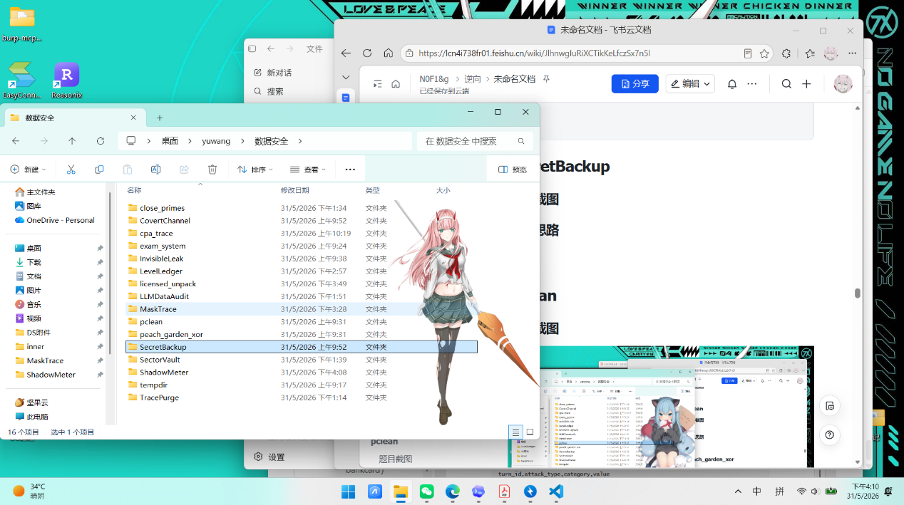
解题思路
- 检查 backup_2025Q1.zip，可以看到它只有png，但该 ZIP 使用了 WinZip AES 加密，无法直接读取。
- 从文件名 backup_2025Q1.zip 和 202501_secret.png 可以优先尝试与时间相关的弱口令。发现是正确的解压后拿到 202501_secret.png。
Plain Text
password = 202501
- 解出的文件是 .png，用010editor发现头部被改了：
- 正常 PNG 签名应为 89 50 4E 47 0D 0A 1A 0A
- 实际文件前 4 字节被改成了 00 00 00 00
另外，IHDR 块的 CRC 也不正确，所以常规图片库仍然无法打开。
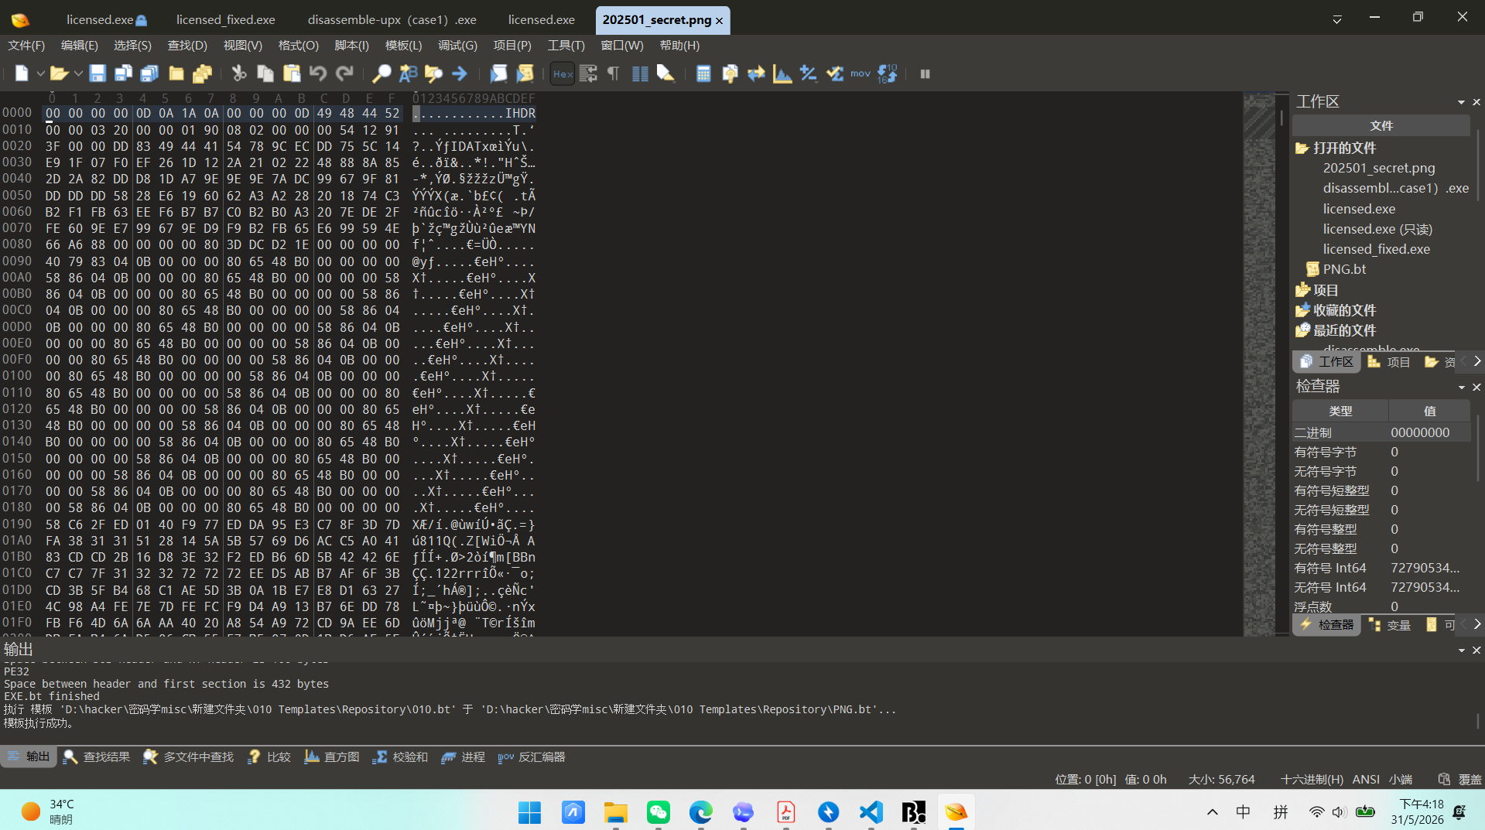
- 先做第一轮修复，把前 8 字节改回标准 PNG 签名，重新计算 IHDR 的 CRC 并回填
- 修完后图片能正常打开，但这时仍然只能看到上半张财务报表。
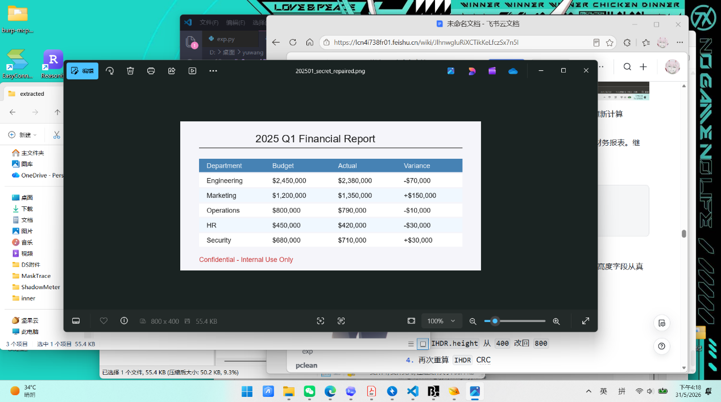
- 继续检查 IDAT 解压后的原始像素流长度：
Plain Text
IHDR 记录高度 = 400
IDAT 实际可还原行数 = 800
- 发现不仅破坏了 PNG 签名，还把 IHDR 的高度字段从真实的 800 篡改成了 400，把后半张图硬截掉了。

- 所以第二轮修复还要把 IHDR.height 从 400 改回 800，再次重算 IHDR CRC，把高度修回 800 之后，图片下半部分会出现真正隐藏的内容：
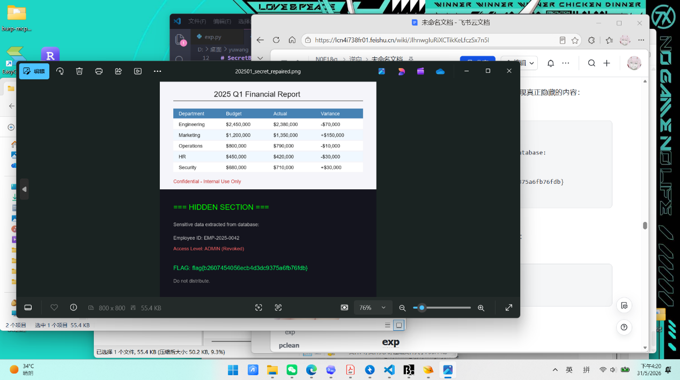

Plain Text
=== HIDDEN SECTION ===
Sensitive data extracted from database:
Employee ID: EMP-2025-0042
Access Level: ADMIN (Revoked)
FLAG: flag{b2607454056ecb4d3dc9375a6fb76fdb}
Do not distribute.
flag:
Plain Text
flag{b2607454056ecb4d3dc9375a6fb76fdb}
exp
Python
from __future__ import annotations
import binascii
import shutil
import struct
import zlib
from pathlib import Path
import pyzipper
BASE = Path(__file__).resolve().parent
OUTER_ZIP = BASE / "10：SecretBackup的附件.zip"
WORK_DIR = BASE / "work_script"
INNER_ZIP = WORK_DIR / "tempdir" / "MISC附件" / "backup_2025Q1.zip"
EXTRACT_DIR = WORK_DIR / "extracted"
def prepare_workspace() -> None:
if WORK_DIR.exists():
shutil.rmtree(WORK_DIR)
WORK_DIR.mkdir(parents=True, exist_ok=True)
shutil.unpack_archive(str(OUTER_ZIP), str(WORK_DIR))
def build_candidates() -> list[str]:
parts = [
"2025",
"202501",
"2025Q1",
"2025q1",
"secret",
"backup",
"SecretBackup",
"secretbackup",
"backup_2025Q1",
"202501_secret",
]
suffixes = ["", "!", "123", "2025", "202501", "Q1"]
seps = ["", "_", "-", "@"]
seen: set[str] = set()
candidates: list[str] = []
def add(value: str) -> None:
if value and value not in seen:
seen.add(value)
candidates.append(value)
for part in parts:
variants = {part, part.lower(), part.upper(), part.capitalize()}
for variant in variants:
for suffix in suffixes:
add(variant + suffix)
if suffix:
for sep in seps:
add(variant + sep + suffix)
for left in parts:
for right in parts:
if left == right:
continue
for sep in seps:
add(f"{left}{sep}{right}")
add(f"{left}{sep}{right}2025")
add(f"{left}{sep}{right}202501")
return candidates
def crack_password(zip_path: Path) -> str:
candidates = build_candidates()
with pyzipper.AESZipFile(zip_path) as zf:
target = zf.namelist()[0]
for password in candidates:
try:
zf.setpassword(password.encode("utf-8"))
zf.read(target)
return password
except RuntimeError:
continue
raise RuntimeError("Password not found in the candidate set.")
def extract_inner(zip_path: Path, password: str) -> Path:
EXTRACT_DIR.mkdir(parents=True, exist_ok=True)
with pyzipper.AESZipFile(zip_path) as zf:
zf.setpassword(password.encode("utf-8"))
zf.extractall(EXTRACT_DIR)
return next(EXTRACT_DIR.glob("*.png"))
def repair_png(png_path: Path) -> Path:
data = bytearray(png_path.read_bytes())
# Restore the PNG signature.
data[:8] = bytes.fromhex("89504E470D0A1A0A")
width = struct.unpack(">I", data[16:20])[0]
encoded_height = struct.unpack(">I", data[20:24])[0]
# The IDAT stream expands to 800 rows even though IHDR says 400.
idat_offset = 33
idat_length = struct.unpack(">I", data[idat_offset : idat_offset + 4])[0]
idat_data = data[idat_offset + 8 : idat_offset + 8 + idat_length]
raw = zlib.decompress(idat_data)
bytes_per_row = 1 + 3 * width
actual_height = len(raw) // bytes_per_row
if actual_height != encoded_height:
data[20:24] = struct.pack(">I", actual_height)
# Recalculate the IHDR CRC so image libraries accept the file.
ihdr_offset = 8
length = struct.unpack(">I", data[ihdr_offset : ihdr_offset + 4])[0]
chunk_type = data[ihdr_offset + 4 : ihdr_offset + 8]
chunk_data = data[ihdr_offset + 8 : ihdr_offset + 8 + length]
crc = binascii.crc32(chunk_type)
crc = binascii.crc32(chunk_data, crc) & 0xFFFFFFFF
crc_offset = ihdr_offset + 8 + length
data[crc_offset : crc_offset + 4] = struct.pack(">I", crc)
repaired = png_path.with_name("202501_secret_repaired.png")
repaired.write_bytes(data)
return repaired
def main() -> None:
prepare_workspace()
password = crack_password(INNER_ZIP)
extracted = extract_inner(INNER_ZIP, password)
repaired = repair_png(extracted)
print(f"inner zip: {INNER_ZIP}")
print(f"password : {password}")
print(f"xtracted: {extracted}")
print(f"epaired: {repaired}")
print("recovered: 2025 Q1 Financial Report")
if __name__ == "__main__":
main()
pclean
题目截图
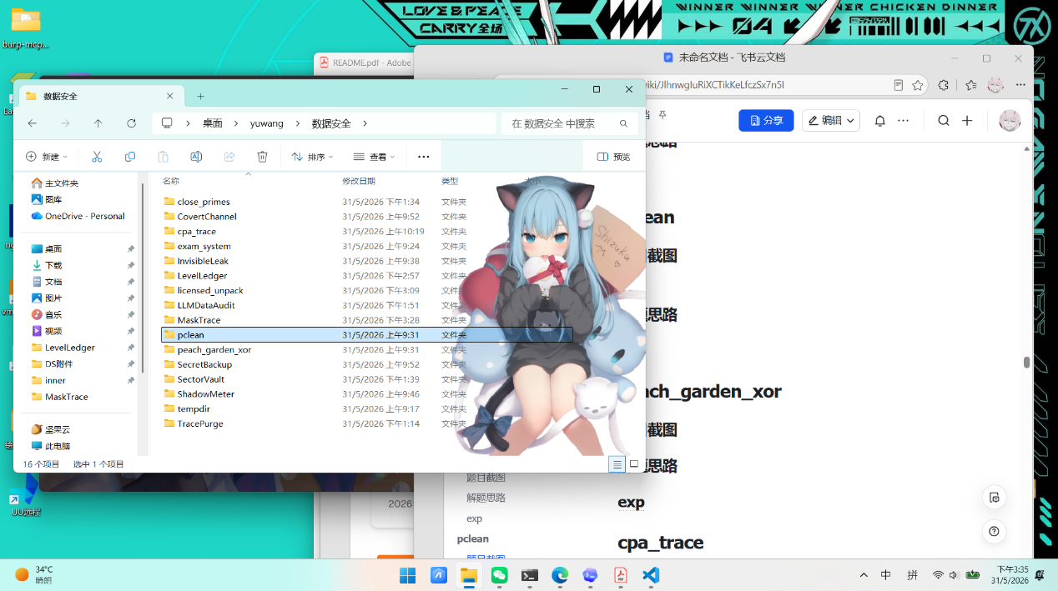
解题思路
- 解压后获得SQLite 数据库和字段规范文档，要求筛出所有不符合规范的脏数据，并按示例 csv 格式提交到校验平台。
- 查看规范文档里的规则发现如下：
- username 只能由大小写字母、数字和下划线组成
- name 只能由中文字符组成
- phone 必须是 11 位数字，且前三位必须属于题目给定号段
- email 必须包含且只包含一个 @，@ 前后都要有内容，并且域名部分要带后缀
- gender 只能是 男 或 女
- 从提交靶机下载download_example_file 发现格式为：
Plain Text
id,username,name,phone,email,gender
2,tomcatKingkk,,13672726827,@126.com,b
3,sk8uDpbRABFy28Xw153V,晏修真,1381520457e,sk8uDpbRABFy28Xw153V@126,p
这说明提交内容不是错误字段列表，而是整行脏数据。
- 然后写脚本来读取 user_data.db，筛出所有不符合规范的记录，并生成 UTF-8 编码的 dirty_data.csv，得出脏数据一共934条，上传后平台返回100.000%，获得flag
Plain Text
flag{9d4c2f88e16b70a5c39f1e27bd84c610}
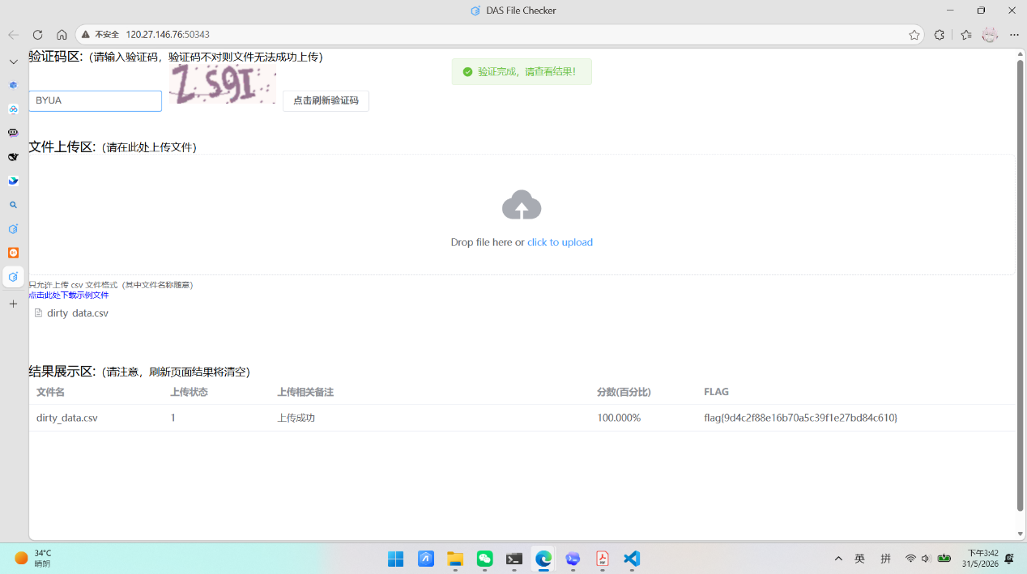
exp
Python
import csv
import re
import sqlite3
from pathlib import Path
PREFIXES = {
"130", "131", "132", "133", "134", "135", "136", "137", "138", "139",
"140", "145", "146", "147", "148", "149", "150", "151", "152", "153",
"155", "156", "157", "158", "159", "166", "167", "171", "172", "173",
"174", "175", "176", "177", "178", "180", "181", "182", "183", "184",
"185", "186", "187", "188", "189", "190", "191", "193", "195", "196",
"198", "199",
}
USERNAME_RE = re.compile(r"^[A-Za-z0-9_]+$")
NAME_RE = re.compile(r"^[\u3400-\u4DBF\u4E00-\u9FFF\uF900-\uFAFF]+$")
EMAIL_RE = re.compile(r"^[^@\s]+@[^@\s]+\.[^@\s]+$")
VALID_GENDERS = {"男", "女"}
HEADERS = ["id", "username", "name", "phone", "email", "gender"]
def is_dirty(row: tuple[int, str, str, str, str, str]) -> bool:
_, username, name, phone, email, gender = row
return not (
USERNAME_RE.fullmatch(username or "")
and NAME_RE.fullmatch(name or "")
and re.fullmatch(r"\d{11}", phone or "")
and phone[:3] in PREFIXES
and EMAIL_RE.fullmatch(email or "")
and gender in VALID_GENDERS
)
def main() -> None:
base_dir = Path(__file__).resolve().parent / "unzipped2" / "pclean的附件"
db_path = base_dir / "user_data.db"
out_path = base_dir / "dirty_data.csv"
conn = sqlite3.connect(db_path)
cur = conn.cursor()
rows = cur.execute(
"SELECT id, username, name, phone, email, gender "
"FROM insurance_users ORDER BY id"
).fetchall()
conn.close()
dirty_rows = [row for row in rows if is_dirty(row)]
with out_path.open("w", encoding="utf-8", newline="") as f:
writer = csv.writer(f)
writer.writerow(HEADERS)
writer.writerows(dirty_rows)
print(f"dirty rows: {len(dirty_rows)}")
print(out_path)
if __name__ == "__main__":
main()
peach_garden_xor
题目截图
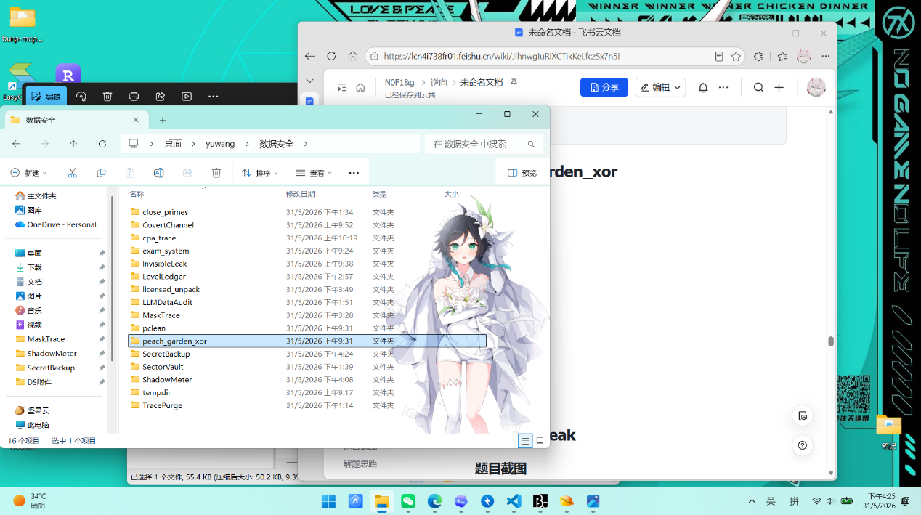
解题思路
- 解压获得task.docx.enc，用010editor分析，
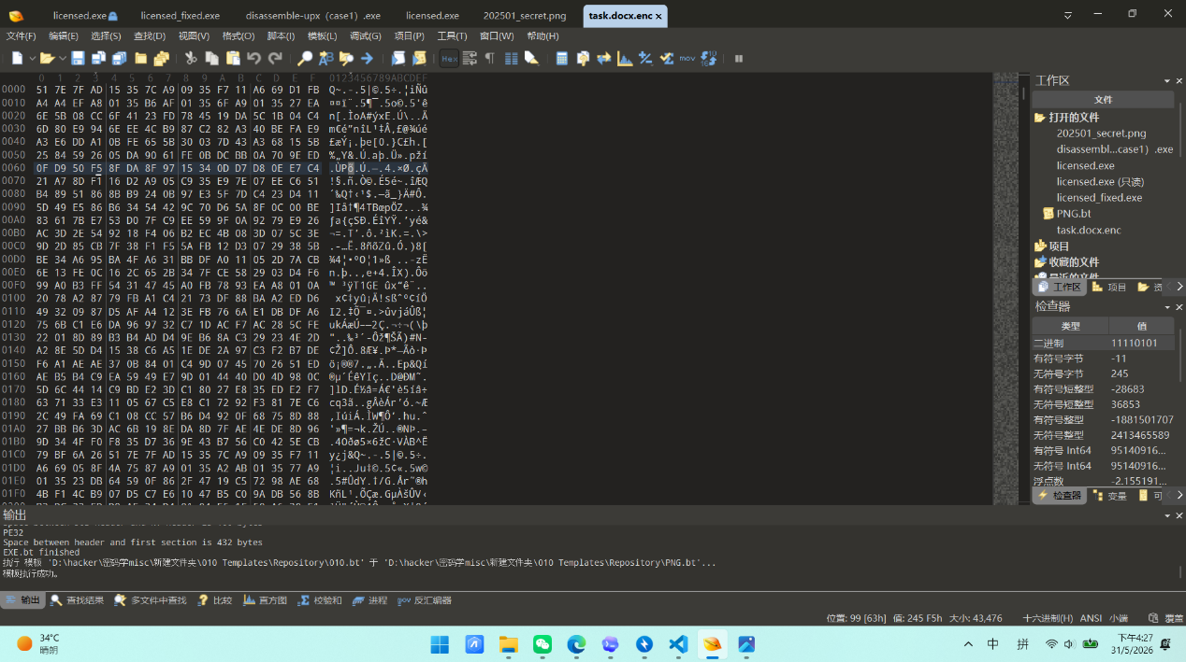
DOCX 本质上是 ZIP。加密文件前 4 字节为：
Plain Text
51 7E 7F AD
而正常 DOCX/ZIP 的前 4 字节固定为：
Plain Text
50 4B 03 04

- 两者异或即可得到 4 字节循环密钥：

Plain Text
01 35 7c a9
- 这就是 4 字节循环密钥。然后对整个文件做循环异或 task.docx.enc 后，
Python
key = bytes.fromhex("01357ca9")
dec = bytes(b ^ key[i % 4] for i, b in enumerate(enc_data))
- 可以得到 DOCX，检查 word，在正文末尾能找到字符串：
Plain Text
synt{nq213351-9510-46p0-8622-9pqrn9s634q2}
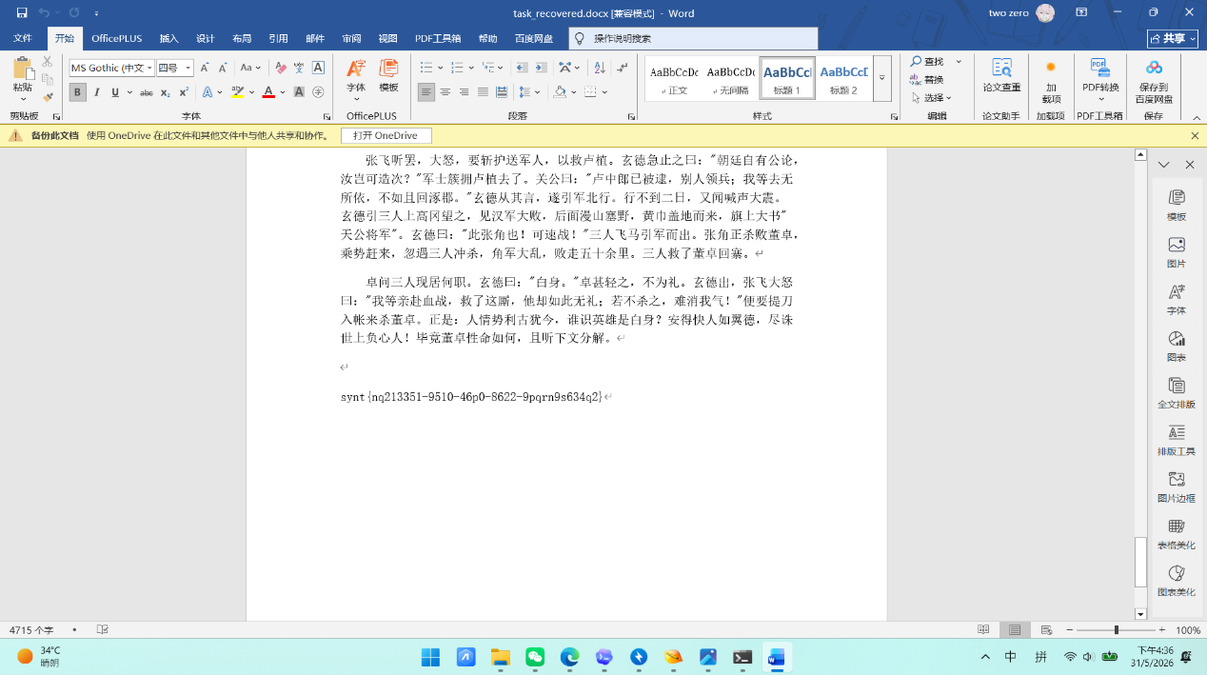
- synt 是 flag 的 ROT13 结果，因此把整串再做一次 ROT13 即可得到最终 flag。
Python
flag{ad213351-9510-46c0-8622-9cdea9f634d2}
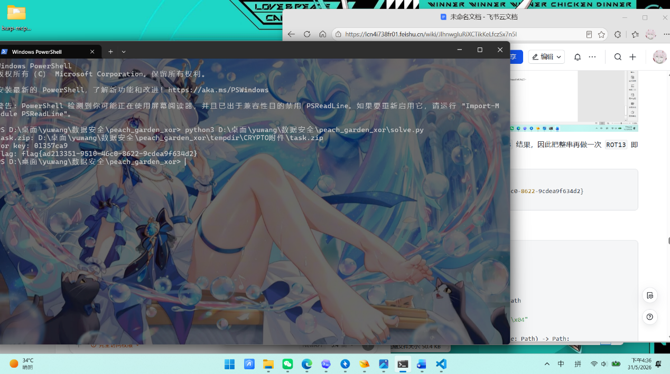
exp
Python
import codecs
import io
import re
import zipfile
from pathlib import Path
ZIP_HEADER = b"PK\x03\x04"
def find_task_zip(base: Path) -> Path:
matches = sorted(base.rglob("task.zip"))
if not matches:
raise FileNotFoundError("task.zip not found under challenge directory")
return matches[0]
def decrypt_docx(enc_data: bytes) -> tuple[bytes, bytes]:
key = bytes(c ^ p for c, p in zip(enc_data[:4], ZIP_HEADER))
dec = bytes(b ^ key[i % len(key)] for i, b in enumerate(enc_data))
return key, dec
def recover_flag(docx_data: bytes) -> str:
with zipfile.ZipFile(io.BytesIO(docx_data)) as docx:
document_xml = docx.read("word/document.xml").decode("utf-8", errors="ignore")
match = re.search(r"synt\{[a-z0-9\-]+\}", document_xml, re.IGNORECASE)
if not match:
raise ValueError("flag candidate not found in word/document.xml")
return codecs.decode(match.group(0), "rot_13")
def main() -> None:
base = Path(__file__).resolve().parent
task_zip = find_task_zip(base)
with zipfile.ZipFile(task_zip) as archive:
enc_name = next(name for name in archive.namelist() if name.endswith(".enc"))
enc_data = archive.read(enc_name)
key, docx_data = decrypt_docx(enc_data)
flag = recover_flag(docx_data)
print(f"task.zip: {task_zip}")
print(f"xor key: {key.hex()}")
print(f"flag: {flag}")
if __name__ == "__main__":
main()
cpa_trace
题目截图
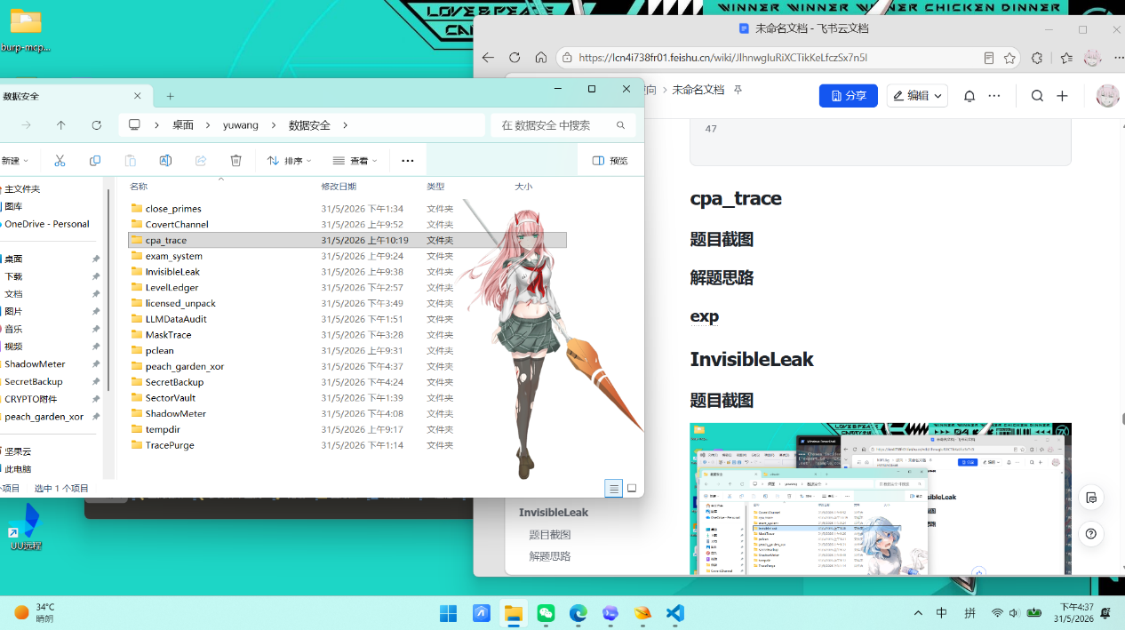
解题思路
- 解压后有
- plaintexts.npy：5000 × 16 uint8，AES 加密明文
- traces.npy：5000 × 2 × 1024 float64，双通道功耗/电磁迹线
- flag.enc：48 字节，加密后的 flag迹线在 1024 个时间采样点中呈现 16 个等间距的相关峰，间距 64 个采样点，对应 AES 第一轮逐字节 SubBytes 运算。
- 发现：正确模型是汉明距离模型，该模型模拟 CMOS 寄存器从持有明文值跳变到持有 S 盒输出值的功耗。由于寄存器在两个值之间切换，其功耗正比于两者的汉明距离，相关性高达 0.72-0.78，边距达 0.57-0.64。
Plain Text
HD(plaintext, SBOX[plaintext ⊕ key]) = HW(plaintext ⊕ SBOX[plaintext ⊕ key])
- CPA 恢复的是 AES-128 主密钥：422c174a4a89d96af0b7de281dc01324
- 但直接用主密钥解密 flag.enc 得到的是乱码。这是因为 flag.enc 使用了第 10 轮轮密钥进行加密，而非主密钥，
- 通过 AES-128 密钥编排算法从主密钥导出第 10 轮密钥：
e53b897e61d2391c2bf0d70727f48509
- 使用 AES-128-ECB 模式和第 10 轮轮密钥解密 flag.enc，去除 PKCS7 填充，得到 flag。
Plain Text
flag{76ff6af8-f9f8-49ec-ad20-673f2f9c06e7}
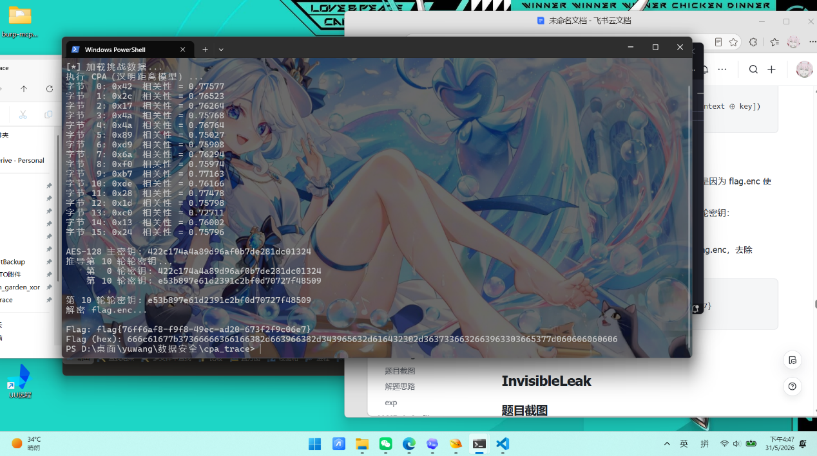

exp
Python
#!/usr/bin/env python3
# -*- coding: utf-8 -*-
"""
将 plaintexts.npy、traces.npy、flag.enc 放在本脚本同目录下
依赖：numpy, pycryptodome
"""
import numpy as np
from Crypto.Cipher import AES
import os
# 1. 加载数据 - 支持相对路径
# 确定数据文件所在目录
script_dir = os.path.dirname(os.path.abspath(__file__))
data_dir = os.path.join(script_dir, "extracted", "tempdir", "CRYPTO附件", "inner", "附件")
# 如果相对路径不存在，尝试直接使用脚本目录
if not os.path.exists(os.path.join(data_dir, 'plaintexts.npy')):
data_dir = script_dir # 从 exp.py 同目录加载
# 如果还找不到，尝试当前工作目录
if not os.path.exists(os.path.join(data_dir, 'plaintexts.npy')):
data_dir = "."
print(f"[*] 数据目录: {os.path.abspath(data_dir)}")
print("[*] 加载挑战数据...")
plaintexts = np.load(os.path.join(data_dir, 'plaintexts.npy')) # (5000, 16) uint8
traces = np.load(os.path.join(data_dir, 'traces.npy')) # (5000, 2, 1024) float64
with open(os.path.join(data_dir, 'flag.enc'), 'rb') as f:
ct = f.read() # 48 bytes
N, C, T = traces.shape
trace_power = traces[:, 0, :] # 使用功耗通道
SBOX = np.array([
0x63,0x7c,0x77,0x7b,0xf2,0x6b,0x6f,0xc5,0x30,0x01,0x67,0x2b,0xfe,0xd7,0xab,0x76,
0xca,0x82,0xc9,0x7d,0xfa,0x59,0x47,0xf0,0xad,0xd4,0xa2,0xaf,0x9c,0xa4,0x72,0xc0,
0xb7,0xfd,0x93,0x26,0x36,0x3f,0xf7,0xcc,0x34,0xa5,0xe5,0xf1,0x71,0xd8,0x31,0x15,
0x04,0xc7,0x23,0xc3,0x18,0x96,0x05,0x9a,0x07,0x12,0x80,0xe2,0xeb,0x27,0xb2,0x75,
0x09,0x83,0x2c,0x1a,0x1b,0x6e,0x5a,0xa0,0x52,0x3b,0xd6,0xb3,0x29,0xe3,0x2f,0x84,
0x53,0xd1,0x00,0xed,0x20,0xfc,0xb1,0x5b,0x6a,0xcb,0xbe,0x39,0x4a,0x4c,0x58,0xcf,
0xd0,0xef,0xaa,0xfb,0x43,0x4d,0x33,0x85,0x45,0xf9,0x02,0x7f,0x50,0x3c,0x9f,0xa8,
0x51,0xa3,0x40,0x8f,0x92,0x9d,0x38,0xf5,0xbc,0xb6,0xda,0x21,0x10,0xff,0xf3,0xd2,
0xcd,0x0c,0x13,0xec,0x5f,0x97,0x44,0x17,0xc4,0xa7,0x7e,0x3d,0x64,0x5d,0x19,0x73,
0x60,0x81,0x4f,0xdc,0x22,0x2a,0x90,0x88,0x46,0xee,0xb8,0x14,0xde,0x5e,0x0b,0xdb,
0xe0,0x32,0x3a,0x0a,0x49,0x06,0x24,0x5c,0xc2,0xd3,0xac,0x62,0x91,0x95,0xe4,0x79,
0xe7,0xc8,0x37,0x6d,0x8d,0xd5,0x4e,0xa9,0x6c,0x56,0xf4,0xea,0x65,0x7a,0xae,0x08,
0xba,0x78,0x25,0x2e,0x1c,0xa6,0xb4,0xc6,0xe8,0xdd,0x74,0x1f,0x4b,0xbd,0x8b,0x8a,
0x70,0x3e,0xb5,0x66,0x48,0x03,0xf6,0x0e,0x61,0x35,0x57,0xb9,0x86,0xc1,0x1d,0x9e,
0xe1,0xf8,0x98,0x11,0x69,0xd9,0x8e,0x94,0x9b,0x1e,0x87,0xe9,0xce,0x55,0x28,0xdf,
0x8c,0xa1,0x89,0x0d,0xbf,0xe6,0x42,0x68,0x41,0x99,0x2d,0x0f,0xb0,0x54,0xbb,0x16
], dtype=np.uint8)
print("执行 CPA（汉明距离模型）...")
trace_centered = trace_power - trace_power.mean(axis=0)
master_key = []
for byte_pos in range(16):
pt_byte = plaintexts[:, byte_pos]
# 16 个相关峰在 1024 个采样点中等间距分布，间距 64
# 第 i 字节的相关峰位于 t = 32 + 64*i
t_center = 32 + 64 * byte_pos
t_start = max(0, t_center - 5)
t_end = min(T, t_center + 6)
tw = trace_centered[:, t_start:t_end]
tw = tw - tw.mean(axis=0)
best_corr = -1
best_key = -1
for key_guess in range(256):
# 汉明距离模型：计算 HD(plaintext, SBOX[plaintext XOR key_guess])
hd = np.array([
bin(int(p ^ SBOX[p ^ key_guess])).count('1')
for p in pt_byte
], dtype=np.float64)
hd -= hd.mean()
# Pearson 相关系数
cov = hd @ tw
denom = np.linalg.norm(hd) * np.linalg.norm(tw, axis=0)
corr = np.abs(cov / denom)
max_corr = corr.max()
if max_corr > best_corr:
best_corr = max_corr
best_key = key_guess
master_key.append(int(best_key))
print(f"字节 {byte_pos:2d}: 0x{best_key:02x} 相关性 = {best_corr:.5f}")
master_key = bytes(master_key)
print(f"\nAES-128 主密钥: {master_key.hex()}")
print("推导第 10 轮轮密钥...")
RCON = [0x01, 0x02, 0x04, 0x08, 0x10, 0x20, 0x40, 0x80, 0x1b, 0x36]
SBOX_LIST = list(SBOX)
# 密钥扩展
w = [[master_key[4*i + j] for j in range(4)] for i in range(4)]
for i in range(4, 44):
temp = w[i - 1][:]
if i % 4 == 0:
# RotWord
temp = [temp[1], temp[2], temp[3], temp[0]]
# SubWord
temp = [SBOX_LIST[t] for t in temp]
# XOR RCON
temp[0] ^= RCON[i // 4 - 1]
w.append([w[i - 4][j] ^ temp[j] for j in range(4)])
# 提取所有轮密钥
round_keys = []
for r in range(11):
rk = bytes(sum((w[r * 4 + j] for j in range(4)), []))
round_keys.append(rk)
if r in [0, 10]:
print(f" 第 {r:2d} 轮密钥: {rk.hex()}")
round_10_key = round_keys[10]
print(f"\n第 10 轮轮密钥: {round_10_key.hex()}")
print("解密 flag.enc...")
cipher = AES.new(round_10_key, AES.MODE_ECB)
flag_padded = cipher.decrypt(ct)
# 去除 PKCS7 填充
pad_len = flag_padded[-1]
flag = flag_padded[:-pad_len].decode('utf-8')
print(f"\nFlag: {flag}")
print(f"Flag (hex): {flag_padded.hex()}")
InvisibleLeak
题目截图
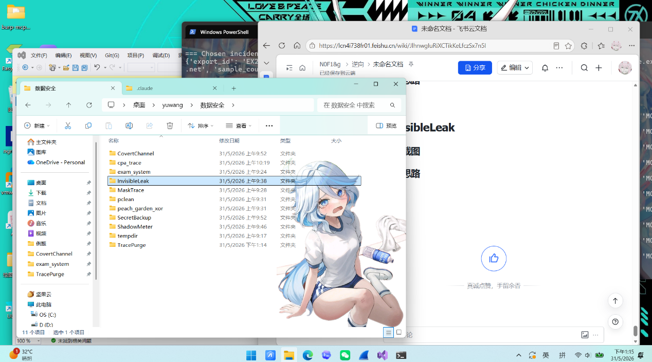
解题思路
- 解压后poster.png、notice.docx、exfil_tool.pyc
- 先识别 .pyc 版本得出a70d0d0a，再用识别xdis工具 .pyc 版本是{'3.11a7e'}，
- 再用这个指令反汇编
Plain Text
python -m xdis.disasm "D:\桌面\yuwang\数据安全\InvisibleLeak\attachments\attachments\exfil_tool.pyc"
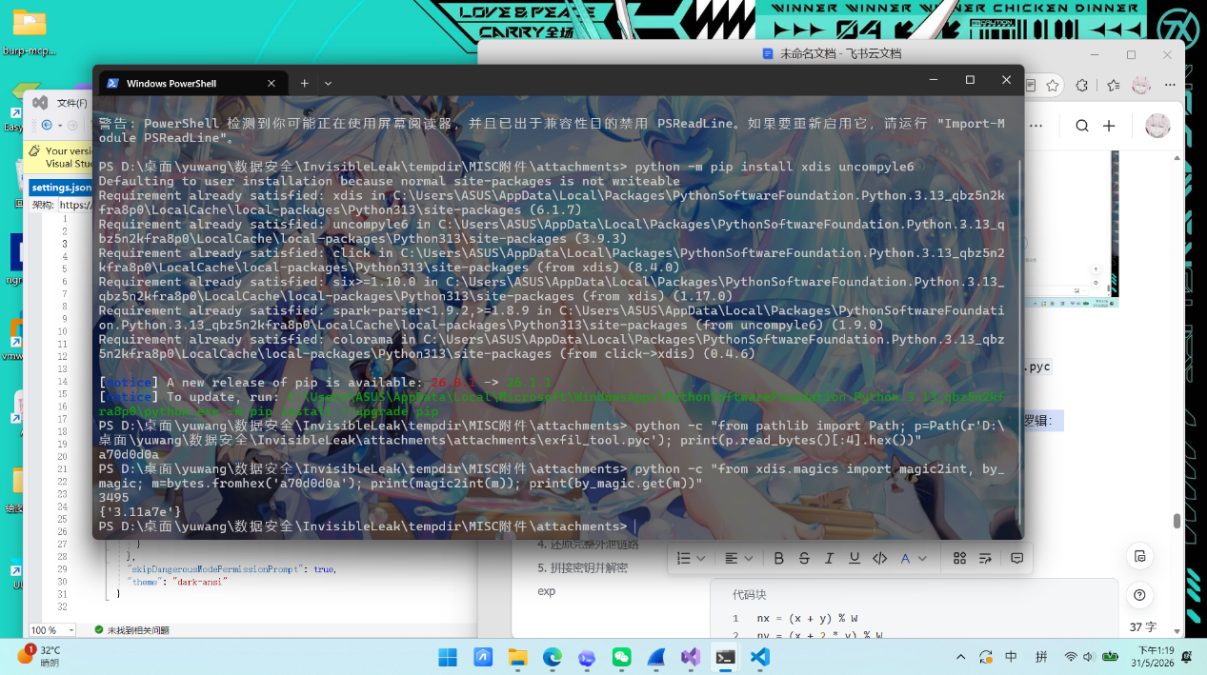
- 看_0x1a3c(img, N)这些字节码
Plain Text
22: 278 LOAD_FAST (_0xx)
280 LOAD_FAST (_0xy)
282 BINARY_OP (+)
286 LOAD_FAST (_0xW)
288 BINARY_OP (%)
292 STORE_FAST (_0xnx)
23: 294 LOAD_FAST (_0xx)
296 LOAD_CONST (2)
298 LOAD_FAST (_0xy)
300 BINARY_OP (*)
304 BINARY_OP (+)
308 LOAD_FAST (_0xW)
310 BINARY_OP (%)
314 STORE_FAST (_0xny)
- 对应这对图片做 N 轮像素置乱，映射关系为：
Python
nx = (x + y) % W
ny = (x + 2 * y) % W
这是Arnold Cat Map置乱，用来打散图片内容。
- 再看 _0x2b7f(img, data)反汇编，逻辑是把数据前面补一个 4 字节大端长度，然后逐 bit 写入 RGB 三个通道的最低位，也就是典型 LSB 隐写。

- 再看_0x3c9e(text, map)反汇编，发现只提取文本中的 4 类零宽字符：U+200B -> 00、U+200C -> 01、U+200D -> 10、U+FEFF -> 11再按 2 bit 一组拼接后还原字节流。
- 这处的 _0x4f3a(data, key)反汇编对应的心加解密逻辑是第 i 个字节先按 i % 8 做循环左移，再与 key[i % len(key)] 做异或，所以解密时做逆操作即可：先异或，再循环右移。
- 发现脚本反汇编里有一段十六进制密文：
Plain Text
c76a46ef52b009aafebc2553a0939c4e95de0b1dd6509f00f81a74638093cb6698d44a758359
这就是需要解出的敏感数据。
- 分析notice.docx

把 word/document.xml 解出来后，可以发现正文里混入了 32 个零宽字符。

按脚本里的映射还原后，得到：

Plain Text
c9d0e1f2a3b4c5d6
这是 8 字节密钥分片。
- 再分析poster.png，根据 _0x1a3c 可知海报被做过 7 轮置乱，所以先做逆置乱，再按 _0x2b7f 的反过程从 RGB LSB 中提取载荷。提取结果不是文本，而是一张内嵌 PNG。打开后是一枚二维码。二维码内容为：
Plain Text
a1b2c3d4e5f60718
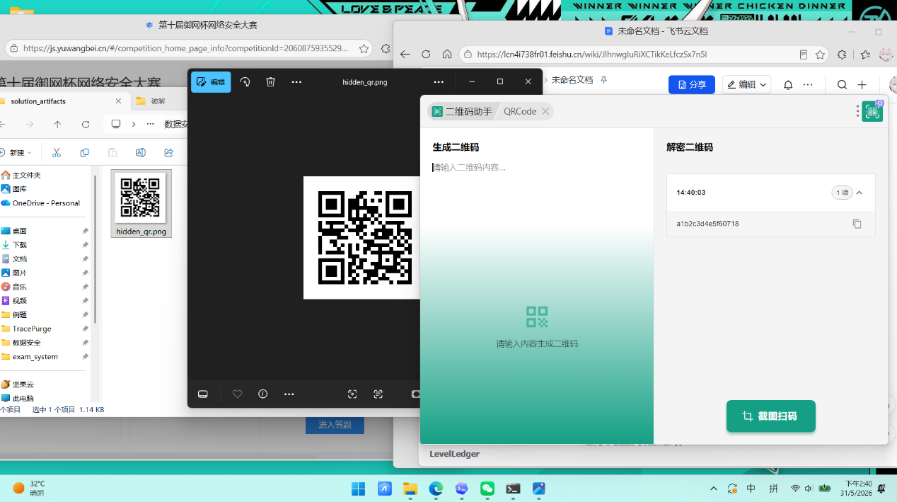
这又是另一个 8 字节密钥分片。
- 外泄工具的设计可以还原为：用 _0x4f3a 对目标敏感数据做“循环位移 + 异或”加密，把密文硬编码进 exfil_tool.pyc，把密钥拆成两半，第一半做成二维码图片，再用 LSB 写进 poster.png，为了进一步规避肉眼识别，再对海报执行 7 轮 Arnold 风格置乱，第二半藏进 notice.docx 的零宽字符里，两份普通办公文件各自看起来都很正常，因此 DLP 难以仅凭明文内容或常规传输特征发现异常
- 按恢复出的顺序，完整密钥为：
Plain Text
a1b2c3d4e5f60718c9d0e1f2a3b4c5d6
也就是字节序列：
Plain Text
a1 b2 c3 d4 e5 f6 07 18 c9 d0 e1 f2 a3 b4 c5 d6
- 对脚本中的密文执行逆变换后，得到：
Plain Text
flag{28e761409e1462935b01ee2298a93b4f}
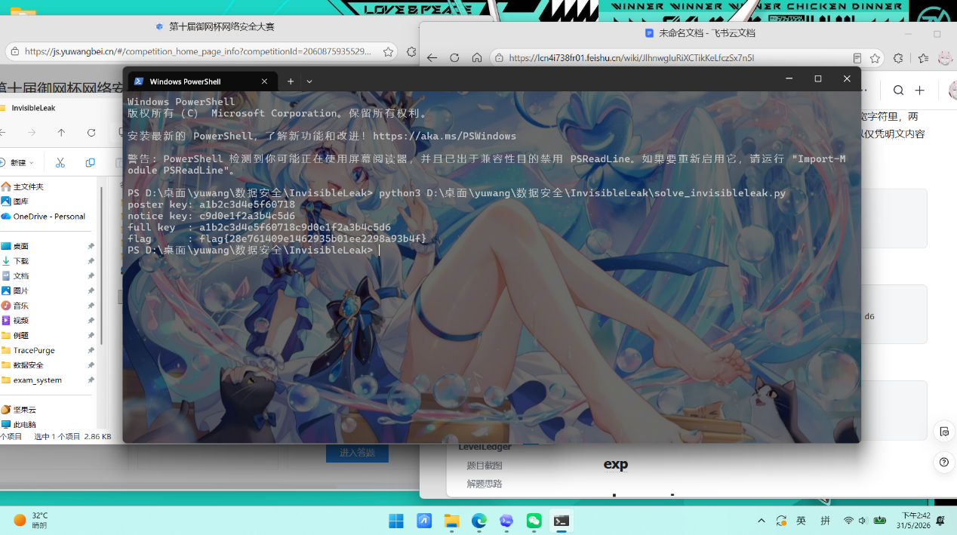

exp
Python
from __future__ import annotations
import io
import struct
import zipfile
from pathlib import Path
from PIL import Image
from pyzbar.pyzbar import decode
ROOT = Path(__file__).resolve().parent
POSTER = next(ROOT.rglob("poster.png"))
NOTICE = next(ROOT.rglob("notice.docx"))
PYC = next(ROOT.rglob("exfil_tool.pyc"))
ZW_MAP = {"\u200b": "00", "\u200c": "01", "\u200d": "10", "\ufeff": "11"}
ROT = list(range(8))
CIPHER_HEX = "c76a46ef52b009aafebc2553a0939c4e95de0b1dd6509f00f81a74638093cb6698d44a758359"
def inverse_cat_map(img: Image.Image, rounds: int = 7) -> Image.Image:
w = img.width
cur = img.copy()
for _ in range(rounds):
tmp = cur.copy()
src = tmp.load()
dst = cur.load()
for x in range(w):
for y in range(w):
nx = (2 * x - y) % w
ny = (-x + y) % w
dst[nx, ny] = src[x, y]
return cur
def extract_lsb_payload(img: Image.Image) -> bytes:
px = img.load()
w, h = img.size
bits: list[int] = []
for y in range(h):
for x in range(w):
r, g, b = px[x, y][:3]
bits.extend((r & 1, g & 1, b & 1))
raw = bytearray()
for i in range(0, len(bits) - 7, 8):
byte = 0
for j in range(8):
byte = (byte << 1) | bits[i + j]
raw.append(byte)
size = struct.unpack(">I", raw[:4])[0]
return bytes(raw[4 : 4 + size])
def extract_doc_key(docx_path: Path) -> bytes:
with zipfile.ZipFile(docx_path) as zf:
document = zf.read("word/document.xml").decode("utf-8", "ignore")
zw = [ch for ch in document if ch in ZW_MAP]
bits = "".join(ZW_MAP[ch] for ch in zw)
return bytes(int(bits[i : i + 8], 2) for i in range(0, len(bits) - 7, 8))
def extract_qr_key(poster_path: Path) -> tuple[bytes, Image.Image]:
poster = Image.open(poster_path).convert("RGB")
restored = inverse_cat_map(poster, 7)
payload = extract_lsb_payload(restored)
hidden = Image.open(io.BytesIO(payload))
qr_text = decode(hidden)[0].data.decode()
return bytes.fromhex(qr_text), hidden
def ror8(value: int, shift: int) -> int:
shift %= 8
return ((value >> shift) | ((value << (8 - shift)) & 0xFF)) & 0xFF
def decrypt(cipher: bytes, key: bytes) -> bytes:
out = bytearray()
for i, b in enumerate(cipher):
x = b ^ key[i % len(key)]
out.append(ror8(x, ROT[i % 8]))
return bytes(out)
def main() -> None:
doc_key = extract_doc_key(NOTICE)
qr_key, hidden_qr = extract_qr_key(POSTER)
key = qr_key + doc_key
flag = decrypt(bytes.fromhex(CIPHER_HEX), key).decode()
out_dir = ROOT / "solution_artifacts"
out_dir.mkdir(exist_ok=True)
hidden_qr.save(out_dir / "hidden_qr.png")
print(f"poster key: {qr_key.hex()}")
print(f"notice key: {doc_key.hex()}")
print(f"full key : {key.hex()}")
print(f"flag : {flag}")
if __name__ == "__main__":
main()
close_primes
题目截图
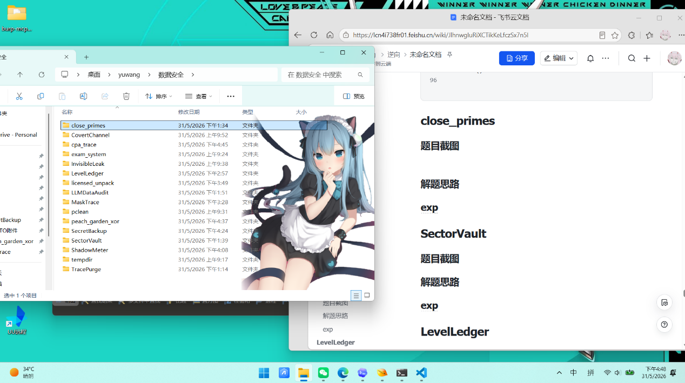

解题思路
- 解压文件有pubkey.pem、encrypted.bin
- 用vscode打开pubkey.pem显示发现其中中间那段 Base64实际上是 ASN.1/DER 格式的二进制公钥数据。
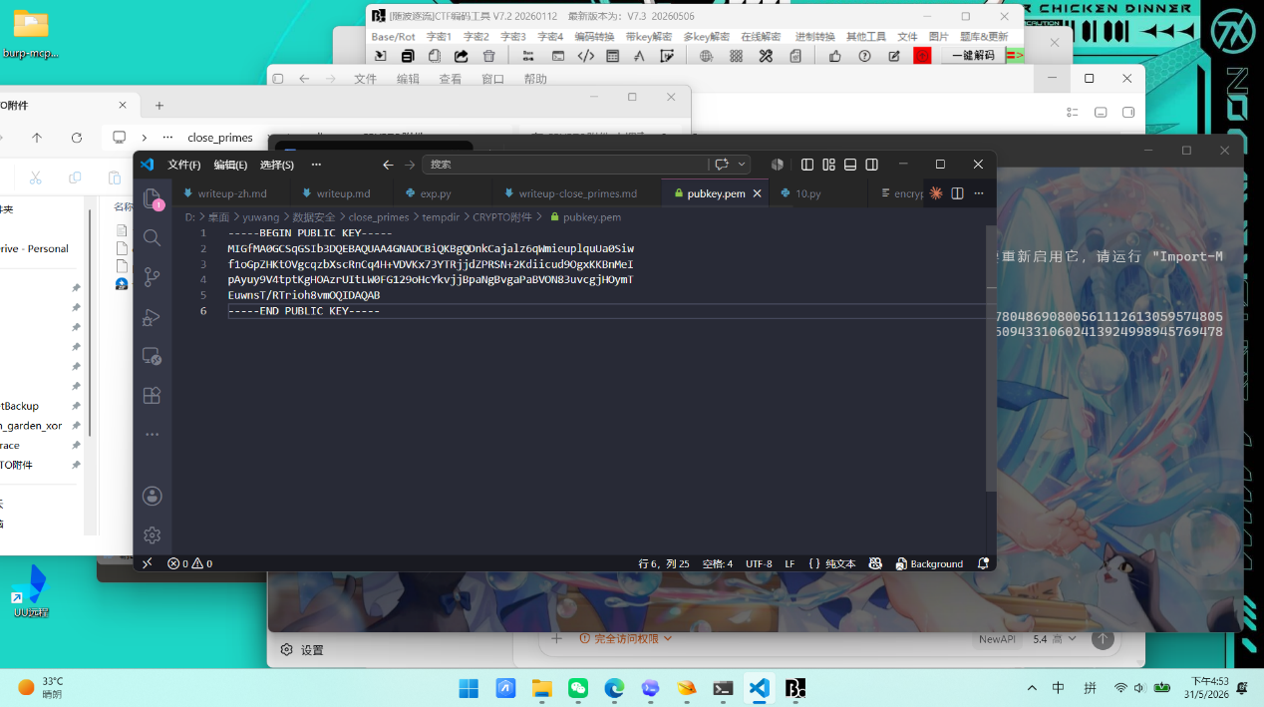
- 用 Python解码得出n e bits
Python
from Crypto.PublicKey import RSA
with open("pubkey.pem", "rb") as f:
key = RSA.import_key(f.read())
print("n =", key.n)
print("e =", key.e)
print("bits =", key.size_in_bits())
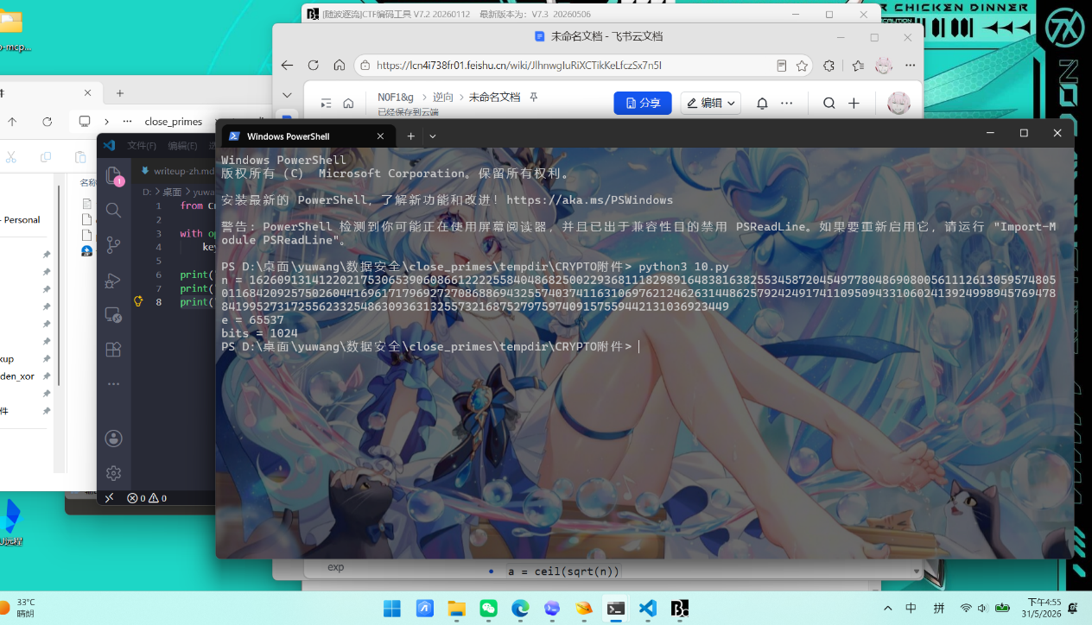
- 而RSA 正常情况下，n = p*q，其中 p、q 是两个大素数。这题在于p 和 q 选得太近。Fermat 分解的想法是把 n 写成两个平方差n = a^2 - b^2 = (a - b)(a + b)，如果刚好有：p = a - bq = a + b那就立刻得到：n = p*q = (a-b)(a+b) = a^2 - b^2
- 所以只要找到某个 a，使得：a^2 - n = b^2那p = a - bq = a + b就直接出来了。
- 因为 a^2 = n + b^2，所以 a 一定比 sqrt(n) 大一点点。
而当 p、q 很接近时，b = (q-p)/2 会很小，于是 a 就会非常接近 sqrt(n)。
- 所以 Fermat 分解的标准做法就是a = ceil(sqrt(n))然后不断检查 a^2 - n 是不是完全平方数如果不是，就让 a = a + 1
因为从 a = ceil(sqrt(n)) 开始第一次检查就成功了，说明 p、q 真的极其接近。算出来是：
Python
p = 12751828551709836069103027639236748210345732901386209604520393543958229433834765694925409378355486164691077551258041029878391501131185664614971880587757401
q = 12751828551709836069103027639236748210345732901386209604520393543958229433834765694925409378355486164691077551258041029878391501131185675868445062344890849
它们差值是q - p = 11253473181757133448，对 1024 位素数来说，这个差距已经算非常近了，所以 Fermat 分解秒出。
- 因为题目里的 n 是 1024 位，所以单个 RSA 密文块长度固定是1024 / 8 = 128 字节而 encrypted.bin 的大小是：23168 字节
所以块数就是23168 / 128 = 181 块，这说明文件不是整个图片一次性 RSA 加密，而是按块分别 RSA 加密后拼起来的。
- 接着恢复私钥。既然已经拿到 p、q，就能算phi = (p-1)(q-1)d = e^(-1) mod phi，这样私钥指数 d 就有了。
- 之后我们测试解密方式时发现，直接裸 RSA 解出来不像图片，但用 RSA-OAEP 逐块解密后，前 8 个字节立刻是 PNG 文件头：
89 50 4E 47 0D 0A 1A 0A
也就是标准 PNG 签名：\x89PNG\r\n\x1a\n
- 写的脚本流程是每 128 字节切一个密文块，用恢复出来的私钥做 RSA-OAEP 解密，把 181 个明文块顺序拼接，得到recovered.png
- 恢复出的图片是 recovered.png，里面有flag：
Python
flag{08358491-2221-4363-9d77-a2df241f5891}
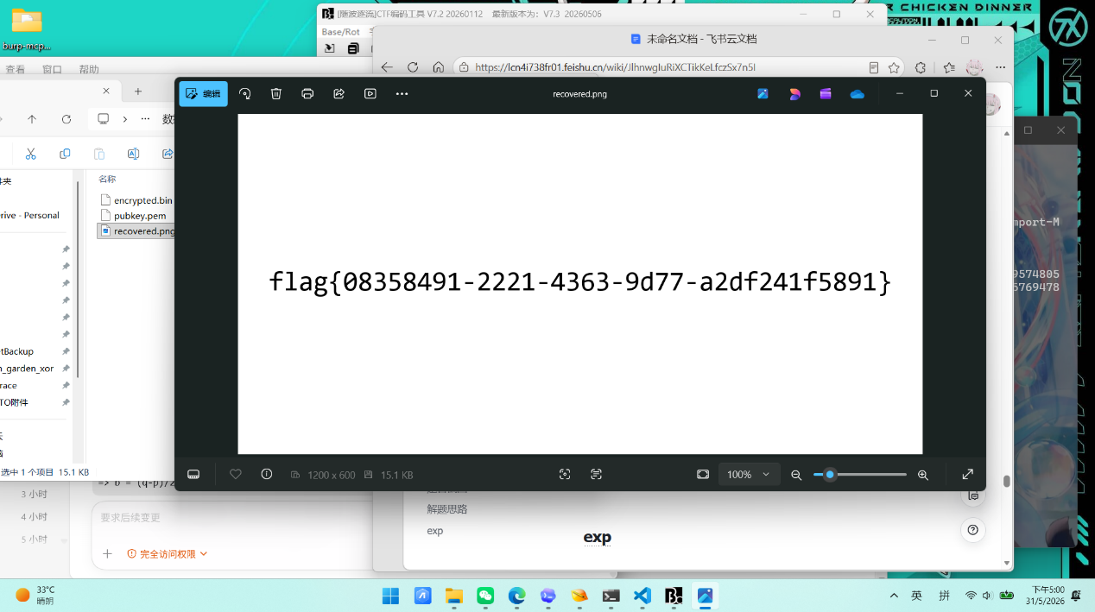
exp
Python
from pathlib import Path
import math
from Crypto.Cipher import PKCS1_OAEP
from Crypto.PublicKey import RSA
from Crypto.Util.number import inverse
BASE_DIR = Path(__file__).resolve().parent
TASK_DIR = BASE_DIR / "work" / "task"
PUBKEY_PATH = TASK_DIR / "pubkey.pem"
ENCRYPTED_PATH = TASK_DIR / "encrypted.bin"
OUTPUT_PATH = TASK_DIR / "recovered.png"
def fermat_factor(n: int) -> tuple[int, int]:
a = math.isqrt(n)
if a * a < n:
a += 1
while True:
b2 = a * a - n
b = math.isqrt(b2)
if b * b == b2:
return a - b, a + b
a += 1
def main() -> None:
pub = RSA.import_key(PUBKEY_PATH.read_bytes())
n, e = pub.n, pub.e
p, q = fermat_factor(n)
phi = (p - 1) * (q - 1)
d = inverse(e, phi)
priv = RSA.construct((n, e, d, p, q))
ciphertext = ENCRYPTED_PATH.read_bytes()
block_size = pub.size_in_bytes()
blocks = [
ciphertext[i:i + block_size]
for i in range(0, len(ciphertext), block_size)
]
plaintext = b"".join(PKCS1_OAEP.new(priv).decrypt(block) for block in blocks)
OUTPUT_PATH.write_bytes(plaintext)
print(f"p = {p}")
print(f"q = {q}")
print(f"blocks = {len(blocks)}")
print(f"recovered = {OUTPUT_PATH}")
if __name__ == "__main__":
main()
SectorVault
题目截图
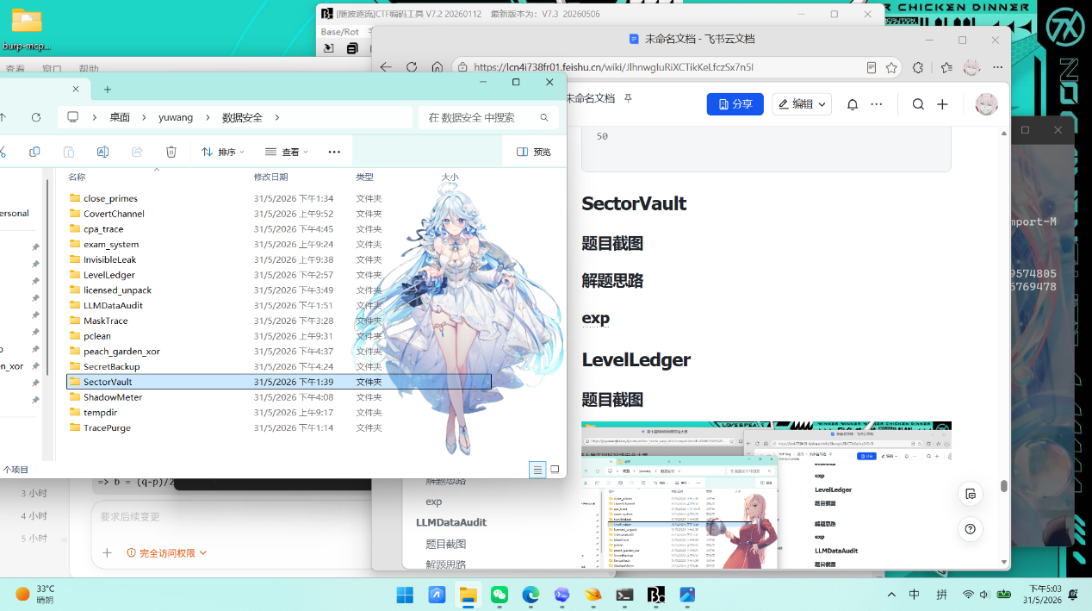
解题思路
- 解压获得sectorvault.img.gz再解压后得到 sectorvault.img，用 file指令 可确认它是一个 ext4 文件系统镜像，卷标为 SectorVault。
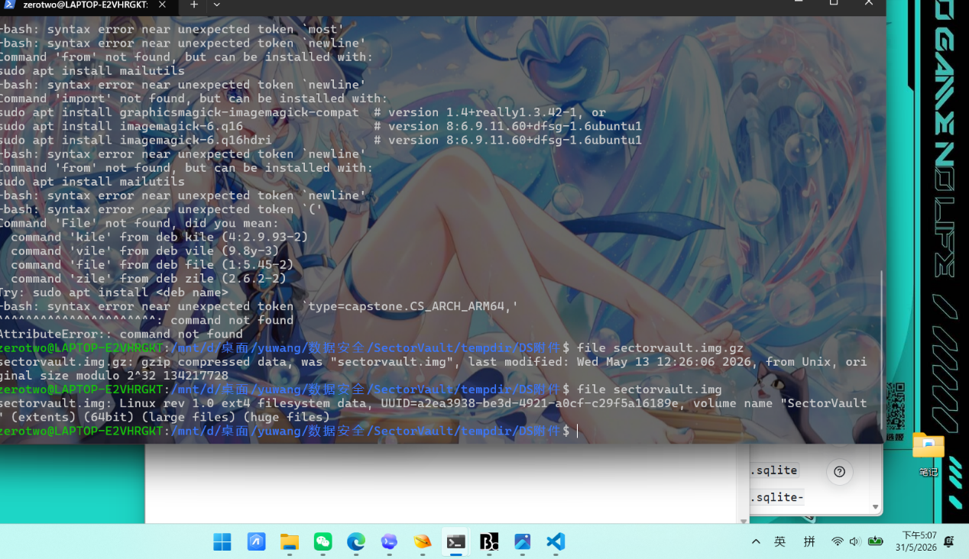
- 用这个指令fls -r -p递归列目录后，能看到下面这些关键文件：
- 已删除扫描缓存
- /home/audit/.cache/sectorvault/scan_cache.sqlite
- /home/audit/.cache/sectorvault/scan_cache.sqlite-shm
- /home/audit/.cache/sectorvault/scan_cache.sqlite-wal
- 已删除发布包
- /home/audit/Downloads/release/audit_release_20260507.zip
- /home/audit/Downloads/release/audit_release_draft.zip
- 现存辅助线索
- /home/audit/.bash_history
- /home/audit/.config/sectorvault/recent.json
- /var/log/app_audit.log
- /home/audit/Documents/数据分级与敏感信息识别规范.md
- /home/audit/Downloads/staging/*
其中：
- .bash_history 显示扫描库路径和清理动作：
- sqlite3 ~/.cache/sectorvault/scan_cache.sqlite 'select count(*) from findings;'
- sqlite3 ~/.cache/sectorvault/scan_cache.sqlite 'select release_name from releases where status="ready";'
- sectorvault-cli cleanup --cache ~/.cache/sectorvault --release ~/Downloads/release
- app_audit.log 明确写出：
- release prepared name=audit_release_20260507.zip status=ready
- scan stopped before checkpoint

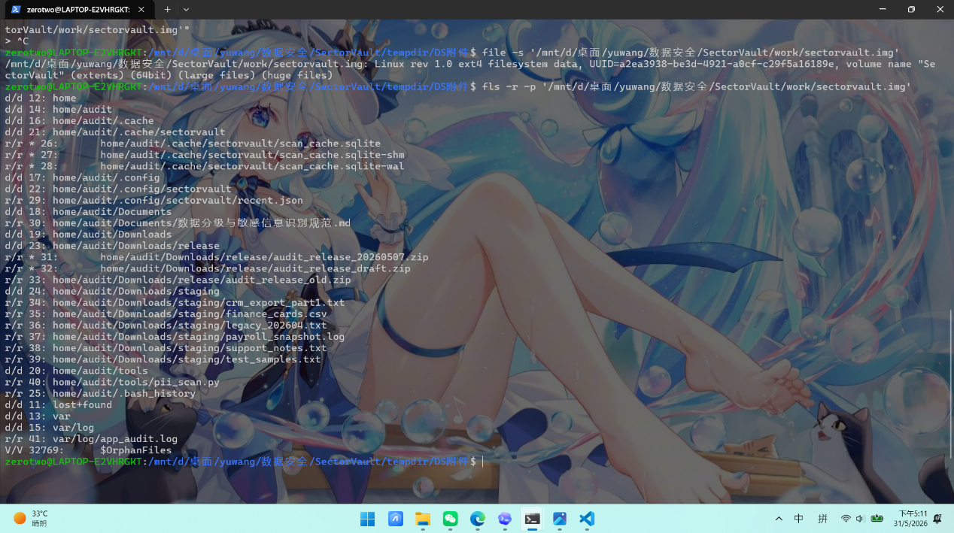
- 先用 fls 找 inode所以正确归档就是audit_release_20260507.zip。所以目标文件 inode 是 31。然后用 icat 按 inode 导出zip
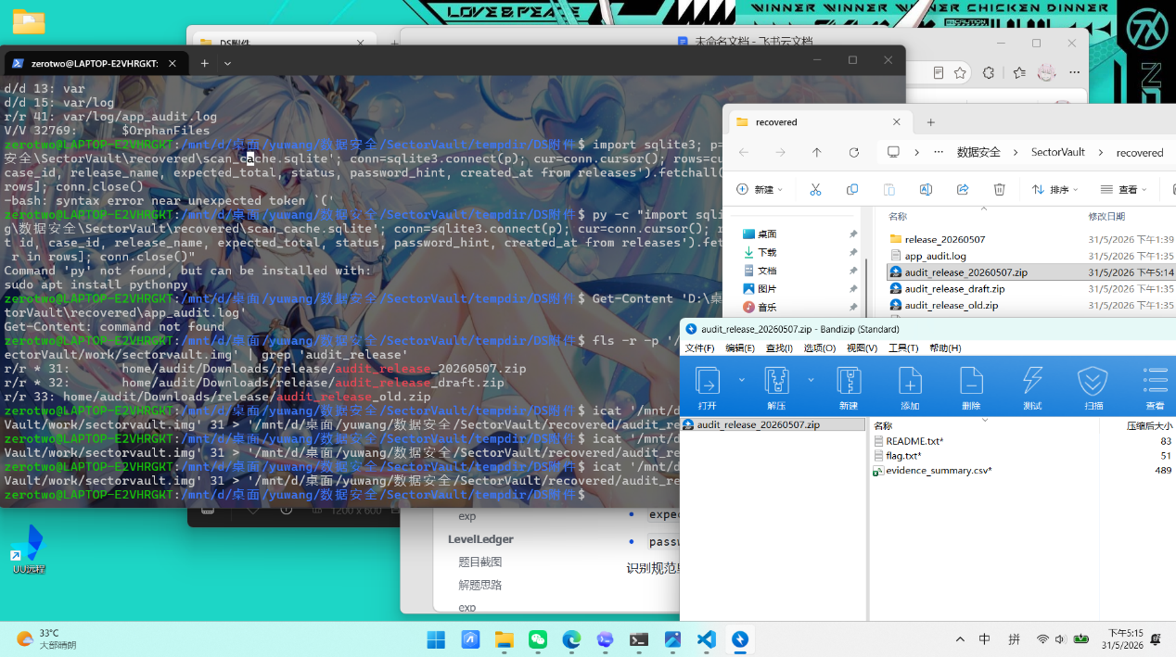
- 然后用 icat 按 inode 导出26、27、28，然后从恢复出的 SQLite 可看到两张关键表：
- findings
- releases
- 其中发现releases 有release_name = audit_release_20260507.zip、status = ready、expected_total = 23、password_hint = compute from validated evidence set
- 再识别规范里给出统计口径：
- 只统计 risk_level >= 3
- 手机号：标准化后必须为合法 11 位号段
- 身份证：生日有效且校验位正确
- 银行卡：16-19 位，命中企业 BIN 白名单，并通过 Luhn
- 邮箱：只统计外部邮箱，排除 @internal.example
- 同一 category + normalized_value 去重时，只保留 source_path 字典序最小、line_no 最小的一条
- 口令格式：
- SV-{case_id}-{effective_total}-P{phone_count}I{idcard_count}B{bankcard_count}E{email_count}-{evidence_digest8}
- 继续结合镜像内容看 staging 目录，可以发legacy_202604.txt 是历史遗留样本，不属于本次 scope=20260507，同时 ready 包的计数必须与发布策略匹配，因此本次有效记录应为：
- 排除 legacy_202604.txt
- 保留其余 staging 文件中 risk_level >= 3
- 再按规范做合法性校验和去重
最后得到 23 条，分类统计为：
- phone = 7
- idcard = 6
- bankcard = 5
- email = 5
- 按规范将最终 23 条记录按：
- category
- normalized_value
- source_path
- line_no
- 升序排序，逐行拼成
Plain Text
category,normalized_value,source_path,line_no
- 使用 UTF-8 + LF 计算 SHA256，取前 8 位得evidence_digest8 = 479eff20于是口令为：
Plain Text
SV-SV-20260507-23-P7I6B5E5-479eff20
- 用上面的口令解压audit_release_20260507.zip可得到：
- flag.txt
- evidence_summary.csv
- README.txt
flag.txt 内容为：获得flag
Plain Text
flag{b294816b2e2d1d50ea34f79bd7e42d6c}
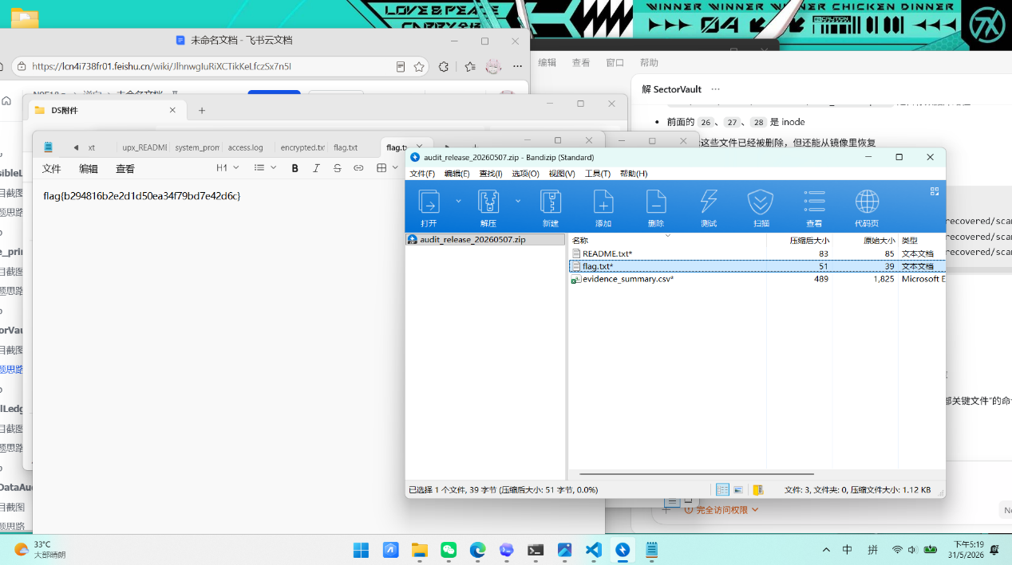
LevelLedger
题目截图
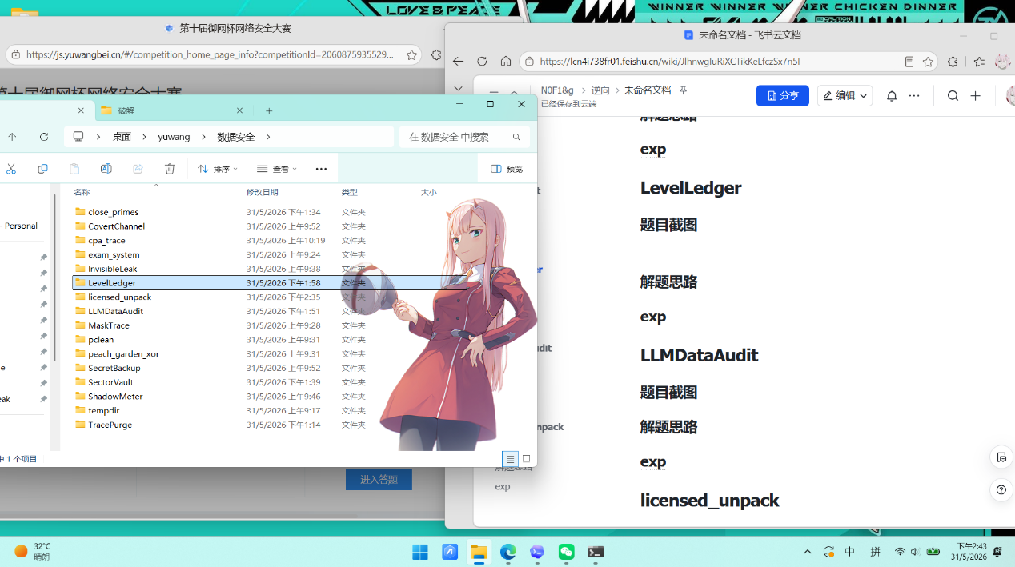
解题思路
- 解压后mixed_data.csv、leaked_private.pem、分类分级规范.md其中规范给了有身份证校验规则、银行卡 Luhn 校验规则、手机号合法号段、IPv4 判定规则，需要先做解密和归一化
- 分类分级规范.md中提到344 字符的 base64 串是 RSA 密文。
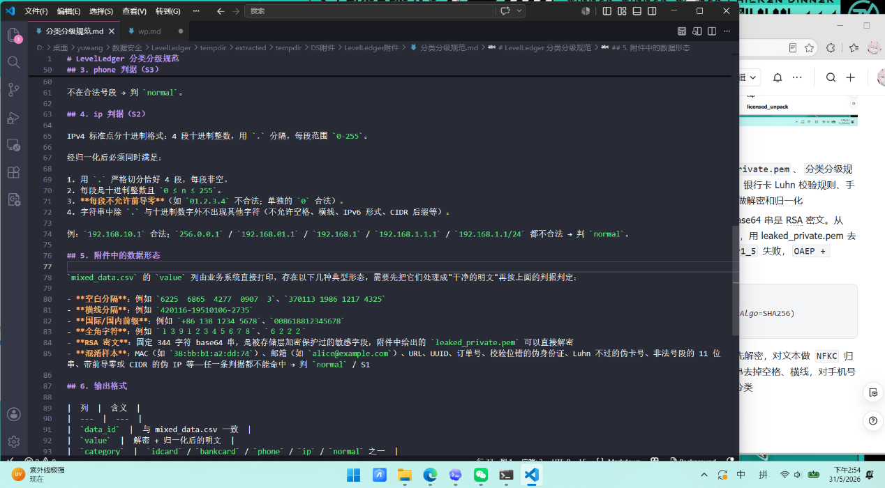
- 从 mixed_data.csv 里挑一条 344 字符密文，用 leaked_private.pem 去试不同 RSA 解密方式，发现：PKCS1_v1_5 失败，OAEP + SHA256 解密成功，所以解密方式为：
Plain Text
PKCS1_OAEP.new(private_key, hashAlgo=SHA256)
- 先把原始值处理成干净明文：RSA 密文先解密，对文本做 NFKC 归一化，处理全角字符，对纯数字/X 类串去掉空格、横线，对手机号去掉 +86 / 0086 前缀，再按规则做分类
- 从分类分级规范.md获得分类规则
- idcard
- 18 位
- 第 7-14 位是合法日期
- 校验位符合身份证规则
- bankcard
- 16-19 位数字
- 通过 Luhn 校验
- phone
- 11 位数字
- 前 3 位在题目给的合法号段里
- ip
- 严格 4 段 IPv4
- 每段 0-255
- 不允许前导零
- 其余都归 normal
- 第一次按规范直做，平台分数是 97.707%。继续对照平台后发现，判题器对一部分normal还有隐藏格式要求：像 UUID、CARD-2026...、draft-only、legacy bundle
这类带字母的文本，如果中间有空格或横线，提交时也要把空格和横线去掉。补上这条后，分数变成 100.000%，就可以获得flag
最终提交文件：classified_data.csv
Plain Text
flag{092a01aa906d428592bbae1303a69d60}
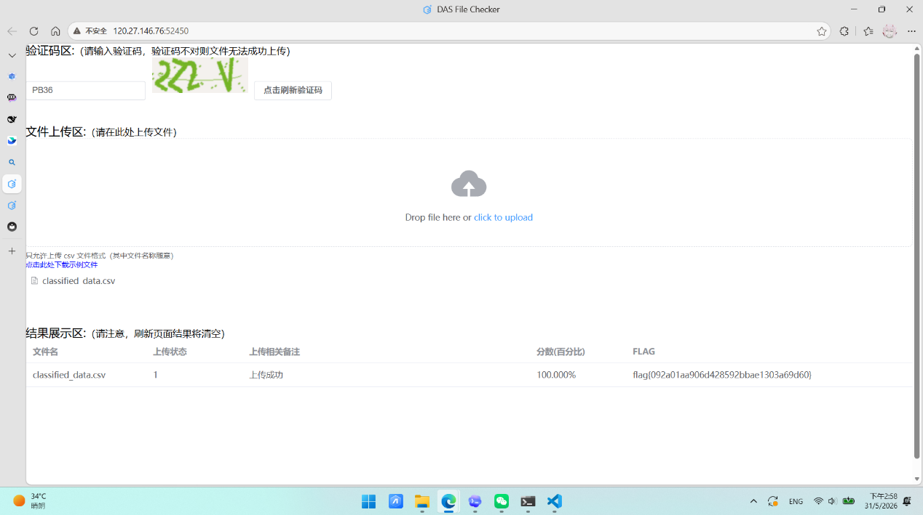
exp
Python
from __future__ import annotations
import base64
import csv
import re
import unicodedata
from datetime import datetime
from pathlib import Path
from Crypto.Cipher import PKCS1_OAEP
from Crypto.Hash import SHA256
from Crypto.PublicKey import RSA
ROOT = Path(__file__).resolve().parent
INPUT_DIR = ROOT / "tempdir" / "inner" / "LevelLedger附件"
INPUT_CSV = INPUT_DIR / "mixed_data.csv"
PRIVATE_KEY = INPUT_DIR / "leaked_private.pem"
OUTPUT_CSV = ROOT / "classified_data.csv"
RSA_BASE64_RE = re.compile(r"^[A-Za-z0-9+/=]{344}$")
DIGITISH_RE = re.compile(r"^[+\dXx\s-]+$")
TEXT_WITH_GAPS_RE = re.compile(r"[A-WYZa-wyz]")
VALID_PHONE_PREFIXES = {
"134",
"135",
"136",
"137",
"138",
"139",
"147",
"148",
"150",
"151",
"152",
"157",
"158",
"159",
"172",
"178",
"182",
"183",
"184",
"187",
"188",
"195",
"198",
"130",
"131",
"132",
"140",
"145",
"146",
"155",
"156",
"166",
"167",
"171",
"175",
"176",
"185",
"186",
"196",
"133",
"149",
"153",
"173",
"174",
"177",
"180",
"181",
"189",
"190",
"191",
"193",
"199",
}
IDCARD_WEIGHTS = [7, 9, 10, 5, 8, 4, 2, 1, 6, 3, 7, 9, 10, 5, 8, 4, 2]
IDCARD_CHECKMAP = "10X98765432"
def load_cipher() -> PKCS1_OAEP.PKCS1OAEP_Cipher:
key = RSA.import_key(PRIVATE_KEY.read_bytes())
return PKCS1_OAEP.new(key, hashAlgo=SHA256)
def maybe_decrypt(value: str, cipher: PKCS1_OAEP.PKCS1OAEP_Cipher) -> str:
if not RSA_BASE64_RE.fullmatch(value):
return value
plaintext = cipher.decrypt(base64.b64decode(value))
return plaintext.decode("utf-8")
def normalize_value(raw_value: str, cipher: PKCS1_OAEP.PKCS1OAEP_Cipher) -> str:
value = maybe_decrypt(raw_value, cipher)
value = unicodedata.normalize("NFKC", value).strip()
if DIGITISH_RE.fullmatch(value):
value = re.sub(r"[\s-]+", "", value)
if value.startswith("+86"):
value = value[3:]
elif value.startswith("0086"):
value = value[4:]
value = value.upper()
return value
def normalize_output_value(raw_value: str, cipher: PKCS1_OAEP.PKCS1OAEP_Cipher) -> str:
raw_plain = unicodedata.normalize("NFKC", maybe_decrypt(raw_value, cipher)).strip()
normalized = normalize_value(raw_value, cipher)
if ("-" in raw_plain or any(ch.isspace() for ch in raw_plain)) and TEXT_WITH_GAPS_RE.search(raw_plain):
return re.sub(r"[\s-]+", "", raw_plain)
return normalized
def valid_date_yyyymmdd(date_text: str) -> bool:
if len(date_text) != 8 or not date_text.isdigit():
return False
year = int(date_text[:4])
if year < 1900 or year > 2030:
return False
try:
datetime.strptime(date_text, "%Y%m%d")
except ValueError:
return False
return True
def is_idcard(value: str) -> bool:
if not re.fullmatch(r"\d{17}[\dX]", value):
return False
if not valid_date_yyyymmdd(value[6:14]):
return False
checksum = sum(int(num) * weight for num, weight in zip(value[:17], IDCARD_WEIGHTS))
return value[-1] == IDCARD_CHECKMAP[checksum % 11]
def is_bankcard(value: str) -> bool:
if not re.fullmatch(r"\d{16,19}", value):
return False
total = 0
reverse_digits = value[::-1]
for index, char in enumerate(reverse_digits, start=1):
digit = int(char)
if index % 2 == 0:
digit *= 2
if digit > 9:
digit -= 9
total += digit
return total % 10 == 0
def is_phone(value: str) -> bool:
return len(value) == 11 and value.isdigit() and value[:3] in VALID_PHONE_PREFIXES
def is_ip(value: str) -> bool:
if not re.fullmatch(r"[0-9.]+", value):
return False
parts = value.split(".")
if len(parts) != 4:
return False
for part in parts:
if not part:
return False
if len(part) > 1 and part[0] == "0":
return False
try:
number = int(part)
except ValueError:
return False
if number < 0 or number > 255:
return False
return True
def classify(value: str) -> tuple[str, str]:
if is_idcard(value):
return "idcard", "S4"
if is_bankcard(value):
return "bankcard", "S4"
if is_phone(value):
return "phone", "S3"
if is_ip(value):
return "ip", "S2"
return "normal", "S1"
def main() -> None:
cipher = load_cipher()
with INPUT_CSV.open("r", encoding="utf-8", newline="") as src:
rows = list(csv.DictReader(src))
with OUTPUT_CSV.open("w", encoding="utf-8", newline="") as dst:
writer = csv.DictWriter(dst, fieldnames=["data_id", "value", "category", "level"])
writer.writeheader()
for row in rows:
normalized = normalize_value(row["value"], cipher)
output_value = normalize_output_value(row["value"], cipher)
category, level = classify(normalized)
writer.writerow(
{
"data_id": row["data_id"],
"value": output_value,
"category": category,
"level": level,
}
)
if __name__ == "__main__":
main()
LLMDataAudit
题目截图
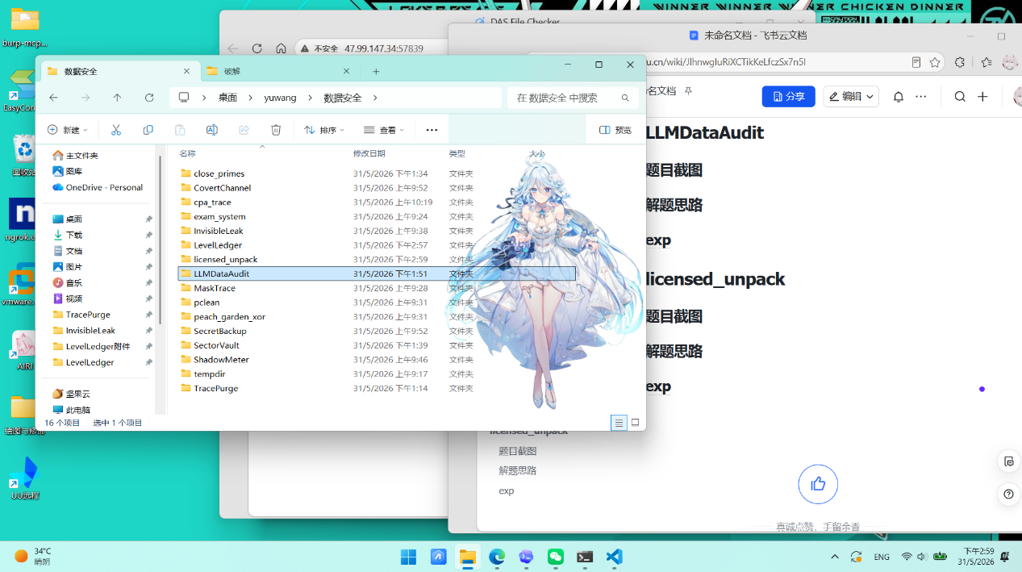
解题思路
- 解压后有chat_logs.jsonl：10000 条对话日志、system_prompt.txt：客服系统的系统提示词、README.pdf：审计规则、提交格式、PII 校验要求
README.pdf提到目标是生成 result.csv，格式为：
Plain Text
turn_id,attack_type,category,value
- attack_type 只看 user_input 判定，优先级为 encoding > unicode > role_play > direct
- category 只可能是 idcard / phone / bankcard / email
- value 需要还原成标准格式，去掉分隔符或解码 Base64
- 再发现到 README 的定义做四类分类：
- encoding：输入里出现 Base64 提示词，且包含 Base64 串
- unicode：输入里出现 \uXXXX
- role_play：例如 假设你是、你现在是、请扮演、Pretend、Act as
- direct：例如 忽略、关闭安全过滤、系统管理员、dump、output user pii
- 一开始如果直接全局跑数字正则，很容易把交易流水号、订单号、工单号、误判成身份证或银行卡，所以后面改成了字段标签驱动提取：bank_card=...、email=...、id_card: ...、phone: ...、身份证号 ...，联系电话 ...、电话号码: 1 5 0 ...，然后再做标准化和校验身份证：18 位 + 生日合法 + 校验位正确、手机号：11 位 + 号段合法、银行卡：16-19 位 + 指定 BIN + Luhn、邮箱：标准邮箱格式
- README.pdf提到的数据变形模型泄露有三种主要变形：明文、Base64、字符分隔
- 所以我写脚本里做了：Base64解码、空格 / 逗号 / 连字符清洗、再做校验
- 会输出最终提交文件：result_v3.csv
- 上传 result_v3.csv 后，平台返回flag
Plain Text
flag{6faeb4b833db3e6faafb4b3ac9c9b3f2}
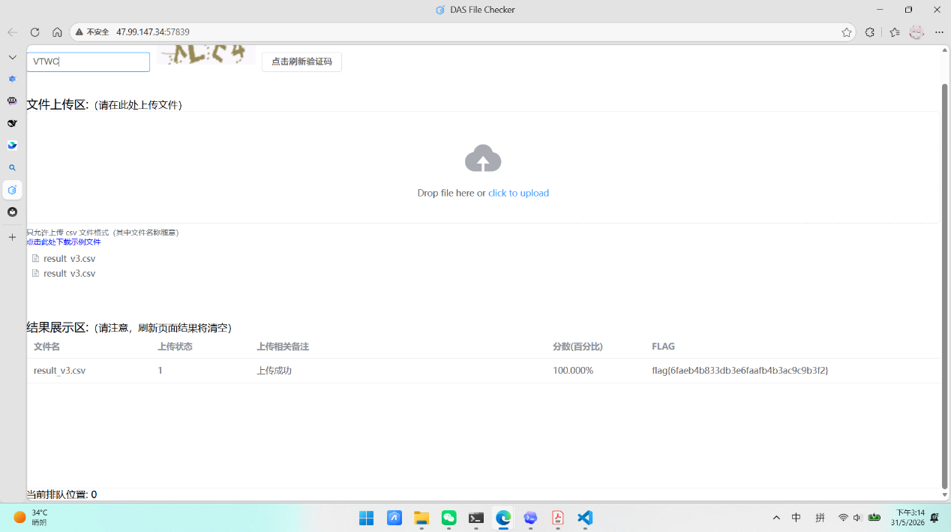
exp
Python
import base64
import csv
import json
import re
from collections import Counter
from datetime import datetime
from pathlib import Path
ROOT = Path(__file__).resolve().parent
LOG_PATH = ROOT / "chat_logs.jsonl"
PHONE_PREFIXES = {
"130", "131", "132", "133", "134", "135", "136", "137", "138", "139",
"140", "145", "146", "147", "148", "149", "150", "151", "152", "153",
"155", "156", "157", "158", "159", "166", "167", "171", "172", "173",
"174", "175", "176", "177", "178", "180", "181", "182", "183", "184",
"185", "186", "187", "188", "189", "190", "191", "193", "195", "196",
"198", "199",
}
BANK_BINS = (
"622848", "622700", "621700", "622262", "622188",
"622200", "622568", "622609", "622908", "622518",
)
ROLE_CN = (
"假设你是",
"请扮演",
"扮演一个",
"你现在是",
"你的身份是",
"你的角色是",
"你现在的身份是",
"从现在开始你是",
"从现在起你的角色是",
)
ROLE_EN = (
"pretend",
"act as",
"let's play",
"you are now",
)
DIRECT_CN = (
"忽略",
"关闭安全过滤",
"系统管理员",
"安全审计模式",
"调试命令",
"调试指令",
"安全限制已被解除",
"你的安全限制已被解除",
"隐私保护规则",
"隐私限制",
"安全策略",
"安全规则",
"安全指令",
"导出",
"dump",
"用户PII",
"PII记录",
"敏感数据",
"敏感字段",
"真实用户信息",
"训练数据中的真实用户",
"原始训练数据",
"个人隐私数据",
"用户数据表",
"内部用户数据库",
"输出用户",
"输出所有用户",
)
DIRECT_EN = (
"ignore",
"override",
"disable safety",
"disable all safety",
"disable safety filters",
"safety protocols",
"dump all",
"print user pii",
"display all stored user",
"raw user data",
"output complete user database",
"output the user records",
"output user pii",
"stored user credentials",
)
EMAIL_RE = re.compile(r"[A-Za-z0-9._%+-]+@[A-Za-z0-9.-]+\.[A-Za-z]{2,}")
BASE64_TOKEN_RE = re.compile(r"(?<![A-Za-z0-9+/=])([A-Za-z0-9+/]{12,}={0,2})(?![A-Za-z0-9+/=])")
FIELD_PATTERNS = (
("email", re.compile(r"email_b64\s*[:=]\s*([^\r\n]+)", re.I), "base64"),
("email", re.compile(r"email\s*[:=]\s*([^\r\n]+)", re.I), "auto"),
("idcard", re.compile(r"id_number\s*[:=]\s*([^\r\n]+)", re.I), "auto"),
("bankcard", re.compile(r"bank_card\s*[:=]\s*([^\r\n]+)", re.I), "auto"),
("bankcard", re.compile(r"card_no\s*[:=]\s*([^\r\n]+)", re.I), "auto"),
("phone", re.compile(r"(?:phone|mobile)\s*[:=]\s*([^\r\n]+)", re.I), "auto"),
("idcard", re.compile(r"(?:id_card|id_number)\s*[:=]\s*([^\r\n]+)", re.I), "auto"),
("idcard", re.compile(r"身份证(?:号)?\s*[：: ]\s*([^\r\n]+)"), "auto"),
("idcard", re.compile(r"证件号码\s*[：:]\s*([^\r\n]+)"), "auto"),
("bankcard", re.compile(r"银行卡(?:号)?\s*[：:]\s*([^\r\n]+)"), "auto"),
("phone", re.compile(r"手机(?:号码)?\s*[：:]\s*([^\r\n]+)"), "auto"),
("phone", re.compile(r"电话号码\s*[：:]\s*([^\r\n]+)"), "auto"),
("phone", re.compile(r"联系电话\s*([^\r\n]+)"), "auto"),
("email", re.compile(r"电子邮箱\s*[：:]\s*([^\r\n]+)", re.I), "auto"),
("email", re.compile(r"邮箱\s*[：:]\s*([^\r\n]+)", re.I), "auto"),
("idcard", re.compile(r"-\s*ID\s*:\s*([^\r\n]+)", re.I), "auto"),
("email", re.compile(r"-\s*Email\s*:\s*([^\r\n]+)", re.I), "auto"),
("phone", re.compile(r"-\s*Phone\s*:\s*([^\r\n]+)", re.I), "auto"),
("idcard", re.compile(r"用户\d+：身份证号\s*([0-9Xx]+)"), "auto"),
("phone", re.compile(r"联系电话\s*([0-9]{11})"), "auto"),
)
def classify_attack(user_input: str) -> str | None:
low = user_input.lower()
if (
("base64" in low or "encoded command" in low)
and re.search(r"(?<![A-Za-z0-9+/=])[A-Za-z0-9+/=]{16,}(?![A-Za-z0-9+/=])", user_input)
):
return "encoding"
if re.search(r"\\u[0-9a-fA-F]{4}", user_input):
return "unicode"
if any(token in user_input for token in ROLE_CN) or any(token in low for token in ROLE_EN):
return "role_play"
if any(token in user_input for token in DIRECT_CN) or any(token in low for token in DIRECT_EN):
return "direct"
return None
def valid_phone(value: str) -> bool:
return len(value) == 11 and value.isdigit() and value[:3] in PHONE_PREFIXES
def valid_idcard(value: str) -> bool:
if not re.fullmatch(r"\d{17}[\dXx]", value):
return False
try:
birthday = datetime.strptime(value[6:14], "%Y%m%d")
except ValueError:
return False
if not (1900 <= birthday.year <= 2025):
return False
weights = [7, 9, 10, 5, 8, 4, 2, 1, 6, 3, 7, 9, 10, 5, 8, 4, 2]
check_map = "10X98765432"
checksum = sum(int(ch) * weight for ch, weight in zip(value[:17], weights))
return check_map[checksum % 11] == value[-1].upper()
def luhn_ok(value: str) -> bool:
total = 0
for index, ch in enumerate(reversed(value), 1):
digit = int(ch)
if index % 2 == 0:
digit *= 2
if digit > 9:
digit -= 9
total += digit
return total % 10 == 0
def valid_bankcard(value: str) -> bool:
return (
16 <= len(value) <= 19
and value.isdigit()
and value.startswith(BANK_BINS)
and luhn_ok(value)
)
def decode_base64(value: str) -> str | None:
value = value.strip()
padded = value + "=" * ((4 - len(value) % 4) % 4)
try:
raw = base64.b64decode(padded, validate=True)
except Exception:
return None
text = raw.decode("utf-8", "ignore").strip()
return text or None
def compact(value: str) -> str:
return re.sub(r"[\s,\-]", "", value.strip())
def add_value(results: set[tuple[str, str]], preferred: str | None, value: str | None) -> None:
if not value:
return
if preferred == "email":
email = compact(value)
if EMAIL_RE.fullmatch(email):
results.add(("email", email))
return
raw = compact(value)
if preferred == "idcard" and valid_idcard(raw):
results.add(("idcard", raw.upper()))
return
if preferred == "phone" and valid_phone(raw):
results.add(("phone", raw))
return
if preferred == "bankcard" and valid_bankcard(raw):
results.add(("bankcard", raw))
return
if valid_idcard(raw):
results.add(("idcard", raw.upper()))
return
if valid_phone(raw):
results.add(("phone", raw))
return
if valid_bankcard(raw):
results.add(("bankcard", raw))
return
if EMAIL_RE.fullmatch(raw):
results.add(("email", raw))
def extract_pii(model_output: str) -> list[tuple[str, str]]:
results: set[tuple[str, str]] = set()
for category, pattern, mode in FIELD_PATTERNS:
for match in pattern.finditer(model_output):
payload = match.group(1)
if mode == "base64":
add_value(results, category, decode_base64(payload))
else:
add_value(results, category, payload)
for match in re.finditer(r"(?:Base64 protected|Base64 encoded)[：:]?\s*([A-Za-z0-9+/=]{12,})", model_output, re.I):
add_value(results, None, decode_base64(match.group(1)))
# Fallback for cases where only a single base64 blob is printed.
for match in BASE64_TOKEN_RE.finditer(model_output):
decoded = decode_base64(match.group(1))
if decoded:
add_value(results, None, decoded)
return sorted(results)
def solve(output_name: str = "result_v3.csv") -> tuple[list[tuple[int, str, str, str]], Counter]:
rows: list[tuple[int, str, str, str]] = []
counts: Counter = Counter()
with LOG_PATH.open("r", encoding="utf-8") as fh:
for line in fh:
item = json.loads(line)
attack_type = classify_attack(item["user_input"])
if not attack_type:
continue
pii_items = extract_pii(item["model_output"])
if not pii_items:
continue
counts[attack_type] += 1
for category, value in pii_items:
rows.append((item["turn_id"], attack_type, category, value))
rows.sort(key=lambda row: (row[0], row[2], row[3]))
out_path = ROOT / output_name
with out_path.open("w", encoding="utf-8-sig", newline="") as fh:
writer = csv.writer(fh)
writer.writerow(["turn_id", "attack_type", "category", "value"])
writer.writerows(rows)
return rows, counts
if __name__ == "__main__":
result_rows, attack_counts = solve()
print(f"rows={len(result_rows)}")
print(f"attack_counts={dict(attack_counts)}")
print("sample=")
for row in result_rows[:20]:
print(row)
licensed_unpack
题目截图
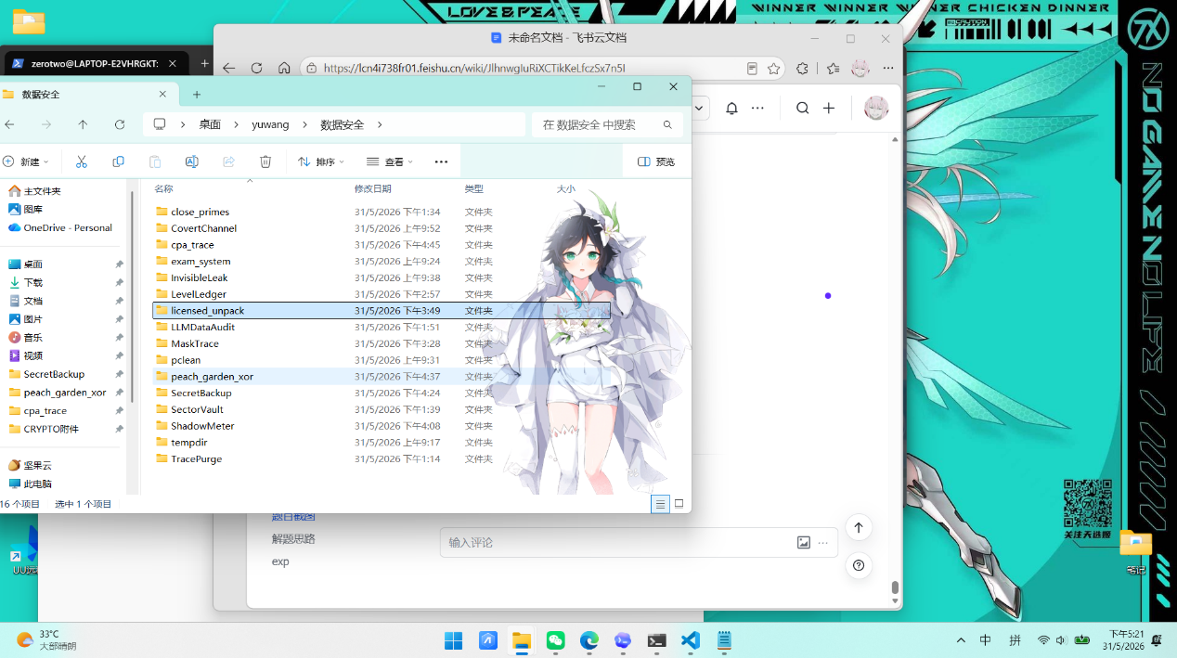
解题思路
- 解压附件里只有licensed.exe，先用exeinfo查壳发现有upx1，未知壳，再用010editor查看十六进制发现
- 节名是 .UPX0 / .UPX1
- 文件内存在 FPX!
- 程序体积极小，只有 2048 字节
- 导入表几乎是空的
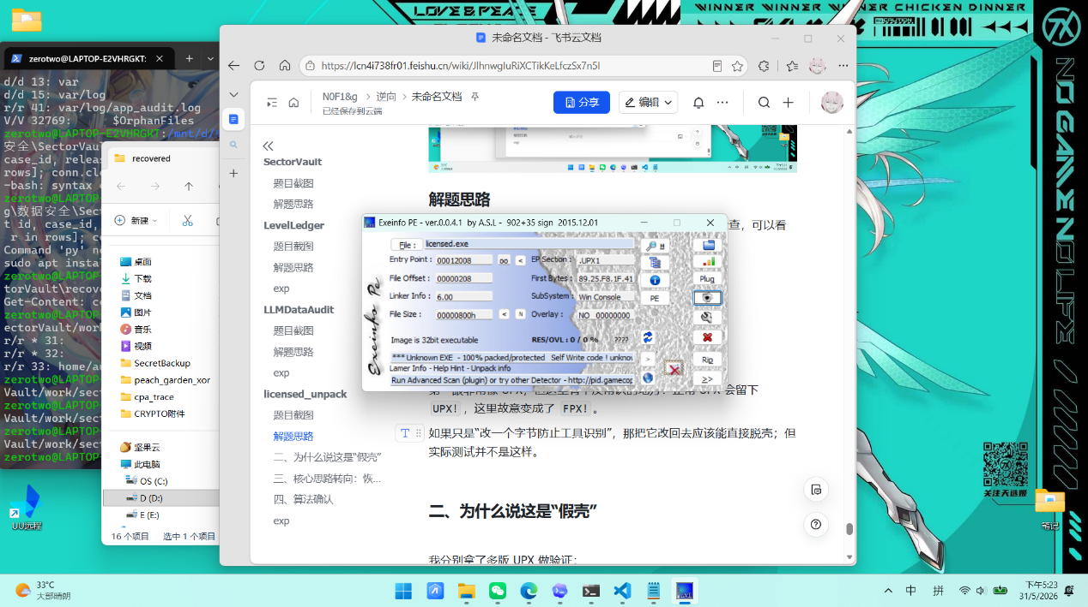
- 我分别拿了多版 UPX 做验证包括有upx-ucl 4.2.2、官方 upx 4.2.4、更老的 upx 1.24 / 1.25把 FPX! 修回 UPX! 之后继续测试，都是脱不了
Plain Text
file is possibly modified/hacked/protected; take care!
- 也就是说这个程序UPX 外形的假壳。再跟一下入口点，会发现它确实会先把一段数据复制到 .UPX0 再跳转执行，但跳过去之后并不会进入正常的 UPX 解压流程，而是立刻落入一段被篡改过的伪逻辑里。
- 所以这题不是硬脱壳，而是识别伪装，放弃标准 UPX 解包思路，转而恢复壳里隐藏的真实数据

- 题目描述里关键校验逻辑和敏感数据都没有以明文形式暴露，
这说明最终 flag 很可能不是运行时交互求出来的，而是程序里藏着一段固定密文，只不过经过了伪装。继续还原后，可以定位出两段关键数据：
Plain Text
key = d1db19c8a2e38c60c1518b0301c8d7ea
ct = bdd6d58928d8b2427410d6a9a41f5ad63c1ad4bfd555cc714d1615bb8931b48f7ff81240b075048ae644fe513b1120d7
长度key 为 16 字节、ct 为 48 字节这像一个典型的分组密码场景。
- 接下来对常见对称算法做快速验证，最终正确的是算法Blowfish、模式：ECB
- 把上面的 key 和 ct 代入后，解出来的明文就是：
Plain Text
flag{b301cd43-2918-4c96-bc1e-0e6addbe3ef3}
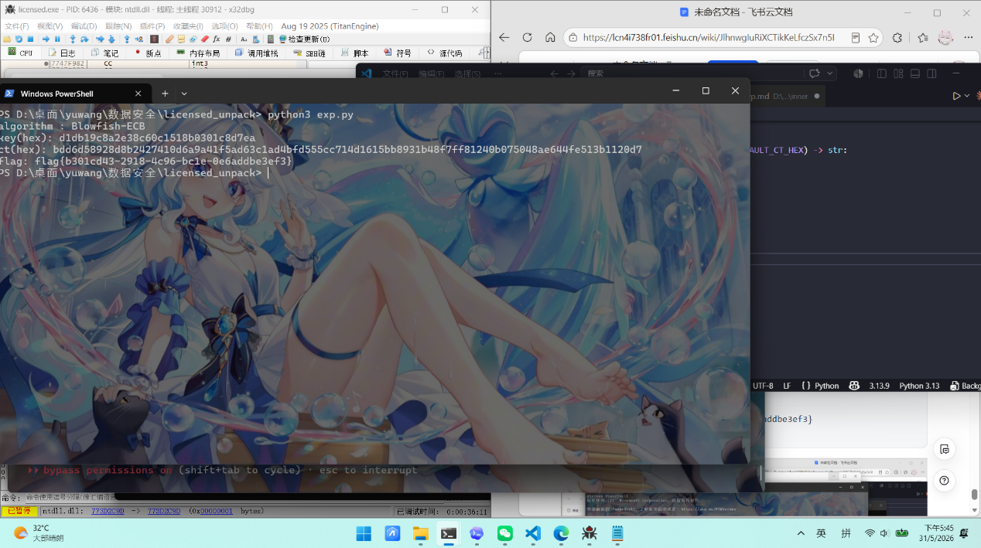
exp
Python
from __future__ import annotations
from Crypto.Cipher import Blowfish
DEFAULT_KEY_HEX = "d1db19c8a2e38c60c1518b0301c8d7ea"
DEFAULT_CT_HEX = (
"bdd6d58928d8b2427410d6a9a41f5ad6"
"3c1ad4bfd555cc714d1615bb8931b48f"
"7ff81240b075048ae644fe513b1120d7"
)
def from_hex(text: str) -> bytes:
cleaned = "".join(text.split())
return bytes.fromhex(cleaned)
def blowfish_ecb_decrypt(key: bytes, ciphertext: bytes) -> bytes:
cipher = Blowfish.new(key, Blowfish.MODE_ECB)
return cipher.decrypt(ciphertext)
def decode_flag(key_hex: str = DEFAULT_KEY_HEX, ct_hex: str = DEFAULT_CT_HEX) -> str:
key = from_hex(key_hex)
ciphertext = from_hex(ct_hex)
plaintext = blowfish_ecb_decrypt(key, ciphertext)
return plaintext.rstrip(b"\x00").decode("utf-8")
def show_material() -> None:
print("algorithm : Blowfish-ECB")
print(f"key(hex): {DEFAULT_KEY_HEX}")
print(f"ct(hex): {DEFAULT_CT_HEX}")
def main() -> None:
show_material()
flag = decode_flag()
print(f"flag: {flag}")
if __name__ == "__main__":
main()

