ISCC2026 WriteUp 黑白琴弦misc

解题思路：
解压后得到 21 张条形码图,和一个加密的 score.rar 文件
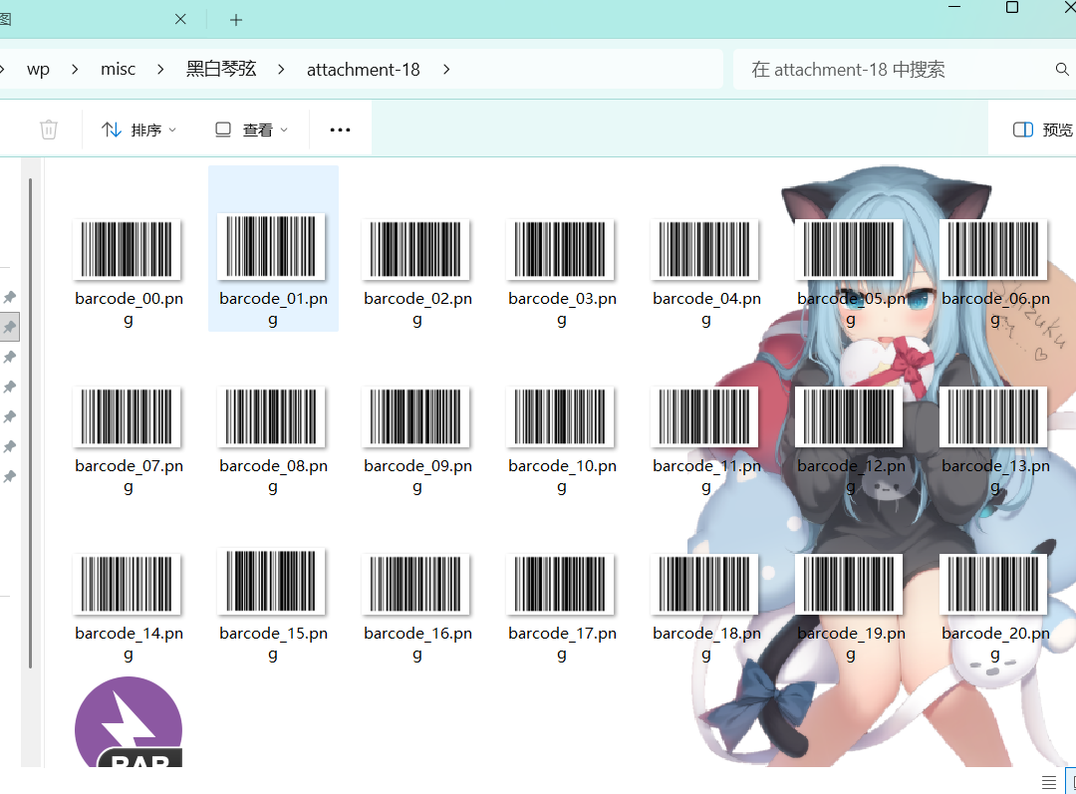
这 21 张条形码图片,每张图片都包含了三层隐藏信息，需要逐一提取。
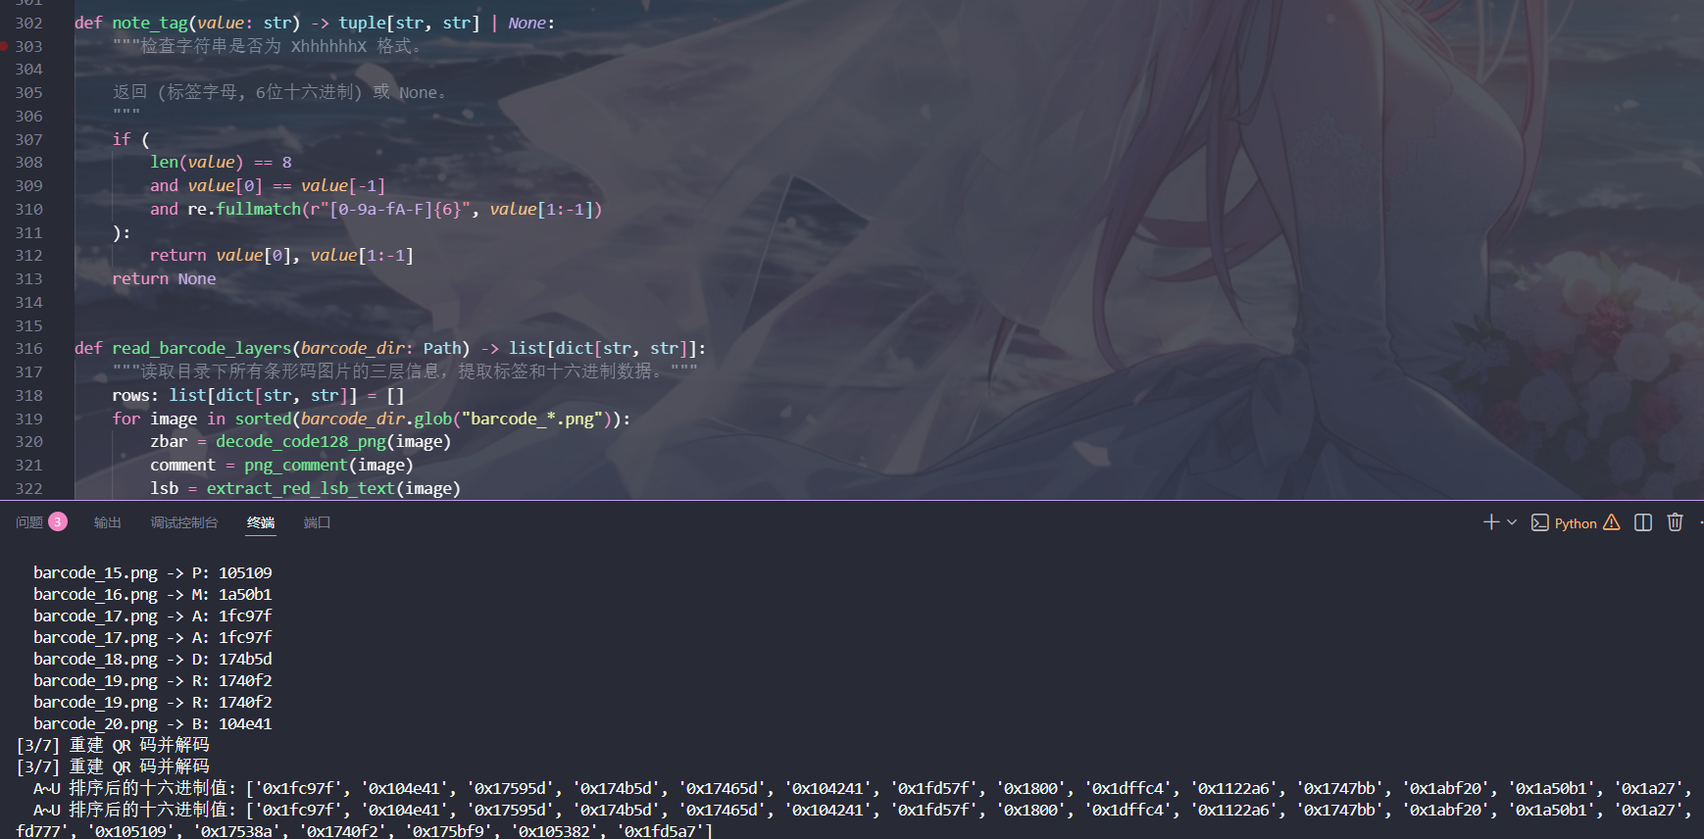
第一层是图片中央绘制的 Code128 一维条形码。解码时取图片中间一行像素，按灰度值二值化（黑色为 1、白色为 0），然后裁剪两侧空白区域。接着对黑白游程长度进行编码，估算模块宽度后按 11 位一组查 Code128 编码表，最后根据编码集（Code128-B 或 Code128-C）还原为字符串。

第二层藏在 PNG 文件的 tEXt 元数据块中。PNG 文件由一系列 chunk 组成，其中 tEXt 类型的 chunk 可以存储文本键值对。遍历所有 chunk，找到关键字为 Comment 的 tEXt 块，其数据部分就是隐藏字符串。
第三层是红色通道的最低位（Red LSB）隐写。逐像素提取 R 分量的最低有效位，每 8 位组成一个字节。第一个字节表示后面字符串的长度，后续字节为实际的 ASCII 内容。这里只用了红色通道，绿色和蓝色通道没有参与，可能是为了降低对图片视觉质量的影响。
三层信息提取出来的字符串中，大部分是干扰数据还有一些随机字符串，真正有用的是符合 XhhhhhhX 格式的数据，首尾是同一个字母，中间是 6 位十六进制数。比如从某张图片的 Comment 中提取到 A1fc97fA，解析为标签 A 和十六进制值 1fc97f。
21 张图片提取到的标签从 A 到 U 共 21 个，每个标签对应一个 6 位十六进制
值。QR 码 Version 1 的尺寸正好是 21×21，每个标签对应 QR 码的一列，6 位十六进制数（24 bit）中取连续的 21 bit 对应 21 行。
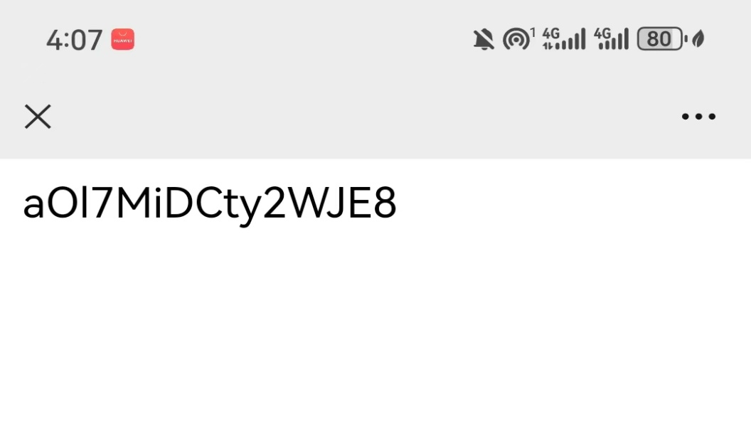
将标签按 A~U 排序后，遍历 21 行，每行取第 3~23 位（共 21 bit），按列填充到 QR 码中。用 Python 的 Pillow 库绘制出 21×21 的黑白点阵图，放大并添加边框以便 OpenCV 识别。使用 OpenCV 的 QRCodeDetector 解码，得到 aOl7MiDCty2WJE8—— score.rar 的解压密码。

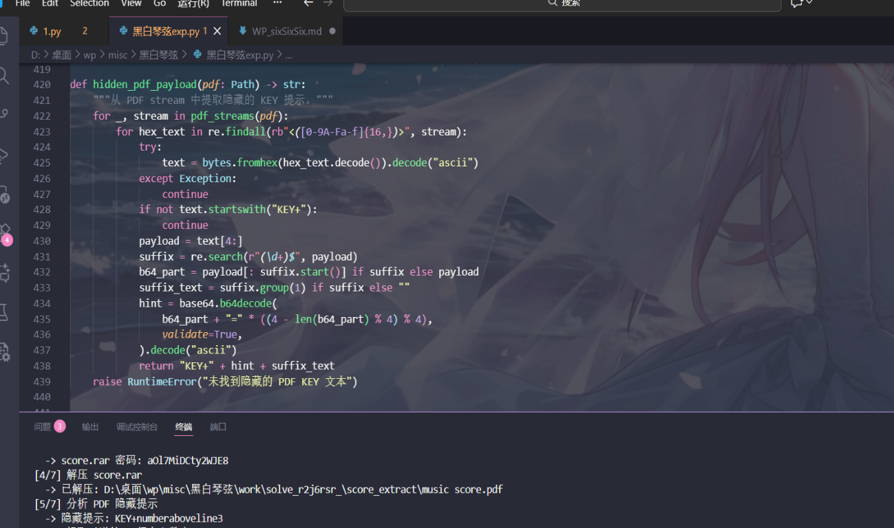
解压 score.rar，得到 music score.pdf——一份五线谱乐谱。PDF ，其中可能隐藏额外信息。遍历 PDF 中所有 stream 块，对于使用 /FlateDecode的 stream，先解压再分析。在解压后的数据中搜索形如 <十六进制> 的 PDF 字符串，找到一段数据：解码得到 KEY+numberaboveline3。这个提示告诉我们密钥（key）在乐谱的第 3 行上方。

PDF 内嵌了一张五线谱图像。从 PDF stream 中找到 /Subtype/Image 类型的字典，读取 Width 和 Height 参数后直接提取像素数据，还原为 8 位灰度图。将图像裁切第 3 行上方区域，坐标范围约为 x:50~640、y:390~416。对裁切区域做二值化（阈值 200）后使用 8-连通域分析识别每个数字区域。识别策略：该区域的第一个数字固定为 4；宽度 ≤2 像素的一律为 1；其余为 5。最终得到 4151515。
将 QR 码解码得到的密码 aOl7MiDCty2WJE8 与乐谱第 3 行上方数字 4151515 直接拼接，再加上 ISCC{} 的 flag 外壳，得到最终 flag。
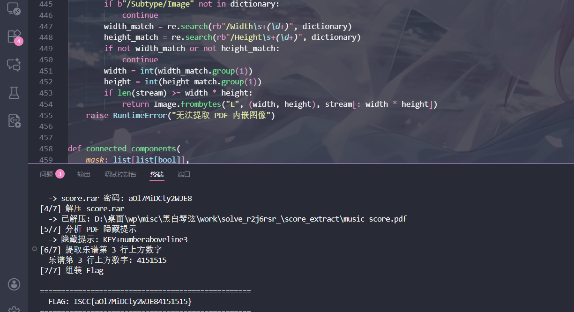
FLAG: ISCC{aOl7MiDCty2WJE84151515}

Exp
运行前需通过 pip install Pillow opencv-python numpy 安装 Python 依赖，并确保系统中安装了 unrar/7z/WinRAR 等 RAR 解压工具且已加入 PATH 环境变量。脚本支持 --barcode-dir 参数直接读取已解压的目录，方便分步调试。
#!/usr/bin/env python3
"""
pip install Pillow opencv-python numpy
需系统安装 unrar / 7z / WinRAR 之一并加入 PATH
"""

from __future__ import annotations

import argparse
import base64
import os
import re
import shutil
import subprocess
import sys
import tempfile
import zlib
from collections import deque
from pathlib import Path

from PIL import Image
CODE128 = (
"11011001100", "11001101100", "11001100110", "10010011000", "10010001100", "10001001100",
"10011001000", "10011000100", "10001100100", "11001001000", "11001000100", "11000100100",
"10110011100", "10011011100", "10011001110", "10111001100", "10011101100", "10011100110",
"11001110010", "11001011100", "11001001110", "11011100100", "11001110100", "11101101110",
"11101001100", "11100101100", "11100100110", "11101100100", "11100110100", "11100110010",
"11011011000", "11011000110", "11000110110", "10100011000", "10001011000", "10001000110",
"10110001000", "10001101000", "10001100010", "11010001000", "11000101000", "11000100010",
"10110111000", "10110001110", "10001101110", "10111011000", "10111000110", "10001110110",
"11101110110", "11010001110", "11000101110", "11011101000", "11011100010", "11011101110",
"11101011000", "11101000110", "11100010110", "11101101000", "11101100010", "11100011010",
"11101111010", "11001000010", "11110001010", "10100110000", "10100001100", "10010110000",
"10010000110", "10000101100", "10000100110", "10110010000", "10110000100", "10011010000",
"10011000010", "10000110100", "10000110010", "11000010010", "11001010000", "11110111010",
"11000010100", "10001111010", "10100111100", "10010111100", "10010011110", "10111100100",
"10011110100", "10011110010", "11110100100", "11110010100", "11110010010", "11011011110",
"11011110110", "11110110110", "10101111000", "10100011110", "10001011110", "10111101000",
"10111100010", "11110101000", "11110100010", "10111011110", "10111101110", "11101011110",
"11110101110", "11010000100", "11010010000", "11010011100",
)
CODE128_MAP = {bits: idx for idx, bits in enumerate(CODE128)}
CODE128_STOP = "11000111010"

# =========================================================================
# 工具函数
# =========================================================================

def run(cmd: list[str], cwd: Path, timeout: int = 30) -> subprocess.CompletedProcess[str]:
return subprocess.run(
[str(x) for x in cmd],
cwd=cwd,
text=True, stdout=subprocess.PIPE, stderr=subprocess.PIPE,
timeout=timeout, check=False,
)

def _build_rar_cmd(kind: str, tool: Path, archive: Path, out_dir: Path, password: str | None = None) -> list[str]:
"""根据不同工具构建 RAR 解压命令。"""
if kind == "unar" or tool.name.lower() == "unar":
cmd = [
str(tool), "-quiet", "-force-overwrite", "-no-directory",
"-output-directory", str(out_dir),
]
if password:
cmd.extend(["-password", password])
cmd.append(str(archive))
elif "7z" in kind or tool.name.lower().startswith("7z"):
cmd = [str(tool), "x", "-y", f"-o{out_dir}", str(archive)]
if password:
cmd.insert(3, f"-p{password}")
else:
cmd = [str(tool), "x", "-o+"]
if password:
cmd.append(f"-p{password}")
cmd.extend([str(archive), str(out_dir) + "\\"])
return cmd

def extract_rar_with_tool(kind: str, tool: Path, archive: Path, out_dir: Path, password: str | None = None) -> None:
"""用指定工具解压 RAR。"""
cmd = _build_rar_cmd(kind, tool, archive, out_dir, password)
result = subprocess.run(
cmd, text=True, stdout=subprocess.PIPE, stderr=subprocess.PIPE,
timeout=60, check=False,
)
if result.returncode != 0:
err = result.stdout + "\n" + result.stderr
raise RuntimeError(f"{tool.name} 解压失败 (返回码 {result.returncode}):\n{err}")

def _collect_rar_candidates() -> list[tuple[str, Path]]:
"""收集所有可能的 RAR 解压工具路径。"""
candidates: list[tuple[str, Path]] = []
for name in ("unrar", "rar", "7z", "7zz", "unar"):
found = shutil.which(name)
if found:
candidates.append((name, Path(found)))
for base in filter(None, (os.environ.get("ProgramFiles"), os.environ.get("ProgramFiles(x86)"))):
for rel in (
Path("WinRAR") / "UnRAR.exe",
Path("WinRAR") / "WinRAR.exe",
Path("7-Zip") / "7z.exe",
):
path = Path(base) / rel
if path.exists():
candidates.append((path.stem.lower(), path))
return candidates

def extract_rar(archive: Path, out_dir: Path, password: str | None = None) -> None:
"""解压 RAR 文件，自动尝试所有可用工具。"""
candidates = _collect_rar_candidates()
if not candidates:
raise RuntimeError("未找到 RAR 解压工具，请安装 WinRAR/7-Zip/unar 并加入 PATH")

out_dir.mkdir(parents=True, exist_ok=True)

errors: list[str] = []
for kind, tool in candidates:
try:
r = subprocess.run(
[str(tool)], capture_output=True, timeout=5, check=False,
)
except (OSError, subprocess.TimeoutExpired) as e:
errors.append(f"{tool.name}: 无法运行 - {e}")
continue

try:
extract_rar_with_tool(kind, tool, archive, out_dir, password)
return
except RuntimeError as e:
errors.append(f"{tool.name}: {e}")
continue

raise RuntimeError(
"所有 RAR 工具均解压失败:\n" + "\n".join(errors)
)

# =========================================================================
# PNG 元数据提取
# =========================================================================

def png_comment(path: Path) -> str:
"""读取 PNG 文件的 Comment 元数据。"""
data = path.read_bytes()
pos = 8 # 跳过 PNG 签名
while pos + 12 <= len(data):
length = int.from_bytes(data[pos: pos + 4], "big")
typ = data[pos + 4: pos + 8]
chunk = data[pos + 8: pos + 8 + length]
if typ == b"tEXt" and chunk.startswith(b"Comment\x00"):
return chunk.split(b"\x00", 1)[1].decode("latin1")
pos += 12 + length
raise RuntimeError(f"未在 {path.name} 中找到 PNG Comment")

# =========================================================================
# 红色通道 LSB 隐写提取
# =========================================================================

def extract_red_lsb_text(image: Path) -> str:
"""提取红色通道最低有效位中隐藏的文本。

第一个字节表示字符串长度，后续字节为 ASCII 内容。
"""
im = Image.open(image).convert("RGB")
bits = []
for y in range(im.height):
for x in range(im.width):
bits.append(im.getpixel((x, y))[0] & 1)

data = bytes(
int("".join(str(b) for b in bits[i: i + 8]), 2)
for i in range(0, len(bits) - 7, 8)
)
ln = data[0]
return data[1: 1 + ln].decode("ascii")

# =========================================================================
# Code128 条形码解码
# =========================================================================

def decode_code128_words(codewords: list[int]) -> str:
"""将 Code128 码字序列解码为字符串。"""
if not codewords or codewords[0] not in (103, 104, 105):
raise RuntimeError("无效的 Code128 起始码")
code_set = {103: "A", 104: "B", 105: "C"}[codewords[0]]
out: list[str] = []
for code in codewords[1:-1]:
if code_set == "B":
if 0 <= code <= 95:
out.append(chr(code + 32))
elif code == 99:
code_set = "C"
elif code in (100, 101):
code_set = "B" if code == 100 else "A"
else:
raise RuntimeError(f"不支持的 Code128-B 码: {code}")
elif code_set == "C":
if 0 <= code <= 99:
out.append(f"{code:02d}")
elif code == 100:
code_set = "B"
elif code == 101:
code_set = "A"
else:
raise RuntimeError(f"不支持的 Code128-C 码: {code}")
else:
raise RuntimeError("本题不需要 Code128-A 解码")
return "".join(out)

def decode_code128_png(path: Path) -> str:
"""解码 PNG 图片中的 Code128 条形码。"""
im = Image.open(path).convert("L")
y = im.height // 2
row = [1 if im.getpixel((x, y)) < 128 else 0 for x in range(im.width)]

# 裁剪空白边界
left = next(i for i, bit in enumerate(row) if bit)
right = len(row) - next(i for i, bit in enumerate(reversed(row)) if bit)
row = row[left:right]

# 计算游程编码
runs: list[tuple[int, int]] = []
last = row[0]
count = 0
for bit in row:
if bit == last:
count += 1
else:
runs.append((last, count))
last = bit
count = 1
runs.append((last, count))

# 尝试不同的模块宽度
best: tuple[int, str] | None = None
for total_modules in range(115, 130):
module = len(row) / total_modules
bits = "".join(
str(bit) * max(1, round(width / module)) for bit, width in runs
)
for offset in range(3):
codewords: list[int] = []
pos = offset
ok = True
while pos + 11 <= len(bits):
chunk = bits[pos: pos + 11]
if chunk == CODE128_STOP:
break
if chunk not in CODE128_MAP:
ok = False
break
codewords.append(CODE128_MAP[chunk])
pos += 11
if ok and codewords and codewords[0] in (103, 104, 105):
try:
text = decode_code128_words(codewords)
except RuntimeError:
continue
score = len(text)
if best is None or score > best[0]:
best = (score, text)

if best is None:
raise RuntimeError(f"无法解码 Code128: {path.name}")
return best[1]

# =========================================================================
# 条形码三层信息提取 & 标签识别
# =========================================================================

def note_tag(value: str) -> tuple[str, str] | None:
"""检查字符串是否为 XhhhhhhX 格式。

返回 (标签字母, 6位十六进制) 或 None。
"""
if (
len(value) == 8
and value[0] == value[-1]
and re.fullmatch(r"[0-9a-fA-F]{6}", value[1:-1])
):
return value[0], value[1:-1]
return None

def read_barcode_layers(barcode_dir: Path) -> list[dict[str, str]]:
"""读取目录下所有条形码图片的三层信息，提取标签和十六进制数据。"""
rows: list[dict[str, str]] = []
for image in sorted(barcode_dir.glob("barcode_*.png")):
zbar = decode_code128_png(image)
comment = png_comment(image)
lsb = extract_red_lsb_text(image)

found = None
for value in (zbar, comment, lsb):
parsed = note_tag(value)
if parsed:
found = parsed
break

if found is None:
raise RuntimeError(
f"未在 {image.name} 中找到有效标签: {zbar}, {comment}, {lsb}"
)
label, hex_value = found
rows.append({"label": label, "hex": hex_value})
print(f" {image.name} -> {label}: {hex_value}")
return rows

# =========================================================================
# QR 重建 & 解码
# =========================================================================

def qr_password_from_notes(rows: list[dict[str, str]], qr_save_dir: Path) -> str:
"""将 21 列标签数据重建为 QR 码并解码。"""
try:
import cv2
except ImportError:
raise RuntimeError("需要安装 opencv-python: pip install opencv-python")

ordered = sorted(rows, key=lambda item: item["label"])
values = [int(item["hex"], 16) for item in ordered]
print(f" A~U 排序后的十六进制值: {[hex(v) for v in values]}")

# 检查是否刚好有 21 个标签
labels = [item["label"] for item in ordered]
if labels != [chr(ord("A") + i) for i in range(21)]:
print(f" [!] 警告: 标签顺序异常: {labels}")

scale = 12
border = 4
img = Image.new(
"L", ((21 + 2 * border) * scale, (21 + 2 * border) * scale), 255
)
pix = img.load()

# 每组 hex 有 24 bit，QR 只需 21 bit，取中间 21 位
for y in range(21):
bit = y + 3
for x, value in enumerate(values):
black = (value >> (23 - bit)) & 1
for yy in range((y + border) * scale, (y + border + 1) * scale):
for xx in range((x + border) * scale, (x + border + 1) * scale):
pix[xx, yy] = 0 if black else 255

qr_save_dir.mkdir(parents=True, exist_ok=True)
qr_path = qr_save_dir / "reconstructed_qr.png"
img.save(qr_path)
print(f" QR 码已保存至: {qr_path}")

import numpy as np

qr_array = cv2.imdecode(
np.frombuffer(qr_path.read_bytes(), dtype=np.uint8), cv2.IMREAD_COLOR
)
if qr_array is None:
raise RuntimeError(f"无法读取 QR 图片: {qr_path}")

decoded, points, _ = cv2.QRCodeDetector().detectAndDecode(qr_array)
if not decoded:
raise RuntimeError("QR 码解码失败，请检查 reconstructed_qr.png")

print(f" QR 解码结果: {decoded!r}")
return decoded

# =========================================================================
# PDF 分析
# =========================================================================

def pdf_streams(pdf: Path) -> list[tuple[bytes, bytes]]:
"""提取 PDF 中所有 stream 及其字典。"""
data = pdf.read_bytes()
streams: list[tuple[bytes, bytes]] = []
for match in re.finditer(
rb"<<(.*?)>>\s*stream\r?\n(.*?)\r?\nendstream", data, re.S
):
dictionary = match.group(1)
stream = match.group(2)
if b"/FlateDecode" in dictionary:
try:
stream = zlib.decompress(stream)
except zlib.error:
pass
streams.append((dictionary, stream))
return streams

def hidden_pdf_payload(pdf: Path) -> str:
"""从 PDF stream 中提取隐藏的 KEY 提示。"""
for _, stream in pdf_streams(pdf):
for hex_text in re.findall(rb"<([0-9A-Fa-f]{16,})>", stream):
try:
text = bytes.fromhex(hex_text.decode()).decode("ascii")
except Exception:
continue
if not text.startswith("KEY+"):
continue
payload = text[4:]
suffix = re.search(r"(\d+)$", payload)
b64_part = payload[: suffix.start()] if suffix else payload
suffix_text = suffix.group(1) if suffix else ""
hint = base64.b64decode(
b64_part + "=" * ((4 - len(b64_part) % 4) % 4),
validate=True,
).decode("ascii")
return "KEY+" + hint + suffix_text
raise RuntimeError("未找到隐藏的 PDF KEY 文本")

def extract_pdf_image(pdf: Path) -> Image.Image:
"""提取 PDF 中的内嵌图像。"""
for dictionary, stream in pdf_streams(pdf):
if b"/Subtype/Image" not in dictionary:
continue
width_match = re.search(rb"/Width\s+(\d+)", dictionary)
height_match = re.search(rb"/Height\s+(\d+)", dictionary)
if not width_match or not height_match:
continue
width = int(width_match.group(1))
height = int(height_match.group(1))
if len(stream) >= width * height:
return Image.frombytes("L", (width, height), stream[: width * height])
raise RuntimeError("无法提取 PDF 内嵌图像")

def connected_components(
mask: list[list[bool]],
) -> list[tuple[int, int, int, int, int]]:
"""8-连通域分析。"""
height = len(mask)
width = len(mask[0])
seen = [[False] * width for _ in range(height)]
comps: list[tuple[int, int, int, int, int]] = []
for y in range(height):
for x in range(width):
if not mask[y][x] or seen[y][x]:
continue
q: deque[tuple[int, int]] = deque([(x, y)])
seen[y][x] = True
xs: list[int] = []
ys: list[int] = []
while q:
cx, cy = q.popleft()
xs.append(cx)
ys.append(cy)
for nx, ny in (
(cx + 1, cy), (cx - 1, cy), (cx, cy + 1), (cx, cy - 1),
(cx + 1, cy + 1), (cx - 1, cy - 1),
(cx + 1, cy - 1), (cx - 1, cy + 1),
):
if (
0 <= nx < width
and 0 <= ny < height
and mask[ny][nx]
and not seen[ny][nx]
):
seen[ny][nx] = True
q.append((nx, ny))
comps.append(
(
min(xs), min(ys),
max(xs) - min(xs) + 1,
max(ys) - min(ys) + 1,
len(xs),
)
)
return comps

def number_above_line_three(pdf: Path) -> str:
"""从乐谱 PDF 图像中提取第 3 行上方数字。"""
im = extract_pdf_image(pdf).convert("L")
# 裁切区域: 第 3 行上方数字所在区域
x0, y0, x1, y1 = 50, 390, 640, 416
crop = im.crop((x0, y0, x1, y1))
pixels = crop.load()
mask = [
[pixels[x, y] < 200 for x in range(crop.width)]
for y in range(crop.height)
]
comps = connected_components(mask)

digits: list[str] = []
for cx, cy, w, h, area in sorted(comps):
ax = cx + x0
if not (100 <= ax <= 410 and 4 <= h <= 9 and 6 <= area <= 20):
continue
if not digits:
digits.append("4") # 最左数字固定为 4
elif w <= 2:
digits.append("1")
else:
digits.append("5")

text = "".join(digits)
if text != "4151515":
raise RuntimeError(f"乐谱数字异常: {text!r}")
print(f" 乐谱第 3 行上方数字: {text}")
return text

# =========================================================================
# 主流程
# =========================================================================

REQUIRED_PACKAGES = {
"cv2": "opencv-python",
"PIL": "Pillow",
"numpy": "numpy",
}

def ensure_dependencies() -> None:
"""检查并自动安装缺失的 Python 依赖。"""
missing = []
for import_name, pkg_name in REQUIRED_PACKAGES.items():
try:
__import__(import_name)
except ImportError:
missing.append(pkg_name)

if not missing:
return

print(f"[*] 检测到缺少依赖: {', '.join(missing)}，正在自动安装...")
import subprocess as sp
result = sp.run(
[sys.executable, "-m", "pip", "install", *missing],
capture_output=True, text=True, timeout=120,
)
if result.returncode != 0:
print(f"自动安装失败，请手动执行:\n pip install {' '.join(missing)}")
print(result.stderr)
raise RuntimeError("缺少依赖，无法继续")
print(f"[*] 依赖安装完成。")

def main() -> int:
ensure_dependencies()

parser = argparse.ArgumentParser(description="黑白琴弦 — ISCC 2025 Misc 解题脚本")
parser.add_argument(
"archive", nargs="?",
default="attachment-18.rar",
help="外层 RAR 附件路径 (默认: attachment-18.rar)",
)
parser.add_argument(
"--barcode-dir",
help="如果已解压，直接指定 barcode 图片所在目录，跳过 RAR 解压",
)
args = parser.parse_args()

work_dir = Path("work")
work_dir.mkdir(parents=True, exist_ok=True)
extract_dir = Path(tempfile.mkdtemp(prefix="solve_", dir=work_dir))

if args.barcode_dir:
# 直接使用已有解压目录
barcode_dir = Path(args.barcode_dir)
if not barcode_dir.exists():
print(f"指定的目录不存在: {barcode_dir}", file=sys.stderr)
return 1
else:
# 解压外层 RAR
archive = Path(args.archive).expanduser().resolve()
if not archive.exists():
print(f"附件不存在: {archive}", file=sys.stderr)
return 1
print(f"[1/7] 解压外层 RAR: {archive}")
extract_rar(archive, extract_dir)
barcode_dir = extract_dir

# ----------------------------------------------------------------
print(f"[2/7] 提取条形码三层信息 (目录: {barcode_dir})")
rows = read_barcode_layers(barcode_dir)

# ----------------------------------------------------------------
print("[3/7] 重建 QR 码并解码")
password = qr_password_from_notes(rows, work_dir)
print(f" -> score.rar 密码: {password}")

# ----------------------------------------------------------------
print("[4/7] 解压 score.rar")
score_rar = barcode_dir / "score.rar"
if not score_rar.exists():
# 可能在提取目录同层
score_rar = extract_dir / "score.rar"
if not score_rar.exists():
raise RuntimeError(f"未找到 score.rar")

score_out = extract_dir / "score_extract"
extract_rar(score_rar, score_out, password=password)
pdf = score_out / "music score.pdf"
if not pdf.exists():
raise RuntimeError("未找到 music score.pdf")
print(f" -> 已解压: {pdf}")

# ----------------------------------------------------------------
print("[5/7] 分析 PDF 隐藏提示")
payload = hidden_pdf_payload(pdf)
print(f" -> 隐藏提示: {payload}")
if payload != "KEY+numberaboveline3":
print(f" [!] 提示与预期不符，继续尝试...")

# ----------------------------------------------------------------
print("[6/7] 提取乐谱第 3 行上方数字")
number = number_above_line_three(pdf)

# ----------------------------------------------------------------
print("[7/7] 组装 Flag")
flag = f"ISCC{{{password}{number}}}"
print(f"\n{'=' * 50}")
print(f" FLAG: {flag}")
print(f"{'=' * 50}")

return 0

if __name__ == "__main__":
raise SystemExit(main())

