ISCC—— 密码验证mobile

Writeup
总体目标是从 APK 中定位 native 校验逻辑，静态分析三个分段校验，最后反解 flag。附件中的 APK 文件为 attachment-23.apk，使用 jadx 提取了 Java 层伪代码，同时使用 IDA Pro 对 libnativecrypto.so 进行了逆向分析。

1. 解包 APK
首先使用 jadx 提取 APK 文件：
解包后关注两个关键位置：
/lib/x86_64/libnativecrypto.so
/assets/
assets 目录中有以下几个关键文件：
cipher1.bin —— 8 bytes，第一段密文（TEA 加密）
cipher2.bin —— 12 bytes，第二段密文（GF(2^8) 矩阵）
cipher3.bin —— 10 bytes，第三段密文（LCG 流加密）
puzzle.bin —— 20 bytes，附加数据
、

2. Java 层分析（jadx）
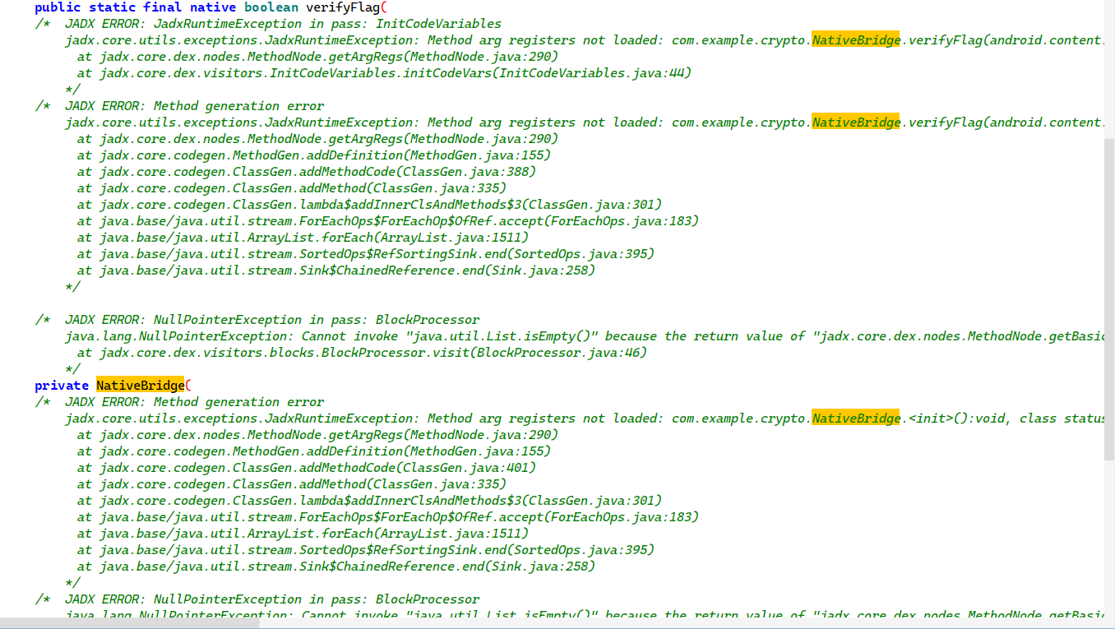
使用 jadx 反编译 APK，查看 Java 层代码。关键类为 com.example.crypto.NativeBridge，其代码如下：

package com.example.crypto;
public final class NativeBridge {
public static final NativeBridge INSTANCE = new NativeBridge();
public static final native boolean verifyFlag(AssetManager assetManager, String flag);
static {
System.loadLibrary("nativecrypto");
}
}
可以看到 verifyFlag 是一个 native 方法，通过 JNI 调用 libnativecrypto.so 中的实现。MainActivity 中使用 Compose 搭建 UI，接收用户输入并调用 verifyFlag 进行校验。

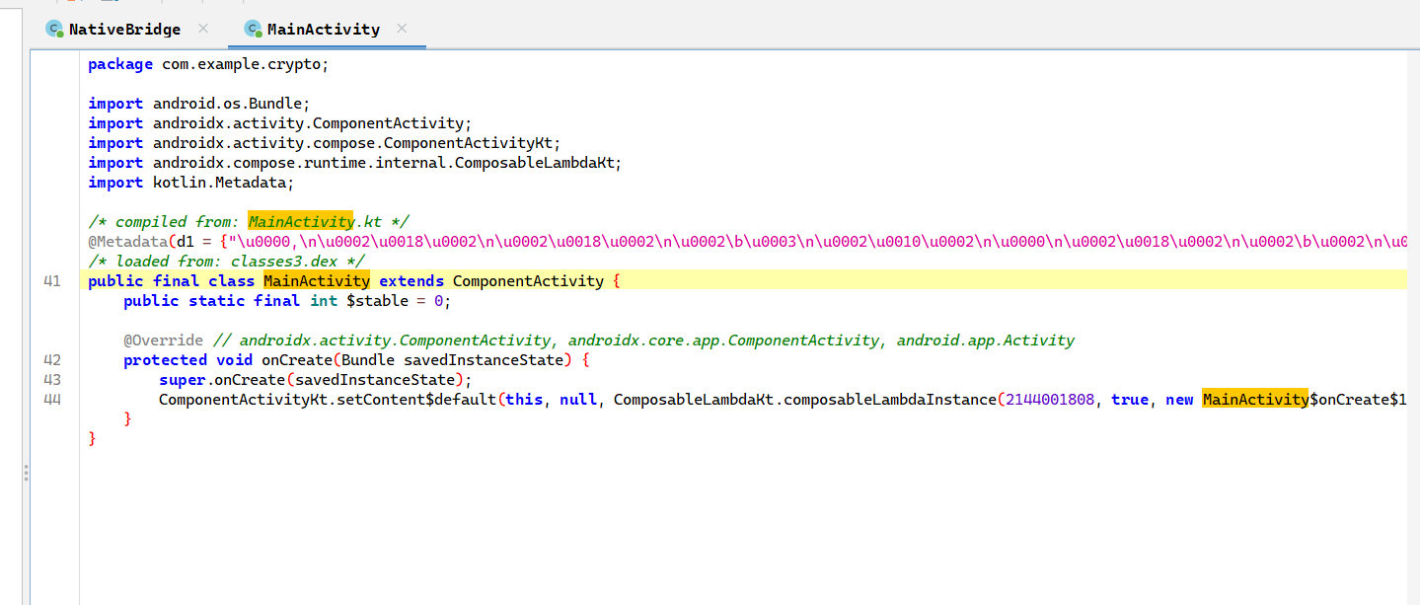

3. 定位 Native 校验函数
使用 IDA Pro 打开 libnativecrypto.so（选择 x86_64 架构），在 Exports 窗口中搜索 verifyFlag 相关的 JNI 导出函数。也可以在命令行中快速验证：
nm -D apk_out/lib/x86_64/libnativecrypto.so | grep Java
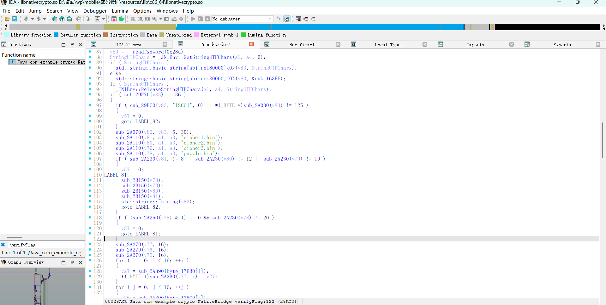
可以看到导出函数名为 Java_com_example_crypto_NativeBridge_verifyFlag。

通过 IDA 分析，校验函数 verifyFlag 的主要逻辑如下：
1. 检查输入是否以 ISCC{ 开头
2. 检查是否以 } 结尾
3. 检查总长度是否为 36（ISCC{ + 30 字节内容 + }）
4. 将花括号内的 30 字节拆分为三段：p1（8字节）、p2（12字节）、p3（10字节）
5. 分别使用三段独立的算法进行校验
6. 在三段之间存在交叉约束验证

4. 从 .rodata 提取三组常量
在 IDA 中查看 .rodata 段，可以找到三组 16 字节的常量。这些常量不是直接使用的，而是先经过一个解码变换：
def decode_byte(b):
return (((b - 0x13) & 0xff) ^ 0x5a) & 0xff
三条常量在 .rodata 中的原始编码为：
raw_C1 = bytes.fromhex("5384792a17483deedb0c01b29fd0b566")
raw_C2 = bytes.fromhex("6e6d6d6d6d6e6d6d6d6d6e6d6d6d6d6e")
raw_C3 = bytes.fromhex("03f4a99a5e8b7c31224f40e5d66db7ca")
经过 decode_byte 解码后还原得到：
C1 = 1a2b3c4d5e6f708192a3b4c5d6e7f809
C2 = 01000000000100000000010000000001
C3 = aabbccdd11223344556677889900feed
这三组常量后续会通过 f1、f2、f3 三个变换生成中间值 v128、v140、v158，分别用于 TEA 密钥、GF(2^8) 矩阵和 LCG 种子。

5. 还原三个变换并计算中间值

变换 f1
f1 将 C1 和 C3 逐字节异或，然后整体循环左移 3 字节：
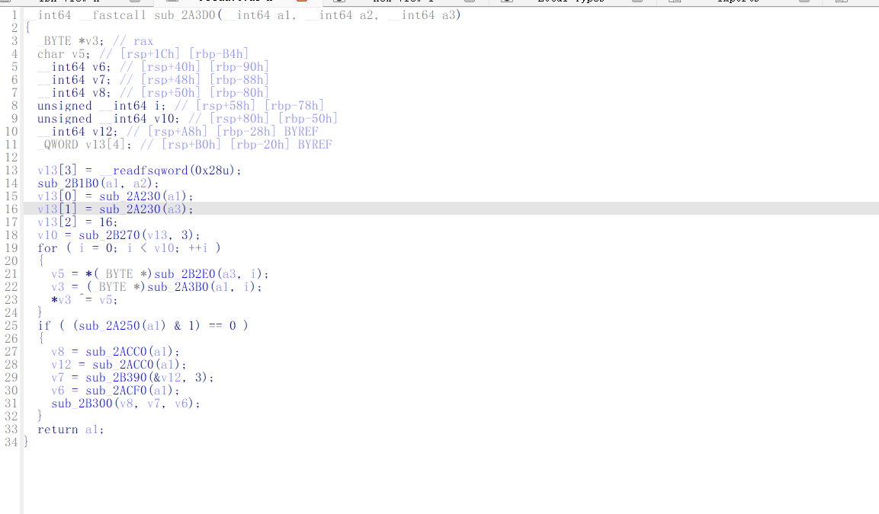
def f1(a, b):
d = bytearray(a)
for i in range(min(len(a), len(b), 16)):
d[i] ^= b[i]
return bytes(d[3:] + d[:3])
v128 = f1(C1, C3) # = 904f4d43c5c7c5c34d4fe706e4b090f0

5.2 GF(2^8) 乘法
native 中实现了一个 GF(2^8) 乘法函数，模多项式为 AES 使用的 0x1b，用于后续的矩阵运算：
def gf(a, b):
a &= 0xff
b &= 0xff
res = 0
while b:
if b & 1:
res ^= a
hi = a & 0x80
a = (a << 1) & 0xff
if hi:
a ^= 0x1b
b >>= 1
return res

变换 f2
f2 是一个 4x4 矩阵乘法，所有运算在 GF(2^8) 上完成。计算完成后还有一个行置换顺序 [2, 3, 0, 1]：
def f2(src1, src2):
tmp = [0] * 16
for row in range(4):
for col in range(4):
v = src2[row * 4 + col]
for k in range(4):
tmp[row * 4 + k] ^= gf(v, src1[col * 4 + k])
order = [2, 3, 0, 1]
out = []
for r in order:
out += tmp[r * 4:r * 4 + 4]
return bytes(out)
v140 = f2(v128, C2) # = 4d4fe706e4b090f0904f4d43c5c7c5c3

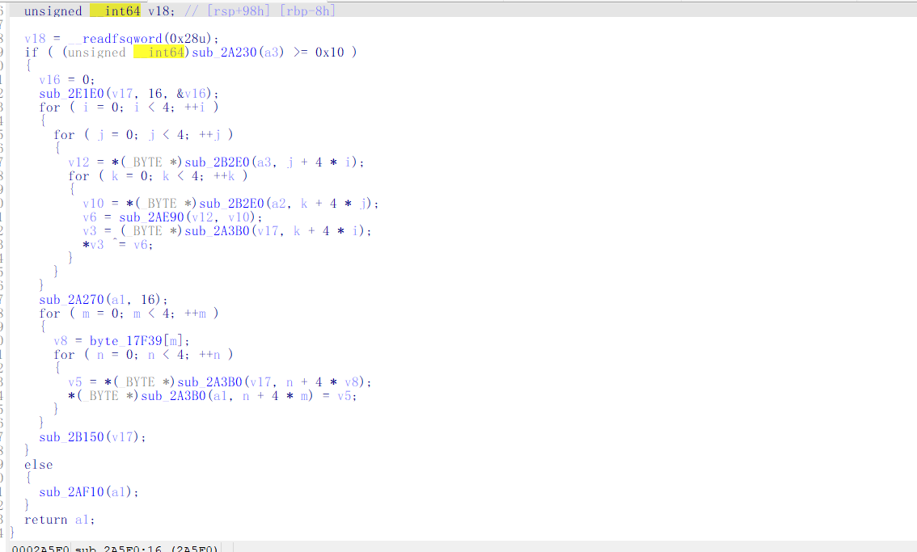

变换 f3
f3 做了三件事：三个输入逐字节异或 → 查 AES S-box → 前缀异或：
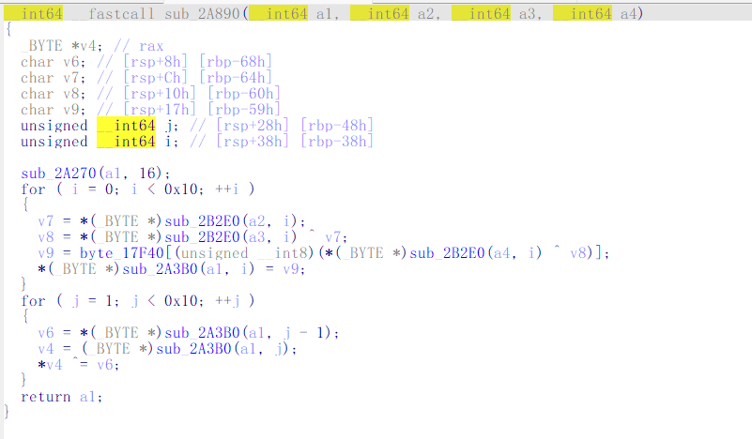
def f3(a, b, c):
out = bytearray(16)
for i in range(16):
out[i] = AES_SBOX[a[i] ^ b[i] ^ c[i]]
for i in range(1, 16):
out[i] ^= out[i - 1]
return bytes(out)
v158 = f3(v128, v140, C3) # = f51f2c6a6e92a15490a362dfb3462439

三个中间值计算结果汇总：
v128 = 904f4d43c5c7c5c34d4fe706e4b090f0 (用于 TEA key)
v140 = 4d4fe706e4b090f0904f4d43c5c7c5c3 (用于 GF 矩阵)
v158 = f51f2c6a6e92a15490a362dfb3462439 (用于 LCG seed + XOR mask)

6. 反解第一段 p1（TEA 解密）
cipher1.bin 是使用 TEA 算法加密的 8 字节密文：
cipher1 = bytes.fromhex("0f06b976e2cd6f21")
TEA 密钥由 v128 按大端序拆分为 4 个 32 位整数：
key = [
0x904f4d43,
0xc5c7c5c3,
0x4d4fe706,
0xe4b090f0,
]
TEA 解密算法实现（16 轮）：
MASK = 0xffffffff
def tea_decrypt(v0, v1, k, rounds=16):
delta = 0x9e3779b9
s = (delta * rounds) & MASK
for _ in range(rounds):
v1 = (v1 - ((((v0 << 4) & MASK) + k[2])
^ ((v0 + s) & MASK)
^ (((v0 >> 5) + k[3]) & MASK))) & MASK
v0 = (v0 - ((((v1 << 4) & MASK) + k[0])
^ ((v1 + s) & MASK)
^ (((v1 >> 5) + k[1]) & MASK))) & MASK
s = (s - delta) & MASK
return v0, v1
TEA 解密后还需要与 v158 的旋转字节进行异或：
ct0 = int.from_bytes(cipher1[:4], "big")
ct1 = int.from_bytes(cipher1[4:], "big")
pt0, pt1 = tea_decrypt(ct0, ct1, key)
x = pt0.to_bytes(4, "big") + pt1.to_bytes(4, "big")
rot = bytes(v158[(i + 1) % 16] for i in range(8))
p1 = bytes(a ^ b for a, b in zip(x, rot))
解密得到 p1 = >/{%v65k（8 字节）
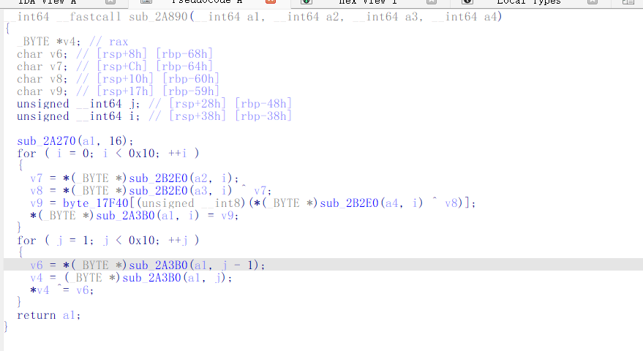

7. 反解第二段 p2（GF(2^8) 矩阵求逆）
cipher2.bin 是 12 字节密文，由 3x4 的输入和 4x4 矩阵在 GF(2^8) 上相乘得到：
cipher2 = bytes.fromhex("2d4b5c2e6da4faa90cee6f18")
# 要求 f4(p2, v140) == cipher2
需要对 4x4 矩阵 v140 求 GF(2^8) 逆矩阵，然后用逆矩阵乘以密文恢复 p2。
GF(2^8) 求逆函数：
def gf_inv(a):
if a == 0:
raise ZeroDivisionError
for x in range(1, 256):
if gf(a, x) == 1:
return x
raise ValueError("no inverse")
4x4 矩阵在 GF(2^8) 上的 Gauss-Jordan 求逆：
def invert_mat4(M):
A = [[M[r * 4 + c] for c in range(4)] for r in range(4)]
inv = [[1 if i == j else 0 for j in range(4)] for i in range(4)]
for col in range(4):
pivot = next(r for r in range(col, 4) if A[r][col])
if pivot != col:
A[col], A[pivot] = A[pivot], A[col]
inv[col], inv[pivot] = inv[pivot], inv[col]
ip = gf_inv(A[col][col])
for j in range(4):
A[col][j] = gf(A[col][j], ip)
inv[col][j] = gf(inv[col][j], ip)
for r in range(4):
if r == col: continue
f = A[r][col]
if f:
for j in range(4):
A[r][j] ^= gf(f, A[col][j])
inv[r][j] ^= gf(f, inv[col][j])
return inv
反解函数和结果：
def inv_f4(cipher, matrix):
inv = invert_mat4(matrix)
out = bytearray()
for row in range(3):
y = cipher[row * 4:row * 4 + 4]
for i in range(4):
acc = 0
for j in range(4):
acc ^= gf(inv[i][j], y[j])
out.append(acc)
return bytes(out)
p2 = inv_f4(cipher2, v140) # = oK7o8^7fo\\e(
得到 p2 = oK7o8^7fo\e(（12 字节）

8. 反解第三段 p3（LCG 流解密）
cipher3.bin 是 10 字节密文，使用 LCG 生成的伪随机流进行异或加密：
cipher3 = bytes.fromhex("bd84f95dd75725b6a0d3")
A = 0x5851f42d4c957f2d
C = 0x14057b7ef767814f
seed 来自 v158 的前 8 字节：
seed = int.from_bytes(v158[:8], "big") # = 0xf51f2c6a6e92a154
PRNG 实现和反解：
def prng(n, seed):
state = seed & ((1 << 64) - 1)
out = []
for _ in range(n):
state = (A * state + C) & ((1 << 64) - 1)
out.append((state >> 24) & 0xff)
return bytes(out)
ks = prng(len(cipher3), seed)
p3 = bytes(a ^ b for a, b in zip(cipher3, ks)) # = F5Z7i0crC#
得到 p3 = F5Z7i0crC#（10 字节）

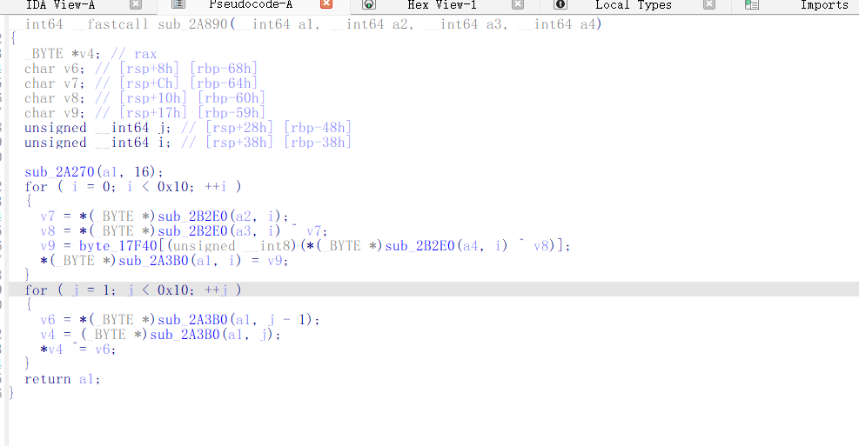

9. 组装 Flag
将三段拼接起来得到完整的 flag：
p1 = b'>/{%v65k' # 8 bytes
p2 = b'oK7o8^7fo\\e(' # 12 bytes
p3 = b'F5Z7i0crC#' # 10 bytes
flag = b"ISCC{" + p1 + p2 + p3 + b"}"
最终 flag：
ISCC{>/{%v65koK7o8^7fo\e(F5Z7i0crC#}

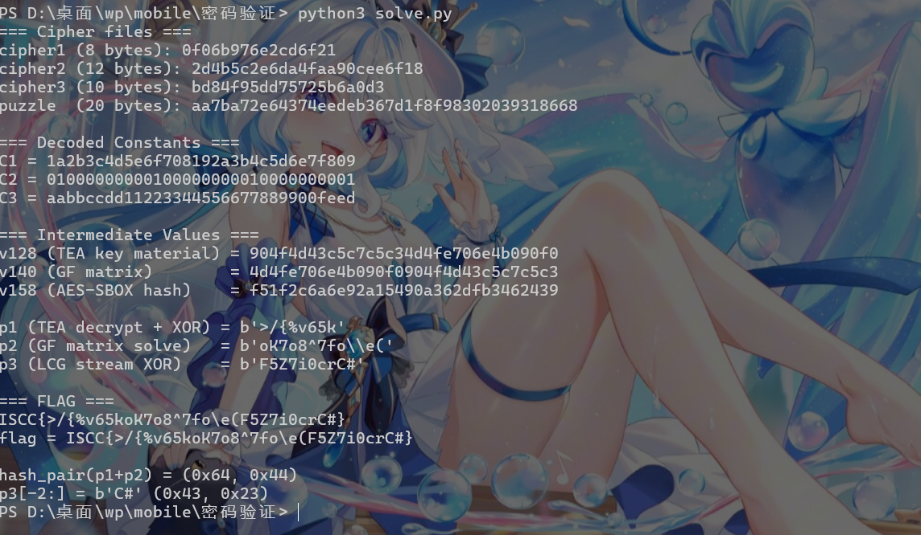
10. 交叉约束验证
native 代码中除了三段独立校验外，还有交叉约束确保三段数据之间的关联性。
其中一个是 hash_pair 校验，对 p1 + p2 计算哈希后映射得到 p3 的最后两个字符：
def hash_pair(data):
x = 0
s = 0
for b in data:
x ^= b
s = (s + b) & 0xff
return x, s
hx, hs = hash_pair(p1 + p2)
# hx = 0x64, hs = 0x44
# p3[-2:] = b'C#' = (0x43, 0x23)

11. 完整解题脚本

MASK = 0xffffffff

def decode_byte(b):
"""Decode .rodata constants: reverse of the simple XOR+SUB encoding"""
return (((b - 0x13) & 0xff) ^ 0x5a) & 0xff

def gf(a, b):
"""GF(2^8) multiplication with AES irreducible poly 0x1b"""
a &= 0xff
b &= 0xff
res = 0
while b:
if b & 1:
res ^= a
hi = a & 0x80
a = (a << 1) & 0xff
if hi:
a ^= 0x1b
b >>= 1
return res

def f1(a, b):
"""C1 XOR C3, then rotate left by 3 bytes"""
d = bytearray(a)
for i in range(min(len(a), len(b), 16)):
d[i] ^= b[i]
return bytes(d[3:] + d[:3])

def f2(src1, src2):
"""
4x4 GF(2^8) matrix multiplication
src2 acts as the matrix (row-major), src1 as the operand
Final row permutation: [2, 3, 0, 1]
"""
tmp = [0] * 16
for row in range(4):
for col in range(4):
v = src2[row * 4 + col]
for k in range(4):
tmp[row * 4 + k] ^= gf(v, src1[col * 4 + k])
order = [2, 3, 0, 1]
out = []
for r in order:
out += tmp[r * 4:r * 4 + 4]
return bytes(out)

AES_SBOX = bytes.fromhex(
"637c777bf26b6fc53001672bfed7ab76ca82c97dfa5947f0add4a2af9ca472c0"
"b7fd9326363ff7cc34a5e5f171d8311504c723c31896059a071280e2eb27b275"
"09832c1a1b6e5aa0523bd6b329e32f8453d100ed20fcb15b6acbbe394a4c58cf"
"d0efaafb434d338545f9027f503c9fa851a3408f929d38f5bcb6da2110fff3d2"
"cd0c13ec5f974417c4a77e3d645d197360814fdc222a908846eeb814de5e0bdb"
"e0323a0a4906245cc2d3ac629195e479e7c8376d8dd54ea96c56f4ea657aae08"
"ba78252e1ca6b4c6e8dd741f4bbd8b8a703eb5664803f60e613557b986c11d9e"
"e1f8981169d98e949b1e87e9ce5528df8ca1890dbfe6426841992d0fb054bb16"
)

def f3(a, b, c):
"""XOR three inputs, apply AES S-box, then prefix XOR"""
out = bytearray(16)
for i in range(16):
out[i] = AES_SBOX[a[i] ^ b[i] ^ c[i]]
for i in range(1, 16):
out[i] ^= out[i - 1]
return bytes(out)

def tea_decrypt(v0, v1, k, rounds=16):
"""TEA decryption with 16 rounds"""
delta = 0x9e3779b9
s = (delta * rounds) & MASK
for _ in range(rounds):
v1 = (v1 - ((((v0 << 4) & MASK) + k[2])
^ ((v0 + s) & MASK)
^ (((v0 >> 5) + k[3]) & MASK))) & MASK
v0 = (v0 - ((((v1 << 4) & MASK) + k[0])
^ ((v1 + s) & MASK)
^ (((v1 >> 5) + k[1]) & MASK))) & MASK
s = (s - delta) & MASK
return v0, v1

def gf_inv(a):
"""GF(2^8) multiplicative inverse"""
if a == 0:
raise ZeroDivisionError
for x in range(1, 256):
if gf(a, x) == 1:
return x
raise ValueError("no inverse")

def invert_mat4(M):
"""Invert a 4x4 matrix in GF(2^8) using Gauss-Jordan elimination"""
A = [[M[r * 4 + c] for c in range(4)] for r in range(4)]
inv = [[1 if i == j else 0 for j in range(4)] for i in range(4)]

for col in range(4):
pivot = None
for r in range(col, 4):
if A[r][col]:
pivot = r
break
if pivot is None:
raise ValueError("singular matrix")
if pivot != col:
A[col], A[pivot] = A[pivot], A[col]
inv[col], inv[pivot] = inv[pivot], inv[col]

inv_pivot = gf_inv(A[col][col])
for j in range(4):
A[col][j] = gf(A[col][j], inv_pivot)
inv[col][j] = gf(inv[col][j], inv_pivot)

for r in range(4):
if r == col:
continue
factor = A[r][col]
if factor:
for j in range(4):
A[r][j] ^= gf(factor, A[col][j])
inv[r][j] ^= gf(factor, inv[col][j])

return inv

def inv_f4(cipher, matrix):
"""
Reverse of f4: given output Y and matrix M, find X where Y = M * X
Each row: y_row = matrix * x_row (all in GF(2^8))
"""
inv = invert_mat4(matrix)
out = bytearray()
for row in range(3):
y = cipher[row * 4:row * 4 + 4]
x = []
for i in range(4):
acc = 0
for j in range(4):
acc ^= gf(inv[i][j], y[j])
x.append(acc)
out += bytes(x)
return bytes(out)

def prng(n, seed):
"""LCG-based PRNG: generates n bytes of pseudo-random stream"""
state = seed & ((1 << 64) - 1)
A = 0x5851f42d4c957f2d
C = 0x14057b7ef767814f
out = []
for _ in range(n):
state = (A * state + C) & ((1 << 64) - 1)
out.append((state >> 24) & 0xff)
return bytes(out)

# ============================================================
# MAIN SOLVE
# ============================================================

# Read cipher files from assets
import pathlib
ASSETS = pathlib.Path("D:/桌面/wp/mobile/密码验证/resources/assets")

cipher1 = (ASSETS / "cipher1.bin").read_bytes()
cipher2 = (ASSETS / "cipher2.bin").read_bytes()
cipher3 = (ASSETS / "cipher3.bin").read_bytes()
puzzle = (ASSETS / "puzzle.bin").read_bytes()

print("=== Cipher files ===")
print(f"cipher1 ({len(cipher1)} bytes): {cipher1.hex()}")
print(f"cipher2 ({len(cipher2)} bytes): {cipher2.hex()}")
print(f"cipher3 ({len(cipher3)} bytes): {cipher3.hex()}")
print(f"puzzle ({len(puzzle)} bytes): {puzzle.hex()}")

# Step 1: Constants from .rodata (encoded, then decoded)
raw_C1 = bytes.fromhex("5384792a17483deedb0c01b29fd0b566")
raw_C2 = bytes.fromhex("6e6d6d6d6d6e6d6d6d6d6e6d6d6d6d6e")
raw_C3 = bytes.fromhex("03f4a99a5e8b7c31224f40e5d66db7ca")

C1 = bytes(decode_byte(b) for b in raw_C1)
C2 = bytes(decode_byte(b) for b in raw_C2)
C3 = bytes(decode_byte(b) for b in raw_C3)

print(f"\n=== Decoded Constants ===")
print(f"C1 = {C1.hex()}")
print(f"C2 = {C2.hex()}")
print(f"C3 = {C3.hex()}")

# Step 2: Compute intermediate values
v128 = f1(C1, C3)
v140 = f2(v128, C2)
v158 = f3(v128, v140, C3)

print(f"\n=== Intermediate Values ===")
print(f"v128 (TEA key material) = {v128.hex()}")
print(f"v140 (GF matrix) = {v140.hex()}")
print(f"v158 (AES-SBOX hash) = {v158.hex()}")

# Step 3: Solve p1 (TEA decryption + XOR with v158 rotation)
key = [int.from_bytes(v128[i * 4:(i + 1) * 4], "big") for i in range(4)]

ct0 = int.from_bytes(cipher1[:4], "big")
ct1 = int.from_bytes(cipher1[4:], "big")
pt0, pt1 = tea_decrypt(ct0, ct1, key)

x = pt0.to_bytes(4, "big") + pt1.to_bytes(4, "big")
rot = bytes(v158[(i + 1) % 16] for i in range(8))
p1 = bytes(a ^ b for a, b in zip(x, rot))
print(f"\np1 (TEA decrypt + XOR) = {p1}")

# Step 4: Solve p2 (GF(2^8) matrix inversion)
p2 = inv_f4(cipher2, v140)
print(f"p2 (GF matrix solve) = {p2}")

# Step 5: Solve p3 (LCG PRNG stream XOR)
seed = int.from_bytes(v158[:8], "big")
ks = prng(len(cipher3), seed)
p3 = bytes(a ^ b for a, b in zip(cipher3, ks))
print(f"p3 (LCG stream XOR) = {p3}")

# Step 6: Construct flag
flag = b"ISCC{" + p1 + p2 + p3 + b"}"
print(f"\n=== FLAG ===")
print(f"ISCC{{{p1.decode()}{p2.decode()}{p3.decode()}}}")
print(f"flag = {flag.decode()}")

# Verify lengths
assert len(p1) == 8
assert len(p2) == 12
assert len(p3) == 10
assert len(flag) == 5 + 30 + 1 # ISCC{ + 30 chars + }

# Cross-constraint check: hash_pair(p1+p2)
def hash_pair(data):
x = 0
s = 0
for b in data:
x ^= b
s = (s + b) & 0xff
return x, s

hx, hs = hash_pair(p1 + p2)
print(f"\nhash_pair(p1+p2) = (0x{hx:02x}, 0x{hs:02x})")
print(f"p3[-2:] = {p3[-2:]} (0x{p3[-2]:02x}, 0x{p3[-1]:02x})")
运行结果：
FLAG: ISCC{>/{%v65koK7o8^7fo\e(F5Z7i0crC#}

