Writeup灰签名回廊mobile

1.题目
APK 主包 com.example.gnd，核心校验在 SecureValidator 中，底层由 libnative-verify.so 通过 JNI 完成。无加固。资源文件中有假 flag。
Flag 结构：ISCC{ + part1(7) + part2(5) + part3(5) + part4(7) + }，内部共 24 字符。
四段依次经过：JNI nativeVerifyPart1 → nativeVerifyPart2（关联 ContentProvider fragment2）→ nativeVerifyPart3（关联 BroadcastReceiver fragment3）→ nativeVerifyPart4（含 RC4 + 位运算 + 最终 SHA-256）。前三段通过后生成的 chain token 是第四段 RC4 密钥来源。

2. 三段 Fragment 获取

2.1 ContentProvider → fragment2
ContentProvider 的 authority 为 "com.example.gnd.secret.provider"，路径 "keys/fragment"。{109, 65, 125, 78} 异或 23 得 "zVjY"，经自定义 Base64 解码后得到最终的 fragment2 字节，用作 part2 校验和 chain token 计算。
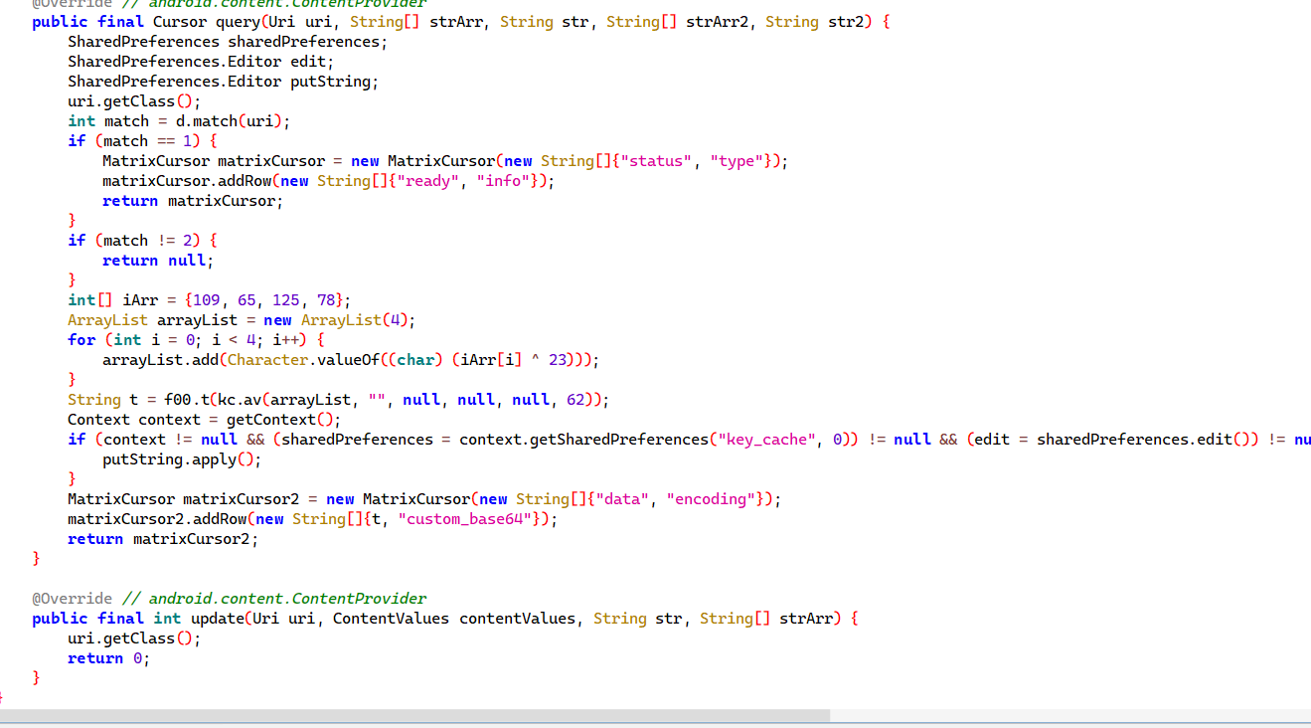

2.2 BroadcastReceiver → fragment3
SecretReceiver 监听 "com.example.gnd.SECRET_ACTION"。触发：先发 auth 广播（code=auth, token=ISCC2026），5 分钟内发送 getkey 广播（code=getkey, part=3）。得到 "Mzuy"，自定义 Base64 解码后作为 fragment3。

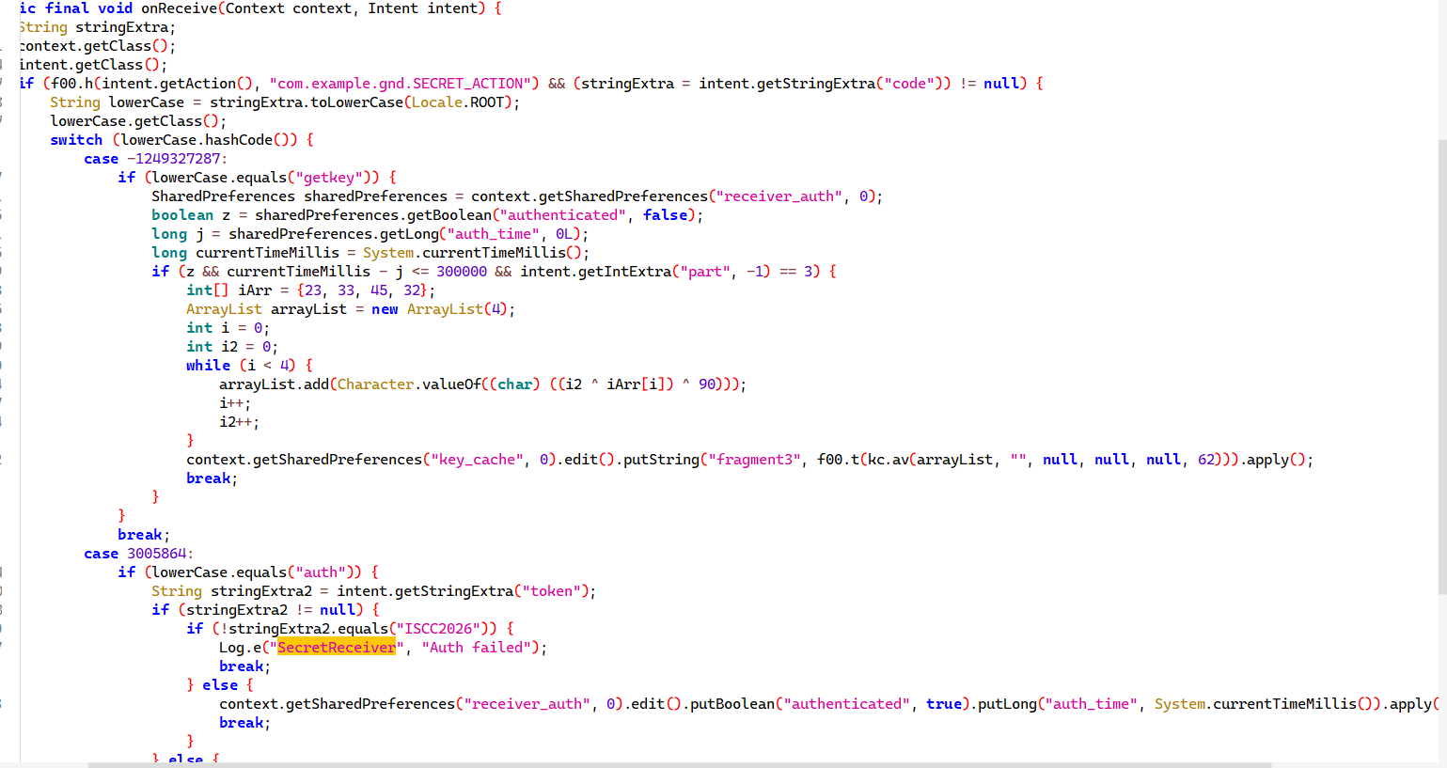

2.3 DeepLink Activity → fragment4
SecretActivity 通过 DeepLink 唤醒：securevault://secret/unlock?token=RC4_KEY_PART4。成功后从 "ISCC202FK" 取最后两字符 "FK" 作为 fragment4。

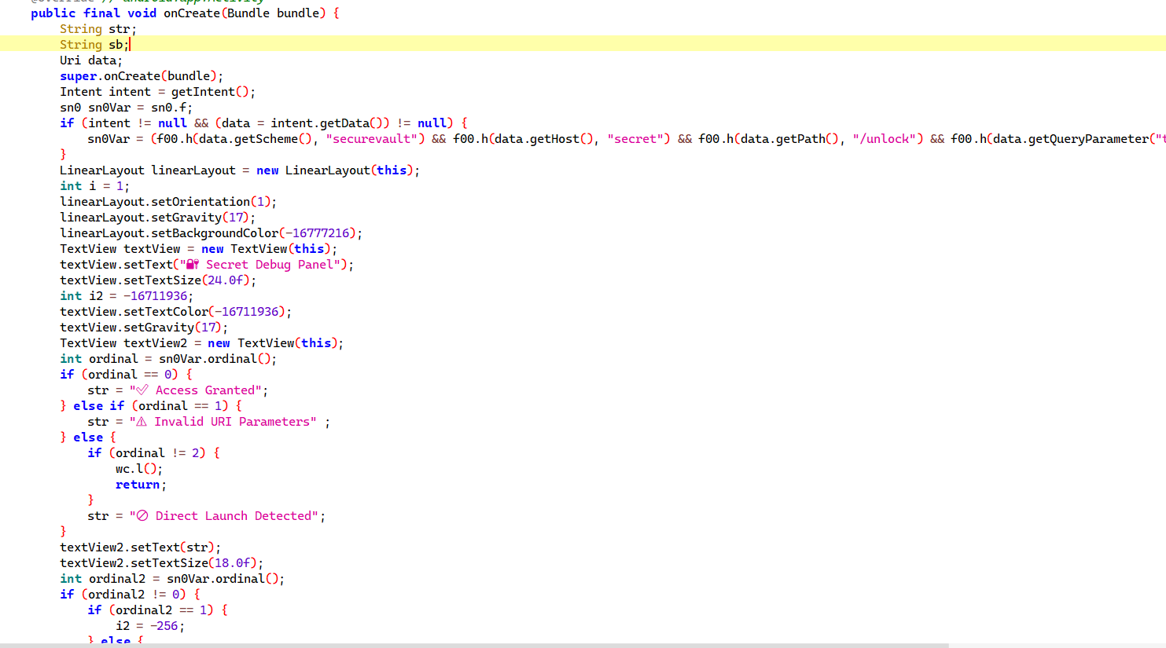

2.4 自定义 Base64
ContentProvider 和 Receiver 存入 key_cache 前使用自定义 Base64 编码，字母表反转。

3. Native 层逆向分析

3.1 nativeVerifyPart1 → part1 = "bgEXwK2"
SecureValidator 中静态 fill_array = {100, 111, 65, 94, 127, 75, 52}。a(sigHash) = fill_array XOR sigHash。native 变换为 ((ch + 1) ^ 7) XOR sigHash，两者相等，推导：
part1[i] = (fill_array[i] ^ 7) - 1
= "bgEXwK2"
注意：传入 chain 计算的不是 part1 明文，而是 nativeVerifyPart1 的返回值 （fill_array XOR sigHash），否则 chain 算错导致 RC4 密钥对不上。

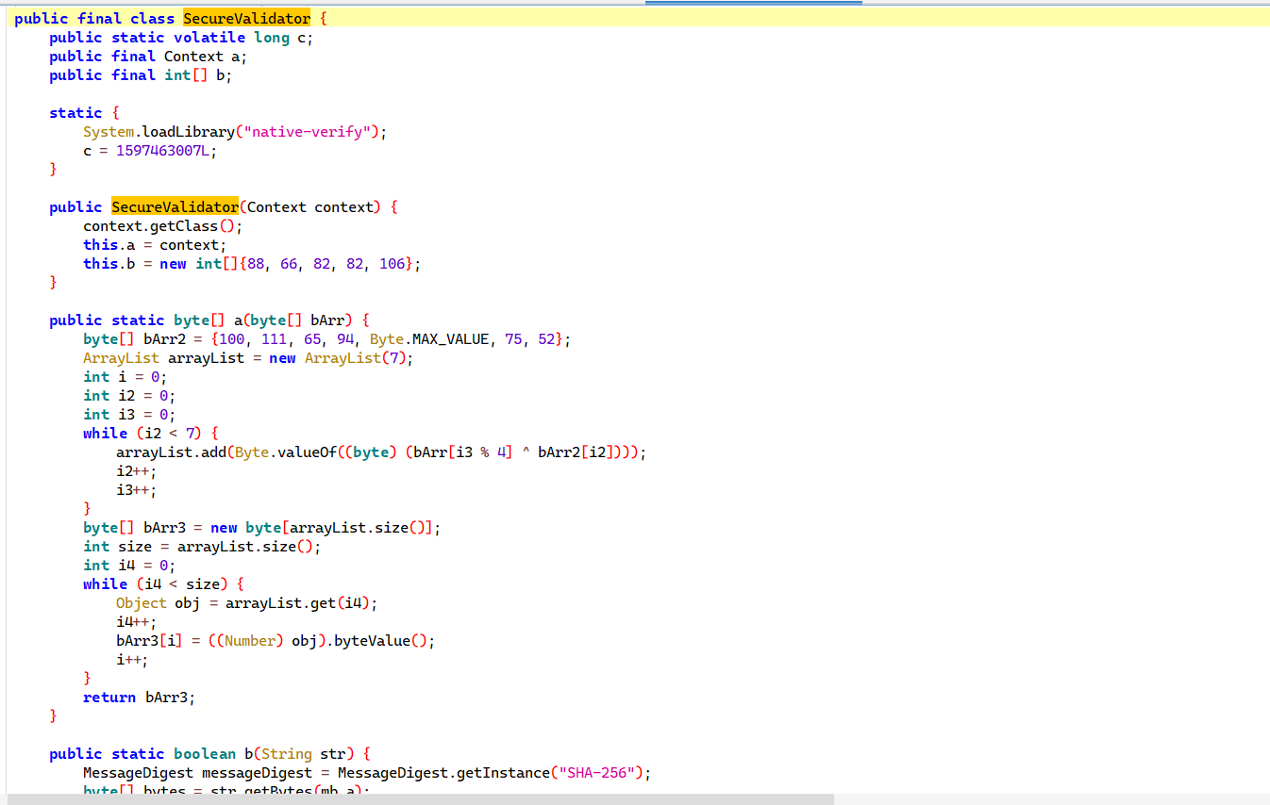

3.2 nativeVerifyPart2 → part2 = "_C2hS"
fragment2 字节与 part2 做异或旋转校验。从 IDA 提取常数 0x31581529 和 0x25：
part2[0] = fragment2[0] ^ 0x25
part2[1] = fragment2[1] ^ 0x15
part2[2] = fragment2[2] ^ 0x58
part2[3] = fragment2[3] ^ 0x31
part2[4] = fragment2[0] ^ 0x29
fragment2 = "zVjY" = [0x7A, 0x56, 0x6A, 0x59]，计算得 part2 = "_C2hS"。

3.3 nativeVerifyPart3 → part3 = "_qmPf"
fragment3 字节顺序参与加法校验。IDA 提取比较常量为 0xCCC2E9E2 和 0x93。part3[i] 先异或 0x19，再与 fragment3 对应字节相加，结果匹配常量。
part3[0] = (0x93 - fragment3[0]) ^ 0x19
part3[1] = (0xE2 - fragment3[1]) ^ 0x19
part3[2] = (0xE9 - fragment3[2]) ^ 0x19
part3[3] = (0xC2 - fragment3[3]) ^ 0x19
part3[4] = (0xCC - fragment3[0]) ^ 0x19
fragment3 = "Mzuy" = [0x4D, 0x7A, 0x75, 0x79]，计算得 part3 = "_qmPf"。

3.4 nativeComputeChainToken — 生成 chain
三次调用生成链式 token：
chain = compute_chain(1, seed=1597463007, nativeVerifyPart1_return)
chain = compute_chain(2, chain, fragment2_bytes)
chain = compute_chain(3, chain, fragment3_bytes)

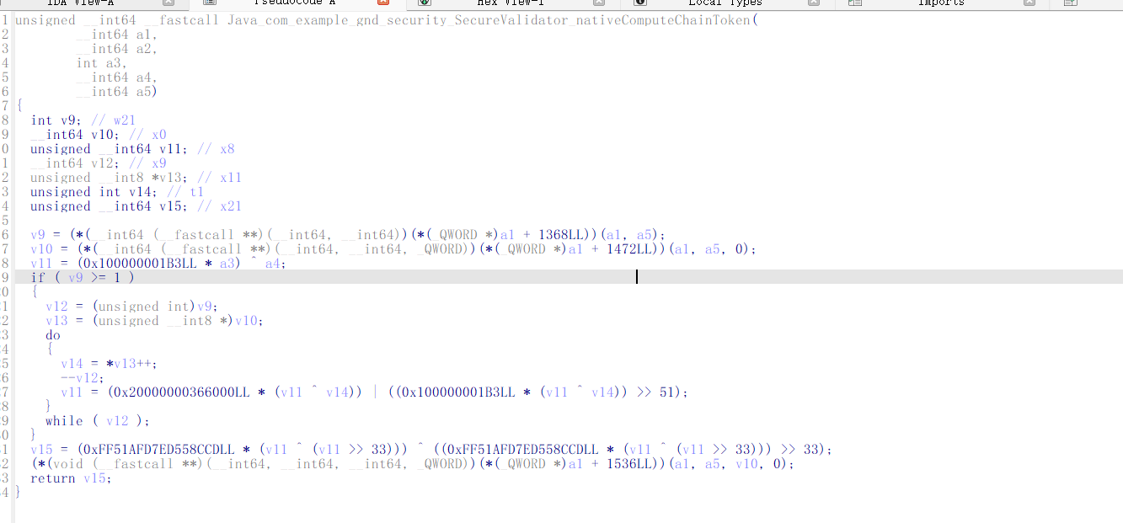

3.5 nativeVerifyPart4 — RC4 + 位运算 + SHA-256
构造 14 字节 RC4 密钥：
key[0:4] = chain_low32 XOR "Secu"
key[4:8] = fragment2_bytes = "zVjY"
key[8:12] = fragment3_bytes = "Mzuy"
key[12:14] = fragment4 XOR tail_const = FK XOR FK = [0, 0]
RC4 输出前 4 字节 keystream 后，对 part4 前 4 字符做位运算校验：
value = (((d2 ^ (d1 << 3) ^ (d0 << 6)) << 12) ^ (d3 << 9)) & 0x3FF0000
value == 0x01A00000

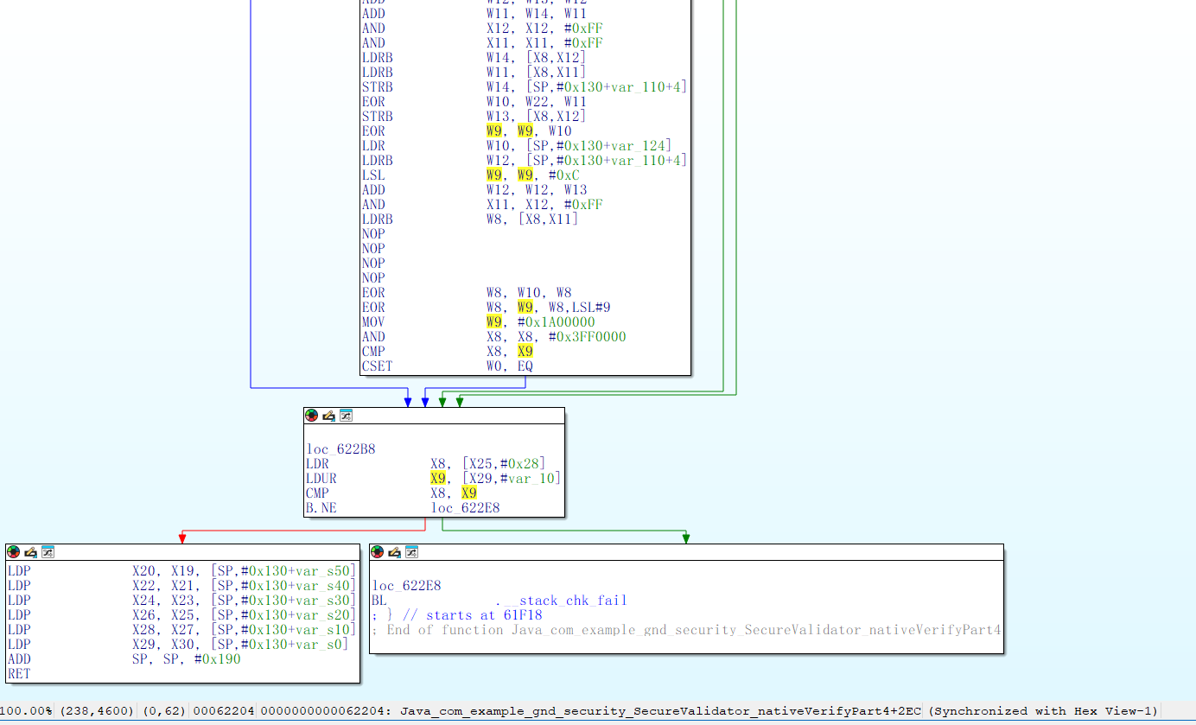
运行脚本得到
sig_哈希 = 133415c3f8aad739be8d0df905481208aa7448da7254a474028eeeddfc2849af
目标 = 61520ee3d9b7ff6c50cc9ac7c46989408b1c31404d5c201ba717140c3c89c388
prefix = b'ISCC{bgEXwK2_C2hS_qmPf'
链 = 0x77f95221313f5f7c
ks = 377ddb82
ISCC{bgEXwK2_C2hS_qmPf_icZQXg}
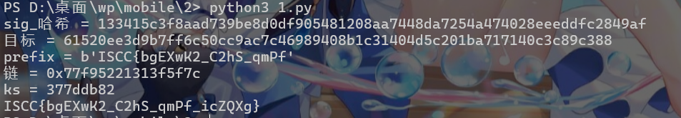

4. 解题脚本
#!/usr/bin/env python3
import hashlib, itertools, multiprocessing, re, struct, sys, zipfile
from pathlib import Path

def rol64(x, b):
x &= 0xffffffffffffffff
return ((x << b) & 0xffffffffffffffff) | (x >> (64 - b))

def compute_chain(part, seed, data):
prime = 0x100000001B3
v = (seed ^ ((part * prime) & 0xffffffffffffffff)) & 0xffffffffffffffff
for bb in data:
v = rol64(((v ^ bb) * prime) & 0xffffffffffffffff, 13)
v = (v ^ (v >> 33)) & 0xffffffffffffffff
v = (v * 0xFF51AFD7ED558CCD) & 0xffffffffffffffff
v = (v ^ (v >> 33)) & 0xffffffffffffffff
return v

def rc4_stream(key, n):
s = list(range(256)); j = 0
for i in range(256):
j = (j + s[i] + key[i % len(key)]) & 0xff
s[i], s[j] = s[j], s[i]
i = j = 0; out = []
for _ in range(n):
i = (i + 1) & 0xff; j = (j + s[i]) & 0xff
s[i], s[j] = s[j], s[i]
out.append(s[(s[i] + s[j]) & 0xff])
return bytes(out)

def read_u32(buf, off):
return struct.unpack_from("<I", buf, off)[0]

def read_u64(buf, off):
return struct.unpack_from("<Q", buf, off)[0]

def read_lv(buf, off):
size = read_u32(buf, off)
off += 4
return buf[off:off + size], off + size

def extract_v2_cert_sha256(apk_data):
eocd = apk_data.rfind(b"PK\x05\x06")
if eocd < 0: raise ValueError("EOCD not found")
central_dir_off = read_u32(apk_data, eocd + 16)
if apk_data[central_dir_off - 16:central_dir_off] != b"APK Sig Block 42":
raise ValueError("APK Signing Block没有找到")
size2 = read_u64(apk_data, central_dir_off - 24)
block_start = central_dir_off - size2 - 8
off = block_start + 8
end = central_dir_off - 24
v2_block = None
while off < end:
pair_size = read_u64(apk_data, off)
off += 8
pair_id = read_u32(apk_data, off)
off += 4
value = apk_data[off:off + pair_size - 4]
off += pair_size - 4
if pair_id == 0x7109871A:
v2_block = value; break
if v2_block is None: raise ValueError("APKv2签名block没有找到")
signers, _ = read_lv(v2_block, 0)
signer, _ = read_lv(signers, 0)
signed_data, off = read_lv(signer, 0)
_digests, off = read_lv(signed_data, 0)
certs, off = read_lv(signed_data, off)
cert, _ = read_lv(certs, 0)
return hashlib.sha256(cert).digest()

def extract_target_hash(apk_path):
with zipfile.ZipFile(apk_path) as z:
for name in z.namelist():
if name.endswith(".dex"):
for m in re.findall(rb"[0-9a-f]{64}", z.read(name)):
h = m.decode()
if h != "0" * 64: return h
return None

WD = None
def init_wd(*a): global WD; WD = a

def worker(fc):
prefix, target, charset, ks = WD
base = hashlib.sha256(); base.update(prefix)
s0 = ord("_")
for c2 in charset:
for c3 in charset:
sf = bytes([s0, ord(fc), ord(c2), ord(c3)])
d0, d1, d2, d3 = [sf[i] ^ ks[i] for i in range(4)]
v = (((d2 ^ (d1 << 3) ^ (d0 << 6)) << 12) ^ (d3 << 9)) & 0x3ff0000
if v != 0x1a00000: continue
st = base.copy(); st.update(sf)
for t in itertools.product(charset, repeat=3):
h = st.copy(); h.update("".join(t).encode() + b"}")
if h.hexdigest() == target: return (prefix + sf + "".join(t).encode() + b"}").decode()
return None

def solve(apk_path):
import sys
sig = extract_v2_cert_sha256(Path(apk_path).read_bytes())
target = extract_target_hash(apk_path)
print(f"sig_哈希 = {sig.hex()}", file=sys.stderr)
print(f"目标 = {target}", file=sys.stderr)
fill = bytes([100, 111, 65, 94, 127, 75, 52])
p1 = bytes(((b ^ 7) - 1) & 0xff for b in fill)
np1 = bytes(fill[i] ^ sig[i % 4] for i in range(7))
f2 = bytes([109^23, 65^23, 125^23, 78^23])
f3 = bytes([0^23^90, 1^33^90, 2^45^90, 3^32^90])
f4 = b"FK"
p2 = bytes([f2[0]^0x25, f2[1]^0x15, f2[2]^0x58, f2[3]^0x31, f2[0]^0x29])
p3 = bytes([(0x93-f3[0])&0xff^0x19, (0xE2-f3[1])&0xff^0x19,
(0xE9-f3[2])&0xff^0x19, (0xC2-f3[3])&0xff^0x19,
(0xCC-f3[0])&0xff^0x19])
prefix = b"ISCC{" + p1 + p2 + p3
print(f"prefix = {prefix}", file=sys.stderr)
chain = compute_chain(3, compute_chain(2, compute_chain(1, 1597463007, np1), f2), f3)
low = chain & 0xffffffff
key = bytearray(14)
for i, ch in enumerate(b"Secu"): key[i] = ((low >> (8*i)) & 0xff) ^ ch
key[4:8] = f2; key[8:12] = f3
key[12] = f4[0] ^ 0x46; key[13] = f4[1] ^ 0x4b
ks = rc4_stream(bytes(key), 4)
print(f"链 = {hex(chain)}", file=sys.stderr)
print(f"ks = {ks.hex()}", file=sys.stderr)
charset = "0123456789abcdefghijklmnopqrstuvwxyzABCDEFGHIJKLMNOPQRSTUVWXYZ_"
with multiprocessing.Pool(initializer=init_wd,
initargs=(prefix, target, charset, ks)) as pool:
for r in pool.imap_unordered(worker, charset, 1):
if r: pool.terminate(); return r

if __name__ == "__main__":
import os
path = sys.argv[1] if len(sys.argv) > 1 else "attachment-68.apk"
if not os.path.exists(path):
path = "attachment.apk"
if not os.path.exists(path):
for f in os.listdir("."):
if f.endswith(".apk"):
path = f; break
print(solve(path))

