ISCC 2026 WriteUp蔡文姬的胡笳琴音波谜阵mobile
：zerotwo

解题思路
- 分析

拖进jadx,APK 里还有 lib/arm64-v8a/libmobile04.so 这个原生库，说明核心校验逻辑在 native 代码中。包名是 com.example.mobile04。
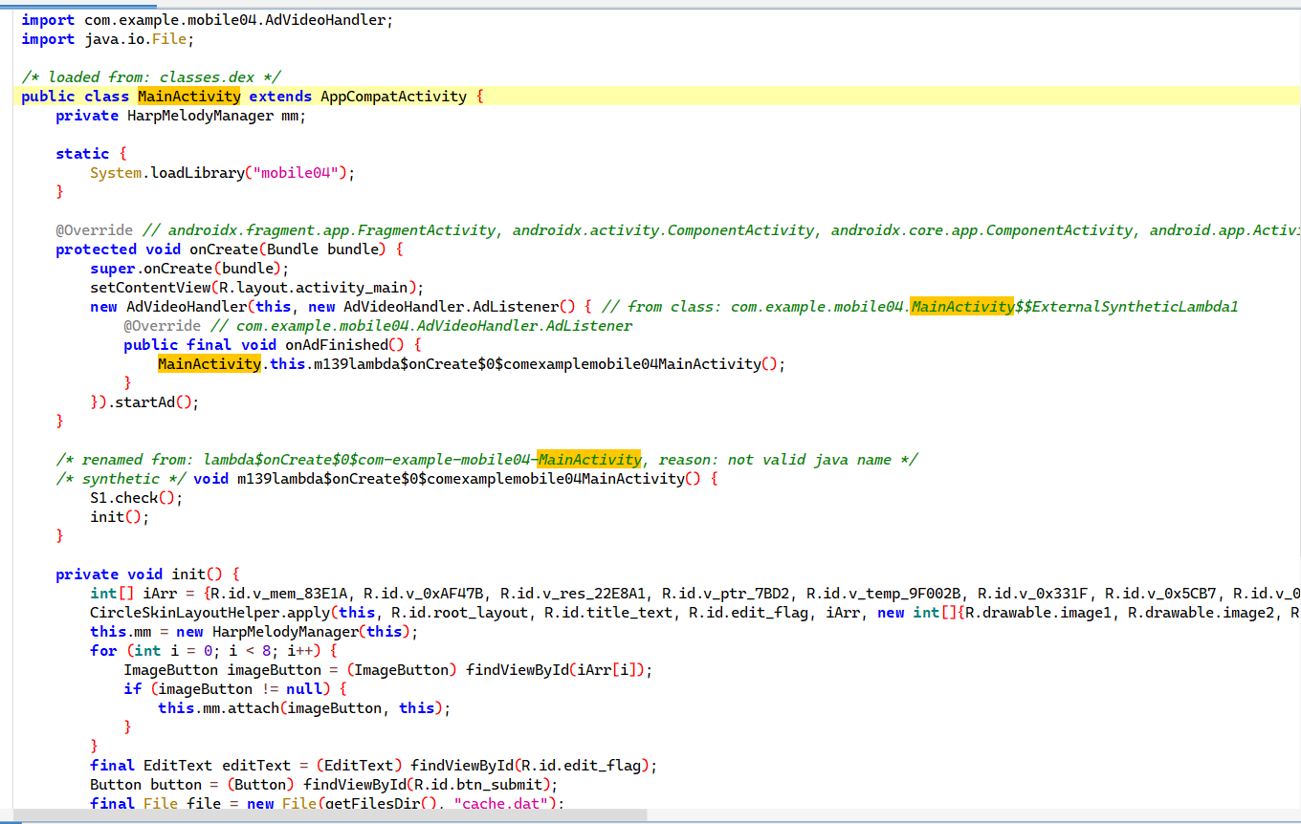

2. 皮肤与音高序列
在 com.example.mobile04 包下有个 HarpMelodyManager 类，构造函数里依次注册了 8 个皮肤。每个皮肤在创建时都分配了一个代号和一个 float 类型的频率值：
FLOW -> 329.6 Hz
CWJ -> 261.6 Hz
ROSE -> 392.0 Hz
XMAS -> 293.7 Hz
STAR -> 349.2 Hz
GOAL -> 440.0 Hz
MAGI -> 523.3 Hz
DANCE -> 493.9 Hz
题目提到"宫商角徵羽等古乐音阶"，按音高排列。所以正确的点按顺序应该把频率最低的 CWJ 放最前面，然后依次升高到最高的 MAGI：
CWJ (261.6 Hz) 宫
XMAS (293.7 Hz) 商
FLOW (329.6 Hz) 角
STAR (349.2 Hz) 变徵
ROSE (392.0 Hz) 徵
GOAL (440.0 Hz) 羽
DANCE (493.9 Hz) 变宫
MAGI (523.3 Hz) 少宫
按此顺序拼接：CWJXMASFLOWSTARROSEGOALDANCEMAGI，刚好 32 个字符。

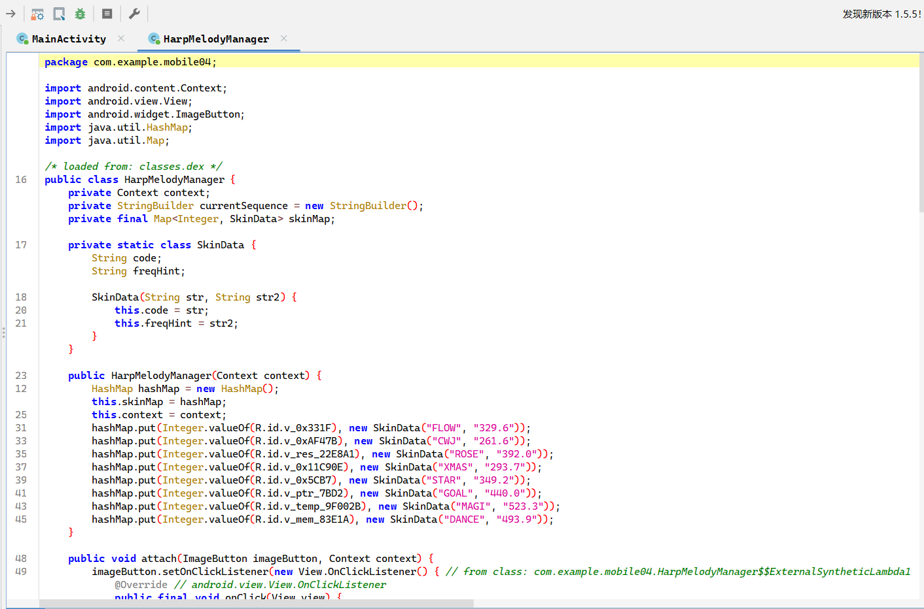

3. Tag 生成
用户输入 ISCC{} 格式字符串后，程序截取中间 32 字节调用 E1.v() 计算 tag。
String input = editText.getText().toString().trim();
if (input.startsWith("ISCC{") && input.endsWith("}")) {
String body = input.substring(5, input.length() - 1);
String tag = E1.v(input);
boolean result = E1.callNative(cachePath, tag, body);
}
E1.v() 流程：对序列每个字节做相邻 bit 交换；(b & 0x55) << 1 | (b & 0xAA) >> 1 → 然后做 FNV-1a 64 位哈希 → 拆成低 32 / 高 32 → 用 K1.g() + Z1.d() 派生的 4 个密钥做 32 轮 TEA 加密 → 结果打包 8 字节再算 CRC32 → 组装为 "cw:xxxxxxxxxxxxxxxx:xxxxxxxx"。

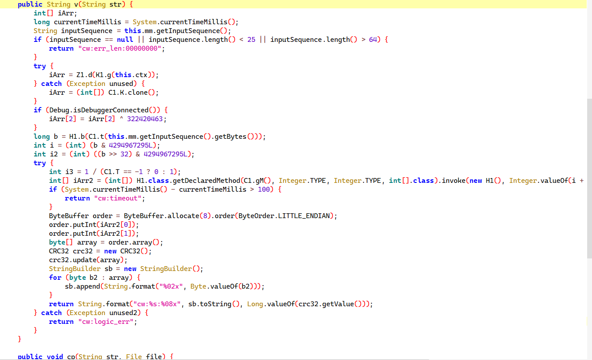

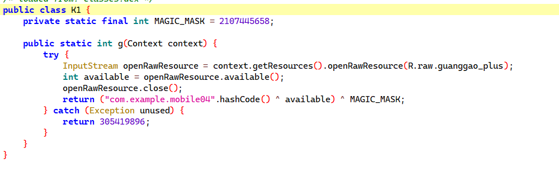
K1.g() 对包名做 hashCode()，异或视频文件大小 77055908，再异或魔术掩码 0x7D9D119A 得到种子。种子传给 native Z1.d() 异或 4 个硬编码常量得到 TEA 密钥。

4. 原生函数逆向
用 IDA 打开 libmobile04.so (arm64-v8a)。从 Exports 找到 _n_impl 函数。函数开头校验 body 长度是否为 32：
bl Java_java_lang_String_length
cmp x0, #0x20
b.ne loc_630B8

5. appview_cache.db 加密
assets/appview_cache.db 被异或加密。解密：读文件前 16 字节，计算 CRC32(tag + first16) 作为 crc_key，逐字节异或：
decrypted[i] = encrypted[i] ^ (((crc_key >> ((i * 8) & 0x18)) + i) & 0xFF)
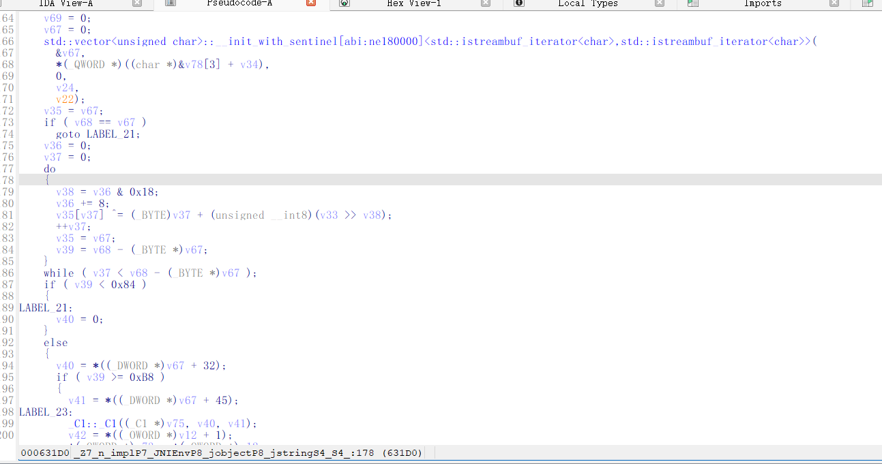
用正确 tag 解密后文件头变为 "SQLite format 3"。提取两个种子：偏移 0x80 → 0xA2AA216A (seed1)，偏移 0xB4 → 0x5B74C718 (seed2)。

6. 提取 RC6 加密参数
在 IDA 的 .rodata 段找到字符串常量：
_K1 = "WIrQW"
_K2 = "Vmy0s5bla5&kzFpf"
_TGT = "2dAvRgJZsh1EiQ5DtrJiaLL9gp81z71ZMFGecH3BN3F2"
_K2 的 16 字节构成 RC6 密钥调度 L 数组。_TGT 用 Base58 字母表换算回去就是 32 字节密文。_K1 是 RC6 加密后的循环异或密钥。
_C1 构造函数中提取 P、Q 魔术常量：
P_XOR = 0xE73C49EA
Q_ADD = 0x7F9880A6
7. _n_derive_impl
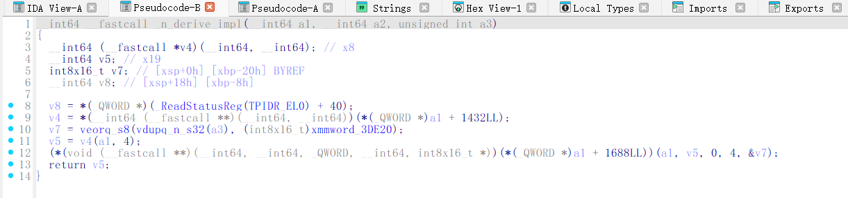
_n_derive_impl 接收种子后被加载 16 字节常量，异或后分为 4 个 32 位整数作为 TEA 密钥。

[+] tag = cw:b659bb46e86375f7:4c8314d0
[+] body = WenJiQuiI@Vmy0s5bla5?*kzFpf*ITta
[+] flag = ISCC{WenJiQuiI@Vmy0s5bla5?*kzFpf*ITta}

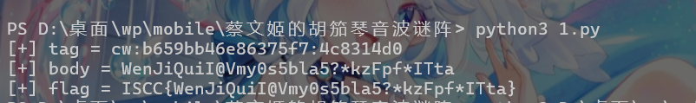

Exp
import struct
import zlib
M32 = 0xFFFFFFFF
def clamp(x):
return x & M32
def rotl(val, r):
val &= M32
r &= 31
if r == 0:
return val
return ((val << r) | (val >> (32 - r))) & M32
def rotr(val, r):
val &= M32
r &= 31
if r == 0:
return val
return ((val >> r) | (val << (32 - r))) & M32
def bitflip(data):
out = []
for b in data:
lo = (b & 0x55) << 1
hi = (b & 0xAA) >> 1
out.append((lo | hi) & 0xFF)
return bytes(out)
def fnv1a_64(buf):
h = 0xCBF29CE484222325
for byte in buf:
h ^= byte
h = (h * 0x100000001B3) & 0xFFFFFFFFFFFFFFFF
return h
def tea_rounds(v0, v1, k4):
delta = 0x9E3779B9
s = 0
for _ in range(32):
s = clamp(s + delta)
term0 = ((v1 << 4) & M32) + k4[0]
term1 = v1 + s
term2 = (v1 >> 5) + k4[1]
v0 = clamp(v0 + (clamp(term0 ^ term1 ^ term2)))
term0 = ((v0 << 4) & M32) + k4[2]
term1 = v0 + s
term2 = (v0 >> 5) + k4[3]
v1 = clamp(v1 + (clamp(term0 ^ term1 ^ term2)))
return v0, v1
def jhash(s):
h = 0
for ch in s:
h = clamp(h * 31 + ord(ch))
return h
def build_tag(seq):
video_size = 77055908
magic_mask = 0x7D9D119A
seed = jhash("com.example.mobile04") ^ video_size ^ magic_mask
deriv = [0xE8C5FA02, 0x218D0108, 0x79EC04B9, 0xCD353AB8]
k = [clamp(seed ^ d) for d in deriv]
fp = fnv1a_64(bitflip(seq.encode()))
lo = fp & M32
hi = (fp >> 32) & M32
a, b = tea_rounds(lo, hi, k)
blob = struct.pack("<II", a, b)
return "cw:{:s}:{:08x}".format(blob.hex(), zlib.crc32(blob) & M32)
def debase58(s):
alpha = "123456789ABCDEFGHJKLMNPQRSTUVWXYZabcdefghijkmnopqrstuvwxyz"
n = 0
for ch in s:
n = n * 58 + alpha.index(ch)
raw = n.to_bytes((n.bit_length() + 7) // 8, "big")
pad_cnt = len(s) - len(s.lstrip("1"))
return b"\x00" * pad_cnt + raw
def rc6_expand(seed1, seed2, k2, px, qa):
P = clamp(rotl(seed2, 13) ^ seed1 ^ px)
Q = clamp(rotl(seed2, 25) ^ seed1)
Q = clamp((Q | 1) + qa)
L = list(struct.unpack("<4I", k2))
S = [0] * 44
S[0] = P
for i in range(1, 44):
S[i] = clamp(S[i - 1] + Q)
A = B = i = j = 0
for _ in range(132):
A = S[i] = rotl(clamp(S[i] + A + B), 3)
B = L[j] = rotl(clamp(L[j] + A + B), clamp(A + B) & 31)
i = (i + 1) % 44
j = (j + 1) % 4
return S
def rc6_block(blk, S):
w, x, y, z = struct.unpack("<4I", blk)
y = clamp(y - S[43])
w = clamp(w - S[42])
for r in range(20, 0, -1):
w, x, y, z = z, w, x, y
u = rotl(clamp(z * clamp(2 * z + 1)), 5)
t = rotl(clamp(x * clamp(2 * x + 1)), 5)
y = rotr(clamp(y - S[2 * r + 1]), t & 31) ^ u
w = rotr(clamp(w - S[2 * r]), u & 31) ^ t
z = clamp(z - S[1])
x = clamp(x - S[0])
return struct.pack("<4I", w, x, y, z)
def main():
seq = "CWJXMASFLOWSTARROSEGOALDANCEMAGI"
tag = build_tag(seq)
print("[+] tag =", tag)
assert tag == "cw:b659bb46e86375f7:4c8314d0"
s1 = 0xA2AA216A
s2 = 0x5B74C718
K2 = b"Vmy0s5bla5&kzFpf"
K1 = b"WIrQW"
TGT = "2dAvRgJZsh1EiQ5DtrJiaLL9gp81z71ZMFGecH3BN3F2"
cipher = debase58(TGT)
cipher = bytes(cipher[i] ^ K1[i % len(K1)] for i in range(len(cipher)))
S = rc6_expand(s1, s2, K2, 0xE73C49EA, 0x7F9880A6)
body = rc6_block(cipher[:16], S) + rc6_block(cipher[16:], S)
print("[+] body =", body.decode())
print("[+] flag = ISCC{" + body.decode() + "}")
if __name__ == "__main__":
main()

