卜肆残局 WriteUp misc
解题思路
用file指令附件是zip压缩包。当前目录里的 .zip ，有窥得天机.zip 与 终局.7z 和卜肆残局文件夹，再看卜肆残局文件夹中 svg,F12看源代码。有隐藏的是“天盘依文王位，记文仍从伏羲”，说明图上摆位按文王位，但实际读取顺序改成伏羲次。每个宫位都有外圈三爻和内圈三爻，刚好拼成 6 bit，所以 8 个宫位恰好能拼出 8 个 Base64 字符。按乾、兑、离、震、巽、坎、艮、坤去读，得到 cVcyTzB6，再做一次 Base64 解码，就是第一段 qW2O0z。
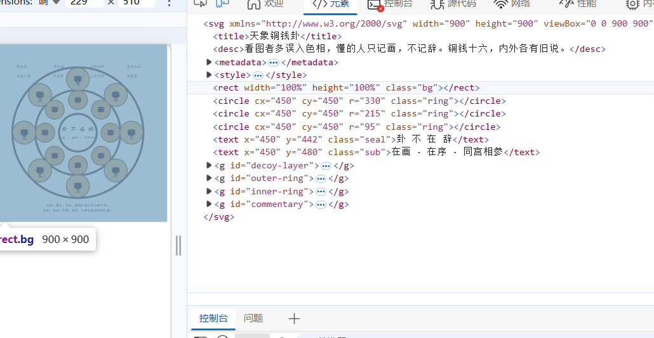
3. 人言txt文件看批注和句号形状。每门后面的 Base64 批注解开后分别是“去二五、去三八、去三六……”这一类删句指令。按夹页录里的门次“休生伤杜景死惊开”重排后，每门先删两句，只剩 6 句；再把普通句号“。”记成 0，把抬高句号“﹒”记成 1，每门就能产出 1 个 Base64 字符，8 门连起来得到 NWJuSW1H，再 Base64 解码得到第二段 5bnImG。
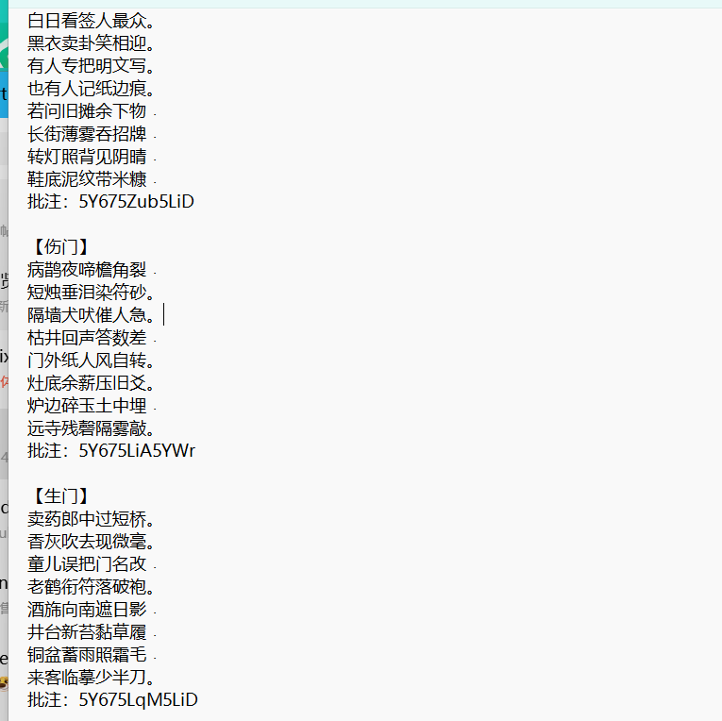
4. 地理-洛书盘文件是追加包。把 bmp 拉到文件尾以后，可以看到明显的 PK 头，说明图片后面有一段 zip。用foremost分离有盘中盘.zip，再往里是 覆土匣.tar.gz，最后是 后天九宫.txt 和 字契簿.txt。后天九宫给的是宫位到字契的对应关系，字契簿给的是字契到字符的映射。按“坎一坤二震三巽四中五乾六兑七艮八离九”去读，并且按“中位压土，不与旁争”去掉中五，正好拼出 NHlGdVVj，再 Base64 解码就是第三段 4yFuUc。
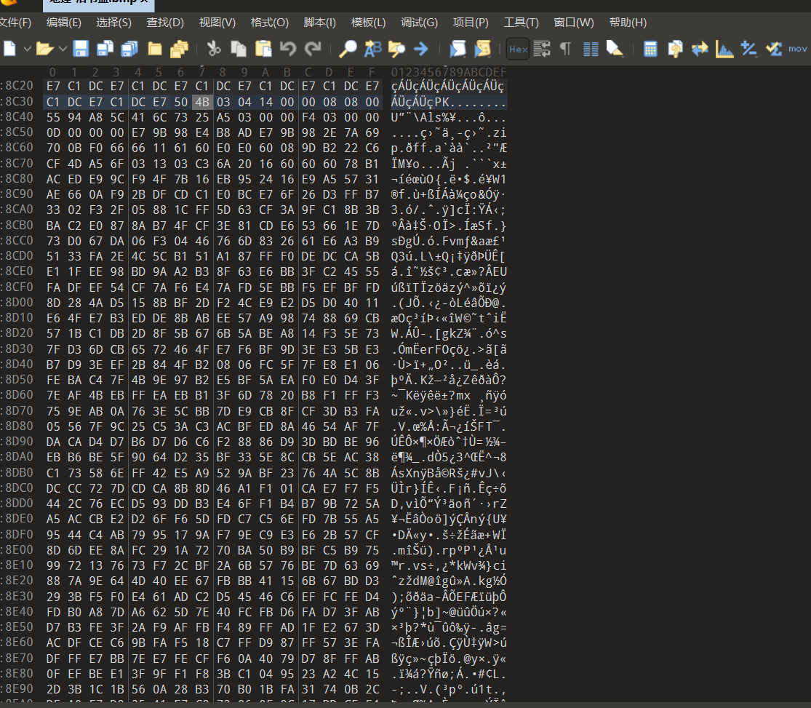
5. 时令部分要先结合夹页录里的提示做筛选。候气骨谜base64解码后写的是“春只认起与平，夏只认起与极，秋只认起与平，冬只认起与极”拿 8 个节气：立春、春分、立夏、夏至、立秋、秋分、立冬、冬至。然后只看 csv 的“六断”列，把“忌”当 0、“宜”当 1，每条就是 6 bit，对应 1 个 Base64 字符。8 条拼出来是 NFkwblY5，再 Base64 解码得到第四段 4Y0nV9。
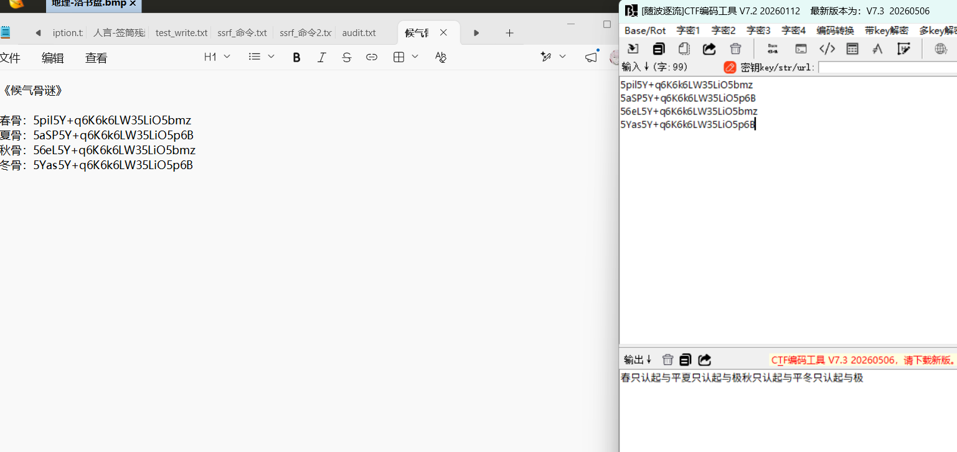
6. 四段拼起来就是 mid = qW2O0z5bnImG4yFuUc4Y0nV9，MD5 得到 228a53da12c42a65235ca2ebefa826c1。这个是窥得天机.zip 的解压密码。而且窥得天机.zip注解有q7LxP0aR9Yv+u1kC3wFjI2sQmD4oJ6GfXr5hN8KpTtUVeBylHcSgZdWiEOAbMn/z有64个字符，解出来以后有 64 个 txt，注解每个字符都落在 Base64 表里， 注解每个字符换成 Base64 下标，再去同序号 txt 的对应位置取字符，64 次拼完就是 seven_pwd
UQC8TBH7FkJn7bmz7ikjttXfwjvsp99CHBWmH7+M9HxppE7W7a68mo/Ua4cfQUq2。
7. seven_pwd 用来打开终局.7z，得到的终局.txt 里面是一段 Base64 密文。Base64解密：\xee8\x11MTqK\xf1\xd2\xb0\x8e\xbb\xdd%\x96\xdb(%,\x96\xd8f\xad\xbd\xe7\x1e\xc4\xbb\xaa\x82\x12\xfc\xa6Zy\xe1\x93\x0c\x83\x83\xff\x02v\xe06\x81\nE，有48位二进制密文，是 AES 这类分组加密常见的 16 字节倍数，适合往 AES-CBC 方向试。AES-CBC 至少需要两样东西key、iv如果走 AES-128-CBC，那两者都要 16 字节。手头这两个字符串都比 16 字节长，先试：key = mid[:16]、iv = seven_pwd[:16]，所以最后一步是常规 AES-CBC：key 取 mid 的前 16 字节，iv 取 seven_pwd 的前 16 字节，解密以后得到最终 flag：ISCC{cd1e6a3c-8348-4d9e-a26c-59c269004f84}。
最终 Flag
ISCC{cd1e6a3c-8348-4d9e-a26c-59c269004f84}
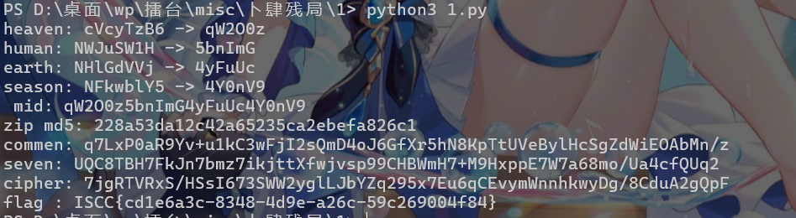
Exp
import base64
import csv
import hashlib
import io
import re
import tarfile
import tempfile
import zipfile
from pathlib import Path
import py7zr
from Crypto.Cipher import AES
from Crypto.Util.Padding import unpad

B64 = "ABCDEFGHIJKLMNOPQRSTUVWXYZabcdefghijklmnopqrstuvwxyz0123456789+/"
CN_NUM = {"一": 1, "二": 2, "三": 3, "四": 4, "五": 5, "六": 6, "七": 7, "八": 8, "九": 9}
FUXI_ORDER = ["乾", "兑", "离", "震", "巽", "坎", "艮", "坤"]
SEASON_PICK = {
"春": ("立春", "春分"),
"夏": ("立夏", "夏至"),
"秋": ("立秋", "秋分"),
"冬": ("立冬", "冬至"),
}

def find_single(base: Path, pattern: str) -> Path:
matches = list(base.rglob(pattern))
if len(matches) != 1:
raise FileNotFoundError(f"expected exactly one {pattern}, got {len(matches)}")
return matches[0]

def find_named(base: Path, filename: str) -> Path:
matches = [path for path in base.rglob("*") if path.is_file() and path.name == filename]
if len(matches) != 1:
raise FileNotFoundError(f"expected exactly one {filename}, got {len(matches)}")
return matches[0]

def find_challenge_dir(base: Path) -> Path:
candidates = []
for path in base.iterdir():
if not path.is_dir():
continue
names = {p.name for p in path.iterdir() if p.is_file()}
if {
"天象-铜钱卦.svg",
"地理-洛书盘.bmp",
"人言-签筒残册.txt",
"时令-漏刻历盘.csv",
}.issubset(names):
candidates.append(path)
if len(candidates) != 1:
raise FileNotFoundError(f"expected exactly one challenge dir, got {len(candidates)}")
return candidates[0]

def decode_attachment_zip(base: Path) -> dict[str, str]:
note_zip = find_named(base, "夹页录.zip")
decoded: dict[str, str] = {}
with zipfile.ZipFile(note_zip, "r") as zf:
for name in zf.namelist():
decoded[name] = zf.read(name).decode("utf-8")
return decoded

def solve_heaven(svg_path: Path) -> tuple[str, str]:
svg = svg_path.read_text(encoding="utf-8")
coins: dict[str, dict[str, str]] = {}
pattern = re.compile(r'<g class="coin [^"]+" id="(outer|inner)-([^"]+)">(.*?)</g>', re.S)
for ring, seat, body in pattern.findall(svg):
levels = sorted(set(float(y) for y in re.findall(r'y1="([0-9.]+)"', body)))
bits = []
for y in levels:
hits = len(re.findall(fr'y1="{y}"', body))
bits.append("0" if hits == 2 else "1")
coins.setdefault(seat, {})[ring] = "".join(bits)

heaven_b64 = "".join(coins[seat]["outer"] + coins[seat]["inner"] for seat in FUXI_ORDER)
heaven_b64 = "".join(B64[int(bits, 2)] for bits in re.findall(r".{6}", heaven_b64))
return heaven_b64, base64.b64decode(heaven_b64).decode("utf-8")

def solve_human(text_path: Path, attachment_notes: dict[str, str]) -> tuple[str, str]:
text = text_path.read_text(encoding="utf-8").split("旁注数条：")[0]
parts = re.split(r"【([^】]+)】\n", text)[1:]
gates = {}
for i in range(0, len(parts), 2):
name = parts[i].replace("门", "")
body = parts[i + 1].strip()
note = re.search(r"批注：([A-Za-z0-9+/=]+)", body)
if note is None:
continue
rule = base64.b64decode(note.group(1)).decode("utf-8")
lines = re.sub(r"批注：[A-Za-z0-9+/=]+", "", body).strip().splitlines()
gates[name] = {
"drop": [CN_NUM[ch] for ch in rule if ch in CN_NUM],
"lines": [line.strip() for line in lines if line.strip()],
}

gate_note = attachment_notes["门位札记.txt"]
gate_order_b64 = re.search(r"唱门旧次：([A-Za-z0-9+/=]+)", gate_note)
if gate_order_b64 is None:
raise ValueError("missing gate order")
gate_order = list(base64.b64decode(gate_order_b64.group(1)).decode("utf-8"))

human_b64_chars = []
for gate in gate_order:
remaining = [
line for idx, line in enumerate(gates[gate]["lines"], start=1) if idx not in gates[gate]["drop"]
]
bits = "".join("0" if line.endswith("。") else "1" for line in remaining)
human_b64_chars.append(B64[int(bits, 2)])

human_b64 = "".join(human_b64_chars)
return human_b64, base64.b64decode(human_b64).decode("utf-8")

def solve_earth(bmp_path: Path) -> tuple[str, str]:
data = bmp_path.read_bytes()
start = data.find(b"PK\x03\x04")
if start == -1:
raise ValueError("no appended zip found in bmp")

with zipfile.ZipFile(io.BytesIO(data[start:]), "r") as outer_zip:
inner_zip_name = next(name for name in outer_zip.namelist() if name.endswith(".zip"))
inner_zip_bytes = outer_zip.read(inner_zip_name)

with zipfile.ZipFile(io.BytesIO(inner_zip_bytes), "r") as middle_zip:
gz_name = next(name for name in middle_zip.namelist() if name.endswith(".gz"))
gz_bytes = middle_zip.read(gz_name)

with tarfile.open(fileobj=io.BytesIO(gz_bytes), mode="r:gz") as tar:
palace_text = tar.extractfile("覆土匣/后天九宫.txt").read().decode("utf-8")
book_text = tar.extractfile("覆土匣/字契簿.txt").read().decode("utf-8")

palace_to_token = {}
for palace, _, token in re.findall(r"([坎坤震巽中乾兑艮离])([一二三四五六七八九])：(\S+)", palace_text):
palace_to_token[palace] = token
token_to_char = dict(re.findall(r"(\S)：(\S)", book_text))
order = [palace for palace, _ in re.findall(r"([坎坤震巽中乾兑艮离])([一二三四五六七八九])", palace_text.splitlines()[3])]

earth_b64 = "".join(token_to_char[palace_to_token[palace]] for palace in order if palace != "中")
return earth_b64, base64.b64decode(earth_b64).decode("utf-8")

def solve_season(csv_path: Path, attachment_notes: dict[str, str]) -> tuple[str, str]:
raw = csv_path.read_text(encoding="utf-16")
rows = list(csv.DictReader(io.StringIO("\n".join(raw.splitlines()[6:]))))
row_by_name = {row["节气"]: row for row in rows}

clue_text = attachment_notes["候气骨谜.txt"]
picks = []
for season in ("春", "夏", "秋", "冬"):
if f"{season}骨" not in clue_text:
raise ValueError(f"missing {season} clue")
picks.extend(SEASON_PICK[season])

season_b64_chars = []
for name in picks:
row = row_by_name[name]
bits = "".join("0" if piece.strip() == "忌" else "1" for piece in row["六断"].split("/"))
season_b64_chars.append(B64[int(bits, 2)])

season_b64 = "".join(season_b64_chars)
return season_b64, base64.b64decode(season_b64).decode("utf-8")

def load_stage_archives(base: Path) -> tuple[bytes, bytes]:
direct_peek = base / "窥得天机.zip"
direct_final = base / "终局.7z"
if direct_peek.exists() and direct_final.exists():
return direct_peek.read_bytes(), direct_final.read_bytes()

outer = base / ".zip"
if outer.exists():
with zipfile.ZipFile(outer, "r") as zf:
root_files = [info.filename for info in zf.infolist() if "/" not in info.filename.rstrip("/")]
peek_name = next(name for name in root_files if name.endswith(".zip"))
final_name = next(name for name in root_files if name.endswith(".7z"))
return zf.read(peek_name), zf.read(final_name)

raise FileNotFoundError("neither direct archives nor outer .zip found")

def derive_stage_two(peek_zip_bytes: bytes, mid: str) -> tuple[str, str]:
password = hashlib.md5(mid.encode("utf-8")).hexdigest()
with tempfile.TemporaryDirectory() as tmpdir:
out_dir = Path(tmpdir)
with zipfile.ZipFile(io.BytesIO(peek_zip_bytes), "r") as zf:
zf.extractall(out_dir, pwd=password.encode("utf-8"))
comment = zf.comment.decode("utf-8")

txt_files = sorted(
out_dir.rglob("*.txt"),
key=lambda path: int(re.search(r"\d+", path.stem).group()) if re.search(r"\d+", path.stem) else path.stem,
)
if len(txt_files) != 64:
raise ValueError(f"expected 64 txt files, got {len(txt_files)}")

chars = []
for index, marker in enumerate(comment):
char_index = B64.index(marker)
content = txt_files[index].read_text(encoding="utf-8", errors="ignore")
chars.append(content[char_index])

return comment, "".join(chars)

def derive_flag(final_7z_bytes: bytes, mid: str, seven_pwd: str) -> tuple[str, str]:
with tempfile.TemporaryDirectory() as tmpdir:
out_dir = Path(tmpdir)
with py7zr.SevenZipFile(io.BytesIO(final_7z_bytes), mode="r", password=seven_pwd) as archive:
archive.extractall(path=out_dir)
final_txt = next(out_dir.rglob("*.txt"))
ciphertext_b64 = final_txt.read_text(encoding="utf-8").strip()

cipher = AES.new(mid.encode("utf-8")[:16], AES.MODE_CBC, seven_pwd.encode("utf-8")[:16])
plaintext = unpad(cipher.decrypt(base64.b64decode(ciphertext_b64)), AES.block_size).decode("utf-8")
return ciphertext_b64, plaintext

def main() -> None:
base = Path.cwd()
challenge_dir = find_challenge_dir(base)
notes = decode_attachment_zip(challenge_dir)

heaven_b64, heaven = solve_heaven(find_named(challenge_dir, "天象-铜钱卦.svg"))
human_b64, human = solve_human(find_named(challenge_dir, "人言-签筒残册.txt"), notes)
earth_b64, earth = solve_earth(find_named(challenge_dir, "地理-洛书盘.bmp"))
season_b64, season = solve_season(find_named(challenge_dir, "时令-漏刻历盘.csv"), notes)

mid = heaven + human + earth + season
peek_zip_bytes, final_7z_bytes = load_stage_archives(base)
comment, seven_pwd = derive_stage_two(peek_zip_bytes, mid)
ciphertext_b64, flag = derive_flag(final_7z_bytes, mid, seven_pwd)

print("heaven:", heaven_b64, "->", heaven)
print("human:", human_b64, "->", human)
print("earth:", earth_b64, "->", earth)
print("season:", season_b64, "->", season)
print(" mid:", mid)
print("zip md5:", hashlib.md5(mid.encode("utf-8")).hexdigest())
print("commen:", comment)
print("seven:", seven_pwd)
print("cipher:", ciphertext_b64)
print("flag :", flag)

if __name__ == "__main__":
main()

