ISCC2026 WriteUp盲相阵列misc

解题思路
附件后压缩先看 rx_note.txt。内容告诉我们采样率 48000 Hz，符号率 1200 baud，所以每个符号正好 40 个采样点；残余载波偏差接近 +1700 Hz；前 80 个恢复符号属于 training/sync；真正的载荷要经过 PN mask、16 路 column DMA、H(7,4) 和 BP1 frame 这几层处理。
原始 IQ 在复平面里是一个持续转动的云团。BPSK 的一个常用办法是看 z[n]^2：数据符号平方后只剩 2 倍频偏项，所以只要对 z[n]^2 做频谱，峰值除以 2 就能得到 CFO。这里峰值在 3399.45 Hz 左右，对应原信号偏差约 1699.73 Hz，和备注里的 +1700 Hz 一致。后面我直接用 1700 Hz 做数字下变频，再用 mean(symbol^2) 的相位/2 去补公共相位。

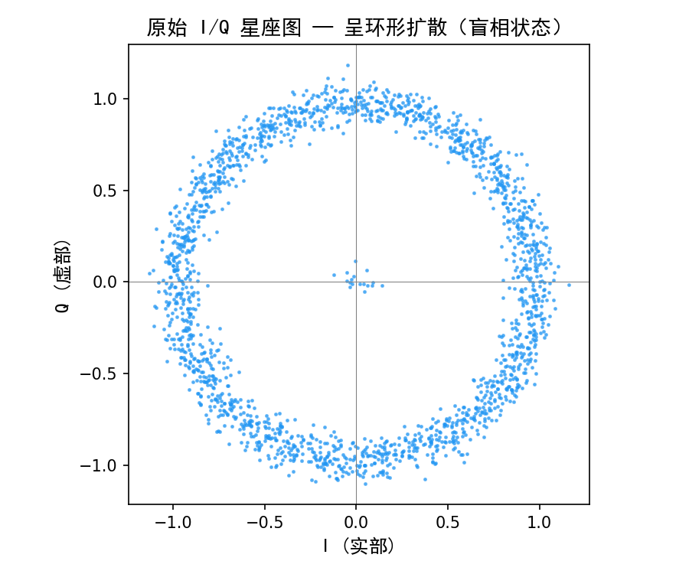

确定频偏以后，再做 0~39 的符号边界遍历。利用训练段前 64 bit 是交替 1010... 这一点：每个 offset 都先按 40 点取均值、做 BPSK 判决，先筛掉和交替序列不一致的候选；如果出现并列，再看训练段投影到实轴后的平均幅度，幅度最大的就是最稳的采样点。这样最终落在 offset=17，这时训练段已经稳定到 aaaaaaaaaaaaaaaae5a2。这里如果整体极性翻转，同一段会写成互补值；只要后续判决方向和去扰方向保持一致，得到的帧内容是等价的。

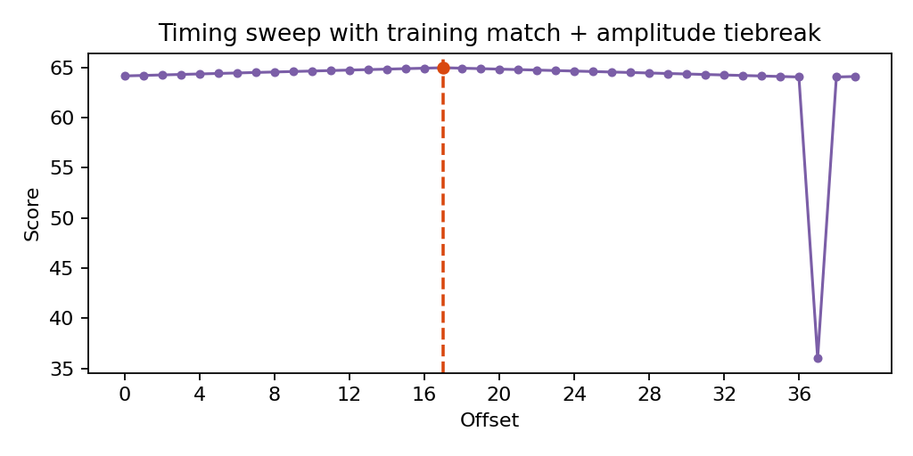

接下来按 note 给的路径反着走。先取训练块后面的 560 个有效payload bit，用8 位 LFSR 生成 PN 掩码去扰；用初值 0xA5，反馈位为 bit7^bit5^bit4^bit3，输出取当前最低位。然后把去扰后的比特按 16 列 35 行重排，做一次转置，就恢复了 column DMA 之前的 Hamming 码字顺序。
H(7,4) 这一层按 [p1,p2,d1,p4,d2,d3,d4] 解码。综合症非 0 时翻转对应位置，本题一共修正了 5 个单比特错误。纠错后的字节流开头是 ASCII `BP1 `，末尾 4 字节解释为大端 CRC32；把中间正文拿去重新算 CRC，结果和帧尾完全一致，所以这一条恢复链是闭合的。最后得到 flag：ISCC{R7!q_Z@4m^T9?p$V%k&2*n~L#x}。

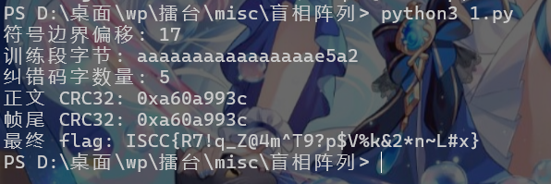
ISCC{R7!q_Z@4m^T9?p$V%k&2*n~L#x}
Exp
#!/usr/bin/env python3
import cmath
import csv
import math
import sys
import zlib

SAMPLE_RATE = 48_000
SYMBOL_RATE = 1_200
SAMPLES_PER_SYMBOL = SAMPLE_RATE // SYMBOL_RATE
NOMINAL_OFFSET_HZ = 1700.0
TRAINING_SYMBOLS = 80
PAYLOAD_BITS = 560
LANES = 16
ROWS = 35

def read_complex_csv(path):
points = []
with open(path, "r", encoding="utf-8", newline="") as f:
for row in csv.DictReader(f):
points.append(complex(float(row["i"]), float(row["q"])))
return points

def compensate_carrier(samples):
rotated = []
step = -2.0 * math.pi * NOMINAL_OFFSET_HZ / SAMPLE_RATE
for idx, value in enumerate(samples):
rotated.append(value * cmath.exp(1j * step * idx))
return rotated

def average_symbol_windows(samples, start):
out = []
cursor = start
while cursor + SAMPLES_PER_SYMBOL <= len(samples):
window = samples[cursor : cursor + SAMPLES_PER_SYMBOL]
out.append(sum(window) / SAMPLES_PER_SYMBOL)
cursor += SAMPLES_PER_SYMBOL
return out

def remove_common_phase(symbols):
phasor = sum(value * value for value in symbols)
phase = cmath.phase(phasor) / 2.0
rotator = cmath.exp(-1j * phase)
return [value * rotator for value in symbols]

def training_metric(symbols):
# Training preamble is alternating BPSK. Use correlation magnitude rather than
# hard-equality counts so timing is selected by the strongest real-axis energy.
expected = [1.0 if i % 2 == 0 else -1.0 for i in range(64)]
corr = sum(expected[i] * symbols[i].real for i in range(64))
return abs(corr)

def select_timing(samples):
best = None
for offset in range(SAMPLES_PER_SYMBOL):
coarse = average_symbol_windows(samples, offset)
if len(coarse) < TRAINING_SYMBOLS:
continue
locked = remove_common_phase(coarse)
metric = training_metric(locked)
if best is None or metric > best[0]:
best = (metric, offset, locked)
if best is None:
raise RuntimeError("timing search failed")
return best[1], best[2]

def slice_bpsk(symbols):
return [1 if value.real < 0 else 0 for value in symbols]

def whitening_bits(count, seed=0xA5):
state = seed & 0xFF
for _ in range(count):
yield state & 1
feedback = ((state >> 7) ^ (state >> 5) ^ (state >> 4) ^ (state >> 3)) & 1
state = ((state << 1) & 0xFF) | feedback

def undo_lane_dump(bits):
restored = [0] * len(bits)
src = 0
for lane in range(LANES):
for row in range(ROWS):
restored[row * LANES + lane] = bits[src]
src += 1
return restored

def hamming74_codebook():
table = []
for nibble in range(16):
d1 = (nibble >> 3) & 1
d2 = (nibble >> 2) & 1
d3 = (nibble >> 1) & 1
d4 = nibble & 1
p1 = d1 ^ d2 ^ d4
p2 = d1 ^ d3 ^ d4
p4 = d2 ^ d3 ^ d4
table.append((nibble, [p1, p2, d1, p4, d2, d3, d4]))
return table

def decode_hamming_stream(bits):
codebook = hamming74_codebook()
nibbles = []
corrected_words = 0
for pos in range(0, len(bits), 7):
word = bits[pos : pos + 7]
if len(word) < 7:
break
best_nibble = None
best_dist = 8
for nibble, codeword in codebook:
dist = sum(a ^ b for a, b in zip(word, codeword))
if dist < best_dist:
best_dist = dist
best_nibble = nibble
if best_dist:
corrected_words += 1
nibbles.append(best_nibble)

packed = bytearray()
for idx in range(0, len(nibbles), 2):
packed.append((nibbles[idx] << 4) | nibbles[idx + 1])
return bytes(packed), corrected_words

def decode_frame(path):
raw = read_complex_csv(path)
mixed = compensate_carrier(raw)
offset, locked_symbols = select_timing(mixed)
bits = slice_bpsk(locked_symbols)
training_bits = bits[:TRAINING_SYMBOLS]
training_bytes = bytearray()
for start in range(0, TRAINING_SYMBOLS, 8):
value = 0
for bit in training_bits[start : start + 8]:
value = (value << 1) | bit
training_bytes.append(value)

payload = bits[TRAINING_SYMBOLS : TRAINING_SYMBOLS + PAYLOAD_BITS]
unwhitened = [bit ^ mask for bit, mask in zip(payload, whitening_bits(PAYLOAD_BITS))]
ordered = undo_lane_dump(unwhitened)
frame, corrected_words = decode_hamming_stream(ordered)

if offset != 17:
raise RuntimeError(f"unexpected timing offset: {offset}")
if not frame.startswith(b"BP1 "):
raise RuntimeError("frame header check failed")

body = frame[4:-4]
expected_crc = int.from_bytes(frame[-4:], "big")
actual_crc = zlib.crc32(body) & 0xFFFFFFFF
if actual_crc != expected_crc:
raise RuntimeError("CRC validation failed")
return {
"flag": body.decode("ascii"),
"timing_offset": offset,
"training_bytes": bytes(training_bytes).hex(),
"corrected_words": corrected_words,
"crc_calc": actual_crc,
"crc_tail": expected_crc,
}

def main():
source = sys.argv[1] if len(sys.argv) > 1 else "bundle/array_iq.csv"
result = decode_frame(source)
print(f"符号边界偏移: {result['timing_offset']}")
print(f"训练段字节: {result['training_bytes']}")
print(f"纠错码字数量: {result['corrected_words']}")
print(f"正文 CRC32: 0x{result['crc_calc']:08x}")
print(f"帧尾 CRC32: 0x{result['crc_tail']:08x}")
print(f"最终 flag: {result['flag']}")
if __name__ == "__main__":
main()

