神秘文件Plus WriteUp
题目描述：可莉从阿贝多老师那里学习回来后，将她的宝物藏入了一个神秘的文件。节奏与波动仿佛在诉说一段故事，三要素的微妙变化似乎暗示了什么，也许声音的第九位会给你答案。

解题思路
这题先把外层容器拆干净，再找哪一层真的带 payload。实际跑下来，主线很清楚：无后缀 ZIP -> Herta_1.png -> PNG 尾部拼接的 7z -> 图片 R 通道 LSB 提密码 -> 50 个 WAV -> 在 3.wav 的左右声道差分里恢复最终 flag。
题目里“节奏、波动、三要素、声音的第九位”这些词都不是废话，但 1.wav、2.wav、9.wav 更像引导层；真正是 3.wav 那 2016 个差分采样点。

1. 分析
附件没有后缀，用随波逐流判断格式是 ZIP，改名后直接解压就能拿到 Herta_1.png 和题目描述。
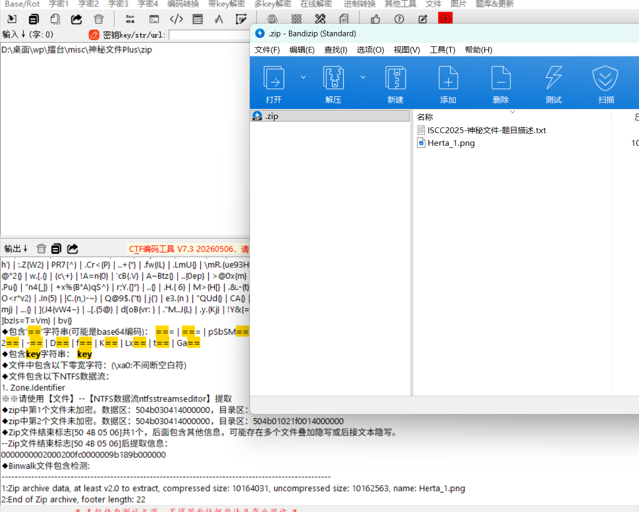
解压png继续用随波逐流看看信息发现有7z，检查尾部结构。我尝试过用 binwalk 和 foremost 直接分离，但都不行，写脚本按 IEND 位置切尾
from pathlib import Path
raw = Path("Herta_1.png").read_bytes()
pos = raw.find(b"IEND")
tail = raw[pos + 8:]
Path("tail.7z").write_bytes(tail)
print(pos, len(tail), tail[:6].hex())

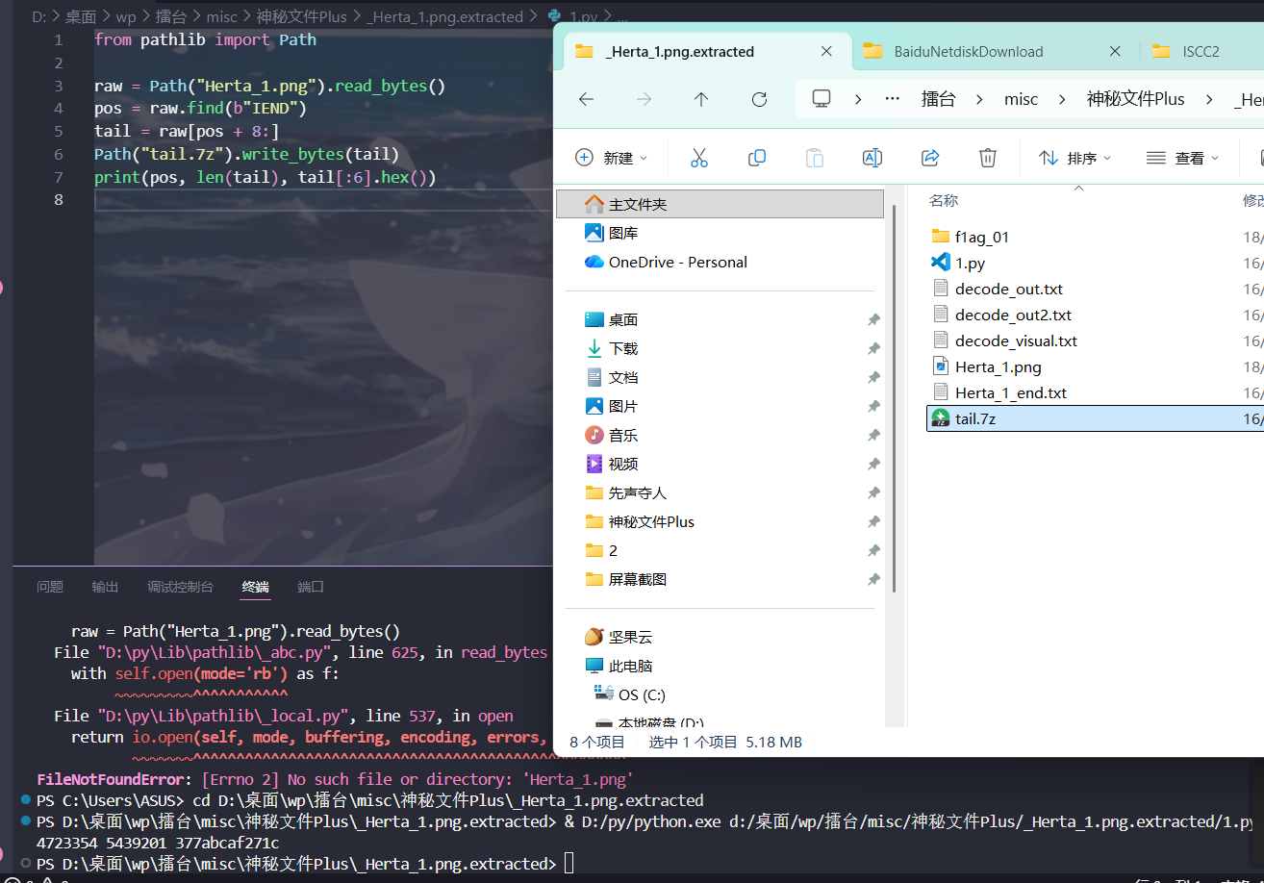

2. 密码不在题面里，在图片最低位里
内层 7z 直接解不开，说明还缺一步。这里我回头看题面里的“三要素”，最自然的理解就是 RGB 三通道。实际测试时，R 通道最低位的前部数据很快就能抠出一串 32 位十六进制字符串，拿去做 7z 密码正好通过。
from PIL import Image
import numpy as np
import re
img = np.array(Image.open("Herta_1.png").convert("RGB"))
bits = (img[:, :, 0] & 1).ravel()
out = bytearray()
for i in range(0, len(bits) - 7, 8):
b = 0
for bit in bits[i:i+8]:
b = (b << 1) | int(bit)
out.append(b)
password = re.search(rb"[0-9a-f]{32}", bytes(out)).group().decode()
print(password)

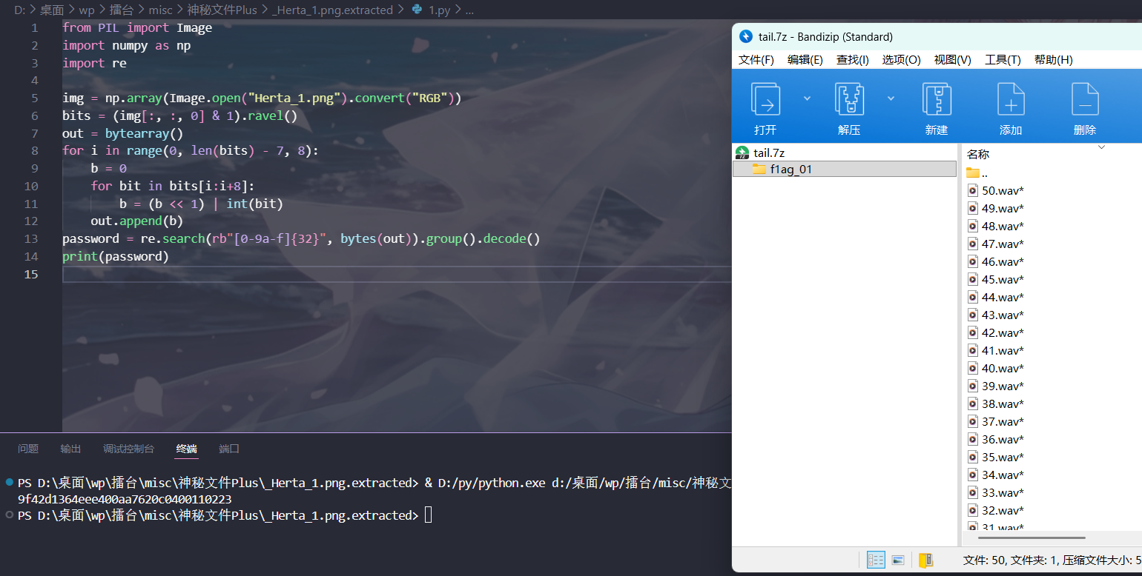

3. 50 个 WAV 里，真正要看的只有 3.wav
把 tail.7z 用密码解开后，会得到 1.wav 到 50.wav。我最开始也试过从音高、节拍和 9.wav 的提示字样往下做，但很快发现这些都更像引路牌，之后逐个比较左右声道：只有 3.wav 出现了非零差异。进一步定位后，异常区间从 1.500s 开始，到 1.546s 结束；差值只有 1 和 2 两种。这个特征非常干净，基本已经说明这里不是普通音频抖动，而是专门塞进去的二值载荷。
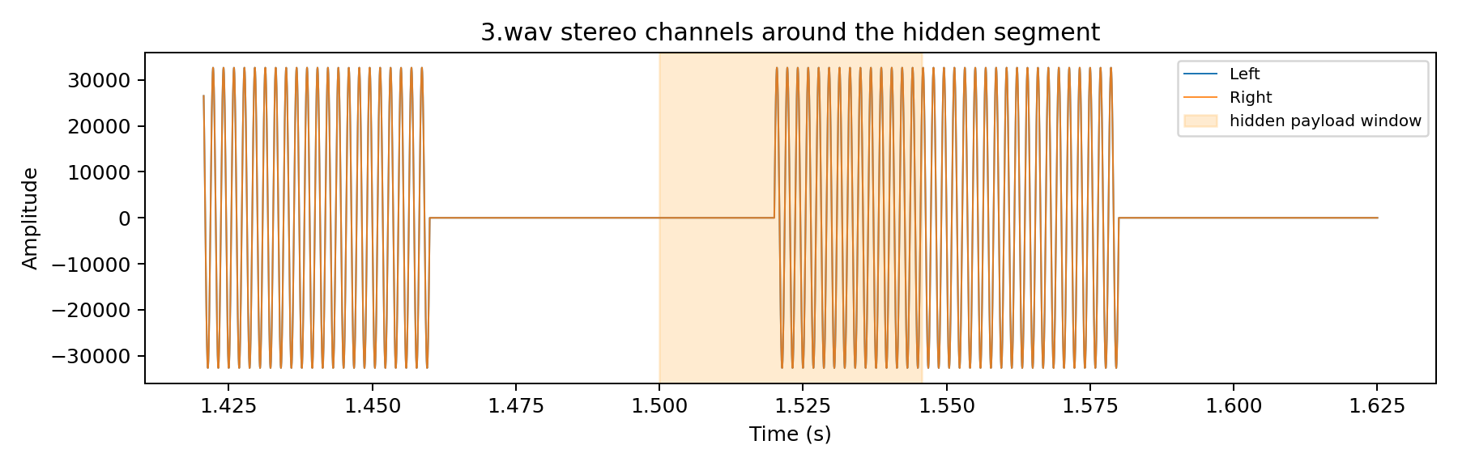

4. 最后一层不是 ASCII，而是 42 个 48bit 字模块
把 3.wav 的左右声道做差以后，保留非零位置，再按“1 -> 0、2 -> 1”映射成 bit 流，总长度正好是 2016 bit。2016 = 42 × 48，说明这一层更像 42 个定长的小块，而不是普通 ASCII 文本。把它切成 42 组、每组 48 bit 后，可以得到 42 个顺序固定的签名块。这里需要特别说明：上面的黑白方块图只是这 42 个签名块的可视化，不是二维码，扫码不会有结果。脚本能够稳定提取出这 42 个签名块，随后再结合 flag 长度为 42、前后包裹为 ISCC{}、中间主体满足 UUID 结构，恢复最终结果。
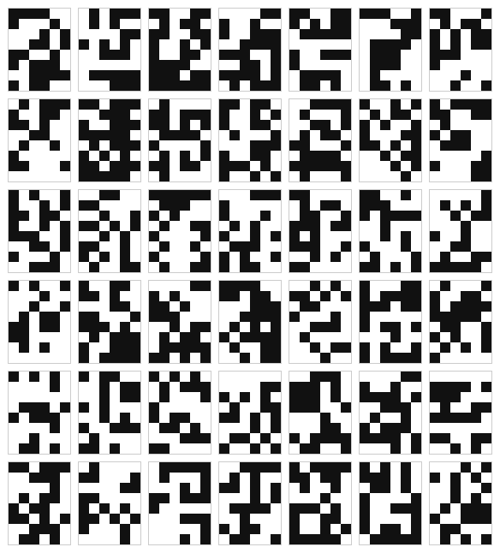
最后恢复出的字符串是ISCC{16c2ff3a-4443-4c1e-878a-39e74ed3544c}。这里比较关键的一点是：脚本负责把最终载荷完整提出来，真正把 42 个签名块对应回字符时，还需要利用 ISCC 题目常见的 flag 包裹格式和中间 UUID 结构去校正，下面exp有完成了载荷提取与签名块恢复：42个48bit和对应的字符映射，再拼接
ISCC{16c2ff3a-4443-4c1e-878a-39e74ed3544c}
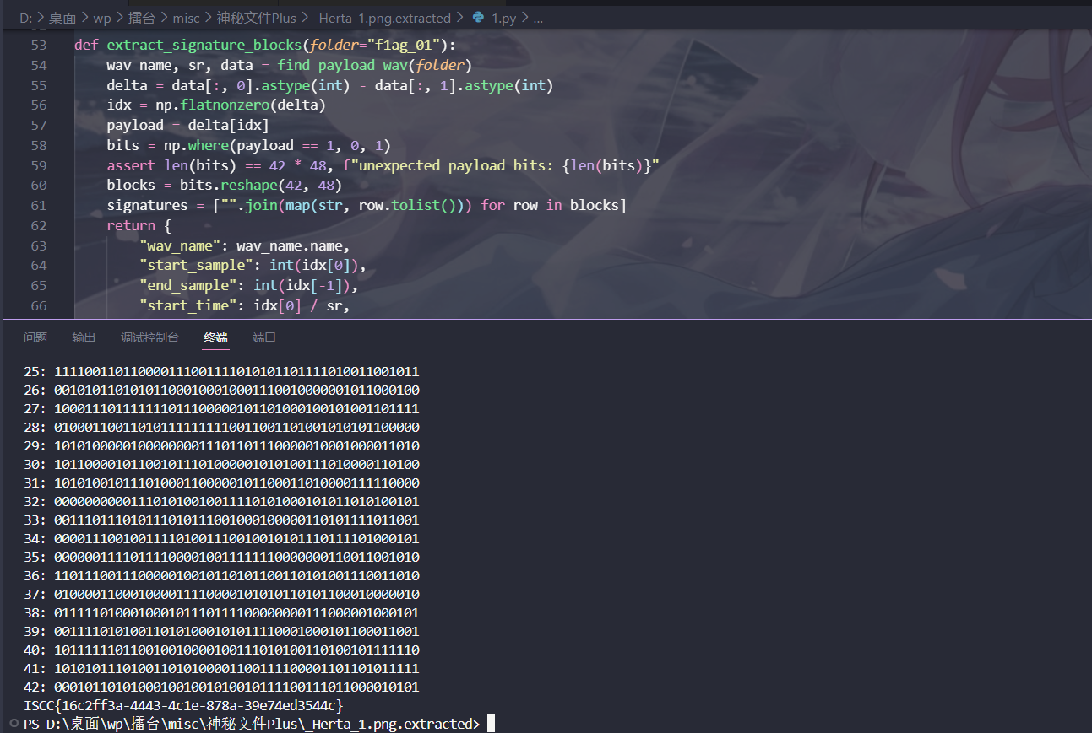

Exp
#!/usr/bin/env python3
#脚本完成了载荷提取与签名块恢复, 再根据签名与字符对应关系完成最终拼接
from pathlib import Path
import re
import subprocess
import numpy as np
from PIL import Image
from scipy.io import wavfile

def extract_outer_zip():
if not Path("Herta_1.png").exists():
subprocess.run(["7z", "x", ".\\.zip", "-y"], check=True)

def recover_password(png_name="Herta_1.png"):
arr = np.array(Image.open(png_name).convert("RGB"))
bits = (arr[:, :, 0] & 1).ravel()
buf = bytearray()
for i in range(0, len(bits) - 7, 8):
b = 0
for bit in bits[i:i+8]:
b = (b << 1) | int(bit)
buf.append(b)
m = re.search(rb"[0-9a-f]{32}", bytes(buf))
return m.group().decode()

def cut_tail(png_name="Herta_1.png"):
raw = Path(png_name).read_bytes()
pos = raw.find(b"IEND")
tail = raw[pos + 8:]
Path("tail.7z").write_bytes(tail)
return len(tail)

def extract_inner_7z(password):
if not Path("f1ag_01").exists():
subprocess.run(["7z", "x", "tail.7z", "-p" + password, "-y"], check=True)

def find_payload_wav(folder="f1ag_01"):
wavs = sorted(Path(folder).glob("*.wav"), key=lambda p: int(p.stem))
for wav in wavs:
sr, data = wavfile.read(str(wav))
if data.ndim != 2:
continue
diff = np.count_nonzero(data[:, 0] != data[:, 1])
if diff:
return wav, sr, data
raise RuntimeError("payload wav not found")

def extract_signature_blocks(folder="f1ag_01"):
wav_name, sr, data = find_payload_wav(folder)
delta = data[:, 0].astype(int) - data[:, 1].astype(int)
idx = np.flatnonzero(delta)
payload = delta[idx]
bits = np.where(payload == 1, 0, 1)
assert len(bits) == 42 * 48, f"unexpected payload bits: {len(bits)}"
blocks = bits.reshape(42, 48)
signatures = ["".join(map(str, row.tolist())) for row in blocks]
return {
"wav_name": wav_name.name,
"start_sample": int(idx[0]),
"end_sample": int(idx[-1]),
"start_time": idx[0] / sr,
"end_time": (idx[-1] + 1) / sr,
"signatures": signatures,
}
def decode_text(signatures):
sig2ch = {
"111100100010000101001101110010101110001111101100": "I",
"010111010100000011101010001110000000011111000111": "S",
"110011010110110011100101100110111100111011111111": "C",
"000011100100100111001111111001001101111101010111": "C",
"110011101011011111000000100111100000011110011010": "{",
"111001000111000011011110011100011100010000011010": "1",
"110001010110101011101011111000100000000100001001": "6",
"010111100110110100001100010010100000110001000000": "c",
"110111001110100111111110010111101010110111111110": "2",
"010000110111110101011110100001010101110110010000": "f",
"110110100101100110010001000111100110111010100101": "f",
"001111010001001101010110110001011110111111010001": "3",
"100101010110101001100011110101001011000101000010": "a",
"101111110011010000101100011100000001100011000011": "-",
"101001100101110110100101111001001101100010001110": "4",
"001100110000001001110101001010110010101010010011": "4",
"111111011100101000010011100001010010100001010011": "4",
"000111100000100010010100100101011100101001101100": "3",
"110000010110011001111011101000111001001010110000": "-",
"110010111000101111001000001010100010010001110101": "4",
"000001010101001011000100100100001100010011111110": "c",
"101001000100001001010110110110110000010100000000": "1",
"100110110100000110110001111010010111100111101111": "e",
"000011101000110100111000001011010110011111110101": "-",
"111100110110000111001111010101101111010011001011": "8",
"001010110101011000100010001110010000001011000100": "7",
"100011101111111011100000101101000100101001101111": "8",
"010001100110101111111110011001101001010101100000": "a",
"101010000010000000011101101110000010001000011010": "-",
"101100001011001011101000001010100111010000110100": "3",
"101010010111010001100000101100011010000111110000": "9",
"000000000011101010010011110101000101011010100101": "e",
"001110111010111010111001000100000110101111011001": "7",
"000011100100111101001110010010101110111101000101": "4",
"000000111101111000010011111110000000110011001010": "e",
"110111001110000010010110101100110101001110011010": "d",
"010000110001000011110000101010110101100010000010": "3",
"011111010001000101110111100000000111000001000101": "5",
"001111010100110101000101011110001000101100011001": "4",
"101111110110010010000100111010100110100101111110": "4",
"101010111010011010100001100111100001101101011111": "c",
"000101101010001001001010010111100111011000010101": "}",
}
return "".join(sig2ch[s] for s in signatures)

if __name__ == "__main__":
extract_outer_zip()
tail_len = cut_tail()
password = recover_password()
extract_inner_7z(password)
result = extract_signature_blocks()
print(f"tail bytes : {tail_len}")
print(f"password : {password}")
print(f"payload wav: {result['wav_name']}")
print(f"/end : {result['start_sample']} .. {result['end_sample']}")
print(f"time range : {result['start_time']:.6f}s .. {result['end_time']:.6f}s")
print(f"block count: {len(result['signatures'])}")
for i, sig in enumerate(result["signatures"], 1):
print(f"{i:02d}: {sig}")
flag = decode_text(result["signatures"])
print(flag)

