ISCC2026 WriteUp逆向 + QuorumGlyph

解题思路
1. 文件分析
用 IDA Pro 打开分析。程序运行后通过 scanf 读取输入 flag，随后输出 "Yes???" 或 "No???"。题"One witness lies. Two are incomplete. Three agree."，说明程序内部有三条独立的校验路径。
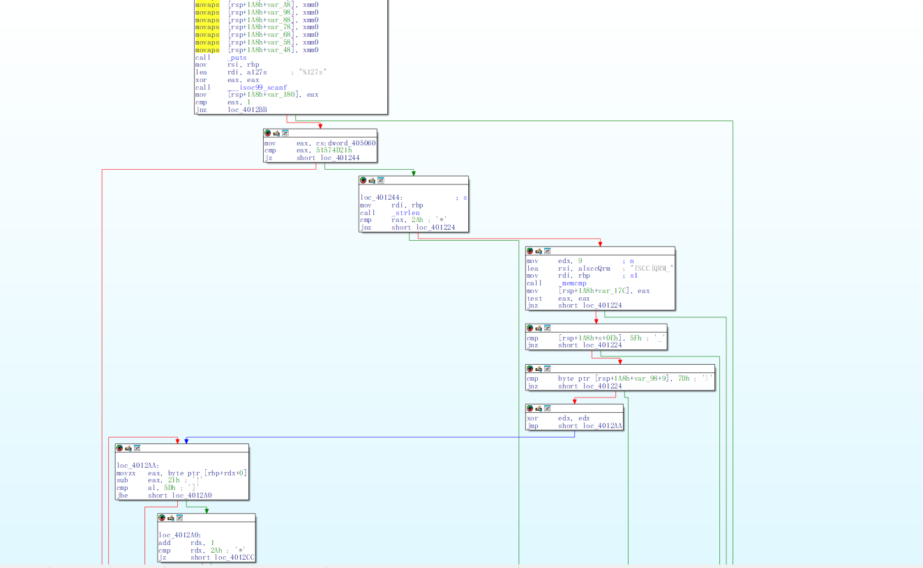 main 函数
main 函数 (0x401190)，查看伪代码有：
• 输入长度必须为 42
• 前缀必须为 "ISCC{QRM_"（9字节）
• s[14] == '_' 且 s[41] == '}'
• 所有字符必须在可打印 ASCII 范围内 (33-126)
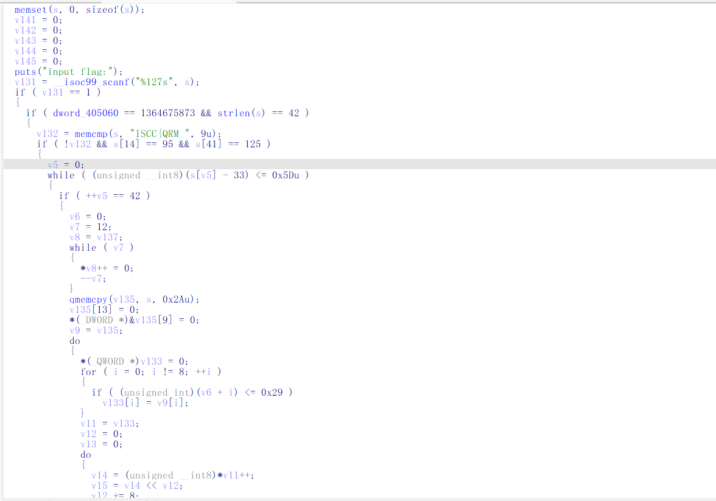3. 奇偶校验
第一段校验逻辑先将中间 5 个字符 (s[9]~s[13]) 清零，然后将 42 字节每 6 个一组打包为 qword，做按位奇偶校验 (popcount)。
该段用到的数据来自 .rodata 段的 unk_402040 和 unk_4020E0。
这段校验只能确定外层结构，无法给出中间 5 个字符的信息，因为中间 5 位已被清零。
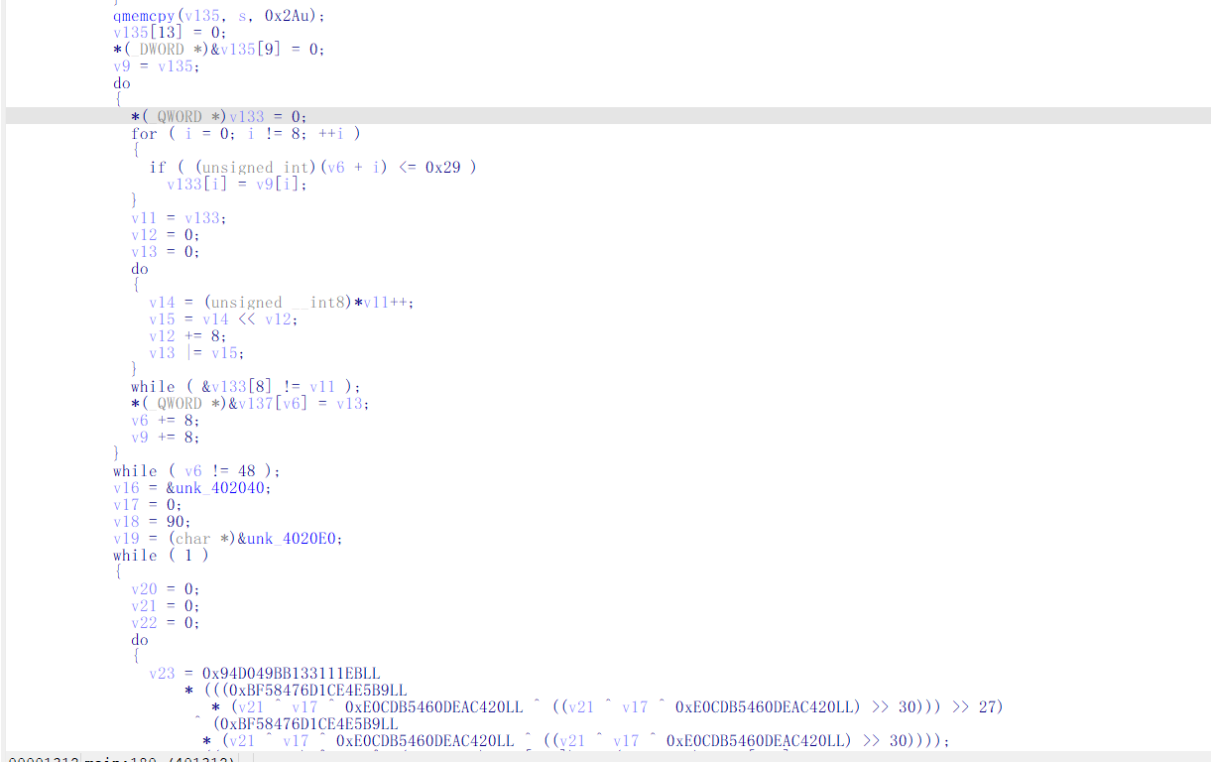4.可逆变换
第二段校验同样先将中间 5 字符清零，然后将 42 字节通过字节打包变换为 16 个 uint32，再执行 37 轮变换。
每轮变换包含：正向 ROL+XOR、反向 ROL+XOR、基于 round 的 swap。变换结束后计算四个 popcount 累加值，与运行时目标值（由构造器 sub_401080 设置）进行比较。同时还会检查一个 64 位哈希累加器 qword_405068 (0x4A9B46E51D6EEEB3)。
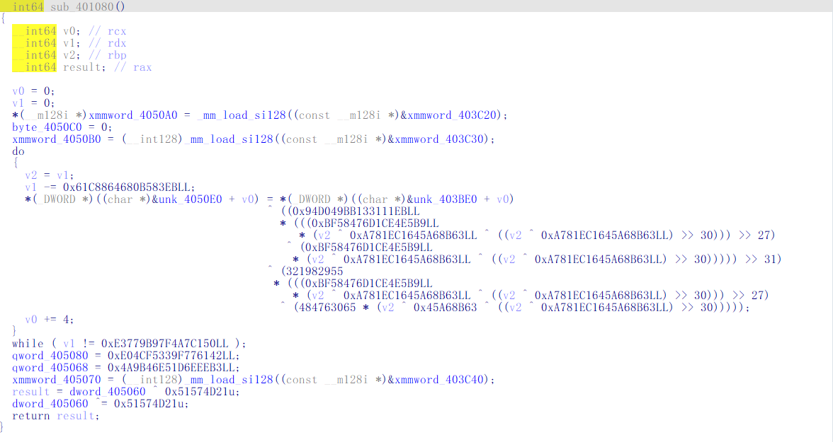5.中间 5 字符校验
第三段校验只检查中间 5 个字符 (s[9]~s[13])，不检查外层结构。
这 5 个字符必须来自 32 字符集合：ABCDEFGHJKLMNPQRSTUVWXYZ23456789
校验过程：
• 通过 strchr 获取每个字符在字符集中的下标
• 将 5 个下标编码为一个 24-bit 值 v121（v121 <= 0xFFFFFF 限制）
• 对 v121 做仿射变换: x = ((v121 - 0xB3EF33) * inv(0xD1D7D5)) & 0xFFFFFF
• 将 x 输入自定义哈希函数 sub_401CA0，检查是否等于目标值 0xE04CF5339F776142
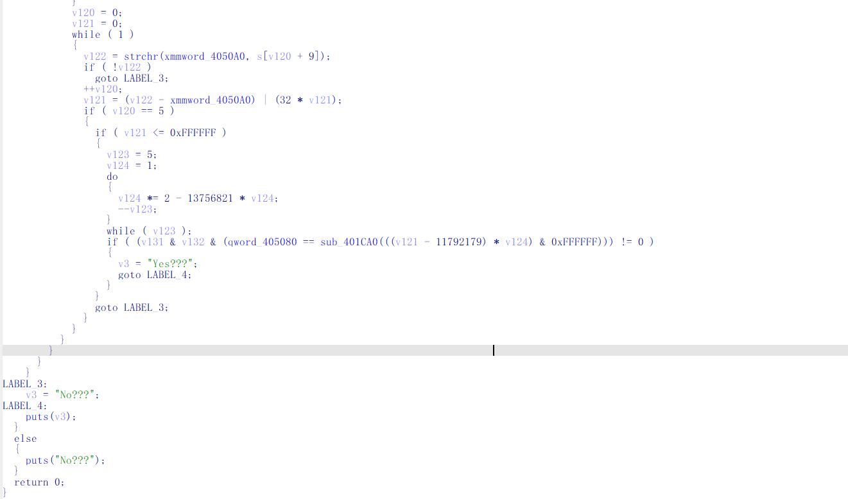6. 哈希函数 sub_401CA0
该函数为一个自定义哈希结构为：
• 用 splitmix64 风格 PRNG 初始化 1024 个 qword 的数组
• 执行 1536 轮混合变换（查表、异或、旋转）
• 最终从数组中提取结果并经过 splitmix64 收尾
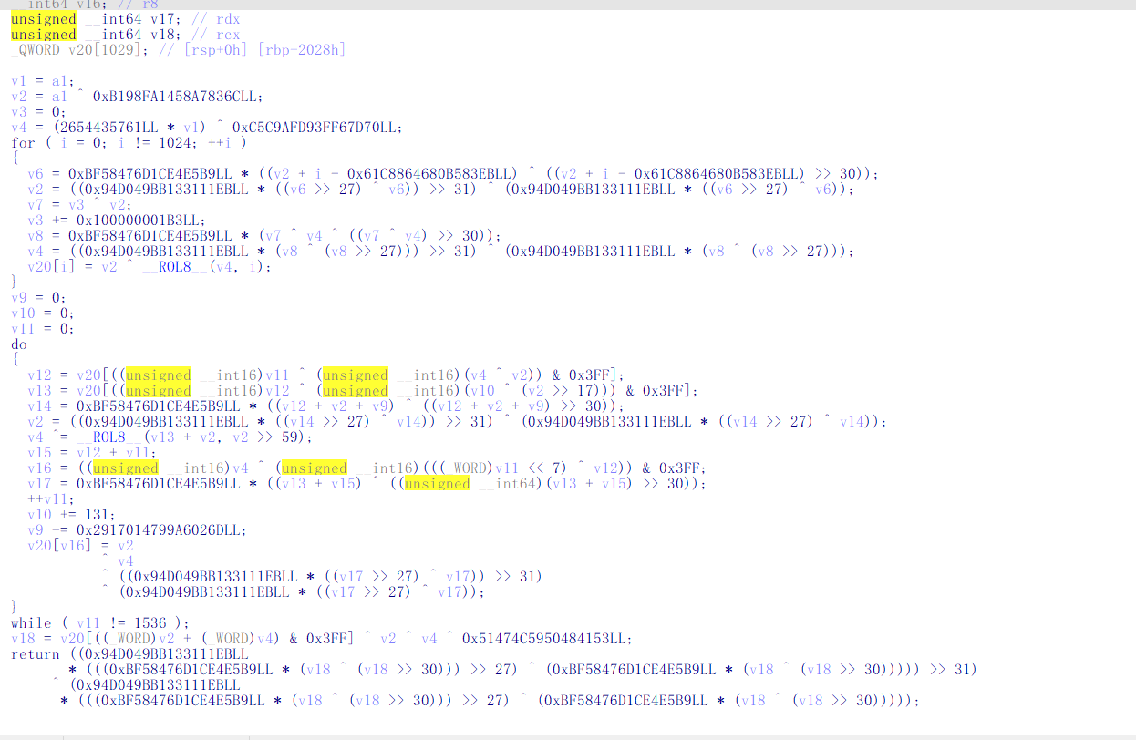7. 穷举中间 5 字符
由于搜索空间仅为 2^24 = 16,777,216 个可能值（5 个字符编码为 24-bit），可以采用直接穷举。利用 Numba JIT 加速哈希函数的计算，穷举所有 24-bit 仿射变换前的 x 值，检查 sub_401CA0(x) 是否等于目标哈希。命中后通过仿射反变换得到 v121 = (x * 0xD1D7D5 + 0xB3EF33) & 0xFFFFFF，再解码为 5 个字符。穷举约 66 秒得到唯一命中结果：FE6V6
将中间 5 字符补回骨架，得到完整 flag：
ISCC{QRM_FE6V6_3_w1tness_no_single_path!!}

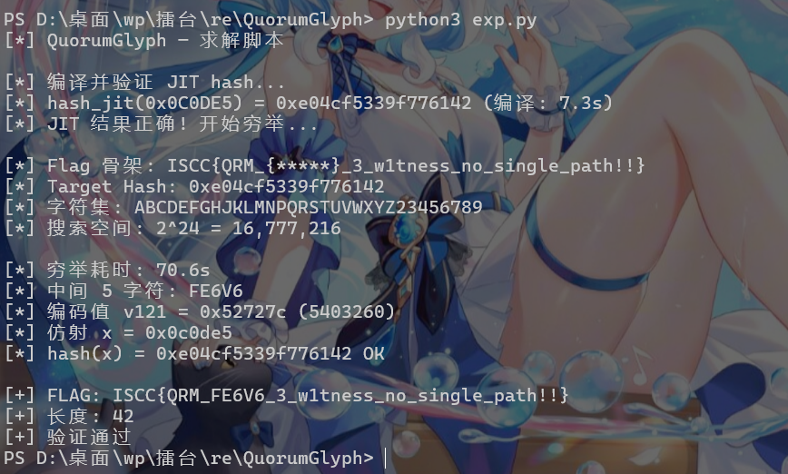

Exp 代码：

# -*- coding: utf-8 -*-
# -*- coding: utf-8 -*-
"""
QuorumGlyph — 完整求解脚本
ISCC{QRM_XXXXX_3_w1tness_no_single_path!!}
"""

import sys
import numpy as np
from numba import njit

M32 = 0xFFFFFFFF
M64 = 0xFFFFFFFFFFFFFFFF

TARGET_HASH = 0xE04CF5339F776142
CHARSET = b'ABCDEFGHJKLMNPQRSTUVWXYZ23456789'

def rol64(x, n):
n &= 63
return ((x << n) | (x >> (64 - n))) & M64

def splitmix64(x):
"""标准 splitmix64 单步: x = state, 返回 (next_state, output)"""
x = (x + 0x9E3779B97F4A7C15) & M64
z = x
z = (z ^ (z >> 30)) * 0xBF58476D1CE4E5B9 & M64
z = (z ^ (z >> 27)) * 0x94D049BB133111EB & M64
z = (z ^ (z >> 31)) & M64
return x, z

def hash_401CA0_py(a1):
"""纯 Python 版 sub_401CA0（对照用）"""
v1 = a1 & M32
v2 = (a1 ^ 0xB198FA1458A7836C) & M64
v3 = 0
v4 = ((2654435761 * v1) ^ 0xC5C9AFD93FF67D70) & M64

v20 = [0] * 1024
for i in range(1024):
t = (v2 + i - 0x61C8864680B583EB) & M64
t = (t ^ (t >> 30)) & M64
v6 = (0xBF58476D1CE4E5B9 * t) & M64
r1 = ((v6 >> 27) ^ v6) & M64
prod1 = (0x94D049BB133111EB * r1) & M64
v2 = ((prod1 >> 31) ^ prod1) & M64

v7 = (v3 ^ v2) & M64
v3 = (v3 + 0x100000001B3) & M64

t2 = ((v7 ^ v4) ^ ((v7 ^ v4) >> 30)) & M64
v8 = (0xBF58476D1CE4E5B9 * t2) & M64
r2 = (v8 ^ (v8 >> 27)) & M64
prod2 = (0x94D049BB133111EB * r2) & M64
v4 = ((prod2 >> 31) ^ prod2) & M64

v20[i] = (v2 ^ rol64(v4, i)) & M64

v9 = 0
v10 = 0
for v11 in range(1536):
idx1 = ((v11 & 0xFFFF) ^ ((v4 ^ v2) & 0xFFFF)) & 0x3FF
v12 = v20[idx1]
idx2 = ((v12 & 0xFFFF) ^ ((v10 ^ (v2 >> 17)) & 0xFFFF)) & 0x3FF
v13 = v20[idx2]

t3 = (v12 + v2 + v9) & M64
t3 = (t3 ^ (t3 >> 30)) & M64
v14 = (0xBF58476D1CE4E5B9 * t3) & M64
r3 = ((v14 >> 27) ^ v14) & M64
prod3 = (0x94D049BB133111EB * r3) & M64
v2 = ((prod3 >> 31) ^ prod3) & M64

v4 ^= rol64((v13 + v2) & M64, v2 >> 59)
v4 &= M64

v15 = (v12 + v11) & M64
idx3 = ((v4 & 0xFFFF) ^ (((v11 << 7) ^ v12) & 0xFFFF)) & 0x3FF

t4 = (v13 + v15) & M64
t4 = (t4 ^ (t4 >> 30)) & M64
v17 = (0xBF58476D1CE4E5B9 * t4) & M64
r4 = ((v17 >> 27) ^ v17) & M64
prod4 = (0x94D049BB133111EB * r4) & M64
v20[idx3] = (v2 ^ v4 ^ ((prod4 >> 31) ^ prod4)) & M64

v10 += 131
v9 = (v9 - 0x2917014799A6026D) & M64

idx_final = (((v2 + v4) & 0xFFFF)) & 0x3FF
v18 = (v20[idx_final] ^ v2 ^ v4 ^ 0x51474C5950484153) & M64
t5 = (v18 ^ (v18 >> 30)) & M64
t6 = (0xBF58476D1CE4E5B9 * t5) & M64
r5 = ((t6 >> 27) ^ t6) & M64
prod5 = (0x94D049BB133111EB * r5) & M64
return ((prod5 >> 31) ^ prod5) & M64

# ---- Numba JIT 加速版 (全部使用 uint64 确保逻辑移位) ----
U0 = np.uint64(0)

@njit
def hash_401CA0(a1):
"""sub_401CA0 — JIT 加速"""
v2 = np.uint64(a1) ^ np.uint64(0xB198FA1458A7836C)
v3 = U0
v4 = np.uint64(2654435761) * np.uint64(a1 & 0xFFFFFFFF) ^ np.uint64(0xC5C9AFD93FF67D70)

v20 = np.zeros(1024, dtype=np.uint64)

for i in range(1024):
t = v2 + np.uint64(i) - np.uint64(0x61C8864680B583EB)
t = t ^ (t >> np.uint64(30))
v6 = np.uint64(0xBF58476D1CE4E5B9) * t
r1 = (v6 >> np.uint64(27)) ^ v6
p1 = np.uint64(0x94D049BB133111EB) * r1
v2 = (p1 >> np.uint64(31)) ^ p1

v7 = v3 ^ v2
v3 = v3 + np.uint64(0x100000001B3)

t2 = (v7 ^ v4) ^ ((v7 ^ v4) >> np.uint64(30))
v8 = np.uint64(0xBF58476D1CE4E5B9) * t2
r2 = (v8 >> np.uint64(27)) ^ v8
p2 = np.uint64(0x94D049BB133111EB) * r2
v4 = (p2 >> np.uint64(31)) ^ p2

v20[i] = v2 ^ _rol64(v4, np.uint64(i))

v9 = U0
v10 = U0
for v11 in range(1536):
idx1 = (np.uint64(v11) ^ (v4 ^ v2)) & np.uint64(0x3FF)
v12 = v20[idx1]
idx2 = (v12 ^ (v10 ^ (v2 >> np.uint64(17)))) & np.uint64(0x3FF)
v13 = v20[idx2]

t3 = v12 + v2 + v9
t3 = t3 ^ (t3 >> np.uint64(30))
v14 = np.uint64(0xBF58476D1CE4E5B9) * t3
r3 = (v14 >> np.uint64(27)) ^ v14
p3 = np.uint64(0x94D049BB133111EB) * r3
v2 = (p3 >> np.uint64(31)) ^ p3

v4 ^= _rol64(v13 + v2, v2 >> np.uint64(59))

v15 = v12 + np.uint64(v11)
idx3 = (v4 ^ ((np.uint64(v11) << np.uint64(7)) ^ v12)) & np.uint64(0x3FF)

t4 = v13 + v15
t4 = t4 ^ (t4 >> np.uint64(30))
v17 = np.uint64(0xBF58476D1CE4E5B9) * t4
r4 = (v17 >> np.uint64(27)) ^ v17
p4 = np.uint64(0x94D049BB133111EB) * r4
v20[idx3] = v2 ^ v4 ^ ((p4 >> np.uint64(31)) ^ p4)

v10 += np.uint64(131)
v9 -= np.uint64(0x2917014799A6026D)

idx_final = (v2 + v4) & np.uint64(0x3FF)
v18 = v20[idx_final] ^ v2 ^ v4 ^ np.uint64(0x51474C5950484153)
t5 = v18 ^ (v18 >> np.uint64(30))
t6 = np.uint64(0xBF58476D1CE4E5B9) * t5
r5 = (t6 >> np.uint64(27)) ^ t6
p5 = np.uint64(0x94D049BB133111EB) * r5
return (p5 >> np.uint64(31)) ^ p5

@njit
def _rol64(x, n):
n &= np.uint64(63)
return (x << n) | (x >> (np.uint64(64) - n))

def solve_witness3(charset_bytes, target, hashfn):
"""穷举 Witness-3"""
inv = 1
c = 13756821
for _ in range(5):
inv = (inv * (2 - c * inv)) & M64
inv_24 = inv & 0xFFFFFF

B = 11792179

for v121 in range(0x1000000):
x = ((v121 - B) * inv_24) & 0xFFFFFF
if hashfn(x) == target:
# 解码 v121 -> 5 chars
d0 = v121 // 1048576
r = v121 - d0 * 1048576
d1 = r // 32768
r -= d1 * 32768
d2 = r // 1024
r -= d2 * 1024
d3 = r // 32
d4 = r - d3 * 32
mid = (chr(charset_bytes[d0]) + chr(charset_bytes[d1]) +
chr(charset_bytes[d2]) + chr(charset_bytes[d3]) + chr(charset_bytes[d4]))
return v121, mid

return 0, ""

def main():
print("[*] QuorumGlyph — 求解脚本")
print()

# 验证 JIT 版
print("[*] 编译并验证 JIT hash...")
import time
t0 = time.time()
h_jit = hash_401CA0(0x0C0DE5)
t1 = time.time()
print(f"[*] hash_jit(0x0C0DE5) = 0x{h_jit:016x} (编译: {t1-t0:.1f}s)")

if h_jit == TARGET_HASH:
print("[*] JIT 结果正确! 开始穷举...")
hashfn = hash_401CA0
else:
print("[*] JIT 结果错误! 使用 Python 版本...")
hashfn = hash_401CA0_py

print()

# 穷举 Witness-3
print(f"[*] Flag 骨架: ISCC{{QRM_{{*****}}_3_w1tness_no_single_path!!}}")
print(f"[*] Target Hash: 0x{TARGET_HASH:016x}")
print(f"[*] 字符集: {CHARSET.decode()}")
print(f"[*] 搜索空间: 2^24 = 16,777,216")
print()

t2 = time.time()
v121, middle = solve_witness3(np.frombuffer(CHARSET, dtype=np.uint8), TARGET_HASH, hashfn)
t3 = time.time()

if not middle:
print("[-] 未找到匹配!")
return

print(f"[*] 穷举耗时: {t3 - t2:.1f}s")
print(f"[*] 中间 5 字符: {middle}")
print(f"[*] 编码值 v121 = 0x{v121:06x} ({v121})")

# 仿射验证
inv = 1
c = 13756821
for _ in range(5):
inv = (inv * (2 - c * inv)) & M64
inv_24 = inv & 0xFFFFFF
x_val = ((v121 - 11792179) * inv_24) & 0xFFFFFF
h_check = hashfn(x_val)
print(f"[*] 仿射 x = 0x{x_val:06x}")
print(f"[*] hash(x) = 0x{h_check:016x} {'OK' if h_check == TARGET_HASH else 'FAIL'}")

flag = f"ISCC{{QRM_{middle}_3_w1tness_no_single_path!!}}"
print()
print(f"[+] FLAG: {flag}")
print(f"[+] 长度: {len(flag)}")

if len(flag) == 42:
print("[+] 验证通过")

if __name__ == '__main__':
main()

