Hello //User_ID//

Welcome to //Company// and please read the following information to get you started.  Please also go through the additional materials in the attached file.

Below is your user name and temporary password. Your logon credentials are used for all //Company// logons, except Skype, and you can change your password at any time by following the steps mentioned in the follow section.

Your email: //Email_ID//

**Your user name**: //User_ID//

**Your temporary password**: //Pcpassword//

SAP User: //SAP_ID//

SAP password: //SAPpassword//

Upon your successful logon to your Windows workstation, please change your password by press the Ctrl + Alt + Delete keys, select the option to change the password and fill out the input fields (The below picture shows the steps to change your password).  Windows requires the password to have at least 1 capital character and minimum of 8 alphanumeric characters.  This password is used for all BRTCHIP logons, except Skype, so don’t forget it.   Please note that the FTDI password is good for a 45-day period and Windows will prompt you to change your password before it expires as well a reminder email.

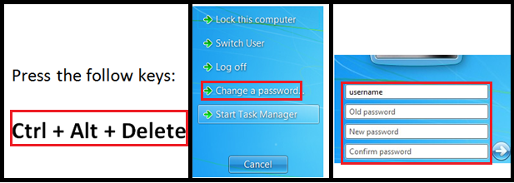

The above method can be used if you were using a local workstation.  Alternatively, your logon password can be changed when you’re accessing your email through the web browser, it’s useful when you’re unable to access a local workstation PC.  Scroll down this email to see how to access the FTDI email through a web browser.  To change the //Company// logon password, simply click the “Options” dropdown menu located in the upper right area, choose “Change Your Password…” option and enter your new logon credential.

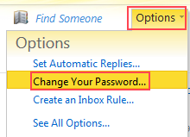

Below is your Skype user name and temporary password.

**Skype user name**: //Skype_ID//

**Skype temporary password**: //skypepassword// (Do not change the password)

We mostly use Skype for video/audio conferences with oversea colleagues.  Many staffs have the following Skype naming convention://Company//. (first name).(last name), but not all of them do though.  Please note that Skype credentials cannot be used with any //Company// Logons, e.g. VPN, Sharepoint, workstation.  Once again, changing your //Company// password, as mentioned above, wouldn’t affect your Skype password and vice versa.

**For your information:**

Microsoft SharePoint server is used to share company-wide documents, e.g. employee manual, department documents…  You can access the server with the following web browser address, the logon credential is the same as your //Company// logon credentials (NOTE: This server can only be accessed in local network or via VPN):

               BRT Sharepoint: <http://sharepoint.brtchip.local>

FTDI Sharepoint: <http://sharepoint.ftdi.local>