8/3/2017

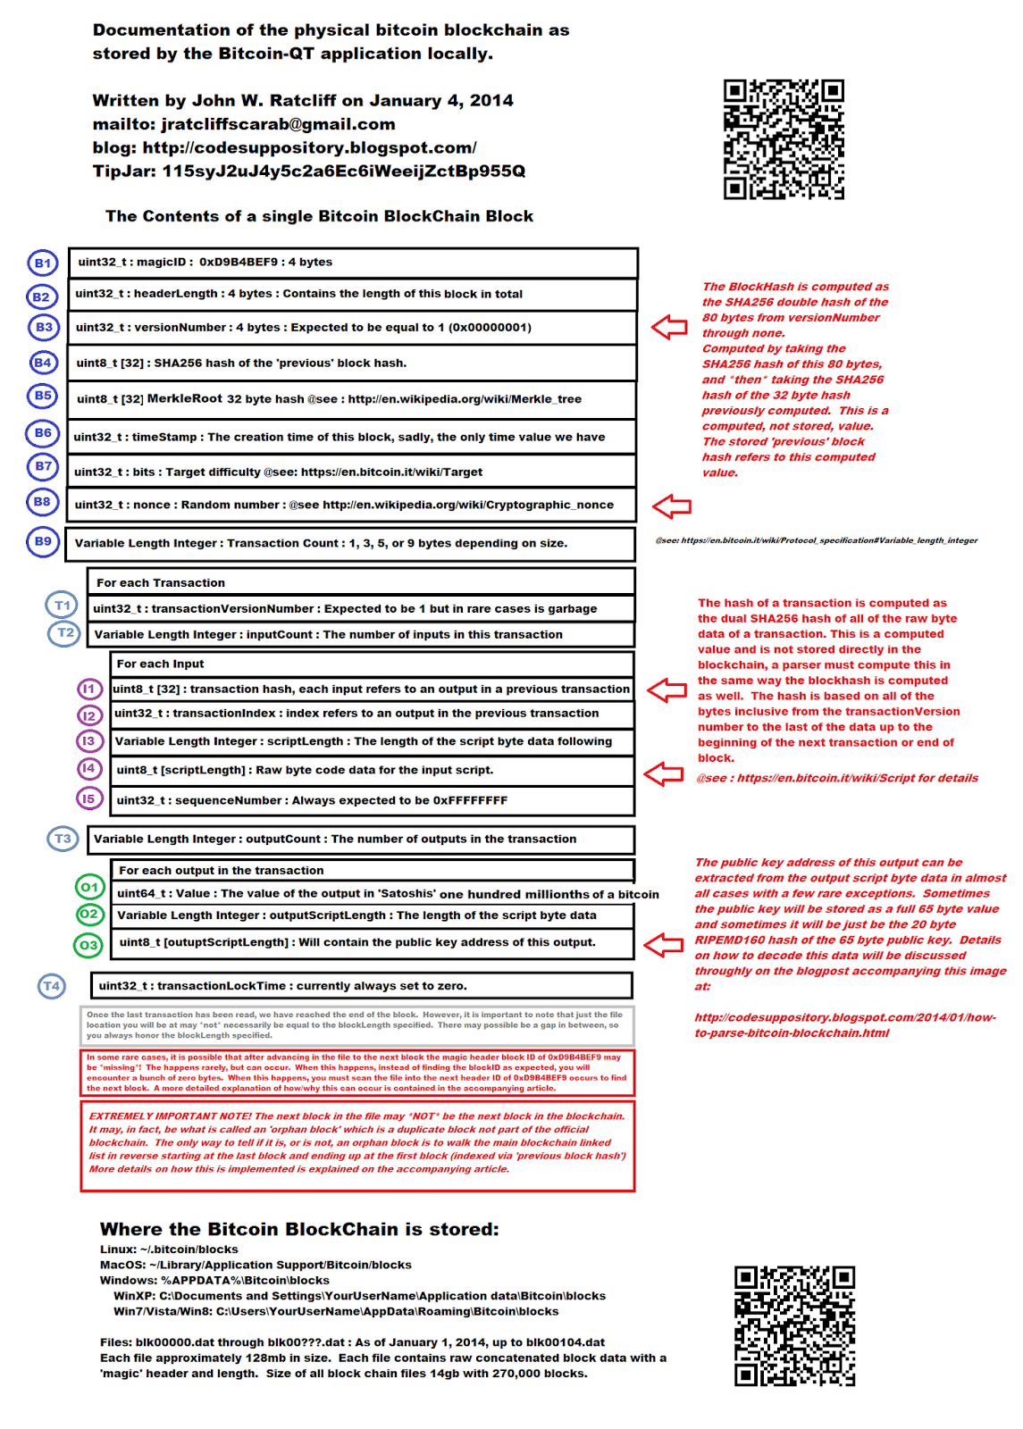

Processing steps to parse the entire blockchain

1. Read list of .dat files in from the blocks folder
2. Iterate through each file
   1. Read in the entire file
   2. Iterate through each block
      1. Read in the magic number: UINT32 0xD9B4BEF9 (4 bytes)
      2. Read in the length of the block: UINT32 (4 bytes)
      3. Read the rest of the block based in the length
         1. Read in hash of the previous block: UINT8[32], SHA256
         2. Read in Merkle Root: UINT8[32], SHA256
         3. Read in timestamp: UINT32, creation time of the block (4 bytes)