KTU C opy Scanner
Test Results

Device: “MI Tablet”
Internet Medium: Wi-Fi
Connection Speed: 1 Mbps

- OBSERVATION-1 (QR code vs Bar code)

Number of copies scanned: 70

QR codes scanned: 50
Number of QR codes successfully scanned: 50
Accuracy: 100%

Bar codes scanned: 20
Number of Bar codes scanned successfully: 14
Accuracy: 70%

Conclusion:
Application is working more effectively with QR codes rather than Bar codes. Accuracy difference is considerably large.

- OBSERVATION-2 (PDF generating time)

Number of copies scanned: 50

Total images scanned: 204 (~4 images per copy)
PDFs generated: 50
Average size of one PDF: ~1 MB
PDF generation time: 93 seconds
Max time: 120 seconds

Conclusion:
It takes around 2-3 minutes to generate PDF's for 50 copies, where each copy contains approximately 4 images.

- OBSERVATION-3 (Network Latency / Upload Time)

Number of copies scanned: 50

Total images scanned: 204 (~4 images per copy)
PDFs generated: 50
Average size of one PDF: ~1 MB
Time consumed to synchronize: ~30 min

Conclusion:
It takes nearly half an hour to synchronize or upload 50 PDFs to server, with internet speed of approximately 1Mbps. This includes log upload and database synchronization as well.

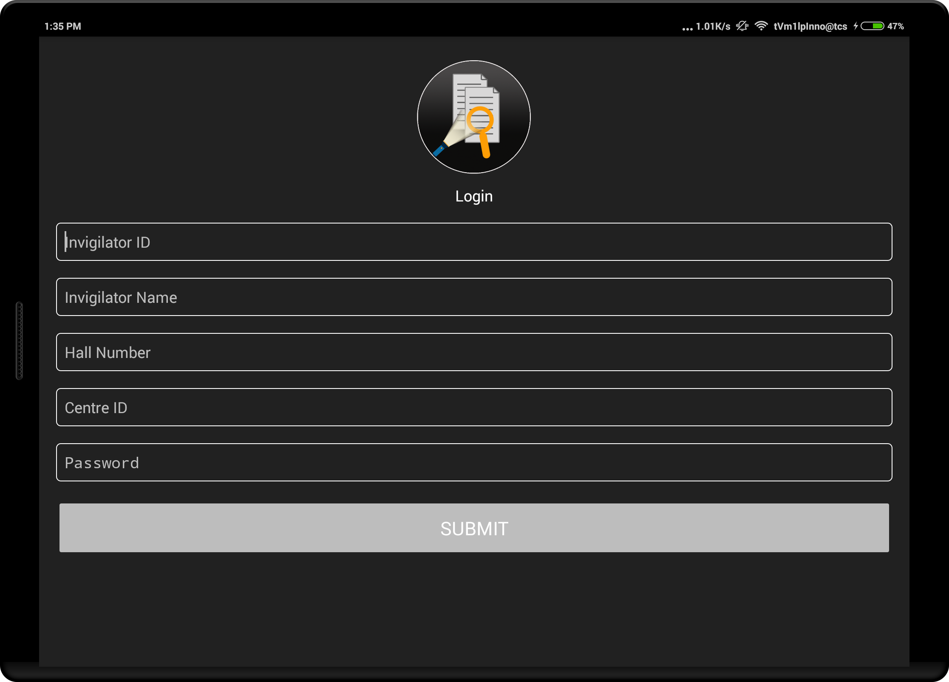

- Log-in screen
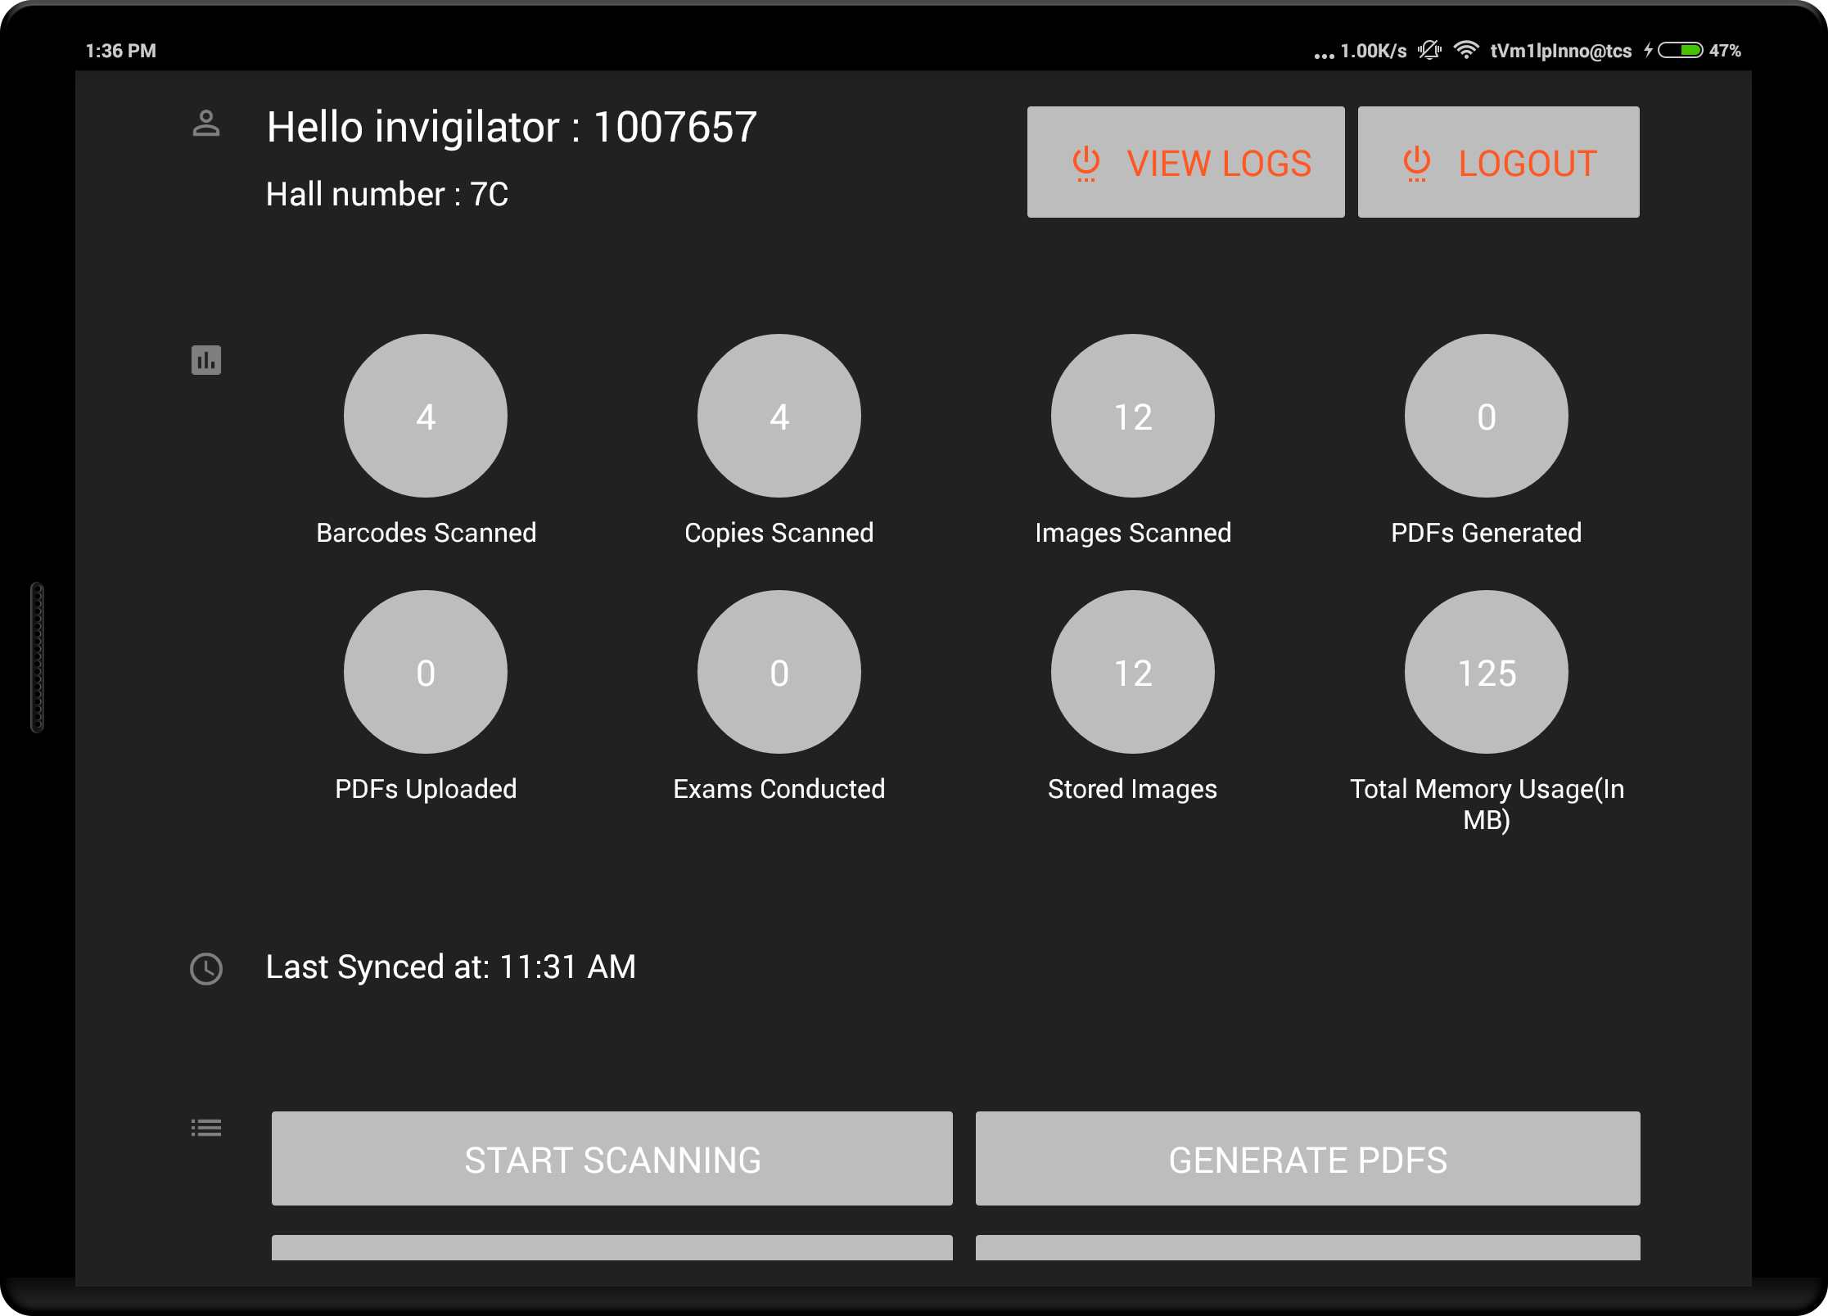

- Home Screen

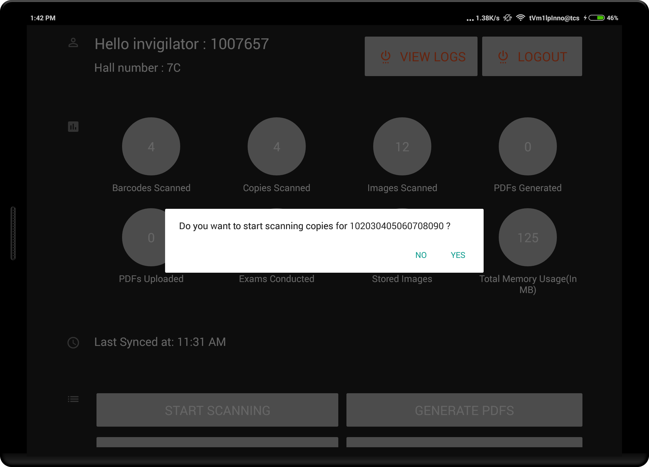
- Starting scan
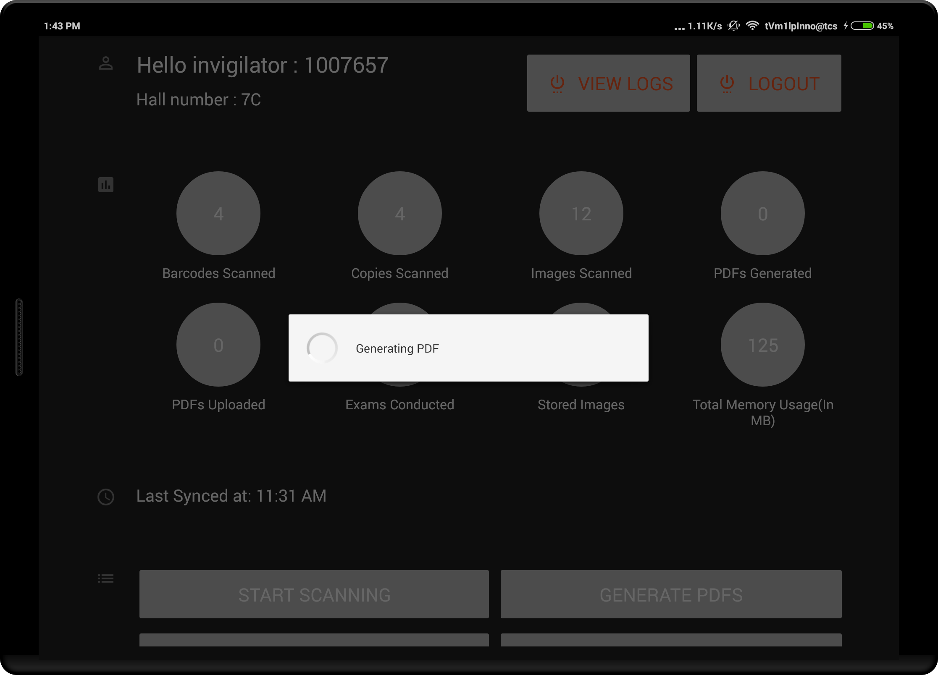

- Generating PDF

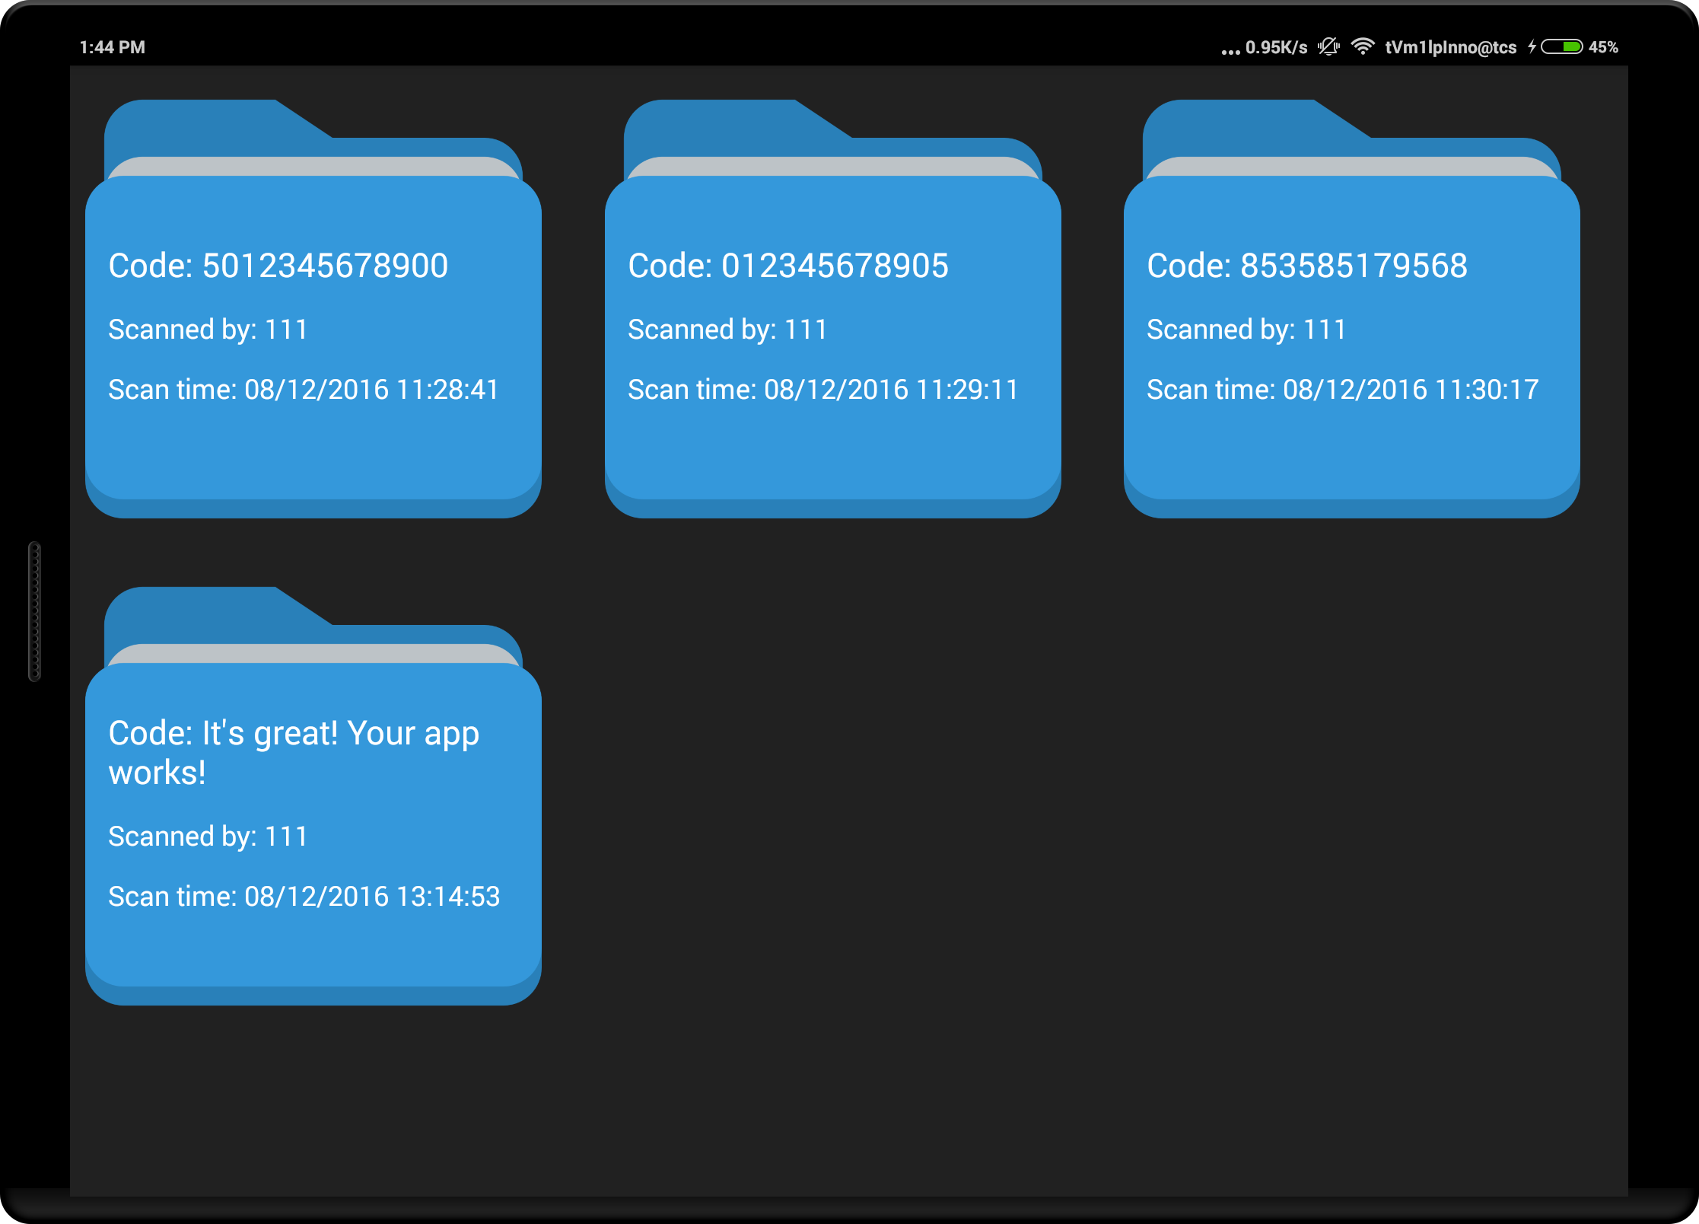
- Viewing PDFs
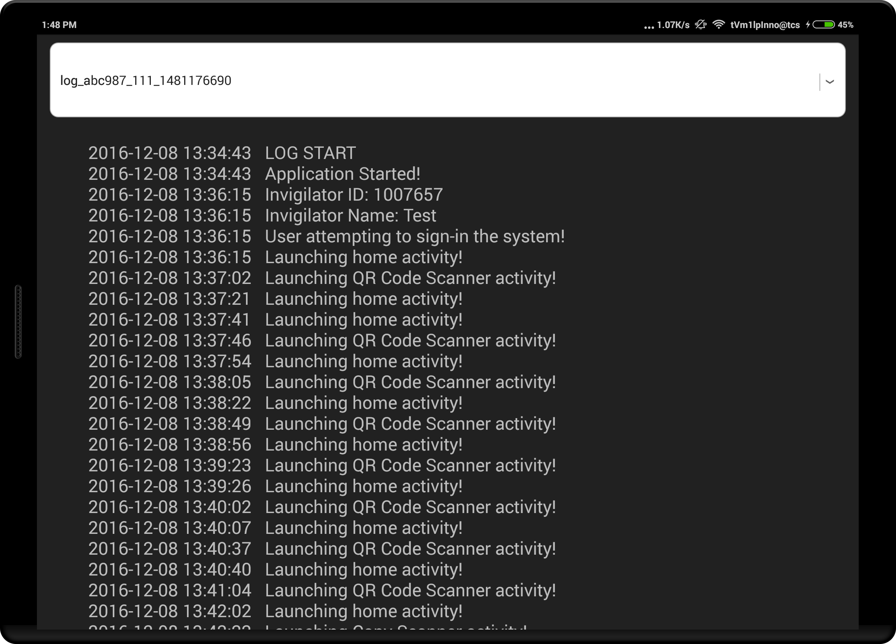

- Logs Screen

