Altay İlker Yiğitel

22203024

CS 223 Lab01 Preliminary Work

For the first part of the preliminary task the function where 3 switches affect the outcome and where it has to be possible to turn the light on or off by changing the state of any one of the switches has only one solution. It is where we after applying the base condition of 0 0 0 resulting in 0 any switch changed should give 1 so any situation where there is only 1 switch closed (1) results in 1. Same logic can be applied where only 2 or only 3 switches are closed as well so only 2 switch closed gives 0 and all switches closed gives 1.

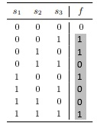

F(s1, s2, s3) = s1s2s3 + s1's2's3 + s1s2's3’ + s1's2s3’

F(s1, s2, s3) = (s1 + s2 + s3) \*(s1 + s2' + s3') \*(s1' + s2’ + s3) \*(s1' + s2 + s3’)

Second digit of my ID is even

Logic diagram of the circuit canonical sum-of-products:

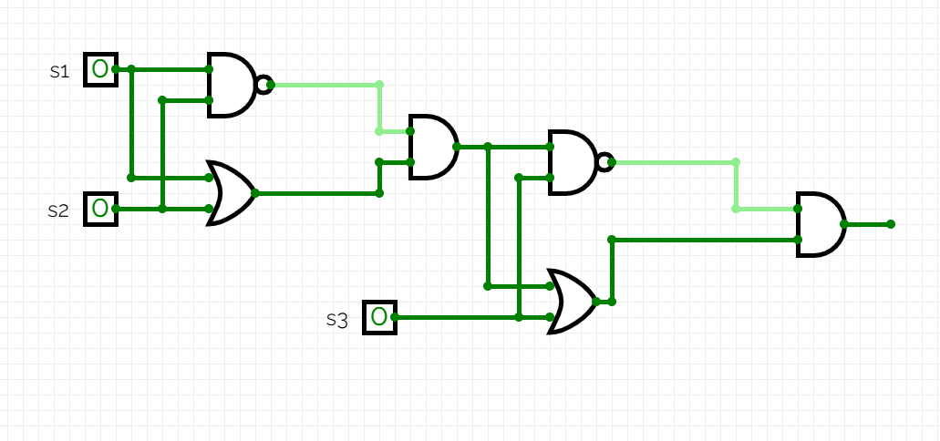

2 AND, 2OR, 2NAND gates are required

3 packages are required for the diagram

Circuit Schematic:

