CS223 LAB5

Altay İlker Yiğitel

22203024

CS223 sec: 01

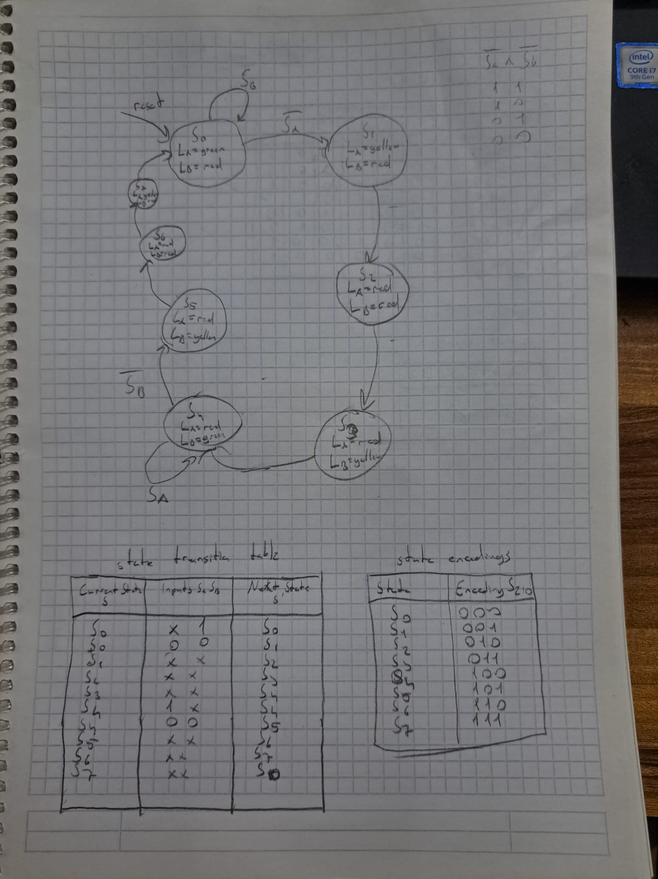

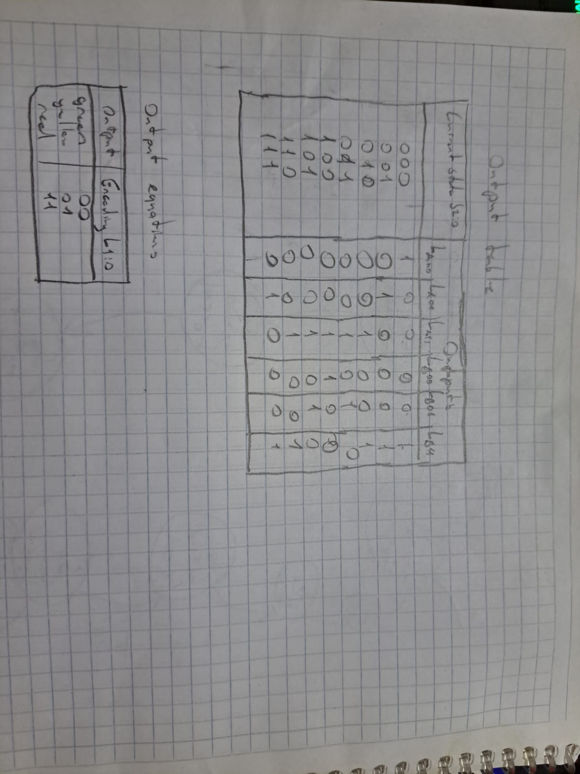

2 flip flops are needed as there are 2 important states La=green Lb=red and La=red and Lb=green

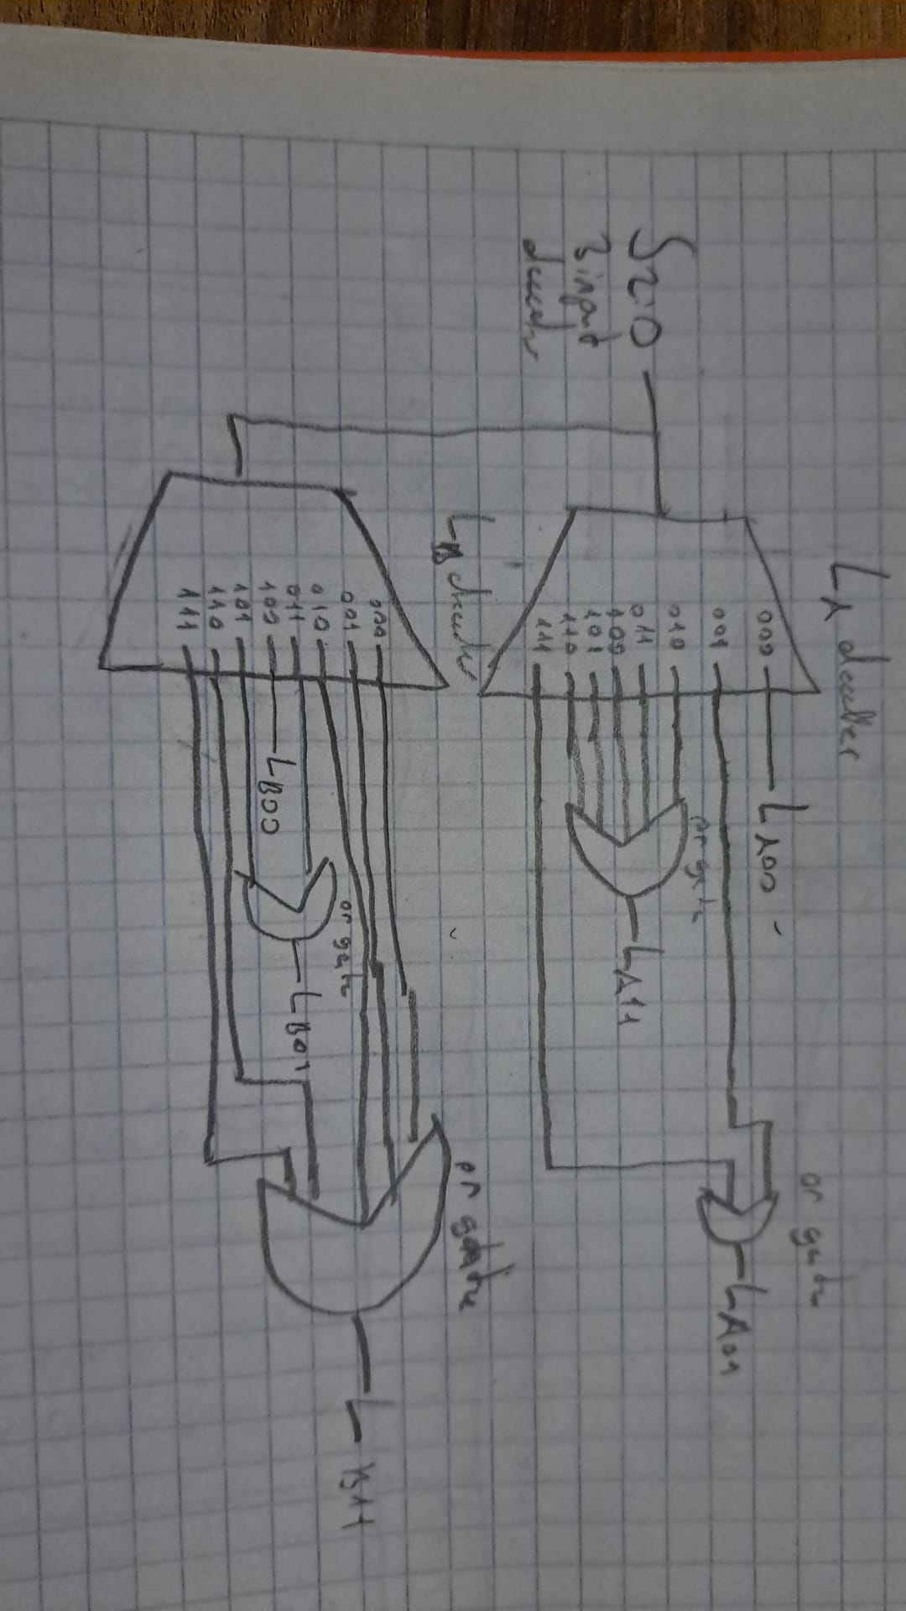

System verilog code

Traffic Light System

module traffic(

input SA,

input SB,

output LA_green,

output LA_yellow,

output LA_red,

output LB_green,

output LB_yellow,

output LB_red,

input clk

);

typedef enum logic [3:0] {

BOTH_RED1,

BOTH_RED2,

LA_GREEN,

LB_GREEN,

LA_YELLOW1,

LB_YELLOW1,

LA_YELLOW2,

LB_YELLOW2

} state_t;

state_t current_state, next_state;

logic [1:0] counter;

initial begin

current_state = LA_GREEN;

counter = 0;

LA_green = 1; LA_yellow = 0; LA_red = 0;

LB_green = 0; LB_yellow = 0; LB_red = 1;

end

always @(posedge clk) begin

case (current_state)

LA_GREEN: begin

if (!(SA && SB)) begin

next_state = LA_GREEN;

end else begin

next_state = LA_YELLOW1;

end

end

LB_GREEN: begin

if (!(SA && SB)) begin

next_state = LB_GREEN;

end else begin

next_state = LB_YELLOW1;

end

end

BOTH_RED1: begin

if (counter == 3) begin

next_state = LA_YELLOW2;

end else begin

next_state = BOTH_RED1;

end

end

BOTH_RED2: begin

if (counter == 3) begin

next_state = LB_YELLOW2;

end else begin

next_state = BOTH_RED2;

end

end

LA_YELLOW1: begin

if (counter == 3) begin

next_state = BOTH_RED1;

end else begin

next_state = LA_YELLOW1;

end

end

LB_YELLOW1: begin

if (counter == 3) begin

next_state = BOTH_RED2;

end else begin

next_state = LB_YELLOW1;

end

end

LA_YELLOW2: begin

if (counter == 3) begin

next_state = LB_GREEN;

end else begin

next_state = LA_YELLOW2;

end

end

LB_YELLOW2: begin

if (counter == 3) begin

next_state = LA_GREEN;

end else begin

next_state = LB_YELLOW2;

end

end

endcase

end

always @(posedge clk) begin

if (counter == 3) begin

counter <= 0;

end else begin

counter <= counter + 1;

end

case (next_state)

BOTH_RED: begin

LA_green = 0; LA_yellow = 0; LA_red = 1;

LB_green = 0; LB_yellow = 0; LB_red = 1;

end

BOTH_YELLOW: begin

LA_green = 0; LA_yellow = 1; LA_red = 0;

LB_green = 0; LB_yellow = 1; LB_red = 0;

end

LA_GREEN: begin

LA_green = 1; LA_yellow = 0; LA_red = 0;

LB_green = 0; LB_yellow = 0; LB_red = 1;

end

LB_GREEN: begin

LA_green = 0; LA_yellow = 0; LA_red = 1;

LB_green = 1; LB_yellow = 0; LB_red = 0;

end

LA_YELLOW: begin

LA_green = 0; LA_yellow = 1; LA_red = 0;

LB_green = 0; LB_yellow = 0; LB_red = 1;

end

LB_YELLOW: begin

LA_green = 0; LA_yellow = 0; LA_red = 1;

LB_green = 0; LB_yellow = 1; LB_red = 0;

end

endcase

current_state <= next_state;

end

endmodule

Testbench

module traffic_tb;

input SA;

input SB;

input clk;

output LA_green;

output LA_yellow;

output LA_red;

output LB_green;

output LB_yellow;

output LB_red;

traffic dut (

.SA(SA),

.SB(SB),

.LA_green(LA_green),

.LA_yellow(LA_yellow),

.LA_red(LA_red),

.LB_green(LB_green),

.LB_yellow(LB_yellow),

.LB_red(LB_red),

.clk(clk)

);

always #5 clk = ~clk;

initial begin

SA = 0;

SB = 0;

#10;

assert(LA_green && LB_red);

SA = 1;

#10;

assert(LA_yellow && LB_red);

SA = 0;

SB = 1;

#10;

assert(LB_green && LA_red);

SA = 1;

#10;

assert(LA_red && LB_red);

$finish;

end

endmodule

Counter

module BCD_Counter(

input clk,

input reset,

input enable,

input load,

input [3:0] D,

output [3:0] Q

);

always @(posedge clk) begin

if (reset) begin

Q <= 4'b0000;

end

if (enable) begin

if (load) begin

Q <= D;

end else begin

if (Q == 4'b1001) begin

Q <= 4'b0000;

end else begin

Q <= Q + 1;

end

end

end

end

endmodule

testbench

module BCD_Counter_TB;

input clk;

input reset;

input enable;

input load;

input [3:0] D;

output [3:0] Q;

BCD_Counter counter(

.clk(clk),

.reset(reset),

.enable(enable),

.load(load),

.D(D),

.Q(Q)

);

always #((CLK_PERIOD)/2) clk = ~clk;

initial begin

clk = 0;

reset = 0;

enable = 0;

load = 0;

D = 0;

#20 reset = 1;

#20 reset = 0;

#10 enable = 1;

#20;

assert(Q == 4'b0001) else ;

#30;

assert(Q == 4'b0000) ;

D = 4'b1100;

load = 1;

#20;

load =0;

assert(Q == 4'b1100) ;

#20;

assert(Q == 4'b1101) ;

$finish;

end

endmodule

BCD Counter

module BCD_Counter(

input clk,

input reset,

input enable,

output [3:0] BCD

);

always @(posedge clk) begin

if (reset) begin

BCD <= 4'b0000;

end else if (enable) begin

if (BCD == 4'b1001) begin

BCD <= 4'b0000;

end else begin

BCD <= BCD+1;

end

end

end

endmodule

module BCD_Counter_Reset_TB;

input clk;

inpt reset;

input enable;

output [3:0] BCD;

BCD_Counter counter(

.clk(clk),

.reset(reset),

.enable(enable),

.BCD(BCD)

);

always #((CLK_PERIOD)/2) clk = ~clk;

initial begin

clk = 0;

reset = 0;

enable = 0;

#20 reset = 1;

#20 reset = 0;

#10 enable = 1;

#20;

assert(BCD == 4'b0001) ;

#30;

assert(BCD == 4'b0000) ;

#30;

assert(BCD == 4'b0001) ;

#200;

assert(BCD == 4'b1001) ;

#30;

assert(BCD == 4'b0000) ;

#30;

assert(BCD == 4'b0001);

$finish;

end

endmodule

Two digit

module TwoDigit_BCD_Counter(

input clk,

input reset,

output [3:0] ones,

output [3:0] tens

);

always @(posedge clk) begin

if(ones ==9) begin

ones <=0;

if(tens ==9) begin

tens <=0;

end

else begin

tens <= tens+1;

end

end

else begin

ones <=ones+1;

end

endmodule

Testbench

module TwoDigit_BCD_Counter_TB;

reg clk;

reg reset;

wire [3:0] ones;

wire [3:0] tens;

TwoDigit_BCD_Counter counter(

.clk(clk),

.reset(reset),

.ones(ones),

.tens(tens),

);

always #((CLK_PERIOD)/2) clk = ~clk;

initial begin

clk = 0;

reset = 0;

#20 reset = 1;

#20 reset = 0;

#10;

assert(ones == 4'b0000 && tens 4'b0000);

$finish;

end

endmodule