I.R.  ITC Teacher and Technical Consultant (Developer) | 
Year | Project/IT Experience
Birth. 1969 | Since 1987
Language Skills | Focus on
English=B2, Italian=B2, German=B1 | - Full Stack ERP Development  - Software Testing in an Agile Environment  - SAP PI/PO/CPI Consulting
Training | Other Skills
- Master of Science in Engineering Geophysics  - Master of Science in Engineering Informatics | Installation, configuration and maintenance of networks  Communication | Problem solving
Available | Knowledge
By arrangement | SAP Certified Associate - Integration Developer (C_CPI_2403)  SAP Certified Technology Associate - Process Orchestration (C_PO_7517)  Editing and graphic design of presentations
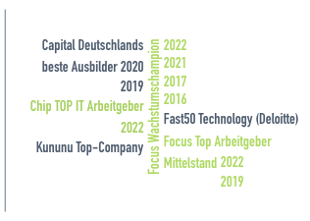


RealCore Group GmbH | Im Welterbe 2 | 45141 Essen
info@realcore.de | Phone: +49 201 486 399 10

PERSONAL DATA

Experience and skillset
Technical environment
Programming languages | C++, Java | Javascript | PHP
Databases | SQL | MySQL | SAP Hana
Operating systems | Unix | Ms. DOS | Linux
Other | Application Maintenance  and support | … | …

Certificates

LinkedIn - Skill Assessment Badge - in the top 5% for OOP, Javascript, Java
Udemy - SAP ABAP Programming for Beginners – Online training
Coursera - SAP PI Process Integration Consultant Training + Scenarios
Udemy - SAP CPI: Overview of SAP Cloud Platform Integration
SAP - SAP Certified Technology Associate - Process Orchestration
SAP SAP Certified Development Associate - SAP Integration Suite

project / operational experience

01/2025 – till Present  Position / Role  SAP Development & Testing  Technologies used  Javascript, Node.js, SAP CPI, SAP UI5, Advanced Event Mesh & S4/Hana DB | Event-Driven Integration with SAP Advanced Event Mesh  "RealCore Albania" Tirana, AL  Automate the creation of sales orders of „CompuMac“ – Bodensee Sales System, JS, using SAP Integration Suite, UI5 APIs, and S4/Hana DB)  - iFlow creation in SAP Cloud Integration  - Create a web API in SAP Fiori (UI5) to start the process,  - Create & Publish an Event in ERP Sytem  - Distribute the event through AEM broker to all Consumers (SAP CI, POS & S4/Hana  - Return the acknowledgement (Ack) event after processing the message  - Using Cloud Connector to manipulate the S4/Hana database  - CRUD operations through Odata adapter in SAP S/4Hana database  - Frontend development with PHP, HTML5 & CSS  - Server backend development with JS and Node.js)
08/2024 – 10/2025  Position / Role  SAP Development & Consulting  Technologies used  Javascript, Node.js, SAP CPI, SAP UI5, API Management, SQL & S4/Hana DB | JS, SAP UI5 & SAP CI, API Management Development & Testing  "RealCore Albania" Tirana, AL  Automate the creation and processing of exams, in „Elite Online Academy“ using Javascript, Node.js, SAP UI5 and SAP Integration Suite, and databases (SQL and S4/Hana)  - iFlow creation in SAP Cloud Integration to adjust and transmit the exams data  - Create a web API in SAP Fiori (UI5) to start the process  - Build API proxy for REST API from API provider,  - Create and publish a product, add Policy, generate and use API-Key  - Manage Traffic with Spike Arrest API Policy  - Using Cloud Connector to manipulate the SQL database  - CRUD operations through Odata adapter in SAP S/4Hana database  - Frontend development with PHP, JS, HTML5 & CSS  - Server backend development with PHP, Javascript)  - Use of XML, JSON and Ajax data languages – data parsing and conversion

project / operational experience
04/2024 – 07/2025  Position / Role  Developer  Technologies used  SAP Fiori, SAP BTP, SAP Hana DB, SAP Integration Suite, PHP, Javascript, React JS, Html5, CSS | SAP CPI Development & Consultation  "RealCore Albania" Tirana, AL  Automate the creation of sales orders using SAP Integration Suite, UI5 APIs, and databases (SQL and S4/Hana)  - iFlow creation in SAP Integration Suite  - Create a web API in SAP Fiori (UI5) to start the process  - Using Open Connector to manipulate the SQL database  - CRUD operations through Odata adapter in SAP S/4Hana database  - Frontend development with PHP, HTML5 & CSS  - Server backend development with PHP, Javascript)  - Use of XML, JSON and Ajax data languages – data parsing and conversion
08/2022 – 09/2025  Position / Role  SAP Consultant  Technologies used  OCC Consultation, AMS Support, SAP PI/PO/CPI Consulting and Development | PI/PO Consulting & Development  "RealCore Albania" Tirana, AL  Consulting & Development and various skills:  - Monitoring of network parameters and digital infrastructure in OCC  - Create SAP system documentation and consulting  - Experience in the operations control center  - SAP PI/PO/CPI consulting, error analysis, ticket creation and troubleshooting  - Conception and structuring of processes in BPM  - Realization of integration objects & mappings  - Creating Java user functions  - Knowledge and skills to create rules and alerts in BPM
03/2003 – 07/2022  Position / Role  Backend Developer, SQL Maintenance  Technologies used  Python, PHP, NodeJs, Javascript, SQL | School Manager - ERP  "No.1" Gymnasium – Vlore, AL  Complete electronic data management of the teaching and educational process in the school:  - Student attendance monitoring  - Register the results in the exams  - Inform parents via email & text message  - Create and print reports
06/2006 – 08/2013  Position / Role  Fullstack Developer  Technologies used  PHP, Javascript, MySQL, Html, CSS | My Clinic - ERP  "Malaj" Health Clinic, AL  Complete electronic management of patient data in a medical clinic:  - Monitoring of medical history in the database  - Analysis and diagnostics stored in the database  - Transmitting tracking parameters with a remote sensor  - Graphical representation of the patient's vital signs  - Planning of doctor's visits and medical operations
06/2011 – 12/2015  Position / Role  Fullstack Developer  Technologies used  Java, Javascript, P5 Library | Signal elaborating with FFT  "Polytechnic" University of Tirana  Convolution and signal processing with FFT based on functions of complex variables  - Interactive drawings of wave signals  - Frequency spectrum analysis with Fast Fourier transform  - Decomposition of primitive wave components into analog time fields
09/2016 – 07/2019  Position / Role  Frontend Developer  Technologies used  Python, Mongo DB, Visual Basic, GIS | Real Estate Mapping & Sales  Century 21 – Real Estate Agency, Vlora, AL  Property mapping with electronic surveying and GIS system to accurately document properties for sale.  - Adding new properties to the map  - Storing real estate records in the database  - Connecting the properties to the online sales system
05/2021 – 06/2022  Position / Role  Fullstack Developer  Technologies used  PHP, Javascript, MySQL, Html, CSS | Elite Online Akadem i e -ERP  "Elite" – Gymnasium Vlore, AL  Online Training and Certification of Students - Interactive Multimedia Material  - Projects and tasks stored in the database  - Progress tracking and approved certification  - Create and print forms

01/2009 – 07/2018  Position / Role  Fullstack Developer, SQL Maintenance  Technologies used  PHP, Javascript, MySQL, Adobe, Autodesk | Digital Archiving - ERP  "TV 6+1" Vlora – Vlore, AL  Management and electronic archiving of media data volumes:  - the conception of the digitization of memory databases  - Implementation of a cloud system for video and data archiving  - Graphic design of logos and banners  - Audio-video editing for the advertising campaign
06/2005 – 06/2015  Position / Role  Engineer for automatic systems  Technologies used  C, C#, Java, Javascript | Albsale - Automation  "Albsale Vlora" Vlore, AL  Automation of the production line and installation of new systems for automatic process control:  - Automation of the production process with central controlling packages  - Programming in C++ of command circuits  - Installation and testing of automatic systems  - Repair of electronic devices  - Error diagnosis and analysis stored in the database

my company

PORTFOLIO  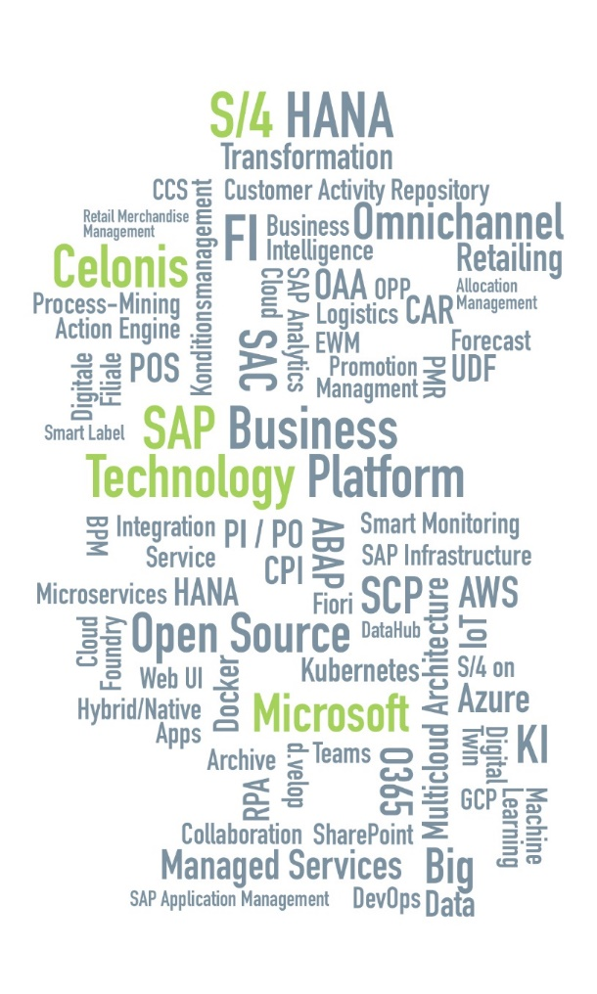 | FACTS AND FIGURES  Focus: Process and technology consulting  Customers: Trade and Cross Industry  Founded in 2007, headquarters: Essen  4 locations in Germany, further locations in Málaga/ES, Istanbul/TR, Ljubljana/SLO  > 300 highly qualified employees  Recognised training company (25 trainees)  Full-service IT service provider  Processes, Applications, Technology, AMS (24/7)  ^{Strategic partnerships}  SAP, Microsoft, Celonis, Deutsche Telekom  ^{Focus Growth Champion}  ^{2021 | 2017 | 2019}  ^{Germany's best trainers}  ^{2021 | 2019}  ^{Fast50 Technology (Deloitte)}  ^{Kununu Top-Company}

"If you don't share your knowledge, you have no reason to learn new things"


