GRIN-Global Import Wizard

(draft) a work in progress…

Revision Date
June 1, 2010 – [Publish Date]

 | Thank you for your patience! Any references that include [tbd] (“to be developed”) will be developed – we promise!

 | This guide provides …

Comments/Suggestions:
Please contact Marty Reisinger with any suggestions or questions related to this document. marty.reisinger@ars.usda.gov // Beltsville # 1.301.504.5439 // Telework # 1.410.666.0100

Contents
GRIN-Global Import Wizard 4
Overview 4
Launch the Import Wizard 4
Step-by-step 5
Step 1 – Choose Type of Data 5
Preparing your data 6
Step 2 – Specify Data 6
Import your data 7
Step 3 – View Results 7
Update Search Engine indexes 9
Tips and Tricks 9
Required Fields 9
Building your own import dataview 12

GRIN-Global Import Wizard

Overview
The Import Wizard (IW) is designed to assist with bulk loading large sets of data. It utilizes dataviews that are designed specifically for importing, and is only available to users with rights to run the Admin Tool.
The IW allows a user to copy and paste data from a spreadsheet as well as import .csv files. Like the Curator Tool (CT), it looks for matching column headings to align the data properly, despite the order the data is presented.
The IW follows a multi-step process for adding the new records to the database:
- User provides the data via copy/paste or importing a .csv
- IW aligns the data using properly named column headings and ignores those that it cannot match.
- User can make modifications to the data within the gridview prior to submitting for import.
- Once submitted, the IW adds/updates records in the database, and returns an itemized list of all database tables that were affected, as well as records that failed to import (including a reason).
- User has the option to return to the records that failed import, modify the data, then re-submit.
- Once all work is complete, the IW will prompt the user to update the search engine indexes to include the new records. (Depending on the number of records that were added, this could take a few minutes or a few hours.)

Launch the Import Wizard
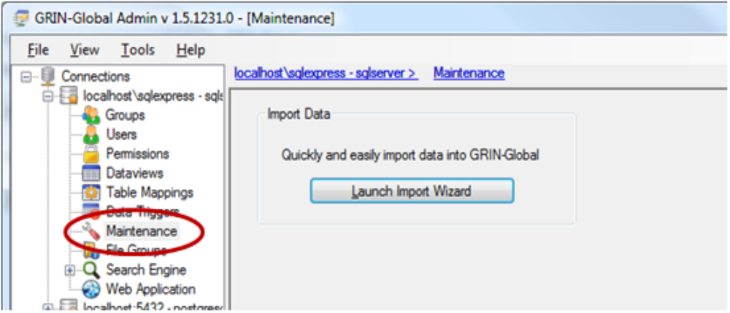
Figure 1 Maintenance Node is where you will find the Import Wizard
You can find the Import Wizard under the Maintenance node of the Admin Tool.
- Launch the Admin Tool
- Click on the Maintenance node
- Click on the Launch Import Wizard button

Step-by-step

Step 1 – Choose Type of Data
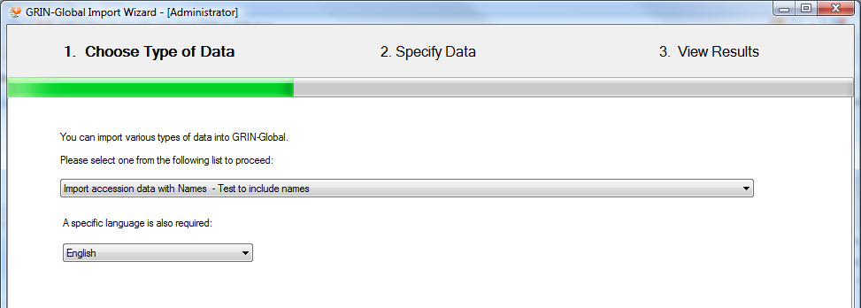Figure 2 Choose type of data from the drop down list
Choose which type of data you wish to import from the drop down list. Also, specify a language. Choosing a language will insure that the dataview you see in Step 2 displays column headings in the appropriate language.

Preparing your data
The easiest way to prepare your data for import is to create a spreadsheet with the columns you wish to add. These columns should associate with existing database fields, and follow the formatting requirements for those fields. Similar to the CT, you can drag and drop the column headings from the Import Wizard’s grid view into a spreadsheet. Doing this will insure your headings will match perfectly during import.
Hints for setting up your data:
- Column headings must match (not case sensitive)
- Do not append the asterisk (*) for required columns
- For columns with a checkbox, Y or N are appropriate values
- For columns with a dropdown, the stored value (value_member) or the friendly name value (display_member) can be provided (Example: for Initial Received Date Format, ‘MM/DD/YYYY’ or ‘Complete Date’ would be accepted.)

Step 2 – Specify Data
There are two ways to specify your data in the Import Wizard:
- Import a correctly formatted .csv file by clicking the Load from CSV button in the top right corner.
- Use a copy/paste method from a spreadsheet to the IW
  - Select data (including column headings) in the spreadsheet and copy to the clipboard (Ctrl+C or File > Copy)
  - Within the Import Wizard grid view, paste the data (Ctrl+V)
Once your data is placed, individual records can be modified and added.
To delete a record, select the row, then Right-click > Delete.
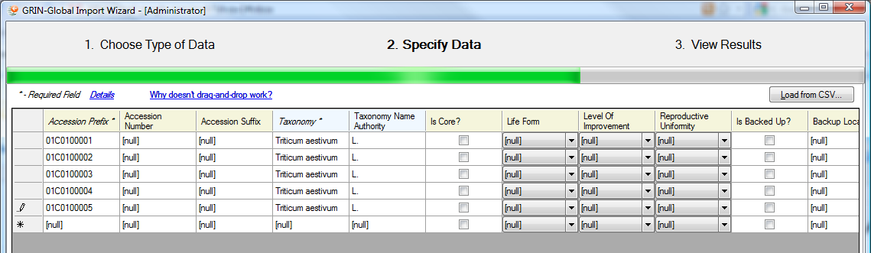Figure 3 Data is in place, ready for import.

Import your data
Once your data is placed, review it. When you are ready, click the Import button in the lower right corner.
The IW will parse each record and update tables accordingly. If there are errors, the entire row will be skipped (and an error returned on the results page).

Step 3 – View Results
After the IW has gone through all of the data rows submitted, it will return a summary report. The summary will itemize each row that was submitted along with the specific tables and fields that were updated.
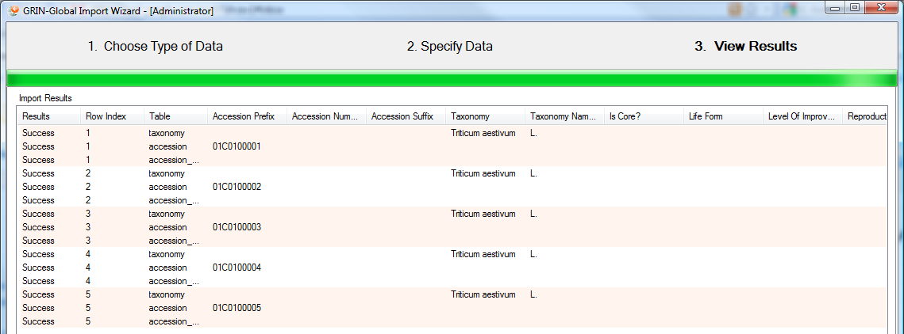Figure 4 All records imported successfully.
If the IW encounters problems with the data, it will skip the errant row and present an error message on the Results page.
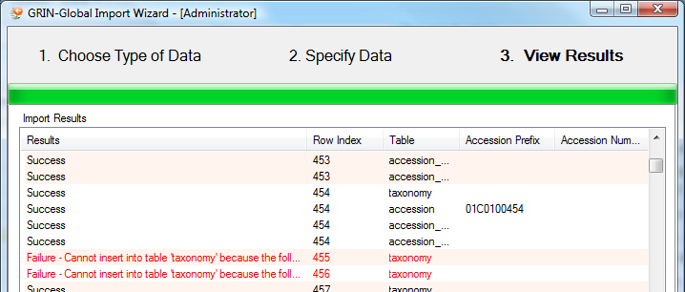Figure 5 Records that did not import are red, and show a reason for failure.
At this point you have three options. Exit will close the IW and prompt you to update indexes (see Update Search Engine Indexes section). Fix Errors will allow you to correct the data that was skipped (see Fix Errors section). Import More Data will take you back to the beginning of step one.
Fix Errors
Choosing the Fix Errors option after import will take you back to the gridview and display all records that were skipped due to error.

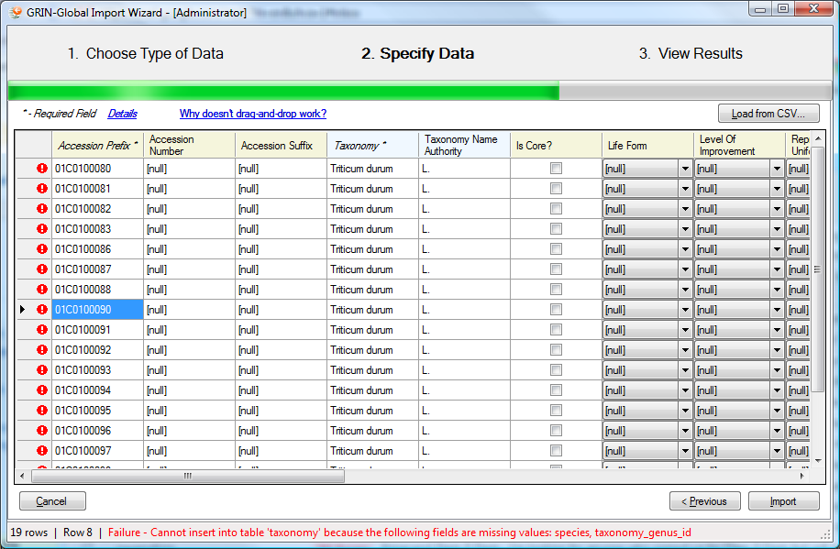
Figure 6 All records shown have errors.
Like the Results page, you can find the specific error of each record by placing your cursor within the cell of a row. An error message will be displayed at the bottom of the window, with details of each error.
Edits can be made directly within the gridview, or, you can select the data and put it into a spreadsheet for further refinement at a later time.
If you make your edits within the gridview, simply click Import again when you are ready to submit the changes.
If you wish to correct the errors in a spreadsheet, it is recommended that you:
- Copy the errant data to a spreadsheet
- Cancel out of the gridview and return to step one of the import process.
- When prompted with a window that asks about “unsaved changes”. Click Yes.
- When prompted about rebuilding search engine indexes. Click Yes.
- Once you have made the appropriate changes to the data and are ready to import, follow the same process as listed above, starting with step one.

Update Search Engine indexes
When new records have been imported, the search engine needs to run some self-maintenance to add these new records to its indexes, making them quickly and easily found when searching.
When exiting the Import Wizard, the system will prompt you to rebuild the search engine indexes (if records have been imported).
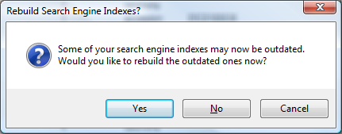
Figure 7 Prompt to rebuild indexes when exiting the Import Wizard
You can monitor the status of the indexes that are processing by going to the Search Engine node in the Admin Tool, then clicking on the Status tab. You will need to manually click the Refresh button to update the value being shown.
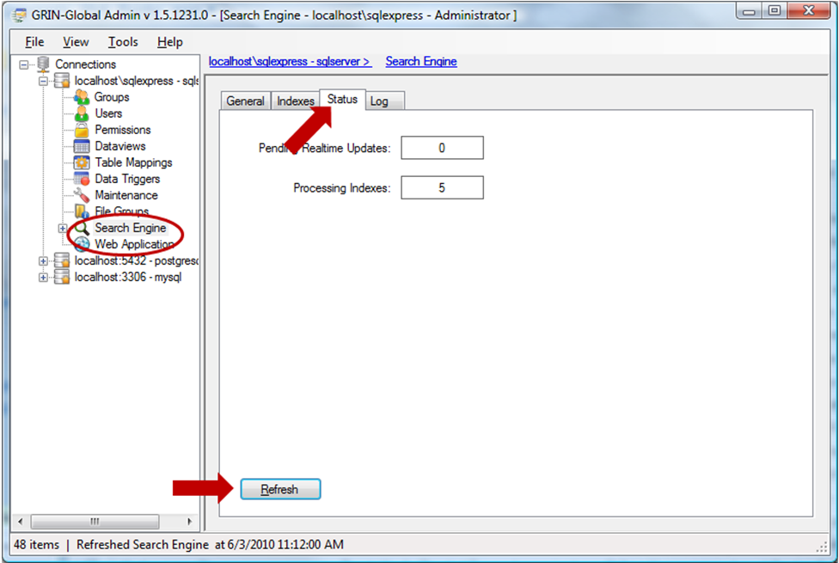Figure 8 On the Status tab of the Search Engine node you will find the current progress of indexes being processed

Tips and Tricks

Required Fields
To distinguish which fields are required for importing, let’s first look at a few visual cues that the IW provides.
- Color of column headings match for fields that are in the same table.
- Order of the columns from left to right.
- Italicized column names with an asterisk (*) appended to the end
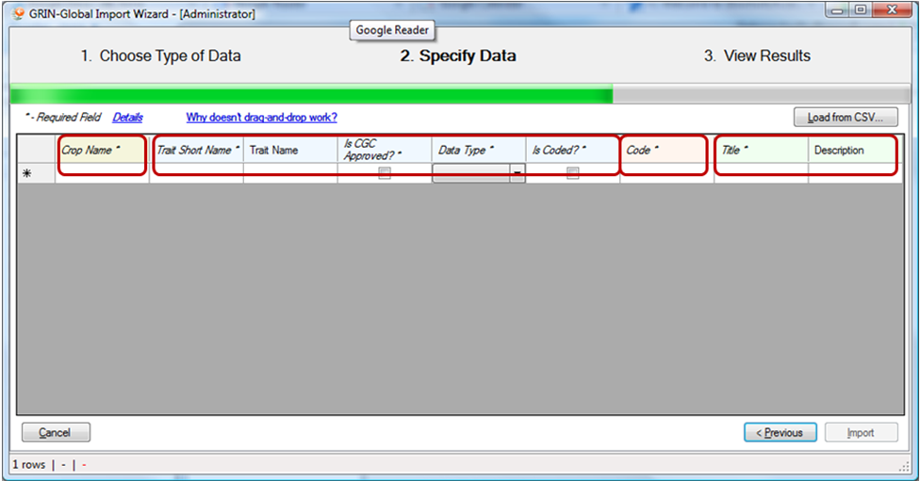
In this partial view, the columns Trait Short Name, Trait Name, Is CGC Approved?, Data Type, and Is Coded? are all the same color (light blue). The column Crop Name is a light yellow. The column Code is a light pink. The columns Title and Description are a light green.
The different colors each represent a different table in the database, and the columns are a part of that table.
Also notice that some of the column headings are italicized and have an asterisk (*) after their name. This indicates the fields that are required if you want to update that table.
You do not have enter data for all required fields in the import dataview – only those that are required for the tables you wish to update.
Example:
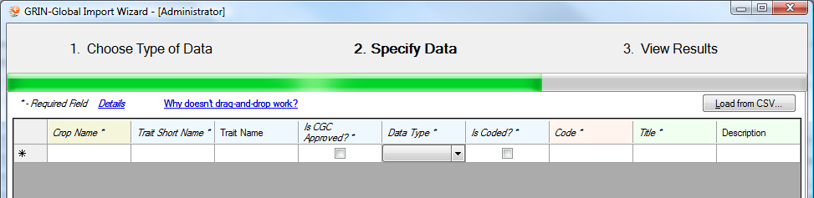
In the Crop Information dataview (same as above), there are four tables represented.

Crop Name * | Required

Trait Short Name * | Required
Trait Name
Is CGC Approved? * | Required
Data Type * | Required
Is Coded? * | Required

Code * | Required

Title * | Required
Description

ACCEPTABLE
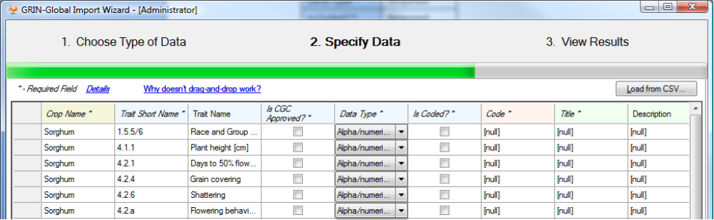
Because the required fields for the first two tables are all provided, this data would be accepted without errors.
NOT ACCEPTABLE
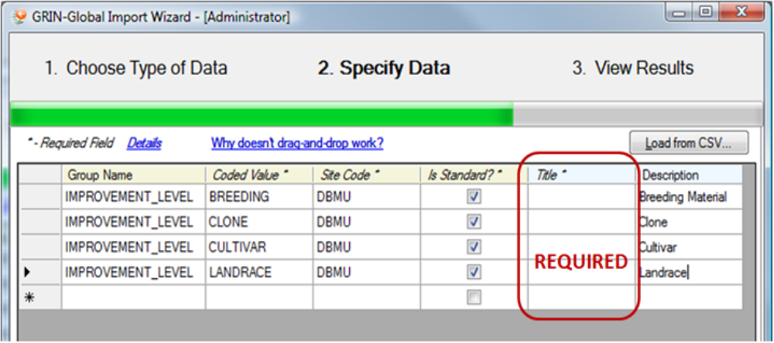
The import of this data would fail because the required fields for the second table were not provided.

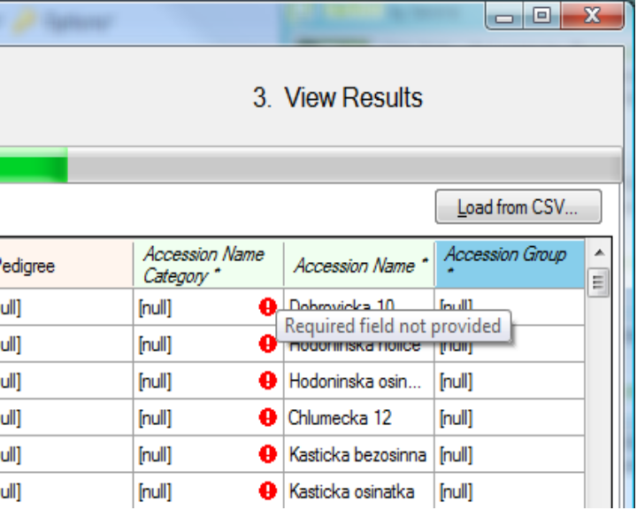
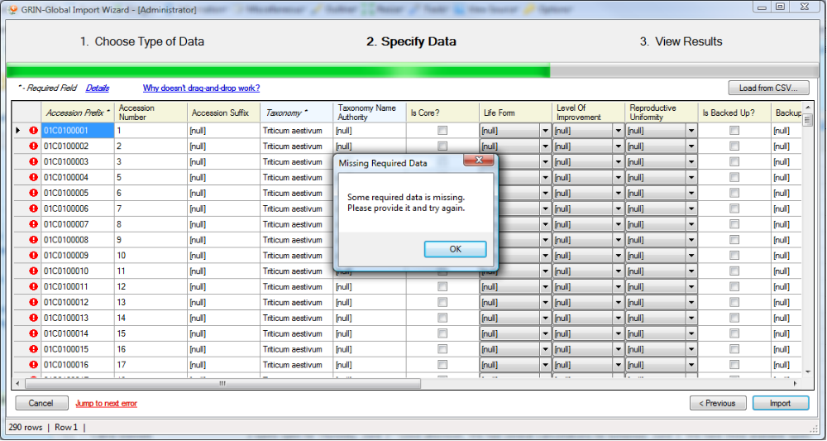

Building your own import dataview
prepare

