##### MANAGEMENT OF FOOD WASTE AND EXCESS FOOD

##### MINI PROJECT REPORT

***Submitted by***

##### DHEVESH BC 211420104065 DINESH KUMAR MP 211420104068

***in partial fulfilment for the award of the degree***

***of***

**BACHELOR OF ENGINEERING**

***in***

COMPUTER SCIENCE AND ENGINEERING



**PANIMALAR ENGINEERING COLLEGE**

**(An Autonomous Institution, Affiliated to Anna University, Chennai)**

**APRIL 2023**

##### PANIMALAR ENGINEERING COLLEGE

**(An Autonomous Institution, Affiliated to Anna University, Chennai)**

##### BONAFIDE CERTIFICATE

**Certified that this project report “MANAGEMENT OF FOOD WASTE AND EXCESS FOOD” is the bonafide work of DHEVESH BC(211420104065) & DINESH KUMAR MP(211420104068)** who carried out the project work under my supervision.

SIGNATURE SIGNATURE

**Dr.L.JABASHEELA , M.E .,Ph.D Mrs.R.DEVI,M.E.,**

PROFESSOR, ASSISTANT PROFEESOR,

**HEAD OF THE DEPARTMENT (Grade -I)**

DEPARTMENT OF CSE, DEPARTMENT OF CSE,

PANIMALAR ENGINEERING PANIMALAR ENGINEERING COLLEGE,

COLLEGE, NASARATHPETTAI, NASARATHPETTAI,

POONAMALLEE, POONAMALLEE,

CHENNAI-600 123. CHENNAI-600 123.

Certified that the above candidate(s) were examined in the Mini Project Viva-Voce Examination held on...........................

**ACKNOWLEDGEMENT**

We would like to express our deep gratitude to our respected Secretary and Correspondent Dr.P.CHINNADURAI, M.A., Ph.D. for his kind words and enthusiastic motivation, which inspired us a lot in completing this project.

**We express our sincere thanks to our beloved Directors**

**Tmt.C.VIJAYARAJESWARI**, **Dr.C.SAKTHI KUMAR,M.E.,Ph.D** and

Dr.SARANYASREE SAKTHI KUMAR B.E.,M.B.A.,Ph.D., for providing us with the necessary facilities to undertake this project.

**We also express our gratitude to our Principal Dr.K.MANI, M.E., Ph.D. who facilitated us in completing the project.**

We thank the Head of the CSE Department, Dr. L.JABASHEELA, M.E.,Ph.D., for the support extended throughout the project.

**We would like to thank our parents, friends, project Guide Mrs.R.DEVI,M.E., and coordinator Dr.P.J.SATHISH KUMAR M.Tech., Ph.D., and all the faculty members of the Department of CSE for their advice and encouragement for the successful completion of the project.**

**NAME OF THE STUDENTS DHEVESH BC** (211420104065**) DINESH KUMAR MP** (211420104068**)**

ABSTRACT

An important goal in our world today is to eliminate food waste by reutilizing available food sources within local communities and leftover food items in homes, restaurants, stores and food distribution centres. A website is created for managing the food waste and excess food by converting the food waste into natural fertilizer and providing the excess food to hunger-needy people or to nearby orphanage homes. This website has the information to do the process, either the process can be done on your own or book an agent in this website, one of the agents collects the resources and does the further process.

# TABLE OF CONTENTS

|  |  |  |
| --- | --- | --- |
| **CHAPTER NO.** | **TITLE** | **PAGE NO.** |
|  | **ABSTRACT** | iv |
|  | **LIST OF TABLES** | vii |
|  | **LIST OF FIGURES** | viii |
| **1.** | **INTRODUCTION** | 01 |
|  | 1.1 Overview | 01 |
|  | 1.2 Problem Definition | 03 |
| **2.** | **SYSTEM ANALYSIS** | 04 |
|  | 2.1 Existing System | 04 |
|  | 2.2 Proposed System | 04 |
|  | 2.3 Development Environment | 05 |
| **3.** | **SYSTEM DESIGN** | 06 |
|  | 3.1 UML Diagrams | 06 |
|  | 3.2 Data Dictionary | 10 |
|  | 3.3 ER Diagram | 12 |
|  | 3.4 Flow Chart Diagram | 13 |
| **4.** | **SYSTEM ARCHITECTURE** | 14 |
|  | 4.1 Architecture Overview | 14 |
|  | 4.2 Module Description | 15 |
| **5.** | **SYSTEM IMPLEMENTATION** | 17 |
|  | 5.1 Frontend Coding | 17 |
|  | 5.2 Backend Coding | 47 |

|  |  |  |
| --- | --- | --- |
| **CHAPTER NO.** | **TITLE** | **PAGE NO.** |
| **6.** | **SYSTEM TESTING** | 48 |
|  | 6.1 Test Cases and Reports | 48 |
| **7.** | **CONCLUSION** | 50 |
|  | 7.1Conclusion | 50 |
|  | 7.2 Future enhancement | 50 |
| **8.** | **APPENDICES** | 51 |
|  | Sample Screenshots | 51 |
| **9.** | **REFERENCES** | 56 |

**LIST OF TABLES**

|  |  |  |
| --- | --- | --- |
| **TABLE NO** | **TABLE**  **DESCRIPTION** | **PAGE NO** |
| 3.2.1 | Selection table for managing food waste an excess food | 10 |
| 3.2.2 | Book Agent table for managing food waste an excess food | 11 |
| 6.1 | Test Cases and Report Table for managing food waste an excess food | 48 |

# LIST OF FIGURES

|  |  |  |
| --- | --- | --- |
| **FIG NO** | **FIGURE DESCRIPTION** | **PAGE NO** |
| 3.1.1 | Use Case Diagram for managing food waste an excess food | 6 |
| 3.1.2 | Class Diagram for managing food waste an excess food | 7 |
| 3.1.3 | Sequence Diagram for managing food waste an excess food | 8 |
| 3.1.4 | Activity Diagram for Managing food waste  an excess food | 9 |
| 3.3 | ER Diagram for Managing food waste an excess food | 12 |
| 3.4.1 | Flow Chart Diagram | 13 |
| 4.1 | Architecture Diagram for Managing food waste an excess food | 14 |
| 8.1 | Selection Page | 51 |
| 8.2 | Food waste and Self-manage Page | 51 |
| 8.3 | Excess food and Self-manage Page | 52 |
| 8.4 | Both and Self-manage Page | 52 |
| 8.5 | Food waste and Book agent Page | 53 |
| 8.6 | Excess food and Book agent Page | 53 |
| 8.7 | Both and Book agent Page | 54 |

## CHAPTER 1

#### INTRODUCTION

* 1. **OVERVIEW**

1. **Food Waste:**

Food loss and waste is food that is not eaten. The causes of food waste or loss are numerous and occur throughout the food system, during production, processing, distribution, retail and food service sales, and consumption. Overall, about one-third of the world's food is thrown away.

###### Categories of food waste than can be separated as: -

1. Kitchen waste
2. Dining waste
3. Non-edible/Spoiled food

These can be seen in homes, marriage halls, when a function takes place at home and any place where cooking or dining takes place.

###### Kitchen wastes include: -

1. Rotten vegetables and fruits
2. Peels of vegetables and fruits
3. Egg shell
4. Scraped portions of vegetables/fruits or slurries.
5. Non-veg waste before cooking (NOTE: HAS TO BE ADDED TO NON- EDIBLE)
6. Even bread waste

###### Dinning waste includes:-

1. Inedible parts of a meal that we separate (both veg and non-veg)
2. Small amount of the leftovers in meal

###### Non-edible/Spoiled food includes:-

1. Spoiled cooked food
2. Non-veg waste before cooking
3. Non-veg waste after dining
4. Spoiled dairy products , oil
5. **Excess food:**

Excess food means any remaining unexpired, unopened, and unconsumed food intended to be served as part of a reimbursable meal that was unable to be utilized for a current or future meal provision after a school has served breakfast and lunch to students during a school day.

Leftovers are surplus foods remaining unconsumed at the end of a meal, which may be put in containers with the intention of eating later. Inedible remains like bones are considered waste, not leftovers. Depending on the situation, the amount of food, and the type of food, leftovers may be saved or thrown away.

Excess food means any remaining unexpired, unopened, and unconsumed food/meal that was unable to be utilized for a current or future meal provision.

###### This includes: -

1. Small number of leftovers at home.
2. Large amount of leftovers in home functions, marriage halls and in any place where a large amount of cooking or dining takes place.

#### PROBLEM DEFINITION

* + - This project is to create a website where both food waste and excess food are managed.
    - The food waste is categorized into three , most of them can be converted into compost and some should be disposed of properly.
    - The excess food can be given to nearby homes or the needy people.
    - These processes can be done either on own by the information available on the website or an agent can be booked for the process.

## CHAPTER 2

#### SYSTEM ANALYSIS

* 1. **EXISTING SYSTEM**
     + In Existing System , users can visualize available food resources in their local area and consequently gain access to food, thereby tackling two major issues,

i.e. hunger and food waste during pandemic situations(covid).

* + - To access this app, users require mobile and internet as the users who are in need of food.
    - If food suppliers intend to donate food through the app, they can enter the type of food they would donate, the quantity of the item(s), date of expiry and so on.

Disadvantages:-

* + - * It only donates food to people who have mobile and internet services.
      * This was created regarding the corona period(situation).

#### PROPOSED SYSTEM

The proposed system , not only includes donating food to the needy people that too only during pandemic(covid).

Whenever , there is some excess food that can be available at where any large amount of cooking and dining takes place , those can be donated to nearby homes or the needy people . The information of the homes will be in the web page , either you can do or if you book an agent in the web page , the agent will come and collect the food and deliver it to the nearby home(s).

This system also helps in managing the food waste by converting most of the food waste into manure , which can be used as natural fertilizer to crops/plants , but some categories should definitely be disposed of properly. The process of converting the food waste into manure is the web page ,either you can do or if you book an agent in the web page , the agent will come and collect the resources and do the further processes.

Advantages:-

* It helps to manage both excess food and food waste.
* You can book an agent for managing them.

#### DEVELOPMENT ENVIRONMENT

**SOFTWARE REQUIREMENT**

* + Windows 11
  + HTML
  + CSS
  + Java Script
  + Visual studio code
  + WhatsApp

#### HARDWARE REQUIREMENT

* + - Processor: Minimum 1 GHz
    - Memory (RAM): Minimum 4 GB
    - Computer /Mobile
    - Internet Connection

## CHAPTER 3

### SYSTEM DESIGN

#### UML DIAGRAMS

##### Use case Diagram

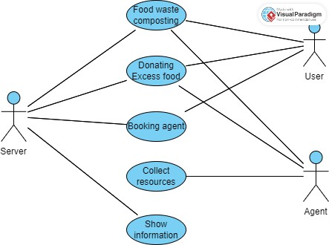

Fig 3.1.1 Use case diagram for managing food waste an excess food

This use case diagram refers to activities done by server, user and the agent and their corresponding use cases.

##### Class Diagram

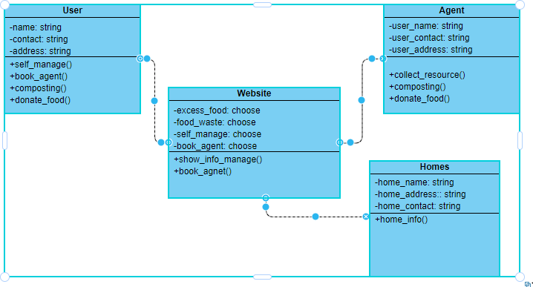

Fig 3.1.2 Class diagram for managing food waste an excess food

The class diagram refers to relationships between different classes, that is items class, website class, user class, homes class etc.

##### Sequence Diagram

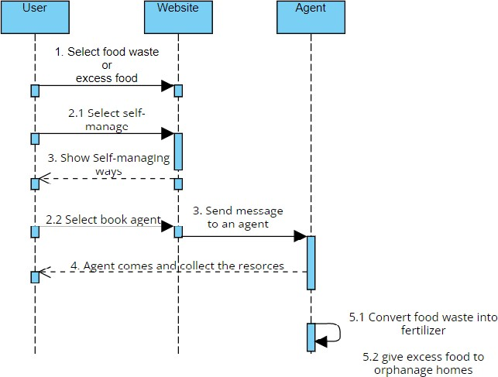

Fig 3.1.3 Sequence diagram for managing food waste an excess food

The sequence diagram of Managing food waste and excess food of artisans shows the sequence of activities of the website.

##### Activity Diagram

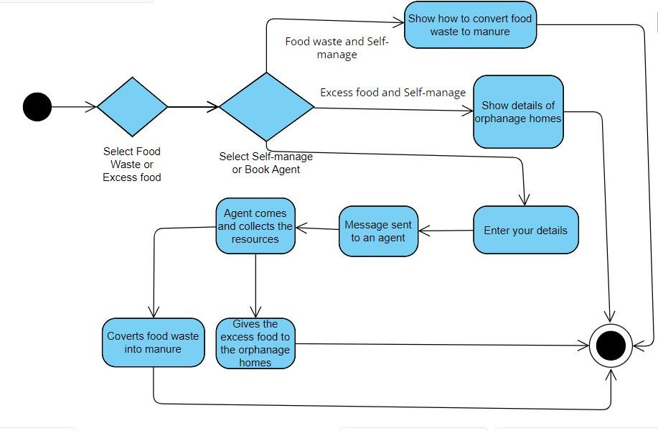

Fig 3.1.5 Activity diagram for managing food waste an excess food

The activity diagram of Managing food waste and excess food shows the flow of activities of the website.

#### DATA DICTIONARY

This is normally represented as the data about data. It is also termed as metadata some times which gives the data about the data stored in the database. It defines each data term encountered during the analysis and design of a new system. Data elements can describe files or the processes. Following are some rules, which defines the construction of data dictionary entries:

1. Words should be defined to understand what they need and not the variable need by which they may be described in the program.
2. Each word must be unique. We cannot have two definitions of the same

client.

1. Aliases or synonyms are allowed when two or more entries show the

same meaning. For example, a vendor number may also be called a customer number.

1. A self-defining word should not be decomposed. It means that the reduction of any information into subparts should be done only if it is really required, that is it is not easy to understand directly.

Data dictionary includes information such as the number of records in a file, the frequency a process will run, security factors like pass word which the user must enter to get excess information.

#### SELECTION TABLE

|  |  |  |  |
| --- | --- | --- | --- |
| **COLUMN NAME** | **DATA TYPE** | **DESCRIPTION** | **CONSTRAINT** |
| FOOD WASTE  OR EXCESS FOOD | RADIO BUTTON | WHICH YOU WANT TO  MANAGE? | NOT NULL |
| SELF-MANAGE OR  BOOK AGENT | RADIO BUTTON | HOW DO YOU WANT TO  MANAGE? | NOT NULL |

* + 1. **Selection table for Managing food waste an excess food**

#### BOOK AGENT TABLE

|  |  |  |  |
| --- | --- | --- | --- |
| **COLUMN NAME** | **DATA TYPE** | **DESCRIPTION** | **CONSTRAINT** |
| NAME | VARCHAR | NAME OF THE USER | NOT NULL |
| NUMBER | VARCHAR | CONTACT NUMBER OF  THE USER | NOT NULL |
| ADDRESS | VARCHAR | ADDRESS OF THE USER | NOT NULL |

**3.2.2 Sign in table for Managing food waste an excess food**

#### ER DIAGRAM

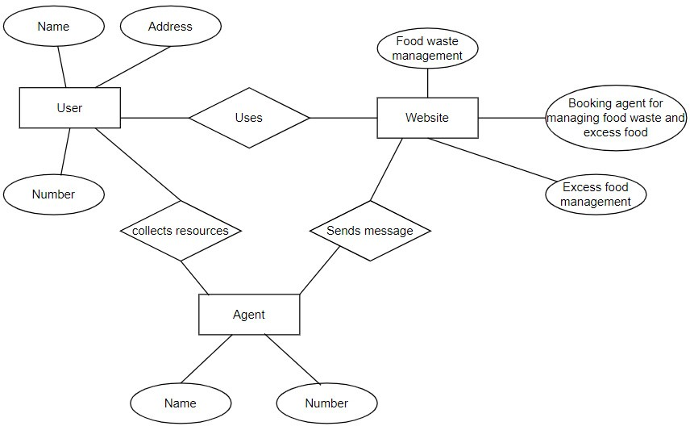

The E-R diagram gives the entities that are user, website, agent and their attributes.

#### FLOW CHART DIAGRAM

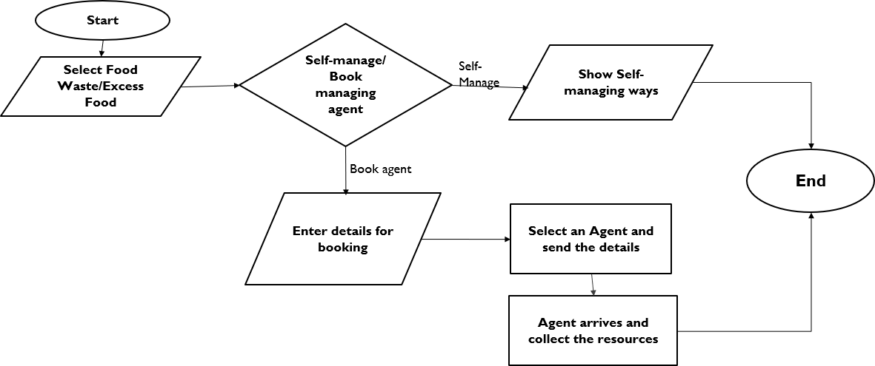

##### Fig 3.3.1 Flow Chart diagram

The flow chart diagram of Managing food waste and excess food shows the control flow.

## CHAPTER 4

### SYSTEM ARCHITECTURE

#### ARCHITECTURE OVERVIEW

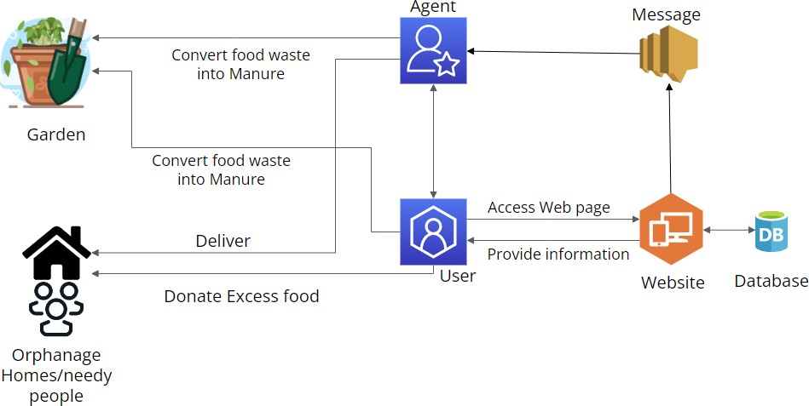

##### Fig 4.1 Architecture diagram for Managing food waste an excess

**food**

The figure 4.1 consists of elements participating in managing food waste and excess food. At first , an User accesses the website either for managing food waste or excess food or even both. The User can either manage themselves or book an agent to manage.The User manages themselves by the information provided in the website, that is the food waste can be converted into manure and given to the garden. And the Excess food can be given to the nearby Orphanage Homes/Needy people by the information available in the website. The User can book an agent to do the above process by providing his/her details in the website and a message is sent to an agent by the User via the website. Then an agent comes and collects the resources such as food waste or excess food or even both. The food waste is converted into manure and given to the garden. And the Excess food will be given to the nearby Orphanage Homes/Needy people.

#### MODULE DESCRIPTION

Managing food waste and excess food consists of 7 modules. They are

* Manage food module
* Food waste and self-manage module.
* Excess food and self-manage module.
* Both and self-manage module.
* Food waste and Book agent module.
* Excess food and Book agent module.
* Both and Book agent module.

**Manage food module**

It is the main module that leads to 6 other modules based on the selection made by the user, it has two questions namely “Which of the following do you want to manage?” And “How do you want to manage?”. If “food waste” and “self-manage” is selected, then the page is directed to “Food waste and self-manage” module, if “excess food” and “self-manage”, then the page is directed to “Excess food and self-manage” module, if “both” and “self-manage” module, then then the page is directed to “Both and self-manage module”, If “food waste” and “book managing agent” is selected, then the page is directed to “Food waste and Book agent” module, if “excess food” and “book managing agent”, then the page is directed to “Excess food and Book agent” module, if “both” and “book managing agent” module, then then the page is directed to “Both and Book agent” module.

**Food waste and self-manage module**

This module has the information about how to manage the food waste by the user on their own. It has the entire information of managing the food waste, by defining what is food waste, how to categorize them, and how to manage them in a proper way. As the food waste is categorized into three namely, kitchen waste, dinning waste and non-edible/spoiled food. In this module Each of them is given in 3 lines respectively, by clicking on each of them it displays how to manage each of them with words, images and a video.

**Excess food and self-manage module**

This module has the information about how to manage the excess food by the user on their own. It has the entire information of managing the excess food, by defining what is excess food and a large bunch of Orphanage Homes all over the Chennai city. The homes information is given in a table as its name of the home, area of the home, contact number of the home. By clicking on the name of the home, the

page directs to the home’s information, by clicking on the area of the home, the page directs to the direction to reach the home and by clicking on the number of the home, the page directs a call from the user’s mobile to the home.

**Both and self-manage module**

This module has the information about how to manage both the food waste and excess food by the user on their own. It has the entire information of managing the food waste and excess food, by defining them and how to manage them each that is for food waste by defining what is food waste, how to categorize them, and how to manage them in a proper way. As the food waste is categorized into three namely, kitchen waste, dinning waste and non-edible/spoiled food. In this module, each of them is given in 3 lines respectively, by clicking on each of them it displays how to manage each of them with words, images and a video. For excess food by defining what is excess food and a large bunch of Orphanage Homes all over the Chennai city. The homes information is given in a table as its name of the home, area of the home, contact number of the home. By clicking on the name of the home, the page directs to the home’s information, by clicking on the area of the home, the page directs to the direction to reach the home and by clicking on the number of the home, the page directs a call from the user’s mobile to the home.

**Food waste and Book agent module**

This module has the information about what is food waste and helps the user to book an agent to manage the food waste that the user has in their residence or in any function hall. If the user has any other work, they can use this website to book an agent by providing their name, number and address, then this information is then sent to an agent via WhatsApp by clicking on the submit button.

**Excess food and Book agent module**

This module has the information about what is excess food and helps the user to book an agent to manage that the user has in their residence or in any function hall. If the user has any other work, they can use this website to book an agent by providing their name, number and address, then this information is then sent to an agent via WhatsApp by clicking on the submit button.

**Both and Book agent module**

This module has the information about what is food waste and excess food and helps the user to book an agent to manage the food waste that the user has in their residence or in any function hall. If the user has any other work, they can use this website to book an agent by providing their name, number and address, then this information is then sent to an agent via WhatsApp by clicking on the submit button.

## CHAPTER 5

### SYSTEM IMPLEMENTATION

#### FRONT-END CODING MANAGE FOOD.HTML

<html>

<meta name="viewport" content="width=device-width, initial-scale=1.0">

<style>h1{text-align:center;font-family:Arial, sans-serif;background-color:rgb(138, 43,

226,0.6);

color:aqua;width: auto;}

body{background-image:url(https://hospitalityinsights.ehl.edu/hubfs/Blog-EHL- Insights/Blog-Header-EHL-Insights/AdobeStock_264542845.jpeg);

background-repeat:no-repeat;background-position:center;background-size:cover;}

h2 {position: relative;left: 10%;color: aqua;font-size: 90%;width:fit-content;font-size: 0.8cm;top: 5%;

background-color:rgba(136, 82, 187, 0.7);}

.div1{position: relative;left: 25%;top:15%;width:fit-content;height: 40%; color:black;font-family: Arial, Helvetica, sans-serif;background-color:rgb(53, 224,

236,0.4);font-size: 120%;}

.div2{position: relative;top:9%;left: -12%;} @media only screen and (max-width: 600px){

body{background-image:url(https://hospitalityinsights.ehl.edu/hubfs/Blog-EHL- Insights/Blog-Header-EHL-Insights/AdobeStock_264542845.jpeg);

background-position: center;}

.div4{text-align: left;position: relative;left: -10%;}

.div1{position: relative;left: 5%;top: 3%;width: 93%;height:42% ;

}

.div2{position: relative;left:-6%;top: -2%;}

}</style>

<head><title> MANAGEMENT OF WASTE FOOD AND EXCESS FOOD </title>

</head>

<body>

<div class="div3"><h1>MANAGEMENT OF WASTE FOOD AND EXCESS

FOOD</h1></div>

<div class="div4"><h2>Kindly fill the form given below:</h2></div>

<div class="div1">

<form><b>

<h3>Which of the following do you want to manage?" </h3>

<input type="radio" id="food waste" name="which" value="1">

<label for="food waste">Food Waste</label><br>

<input type="radio" id="excess food" name="which" value="2">

<label for="excess food">Excess food</label><br>

<input type="radio" id="both" name="which" value="3">

<label for="both">BOTH</label>

<h4>How do you want to manage?</h4>

<input type="radio" id="self managing" name="way" value="4">

<label for="self managing">Self Managing</label><br>

<input type="radio" id="book managing agent" name="way" value="5">

<label for="book managing agent">Book Managing Agent</label><br>

</b></form></div>

<div class="div2"><input type="button" value="Submit" style="height: 5%;width: fit- content;font-size: 20px;left: 50%;position: relative;top: 60%;"

onclick="manage_food()"></div>

</body>

<script>

function manage_food() {

var a=document.getElementById("food waste"); var b=document.getElementById("excess food"); var c=document.getElementById("both");

var d=document.getElementById("self managing");

var e=document.getElementById("book managing agent"); if (a.checked==true && d.checked==true) window.location.href = "fw_sm.html";

else if (a.checked==true && e.checked==true) window.location.href = "fw_bm.html";

else if (b.checked==true && d.checked==true) window.location.href = "Ef_sm.html";

else if (b.checked==true && e.checked==true) window.location.href = "Ef_bm.html";

else if (c.checked==true && d.checked==true) window.location.href = "B_sm.html";

else if (c.checked==true && e.checked==true) window.location.href = "B_bm.html";

else

alert("please fill to proceed");

}

</script>

</html>

#### FOOD WASTE AND SELF MANAGEMENT.HTML

<html>

<meta name="viewport" content="width=device-width, initial-scale=1.0">

<style>

html{scroll-behavior: smooth;}

h1{text-align: center;color: aqua;background-color: rgb(138, 43, 226,0.6);}

p{color: mintcream;font-size: 150%;background-color: rgb(0, 0, 0,0.6);} h2{color:blueviolet;-webkit-text-fill-color: aqua;-webkit-text-stroke-width:

1px;background-color: black;width: fit-content;}

h3{color: aquamarine;font-size: 150%;background-color: rgb(0, 0, 0,1);} body{

background-image: url("https://png.pngtree.com/background/20210710/original/pngtree-vintage-food-poster- background-psd-picture-image_1007040.jpg");

background-repeat: no-repeat;background-size: cover;}

</style>

<head><title>Self-Manage Food Waste</title></head>

<body>

<h1>Self-Manage Food Waste</h1>

<h2>Food Waste</h2>

<div class="div3"><p>Categories of food waste than can be separated as:-<br>

1. Kitchen waste<br>
2. Dining waste<br>
3. Non-edible/Spoiled food<br>

These can be seen in homes , marriage halls , when a function takes place at home and any place where cooking or dining takes place.

</p>

<h3 id="sh">Kitchen waste</h3>

<p>This includes: -<br>

* 1. Rotten vegetables and fruits<br>
  2. Peels of vegetables and fruits<br>
  3. Egg shell<br>
  4. Scraped portions of vegetables/fruits or slurries.<br>
  5. Non-veg waste before cooking( NOTE: HAS TO BE ADDED TO NON- EDIBLE)<br>
  6. Even bread waste<br><br>

<h3 id="sh">Dining Waste</h3>

<p>This includes: -<br>

1. Inedible parts of a meal that we separate (both veg and non-veg).<br>
2. Small amount of the leftovers in meal.<br><br>

<h3 id="sh">Non-edible/Spoiled food</h3>

<p>This includes: -<br>

* 1. Spoiled cooked food<br>
  2. Non-veg waste before cooking<br>
  3. Non-veg waste after dining<br>
  4. Spoiled dairy products , oil<br>

</p></div>

<h2>What to do with the food Waste?</h2>

<p onclick="info1()" id="p11">

<a href="#p1" style="color: aqua;cursor: pointer;"><u>Click for Kitchen Waste Managing</u></a>

</p>

<p onclick="close1()" id="p12">

<a style="color: aqua;cursor: pointer;"><u></u></a>

</p>

<p id="p1"></p>

<p onclick="info2()" id="p22">

<a href="#p2" style="color: aqua;cursor: pointer;"><u>Click for Dining Waste Managing</u></a>

</p>

<p onclick="close2()" id="p23">

<a style="color: aqua;cursor: pointer;"><u></u></a>

</p>

<p id="p2"></p>

<p onclick="info3()" id="p33">

<a href="#p3" style="color: aqua;cursor: pointer;"><u>Click for Non-edible/Spoiled food Waste Managing</u></a>

</p>

<p onclick="close3()" id="p34">

<a style="color: aqua;cursor: pointer;"><u></u></a>

</p>

<p id="p3"></p>

</body>

<script>

function info1() {

document.getElementById("p1").innerHTML="NOTE: Non-veg waste has to be added to Non-edible<br><br>"+

"<video width='320' height='240' autoplay> <source src='compost.mp4'> </video><br>"+ "These process can be done within your garden by implementing these following steps:<br><br>"+

"1.Add Kitchen Waste in a Container (For continuous cycle maintain two containers).<br>"+ "2.Add the Browns for better fertilization (Browns like dry shredded leaves, sawdust or cocopeat ).<br>"+

"3.Collect some garden waste (Collecting grass clippings and leaves from your lawn and placing into your compost bin).<br>"+

"4.Layer with soil and repeat the process for two more times ( add two more layers of above

).<br>"+

"5.Provide Oxygen and water (You can make perforated holes and sprinkle water in your container once in every four days).<br>"+

"6. Once the compost reaches dark colour, it is ready to be used as a fertilizer."; document.getElementById("p12").innerHTML=document.getElementById("p11").innerHT ML;

document.getElementById("p11").innerHTML="";

}

function close1(){ document.getElementById("p1").innerHTML="";

document.getElementById("p11").innerHTML=document.getElementById("p12").inne rHTML;

document.getElementById("p12").innerHTML="";

}

function info2() {

document.getElementById("p2").innerHTML="Veg dining waste can be added to KITCHEN WASTE. That can be further processed to manure.<br><br>"+

"<img src='https://images.hindustantimes.com/img/2022/08/09/1600x900/718abece- 17c0-11ed-b80f-cf61e508c1c3_1660049890956.jpg' style='width:400px;height:200px;'>"+

"<br>Non-veg dining waste can be either given to some kind of pets or can be added to NON-EDIBLE";

document.getElementById("p23").innerHTML=document.getElementById("p22").inne rHTML;

document.getElementById("p22").innerHTML="";

}

function close2(){ document.getElementById("p2").innerHTML="";

document.getElementById("p22").innerHTML=document.getElementById("p23").inne rHTML;

document.getElementById("p23").innerHTML="";

}

function info3() {

document.getElementById("p3").innerHTML="<img src='https://encrypted- tbn0.gstatic.com/images?q=tbn:ANd9GcSt8hJ9Idmw2hjTjLlXTae-NtU1WucS8f- GrkeaD0xvdzB_kUUDa7W-9mfTkFKPRbpEk0I&usqp=CAU>'"+

"<br><br>Sadly these cannot be reused . May be they also be composted<br>"+ "but it is not advised because spoiled cooked rice/food , raw and cooked meat

waste<br>"+

"can contain harmful bacteria, which could spread through your compost and<br>"+ "later contaminate your crops.<br><br>"+

"Oil and Dairy products like milk, sour cream, yogurt, cheese, and butter<br>"+ "should not be composted because they also attract pests. So as these are<br>"+ "completely waste , they have to moved to the trash i.e. disposed properly.";

document.getElementById("p34").innerHTML=document.getElementById("p33").innerHT ML;

document.getElementById("p33").innerHTML="";

}

function close3(){ document.getElementById("p3").innerHTML="";

document.getElementById("p33").innerHTML=document.getElementById("p34").inne rHTML;

document.getElementById("p34").innerHTML="";

}

</script>

</html>

<html>

#### EXCESS FOOD AND SELF-MANAGEMENT.HTML

<meta name="viewport" content="width=device-width, initial-scale=1.0">

<style>

h1{text-align: center;color: aqua;background-color: rgb(138, 43, 226,0.6);}

p{color: mintcream;font-size: 150%;background-color: rgb(0, 0, 0,0.6);} h2{color:blueviolet;-webkit-text-fill-color: aqua;-webkit-text-stroke-width:

1px;background-color: black;width: fit-content;}

h3{color: mintcream;font-size: 150%;background-color: rgb(0, 0, 0,0.6);} body{

background-image: url("https://png.pngtree.com/background/20210710/original/pngtree-vintage-food-poster- background-psd-picture-image_1007040.jpg");

background-repeat: no-repeat;background-size: cover;}

</style>

<head><title>Self-Manage Excess Food</title></head>

<body>

<h1>Self-Manage Excess Food</h1>

<h2>Excess Food</h2>

<p><div class="div3"><p>Excess food means any remaining unexpired, unopened, and unconsumed food intended to be served as part of a reimbursable meal<br>

that was unable to be utilized for a current or future meal provision after a school has served breakfast and lunch to students during a school day.<br>

Leftovers are surplus foods remaining unconsumed at the end of a meal, which may be put in containers with the intention of eating later. Inedible <br>

remains like bones are considered waste, not leftovers. Depending on the situation, the amount of food, and the type of food, leftovers may be saved <br>

or thrown away.Excess food means any remaining unexpired, unopened, and unconsumed food/meal that was unable to be utilized for a current or future meal provision.</p>

<p>This includes: -<br>

1. Small number of leftovers at home.<br>
2. Large amount of leftovers in home functions, marriage halls and in any place where large amount of cooking or dining takes place.

</p></div></p>

<h2>What to do with the Excess food?</h2>

<p>Since the leftovers at home is very small amount , it can either be consumed afterwards or can be added to Spoiled food and further it will be disposed.<br>

We highly recommend you to consume afterwards...

For Large amount of leftovers , those can be given to the hungry-needy people or orphanage homes.<br>

Select for nearby orphanage homes on our website and give the food or book an agent on our website for the process.

</p>

<h3>

To Know About The home , Click on it's name<br>

To Show the route , Click on it's Address/Location<br> To Call the home , Click on the number<br>

</h3>

<div class="div2">

<img src="homes.jpg" usemap="#homes" style="opacity: 0.8;"></div>

<map name="homes">

<area href="https://[www.abilityfoundation.org/](http://www.abilityfoundation.org/)" coords="26,67,390,107" shape="rect">

<area href="https://[www.anbagam.org/](http://www.anbagam.org/)" coords="36,131,386,171" shape="rect">

<area href="https://[www.az-india.com/company/bala_gurukulam-chennai_tn-](http://www.az-india.com/company/bala_gurukulam-chennai_tn-) 1_ashram_street_murugambedu_kallikuppam ambattur" coords="34,185,385,233" shape="rect">

<area href="https://christfaithhome.in/" coords="28,245,371,291" shape="rect">

<area href="https://[www.asklaila.com/listing/Chennai/mangadu/christ-vision-church-](http://www.asklaila.com/listing/Chennai/mangadu/christ-vision-church-) orphanage/1l52E65P/" coords="30,308,384,351" shape="rect">

<area href="https://[www.ngofoundation.in/ngo-directory/community-health-education-](http://www.ngofoundation.in/ngo-directory/community-health-education-) society-ches-society-in-chennai-tamil-nadu_i32841" coords="24,367,384,413" shape="rect">

<area href="https://childrescue.net/" coords="33,428,385,471" shape="rect">

<area href="https://[www.indiacom.com/chennai/christ-faith-home-for-](http://www.indiacom.com/chennai/christ-faith-home-for-) children_chennai_cni_920550.html" coords="35,488,383,531" shape="rect">

<area href="https://yellowpages.goldenchennai.com/info/foundling-home-gc-57227/" coords="30,552,378,619" shape="rect">

<area href="https://[www.helpuindia.com/college/himayath-private-industrial-training-](http://www.helpuindia.com/college/himayath-private-industrial-training-) institute-46878/iti" coords="26,639,383,681" shape="rect">

<area href="https://hopefoundation.org.in/" coords="35,701,380,743" shape="rect">

<area href="https://yellowpages.goldenchennai.com/info/kanker-jain-social-welfare- society-gc-57230/" coords="26,754,381,802" shape="rect">

<area href="https://yellowpages.goldenchennai.com/info/little-flower-sheltered- workshop-gc-57231/" coords="29,822,384,866" shape="rect">

<area href="https://[www.chinmayamissionchennai.com/madraschinmayasevatrust](http://www.chinmayamissionchennai.com/madraschinmayasevatrust)" coords="24,882,384,923" shape="rect">

<area href=["ht](http://www.nalmanam.in/)t[p://www.nalmanam.in/](http://www.nalmanam.in/)" coords="23,938,379,985" shape="rect">

<area href="https://yellowpages.goldenchennai.com/info/naveen-creche-childrens-hostel- gc-57234/" coords="24,1001,381,1043" shape="rect">

<area href="https://yellowpages.goldenchennai.com/info/nesakkaram-seeds-gc-57235/" coords="30,1063,376,1106" shape="rect">

<area href="https://[www.nethrodaya.org/](http://www.nethrodaya.org/)" coords="36,1124,384,1168" shape="rect">

<area href="https://yellowpages.goldenchennai.com/info/people-united-to-services- hunger-(push)-gc-57237/" coords="31,1188,378,1255" shape="rect">

<area href=["ht](http://probusclubchennai.com/)t[p://probusclubchennai.com/](http://probusclubchennai.com/)" coords="40,1272,378,1318" shape="rect">

<area href="https://yellowpages.goldenchennai.com/info/round-table-gc-57239/" coords="49,1332,359,1379" shape="rect">

<area href="https://samarpana.net/" coords="26,1389,386,1440" shape="rect">

<area href=["ht](http://sevachakkaraorphanage.org/)t[p://sevachakkaraorphanage.org/](http://sevachakkaraorphanage.org/)" coords="30,1456,374,1503" shape="rect">

<area href="https://guildofservice.com/seva-samajam-childrens-home-2/" coords="33,1518,380,1561" shape="rect">

<area href="https://shareandcare.org.in/" coords="33,1578,384,1646" shape="rect">

<area href="https://[www.sulekha.com/shepherd-adyar-chennai-contact-address](http://www.sulekha.com/shepherd-adyar-chennai-contact-address)" coords="24,1665,386,1712" shape="rect">

<area href="https://findahelpline.com/organizations/sneha-suicide-prevention-helpline" coords="28,1727,380,1771" shape="rect">

<area href="https://[www.sulekha.com/social-welfare-directorate-park-town-chennai-](http://www.sulekha.com/social-welfare-directorate-park-town-chennai-) contact-address" coords="29,1786,378,1832" shape="rect">

<area href="https://yellowpages.goldenchennai.com/info/sri-meenakshi-welfare-society- gc-57247/" coords="30,1845,380,1894" shape="rect">

<area href="https://en.wikipedia.org/wiki/St._George%27s_School,_Chennai" coords="29,1907,383,1954" shape="rect">

<area href="https://[www.anjhimayath.com/](http://www.anjhimayath.com/)" coords="25,1968,383,2009" shape="rect">

<area href="https://[www.justdial.com/Chennai/Webbs-Memorial-Orphanage-Near-IOB-](http://www.justdial.com/Chennai/Webbs-Memorial-Orphanage-Near-IOB-) Bank-St-Thomas-Mount/044P3024294_BZDET" coords="24,2026,383,2072" shape="rect">

<area href="https://goo.gl/maps/vwKDLgu6V7buyLjU7" coords="397,61,736,112" shape="rect">

<area href="https://goo.gl/maps/yNPJ3FSPRCuA786e7" coords="397,119,735,170" shape="rect">

<area href="https://goo.gl/maps/iPJ6KbRnXeindjCm7" coords="398,180,738,233" shape="rect">

<area href="https://goo.gl/maps/XFFuPvpcuDXPfKPc9" coords="398,240,736,292" shape="rect">

<area href="https://goo.gl/maps/ZR2H6jfGfbMDSCoq9" coords="397,302,734,352" shape="rect">

<area href="https://goo.gl/maps/m8aNz7mbK37W4UWNA" coords="397,362,737,412" shape="rect">

<area href="https://goo.gl/maps/27pVCuNGSVf4QbJJ7" coords="397,421,738,473" shape="rect">

<area href="https://goo.gl/maps/rLoeyA9qGxPuMAV27" coords="398,482,738,532" shape="rect">

<area href="https://goo.gl/maps/6gixjZtcM7it8fTg8" coords="397,541,739,624" shape="rect">

<area href="https://goo.gl/maps/eKZXb6cEL76gy2Fr6" coords="397,633,736,684"

shape="rect">

<area href="https://goo.gl/maps/Yv9AAtxEXjphvadQ9" coords="400,692,738,743" shape="rect">

<area href="https://goo.gl/maps/mKBDk8RB7diiAoRo9" coords="398,753,738,803" shape="rect">

<area href="https://goo.gl/maps/ry6PYefvshtJrQQG7" coords="397,812,737,865" shape="rect">

<area href="https://goo.gl/maps/b7eZQsDJFsvyPJdt9" coords="397,872,737,925" shape="rect">

<area href="https://goo.gl/maps/XJWRWzeDnbx9P3xy6" coords="397,932,737,986" shape="rect">

<area href="https://goo.gl/maps/dpfpmrySThKxTDD28" coords="397,995,736,1046" shape="rect">

<area href="https://goo.gl/maps/yK6YF45cHnFcNUPP9" coords="397,1052,737,1107" shape="rect">

<area href="https://goo.gl/maps/vBt7UhAB3ks5i5y99" coords="397,1112,738,1168" shape="rect">

<area href="https://goo.gl/maps/V2BE22dqNroacose7" coords="398,1268,738,1317" shape="rect">

<area href="https://goo.gl/maps/mxirKHFjQBRufVou5" coords="397,1325,738,1378" shape="rect">

<area href="https://goo.gl/maps/h13DcykzKJduLfRh6" coords="396,1386,736,1443" shape="rect">

<area href="https://goo.gl/maps/VFRwEveYfpdLZboQA" coords="396,1449,737,1503" shape="rect">

<area href="https://goo.gl/maps/rSqUwMw3GJfYKTMh6" coords="395,1510,737,1562" shape="rect">

<area href="https://goo.gl/maps/YafDfSPbeV5h7Z2v8" coords="397,1570,736,1652" shape="rect">

<area href="https://goo.gl/maps/nBbdLkoef8bLBvCG7" coords="396,1660,736,1714" shape="rect">

<area href="https://goo.gl/maps/ciUfVMyiPSay593n6" coords="396,1722,739,1774" shape="rect">

<area href="https://goo.gl/maps/f6hgoaSd3Y9baMZs9" coords="395,1780,738,1835" shape="rect">

<area href="https://goo.gl/maps/ezDM1wTPh45zvneo9" coords="396,1844,738,1896" shape="rect">

<area href="https://goo.gl/maps/AszENzDXZV392kdQA" coords="396,1902,736,1956" shape="rect">

<area href="https://goo.gl/maps/3Lu9umauZy39GYP39" coords="398,1962,734,2014" shape="rect">

<area href="https://goo.gl/maps/ej2cBezqzkTWP7YF9" coords="397,2021,734,2076" shape="rect">

<area href="https://goo.gl/maps/Zph5Yv4725gReBff9" coords="399,1178,730,1254" shape="rect">

<area href="tel:04424413013" coords="748,63,1097,110" shape="rect">

<area href="tel:044-25015165" coords="747,121,1094,169" shape="rect">

<area href="tel:044-26580790" coords="744,184,917,231" shape="rect">

<area href="tel:044-26864607" coords="922,186,1097,232" shape="rect">

<area href="tel:044-22520588" coords="744,240,1093,291" shape="rect">

<area href="tel:044-23820060" coords="747,302,1098,349" shape="rect">

<area href="tel:044-24731283" coords="746,365,1095,413" shape="rect">

<area href="tel:044-32977287" coords="749,425,1091,473" shape="rect">

<area href="tel:044-24767219" coords="749,485,1088,527" shape="rect">

<area href="tel:044-26151849" coords="747,547,1087,616" shape="rect">

<area href="tel:044-28153964" coords="748,637,921,679" shape="rect">

<area href="tel:044-28151485" coords="927,640,1083,681" shape="rect">

<area href="tel:044-24453045" coords="752,698,920,743" shape="rect">

<area href="tel:044-24453046" coords="927,693,1093,743" shape="rect">

<area href="tel:044-66380815" coords="746,755,1096,803" shape="rect">

<area href="tel:044-28269582" coords="746,814,921,862" shape="rect">

<area href="tel:044-28254090" coords="928,819,1099,864" shape="rect">

<area href="tel:044-28363641" coords="751,878,1095,926" shape="rect">

<area href="tel:044-26187835" coords="749,934,1089,984" shape="rect">

<area href="tel:044-30973642" coords="745,998,1095,1041" shape="rect">

<area href="tel:044-28172330" coords="745,1055,920,1104" shape="rect">

<area href="tel:044-28174770" coords="927,1058,1092,1105" shape="rect">

<area href="tel:044-26565012" coords="746,1120,1097,1165" shape="rect">

<area href="tel:044-26310019" coords="750,1181,1092,1254" shape="rect">

<area href="tel:044-24995290" coords="747,1271,923,1316" shape="rect">

<area href="tel:044-24981099" coords="930,1275,1092,1316" shape="rect">

<area href="tel:044-28275760" coords="747,1329,919,1377" shape="rect">

<area href="tel:044-28363862" coords="926,1328,1089,1372" shape="rect">

<area href="tel:044-25562552" coords="746,1387,1093,1438" shape="rect">

<area href="tel:044-25383195" coords="746,1450,1092,1498" shape="rect">

<area href="tel:044-28194289" coords="750,1512,923,1561" shape="rect">

<area href="tel:044-28194288" coords="930,1514,1097,1560" shape="rect">

<area href="tel:044-25376338" coords="747,1573,1090,1648" shape="rect">

<area href="tel:7947427621" coords="748,1666,1097,1709" shape="rect">

<area href="tel:044-24640050" coords="742,1722,916,1773" shape="rect">

<area href="tel:044-24640060" coords="927,1724,1090,1770" shape="rect">

<area href="tel:044-25351360" coords="746,1785,1092,1833" shape="rect">

<area href="tel:044-24338065" coords="749,1850,1093,1891" shape="rect">

<area href="tel:7947423122" coords="747,1909,1093,1953" shape="rect">

<area href="tel:044-28150219" coords="748,1968,920,2012" shape="rect">

<area href="tel: 044-28151485" coords="929,1969,1092,2010" shape="rect">

<area href="tel:044-22341889" coords="746,2026,1097,2076" shape="rect">

</map>

</body>

</html>

<html>

#### BOTH AND SELF-MANAGEMENT.HTML

<meta name="viewport" content="width=device-width, initial-scale=1.0">

<style>

html{scroll-behavior: smooth;}

h1{text-align: center;color: aqua;background-color: rgb(138, 43, 226,0.6);}

p{color: mintcream;font-size: 150%;background-color: rgb(0, 0, 0,0.6);} h2{color:blueviolet;-webkit-text-fill-color: aqua;-webkit-text-stroke-width:

1px;background-color: black;width: fit-content;}

h3{color: aquamarine;font-size: 150%;background-color: rgb(0, 0, 0,1);} body{

background-image: url("https://png.pngtree.com/background/20210710/original/pngtree-vintage-food-poster- background-psd-picture-image_1007040.jpg");

background-repeat: no-repeat;background-size: cover;}

</style>

<head><title>Self-Manage Food Waste</title></head>

<body>

<h1>Self-Manage Food Waste</h1>

<h2>Food Waste</h2>

<div class="div3"><p>Categories of food waste than can be separated as:-<br>

1. Kitchen waste<br>
2. Dining waste<br>
3. Non-edible/Spoiled food<br>

These can be seen in homes , marriage halls , when a function takes place at home and any place where cooking or dining takes place.

</p>

<h3 id="sh">Kitchen waste</h3>

<p>This includes: -<br>

* 1. Rotten vegetables and fruits<br>
  2. Peels of vegetables and fruits<br>
  3. Egg shell<br>
  4. Scraped portions of vegetables/fruits or slurries.<br>
  5. Non-veg waste before cooking( NOTE: HAS TO BE ADDED TO NON- EDIBLE)<br>
  6. Even bread waste<br><br>

<h3 id="sh">Dining Waste</h3>

<p>This includes: -<br>

1. Inedible parts of a meal that we separate (both veg and non-veg).<br>
2. Small amount of the leftovers in meal.<br><br>

<h3 id="sh">Non-edible/Spoiled food</h3>

<p>This includes: -<br>

* 1. Spoiled cooked food<br>
  2. Non-veg waste before cooking<br>
  3. Non-veg waste after dining<br>
  4. Spoiled dairy products , oil<br>

</p></div>

<h2>What to do with the food Waste?</h2>

<p onclick="info1()" id="p11">

<a href="#p1" style="color: aqua;cursor: pointer;"><u>Click for Kitchen Waste Managing</u></a>

</p>

<p onclick="close1()" id="p12">

<a style="color: aqua;cursor: pointer;"><u></u></a>

</p>

<p id="p1"></p>

<p onclick="info2()" id="p22">

<a href="#p2" style="color: aqua;cursor: pointer;"><u>Click for Dining Waste Managing</u></a>

</p>

<p onclick="close2()" id="p23">

<a style="color: aqua;cursor: pointer;"><u></u></a>

</p>

<p id="p2"></p>

<p onclick="info3()" id="p33">

<a href="#p3" style="color: aqua;cursor: pointer;"><u>Click for Non-edible/Spoiled food Waste Managing</u></a>

</p>

<p onclick="close3()" id="p34">

<a style="color: aqua;cursor: pointer;"><u></u></a>

</p>

<p id="p3"></p>

<h1>Self-Manage Excess Food</h1>

<h2>Excess Food</h2>

<p><div class="div3"><p>Excess food means any remaining unexpired, unopened, and unconsumed food intended to be served as part of a reimbursable meal<br>

that was unable to be utilized for a current or future meal provision after a school has served breakfast and lunch to students during a school day.<br>

Leftovers are surplus foods remaining unconsumed at the end of a meal, which may be put in containers with the intention of eating later. Inedible <br>

remains like bones are considered waste, not leftovers. Depending on the situation, the amount of food, and the type of food, leftovers may be saved <br>

or thrown away.Excess food means any remaining unexpired, unopened, and unconsumed food/meal that was unable to be utilized for a current or future meal provision.</p>

<p>This includes: -<br>

1. Small number of leftovers at home.<br>
2. Large amount of leftovers in home functions, marriage halls and in any place where large amount of cooking or dining takes place.

</p></div></p>

<h2>What to do with the Excess food?</h2>

<p>Since the leftovers at home is very small amount , it can either be consumed afterwards or can be added to Spoiled food and further it will be disposed.<br>

We highly recommend you to consume afterwards...

For Large amount of leftovers , those can be given to the hungry-needy people or orphanage homes.<br>

Select for nearby orphanage homes in our website and give the food or book an agent in our website for the process.

</p>

<h3>

To Know About The home , Click on it's name<br>

To Show the route , Click on it's Address/Location<br> To Call the home , Click on the number<br>

</h3>

<div class="div2">

<img src="homes.jpg" usemap="#homes" style="opacity: 0.8;"></div>

<map name="homes">

<area href="https://[www.abilityfoundation.org/](http://www.abilityfoundation.org/)" coords="26,67,390,107" shape="rect">

<area href="https://[www.anbagam.org/](http://www.anbagam.org/)" coords="36,131,386,171" shape="rect">

<area href="https://[www.az-india.com/company/bala_gurukulam-chennai_tn-](http://www.az-india.com/company/bala_gurukulam-chennai_tn-) 1_ashram_street_murugambedu_kallikuppam ambattur" coords="34,185,385,233" shape="rect">

<area href="https://christfaithhome.in/" coords="28,245,371,291" shape="rect">

<area href="https://[www.asklaila.com/listing/Chennai/mangadu/christ-vision-church-](http://www.asklaila.com/listing/Chennai/mangadu/christ-vision-church-) orphanage/1l52E65P/" coords="30,308,384,351" shape="rect">

<area href="https://[www.ngofoundation.in/ngo-directory/community-health-education-](http://www.ngofoundation.in/ngo-directory/community-health-education-) society-ches-society-in-chennai-tamil-nadu_i32841" coords="24,367,384,413" shape="rect">

<area href="https://childrescue.net/" coords="33,428,385,471" shape="rect">

<area href="https://[www.indiacom.com/chennai/christ-faith-home-for-](http://www.indiacom.com/chennai/christ-faith-home-for-) children_chennai_cni_920550.html" coords="35,488,383,531" shape="rect">

<area href="https://yellowpages.goldenchennai.com/info/foundling-home-gc-57227/" coords="30,552,378,619" shape="rect">

<area href="https://[www.helpuindia.com/college/himayath-private-industrial-training-](http://www.helpuindia.com/college/himayath-private-industrial-training-) institute-46878/iti" coords="26,639,383,681" shape="rect">

<area href="https://hopefoundation.org.in/" coords="35,701,380,743" shape="rect">

<area href="https://yellowpages.goldenchennai.com/info/kanker-jain-social-welfare- society-gc-57230/" coords="26,754,381,802" shape="rect">

<area href="https://yellowpages.goldenchennai.com/info/little-flower-sheltered- workshop-gc-57231/" coords="29,822,384,866" shape="rect">

<area href="https://[www.chinmayamissionchennai.com/madraschinmayasevatrust](http://www.chinmayamissionchennai.com/madraschinmayasevatrust)" coords="24,882,384,923" shape="rect">

<area href=["ht](http://www.nalmanam.in/)t[p://www.nalmanam.in/](http://www.nalmanam.in/)" coords="23,938,379,985" shape="rect">

<area href="https://yellowpages.goldenchennai.com/info/naveen-creche-childrens-hostel- gc-57234/" coords="24,1001,381,1043" shape="rect">

<area href="https://yellowpages.goldenchennai.com/info/nesakkaram-seeds-gc-57235/" coords="30,1063,376,1106" shape="rect">

<area href="https://[www.nethrodaya.org/](http://www.nethrodaya.org/)" coords="36,1124,384,1168" shape="rect">

<area href="https://yellowpages.goldenchennai.com/info/people-united-to-services- hunger-(push)-gc-57237/" coords="31,1188,378,1255" shape="rect">

<area href=["ht](http://probusclubchennai.com/)t[p://probusclubchennai.com/](http://probusclubchennai.com/)" coords="40,1272,378,1318" shape="rect">

<area href="https://yellowpages.goldenchennai.com/info/round-table-gc-57239/" coords="49,1332,359,1379" shape="rect">

<area href="https://samarpana.net/" coords="26,1389,386,1440" shape="rect">

<area href=["ht](http://sevachakkaraorphanage.org/)t[p://sevachakkaraorphanage.org/](http://sevachakkaraorphanage.org/)" coords="30,1456,374,1503" shape="rect">

<area href="https://guildofservice.com/seva-samajam-childrens-home-2/" coords="33,1518,380,1561" shape="rect">

<area href="https://shareandcare.org.in/" coords="33,1578,384,1646" shape="rect">

<area href="https://[www.sulekha.com/shepherd-adyar-chennai-contact-address](http://www.sulekha.com/shepherd-adyar-chennai-contact-address)" coords="24,1665,386,1712" shape="rect">

<area href="https://findahelpline.com/organizations/sneha-suicide-prevention-helpline"

coords="28,1727,380,1771" shape="rect">

<area href="https://[www.sulekha.com/social-welfare-directorate-park-town-chennai-](http://www.sulekha.com/social-welfare-directorate-park-town-chennai-) contact-address" coords="29,1786,378,1832" shape="rect">

<area href="https://yellowpages.goldenchennai.com/info/sri-meenakshi-welfare-society- gc-57247/" coords="30,1845,380,1894" shape="rect">

<area href="https://en.wikipedia.org/wiki/St._George%27s_School,_Chennai" coords="29,1907,383,1954" shape="rect">

<area href="https://[www.anjhimayath.com/](http://www.anjhimayath.com/)" coords="25,1968,383,2009" shape="rect">

<area href="https://[www.justdial.com/Chennai/Webbs-Memorial-Orphanage-Near-IOB-](http://www.justdial.com/Chennai/Webbs-Memorial-Orphanage-Near-IOB-) Bank-St-Thomas-Mount/044P3024294_BZDET" coords="24,2026,383,2072" shape="rect">

<area href="https://goo.gl/maps/vwKDLgu6V7buyLjU7" coords="397,61,736,112" shape="rect">

<area href="https://goo.gl/maps/yNPJ3FSPRCuA786e7" coords="397,119,735,170" shape="rect">

<area href="https://goo.gl/maps/iPJ6KbRnXeindjCm7" coords="398,180,738,233" shape="rect">

<area href="https://goo.gl/maps/XFFuPvpcuDXPfKPc9" coords="398,240,736,292" shape="rect">

<area href="https://goo.gl/maps/ZR2H6jfGfbMDSCoq9" coords="397,302,734,352" shape="rect">

<area href="https://goo.gl/maps/m8aNz7mbK37W4UWNA" coords="397,362,737,412" shape="rect">

<area href="https://goo.gl/maps/27pVCuNGSVf4QbJJ7" coords="397,421,738,473" shape="rect">

<area href="https://goo.gl/maps/rLoeyA9qGxPuMAV27" coords="398,482,738,532" shape="rect">

<area href="https://goo.gl/maps/6gixjZtcM7it8fTg8" coords="397,541,739,624" shape="rect">

<area href="https://goo.gl/maps/eKZXb6cEL76gy2Fr6" coords="397,633,736,684" shape="rect">

<area href="https://goo.gl/maps/Yv9AAtxEXjphvadQ9" coords="400,692,738,743" shape="rect">

<area href="https://goo.gl/maps/mKBDk8RB7diiAoRo9" coords="398,753,738,803" shape="rect">

<area href="https://goo.gl/maps/ry6PYefvshtJrQQG7" coords="397,812,737,865" shape="rect">

<area href="https://goo.gl/maps/b7eZQsDJFsvyPJdt9" coords="397,872,737,925" shape="rect">

<area href="https://goo.gl/maps/XJWRWzeDnbx9P3xy6" coords="397,932,737,986" shape="rect">

<area href="https://goo.gl/maps/dpfpmrySThKxTDD28" coords="397,995,736,1046" shape="rect">

<area href="https://goo.gl/maps/yK6YF45cHnFcNUPP9" coords="397,1052,737,1107"

shape="rect">

<area href="https://goo.gl/maps/vBt7UhAB3ks5i5y99" coords="397,1112,738,1168" shape="rect">

<area href="https://goo.gl/maps/V2BE22dqNroacose7" coords="398,1268,738,1317" shape="rect">

<area href="https://goo.gl/maps/mxirKHFjQBRufVou5" coords="397,1325,738,1378" shape="rect">

<area href="https://goo.gl/maps/h13DcykzKJduLfRh6" coords="396,1386,736,1443" shape="rect">

<area href="https://goo.gl/maps/VFRwEveYfpdLZboQA" coords="396,1449,737,1503" shape="rect">

<area href="https://goo.gl/maps/rSqUwMw3GJfYKTMh6" coords="395,1510,737,1562" shape="rect">

<area href="https://goo.gl/maps/YafDfSPbeV5h7Z2v8" coords="397,1570,736,1652" shape="rect">

<area href="https://goo.gl/maps/nBbdLkoef8bLBvCG7" coords="396,1660,736,1714" shape="rect">

<area href="https://goo.gl/maps/ciUfVMyiPSay593n6" coords="396,1722,739,1774" shape="rect">

<area href="https://goo.gl/maps/f6hgoaSd3Y9baMZs9" coords="395,1780,738,1835" shape="rect">

<area href="https://goo.gl/maps/ezDM1wTPh45zvneo9" coords="396,1844,738,1896" shape="rect">

<area href="https://goo.gl/maps/AszENzDXZV392kdQA" coords="396,1902,736,1956" shape="rect">

<area href="https://goo.gl/maps/3Lu9umauZy39GYP39" coords="398,1962,734,2014" shape="rect">

<area href="https://goo.gl/maps/ej2cBezqzkTWP7YF9" coords="397,2021,734,2076" shape="rect">

<area href="https://goo.gl/maps/Zph5Yv4725gReBff9" coords="399,1178,730,1254" shape="rect">

<area href="tel:04424413013" coords="748,63,1097,110" shape="rect">

<area href="tel:044-25015165" coords="747,121,1094,169" shape="rect">

<area href="tel:044-26580790" coords="744,184,917,231" shape="rect">

<area href="tel:044-26864607" coords="922,186,1097,232" shape="rect">

<area href="tel:044-22520588" coords="744,240,1093,291" shape="rect">

<area href="tel:044-23820060" coords="747,302,1098,349" shape="rect">

<area href="tel:044-24731283" coords="746,365,1095,413" shape="rect">

<area href="tel:044-32977287" coords="749,425,1091,473" shape="rect">

<area href="tel:044-24767219" coords="749,485,1088,527" shape="rect">

<area href="tel:044-26151849" coords="747,547,1087,616" shape="rect">

<area href="tel:044-28153964" coords="748,637,921,679" shape="rect">

<area href="tel:044-28151485" coords="927,640,1083,681" shape="rect">

<area href="tel:044-24453045" coords="752,698,920,743" shape="rect">

<area href="tel:044-24453046" coords="927,693,1093,743" shape="rect">

<area href="tel:044-66380815" coords="746,755,1096,803" shape="rect">

<area href="tel:044-28269582" coords="746,814,921,862" shape="rect">

<area href="tel:044-28254090" coords="928,819,1099,864" shape="rect">

<area href="tel:044-28363641" coords="751,878,1095,926" shape="rect">

<area href="tel:044-26187835" coords="749,934,1089,984" shape="rect">

<area href="tel:044-30973642" coords="745,998,1095,1041" shape="rect">

<area href="tel:044-28172330" coords="745,1055,920,1104" shape="rect">

<area href="tel:044-28174770" coords="927,1058,1092,1105" shape="rect">

<area href="tel:044-26565012" coords="746,1120,1097,1165" shape="rect">

<area href="tel:044-26310019" coords="750,1181,1092,1254" shape="rect">

<area href="tel:044-24995290" coords="747,1271,923,1316" shape="rect">

<area href="tel:044-24981099" coords="930,1275,1092,1316" shape="rect">

<area href="tel:044-28275760" coords="747,1329,919,1377" shape="rect">

<area href="tel:044-28363862" coords="926,1328,1089,1372" shape="rect">

<area href="tel:044-25562552" coords="746,1387,1093,1438" shape="rect">

<area href="tel:044-25383195" coords="746,1450,1092,1498" shape="rect">

<area href="tel:044-28194289" coords="750,1512,923,1561" shape="rect">

<area href="tel:044-28194288" coords="930,1514,1097,1560" shape="rect">

<area href="tel:044-25376338" coords="747,1573,1090,1648" shape="rect">

<area href="tel:7947427621" coords="748,1666,1097,1709" shape="rect">

<area href="tel:044-24640050" coords="742,1722,916,1773" shape="rect">

<area href="tel:044-24640060" coords="927,1724,1090,1770" shape="rect">

<area href="tel:044-25351360" coords="746,1785,1092,1833" shape="rect">

<area href="tel:044-24338065" coords="749,1850,1093,1891" shape="rect">

<area href="tel:7947423122" coords="747,1909,1093,1953" shape="rect">

<area href="tel:044-28150219" coords="748,1968,920,2012" shape="rect">

<area href="tel: 044-28151485" coords="929,1969,1092,2010" shape="rect">

<area href="tel:044-22341889" coords="746,2026,1097,2076" shape="rect">

</map>

</body>

<script>

function info1() {

document.getElementById("p1").innerHTML="NOTE: Non-veg waste has to be added to Non-edible<br><br>"+

"<video width='320' height='240' autoplay> <source src='compost.mp4'> </video><br>"+ "These process can be done within your garden by implementing these following steps:<br><br>"+

"1.Add Kitchen Waste in a Container (For continuous cycle maintain two containers).<br>"+ "2.Add the Browns for better fertilization (Browns like dry shredded leaves, sawdust or cocopeat ).<br>"+

"3.Collect some garden waste (Collecting grass clippings and leaves from your lawn and placing into your compost bin).<br>"+

"4.Layer with soil and repeat the process for two more times ( add two more layers of above

).<br>"+

"5.Provide Oxygen and water (You can make perforated holes and sprinkle water in your container once in every four days).<br>"+

"6. Once the compost reaches dark colour, it is ready to be used as a fertilizer."; document.getElementById("p12").innerHTML=document.getElementById("p11").innerHT ML;

document.getElementById("p11").innerHTML="";

}

function close1(){ document.getElementById("p1").innerHTML="";

document.getElementById("p11").innerHTML=document.getElementById("p12").inne rHTML;

document.getElementById("p12").innerHTML="";

}

function info2() {

document.getElementById("p2").innerHTML="Veg dining waste can be added to KITCHEN WASTE. That can be further processed to manure.<br><br>"+

"<img src='https://images.hindustantimes.com/img/2022/08/09/1600x900/718abece- 17c0-11ed-b80f-cf61e508c1c3_1660049890956.jpg' style='width:400px;height:200px;'>"+

"<br>Non-veg dining waste can be either given to some kind of pets or can be added to NON-EDIBLE";

document.getElementById("p23").innerHTML=document.getElementById("p22").inne rHTML;

document.getElementById("p22").innerHTML="";

}

function close2(){ document.getElementById("p2").innerHTML="";

document.getElementById("p22").innerHTML=document.getElementById("p23").inne rHTML;

document.getElementById("p23").innerHTML="";

}

function info3() {

document.getElementById("p3").innerHTML="<img src='https://encrypted- tbn0.gstatic.com/images?q=tbn:ANd9GcSt8hJ9Idmw2hjTjLlXTae-NtU1WucS8f- GrkeaD0xvdzB_kUUDa7W-9mfTkFKPRbpEk0I&usqp=CAU>'"+

"<br><br>Sadly these cannot be reused . May be they also be composted<br>"+ "but it is not advised because spoiled cooked rice/food , raw and cooked meat

waste<br>"+

"can contain harmful bacteria, which could spread through your compost and<br>"+ "later contaminate your crops.<br><br>"+

"Oil and Dairy products like milk, sour cream, yogurt, cheese, and butter<br>"+ "should not be composted because they also attract pests. So as these are<br>"+ "completely waste , they have to moved to the trash i.e. disposed properly.";

document.getElementById("p34").innerHTML=document.getElementById("p33").innerHT ML;

document.getElementById("p33").innerHTML="";

}

function close3(){ document.getElementById("p3").innerHTML="";

document.getElementById("p33").innerHTML=document.getElementById("p34").inne rHTML;

document.getElementById("p34").innerHTML="";

}

</script>

</html>

#### FOOD WASTE AND BOOK AGENT.HTML

<html>

<meta name="viewport" content="width=device-width, initial-scale=1.0">

<style>h1{text-align: center;color: aqua;background-color: rgb(138, 43, 226,0.6);} h2{color:blueviolet;-webkit-text-fill-color: aqua;-webkit-text-stroke-width: 1px;} #sh{color:blueviolet;-webkit-text-fill-color: aqua;-webkit-text-stroke-width: 0.5px;} h3{color: mintcream;}

p{color: mintcream;font-size: 150%;background-color: rgb(0, 0, 0,0.4);} form{color: mintcream;}

.div1{position: relative;top: -3%;}

.div2{position: relative;top: 0%;}

body{background-color: line;width: 100%;

background-image: url("https://img.freepik.com/free-photo/vegetables-set-left-black- slate_1220-685.jpg");

background-repeat: no-repeat; background-size: cover;background-attachment: fixed;background-position: center;}

@media only screen and (max-width: 600px) {

h2{background-color: rgba(0, 0, 0, 0.6);width: fit-content;}

#sh{background-color: rgba(0, 0, 0, 0.6);width: fit-content;}

#ot{color: aquamarine;background-color: rgba(0, 0, 0, 0.6);width: fit-content;} body{background-image:

url("https://previews.123rf.com/images/romastudio/romastudio1603/romastudio160300211/5 4088677-healthy-food-background-studio-photo-of-different-fruits-and-vegetables-on-white- wooden-table-high-r.jpg");

background-attachment: fixed; } p{color: black;font-weight: 700;}

form{color: black;font-weight: 900;}

.div3{width: fit-content;}

.div2{width: 0%;}

.fm{color:aquamarine;background-color: rgba(0, 0, 0, 0.4);width: fit-content;}

}

</style>

<head><title>Book for Food waste</title></head>

<body>

<h1>Book Agent for Food Waste</h1>

<h2>Food Waste</h2>

<div class="div3"><p>Catogories of food waste than can be sepreated as:-<br>

1. Kitchen waste<br>
2. Dining waste<br>
3. Non-edible/Spoiled food<br>

These can be seen in homes , marriage halls , when a function takes place at home and any place where cooking or dining takes place.

</p>

<h3 id="sh">Kitchen waste</h3>

<p>This includes: -<br>

* 1. Rotten vegetables and fruits<br>
  2. Peels of vegetables and fruits<br>
  3. Egg shell<br>
  4. Scraped portions of vegetables/fruits or slurries.<br>
  5. Non-veg waste before cooking( NOTE: HAS TO BE ADDED TO NON- EDIBLE)<br>
  6. Even bread waste<br><br>

<h3 id="sh">Dining Waste</h3>

<p>This includes: -<br>

1. Inedible parts of a meal that we separate (both veg and non-veg).<br>
2. Small amount of the leftovers in meal.<br><br>

<h3 id="sh">Non-edible/Spoiled food</h3>

<p>This includes: -<br>

* 1. Spoiled cooked food<br>
  2. Non-veg waste before cooking<br>
  3. Non-veg waste after dining<br>
  4. Spoiled dairy products , oil<br>

</p></div>

<h2>Please fill in your details for booking an agent:-</h2>

<form id="book_agent">

<label for="name" class="fm">Name:</label>

<input type="text" id="name" name="name" required><br><br>

<label for="num" class="fm">Contact Number:</label>

<input type="text" id="num" name="num" required><br><br>

<label for="adr" class="fm">Address:</label>

<input type="text" id="adr" name="adr" style="height: 12%;" required><h3 id="ot">(Available only in Chennai)</h3><br>

</form>

<div class="div2">

<input ="randomSong" id="search" style="height: 0%;width: 0%;">

</div>

<div class="div1">

<button onclick="book_agent()" type="randomSong" class="srh" style="width: 15%;height: 5%;">Search</button>

</div>

<h3 id="b"></h3><br><br>

<script>

function book_agent() {

document.getElementById("b").innerHTML="Searching. ";

const agent=["9941241248","9360853861"];

let randomIndex = Math.floor(Math.random() * agent.length); document.getElementById("search").setAttribute("value", agent[randomIndex]); setTimeout(searching, 4000);}

function searching() {

var a=document.getElementById("name").value; var b=document.getElementById("num").value; var c=document.getElementById("adr").value; var d="https://wa.me/"

var e=document.getElementById("search").value;

var result = d.concat(e,"?text=You%20have%20been%20booked%20for...(Excess- Food)%0A","Name:","%20",a,"%0A","Contact:","%20",b,"%0A","Address:","%20",c);

window.location.href = result;

}

</script>

</body>

</html>

<html>

#### EXCESS FOOD AND BOOK AGENT.HTML

<meta name="viewport" content="width=device-width, initial-scale=1.0">

<style>h1{text-align: center;color: aqua;background-color: rgb(138, 43, 226,0.6);} h2{background-color:rgb(138, 44, 226,0.6);color: aqua;width: fit-content;position:

relative;left: 45%;}

.hh{position: relative;left: 0%;}

h3{background-color:rgb(138, 43, 226,0.5);color:aqua;width: fit-content;} p{color: mintcream;font-size: 150%;background-color: rgb(0, 0, 0,0.8);} form{color: mintcream;}

.div1{position: relative;top: -3%;}

.div2{position: relative;top: 0%;}

body{background-color: line;width: 100%; background-image:

url("https://t4.ftcdn.net/jpg/04/43/37/07/360_F_443370711_sqHRnSIQovW6uyQ5ZwDpd4k jCG8Q6swm.jpg");

background-repeat: no-repeat; background-size: cover;background-attachment: fixed;} @media only screen and (max-width: 600px) {

body{background-position: center;}

h2{font-size: 170%;position: relative;left: 30%;} h3{width: fit-content;}

#sh{font-size: 130%;}

p{font-weight: 700;}

form{font-weight: 900;}

.div3{width: fit-content;}

.div2{width: 0%;}

.fm{width: fit-content;}

}

</style>

<head><title>Book Agent for Excess Food</title></head>

<style></style>

<body>

<h1>Book Agent for Excess Food</h1>

<h2>Excess Food</h2>

<div class="div3"><p>Excess food means any remaining unexpired, unopened, and unconsumed food intended to be served as part of a reimbursable meal<br>

that was unable to be utilized for a current or future meal provision after a school has served breakfast and lunch to students during a school day.<br>

Leftovers are surplus foods remaining unconsumed at the end of a meal, which may be put in containers with the intention of eating later. Inedible <br>

remains like bones are considered waste, not leftovers. Depending on the situation, the amount of food, and the type of food, leftovers may be saved <br>

or thrown away.Excess food means any remaining unexpired, unopened, and unconsumed food/meal that was unable to be utilized for a current or future meal provision.</p>

<p>This includes: -<br>

1. Small number of leftovers at home.<br>
2. Large amount of leftovers in home functions, marriage halls and in any place where large amount of cooking or dining takes place.

</p></div>

<h2 class="hh">Please fill in your details for booking an agent:-</h2>

<form id="book_agent">

<label for="name" class="fm">Name:</label>

<input type="text" id="name" name="name" required><br><br>

<label for="num" class="fm">Contact Number:</label>

<input type="text" id="num" name="num" required><br><br>

<label for="adr" class="fm">Address:</label>

<input type="text" id="adr" name="adr" style="height: 12%;" required><h3 id="ot">(Available only in Chennai)</h3><br>

</form>

<div class="div2">

<input ="randomSong" id="search" style="height: 0%;width: 0%;">

</div>

<div class="div1">

<button onclick="book_agent()" type="randomSong" class="srh" style="width: 15%;height: 5%;">Search</button>

</div>

<h3 id="b"></h3><br><br>

<script>

function book_agent() {

document.getElementById("b").innerHTML="Searching. ";

const agent=["9941241248","9360853861"];

let randomIndex = Math.floor(Math.random() * agent.length); document.getElementById("search").setAttribute("value", agent[randomIndex]); setTimeout(searching, 4000);}

function searching() {

var a=document.getElementById("name").value; var b=document.getElementById("num").value; var c=document.getElementById("adr").value; var d="https://wa.me/"

var e=document.getElementById("search").value;

var result = d.concat(e,"?text=You%20have%20been%20booked%20for (Excess-

Food)%0A","Name:","%20",a,"%0A","Contact:","%20",b,"%0A","Address:","%20",c);

window.location.href = result;

}

</script>

</body>

</html>

#### BOTH AND BOOK AGENT.HTML

<html>

<meta name="viewport" content="width=device-width, initial-scale=1.0">

<style>h1{text-align: center;color: aqua;background-color: rgb(138, 43, 226,0.6);} h2{background-color:rgb(138, 44, 226,0.6);color: aqua;width: fit-content;position:

relative;left: 45%;}

.hh{position: relative;left: 0%;}

h3{background-color:rgb(138, 43, 226,0.5);color:aqua;width: fit-content;} p{color: mintcream;font-size: 150%;background-color: rgb(0, 0, 0,0.8);} form{color: mintcream;}

.div1{position: relative;top: -3%;}

.div2{position: relative;top: 0%;}

body{background-color: line;width: 100%; background-image:

url("https://t4.ftcdn.net/jpg/04/43/37/07/360_F_443370711_sqHRnSIQovW6uyQ5ZwDpd4k jCG8Q6swm.jpg");

background-repeat: no-repeat; background-size: cover;background-attachment: fixed;} @media only screen and (max-width: 600px) {

body{background-position: center;}

h2{font-size: 170%;position: relative;left: 30%;} h3{width: fit-content;}

#sh{font-size: 130%;}

p{font-weight: 700;}

form{font-weight: 900;}

.div3{width: fit-content;}

.div2{width: 0%;}

.fm{width: fit-content;}

}

</style>

<head><title>Book Agent</title></head>

<style></style>

<body>

<h1>Book Agent for Excess Food and Food Waste</h1>

<h2>Excess Food</h2>

<div class="div3"><p>Excess food means any remaining unexpired, unopened, and unconsumed food intended to be served as part of a reimbursable meal<br>

that was unable to be utilized for a current or future meal provision after a school has served breakfast and lunch to students during a school day.<br>

Leftovers are surplus foods remaining unconsumed at the end of a meal, which may be put in containers with the intention of eating later. Inedible <br>

remains like bones are considered waste, not leftovers. Depending on the situation, the amount of food, and the type of food, leftovers may be saved <br>

or thrown away.Excess food means any remaining unexpired, unopened, and unconsumed food/meal that was unable to be utilized for a current or future meal provision.</p>

<p><u>This includes: -</u><br>

1. Small number of leftovers at home.<br>
2. Large amount of leftovers in home functions, marriage halls and in any place where large amount of cooking or dining takes place.

</p></div>

<h2>Food Waste</h2>

<div class="div3"><p><u>Catogories of food waste than can be sepreated as:-</u><br>

1. Kitchen waste<br>
2. Dining waste<br>
3. Non-edible/Spoiled food<br>

These can be seen in homes , marriage halls , when a function takes place at home and any place where cooking or dining takes place.

</p>

<h3 id="sh">Kitchen waste</h3>

<p><u>This includes: -</u><br>

* 1. Rotten vegetables and fruits<br>
  2. Peels of vegetables and fruits<br>
  3. Egg shell<br>
  4. Scraped portions of vegetables/fruits or slurries.<br>
  5. Non-veg waste before cooking( NOTE: HAS TO BE ADDED TO NON- EDIBLE)<br>
  6. Even bread waste<br><br>

<h3 id="sh">Dining Waste</h3>

<p><u>This includes: -</u><br>

1. Inedible parts of a meal that we separate (both veg and non-veg).<br>
2. Small amount of the leftovers in meal.<br><br>

<h3 id="sh">Non-edible/Spoiled food</h3>

<p><u>This includes: -</u><br>

* 1. Spoiled cooked food<br>
  2. Non-veg waste before cooking<br>
  3. Non-veg waste after dining<br>
  4. Spoiled dairy products , oil<br>

</p></div>

<h2 class="hh">Please fill in your details for booking an agent:-</h2>

<form id="book_agent">

<label for="name" class="fm">Name:</label>

<input type="text" id="name" name="name" required><br><br>

<label for="num" class="fm">Contact Number:</label>

<input type="text" id="num" name="num" required><br><br>

<label for="adr" class="fm">Address:</label>

<input type="text" id="adr" name="adr" style="height: 12%;" required><h3

id="ot">(Available only in Chennai)</h3><br>

</form>

<div class="div2">

<input ="randomSong" id="search" style="height: 0%;width: 0%;">

</div>

<div class="div1">

<button onclick="book_agent()" type="randomSong" class="srh" style="width: 15%;height: 5%;">Search</button>

</div>

<h3 id="b"></h3><br><br>

<script>

function book_agent() {

document.getElementById("b").innerHTML="Searching. ";

const agent=["9941241248","9360853861"];

let randomIndex = Math.floor(Math.random() * agent.length); document.getElementById("search").setAttribute("value", agent[randomIndex]); setTimeout(searching, 4000);}

function searching() {

var a=document.getElementById("name").value; var b=document.getElementById("num").value; var c=document.getElementById("adr").value; var d="https://wa.me/"

var e=document.getElementById("search").value;

var result = d.concat(e,"?text=You%20have%20been%20booked%20for (Excess-

Food%20and%20Food- Waste)%0A","Name:","%20",a,"%0A","Contact:","%20",b,"%0A","Address:","%20",c);

window.location.href = result;

}

</script>

</body>

</html>

#### BACK-END CODING SELECTION.JS

function manage_food() {

var a=document.getElementById("food waste"); var b=document.getElementById("excess food"); var c=document.getElementById("both");

var d=document.getElementById("self managing");

var e=document.getElementById("book managing agent"); if (a.checked==true && d.checked==true) window.location.href = "fw_sm.html";

else if (a.checked==true && e.checked==true) window.location.href = "fw_bm.html";

else if (b.checked==true && d.checked==true) window.location.href = "Ef_sm.html";

else if (b.checked==true && e.checked==true) window.location.href = "Ef_bm.html";

else if (c.checked==true && d.checked==true) window.location.href = "B_sm.html";

else if (c.checked==true && e.checked==true) window.location.href = "B_bm.html";

else

alert("please fill to proceed");

}

#### BOOK AGENT.JS

function book_agent() {

document.getElementById("b").innerHTML="Searching. ";

const agent=["9941241248","9360853861"];

let randomIndex = Math.floor(Math.random() * agent.length); document.getElementById("search").setAttribute("value", agent[randomIndex]); setTimeout(searching, 4000);}

function searching() {

var a=document.getElementById("name").value; var b=document.getElementById("num").value; var c=document.getElementById("adr").value; var d="https://wa.me/"

var e=document.getElementById("search").value;

var result = d.concat(e,"?text=You%20have%20been%20booked%20for (Excess-

Food%20and%20FoodWaste)%0A","Name:","%20",a,"%0A","Contact:","%20",b,"%0A"," Address:","%20",c);

window.location.href = result;

## CHAPTER 6 SYSTEM TESTING

**6.1 TEST CASES & REPORTS**

|  |  |  |  |  |
| --- | --- | --- | --- | --- |
| **TEST CASE ID** | **TESTCASE/ ACTION TO BE PERFORMED** | **EXPECTED RESULT** | **ACTUAL RESULT** | **PASS/ FAIL** |
| 1. | Clicking “Food waste” button | Selection done | Selection done | Pass |
| 2. | Clicking “Excess food” button | Selection done | Selection done | Pass |
| 3. | Clicking “BOTH” button | Selection done | Selection done | Pass |
| 4. | Clicking “Self- manage  Button | Selection done | Selection done | Pass |
| 5. | Clicking “Book agent” button | Selection done | Selection done | Pass |
| 6. | Selecting “Submit” button | Goes to another page | Goes to another page page | Pass |

|  |  |  |  |  |
| --- | --- | --- | --- | --- |
| **TEST CASE ID** | **TESTCASE/ ACTION TO BE PERFORMED** | **EXPECTED RESULT** | **ACTUAL RESULT** | **PASS/ FAIL** |
| 7. | Clicking “Click for Kitchen Waste Managing” | Display how to deal with Kitchen waste | Display how to deal with Kitchen waste | Pass |
| 8 | Clicking “Click for Dining Waste Managing” | Display how to deal with Dining waste | Display how to deal with Dining waste | Pass |
| 9. | Clicking “Click for Non-edible/Spoiled food Waste Managing” | Display how to deal with Non- edible/Spoiled food waste | Display how to deal with Non- edible/Spoiled food waste | Pass |
| 10. | Clicking the name of the home | Goes for the home’s information | Goes for the home’s information | Pass |
| 11. | Clicking the place of the home | Gives the direction to the home | Gives the direction to the home | Pass |
| 12. | Clicking the phone number of the home | Call the home | Call the home | Pass |
| 13. | Typing in the blanks of “Name” , “Number”, “Address” | Adds the information to the message | Adds the information to the message |  |
| 14. | Select “Search” button | Go to whatsapp with the pre-filled message | Go to whatsapp with the pre-filled  message | Pass |

## CHAPTER 7

### CONCLUSION

* + - This page says that most of the food wastes can be reused for providing good nutrition to plants as a natural fertilizer by composting them. But some should be disposed of in a proper way. This page also helps in donating the excess food given to the hungry-needy people or nearby orphanage homes.
    - Thus, by using natural fertilizer to the plants, the plants give us healthy food. Therefore, this helps to be eco-friendly and to be good as humans with humanity by providing food to the needy people.

#### FUTURE ENHANCEMENTS

1. Shall convert the website form into an app form.
2. Can make the booking of agent process as the agent can accept or decline the booking.
3. Mostly can replace artificial manure as natural manure.
4. Major Hunger can be reduced.

The above mentioned are the future enhancements that can be done to make this project much more eco-friendly and easily usable.

## CHAPTER 8 APPENDICES

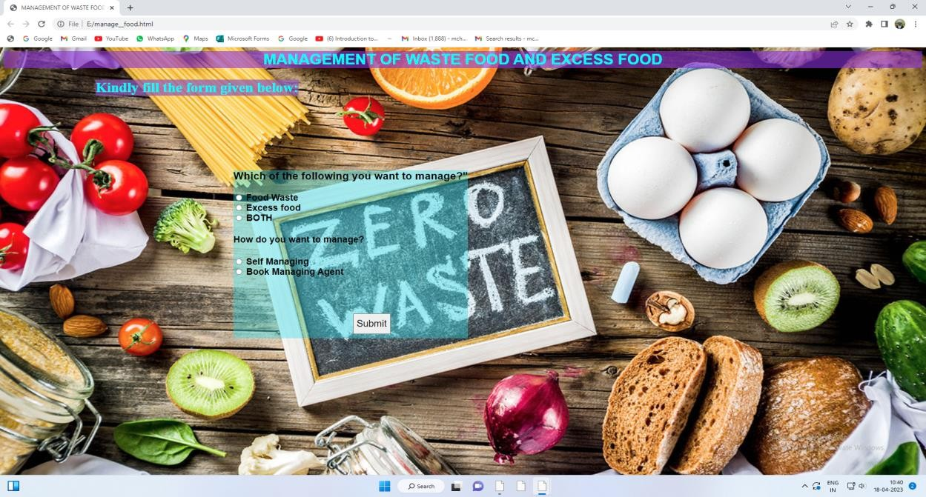

Fig 8.1 Selection Page

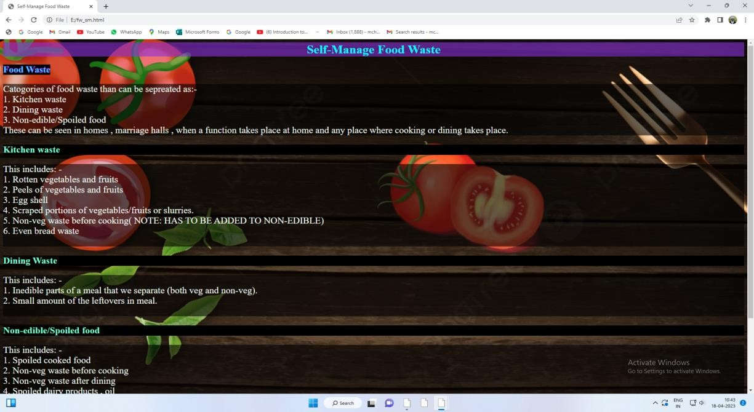

**Fig 8.2 Food waste and self-manage Page**

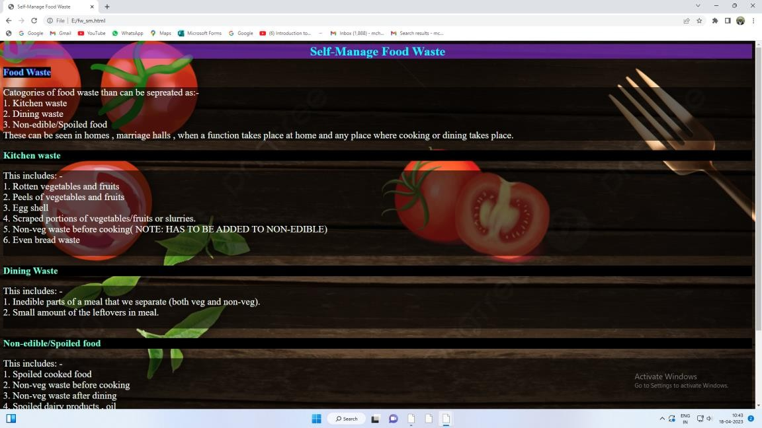

Fig 8.3 Excess food and self-manage Page

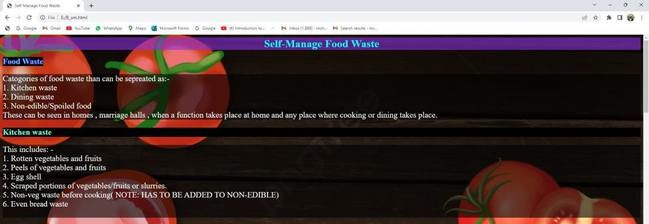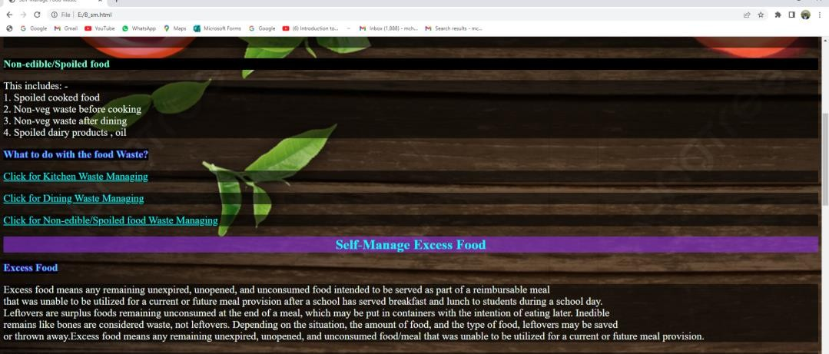

**Fig 8.4 Both and self-manage Page**

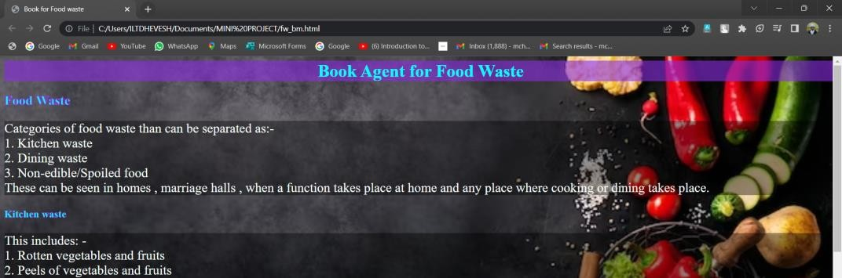

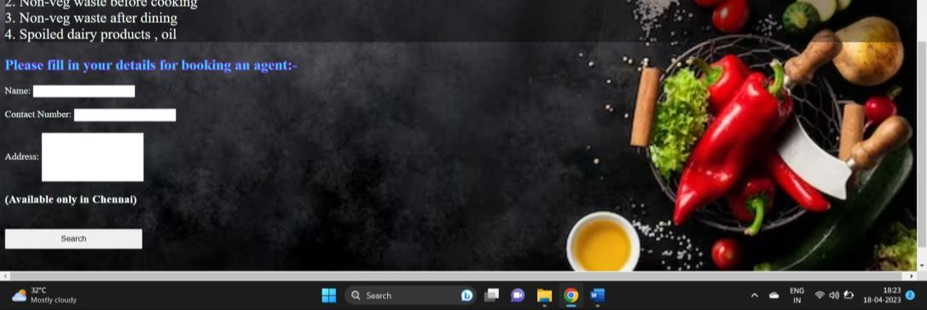

Fig 8.5 Food waste and book agent Page

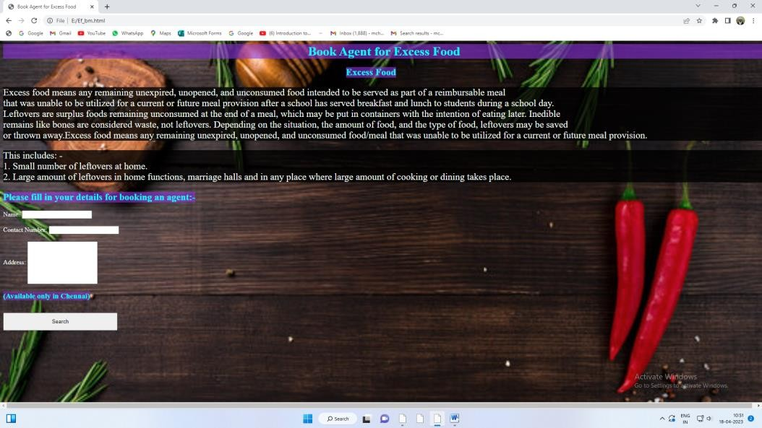

**Fig 8.6 Excess food and book agent Page**

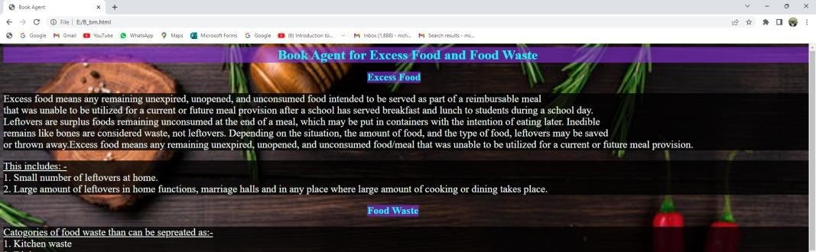

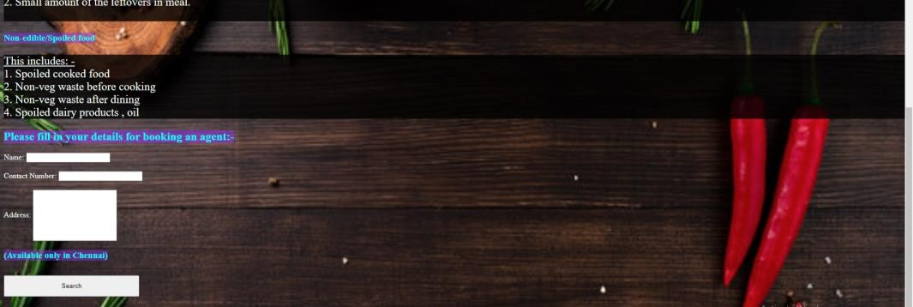

**Fig 8.7 Both and book agent Page**

## CHAPTER 9

### REFERENCES

1. hsph.harvard,https://[www.hsph.harvard.edu/nutritionsource/sustainability/fo](http://www.hsph.harvard.edu/nutritionsource/sustainability/fo) od-waste/
2. **lawinsider,**[**https://www.lawinsider.com/dictionary/excessfood#:~:text=Excess**](https://www.lawinsider.com/dictionary/excessfood#%3A~%3Atext%3DExcess%20food%20means%20any%20remaining%2Cstudents%20during%20a%20school%20day)

[%20food%20means%20any%20remaining,students%20during%20a%20school](https://www.lawinsider.com/dictionary/excessfood#%3A~%3Atext%3DExcess%20food%20means%20any%20remaining%2Cstudents%20during%20a%20school%20day)

[**%20day**](https://www.lawinsider.com/dictionary/excessfood#%3A~%3Atext%3DExcess%20food%20means%20any%20remaining%2Cstudents%20during%20a%20school%20day)

1. **zipinventory,** [**https://zipinventory.com/en/food-waste-management.html**](https://zipinventory.com/en/food-waste-management.html)
2. **futurelearn.,** [**https://www.futurelearn.com/info/courses/an-introduction-to-**](https://www.futurelearn.com/info/courses/an-introduction-to-food-science/0/steps/159644)[**food-science/0/steps/159644**](https://www.futurelearn.com/info/courses/an-introduction-to-food-science/0/steps/159644)
3. **w3schools,** [**https://www.w3schools.com/html/**](https://www.w3schools.com/html/)
4. **javatpoint,** [**https://www.javatpoint.com/html-tutorial**](https://www.javatpoint.com/html-tutorial)
5. **w3schools,** [**https://www.w3schools.com/js/**](https://www.w3schools.com/js/)
6. **Divy Chhibber, Aditi Tripathi, Sandip Ray, “Do VIR: Virtualizing Food Donation Distribution through Mobile Application and Cloud-Based Supply Chain Management”, 2021 IEEE International Conference on Consumer Electronics (ICCE).**
7. Elena-Diana Ungureau-Comanit1, Ersilia Lazar Cosbuc1, Petronela Cozma1, Camelia Smaranda1, Maria Gavrilescu1,2, “Human Health Risks Concerning Food Waste Management”, Grigore T. Popa University of Medicine and Pharmacy, Web Conference, Romania, October 29-30, 2020.
8. **Shinta Oktaviana R, Diana Ambarwati Febriani, Intan Yoshana, LR. Payanta, “FoodX, a System to Reduce Food Waste”, 2020 3rd International Conference on Computer and Informatics Engineering (IC2IE).**