Cable Overview
30 cm
J2 FLARM
50 cm
U1
15 cm
J1 Vario
T1
1m
S1
50 cm

Details and Wiring diagramm:
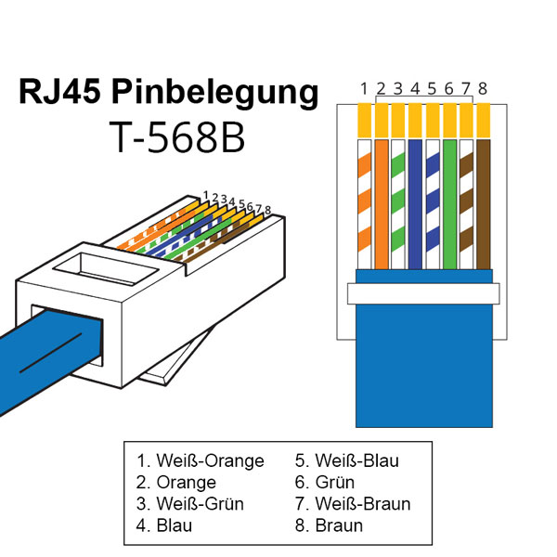  T1 (Dallas DS18B20)  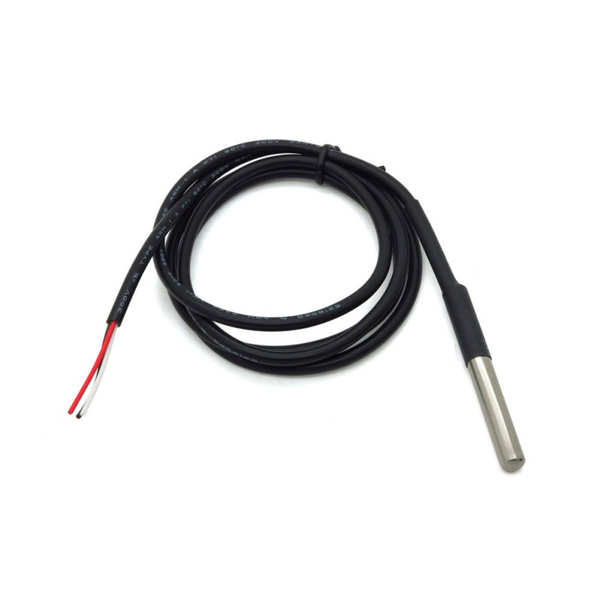  Third party product: e.g. Aliexpress  1 m cable type  „Waterproof 18B20 temperature probe temperature sensor Stainless steel package 1 meter“  Target Price ~ 1$ | S1 (Switch)  open ends  2x AWG26  0,12 mm²  Ends: 5 mm stripped, soldered  Color:  2x Black | J1 (Vario)  RJ45 connector male, 8 pin  RJ45 connector with flat or round cable 15 cm highly flexible, shielded if possible  Color:  don‘t care | U1 (Battery)  open ends  2x 50 cm AWG23 0,25 mm²  Ends: 10mm stripped, soldered  Color:  1 x Black  1 x Red | J2 (FLARM)  RJ45 connector male, 8 pin  RJ45 cable with  flat or round cable 30 cm highly flexible, shielded if possible  Color:  don‘t care
 |  | 1 | +12V | 8
 |  | 2 |  | 7
 |  | 3 |  | 6
 | 1 | 4 |  | 5
3 (+VDD) |  | 5 |  | 4
2 (DQ) |  | 6 |  | 3
1 (GND) |  | 7 |  | 2
 | 2 | 8 | GND | 1

