The Secret Code of AI

Unlocking the Math Behind the Magic.

Why Does AI Need Math?
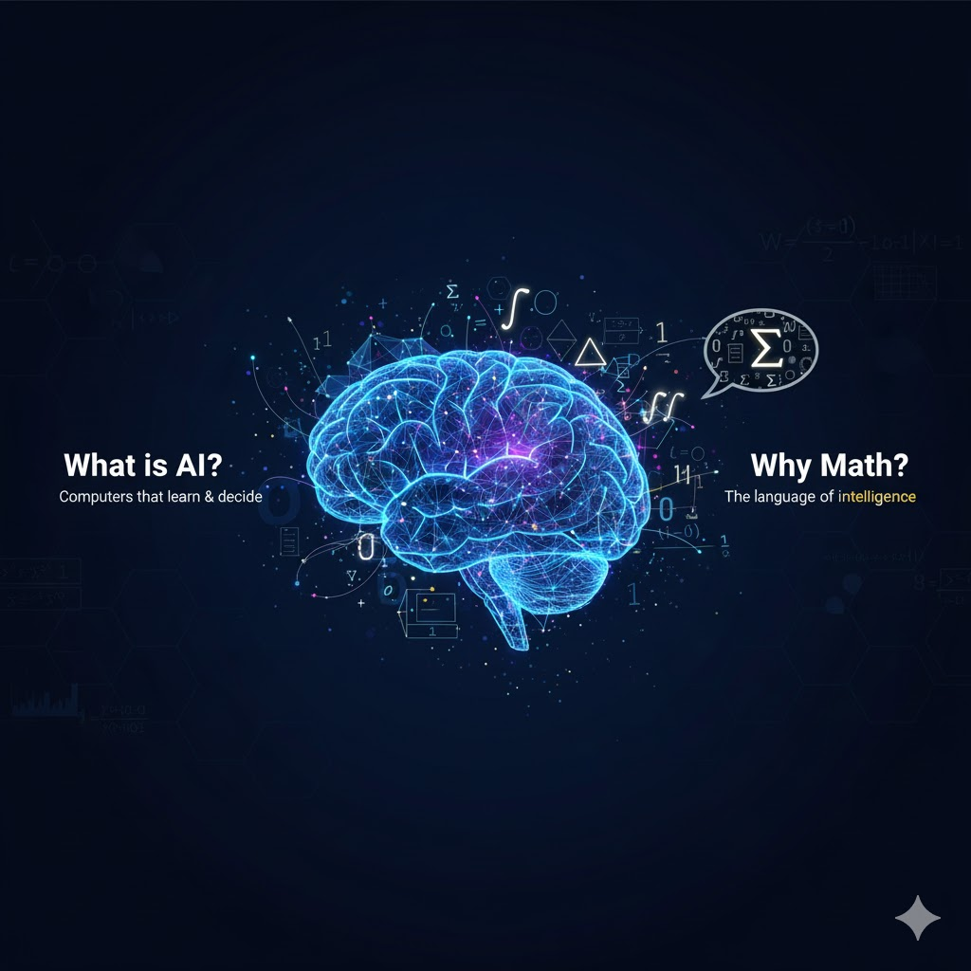
- What is AI? AI helps computers learn and make smart decisions, just like humans.
- Why Math? Math is the language computers use to "think." It gives them a set of rules to understand the world.
Think of it this way: You can't bake a cake without a recipe. Math is the recipe for AI. Today, we'll learn about four key "ingredients" from that recipe.
- Linear Algebra: The language of data.
- Calculus: The science of change and learning.
- Statistics & Probability: The art of making smart guesses.

Section 1 : Linear Algebra (The Language of Data)
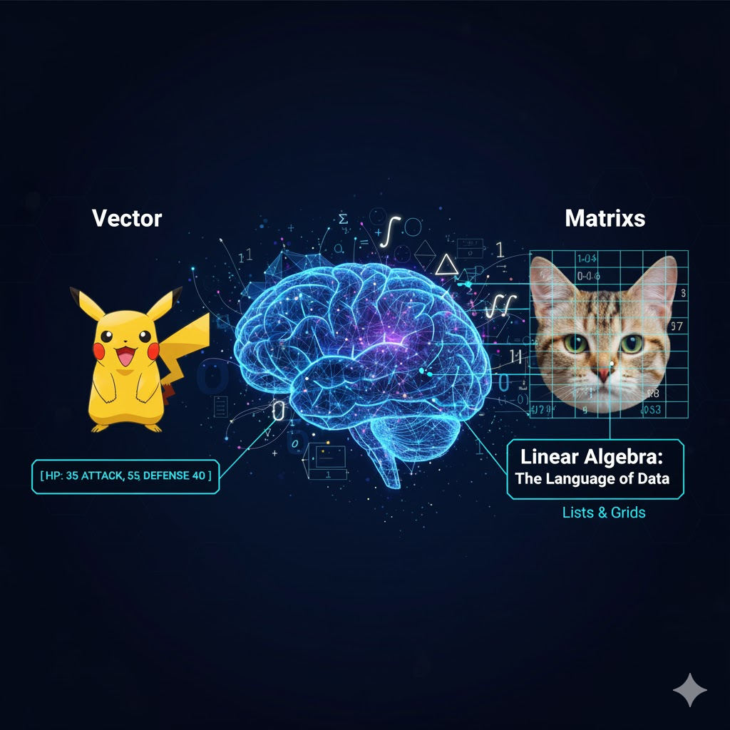
- What it is: Linear Algebra is a way to organize information into lists and grids so a computer can work with it. Everything in AI, from your selfie to this sentence, is turned into numbers.
- Key Idea: Vectors and Matrices
  - Vector: Just a list of numbers. Think of it as a character's stats in a video game.
    - Example: A Pokémon's stats could be a vector: [HP, Attack, Defense]. For Pikachu, it might be [35, 55, 40].
  - Matrix: A grid of numbers (a list of vectors!). This is how computers see images. Each number in the grid is a pixel's color and brightness.
- Why it's important: It allows a computer to process huge amounts of data (like millions of pixels in a photo) all at once, making things like facial recognition possible.

Your Turn!
Examples
Problem 1: Vector Vision Imagine we want to describe a simple video game character with three features:
- Speed (1-10)
- Strength (1-10)
- Magic (1-10)
How would you write a vector for a character that is very fast (9), medium strength (5), and has no magic (0)?
Problem 2: The Image Matrix Let's make a tiny black and white smiley face on a 3x3 grid.
- 1 = Black pixel
- 0 = White pixel
Can you create the matrix for this image?

⚫ | ⚪ | ⚫
⚪ | ⚪ | ⚪
⚫ | ⚪ | ⚫

Section 2 : - Calculus (The Science of Learning)
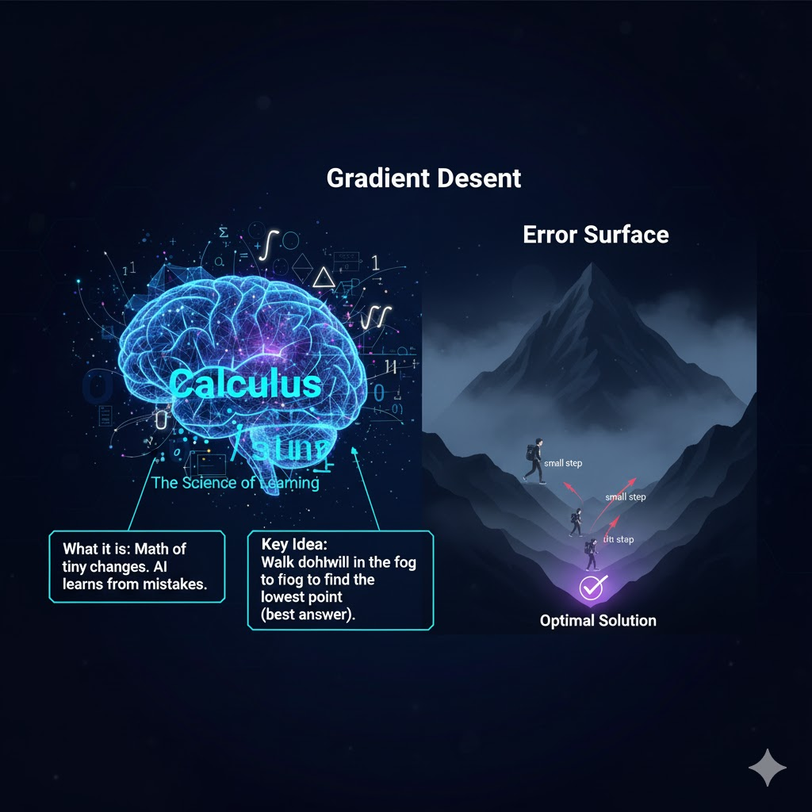
- What it is: Calculus is the math of tiny changes. In AI, it's used to help the AI model learn from its mistakes and get better over time.
- Key Idea: Gradient Descent
  - Imagine you're on a foggy mountain and want to get to the very bottom (the lowest point). You can't see far, so you take a small step in the direction that goes down the most. You repeat this over and over until you can't go down anymore.
  - This process is called Gradient Descent.
  - In AI, the "mountain" is the AI's error, or how wrong its predictions are. The AI uses calculus to find the "steepest downhill direction" and adjusts its own settings (takes a step) to make its error a little smaller. It does this millions of times until its predictions are very accurate.

Your Turn!
Trial Example
Problem: Find the Mistake! An AI is learning to guess a number between 1 and 10. The correct answer is 7.
- Attempt 1: The AI guesses 2. The error is 7 - 2 = 5.
- Attempt 2: The AI guesses 9. The error is 7 - 9 = -2.

- Which attempt had a bigger error?
- If the AI uses Gradient Descent, after guessing 2, should it guess a higher or lower number next to reduce its error?
- After guessing 9, should it guess higher or lower?
Answers:
- Attempt 1 had the bigger error (5 is bigger than 2, we ignore the negative sign for size).
- After guessing 2, it should guess higher.
- After guessing 9, it should guess lower.
This is exactly what calculus helps the AI do automatically!

Statistics & Probability (The Art of Smart Guesses)
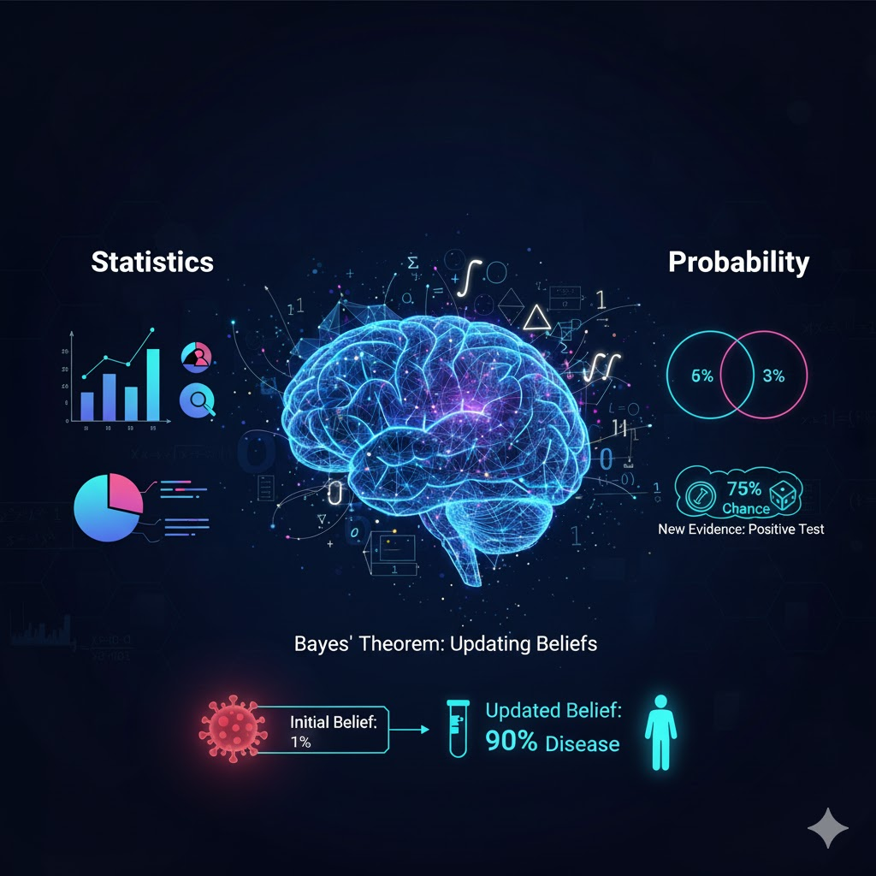
- What they are:
  - Statistics is about collecting and analyzing data to find patterns (like we did with mean, median, and mode).
  - Probability is the chance of something happening. It helps AI deal with uncertainty.
- Key Idea: Bayes' Theorem (Medical Diagnosis Example)
  - This is a famous rule that helps an AI update its beliefs when it gets new information.
  - Example: An AI is helping a doctor.
    - Initial Belief: The probability of any random person having a rare disease is very low (maybe 1%).
    - New Evidence: The person gets a positive test result.
    - Updated Belief: Bayes' Theorem helps the AI combine the initial belief with the test result to calculate a new, more accurate probability that the person actually has the disease. It helps the AI avoid jumping to conclusions.

Your Turn!
Trial Example
Problem: Spam Email Detector An AI is learning to detect spam emails. It has analyzed 100 emails and found these patterns:
- Emails with the word "winner" are spam 90% of the time.
- Emails with your friend's name in them are spam only 5% of the time.
You just received two new emails.
- An email with the subject: "You are the lucky winner!"
- An email with the subject: "Hey, it's Sarah, check this out."
Based on probability, which email is more likely to be spam? Why?
Answer: The email with the word "winner" is far more likely to be spam. The AI uses probability to make this smart guess. It has learned from statistical data that certain words are strong indicators of spam.

Putting It All Together
(Image):
- You see an image of a cat on your phone. What happens?
  - Linear Algebra turns the image into a giant matrix of numbers (pixels).
  - The AI makes a first guess: "I'm 40% sure it's a cat."
  - Calculus helps the AI see it made an error. It uses Gradient Descent to adjust its internal settings to be a little bit better at recognizing cats.
  - Probability & Statistics help the AI make its final decision with confidence. After millions of training examples, it says: "Based on all the patterns I've learned, I am 99% sure this is a cat."

