OEL-5030

1. Feature
▷The OEL-5030is a infrared emitting diode which mounted high power 940㎚IR CHIP.
▷It is encapsulated in water clear epoxy resin with 5㎜ diameter.
▷The radiation substrate material is GaAlAs.
▷ High output power even of a low drive current.

2. Absolute maximum ratings. |  |  |  |  |  |  |  | ( Ta = 2 5℃ )
Parameter |  |  |  | Symbol |  |  |  | Ratings |  |  |  |  |  |  | Unit
Forward current |  |  |  | I_{F} |  |  |  | 100 |  |  |  |  |  |  | ㎃
Reverse voltage |  |  |  | V_{R} |  |  |  | 5 |  |  |  |  |  |  | V
Pulse forward current |  |  |  | I_{FP} |  |  |  | 1 |  |  |  |  |  |  | A
Power dissipation |  |  |  | P_{D} |  |  |  | 150 |  |  |  |  |  |  | ㎽
Operation temperature |  |  |  | Topr. |  |  |  | - 20 + 80 |  |  |  |  |  |  | ℃
Storage temperature |  |  |  | Tstg. |  |  |  | - 30 + 100 |  |  |  |  |  |  | ℃
Soldering temperature |  |  |  | Tsol. |  |  |  | 260 (within 5sec) |  |  |  |  |  |  | ℃
3. Electrical/optical characteristics. |  |  |  |  |  |  |  | ( Ta = 2 5℃ )
Parameter |  |  |  |  |  | Symbol | Test condition |  |  |  | Min. |  |  | Typ. |  |  | Max. | Unit
Forward voltage |  |  |  |  |  | V_{F} | I_{F} = 100 ㎃ |  |  |  |  |  |  | 1.36 |  |  | 1.70 | V
Reverse current |  |  |  |  |  | I_{R} | V_{R} = 5 V |  |  |  |  |  |  |  |  |  | 10 | ㎂
*Radiant intensity |  |  |  |  |  | I_{E} | I_{F} = 100 ㎃ |  |  |  | 50 |  |  | 70 |  |  |  | ㎽/sr
Peak light emitting wavelength |  |  |  |  |  | λp | I_{F} = 100 ㎃ |  |  |  |  |  |  | 940 |  |  |  | ㎚
Spectral half wave width |  |  |  |  |  | Δλ | I_{F} = 100 ㎃ |  |  |  |  |  |  | 45 |  |  |  | ㎚
Viewing angle |  |  |  |  |  | Θ½ | I_{F} = 100 ㎃ |  |  |  |  |  |  | ±30 |  |  |  | Deg
Capacitance |  |  |  |  |  | ct | f = 1㎒ |  |  |  |  |  |  | 25 |  |  |  | PF
*Luminous intensity measuring equipment: OPTRONIC CABORATORIES OL-703C PROGRAMMABLE RADIOMETER.

OSCAR ELECTRONICS
 |  |  |  |  |  |  |  |  |  | Characteristics diagrams
■Forward current Vs Forward voltage. |  |  |  |  |  |  |  |  | ■Forward current Vs Ambient temperature.
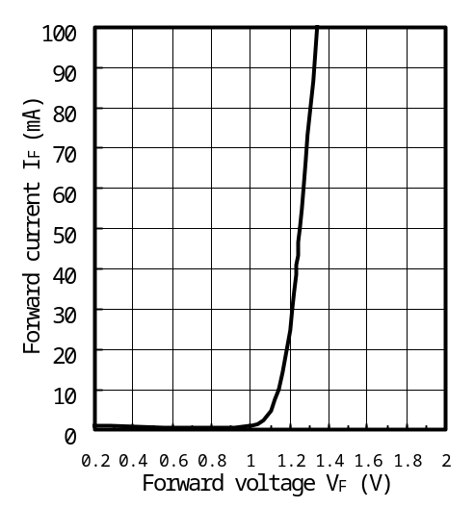 |  |  |  |  |  |  |  |  | 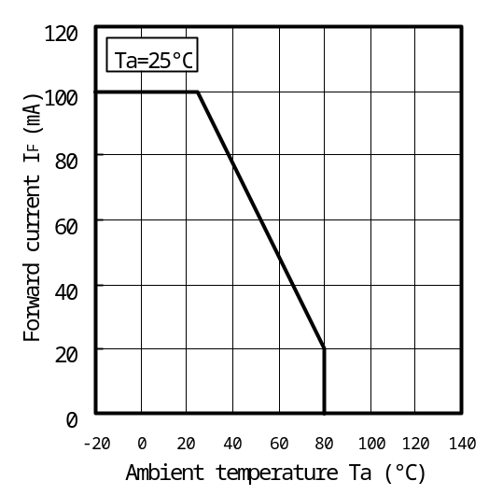
■Relative Radiant intensity Vs Ambient temperature. |  |  |  |  |  |  |  |  | ■ Radiant intensity Vs Forward current.
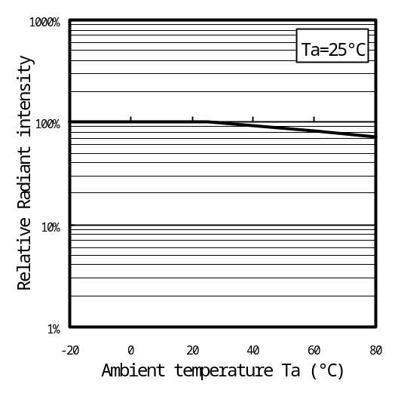 |  |  |  |  |  |  |  |  | 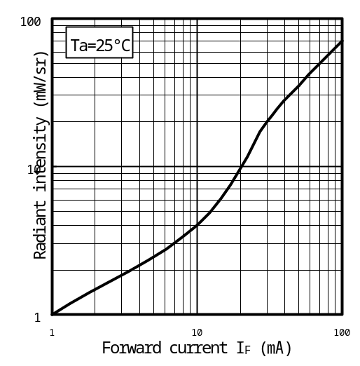
■ Spectral distribution. |  |  |  |  |  |  |  |  | ■ Radiation pattern.
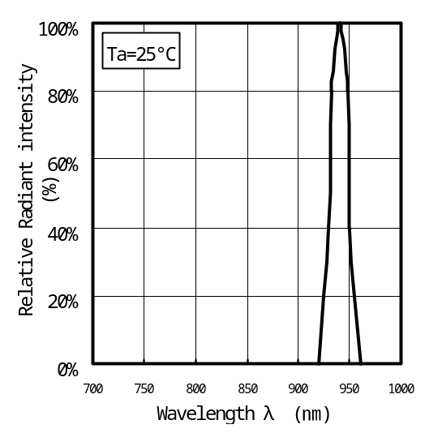 |  |  |  |  |  |  |  |  | 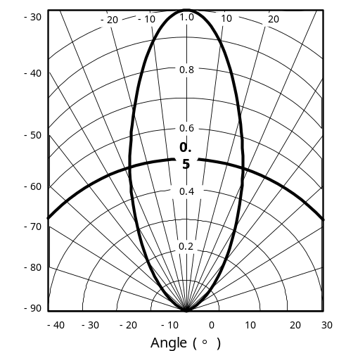
 |  |  |  |  |  |  |  |  |  |  |  |  |  |  |  | DIMENSIONS
 | 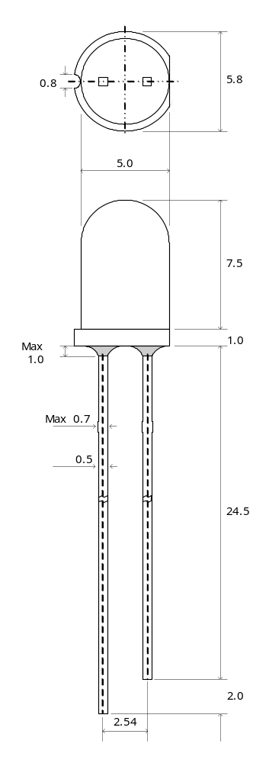 |  |  |  |  |  |  |  |  |  |  |  | NOTES.  - All dimensions are in “㎜”.  - The magnification is 5 : 1.  - Tolerances are ±0.2㎜  Unless otherwise noted.  - Electrode:  