**Московский авиационный институт**

**(Национальный исследовательский университет)**

**Факультет: «Информационные технологии и прикладная математика»**

**Кафедра: 806 «Вычислительная математика и программирование»**

**Дисциплина: «Численные методы»**

**Лабораторная работы по курсу**

**“Численные методы”**

Студент: Семенов И. М.

Группа: М8О-306Б-18

Преподаватель: Ревизников Д. Л.

Дата: 5.06.2021

Оценка:

Москва, 2021

# Лабораторная работа 1.1

Задание: Реализовать алгоритм LU – разложения матриц(с выбором главного элемента) в виде программы. Используя разработанное программное обеспечение, решить систему линейных алгебраических уравнений. Для матрицы СЛАУ вычислить определитель и обратную матрицу

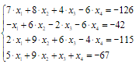Условие:

Исходный код: matrix.h

#ifndef **LAB1_MATRIX_H**#define **LAB1_MATRIX_H**#include <vector>  
#include <stdexcept>  
#include <iostream>  
#include <tuple>  
#include <complex>  
#include <functional>  
  
template <typename T>  
using Column = std::vector<T>;  
  
template <typename T>  
std::ostream& operator << (std::ostream& os, const std::vector<T>& v) {  
 for (const auto& i : v) {  
 os << i << " ";  
 }  
 return os;  
}  
  
template <typename T>  
std::ostream& operator << (std::ostream& os, std::complex<T> cp) {  
 return os << "(re: " << cp.real() << ", im:" << cp.imag() << ")";  
}  
  
template <typename T>  
Column<T> operator * (Column<T> v, T value) {  
 for (T& i : v) {  
 i *= value;  
 }  
 return v;  
}  
  
template <typename T>  
Column<T> operator * (T value, Column<T> v) {  
 return std::move(v) * value;  
}  
  
template <typename T>  
Column<T> operator / (Column<T> v, T value) {  
 for (T& i : v) {  
 i /= value;  
 }  
 return v;  
}  
  
template <typename T>  
Column<T> operator / (T value, Column<T> v) {  
 return std::move(v) / value;  
}  
  
template <typename T>  
class Matrix {  
public:  
 Matrix(const Matrix<T>&);  
 Matrix(Matrix<T>&&);  
  
 Matrix& operator = (const Matrix<T>&other);  
 Matrix& operator = (Matrix<T>&&other);  
  
 Matrix(std::vector<std::vector<T>>);  
  
 static Matrix<T> ones(int n, int m);  
 static Matrix<T> zeros(int n, int m);  
  
 static Matrix<T> construct_row_matrix(std::vector<T>);  
 static Matrix<T> construct_row_matrix(size_t);  
  
 static Matrix<T> construct_column_matrix(const std::vector<T>&);  
 static Matrix<T> construct_column_matrix(size_t);  
  
 static Matrix<T> concatenate_columns(const std::vector<Column<T>>&);  
  
 auto begin();  
 auto begin() const;  
 auto end();  
 auto end() const;  
  
  
 Matrix<T> operator * (T other) const;  
 Matrix<T> operator * (const Matrix<T>& other) const;  
 Matrix<T> operator * (const Column<T>& other) const;  
  
 Matrix<T> operator + (const Matrix<T>& other) const;  
 Matrix<T> operator - (const Matrix<T>& other) const;  
  
  
  
 Matrix<T> transpose() const;  
 const std::vector<std::vector<T>>& get_data() const;  
  
 Column<T> get_column(size_t index) const;  
 explicit operator Column<T>() const;  
 explicit operator T() const;  
 std::vector<T>& operator[](size_t index);  
 const std::vector<T>& operator[](size_t index) const;  
  
 size_t size_rows() const;  
 size_t size_columns() const;  
  
 void swap_rows(int f, int s);  
 void swap_columns(int f, int s);  
  
 std::vector<std::vector<T>> data;  
};  
  
  
template <typename T>  
struct LUDecomposition {  
 using value_type = T;  
 Matrix<T> L;  
 Matrix<T> U;  
 Matrix<T> P;  
 bool odd;  
};  
  
template <typename T>  
std::ostream& operator << (std::ostream& os, const Matrix<T>& m) {  
 for (int i = 0; i < m.size_rows(); ++i) {  
 for (int j = 0; j < m.size_columns(); ++j) {  
 os << m[i][j] << " ";  
 }  
 os << "\n";  
 }  
 return os;  
}  
  
template <typename T>  
Matrix<T>::operator T() const {  
 if (size_rows() == 1 && size_columns() == 1) {  
 return (*this)[0][0];  
 }  
 throw std::logic_error("cant cast matrix to number");  
}  
  
template<typename T>  
Matrix<T> operator * (Matrix<T> mt, T value) {  
 for (int i = 0; mt.size_rows(); ++i) {  
 for (int j = 0; mt.size_columns(); ++i) {  
 mt[i][j] *= value;  
 }  
 }  
 return mt;  
}  
  
template<typename T>  
Matrix<T> operator * (T value, Matrix<T> mt) {  
 return mt * value;  
}  
  
  
template <typename T>  
Matrix<T>::Matrix(const Matrix<T>& other)  
: data(other.data) {}  
  
template <typename T>  
Matrix<T>::Matrix(Matrix<T>&& other)  
: data(std::move(other.data)) {}  
  
template <typename T>  
Matrix<T>::Matrix(std::vector<std::vector<T>> v)  
: data(std::move(v)) {}  
  
template <typename T>  
const std::vector<std::vector<T>>& Matrix<T>::get_data() const {  
 return data;  
}  
  
template <typename T>  
Matrix<T> Matrix<T>::zeros(int n, int m) {  
 return std::vector<std::vector<T>>(n, std::vector<T>(m, T(0)));  
}  
  
template <typename T>  
Matrix<T> Matrix<T>::ones(int n, int m) {  
 auto result = Matrix<T>::zeros(n,m);  
 for (int i = 0, j = 0; i < n && j < m; ++i, ++j) {  
 result[i][j] = T(1);  
 }  
 return result;  
}  
  
template <typename T>  
Matrix<T> Matrix<T>::transpose() const {  
 Matrix<T> result = Matrix<T>::zeros(size_columns(), size_rows());  
 for (int i = 0; i < size_rows(); ++i) {  
 for (int j = 0; j < size_columns(); ++j) {  
 result[j][i] = data[i][j];  
 }  
 }  
 return result;  
}  
  
template <typename T>  
size_t Matrix<T>::size_rows() const {  
 return data.size();  
}  
template <typename T>  
auto Matrix<T>::begin() {  
 return data.begin();  
}  
  
template <typename T>  
auto Matrix<T>::begin() const {  
 return data.begin();  
}  
  
template <typename T>  
auto Matrix<T>::end() {  
 return data.end();  
}  
  
template <typename T>  
auto Matrix<T>::end() const {  
 return data.end();  
}  
  
template<typename T>  
Matrix<T>::operator Column<T>() const {  
 if (size_columns() != 1) {  
 throw std::logic_error("Wrong cast to column");  
 }  
 Column<T> result;  
 for (int i = 0; i < size_rows(); ++i) {  
 result.push_back(data[i][0]);  
 }  
 return result;  
}  
  
template <typename T>  
size_t Matrix<T>::size_columns() const {  
 return (data.size() ? data[0].size() : 0);  
}  
  
template <typename T>  
std::vector<T>& Matrix<T>::operator[](size_t index) {  
 return data[index];  
}  
  
template <typename T>  
const std::vector<T>& Matrix<T>::operator[](size_t index) const {  
 return data[index];  
}  
  
template <typename T>  
Matrix<T> Matrix<T>::operator * (T other) const {  
 auto res = *this;  
 for (int i = 0; i < res.size_rows(); ++i) {  
 for (int j = 0; j < res.size_columns(); ++j) {  
 res[i][j] *= other;  
 }  
 }  
 return res;  
}  
  
template <typename T>  
Matrix<T> Matrix<T>::operator * (const Matrix<T>& other) const {  
 if (size_columns() != other.size_rows()) {  
 throw std::logic_error("cant multiply matrices");  
 }  
 auto result = zeros(size_rows(), other.size_columns());  
 for (int i = 0; i < size_rows(); ++i) {  
 for (int j = 0; j < other.size_columns(); ++j) {  
 T val = 0;  
 for (int k = 0; k < size_columns(); ++k) {  
 val += data[i][k] * other[k][j];  
 }  
 result.data[i][j] = val;  
 }  
 }  
 return result;  
}  
  
template <typename T>  
Matrix<T> Matrix<T>::operator + (const Matrix<T>& other) const {  
 if (size_columns() != other.size_columns() || size_rows() != other.size_rows()) {  
 throw std::logic_error("cant add matrices");  
 }  
 auto result = zeros(size_rows(), size_columns());  
 for (int i = 0; i < size_rows(); ++i) {  
 for (int j = 0; j < other.size_columns(); ++j) {  
 result[i][j] = *this[i][j] + other[i][j];  
 }  
 }  
 return result;  
}  
  
template <typename T>  
Matrix<T> Matrix<T>::operator - (const Matrix<T>& other) const {  
 if (size_columns() != other.size_columns() || size_rows() != other.size_rows()) {  
 throw std::logic_error("cant subtract matrices");  
 }  
 auto result = zeros(size_rows(), size_columns());  
 for (int i = 0; i < size_rows(); ++i) {  
 for (int j = 0; j < other.size_columns(); ++j) {  
 result[i][j] = (*this)[i][j] - other[i][j];  
 }  
 }  
 return result;  
}  
  
template <typename T>  
void Matrix<T>::swap_rows(int f, int s) {  
 data[f].swap(data[s]);  
}  
  
template <typename T>  
void Matrix<T>::swap_columns(int f, int s) {  
 for (int i = 0; i < size_rows(); ++i) {  
 std::swap(data[i][f], data[i][s]);  
 }  
}  
  
template<typename T>  
Matrix<T> to_column_matrix(const Column<T>& c) {  
 Matrix<T> result = Matrix<T>::zeros(c.size(), 1);  
 for (int i = 0; i < c.size(); ++i) {  
 result[i][0] = c[i];  
 }  
 return result;  
}  
  
template<typename T>  
Matrix<T> to_row_matrix(const Column<T>& c) {  
 return Matrix<T>({c});  
}  
  
  
template <typename T>  
Matrix<T>& Matrix<T>::operator = (const Matrix<T>&other) {  
 data = other.data;  
 return *this;  
}  
  
template <typename T>  
Matrix<T>& Matrix<T>::operator = (Matrix<T>&& other) {  
 data = std::move(other.data);  
 return *this;  
}  
  
template <typename T>  
Matrix<T> Matrix<T>::concatenate_columns(const std::vector<Column<T>>& cols) {  
 Matrix<T> result = zeros((cols.size() ? cols[0].size() : 0), cols.size());  
 for (int j = 0; j < cols.size(); ++j) {  
 for (int i = 0; i < cols[j].size(); ++i) {  
 result[i][j] = cols[j][i];  
 }  
 }  
 return result;  
}  
  
template<typename T>  
Column<T> operator + (const Column<T>& lhs, const Column<T>& rhs) {  
 if (lhs.size() != rhs.size()) {  
 throw std::logic_error("error while summing vectors : sizes are not equal");  
 }  
 Column<T> result(lhs.size());  
 for (int i = 0; i < lhs.size(); ++i) {  
 result[i] = lhs[i] + rhs[i];  
 }  
 return result;  
}  
  
template<typename T>  
Column<T> operator - (const Column<T>& lhs, const Column<T>& rhs) {  
 if (lhs.size() != rhs.size()) {  
 throw std::logic_error("error while summing vectors : sizes are not equal");  
 }  
 Column<T> result(lhs.size());  
 for (int i = 0; i < lhs.size(); ++i) {  
 result[i] = lhs[i] - rhs[i];  
 }  
 return result;  
}  
  
  
template <typename T>  
Matrix<T> Matrix<T>::construct_row_matrix(std::vector<T> v) {  
 return Matrix<T>{{std::move(v)}};  
}  
  
template <typename T>  
Matrix<T> Matrix<T>::construct_column_matrix(const std::vector<T>& v) {  
 Matrix<T> result = zeros( v.size(), 1);  
 for (int i = 0; i < v.size(); ++i) {  
 result[i][0] = v[i];  
 }  
 return result;  
}  
  
template <typename T>  
Matrix<T> Matrix<T>::operator * (const Column<T>& other) const {  
 return *this * construct_column_matrix(other);  
}  
  
template <typename T>  
Matrix<T> Matrix<T>::construct_column_matrix(size_t size) {  
 return zeros(size,1);  
}  
  
template <typename T>  
Matrix<T> Matrix<T>::construct_row_matrix(size_t size) {  
 return zeros(1,size);  
}  
  
template <typename T>  
Column<T> Matrix<T>::get_column(size_t index) const {  
 Column<T> result;  
 for (int i = 0; i < size_rows(); ++i) {  
 result.push_back(data[i][index]);  
 }  
 return result;  
}  
  
namespace Math{  
 template <typename T>  
 LUDecomposition<T> lu_decomposition(const Matrix<T>& other) {  
 Matrix<T> L = Matrix<T>::zeros(other.size_rows(), other.size_columns());  
 Matrix<T> U = other;  
 Matrix<T> P = Matrix<T>::ones(other.size_rows(), other.size_columns());  
 bool odd = false;  
 int n = other.size_rows();  
 for (int i = 0; i < n; ++i) {  
 int index = i;  
 for (int j = i; j < n; ++j) {  
 if (std::abs(U[j][i]) > std::abs(U[index][i])) {  
 index = j;  
 }  
 }  
 if (i != index) {  
 L.swap_rows(i, index);  
 U.swap_rows(i, index);  
 P.swap_rows(i, index);  
 odd = !odd;  
 }  
  
  
 L[i][i] = 1;  
 for (int j = i + 1; j < n; ++j) {  
 L[j][i] = U[j][i] / U[i][i];  
 U[j][i] = 0;  
 }  
 for (int j = i + 1; j < n; ++j) {  
 for (int k = i + 1; k < n; ++k) {  
 U[j][k] = U[j][k] - U[i][k] * L[j][i];  
 }  
 }  
 }  
 return {L, U, P, odd};  
 }  
  
  
  
 template <typename T>  
 Column<T> solve_linear_system(const LUDecomposition<T>& dec, Column<T> b) {  
 const auto& [L,U,P,odd] = dec;  
 int n = L.size_rows();  
 b = Column<T>(P * b);  
 *// PA = LU  
 //Solve Lz = b* Column<T> z(n);  
 z[0] = b[0];  
 for (int i = 1; i < n; ++i) {  
 T sum = 0;  
 for (int j = 0; j < i; ++j) {  
 sum += L[i][j] * z[j];  
 }  
 z[i] = b[i] - sum;  
  
 }  
  
 *//Solve Ux = z* Column<T> x(n);  
 x[n - 1] = z[n - 1] / U[n - 1][n - 1];  
 for (int i = n - 2; i >= 0; --i) {  
 T sum = 0;  
 for (int j = i + 1; j < n; ++j) {  
 sum += U[i][j] * x[j];  
 }  
 x[i] = (z[i] - sum) / U[i][i];  
 }  
  
 *//Return x* return x;  
 }  
  
 template <typename T>  
 Matrix<T> solve_matrix_equation(const LUDecomposition<T>& dec, const Matrix<T>& b) {  
 std::vector<Column<T>> result;  
 for (int i = 0; i < dec.L.size_columns(); ++i) {  
 result.push_back(solve_linear_system(dec, b.get_column(i)));  
 }  
 return Matrix<T>::concatenate_columns(result);  
  
 }  
  
 template <typename T>  
 Matrix<T> solve_matrix_equation(const Matrix<T>& a, const Matrix<T>& b) {  
 return solve_matrix_equation(lu_decomposition(a), b);  
  
 }  
  
 template <typename T>  
 T determinant(const LUDecomposition<T>& dec) {  
 const auto& [L, U, P, odd] = dec;  
 double Ldet = 1, Udet = 1;  
 int n = L.size_rows();  
 for (int i = 0; i < n; ++i) {  
 Ldet *= L[i][i];  
 Udet *= U[i][i];  
 }  
 return Ldet * Udet * (odd ? -1 : 1);  
 }  
  
 template <typename T>  
 long double norm(const Column<T>& d, const std::function<bool(int)>& filter = [] (int) {return true;}) {  
 long double sum = 0;  
 for (int i = 0; i < d.size(); ++i) {  
 if (filter(i)) {  
 sum += d[i] * d[i];  
 }  
 }  
 return std::sqrt(sum);  
 }  
  
 template <typename T>  
 long double norm(const Matrix<T>& d, const std::function<bool(int,int)>& filter = [] (int,int) {return true;}) {  
 long double sum = 0;  
 for (int i = 0; i < d.size_rows(); ++i) {  
 for (int j = 0; j < d.size_columns(); ++j) {  
 if (filter(i, j)) {  
 sum += d[i][j] * d[i][j];  
 }  
 }  
 }  
 return std::sqrt(sum);  
 }  
  
  
  
 template <typename T>  
 Column<T> sweep_method(const Matrix<T>& matrix, const Column<T>& d) {  
 struct index_pair {int i; int j;};  
 std::vector<double> P(d.size()), Q(d.size());  
 int n = d.size();  
 auto M = [&matrix] (index_pair elem, int inc) -> T {  
 return matrix[elem.i + inc][elem.j + inc];  
 };  
 index_pair a = {0,-1}, b = {0,0}, c = {0,1};  
 P[0] = -M(c,0) / M(b,0);  
 Q[0] = d[0] / M(b,0);  
 for (int i = 1; i < n - 1; ++i) {  
 P[i] = -M(c,i) / (M(b,i) + M(a,i) * P[i - 1]);  
 Q[i] = (d[i] - M(a,i) * Q[i - 1]) / (M(b,i) + M(a,i) * P[i - 1]);  
 }  
 P[n - 1] = 0;  
 Q[n - 1] = (d[n - 1] - M(a, n - 1) * Q[n - 2]) / (M(b, n - 1) + M(a, n - 1) * P[n - 2]);  
 Column<T> x(d.size());  
 x[n - 1] = Q.back();  
 for (int i = x.size() - 2; i >= 0; --i) {  
 x[i] = P[i] * x[i + 1] + Q[i];  
 }  
 return x;  
 }  
  
 template <typename T>  
 std::vector<Column<T>> simple_iterations(const Matrix<T>& a, const Column<T>& b, long double epsilon, int max_iteration_count = 1'000'000) {  
 int n = b.size();  
 Column<T> beta(n);  
 Matrix<T> alpha = Matrix<T>::zeros(n,n);  
 for (int i = 0; i < n; ++i) {  
 beta[i] = b[i] / a[i][i];  
 }  
 for (int i = 0; i < n; ++i) {  
 for (int j = 0; j < n; ++j) {  
 alpha[i][j] = -a[i][j] / a[i][i];  
 if (i == j) {  
 alpha[i][j] = 0;  
 }  
 }  
 }  
 std::vector<Column<T>> result = {beta};  
 Column<T> x = beta;  
 for (int i = 0; i < max_iteration_count; ++i) {  
 Column<T> new_x = beta + Column<T>(alpha * x);  
 double iter_epsilon = norm(new_x - x) * norm(alpha) / (1 - norm(alpha));  
 result.push_back(new_x);*//std::cout << "Simple iteration " << i + 1 << " eps " << iter_epsilon << "\n";* x = new_x;  
 if (iter_epsilon <= epsilon) {  
 break;  
 }  
 }  
 return result;  
 }  
  
 template <typename T>  
 std::vector<Column<T>> zeidel(const Matrix<T>& a, const Column<T>& b, long double epsilon, int max_iteration_count = 1'000'000) {  
 int n = b.size();  
 Column<T> beta(n);  
 Matrix<T> alpha = Matrix<T>::zeros(n,n);  
 for (int i = 0; i < n; ++i) {  
 beta[i] = b[i] / a[i][i];  
 }  
 for (int i = 0; i < n; ++i) {  
 for (int j = 0; j < n; ++j) {  
 alpha[i][j] = -a[i][j] / a[i][i];  
 if (i == j) {  
 alpha[i][j] = 0;  
 }  
 }  
 }  
 std::vector<Column<T>> result = {beta};  
 Column<T> x = beta;  
 for (int i = 0; i < max_iteration_count; ++i) {  
 Column<T> new_x(n);  
 for (int j = 0; j < n; ++j) {  
 new_x[j] = beta[j];  
 for (int k = 0; k < n; ++k) {  
 new_x[j] += alpha[j][k] * (k < j ? new_x[k] : x[k]);  
 }  
 }  
 double iter_epsilon = (norm(alpha, [] (int i, int j) {return j >= i;}))/(1 - norm(alpha)) * norm(new_x - x);  
 result.push_back(new_x);*//std::cout << "Zeidel iteration " << i + 1 << " eps " << iter_epsilon << "\n";* x = new_x;  
 if (iter_epsilon <= epsilon) {  
 break;  
 }  
 }  
 return result;  
 }  
  
 template<typename T>  
 struct Eigen {  
 Column<T> eigenvalues;  
 std::vector<Column<T>> eigenvectors;  
 std::vector<long double> epsilons;  
 };  
  
 template <typename T>  
 Eigen<T> rotation_method(const Matrix<T>& m, long double epsilon, int max_iteration_count = 1'000'000) {  
 int n = m.size_columns();  
 Matrix<T> A = m;  
 Matrix<T> U = Matrix<T>::ones(n,n);  
 std::vector<long double> epsilons;  
 for (int iter = 0; iter < max_iteration_count; ++iter) {  
 T max = std::abs(A[0][1]);  
 int max_i = 0;  
 int max_j = 1;  
 for (int i = 0; i < n; ++i) {  
 for (int j = 0; j < n; ++j) {  
 if (i != j && std::abs(A[i][j]) > max) {  
 max = std::abs(A[i][j]);  
 max_i = i, max_j = j;  
 }  
 }  
 }  
 Matrix<T> rotate_matrix = Matrix<T>::ones(n,n);  
 long double phi = (A[max_i][max_i] == A[max_j][max_j] ?  
 **M_PI_4** :  
 atan2(2 * A[max_i][max_j], (A[max_i][max_i] - A[max_j][max_j])) / 2.);  
 rotate_matrix[max_i][max_i] = rotate_matrix[max_j][max_j] = std::cos(phi);  
 rotate_matrix[max_i][max_j] = -std::sin(phi);  
 rotate_matrix[max_j][max_i] = std::sin(phi);  
 U = U * rotate_matrix;  
 A = rotate_matrix.transpose() * A * rotate_matrix;  
 epsilons.push_back(norm(A, [] (int i, int j) {return i != j;}));  
 if (epsilons.back() < epsilon) {  
 break;  
 }  
 }  
 Column<T> lambdas(n);  
 for (int i = 0; i < n; ++i) {  
 lambdas[i] = A[i][i];  
 }  
 return {lambdas, U.transpose().get_data(), epsilons};  
 }  
  
 template <typename T>  
 struct QRDecomposition {  
 Matrix<T> Q;  
 Matrix<T> R;  
 };  
  
 template <typename T>  
 int sign(T v) {  
 return (v < 0 ? 1 : -1);  
 }  
  
 template <typename T>  
 std::pair<std::complex<T>,std::complex<T>> find_roots(T a0, T a1, T a2, T a3) {  
 T a = 1;  
 T b = - (a0 + a3);  
 T c = a0 * a3 - a1 * a2;  
 T discriminant = std::pow(b, 2) - 4 * a * c;  
 if (discriminant < 0) {  
 return {{-b / 2., std::sqrt(std::abs(discriminant)) / 2.}, {-b / 2., - std::sqrt(std::abs(discriminant)) / 2.}};  
 }  
 return {{(-b + std::sqrt(discriminant)) / 2.,0},{(-b - std::sqrt(discriminant)) / 2.,0}};  
 }  
  
 template <typename T>  
 QRDecomposition<T> qr_decomposition(Matrix<T> A) {  
 if (A.size_columns() != A.size_rows()) {  
 throw std::logic_error("Not square matrix");  
 }  
 int n = A.size_columns();  
 Matrix<T> H = Matrix<T>::ones(n,n);  
  
  
 for (int i = 0; i < n - 1; ++i) {  
 Column<T> a = A.get_column(i);  
 Column<T> v = a;  
 for (int j = 0; j < i; ++j) {  
 v[j] = 0;  
 }  
 v[i] = a[i] + sign(a[i]) * norm(a, [i] (int index) {return index >= i;});  
 Matrix<T> v_col = Matrix<T>::construct_column_matrix(v);  
 Matrix<T> v_row = Matrix<T>::construct_row_matrix(v);  
 Matrix<T> H_cur = Matrix<T>::ones(n,n) - ((v_col * v_row) * (2 / T(v_row * v_col)));  
  
  
 H = H * H_cur;  
 A = H_cur * A;  
 }  
 return {H, A};  
 }  
  
 template <typename T>  
 std::vector<T> reverse_iter_process(const Matrix<T>& A, T value, long double epsilon, int max_iteration_count = 1'000'000) {  
 Column<T> result(A.size_columns(), 1);  
 Matrix<T> ones = Matrix<T>::ones(A.size_rows(), A.size_columns());  
 for (int i = 0; i < max_iteration_count; ++i) {  
 Column<T> current_result = Column<T>(solve_linear_system(Math::lu_decomposition<T>(A - (value * ones)), result));  
 if (norm(result - (current_result) / norm(current_result)) < epsilon) {  
 result = current_result;  
 break;  
 }  
 result = current_result / norm(current_result);  
 }  
 return result;  
 }  
  
 template<typename T>  
 Eigen<std::complex<T>> reverse_iterations(const Matrix<T>& A, std::vector<std::complex<T>> eigenvalues, long double epsilon, int max_iteration_count = 1'000'000) {  
 int n = A.size_rows();  
 std::vector<std::vector<T>> real_vectors, imag_vectors;  
 for (auto num : eigenvalues) {  
 if (num.real() != 0) {  
 real_vectors.push_back(reverse_iter_process(A, num.real(), epsilon, max_iteration_count));  
 } else {  
 real_vectors.emplace_back(A.size_columns());  
 }  
  
 if (num.imag() != 0) {  
 imag_vectors.push_back(reverse_iter_process(A, num.imag(), epsilon, max_iteration_count));  
 } else {  
 imag_vectors.emplace_back(A.size_columns());  
 }  
 }  
 Eigen<std::complex<T>> result;  
 result.eigenvalues = eigenvalues;  
 result.eigenvectors.resize(eigenvalues.size());  
 for (int i = 0; i < real_vectors.size(); ++i) {  
 for (int j = 0; j < n; ++j) {  
 result.eigenvectors[i].push_back(std::complex(real_vectors[i][j], imag_vectors[i][j]));  
 }  
  
 }  
 return result;  
 }  
  
  
 template <typename T>  
 std::vector<std::complex<T>> qr_algorithm(Matrix<T> A, long double epsilon, int max_iteration_count = 1'000'000) {  
 if (A.size_columns() != A.size_rows()) {  
 throw std::logic_error("not square matrix in qr algo");  
 }  
 int n = A.size_columns();  
 std::vector<bool> complex_convergence(n - 1, false);  
 std::vector<bool> real_convergence(n - 1, false);  
 std::vector<std::complex<T>> complex_roots(n - 1);  
 std::vector<std::complex<T>> result(n);  
 for (int i = 0; i < n - 1; ++i) {  
 auto [root1, root2] = find_roots(A[i][i], A[i][i + 1], A[i + 1][i], A[i + 1][i + 1]);  
 complex_roots[i] = root1;  
 }  
 for (int iter = 0; iter < max_iteration_count; ++iter) {  
 auto [Q,R] = qr_decomposition(A);  
 A = R * Q;  
  
 for (int j = 0; j < n - 1; ++j) {  
 real_convergence[j] = (norm(A.get_column(j), [j] (int index) {return index > j;}) < epsilon);  
 auto [root1, root2] = find_roots(A[j][j], A[j][j + 1], A[j + 1][j], A[j + 1][j + 1]);  
 if (root1.imag() != 0 && abs(root1 - complex_roots[j]) < epsilon) {  
 complex_convergence[j] = true;  
 }  
 complex_roots[j] = root1;  
 }  
 bool end = true;  
 for (int j = 0; j < n - 1; ++j) {  
 if (real_convergence[j]) {  
 result[j] = A[j][j];  
 } else if (complex_convergence[j]) {  
 std::complex<T> root = complex_roots[j];  
 result[j] = root;  
 result[j + 1] = {root.real(), - root.imag()};  
 ++j;  
 } else {  
 end = false;  
 break;  
 }  
 }  
 std::cout << "iter\n" << iter << "\n" << real_convergence << "\n" << complex_convergence << "\n" << A << "\n";  
 if (!complex_convergence[n - 2]) {  
 result[n - 1] = A[n - 1][n - 1];  
 }  
 if (end) {  
 break;  
 }  
 }  
 return result;  
 }  
  
};  
  
#endif *//LAB1_MATRIX_H*

lab1.cpp  
#include<vector>  
#include<cmath>  
#include<iomanip>  
#include "Matrix.h"  
  
using namespace std;  
  
using LMatrix = Matrix<long double>;  
using LColumn = Column<long double>;  
  
int main() {  
 cout << fixed << setprecision(3);  
 LMatrix m({{7, 8, 4, -6},  
 {5, 9, 1, 1},  
 {-1,6,-2, -6},  
 {2, 9,6, -4}});  
 LColumn b{-126,-42,-115,-67};  
 auto decomposition = Math::lu_decomposition(m);  
 auto x = Math::solve_linear_system(decomposition, b);  
 cout << decomposition.L * decomposition.U << "\n\n";  
 cout << "Matrix:\n" << m << "\nSolution:" << x << "\n\n";  
 auto inverse_matrix = Math::solve_matrix_equation(decomposition, LMatrix::ones(m.size_rows(), m.size_columns()));  
 cout << "Inverse matrix:\n" << inverse_matrix << "\n";  
 cout << "M * Inverse\n" << m * inverse_matrix << "\n";  
 cout << "Determinant = " << Math::determinant(decomposition) << "\n";  
  
}

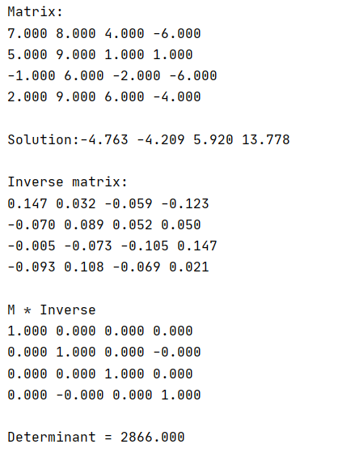Результат:

# Лабораторная работа 1.2

Задание: Реализовать метод прогонки в виде программы, задавая в качестве входных данных ненулевые элементы матрицы системы и вектор правых частей. Используя разработанное программное обеспечение, решить СЛАУ с трехдиагональной матрицей.

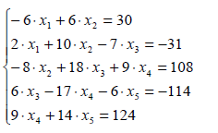Условие:

Исходный код:

#include<vector>  
#include<cmath>  
#include<iomanip>  
#include "Matrix.h"  
  
using namespace std;  
  
using MatrixType = long double;  
using LMatrix = Matrix<MatrixType>;  
using LColumn = Column<MatrixType>;  
  
int main() {  
 cout << fixed << setprecision(1);  
 LMatrix m({{-6, 6, 0, 0, 0},  
 {2, 10, -7, 0, 0},  
 {0, -8, 18, 9, 0},  
 {0,0,6,-17,-6},  
 {0,0,0,9,14}});  
 LColumn b{30,-31,108, -114, 124};  
  
 cout << "Matrix:\n " << m << "\nValues:\n" << b << "\n\nSolution:\n" << Math::sweep_method(m,b) << "\n";  
  
}

Результат:  
Matrix:

-6.0 6.0 0.0 0.0 0.0

2.0 10.0 -7.0 0.0 0.0

0.0 -8.0 18.0 9.0 0.0

0.0 0.0 6.0 -17.0 -6.0

0.0 0.0 0.0 9.0 14.0

Values:

30.0 -31.0 108.0 -114.0 124.0

Solution:

-5.0 0.0 3.0 6.0 5.0

# Лабораторная работа 1.3

Задание: Реализовать метод простых итераций и метод Зейделя в виде программ, задавая в качестве входных данных матрицу системы, вектор правых частей и точность вычислений. Используя разработанное программное обеспечение, решить СЛАУ. Проанализировать количество итераций, необходимое для достижения заданной точности.

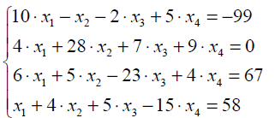Условие:

Исходный код:

#include<vector>  
#include<cmath>  
#include<iomanip>  
#include "Matrix.h"  
  
using namespace std;  
  
  
using MatrixType = long double;  
using LMatrix = Matrix<MatrixType>;  
using LColumn = Column<MatrixType>;  
  
int main() {  
 LMatrix m({{10, -1, -2, 5},  
 {4, 28, 7, 9},  
 {6, 5, -23, 4},  
 {1,4,5,-15}});  
  
 LColumn b{-99,0,67,58};  
 long double epsilon = 0.0001;  
 auto simple_solution = Math::simple_iterations(m, b, epsilon);  
 auto zeidel_solution = Math::zeidel(m, b, epsilon);  
 cout << "Matrix:\n" << m << "\nValues:\n" << b << "\n\n";  
 cout << "Simple iteration method\n";  
 for (int i = 0; i < simple_solution.size(); ++i) {  
 cout << "iteration: " << i << ", solution" << simple_solution[i] << "\n";  
 }  
 cout << "\n";  
  
 cout << "Zeidel method\n";  
 for (int i = 0; i < zeidel_solution.size(); ++i) {  
 cout << "iteration: " << i << ", solution " << zeidel_solution[i] << "\n";  
 }  
 cout << "\n";  
  
 return 0;  
}

Результат:

Matrix:

10 -1 -2 5

4 28 7 9

6 5 -23 4

1 4 5 -15

Values:

-99 0 67 58

Simple iteration method

iteration: 0, solution-9.9 0 -2.91304 -3.86667

iteration: 1, solution-8.54928 3.3854 -6.16812 -5.49768

iteration: 2, solution-8.04624 4.53047 -5.36345 -5.58988

iteration: 3, solution-7.7247 4.28707 -4.99933 -4.98278

iteration: 4, solution-7.97977 3.95497 -4.86278 -4.90487

iteration: 5, solution-8.02462 3.93223 -4.98797 -4.96492

iteration: 6, solution-8.02191 3.98923 -5.01506 -5.0157

iteration: 7, solution-7.99624 4.01194 -5.01079 -5.00935

iteration: 8, solution-7.99629 4.00516 -4.99805 -5.00016

iteration: 9, solution-7.99901 3.99903 -4.99794 -4.99772

iteration: 10, solution-8.00082 3.99861 -4.99956 -4.9995

iteration: 11, solution-8.0003 3.99985 -5.00043 -5.00028

iteration: 12, solution-7.99996 4.00024 -5.00016 -5.0002

iteration: 13, solution-7.99991 4.0001 -4.99997 -4.99999

iteration: 14, solution-7.99999 3.99998 -4.99995 -4.99996

iteration: 15, solution-8.00001 3.99997 -5 -4.99999

iteration: 16, solution-8.00001 4 -5.00001 -5.00001

iteration: 17, solution-8 4.00001 -5 -5

iteration: 18, solution-8 4 -5 -5

Zeidel method

iteration: 0, solution -9.9 0 -2.91304 -3.86667

iteration: 1, solution -8.54928 3.19244 -5.12174 -5.29255

iteration: 2, solution -7.95883 4.11859 -5.01436 -4.97042

iteration: 3, solution -8.0058 3.99491 -4.99748 -5.0009

iteration: 4, solution -7.99955 3.9996 -5.00013 -5.00012

iteration: 5, solution -8.00001 4.00007 -5.00001 -4.99998

iteration: 6, solution -8 4 -5 -5

iteration: 7, solution -8 4 -5 -5

# Лабораторная работа 1.4

Задание: Реализовать метод вращений в виде программы, задавая в качестве входных данных матрицу и точность вычислений. Используя разработанное программное обеспечение, найти собственные значения и собственные векторы симметрических матриц. Проанализировать зависимость погрешности вычислений от числа итераций.

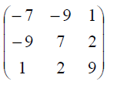Условие:

Исходный код:

#include<vector>  
#include<cmath>  
#include<iomanip>  
#include "Matrix.h"  
  
using namespace std;  
  
  
using MatrixType = long double;  
using LMatrix = Matrix<MatrixType>;  
using LColumn = Column<MatrixType>;  
  
int main() {  
 LMatrix m({{-7,-9,1},  
 {-9,7,2},  
 {1,2,9}});  
  
  
 long double epsilon = 0.0001;  
 auto [eigenvalues, eigenvectors, epsilons] = Math::rotation_method(m, epsilon);  
 cout << "Eigenvalues\n";  
 cout << eigenvalues << "\n\n";  
 cout << "Eigenvectors\n";  
 for (const auto& v : eigenvectors) {  
 cout << v << "\n";  
 }  
 cout << "\n";  
 for (int i = 0; i < eigenvalues.size(); ++i) {  
 cout << "i: " << i + 1 << ", Ax " << LColumn(m * eigenvectors[i]) << ", lambda * x" << eigenvectors[i] * eigenvalues[i] << "\n";  
 }  
 cout << "\n";  
 for (int i = 0; i < epsilons.size(); ++i) {  
 cout << "epsilon on iteration " << i << ": " << epsilons[i] << "\n";  
 }  
 return 0;  
}

Результат:

Eigenvalues

12.0366 8.51939 -11.556

Eigenvectors

0.368925 -0.827393 -0.423456

0.258828 -0.346119 0.901782

-0.892694 -0.442292 0.0864604

i: 1, Ax 4.4406 -9.95899 -5.09696 , lambda * x4.4406 -9.95899 -5.09696

i: 2, Ax 2.20505 -2.94872 7.68262 , lambda * x2.20505 -2.94872 7.68262

i: 3, Ax 10.3159 5.11112 -0.999135 , lambda * x10.3159 5.11112 -0.999134

epsilon on iteration 0: 3.16228

epsilon on iteration 1: 1.91948

epsilon on iteration 2: 0.165323

epsilon on iteration 3: 0.0702142

epsilon on iteration 4: 0.000314979

epsilon on iteration 5: 7.78978e-07

# Лабораторная работа 1.5

Задание: Реализовать алгоритм QR-разложения матриц в виде программы. На его основе разработать программу, реализующую QR – алгоритм решения полной проблемы собственных значений произвольных матриц, задавая в качестве входных данных матрицу и точность вычислений.

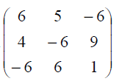Условие:

Исходный код:

#include<vector>  
#include<cmath>  
#include<iomanip>  
#include "Matrix.h"  
  
using namespace std;  
  
  
using MatrixType = long double;  
using LMatrix = Matrix<MatrixType>;  
using LColumn = Column<MatrixType>;  
  
int main() {  
 LMatrix A({{6,5,-6},{4,-6,9},{-6,6,1}});  
 cout << fixed << setprecision(3);  
 auto [Q, R] = Math::qr_decomposition(A);  
 cout << A << "\n";  
 cout << Q << "\n" << R << "\n";  
 cout << Q * R << "\n";  
 *//cout << Math::find_roots(-2.01, -2.58, 0.98, -1.33).first;  
 //cout << "qr\n" << Q * R << "\n";* vector<complex<long double>> values = Math::qr_algorithm(A, 0.01);  
 cout << values << "\n";  
 cout << "Test: " << Math::qr_algorithm(LMatrix({{1,3,5,6},  
 {-1,7,9,2},  
 {-5,4,4,2},  
 {0,1,5,-2}}), 0.01) << "\n";  
 return 0;  
}

Результат:

"D:\Numerical methods\cmake-build-debug\lab5.exe"

6.000 5.000 -6.000

4.000 -6.000 9.000

-6.000 6.000 1.000

Iterations: 29

(re: -13.275, im:0.000) (re: 9.861, im:0.000) (re: 4.415, im:0.000)

# Лабораторная работа 2.1

Задание: Реализовать методы простой итерации и Ньютона решения нелинейных уравнений в виде программ, задавая в качестве входных данных точность вычислений. С использованием разработанного программного обеспечения найти положительный корень нелинейного уравнения (начальное приближение определить графически). Проанализировать зависимость погрешности вычислений от количества итераций

Условие:

Исходный код:

import numpy as np  
import math  
from tabulate import tabulate  
import matplotlib.pyplot as plt  
  
  
def newton(fun, der, x, epsilon=0.001):  
 iter_info = [[0, x, fun(x)]]  
 iter_number = 1  
 while True:  
 new_x = x - fun(x) / der(x)  
 iter_info.append([iter_number, new_x, fun(new_x)])  
 if np.abs(new_x - x) < epsilon:  
 return iter_info  
 x = new_x  
 iter_number = iter_number + 1  
  
def simple_iteration_prep(fi_der, x0, x1, step = 0.001):  
 interval = np.arange(x0, x1, step)  
 return max(np.abs(fi_der(interval)))  
  
def simple_iteration(fi, x, q, fun, epsilon = 0.001):  
 iter_info = [[0, x, fi(x)]]  
 iter_number = 1  
 while True:  
 new_x = fi(x)  
 iter_info.append([iter_number, new_x, fun(x)])  
 if (q / (1 - q)) * np.abs(new_x - x) < epsilon:  
 return iter_info  
 x = new_x  
 iter_number = iter_number + 1  
  
  
def secant(fun, x0, x1, epsilon=0.001):  
 iter_info = [[0, x0, fun(x0)], [1, x1, fun(x1)]]  
 iter_number = 2  
 while True:  
 new_x0, new_x1 = x1, x1 - (fun(x1) * (x1 - x0))/(fun(x1) - f(x0))  
 iter_info.append([iter_number, new_x1, fun(new_x1)])  
 if np.abs(new_x1 - new_x0) < epsilon:  
 return iter_info  
 x0, x1 = new_x0, new_x1  
 iter_number = iter_number + 1  
  
  
def f(x):  
 return np.tan(x) - 5 * np.power(x,2) + 1  
  
  
*# функция фи, полученная заменой уравнения f(x) = 0 эквивалентным x = fi(x)*def fi(x):  
 return np.sqrt((np.tan(x) + 1) / 5)  
  
  
def fi_der(x):  
 return 1 / (10 * np.sqrt((np.tan(x) + 1) / 5) * np.cos(x)**2)  
  
  
def get_derivative(fun, epsilon=0.0001):  
 return lambda x: (fun(x + epsilon) - fun(x)) / epsilon  
  
  
t1 = np.arange(-1, 1, 0.0001)  
  
der = get_derivative(f)  
der2 = get_derivative(der)  
  
plt.plot(t1, f(t1), label=**"f(x)"**)  
plt.plot(t1, der(t1), label=**"f'(x)"**)  
plt.plot(t1, der2(t1), label=**"f''(x)"**)  
plt.legend()  
plt.grid()  
plt.show()  
  
t2 = np.arange(-np.pi / 4, 1, 0.01)  
  
plt.plot(t2, fi(t2), label=**"phi(x)"**)  
plt.plot(t2, get_derivative(fi)(t2), label=**"phi'(x)"**)  
*#plt.plot(t2, fi_der(t2))*plt.xticks(np.arange(-1, 1, 0.1))  
plt.axis([-1, 1, -2, 2])  
plt.legend()  
plt.grid()  
plt.show()  
  
first_root_interval = (-0.75, 0)  
second_root_interval = (0.5, 0.8)  
  
epsilon = 0.001  
  
newton_roots = [newton(f, get_derivative(f, epsilon), -0.5, epsilon), newton(f, get_derivative(f, epsilon), 0.75, epsilon)]  
secant_roots = [secant(f, -0.5, -0.5 + 0.01, epsilon), secant(f, 0.75, 0.75 - 0.01, epsilon)]  
  
q = simple_iteration_prep(fi_der, *second_root_interval)  
simple_iteration_root = simple_iteration(fi, -0.3, q, f, epsilon)  
  
print(**"Newton roots"**)  
for info in newton_roots:  
 print(tabulate(info, headers=[**'iteration'**, **'x'**, **'f(x)'**]))  
  
print(**"Secant roots"**)  
for info in secant_roots:  
 print(tabulate(info, headers=[**'iteration'**, **'x'**, **'f(x)'**]))  
  
print(**"Simple iterations"**)  
print(**"Chosen interval: [{},{}]"**.format(*second_root_interval))  
print(**"q: {}"**.format(q))  
print(tabulate(simple_iteration_root, headers=[**'iteration'**, **'x'**, **'f(x)'**]))

Результат:

Newton roots

iteration x f(x)

----------- --------- ------------

0 -0.5 -0.796302

1 -0.373457 -0.0891958

2 -0.355189 -0.00171645

3 -0.354823 1.25861e-06

iteration x f(x)

----------- -------- -----------

0 0.75 -0.880904

1 0.593684 -0.087397

2 0.574199 -0.00161197

3 0.573826 -2.0867e-06

Secant roots

iteration x f(x)

----------- --------- ------------

0 -0.5 -0.796302

1 -0.49 -0.733888

2 -0.372417 -0.0841173

3 -0.357195 -0.0111442

4 -0.35487 -0.000221577

5 -0.354823 -6.06519e-07

iteration x f(x)

----------- -------- ------------

0 0.75 -0.880904

1 0.74 -0.82491

2 0.592676 -0.0828874

3 0.57622 -0.0103665

4 0.573867 -0.000179662

5 0.573826 -4.05318e-07

Simple iterations

Chosen interval: [0.5,0.8]

q: 0.323352083897837

iteration x f(x)

----------- --------- ----------

0 -0.3 0.371662

1 0.371662 0.240664

2 0.527215 0.699113

3 0.562527 0.192405

4 0.571047 0.0482934

5 0.57314 0.0119721

6 0.573656 0.00296039

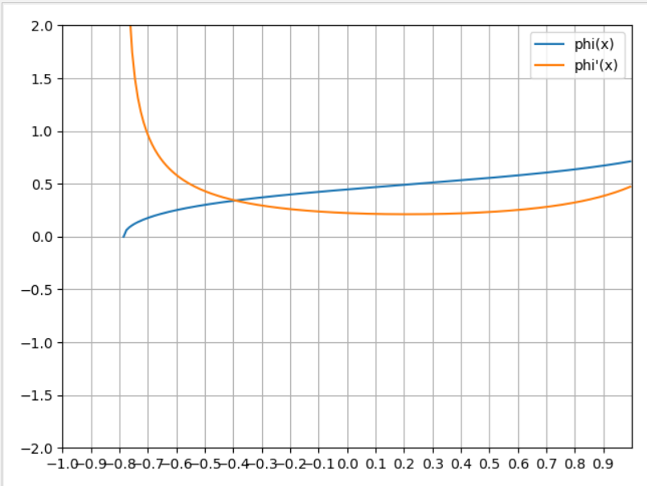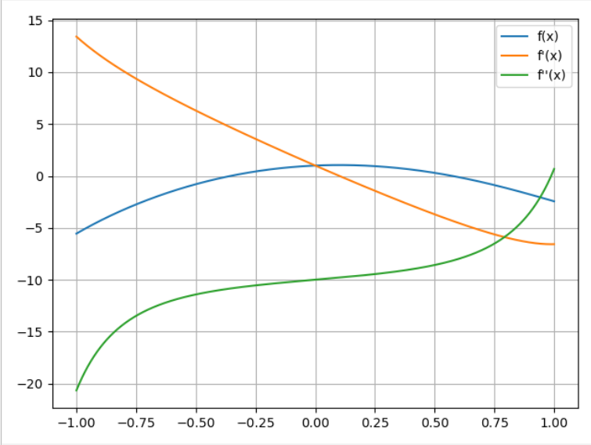

# Лабораторная работа 2.2

Задание: Реализовать методы простой итерации и Ньютона решения систем нелинейных уравнений в виде программного кода, задавая в качестве входных данных точность вычислений. С использованием разработанного программного обеспечения решить систему нелинейных уравнений (при наличии нескольких решений найти то из них, в котором значения неизвестных являются положительными); начальное приближение определить графически. Проанализировать зависимость погрешности вычислений от количества итераций.

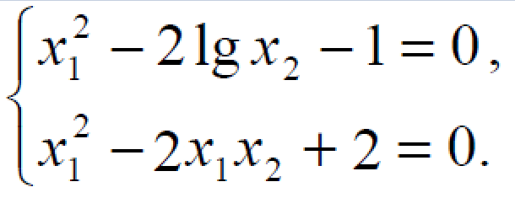Условие:

Исходный код:

import numpy as np  
import math  
import matplotlib.pyplot as plt  
  
from scipy.linalg import lu  
  
def lu_decomposition(other):  
 n, m = other.shape  
 L = np.zeros(other.shape)  
 U = np.copy(other)  
 P = np.eye(n)  
 odd = False  
 for i in range(0,n):  
 index = i  
 for j in range(i,n):  
 if np.abs(U[j, i]) > np.abs(U[index, i]):  
 index = j  
  
 if i != index:  
 L[[i, index]] = L[[index, i]]  
 U[[i, index]] = U[[index, i]]  
 P[[i, index]] = P[[index, i]]  
 odd = not odd  
  
 L[i, i] = 1  
 for j in range(i + 1, n):  
 L[j][i] = U[j][i] / U[i][i]  
 U[j][i] = 0  
   
 for j in range(i + 1, n):  
 for k in range(i + 1, n):  
 U[j][k] = U[j][k] - U[i][k] * L[j][i]  
  
 return L, U, P, odd  
  
def solve_eq(A, b):  
 L,U,P,odd = lu_decomposition(A)  
 n, m = A.shape  
 b = P.dot(b)  
 z = np.empty(n, dtype=float)  
 z[0] = b[0]  
 for i in range(1, n):  
 sum = 0  
 for j in range(0, i):  
 sum += L[i,j] * z[j]  
 z[i] = b[i] - sum  
  
 x = np.empty(n, dtype=float)  
 x[n - 1] = z[n - 1] / U[n - 1, n - 1]  
 for i in range(n - 1, -1, -1):  
 sum = 0  
 for j in range(i + 1, n):  
 sum += U[i, j] * x[j]  
 x[i] = (z[i] - sum) / U[i,i]  
  
 return x  
  
  
def f1(x):  
 return np.power(x[0], 2) - 2 * np.log10(x[1]) - 1  
  
  
def f2(x):  
 return np.power(x[0], 2) - 2 * x[0] * x[1] + 2  
  
  
*# def df1x1(x):  
# return 2 * x[0]  
#  
#  
# def df1x2(x):  
# return 2/(x[1] * np.log(10))  
#  
#  
# def df2x1(x):  
# return 2*x[0] - 2*x[1]  
#  
#  
# def df2x2(x):  
# return -2*x[0]*def construct_equiv_function(f, var, lbd, coef):  
 return lambda x: (coef * x[var] - lbd * f(x)) / coef  
  
def f1_equiv(x):  
 return np.sqrt(2*np.log10(x[1]) + 1)  
  
def f2_equiv(x):  
 return (np.power(x[0], 2) + 2)/(2 * x[0])  
  
def df1edx1(x):  
 return 0  
  
def df1edx2(x):  
 return 1/(np.sqrt(2 * np.log10(x[1]) + 1) * x[1] * np.log(10))  
  
def df2edx1(x):  
 return 0.5 - 1/(np.power(x[0], 2))  
  
def df2edx2(x):  
 return 0  
  
*# def df1edx1(x):  
# return df1x1(x) + 1  
#  
# def df1edx2(x):  
# return df1x2(x)  
#  
# def df2edx1(x):  
# return df2x1(x)  
#  
# def df2edx2(x):  
# return df2x2(x) + 1*def derivative(fun, var_num, epsilon=0.001):  
 def res(x):  
 eps_vector = [(0 if i != var_num else epsilon) for i in range(0, len(x))]  
 return (fun(x + eps_vector) - fun(x)) / epsilon  
 return res  
  
def simple_iterations(functions, x, q, epsilon=0.001):  
 x = np.array(x, dtype=float)  
 while True:  
 new_x = np.array([f(x) for f in functions], dtype=float)  
 if (q / (1 - q)) * np.linalg.norm(new_x - x) < epsilon:  
 return new_x  
 x = new_x  
  
def newton(functions, x, epsilon=0.001):  
 jacobi_matrix = [[derivative(functions[i], j, epsilon) for j in range(0, len(x))] for i in range(0, len(functions))]  
 while True:  
 der_values = [[der(x) for der in ders] for ders in jacobi_matrix]  
 b = [-f(x) for f in functions]  
 *# new_x = x + np.linalg.solve(np.array(der_values, dtype=float), np.array(b, dtype=float))* dx = solve_eq(np.array(der_values, dtype=float), np.array(b, dtype=float))  
 new_x = x + dx  
 if (np.linalg.norm(x - new_x) < epsilon):  
 return new_x  
 x = new_x  
  
  
def make_mesh(interval):  
 indices = np.zeros((len(interval),), dtype=np.int64)  
 dims = [len(part) for part in interval]  
 result_points = []  
 for k in range(0, np.int64(np.prod([len(x) for x in interval]))):  
 result_points.append([interval[i, indices[i]] for i in range(0, len(indices))])  
 for i in range(0, len(indices)):  
 indices[i] += 1  
 if indices[i] == dims[i]:  
 indices[i] = 0  
 else:  
 break  
 return result_points  
  
  
  
def test_function(f, nvar, start, end, step=0.01, ders=None):  
 if ders is None:  
 ders = [derivative(f, i) for i in range(0, nvar)]  
  
 interval = np.array([np.arange(x0, x1, step) for x0, x1 in zip(start, end)])  
 mesh = make_mesh(interval)  
 a = [[np.abs(der(x)) for x in mesh] for der in ders]  
 b = np.sum(a, axis=0)  
 return max(b)  
  
  
start_x = np.array([1.1, 1.4])  
  
g_wide = 0.2  
x1_int = [1.14 - g_wide / 2, 1.14 + g_wide / 2]  
x2_int = [1.4 - g_wide / 2, 1.4 + g_wide / 2]  
  
  
q = max([test_function(f1_equiv, 2, x1_int, x2_int, 0.001, [df1edx1,df1edx2]),  
 test_function(f2_equiv, 2, x1_int, x2_int, 0.001, [df2edx1,df2edx2])])  
print(**"Q in simple iteration method: "**, q)  
  
  
epsilon = 0.001  
  
n_root = newton([f1, f2], start_x, epsilon)  
si_root = simple_iterations([f1_equiv, f2_equiv], start_x, q, epsilon)  
print(n_root, f1(n_root), f2(n_root))  
print(si_root, f1(si_root), f2(si_root))

Результаты:

Q in simple iteration method: 0.4245562130177517

[1.14876666 1.44488213] 1.0227572122545325e-09 1.2587391129414982e-09

[1.14851978 1.44466795] -0.0004383808306007708 0.0006382512444782495

# Лабораторная работа 3.1

Задание: Используя таблицу значений $Y_{i}$ функции $y=f(x)$, вычисленных в точках $X_{i}$, $i=0..3$ построить интерполяционные многочлены Лагранжа и Ньютона, проходящие через точки $\{X_{i}, Y_{i}\}$. Вычислить значение погрешности интерполяции в точке $X^{*}$

Условие:

Исходный код:

import numpy as np  
import math  
import matplotlib.pyplot as plt  
  
  
def f(x):  
 return np.arccos(x) + x  
  
  
points1 = np.array([-0.4, -0.1, 0.2, 0.5])  
points2 = np.array([-0.4, 0, 0.2, 0.5])  
  
  
def Lagrange(points, values=None, function=None):  
 if values is None and function is None:  
 raise ValueError(**"function needs function values or function itself"**)  
  
 if values is None:  
 values = function(points)  
  
 if len(values) != len(points):  
 raise ValueError(**"length is wrong"**)  
  
 values = values[:]  
 points = points[:]  
 n = len(values)  
 return lambda x: np.sum(  
 [values[i] * np.prod([1 if j == i else ((x - points[j]) / (points[i] - points[j])) for j in range(0, n)]) for i  
 in range(0, n)], axis = 0)  
  
def divided_diff(points, function):  
 if (len(points) == 1):  
 return function(points[0])  
  
 if (len(points) == 2):  
 return (function(points[0]) - function(points[1])) / (points[0] - points[1])  
  
 n = len(points)  
 return (divided_diff(points[:n-1], function) - divided_diff(points[1:], function)) / (points[0] - points[n - 1])  
  
def Newton(points, function):  
 points = points[:]  
 n = len(points)  
 cur_arr = []  
 divided_sums_counted = []  
 for i in range(0, n):  
 cur_arr.append(points[i])  
 divided_sums_counted.append(divided_diff(cur_arr, function))  
  
 def result(x):  
 cur_prod = 1  
 res_sum = 0  
 for i in range(0, n):  
 res_sum += divided_sums_counted[i] * cur_prod  
 cur_prod *= (x - points[i])  
 return res_sum  
  
 return result  
  
  
  
interval = np.arange(-1, 1, 0.1)  
  
  
plt.figure()  
plt.subplot(221)  
plt.plot(interval, [Lagrange(points1, function=f)(x) for x in interval])  
plt.plot(interval, f(interval))  
plt.title(**"Lagrange 1"**)  
  
plt.subplot(222)  
plt.plot(interval, [Lagrange(points2, function=f)(x) for x in interval])  
plt.plot(interval, f(interval))  
plt.title(**"Lagrange 2"**)  
  
plt.subplot(223)  
plt.plot(interval, [Newton(points1, function=f)(x) for x in interval])  
plt.plot(interval, f(interval))  
plt.title(**"Newton 1"**)  
  
plt.subplot(224)  
plt.plot(interval, [Newton(points2, function=f)(x) for x in interval])  
plt.plot(interval, f(interval))  
plt.title(**"Newton 2"**)  
plt.show()

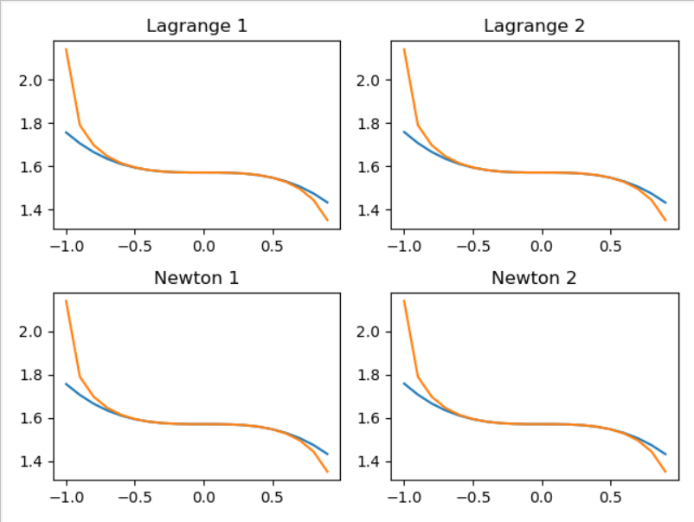Результат:

# Лабораторная работа 3.2

Задание: Построить кубический сплайн для функции, заданной в узлах интерполяции, предполагая, что сплайн имеет нулевую кривизну при $x = x_{0}$ и $x = x_{4}$. Вычислить значение функции в точке $x = X^{*}$

Условие: 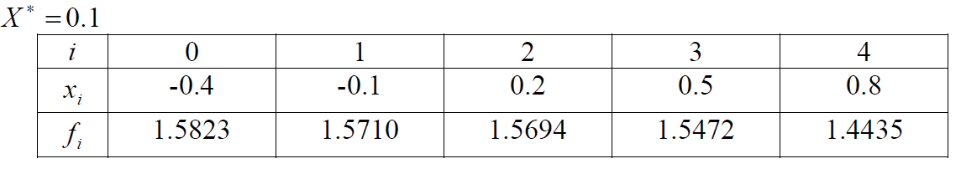

Исходный код:

import numpy as np  
import math  
import matplotlib.pyplot as plt  
  
  
def sweep_method(matrix, d):  
 P = np.zeros((len(d),))  
 Q = np.zeros((len(d),))  
 n = len(d)  
 M = lambda i, j, inc: matrix[i+inc, j+inc]  
 a = lambda i: M(0, -1, i)  
 b = lambda i: M(0, 0, i)  
 c = lambda i: M(0, 1, i)  
 P[0] = -c(0) / b(0)  
 Q[0] = d[0] / b(0)  
 for i in range(1, n - 1):  
 P[i] = -c(i) / (b(i) + a(i) * P[i - 1])  
 Q[i] = (d[i] - a(i) * Q[i - 1]) / (b(i) + a(i) * P[i - 1])  
 P[n - 1] = 0  
 Q[n - 1] = (d[n - 1] - a(n - 1) * Q[n - 2]) / (b(n - 1) + a(n - 1) * P[n - 2])  
 x = np.zeros(n)  
 x[n - 1] = Q[-1]  
 for i in range(n - 2, -1, -1):  
 x[i] = P[i] * x[i + 1] + Q[i]  
 return x  
  
  
def make_spline(a,b,c,d, points):  
 a = np.copy(a)  
 b = np.copy(b)  
 c = np.copy(c)  
 d = np.copy(d)  
 points = np.copy(points)  
  
 def result(x):  
 i = np.searchsorted(points, x)  
 if i == 0 and x == points[0]:  
 i += 1  
 if i == 0 or i == len(points):  
 raise ValueError(**"This point {} doesnt belong to spline"**.format(x))  
 i -= 1  
 return a[i] + b[i] * (x - points[i]) + c[i] * np.power((x - points[i]),2) + d[i] * np.power((x - points[i]), 3)  
  
 return result  
  
def find_coefs(points, values):  
 *#points, values - n + 1* n = len(points) - 1  
 h = [points[i] - points[i - 1] for i in range(1, n + 1)]  
 A = np.zeros((n-1,n-1), dtype=np.float32)  
  
 r = np.array([3 * (((values[i + 1] - values[i]) / h[i]) - ((values[i] - values[i - 1]) / h[i - 1])) for i in range(1, n)])  
  
 last = n - 2  
 A[0,0] = 2 * (h[0] + h[1])  
 A[0,1] = h[1]  
 A[last, last - 1] = h[n - 2]  
 A[last, last] = 2 * (h[n - 2] + h[n - 1])  
 for i in range(1, last):  
 A[i, i - 1] = h[i]  
 A[i, i] = 2 * (h[i] + h[i + 1])  
 A[i, i + 1] = h[i]  
  
 *# c = np.linalg.solve(A, r)* c = sweep_method(A, r)  
 c = np.insert(c,0,0)  
 a = [values[i] for i in range(0, n)]  
 b = [(values[i] - values[i - 1]) / h[i - 1] - (1/3) * h[i - 1] * (c[i] + 2 * c[i - 1]) for i in range(1, n)]  
 b.append((values[-1] - values[-2]) / h[-1] - (2/3) * h[-1] * c[-1])  
 d = [(c[i + 1] - c[i]) / (3 * h[i]) for i in range(0, n - 1)]  
 d.append(-(c[-1] / (3 * h[-1])))  
 return a,b,c,d  
  
points = [-0.4, -0.1, 0.2, 0.5, 0.8]  
values = [1.5823, 1.5710, 1.5694, 1.5472, 1.4435]  
  
  
a,b,c,d = find_coefs(points, values)  
for a0, b0, c0, d0 in zip(a,b,c,d):  
 print(**"{}x^3 + {}x^2 + {}x + {}"**.format(a0, b0, c0, d0))  
  
spline_function = make_spline(*find_coefs(points, values), points)  
  
interval = np.linspace(-0.4, 0.8, 120, endpoint=False)  
plt.plot(points, values, **"ro"**)  
plt.plot(interval, [spline_function(x) for x in interval])  
plt.show()

Результат: 1.5823x^3 + -0.04638095203467811x^2 + 0.0x + 0.09682539297790173

1.571x^3 + -0.020238094645833458x^2 + 0.08714285368011157x + -0.12486771990592774

1.5694x^3 + -0.001666669540935084x^2 + -0.025238094235223413x + -0.7195766909833099

1.5472x^3 + -0.21109524344262584x^2 + -0.6728571161202023x + 0.7476190179113358

# Лабораторная работа 3.3

Задание: Для таблично заданной функции путем решения нормальной системы МНК найти приближающие многочлены a) 1-ой и б) 2-ой степени. Для каждого из приближающих многочленов вычислить сумму квадратов ошибок. Построить графики приближаемой функции и приближающих многочленов

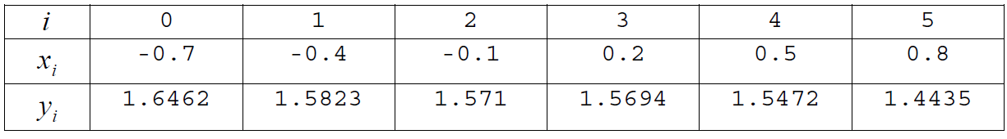Условие:

Исходный код:

import numpy as np  
import math  
import matplotlib.pyplot as plt  
  
  
def lu_decomposition(other):  
 n, m = other.shape  
 L = np.zeros(other.shape)  
 U = np.copy(other)  
 P = np.eye(n)  
 odd = False  
 for i in range(0, n):  
 index = i  
 for j in range(i, n):  
 if np.abs(U[j, i]) > np.abs(U[index, i]):  
 index = j  
  
 if i != index:  
 L[[i, index]] = L[[index, i]]  
 U[[i, index]] = U[[index, i]]  
 P[[i, index]] = P[[index, i]]  
 odd = not odd  
  
 L[i, i] = 1  
 for j in range(i + 1, n):  
 L[j][i] = U[j][i] / U[i][i]  
 U[j][i] = 0  
  
 for j in range(i + 1, n):  
 for k in range(i + 1, n):  
 U[j][k] = U[j][k] - U[i][k] * L[j][i]  
  
 return L, U, P, odd  
  
  
def solve_eq(A, b):  
 L, U, P, odd = lu_decomposition(A)  
 n, m = A.shape  
 b = P.dot(b)  
 z = np.empty(n, dtype=float)  
 z[0] = b[0]  
 for i in range(1, n):  
 sum = 0  
 for j in range(0, i):  
 sum += L[i, j] * z[j]  
 z[i] = b[i] - sum  
  
 x = np.empty(n, dtype=float)  
 x[n - 1] = z[n - 1] / U[n - 1, n - 1]  
 for i in range(n - 1, -1, -1):  
 sum = 0  
 for j in range(i + 1, n):  
 sum += U[i, j] * x[j]  
 x[i] = (z[i] - sum) / U[i, i]  
  
 return x  
  
*#метод наименьших квадратов*x = np.array([-0.7, -0.4, -0.1, 0.2, 0.5, 0.8])  
y = np.array([1.6462, 1.5823, 1.571, 1.5694, 1.5472, 1.4435])  
  
*# x = [0.0, 1.7, 3.4, 5.1, 6.8, 8.5]  
# y = [0.4713, 1.0114, 1.5515, 2.0916, 2.6317, 3.1718]*def count_mse(approx, x, y):  
 return np.sum(np.square(approx(x) - y))  
  
def LSM(x, y, polynom_power):  
 n = polynom_power + 1  
 m = len(x)  
 A = np.zeros((n,n), dtype=np.float32)  
  
 A[-1] = np.array([np.sum([np.power(x_cur,i) for x_cur in x]) for i in range(n - 1, -1, -1)])  
 for i in range(n - 2, -1, -1):  
 A[i,1:n] = A[i + 1, 0:n-1]  
 A[i, 0] = np.sum([np.power(x_cur,2*n - i - 2) for x_cur in x])  
  
 b = np.array([np.sum([np.power(x[j], i) * y[j] for j in range(0, m)]) for i in range(0, n)], dtype=np.float32)  
 b = np.flip(b)  
  
 coefs = solve_eq(A, b)  
  
 return lambda arg: np.sum([coefs[i] * np.power(arg, len(coefs) - i - 1) for i in range(0, len(coefs))], axis=0)  
  
linear_approximator = LSM(x,y,1)  
square_approximator = LSM(x,y,2)  
cubic_approximator = LSM(x,y,3)  
  
interval = np.arange(-1, 1, 0.01)  
  
  
plt.plot(x, y, **'ro'**, label=**"points"**)  
plt.plot(interval, linear_approximator(interval), label=**"linear approximator"**)  
plt.plot(interval, square_approximator(interval), label=**"square approximator"**)  
plt.plot(interval, cubic_approximator(interval), label=**"cubic approximator"**)  
  
print(**"Mean squared errors:**\n**linear {}**\n**square {}**\n**cubic {}"**.format(count_mse(linear_approximator, x, y),  
 count_mse(square_approximator, x, y),  
 count_mse(cubic_approximator, x, y)))  
  
  
plt.legend()  
plt.show()

Результат:

Mean squared errors:

linear 0.003940351047632441

square 0.0032396991428675494

cubic 1.8977142962301985e-05

# Лабораторная работа 3.4

Задание: Вычислить первую и вторую производную от таблично заданной функции $y_{i}=f\left(x_{i}\right), i=0,1,2,3,4$ в точке $x=X^{*}$

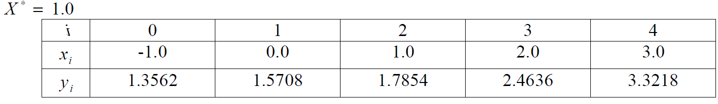Условие:

Исходный код:

import numpy as np  
import math  
import matplotlib.pyplot as plt  
  
x = np.array([-1.0, 0, 1.0, 2.0, 3.0])  
y = np.array([1.3562, 1.5708, 1.7854, 2.4636, 3.3218])  
  
  
*# x = np.array([0.0, 0.1, 0.2, 0.3, 0.4], dtype=np.float64)  
# y = np.array([1.0, 1.1052, 1.2214, 1.3499, 1.4918], dtype=np.float64)*def get_polynom(x,y):  
 x = np.copy(x)  
 y = np.copy(y)  
 def polynom(arg):  
 i = np.searchsorted(x, arg)  
 if (arg == x[0]):  
 i = 1  
 i -= 1  
 return y[i] \  
 + (arg - x[i]) * (y[i + 1] - y[i]) / (x[i + 1] - x[i]) \  
 + (arg - x[i]) * (arg - x[i + 1]) * ((y[i + 2] - y[i + 1])/(x[i + 2] - x[i + 1]) - (y[i + 1] - y[i])/(x[i + 1] - x[i])) / (x[i + 2] - x[i])  
 return polynom  
  
  
  
def get_polynom_derivative(x,y):  
 x = np.copy(x)  
 y = np.copy(y)  
  
 def polynom(arg):  
 i = np.searchsorted(x, arg)  
 if (arg == x[0]):  
 i = 1  
 i -= 1  
 return (y[i + 1] - y[i])/(x[i + 1] - x[i]) + \  
 ((y[i + 2] - y[i + 1])/(x[i + 2] - x[i + 1]) - (y[i + 1] - y[i])/(x[i + 1] - x[i])) * (2 * arg - x[i] - x[i + 1]) / (x[i + 2] - x[i])  
  
 return polynom  
  
def get_polynom_derivative2(x,y):  
 x = np.copy(x)  
 y = np.copy(y)  
  
 def polynom(arg):  
 i = np.searchsorted(x, arg)  
 if (arg == x[0]):  
 i = 1  
 i -= 1  
 return 2 * ((y[i + 2] - y[i + 1])/(x[i + 2] - x[i + 1]) - (y[i + 1] - y[i])/(x[i + 1] - x[i])) / (x[i + 2] - x[i])  
  
 return polynom  
  
def approx_polynom(x,y):  
 x = np.copy(x)  
 y = np.copy(y)  
 return get_polynom(x,y), get_polynom_derivative(x,y), get_polynom_derivative2(x,y)  
  
f, fd, fd2 = approx_polynom(x,y)  
  
print(**"f(x) = {}, f'(x) = {}, f''(x) = {}"**.format(f(0.2), fd(0.2), fd2(0.2)))

Результат:

f(x) = 1.576632, f'(x) = 0.0755200000000002, f''(x) = 0.4635999999999998

# Лабораторная работа 3.5

Задание: Вычислить определенный интеграл $F= \int_{x_{0}}^{x_{1}}{ydx}$, методами прямоугольников, трапеций, Симпсона с шагами $h_{1}, h_{2}$. Оценить погрешность вычислений, используя Метод Рунге-Ромберга:

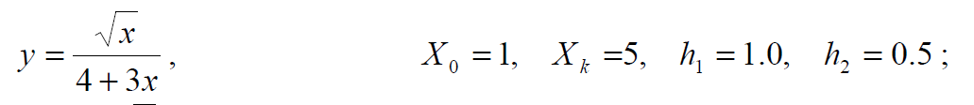Условие:

Исходный код:

import numpy as np  
import math  
import matplotlib.pyplot as plt  
  
def f(x):  
 return np.sqrt(x) / (4 + 3 * x)  
  
def rect_method(x, f):  
 return np.sum([f((x[i + 1] + x[i]) / 2) * (x[i + 1] - x[i]) for i in range(0,len(x) - 1)])  
  
def trapeze_method(x, f):  
 y = f(x)  
 return np.sum([(y[i + 1] + y[i]) * (x[i + 1] - x[i]) for i in range(0, len(x) - 1)]) / 2.  
  
def simpson_method(x, f):  
 y = f(x)  
 return np.sum([(f(x[i]) + 4 * f((x[i] + x[i + 1]) / 2) + f(x[i + 1])) * (x[i + 1] - x[i]) for i in range(0, len(x) - 1)]) / 6.  
  
rect_method.runge_coef = 2  
trapeze_method.runge_coef = 2  
simpson_method.runge_coef = 4  
  
def integrate(method, function, x0, xk, h):  
 res = method(np.arange(x0, xk, h), f)  
 return {**"result"**: res, **"h"**: h}  
  
  
  
def print_results(name, result_list, err):  
 print(**"method: {}, results: {}, errors: {}"**.format(name,result_list, err))  
  
  
*# analitic_solution = 0.5312191613*def test_method(method, function, x0, xk, h):  
 result_list = [integrate(method, function, x0, xk, h_cur) for h_cur in h]  
 k = result_list[0][**"h"**] / result_list[1][**"h"**]  
 err = np.abs(result_list[0][**"result"**] - result_list[1][**"result"**]) / (np.power(k, method.runge_coef) - 1)  
 *# err_analitic = np.abs(result_list[0]["result"] - analitic_solution) / (np.power(k, method.runge_coef) - 1)* return result_list, err  
  
x0 = 1  
xk = 5  
h = [1.0, 0.5, 0.1, 0.01]  
  
print(**"h: {}"**.format(h))  
print_results(**"rectangle method"**, *test_method(rect_method, f, x0, xk, h))  
print_results(**"trapeze method"**, *test_method(trapeze_method, f, x0, xk, h))  
print_results(**"simpson method"**, *test_method(simpson_method, f, x0, xk, h))

Результат:

h: [1.0, 0.5, 0.1, 0.01]

method: rectangle method, results: [{'result': 0.4106006334886676, 'h': 1.0}, {'result': 0.4716775772793693, 'h': 0.5}, {'result': 0.5194232701621695, 'h': 0.1}, {'result': 0.5300420135750599, 'h': 0.01}], errors: 0.02035898126356724

method: trapeze method, results: [{'result': 0.40858460517117917, 'h': 1.0}, {'result': 0.47114719566648966, 'h': 0.5}, {'result': 0.5194019044680592, 'h': 0.1}, {'result': 0.5300418007362198, 'h': 0.01}], errors: 0.02085419683177016

method: simpson method, results: [{'result': 0.40992862404950475, 'h': 1.0}, {'result': 0.47150078340840934, 'h': 0.5}, {'result': 0.519416148264133, 'h': 0.1}, {'result': 0.5300419426287799, 'h': 0.01}], errors: 0.004104810623926972

# Лабораторная работа 4.1

Задание: Реализовать методы Эйлера, Рунге-Кутты и Адамса 4-го порядка в виде программ, задавая в качестве входных данных шаг сетки $h$. С использованием разработанного программного обеспечения решить задачу Коши для ОДУ 2-го порядка на указанном отрезке. Оценить погрешность численного решения с использованием метода Рунге – Ромберга и путем сравнения с точным решением.

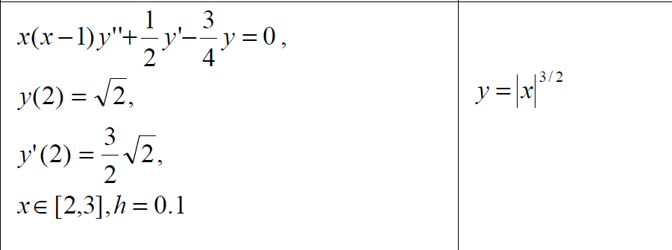Условие:

Исходный код:

import numpy as np  
import math  
from tabulate import tabulate  
import matplotlib.pyplot as plt  
  
  
def precise_solution(x):  
 return np.power(np.abs(x), 1.5) - np.sqrt(2)  
  
  
def f1(x, y1, y2):  
 return y2  
  
  
def f2(x, y1, y2):  
 return (0.5 * y2 - 0.75 * y1) / (x * (1 - x))  
  
  
class Euler:  
 def __init__(self, functions, x0, start_conditions):  
 self.functions = functions  
 self.x0 = x0  
 self.start_conditions = start_conditions  
 self.label = **"Euler"** self.last_points = None  
 self.last_values = None  
 self.p = 1  
  
 def integrate(self, x_end, h):  
 points = [self.x0]  
 values = [self.start_conditions] *# type: list* while points[-1] <= x_end:  
 cur_x = points[-1]  
 cur_condition = values[-1]  
 new_x = cur_x + h  
 new_condition = [cur_condition[i] + h * self.functions[i](cur_x, *cur_condition) for i in range(0, len(cur_condition))]  
 points.append(new_x)  
 values.append(new_condition)  
 self.last_points = np.array(points)  
 self.last_values = np.array(values)  
 return np.array(points), np.array(values)  
  
class EulerKoshi:  
 def __init__(self, functions, x0, start_conditions):  
 self.functions = functions  
 self.x0 = x0  
 self.start_conditions = start_conditions  
 self.label = **"Euler Koshi"** self.last_points = None  
 self.last_values = None  
 self.p = 2  
  
 def integrate(self, x_end, h):  
 points = [self.x0]  
 values = [self.start_conditions] *# type: list* while points[-1] <= x_end:  
 cur_x = points[-1]  
 cur_condition = values[-1]  
 new_x = cur_x + h  
 new_condition = [cur_condition[i] + h * self.functions[i](cur_x, *cur_condition) for i in range(0, len(cur_condition))]  
 new_condition_corrected = [cur_condition[i] + h * (self.functions[i](cur_x, *cur_condition) + self.functions[i](new_x, *new_condition)) / 2 for i in range(0, len(cur_condition))]  
 points.append(new_x)  
 values.append(new_condition_corrected)  
 self.last_points = np.array(points)  
 self.last_values = np.array(values)  
 return np.array(points), np.array(values)  
  
  
class EulerAdvanced:  
 def __init__(self, functions, x0, start_conditions):  
 self.functions = functions  
 self.x0 = x0  
 self.start_conditions = start_conditions  
 self.last_points = None  
 self.last_values = None  
 self.label = **"Euler advanced"** self.p = 2  
  
 def integrate(self, x_end, h):  
 points = [self.x0]  
 values = [self.start_conditions] *# type: list* while points[-1] <= x_end:  
 cur_x = points[-1]  
 cur_condition = values[-1]  
 new_x = cur_x + h  
 half_condition = [cur_condition[i] + (h / 2) * self.functions[i](cur_x, *cur_condition) for i in range(0, len(cur_condition))]  
 new_condition = [cur_condition[i] + h * self.functions[i](cur_x + h / 2, *half_condition) for i in range(0, len(cur_condition))]  
 points.append(new_x)  
 values.append(new_condition)  
 self.last_points = np.array(points)  
 self.last_values = np.array(values)  
 return np.array(points), np.array(values)  
  
  
class RungeKutta:  
 def __init__(self, functions, x0, start_conditions):  
 self.functions = functions  
 self.x0 = x0  
 self.start_conditions = start_conditions  
 self.last_points = None  
 self.last_values = None  
 self.label = **"Runge Kutta 4-th"** self.p = 4  
  
 def integrate(self, x_end, h):  
 points = np.array([self.x0])  
 values = np.array([self.start_conditions])  
 while points[-1] <= x_end:  
 cur_x = points[-1]  
 cur_condition = values[-1]  
 k1 = np.array([h * self.functions[i](cur_x, *cur_condition) for i in range(0, len(cur_condition))])  
 k2 = np.array([h * self.functions[i](cur_x + h / 2, *(cur_condition + (k1 / 2))) for i in range(0, len(cur_condition))])  
 k3 = np.array([h * self.functions[i](cur_x + h / 2, *(cur_condition + (k2 / 2))) for i in range(0, len(cur_condition))])  
 k4 = np.array([h * self.functions[i](cur_x + h, *(cur_condition + k3)) for i in range(0, len(cur_condition))])  
 new_x = cur_x + h  
 new_condition = cur_condition + (k1 + 2 * k2 + 2 * k3 + k4) / 6  
 num = k2 - k3  
 den = k1 - k2  
 *# if np.min(np.abs(den)) == 0 or np.mean(np.abs(num / den)) >= 0.1:  
 # h /= 2  
 # elif np.mean(np.abs(num / den)) < 0.01:  
 # h *= 2* points = np.append(points, [new_x], axis=0)  
 values = np.append(values, [new_condition], axis=0)  
  
 self.last_points = np.array(points)  
 self.last_values = np.array(values)  
 return np.array(points), np.array(values)  
  
  
class Adams:  
 def __init__(self, functions, x0, start_conditions):  
 self.functions = functions  
 self.x0 = x0  
 self.start_conditions = start_conditions  
 self.last_points = None  
 self.last_values = None  
 self.label = **"Adams 4-th"** self.p = 4  
  
 def integrate(self, x_end, h):  
 points = np.array(self.x0)  
 values = np.array(self.start_conditions)  
 while points[-1] <= x_end:  
 cur_points = points[-4:]  
 cur_values = values[-4:]  
 f = np.array([[self.functions[i](cur_points[j], *cur_values[j]) for i in range(0, len(self.functions))] for j in range(0,len(cur_points))])  
 new_values = np.array([cur_values[-1,i] + (h/24)*(55 * f[-1,i] - 59 * f[-2,i] + 37 * f[-3,i] - 9 * f[-4,i]) for i in range(0, len(self.functions))])  
 new_x = points[-1] + h  
 points = np.append(points, [new_x], axis=0)  
 values = np.append(values, [new_values], axis=0)  
 self.last_points = points  
 self.last_values = values  
 return points, values  
  
fig, ax = plt.subplots(2)  
  
ax[0].set_ylim([1, 4])  
ax[1].set_ylim([1, 4])  
  
def plot_solved(solver):  
 for i in range(0, solver.last_values.shape[-1]):  
 ax[i].plot(solver.last_points, solver.last_values[:, i], label=solver.label)  
  
x0 = 2  
x1 = 3  
start_conditions = [np.sqrt(2), 1.5 * np.sqrt(2)]  
h = 0.1  
  
x_interval = np.arange(x0, x1 + h/2, h)  
ax[0].plot(x_interval, precise_solution(x_interval), label=**"precise solution"**)  
  
solvers = [Euler, EulerKoshi, RungeKutta]  
  
adams_start_x = None  
adams_start_y = None  
  
solver_instances = []  
  
for solver_class in solvers:  
 solver = solver_class([f1, f2], x0, start_conditions)  
 points, values = solver.integrate(x1, h)  
 if (solver.__class__.__name__ == **"RungeKutta"**):  
 adams_start_x = points[:3]  
 adams_start_y = values[:3]  
 solver_instances.append(solver)  
 plot_solved(solver)  
  
  
  
x0 = np.append([x0], adams_start_x, axis=0)  
start_conditions = np.append([start_conditions], adams_start_y, axis=0)  
  
adams = Adams([f1,f2], x0, start_conditions)  
adams.integrate(x1,h)  
  
solver_instances.append(adams)  
  
plot_solved(adams)  
  
ax[0].legend()  
plt.show()  
  
for solver in solver_instances:  
 points1, values1 = solver.integrate(x1, h / 2)  
 points1 = points1[::2]  
 values1 = values1[::2]  
  
 points2, values2 = solver.integrate(x1, h)  
  
 if (values1.shape[0] > values2.shape[0]):  
 values1 = np.resize(values1, values2.shape)  
 else:  
 values2 = np.resize(values2, values1.shape)  
  
 error = np.linalg.norm(np.abs(values1[:, 0] - values2[:, 0]) / (np.power(2, solver.p) - 1))  
 print(**"{} error: {}"**.format(solver.label, error))

Результат:

Euler error: 0.014696709883703106

Euler Koshi error: 0.0004363140761390785

Runge Kutta 4-th error: 8.265104990668217e-08

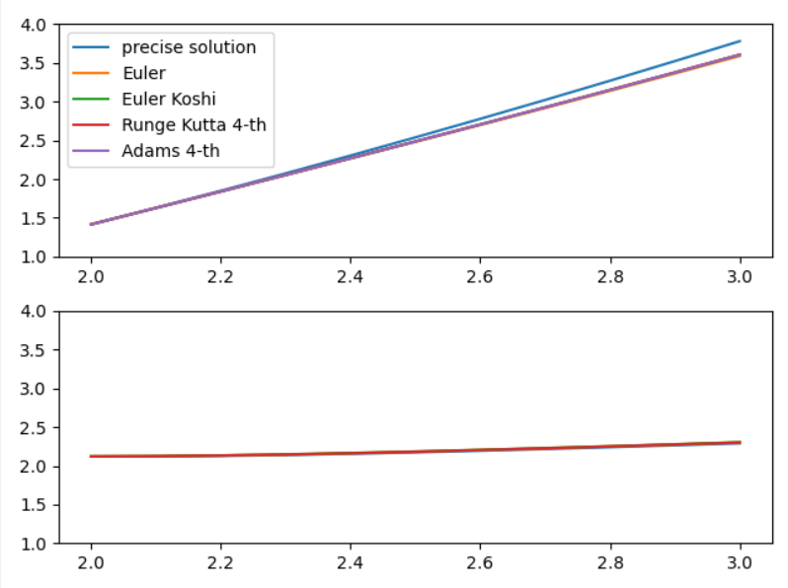Adams 4-th error: 0.06775977573838743

# Лабораторная работа 4.2

Задание: Реализовать метод стрельбы и конечно-разностный метод решения краевой задачи для ОДУ в виде программ. С использованием разработанного программного обеспечения решить краевую задачу для обыкновенного дифференциального уравнения 2-го порядка на указанном отрезке. Оценить погрешность численного решения с использованием метода Рунге – Ромберга и путем сравнения с точным решением.

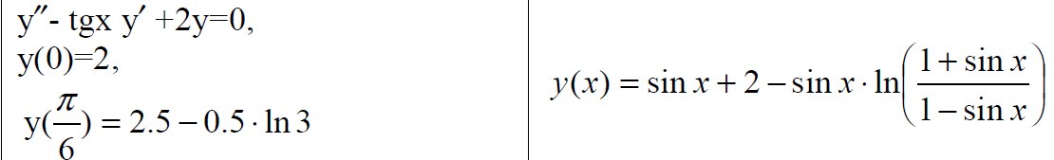Условие:

Исходный код:

import numpy as np  
import math  
from tabulate import tabulate  
import matplotlib.pyplot as plt  
  
class RungeKutta:  
 def __init__(self, functions, x0, start_conditions):  
 self.functions = functions  
 self.x0 = x0  
 self.start_conditions = start_conditions  
 self.last_points = None  
 self.last_values = None  
 self.label = **"Runge Kutta 4-th"** self.p = 4  
  
 def integrate(self, x_end, h):  
 points = np.array([self.x0])  
 values = np.array([self.start_conditions])  
 while points[-1] <= x_end:  
 cur_x = points[-1]  
 cur_condition = values[-1]  
 k1 = np.array([h * self.functions[i](cur_x, *cur_condition) for i in range(0, len(cur_condition))])  
 k2 = np.array([h * self.functions[i](cur_x + h / 2, *(cur_condition + (k1 / 2))) for i in range(0, len(cur_condition))])  
 k3 = np.array([h * self.functions[i](cur_x + h / 2, *(cur_condition + (k2 / 2))) for i in range(0, len(cur_condition))])  
 k4 = np.array([h * self.functions[i](cur_x + h, *(cur_condition + k3)) for i in range(0, len(cur_condition))])  
 new_x = cur_x + h  
 new_condition = cur_condition + (k1 + 2 * k2 + 2 * k3 + k4) / 6  
 num = k2 - k3  
 den = k1 - k2  
 *# if np.min(np.abs(den)) == 0 or np.mean(np.abs(num / den)) >= 0.1:  
 # h /= 2  
 # elif np.mean(np.abs(num / den)) < 0.01:  
 # h *= 2* points = np.append(points, [new_x], axis=0)  
 values = np.append(values, [new_condition], axis=0)  
  
 self.last_points = np.array(points)  
 self.last_values = np.array(values)  
 return np.array(points), np.array(values)  
  
def sweep_method(matrix, d):  
 P = np.zeros((len(d),))  
 Q = np.zeros((len(d),))  
 n = len(d)  
 M = lambda i, j, inc: matrix[i+inc, j+inc]  
 a = lambda i: M(0, -1, i)  
 b = lambda i: M(0, 0, i)  
 c = lambda i: M(0, 1, i)  
 P[0] = -c(0) / b(0)  
 Q[0] = d[0] / b(0)  
 for i in range(1, n - 1):  
 P[i] = -c(i) / (b(i) + a(i) * P[i - 1])  
 Q[i] = (d[i] - a(i) * Q[i - 1]) / (b(i) + a(i) * P[i - 1])  
 P[n - 1] = 0  
 Q[n - 1] = (d[n - 1] - a(n - 1) * Q[n - 2]) / (b(n - 1) + a(n - 1) * P[n - 2])  
 x = np.zeros(n)  
 x[n - 1] = Q[-1]  
 for i in range(n - 2, -1, -1):  
 x[i] = P[i] * x[i + 1] + Q[i]  
 return x  
  
  
  
def increase_matrix_size(matrix, begin):  
 shape = matrix.shape  
 shape = tuple([i + 1 for i in shape])  
 temp = np.zeros(shape)  
 if begin:  
 temp[1:, 1:] = matrix  
 else:  
 temp[:-1,:-1] = matrix  
 return temp  
  
def increase_vec_size(vec, begin):  
 size = vec.shape[0] + 1  
 temp = np.zeros(size)  
 if begin:  
 temp[1:] = vec  
 else:  
 temp[:-1] = vec  
 return temp  
  
  
def solution(x):  
 return np.sin(x) + 2 - np.sin(x) * np.log((1 + np.sin(x)) / (1 - np.sin(x)))  
  
def f(x):  
 return 0  
  
def p(x):  
 return np.tan(x)  
  
def q(x):  
 return 2  
  
  
  
*# уравнение xy'' - 2(x + 1)y + 2y = 0  
# так как x0 = 0, в точке x0 уравнение принимает вид  
# -y' + 2y = 0, что легко приводится к y = e^2x => y(0) = 1  
  
# cond1 = {"order":1, "value":1}  
# cond2 = {"order":2, "beta":-2, "value":-4}  
# cond2 = {"order":1, "value": 2 + np.exp(2)}*h = 0.01  
x0 = 0  
x1 = np.pi / 6  
y0 = 2  
y1 = 2.5 - 0.5 * np.log(3)  
cond1 = {**"order"**: 1, **"value"**: y0}  
cond2 = {**"order"**: 1, **"value"**: y1}  
  
  
def finite_differences(p, q, f, h, x0, x1, cond1, cond2):  
 points = np.arange(x0 + h, x1, h)  
 a = lambda x: (1 / np.power(h, 2) - p(x) / (2 * h))  
 b = lambda x: -2 / np.power(h, 2) + q(x)  
 c = lambda x: (1 / np.power(h, 2) + p(x) / (2 * h))  
 n = len(points)  
 matrix = np.zeros((n, n))  
 d = np.zeros((n,))  
 for i in range(0, n):  
 d[i] = f(points[i])  
  
 if i - 1 >= 0:  
 matrix[i,i - 1] = a(points[i])  
  
 matrix[i,i] = b(points[i])  
  
 if i + 1 < len(points):  
 matrix[i, i + 1] = c(points[i])  
  
 if cond1[**"order"**] == 1:  
 d[0] -= cond1[**"value"**] * a(points[0])  
 else:  
 matrix = increase_matrix_size(matrix, True)  
 d = increase_vec_size(d, True)  
 matrix[1,0] = a(points[0])  
 matrix[0,0] = -(2 / (h * (2 - p(x0) * h))) + (q(x0) * h) / (2 - p(x0) * h) + cond1[**"alpha"**]  
 matrix[0,1] = 2 / (h * (2 - p(x0) * h))  
 d[0] = cond1[**"value"**] + (h * f(x0)) / (2 - p(x0) * h)  
 points = np.insert(points, 0, x0)  
  
 if cond2[**"order"**] == 1:  
 d[-1] -= cond2[**"value"**] * c(points[-1])  
 else:  
 matrix = increase_matrix_size(matrix, False)  
 d = increase_vec_size(d, False)  
 matrix[-2, -1] = c(points[-1])  
 matrix[-1, -2] = - 2 / (h * (2 + p(x1) * h))  
 matrix[-1, -1] = (2 / (h * (2 + p(x1) * h))) - (q(x1) * h) / (2 + p(x1) * h) + cond2[**"beta"**]  
 d[-1] = cond2[**"value"**] - (h * f(x1)) / (2 + p(x1) * h)  
 points = np.insert(points, len(points), x1)  
  
 y = sweep_method(matrix, d)  
 return points, y  
  
def f1(x,y1,y2):  
 return y2  
  
def f2(x,y1,y2):  
 return np.tan(y2) - 2 * y1  
  
def secant(fun, x0, x1, epsilon=0.001):  
 fx0 = None  
  
 while True:  
 fx1 = fun(x1)  
 if fx0 is None:  
 fx0 = fun(x0)  
 new_x0, new_x1 = x1, x1 - (fx1 * (x1 - x0))/(fx1 - fx0)  
 if np.abs(new_x1 - new_x0) < epsilon:  
 return new_x1  
 x0, x1 = new_x0, new_x1  
 fx0 = fx1  
  
  
def shooting_method(functions, x0, x1, y0, y1, tan1, h, epsilon):  
 def solve(x):  
 solver = RungeKutta(functions, x0, [y0, x])  
 points, values = solver.integrate(x1, h)  
 return values[-1, 0] - y1  
  
 result_tan = secant(solve, tan1, tan1 + h / 2, epsilon)  
 p, y = RungeKutta(functions, x0, [y0, result_tan]).integrate(x1, h)  
 return p, y[:,0]  
  
  
def fd_error():  
 hp, hy = finite_differences(p, q, f, h, x0, x1, cond1, cond2)  
 h2p, h2y = finite_differences(p, q, f, h / 2, x0, x1, cond1, cond2)  
 error = [np.abs(hy[i] - h2y[2*i]) for i in range(0, len(hp))]  
 error = np.array(error) / (np.power(2,2) - 1)  
 return error  
  
def sm_error():  
 hp, hy = shooting_method([f1, f2], x0, x1, y0, y1, 0.5, h, 0.001)  
 h2p, h2y = shooting_method([f1, f2], x0, x1, y0, y1, 0.5, h / 2, 0.001)  
 error = [np.abs(hy[i] - h2y[2*i]) for i in range(0, min([len(hp), len(h2p) // 2]))]  
 error = np.array(error) / (np.power(2, 2) - 1)  
 return error  
  
  
  
  
fd_points, fd_y = finite_differences(p, q, f, h, x0, x1, cond1, cond2)  
precise = solution(fd_points)  
sm_points, sm_y = shooting_method([f1, f2], x0, x1, y0, y1, 0.5, h, 0.001)  
plt.plot(fd_points, solution(fd_points), label=**"precise solution"**)  
plt.plot(fd_points, fd_y, label=**"finite differences solution"**)  
plt.plot(sm_points, sm_y, label=**"shooting solution"**)  
print(**"finite differences error {}"**.format(fd_error()))  
print()  
print(**"shooting method error {}"**.format(sm_error()))  
print()  
print(**"finide differences precise error {}"**.format(np.abs(solution(fd_points) - fd_y)))  
print()  
print(**"shooting method precise error {}"**.format(np.abs(solution(sm_points) - sm_points)))  
  
  
  
plt.legend()  
plt.show()

Результат:

finite differences error [1.64361519e-03 1.61707510e-03 1.59005831e-03 1.56257972e-03

1.53465444e-03 1.50629778e-03 1.47752523e-03 1.44835246e-03

1.41879535e-03 1.38886992e-03 1.35859237e-03 1.32797907e-03

1.29704654e-03 1.26581145e-03 1.23429060e-03 1.20250096e-03

1.17045960e-03 1.13818372e-03 1.10569066e-03 1.07299785e-03

1.04012283e-03 1.00708324e-03 9.73896817e-04 9.40581389e-04

9.07154854e-04 8.73635188e-04 8.40040433e-04 8.06388692e-04

7.72698125e-04 7.38986935e-04 7.05273369e-04 6.71575708e-04

6.37912261e-04 6.04301358e-04 5.70761345e-04 5.37310577e-04

5.03967411e-04 4.70750197e-04 4.37677280e-04 4.04766982e-04

3.72037607e-04 3.39507425e-04 3.07194674e-04 2.75117548e-04

2.43294193e-04 2.11742701e-04 1.80481103e-04 1.49527366e-04

1.18899382e-04 8.86149669e-05 5.86918527e-05 2.91476813e-05]

shooting method error [0.00000000e+00 3.22530891e-05 6.53195486e-05 9.91577553e-05

1.33727541e-04 1.68990332e-04 2.04909238e-04 2.41449093e-04

2.78576470e-04 3.16259671e-04 3.54468692e-04 3.93175185e-04

4.32352411e-04 4.71975183e-04 5.12019817e-04 5.52464078e-04

5.93287133e-04 6.34469505e-04 6.75993040e-04 7.17840870e-04

7.59997396e-04 8.02448273e-04 8.45180405e-04 8.88181952e-04

9.31442353e-04 9.74952355e-04 1.01870407e-03 1.06269102e-03

1.10690826e-03 1.15135248e-03 1.19602211e-03 1.24091757e-03

1.28604141e-03 1.33139869e-03 1.37699722e-03 1.42284809e-03

1.46896618e-03 1.51537086e-03 1.56208693e-03 1.60914580e-03

1.65658706e-03 1.70446059e-03 1.75282952e-03 1.80177427e-03

1.85139854e-03 1.90183813e-03 1.95327471e-03 2.00595829e-03

2.06024609e-03 2.11667564e-03 2.17611760e-03 2.24015063e-03

2.31225544e-03]

finide differences precise error [4.00038570e-05 7.80758551e-05 1.12445324e-04 1.41503941e-04

1.63806850e-04 1.78073758e-04 1.83189990e-04 1.78207513e-04

1.62345930e-04 1.34993433e-04 9.57077310e-05 4.42169416e-05

1.95795516e-05 9.56102714e-05 1.83630852e-04 2.83223277e-04

3.93795142e-04 5.14578958e-04 6.44631471e-04 7.82833018e-04

9.27886909e-04 1.07831883e-03 1.23247628e-03 1.38852801e-03

1.54446353e-03 1.69809257e-03 1.84704460e-03 1.98876838e-03

2.12053149e-03 2.23941990e-03 2.34233749e-03 2.42600570e-03

2.48696303e-03 2.52156468e-03 2.52598208e-03 2.49620251e-03

2.42802861e-03 2.31707799e-03 2.15878273e-03 1.94838891e-03

1.68095611e-03 1.35135686e-03 9.54276095e-04 4.84210505e-04

6.45320707e-05 6.97833375e-04 1.42176548e-03 2.24259164e-03

3.16676712e-03 4.20094026e-03 5.35195346e-03 6.62684437e-03]

shooting method precise error [2. 1.99979983 1.99919867 1.9981955 1.99678933 1.99497917

1.992764 1.99014284 1.98711468 1.98367853 1.97983337 1.97557822

1.97091207 1.96583393 1.96034278 1.95443762 1.94811746 1.94138127

1.93422805 1.92665678 1.91866645 1.91025604 1.90142451 1.89217084

1.88249399 1.87239291 1.86186655 1.85091385 1.83953374 1.82772513

1.81548695 1.80281807 1.78971739 1.77618378 1.76221608 1.74781313

1.73297374 1.71769673 1.70198085 1.68582487 1.66922751 1.65218747

1.63470343 1.61677403 1.59839789 1.57957358 1.56029963 1.54057456

1.52039683 1.49976484 1.47867697 1.45713154 1.43512682 1.41266101]

