CGVis Data Sources

Erik Körner
Any CGVis session can integrate multiple data sources, which together form the data used in the application to be visualized:

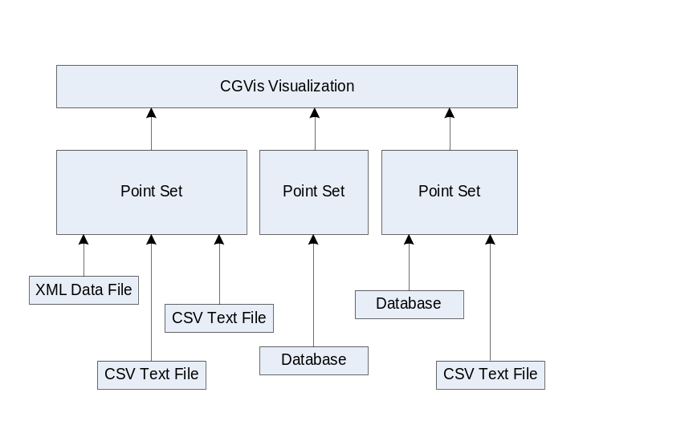

CGVis uses XML based files to specify the location and structure of it's data sources, specify the Point Sets to be generated to and to specify how the data sources combine the data to the PointSets associated.
Currently the following Data Sources are implemented:

- Delimiter Separated Text Files (CSV Files)
- Database Queries

Data Specification Files
A CGVis sample Data Specification File looks like this:

<cgvisdata version = "1">
<set name="Data1+Data2" key="data" rowLabelColumn="PATIENTID">
<normalize column="COL1" mode="RANGE"/>
<csvdata>
<path>data\Data1.csv</path>
<separator>;</separator>
<decimalseparator>.</decimalseparator>
<nan symbol="NaN" />
</csvdata>
<csvdata>
<path>data\Data2.csv</path>
<separator>;</separator>
<decimalseparator>.</decimalseparator>
<nan symbol="NaN" />
</csvdata>
</set>
</cgvisdata>

This file integrates two CSV files into a common Point Set named "Data1+Data2".

All element and property names are case insensitive, so "cgvisdata" is equivalent to "CGVisData" or "CGVISDATA". So you are free to use your preferred style.

Document
The document element for a valid CGVis specification file looks as follows:

<cgvisdata version = "1">
...
</cgvisdata>

The version information is currently for informational purposes, however in future versions it might be used for versioning purposes in case the structure is changed.

Point Sets
A Point Set is generated for each <set> ... </set> substructure.

<set name="Data1+Data2" key=" data" rowLabelColumn="PATIENTID">
...
</set>

All data sources that build the Point Set are contained in the <set> ... </set> substructure are used to build the associated Point Set when the Specification File is interpreted.

Name
The name of the Point Set is specified by the name property of the <set> Element. If the name is not specified, the point set is named "Untitled".

<set name="Data1+Data2" key=" data" rowLabelColumn="PATIENTID">
...
</set>

Row Labels
Each Point Set is basically a table, which has column and row labels and contains double precision floating point data:

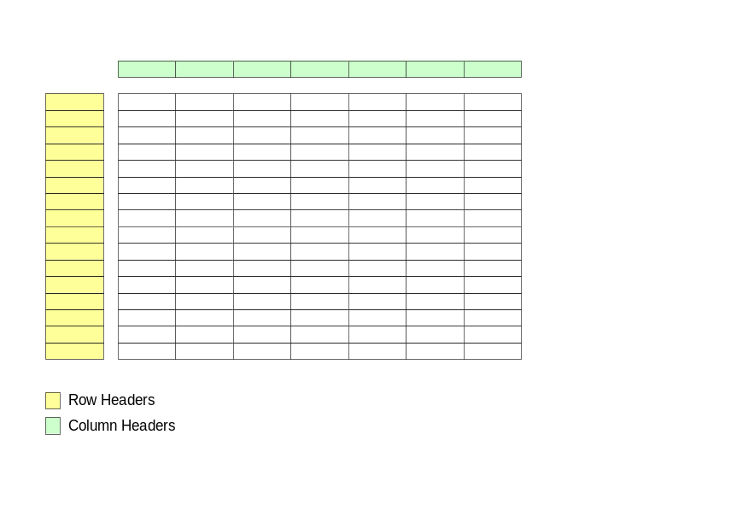

Basically there are two modes to obtain row labels:

- If there are columns in the data sources wich contain unique labels for each row, they can be taken as row labels.
- If there are no label columns, CGVis can autogenerate them.

Row Label Columns
Row label colums retrieved from data source content are defined by the "key" and "rowLabelcolumn" attributes.
The key="data" attribute specifies that row labels are contained in the data provided. The attribute have two different settings:

- "data": A column is taken to retrieve the data row headers
- "auto": An auto generated unique key is generated whilst reading the data source.

The rowLabelColumn="PATIENTID" attribute specifies the column label under which the row labels are to be found.

<set name="Data1+Data2" key="data" rowLabelColumn="PATIENTID"> ... </set>

If different data sources are to be integrated into one pointset they may not share the row labels under the same column label. In this case Aliases have to be specified for the data source columns.
Se the data source section of this documentation for details.

Row labels are always unique. If two data sources share the same value (row and column labels are equal) or field content is specified multiple times in the same data source and the data contained is different from the value already stored, a warning is logged for the specific field. However, the extsting data is overwritten with the new value.

In this case the column with the title "PATIENTID" is used as row label column and therefore will not be contained in the data.

Auto Generated Row Labels
Auto generated Row labels are strings with eight digits forming sequential numbers:

00000002 ← Start Value determined by data source property
00000003
00000004
...

The start value is determined by the startkey element in the respective data source:

<set name="Data1+Data2" key="auto">
<csvdata>
...
<startkey>2</startkey>
...
</csvdata>
</set>

Data Sources
CGVis can integrate different types of data sources, currently text file based data and database based sources are implemented.
Any PointSet can contain an arbitrary number of Data Sources, which are combined into the PointSet by the given Row and Column Labels, whereas Column Labels can be substituted by aliases.

Text File Data
Text File data is specified by a <csvdata> ... </csvdata> substructure:

<csvdata>
<path>Data1.csv</path>
<separator>/t</separator>
<decimalseparator>.</decimalseparator>
<nan symbol="NaN" />
...
</csvdata>

The sample above shows the specification for the import of the tab separated text file named "Data1.csv", located in the same directory as the specification file.

Name
The <name> ... </name> element specifies the same of the data source. This name is used for logging purposes. If the name is not specifed, it defaults to the value "Untitled".

Path
The path to be specified is always relative to the specification file's directory. In the sample above data and spec file reside in the same directory.
Path separators differ in Windows and Unix – therefore the path separators can be Slash ("/") or Backslash ("\") and will be converted appropriately when the configuration file is read.

Separator
The <separator> element specifies the character used to separate the table row content. To specify a tabulator, enter "/t", or the appropriate character otherwise.

Decimal Separator
Sometimes data does not origin from cultures or operatign systems where the dot is used as a decimal sign. Use this element to specify the decimal separator

Start Key
The <startkey> ... </startkey> element contains an integer value that represents the row label of the first row in the data source in case of auto row label generation (see above).
Inportant: In case the content of the element cannot be parsed correctly, the interpretation of the configration file is aborted.

Not a Number – Symbol
In case the content between two separators is empty or unparseable, the PointSet content defaults to "Not a Number" rather than zero. In case the text file specifies special symbols for that (which might be interpreted as numbers), these symbols can be specified in the <nan> element.
Multiple Not a Number – symbols can be specified for each data source.

Aliases
Sometimes it is necessary to consilidate differently named columns of data sources to common target columns. In ths case it is necessary to define alias names for columns:

<csvdata>
...
<alias sourcecol="c1" targetcol="mycol"/>
...
</csvdata>

The sourcecol attribute specifies the column label in the data given, the targetcol attribute specifies the name under which the data is to be handled.

Database Data
Database Data is specified by a <dbdata> ... </dbdata> structure:

<dbdata type = "Oracle">
<server>localhost</server>
<port>1521</port>
<database>DATA</database>
<username>CGVIS</username>
<password>CGVIS</password>
<alias sourcecol="Tick" targetcol="Donald"/>
<selection>SELECT * FROM Test</selection>
</dbdata>

CGVis currently allows for the following database access methods:

- ODBC
- ORACLE
- MYSQL
- POSTGRESQL
- MICROSOFT SQL SERVER
- RAW

These connection types have to be handled slightly different as follows:

Database Type
The database type is specified by the "type" attribute of the dbdata element..

<dbdata type = "Oracle"> ... </dbdata>
<dbdata type = "PostgreSQL"> ... </dbdata>

The content of the attribute value is case insensitive. The following values are defined for this attribute:

- ODBC
- ORACLE
- MYSQL
- POSTGRESQL
- SQLSERVER
- RAW

Server, Port and Database
The Server element defaults to "localhost", the Port element defaults to the standard port of the respective database type (e.g. port 1521 for Oracle databases).

<set key="auto" name="Data1+Data2">
<dbdata type="Oracle">
...
<database>DATA</database>
<username>CGVIS</username>
<password>CGVIS</password>
....
</dbdata>
</set>

The sample above would thus specify a database named "DATA" found on the localhost under the standard Oracle port:

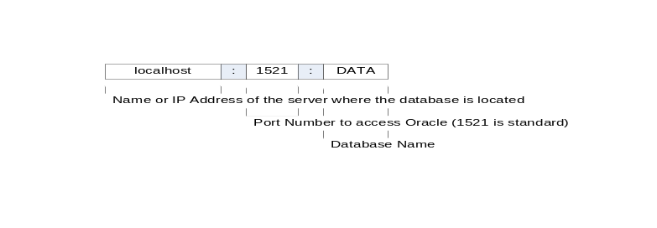

This access mechanism is valid for all other databases supported. The full specification of a database thus would be for example:

<set key="auto" name="Data1+Data2">
<dbdata type="Oracle">
...
<server>lovalhost</server>
<port>1521</port>
<database>DATA</database>
<username>CGVIS</username>
<password>CGVIS</password>
....
</dbdata>
</set>

ODBC
ODBC Data Sources are managed by an operation system's administrative tool. So it is only necessary to specify the Name given to the ODBC data resource in this tool.

<set key="auto" name="Data1+Data2" keyColumn="PATIENTID">
<dbdata type="ODBC">
<database>DATA</database>
<username>CGVIS</username>
<password>CGVIS</password>
<selection>SELECT * FROM Test</selection>
</dbdata>
</set>

Be aware that ODBC offers – at least under Microsoft Windows – a broad range of data sources to be accessed.

User Name and Password
The user name and the password used to access a data source (regardless whether Oracle or ODBC). User names and passwords are mostly case sensitive:

<username>CGVIS</username>
<password>fool</password>

Selection
The content to be retrieved from the database is specified by the <selection> element.

<selection>SELECT * FROM TestTable</selection>

The sample above is the most simple one, to select all rows and columns of a gi-ven table. However, the select statment can be of any complexity.

Separator
The <separator> element specifies the character used to separate the table row content. To specify a tabulator, enter "/t", or the appropriate character otherwise.

Decimal Separator
Sometimes data does not origin from cultures or operatign systems where the dot is used as a decimal sign. Use this element to specify the decimal separator

Start Key
The <startkey> ... </startkey> element contains an integer value that represents the row label of the first row in the data source in case of auto row label generation (see above).
Inportant: In case the content of the element cannot be parsed correctly, the interpretation of the configration file is aborted.

Not a Number – Symbol
In case the content between two separators is empty or unparseable, the PointSet content defaults to "Not a Number" rather than zero. In case the text file specifies special symbols for that (which might be interpreted as numbers), these symbols can be specified in the <nan> element.
Multiple Not a Number – symbols can be specified for each data source.

Aliases
Sometimes it is necessary to consilidate differently named columns of data sources to common target columns. In ths case it is necessary to define alias names for columns:

<csvdata>
...
<alias sourcecol="c1" targetcol="mycol"/>
...
</csvdata>

The sourcecol attribute specifies the column label in the data given, the targetcol attribute specifies the name under which the data is to be handled.

