Команди Create:
CREATE TABLE tournament (
id SERIAL PRIMARY KEY,
name VARCHAR(100) NOT NULL,
start_date DATE NOT NULL CHECK (start_date >= CURRENT_DATE),
prize NUMERIC(12,2) NOT NULL CHECK (prize >= 0),
year_generated INT GENERATED ALWAYS AS (EXTRACT(YEAR FROM start_date)) STORED,
UNIQUE (name, year_generated)
);

CREATE TABLE team (
id SERIAL PRIMARY KEY,
name VARCHAR(100) NOT NULL UNIQUE,
logo BYTEA,
active_roster_id INT
);

CREATE TABLE player (
id SERIAL PRIMARY KEY,
nick VARCHAR(50) NOT NULL UNIQUE,
age INT NOT NULL CHECK (age >= 12)
);

CREATE TABLE roster (
id SERIAL PRIMARY KEY,
team_id INT NOT NULL REFERENCES team(id) ON DELETE CASCADE,
start_date DATE NOT NULL,
end_date DATE CHECK (end_date IS NULL OR end_date > start_date),
CONSTRAINT no_overlap CHECK (start_date < COALESCE(end_date, '9999-12-31'))
);

CREATE TABLE roster_player (
roster_id INT NOT NULL REFERENCES roster(id) ON DELETE CASCADE,
player_id INT NOT NULL REFERENCES player(id) ON DELETE CASCADE,
PRIMARY KEY (roster_id, player_id)
);

CREATE TABLE match (
id SERIAL PRIMARY KEY,
tournament_id INT NOT NULL REFERENCES tournament(id) ON DELETE CASCADE,
score VARCHAR(20),
CHECK (score ~ '^[0-9]+:[0-9]+$' OR score IS NULL)
);

CREATE TABLE match_team (
match_id INT NOT NULL REFERENCES match(id) ON DELETE CASCADE,
team_id INT NOT NULL REFERENCES team(id) ON DELETE CASCADE,
PRIMARY KEY (match_id, team_id)
);

CREATE TABLE team_prize (
id SERIAL PRIMARY KEY,
tournament_id INT NOT NULL REFERENCES tournament(id) ON DELETE CASCADE,
roster_id INT NOT NULL REFERENCES roster(id) ON DELETE CASCADE,
place VARCHAR(20) NOT NULL,
money NUMERIC(12,2) NOT NULL CHECK (money >= 0)
);

CREATE TABLE player_prize (
id SERIAL PRIMARY KEY,
player_id INT NOT NULL REFERENCES player(id) ON DELETE CASCADE,
tournament_id INT NOT NULL REFERENCES tournament(id) ON DELETE CASCADE,
place VARCHAR(20),
money NUMERIC(12,2) NOT NULL CHECK (money >= 0)
);

INSERT INTO tournament (name, start_date, prize)
VALUES
('Major Kyiv', '2026-03-10', 500000),
('Summer Cup', '2026-07-15', 150000),
('Winter Clash', '2026-12-01', 200000);

INSERT INTO team (name)
VALUES
('CyberLions'),
('NightOwls'),
('StormRiders');

INSERT INTO player (nick, age)
VALUES
('ShadowFox', 18),
('Blaze', 21),
('IceWolf', 19),
('Crimson', 22),
('Titan', 20);

INSERT INTO roster (team_id, start_date, end_date)
VALUES
(1, '2026-01-01', NULL),
(2, '2026-01-01', NULL),
(3, '2026-01-01', NULL);

-- CyberLions
INSERT INTO roster_player VALUES
(1, 1),
(1, 2);

-- NightOwls
INSERT INTO roster_player VALUES
(2, 3),
(2, 4);

-- StormRiders
INSERT INTO roster_player VALUES
(3, 5);

INSERT INTO match (tournament_id, score)
VALUES
(1, '2:1'),
(1, '0:2'),
(2, NULL);

INSERT INTO match_team VALUES
(1, 1),
(1, 2),

(2, 2),
(2, 3),

(3, 1),
(3, 3);

INSERT INTO team_prize (tournament_id, roster_id, place, money)
VALUES
(1, 1, '1st', 300000),
(1, 2, '2nd', 150000),
(2, 3, '1st', 150000);

INSERT INTO player_prize (player_id, tournament_id, place, money)
VALUES
(1, 1, 'MVP', 20000),
(3, 1, 'Top Fragger', 10000),
(5, 2, 'MVP', 15000);

SELECT * FROM tournament;

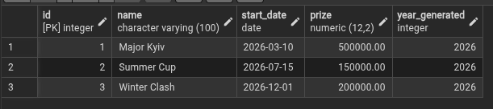

SELECT * FROM team;

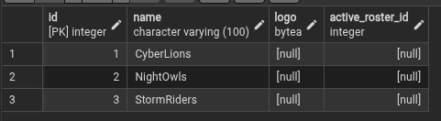

SELECT * FROM player;

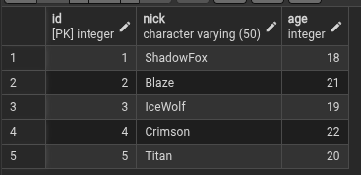

SELECT * FROM roster;

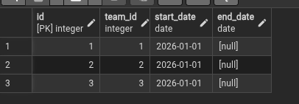

SELECT
rp.roster_id,
r.team_id,
rp.player_id,
p.nick
FROM roster_player rp
JOIN player p ON p.id = rp.player_id
JOIN roster r ON r.id = rp.roster_id
ORDER BY rp.roster_id;

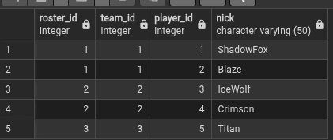

SELECT * FROM match;

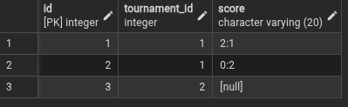

SELECT
mt.match_id,
m.tournament_id,
mt.team_id,
t.name AS team_name
FROM match_team mt
JOIN match m ON m.id = mt.match_id
JOIN team t ON t.id = mt.team_id
ORDER BY match_id;

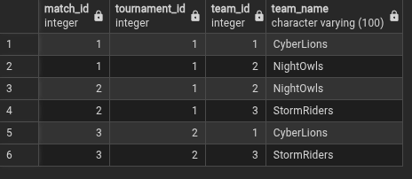

SELECT
tp.id,
tp.tournament_id,
t.name AS tournament_name,
tp.roster_id,
r.team_id,
tm.name AS team_name,
tp.place,
tp.money
FROM team_prize tp
JOIN tournament t ON t.id = tp.tournament_id
JOIN roster r ON r.id = tp.roster_id
JOIN team tm ON tm.id = r.team_id
ORDER BY tp.id;

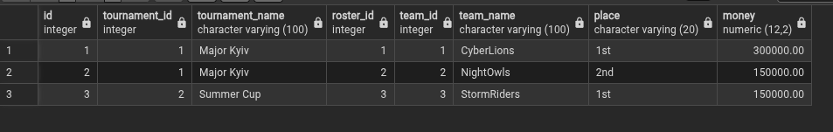

SELECT
pp.id,
pp.player_id,
p.nick,
pp.tournament_id,
t.name AS tournament_name,
pp.place,
pp.money
FROM player_prize pp
JOIN player p ON p.id = pp.player_id
JOIN tournament t ON t.id = pp.tournament_id
ORDER BY pp.id;

