TRUNCATE TABLE player_prize, team_prize, match_team, match, roster_player,
roster, player, team, tournament
RESTART IDENTITY CASCADE;

INSERT INTO tournament (name, start_date, prize)
VALUES
('Major Kyiv', '2026-03-10', 500000),
('Summer Cup', '2026-07-15', 150000),
('Winter Clash', '2026-12-01', 200000);

INSERT INTO team (name)
VALUES
('NAVI'),
('G2'),
('Liquid');

INSERT INTO player (nick, age)
VALUES
('s1mple', 27),
('b1t', 21),
('NiKo', 28),
('m0NESY', 19),
('YEKINDAR', 23);

INSERT INTO roster (team_id, start_date)
VALUES
(1, '2026-01-01'),
(2, '2026-01-01'),
(3, '2026-01-01');

INSERT INTO roster_player (roster_id, player_id)
VALUES
(1, 1), (1, 2),
(2, 3), (2, 4),
(3, 5);

INSERT INTO match (tournament_id, score)
VALUES
(1, '2:1'),
(1, '0:2');

INSERT INTO match_team (match_id, team_id)
VALUES
(1, 1), (1, 2),
(2, 2), (2, 3);

UPDATE tournament
SET prize = 550000
WHERE name = 'Major Kyiv';

UPDATE team
SET active_roster_id = 1
WHERE name = 'NAVI';

UPDATE player
SET age = 28
WHERE nick = 's1mple';

DELETE FROM roster_player
WHERE roster_id = 1 AND player_id = 2;

DELETE FROM match
WHERE id = 2;

DELETE FROM team
WHERE name = 'Liquid';

SELECT * FROM tournament;
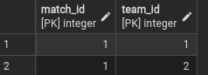

SELECT * FROM team;

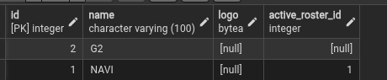

SELECT * FROM player;

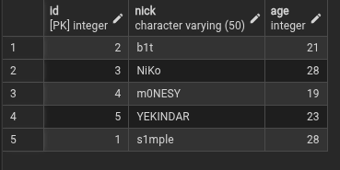

SELECT * FROM roster;

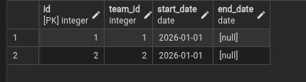

SELECT * FROM roster_player;
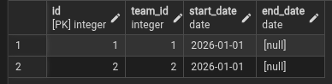
SELECT * FROM match;


SELECT * FROM match_team;
