TRUNCATE TABLE player_prize, team_prize, match_team, match, roster_player,
roster, player, team, tournament
RESTART IDENTITY CASCADE;

INSERT INTO tournament (name, start_date, prize)
VALUES
('Major Kyiv', '2026-03-10', 500000),
('Summer Cup', '2026-07-15', 150000),
('Winter Clash', '2026-12-01', 200000);

INSERT INTO team (name)
VALUES
('NAVI'),
('G2'),
('Liquid');

INSERT INTO player (nick, age)
VALUES
('s1mple', 27),
('b1t', 21),
('NiKo', 28),
('m0NESY', 19),
('YEKINDAR', 23);

INSERT INTO roster (team_id, start_date)
VALUES
(1, '2026-01-01'),
(2, '2026-01-01'),
(3, '2026-01-01');

INSERT INTO roster_player (roster_id, player_id)
VALUES
(1, 1), (1, 2),
(2, 3), (2, 4),
(3, 5);

INSERT INTO match (tournament_id, score)
VALUES
(1, '2:1'),
(1, '0:2');

INSERT INTO match_team (match_id, team_id)
VALUES
(1, 1), (1, 2),
(2, 2), (2, 3);

SELECT
EXTRACT(YEAR FROM start_date) AS year,
AVG(prize) AS avg_prize
FROM tournament
GROUP BY year;

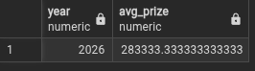

SELECT
t.name AS tournament,
COUNT(m.id) AS matches_count
FROM match m
JOIN tournament t ON m.tournament_id = t.id
GROUP BY t.name;



SELECT
t.name AS tournament,
COUNT(m.id) AS matches_count
FROM match m
JOIN tournament t ON m.tournament_id = t.id
GROUP BY ROLLUP (t.name);

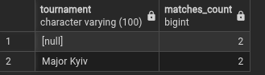

SELECT
t.name AS tournament,
COUNT(DISTINCT mt.team_id) AS teams_count
FROM match_team mt
JOIN match m ON mt.match_id = m.id
JOIN tournament t ON m.tournament_id = t.id
GROUP BY t.name;



SELECT
tm.name AS team,
COUNT(rp.player_id) AS players_in_team
FROM roster r
JOIN team tm ON r.team_id = tm.id
JOIN roster_player rp ON rp.roster_id = r.id
GROUP BY tm.name;

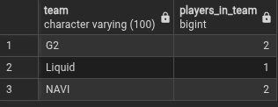

SELECT
t.name AS tournament,
tm.name AS team,
COUNT(m.id) AS matches_played
FROM match_team mt
JOIN team tm ON mt.team_id = tm.id
JOIN match m ON mt.match_id = m.id
JOIN tournament t ON m.tournament_id = t.id
GROUP BY GROUPING SETS (
(t.name, tm.name),
(t.name),
(tm.name),
()
);

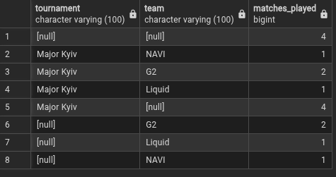

SELECT
t.name AS tournament,
tm.name AS team,
COUNT(m.id) AS matches_played
FROM match_team mt
JOIN match m ON mt.match_id = m.id
JOIN team tm ON mt.team_id = tm.id
JOIN tournament t ON m.tournament_id = t.id
GROUP BY ROLLUP (t.name, tm.name);

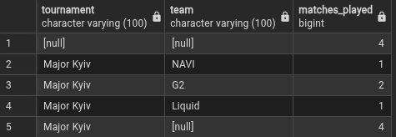

SELECT
tm.name AS team,
p.nick AS player,
p.age
FROM roster r
JOIN team tm ON r.team_id = tm.id
JOIN roster_player rp ON rp.roster_id = r.id
JOIN player p ON p.id = rp.player_id
GROUP BY ROLLUP (tm.name, p.nick, p.age);

