3.3

(b) 0.80

(c)

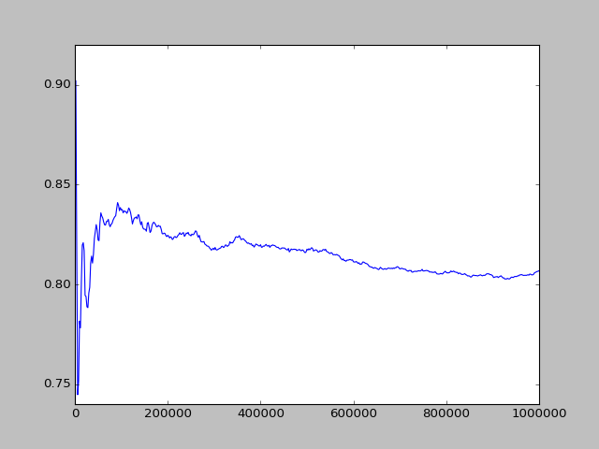

(d)

from random import randint

from math import pow

import matplotlib.pyplot as plt

def convert(B):

f = 0

base = 1

for i in range(0, len(B)):

f += base \* B[i]

base \*= 2

return f

def genRandom(n):

b=[]

for i in range(0,10):

b.append(randint(0,1))

return b

n = 10

alpha = 0.25

numerator = 0

denominator = 0

Z = 128

p = 1

l =[]

t = []

for i in range(0, 1000000):

B = genRandom(n)

f = convert(B)

pf = (1-alpha)/(1+alpha) \* pow(alpha, abs(Z - f))

denominator += pf

if B[7] == 1:

numerator += pf

if denominator > 0:

p = numerator / denominator

if (i+1) % 2000 == 0:

#print p

t.append(i)

l.append(p)

plt.plot(t,l)

plt.show()