4.5

(a)

[ 0.94520006 0.01974237 -0.01364498 0.04678134]

(b)

for 2000: MSE = 13918.63

for 2001: MSE = 2973.02

(c)

import numpy as np

def calculate(array):

A = []

B = []

for i in range(4):

B.append(float(0))

A.append([])

for j in range(4):

A[i].append(float(0))

for i in range(4):

for j in range(4):

cur = 0.0

for k in range(4, len(array)):

cur += array[k-j-1]*array[k-i-1]

A[i][j] = cur

for i in range(4):

cur = 0.0

for k in range(4,len(array)):

cur += array[k] * array[k-i-1]

B[i] = cur

A = np.array(A,float)

B = np.array(B,float)

X = np.dot(np.linalg.inv(A) , B)

return X

def error(array,X):

Y = []

for i in range(4, len(array)):

cur = X[0]*array[i-1] + X[1]*array[i-2] + X[2]*array[i-3] + X[3]*array[i-4]

Y.append(cur)

e = 0.0

for i in range(len(Y)):

e += (Y[i] - array[i+4]) **2

e /= len(Y)

print e

fp = open('nasdaq00.txt', 'r')

#fp = open('nasdaq01.txt', 'r')

array2000 = []

for line in fp.readlines():

line = line.strip('\n').split(' ')

array2000.append(float(line[0]))

X = []

X = calculate(array2000)

print X

error(array2000,X)

4.6

(a)

error rate for train3: 3.57%

error rate for train5: 3.85%

error rate overall: 3.71%

w =

    0.6971   -0.1080   -1.0490   -0.7983   -0.4133   -0.7576   -0.4498   -0.0479

    0.8010   -0.0417   -1.1509   -0.9043   -0.3120    0.2457   -0.1742   -0.4225

    0.9076   -0.3412   -0.7329   -0.6148    0.1957    0.1171   -0.3187   -0.3872

    1.0184    0.1839   -0.3500    0.1273    0.2159   -0.3595   -0.3523   -0.6077

    1.0018   -0.0668   -0.1303    0.5902    0.3105   -0.1145   -0.0138   -0.3400

   -0.2049   -0.4751    1.3796    0.7316    0.2290    0.2519    0.1153   -0.5644

   -0.9889    0.6730    2.5369   -0.1523    0.0097   -0.2046    0.0092    0.2550

   -1.4022    0.6319    1.9222    0.2368    0.3302    0.8040    0.7367    0.1802

The converge of L using gradient:

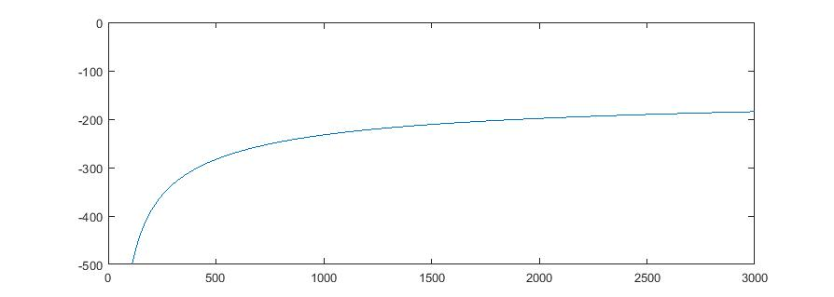

(b)

error rate for test3: 5.25%

error rate for test5: 6.75%

error rate overall:6.00%

(c)

%0 stands for 5

%1 stands for 3

%sigmf(x,[1 0])

Train3=load('Train3.txt');

Train5=load('Train5.txt');

Test3 =load('Test3.txt');

Test5 =load('Test5.txt');

% initial values of weight.

w= 0.5 * ones(64,1);

L0= sum(log(sigmf(Train3 * w,[1 0])))+sum(log(sigmf(-Train5 * w,[1 0])));

Y1 = 1* ones(700,1);

Y2 = 0* ones(700,1);

Gradient= Train3' *(Y1 - sigmf(Train3*w,[1,0])) + Train5' *(Y2 - sigmf(Train5 *w,[1 0]));

Lr=ones(10000,1);

for i= 1:10000

   w=w+0.02/1400*Gradient;

   Gradient= Train3' *(Y1 - sigmf(Train3*w,[1,0])) + Train5' *(Y2 - sigmf(Train5 *w,[1 0]));

   Lr(i)=sum(log(sigmf(Train3 * w,[1 0])))+sum(log(sigmf(-Train5 * w,[1 0])));

end

sigmf(Train3 *w,[1 0])

L= sum(log(sigmf(Train3 * w,[1 0])))+sum(log(sigmf(-Train5 * w,[1 0])));

T3=sigmf(Train3 * w,[1 0]);

T5=sigmf(Train5 * w,[1 0]);

R3=sigmf(Test3 * w,[1 0]);

R5=sigmf(Test5 * w,[1 0]);

c3_5=0;

t3_5=0;

c5_3=0;

t5_3=0;

for i= 1:400

    if(R3(i)<=0.5)

        c3_5=c3_5+1;

    end

    if(R5(i)>0.5)

        c5_3=c5_3+1;

    end

end

for i= 1:700

    if(T3(i)<=0.5)

        t3_5=t3_5+1;

    end

    if(T5(i)>0.5)

        t5_3=t5_3+1;

    end

end

fprintf('Error rate of train3: %f\n',t3_5/700);

fprintf('Error rate of train5: %f\n',t5_3/700);

fprintf('Error rate overall:%f\n',t3_5/1400+t5_3/1400);

fprintf('Error rate of test3: %f\n',c3_5/400);

fprintf('Error rate of test5: %f\n',c5_3/400);

fprintf('Error test rate overall:%f\n',c3_5/800+c5_3/800);

x=1:10000;

y=Lr(x);

plot(x,y)

w= reshape(w, [8,8])