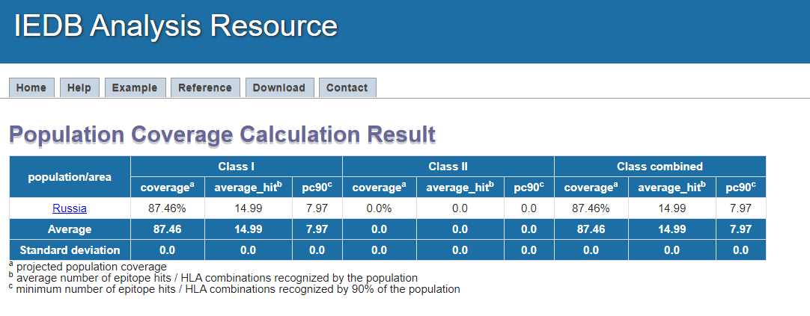

TTRTQLPPAY

GVYYPDKVF

FLPFFSNVTW

LIVNNATNVVIKV

CNDPFLGVYY

EGKQGNFKNLREFVFKNIDGYF

QELGKYEQYIKWPWYIW

MSFPQSAPHGVVFL

ARSVASQSIIAY

AHFPREGVFVSNGTHW +

<http://tools.iedb.org/media/tmp/population/popcov_russia_i.png>

**Population Coverage Calculation Result**

AGCLIGAEHVNNSY

CGPKKSTNLV

NFYEPQIITTDNTF

DLGDISGINASVVNIQK

SNNSIAIPTNFTI

RSFIEDLLFNKV

|  |  |  |  |
| --- | --- | --- | --- |
| **population/area** | **Class I** | | |
| **coveragea** | **average_hitb** | **pc90c** |
| [Russia](http://tools.iedb.org/population/result/#Russia) | 87.46% | 8.99 | 4.78 |
|  |  |  |  |
| **Average** | **87.46** | **8.99** | **4.78** |
| **Standard deviation** | **0.0** | **0.0** | **0.0** |

a projected population coverage  
b average number of epitope hits / HLA combinations recognized by the population  
c minimum number of epitope hits / HLA combinations recognized by 90% of the population

***Population: Russia***

|  |  |  |  |
| --- | --- | --- | --- |
| **MHC class** | **Coverage** | **Average hit** | **PC90** |
| I | 87.46% | 8.99 | 4.78 |
| http://tools.iedb.org/media/tmp/population/popcov_russia_i.png | | | |

**Population Coverage Calculation Result**

|  |  |  |  |
| --- | --- | --- | --- |
| **population/area** | **Class II** | | |
| **coveragea** | **average_hitb** | **pc90c** |
| [Russia](http://tools.iedb.org/population/result/#Russia) | 99.87% | 10.66 | 7.4 |
|  |  |  |  |
| **Average** | **99.87** | **10.66** | **7.4** |
| **Standard deviation** | **0.0** | **0.0** | **0.0** |

a projected population coverage  
b average number of epitope hits / HLA combinations recognized by the population  
c minimum number of epitope hits / HLA combinations recognized by 90% of the population

***Population: Russia***

|  |  |  |  |
| --- | --- | --- | --- |
| **MHC class** | **Coverage** | **Average hit** | **PC90** |
| II | 99.87% | 10.66 | 7.4 |

