**GIT Lab helper (Git Extensions):**

**Exercise I: Adding files**

Clone the repository from: \\isamba.iil.intel.com\nfs\iil\disks\gen_adm_iec_cm_lab\git_repo\gitlab.git

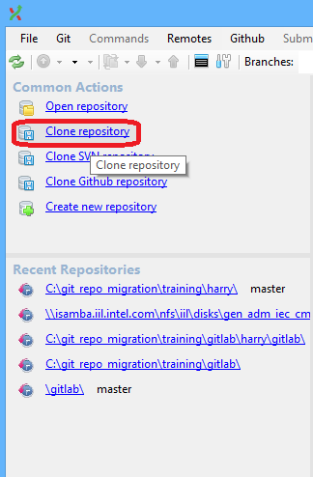 OR 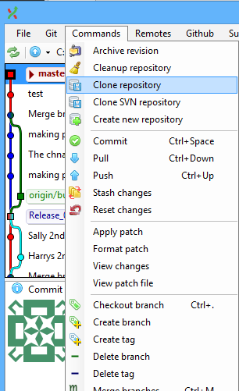

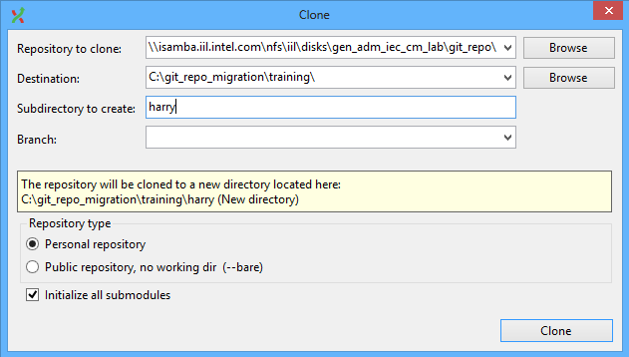

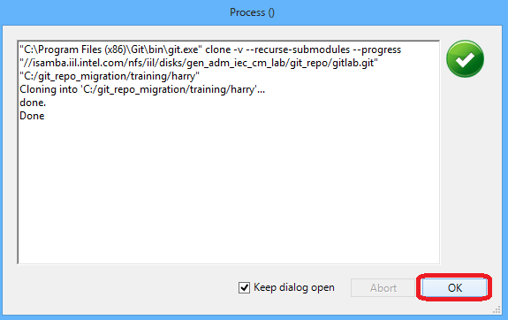 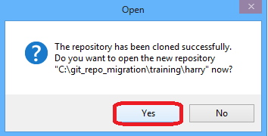

GIT Stage + Commit  
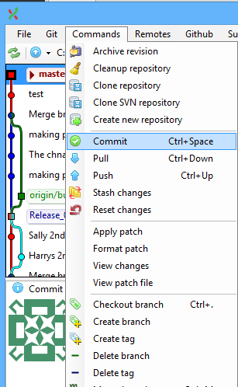 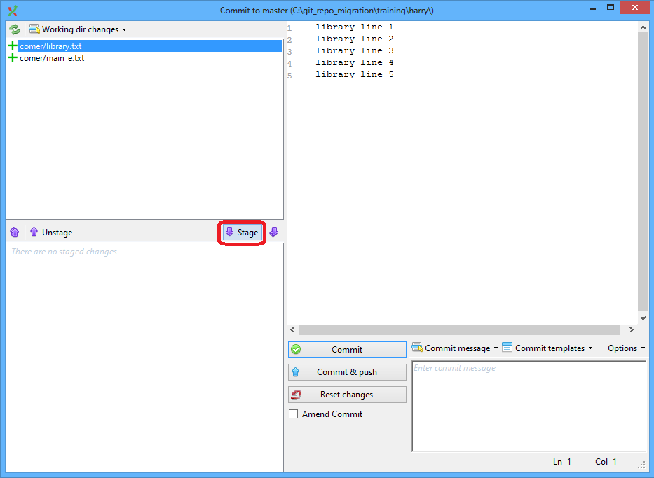  
  
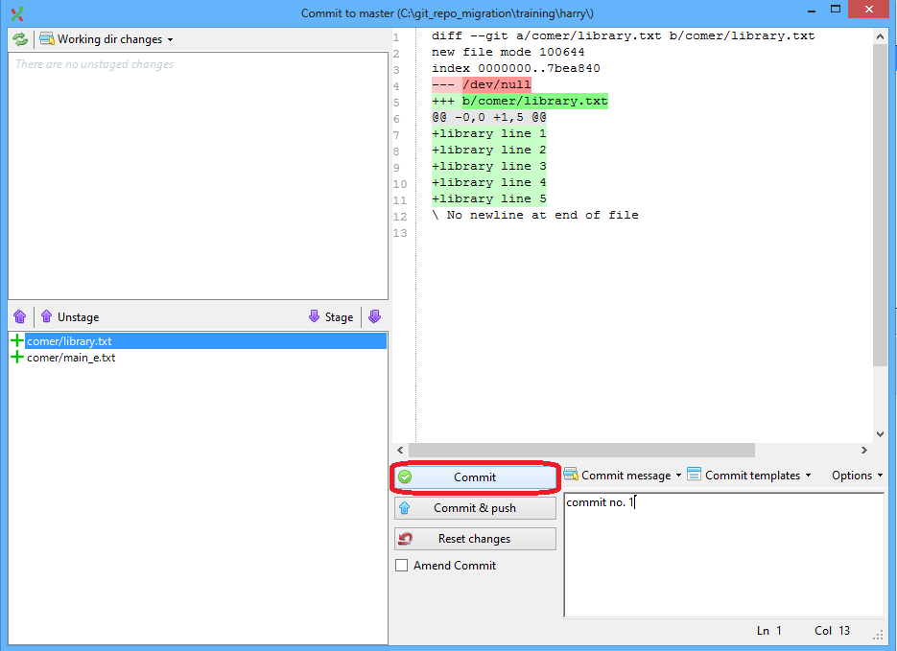 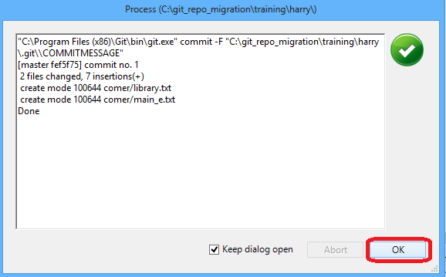

**Exercise II: Restructuring files**

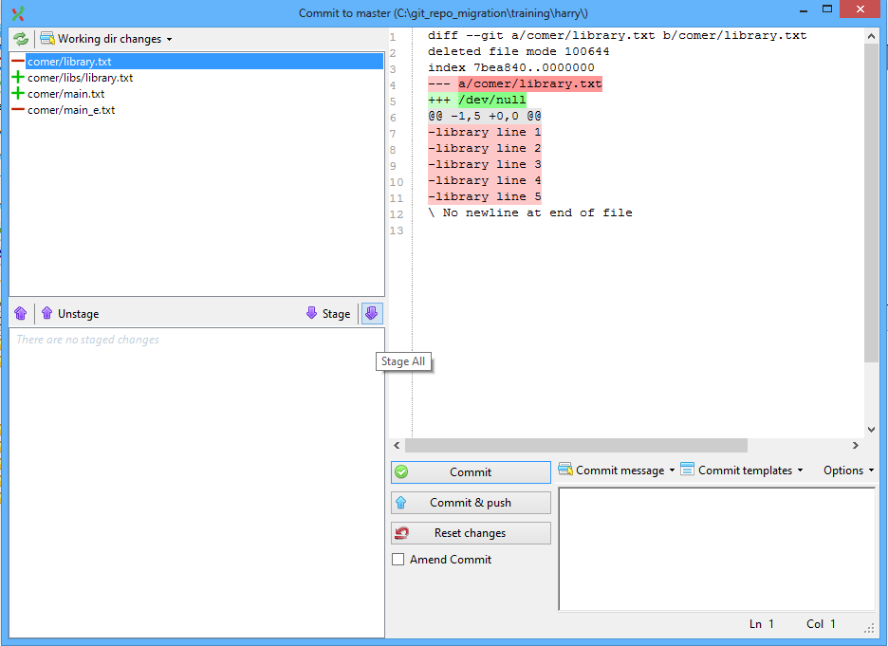

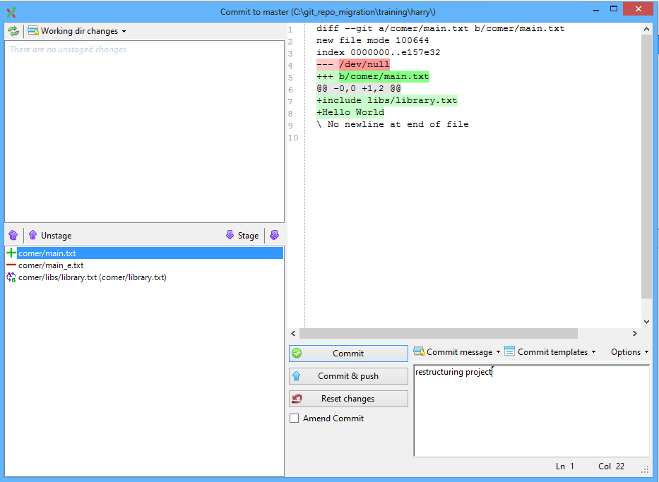

Git push

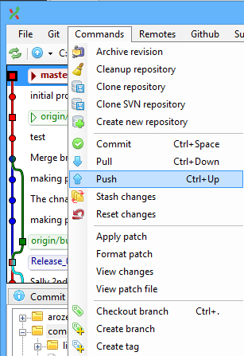 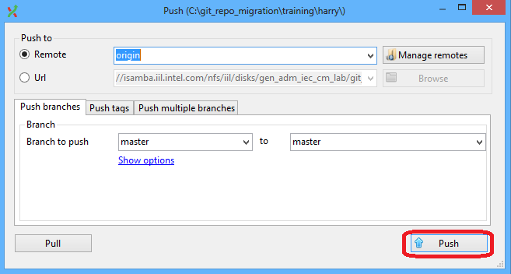

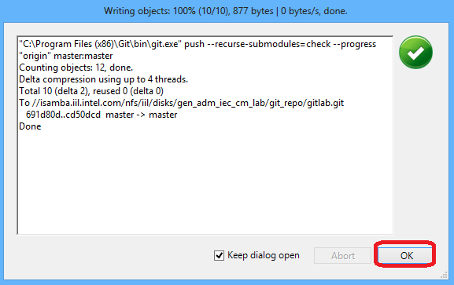

**Exercise III: Teamwork**

SVN push   
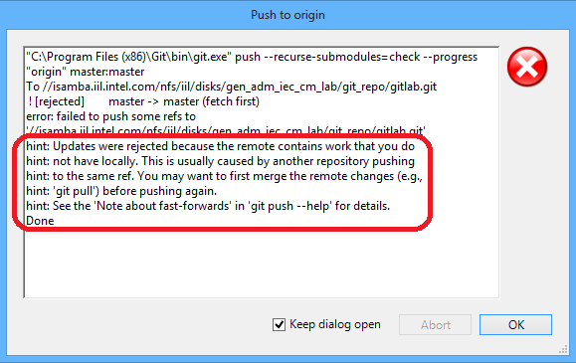

Git Pull

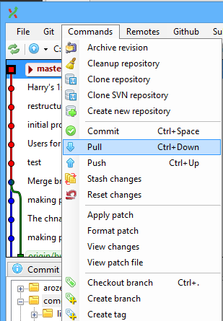 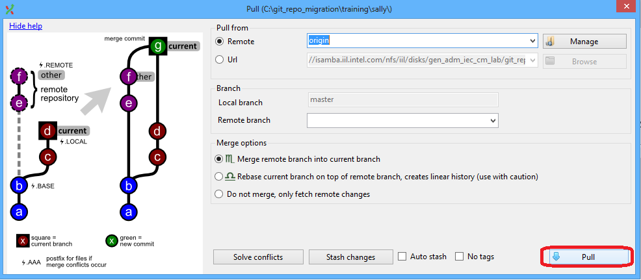  
  
Git diff

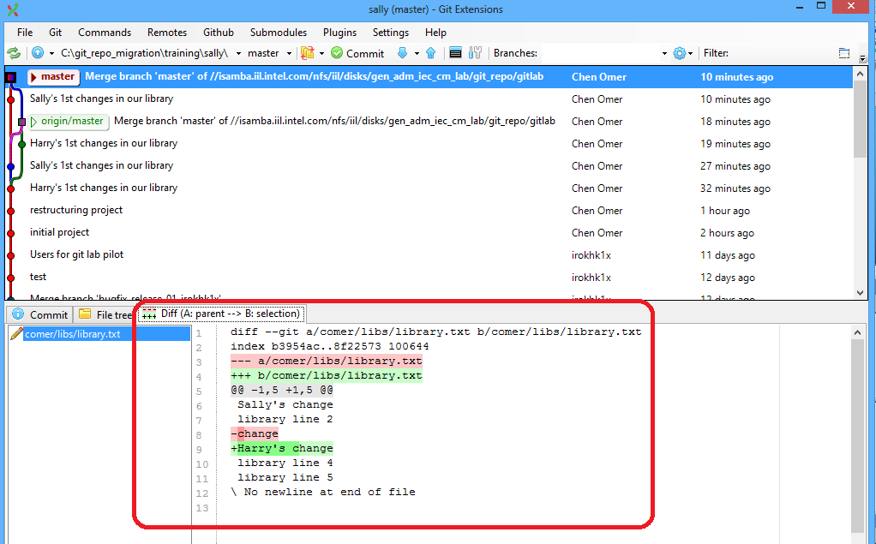

**Exercise IV: Conflicts**Edit conflicts, reconciling the conflict lines, and then save the file

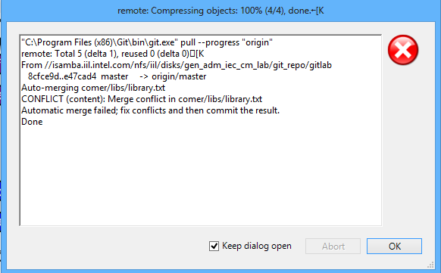 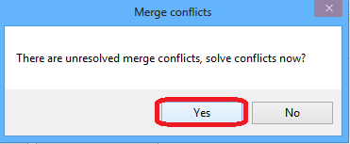

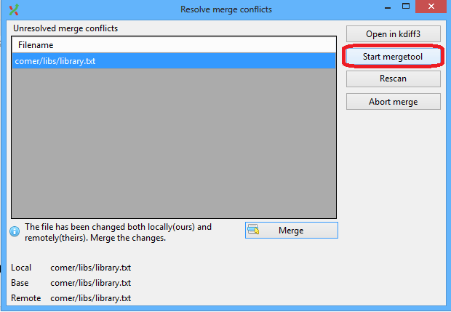

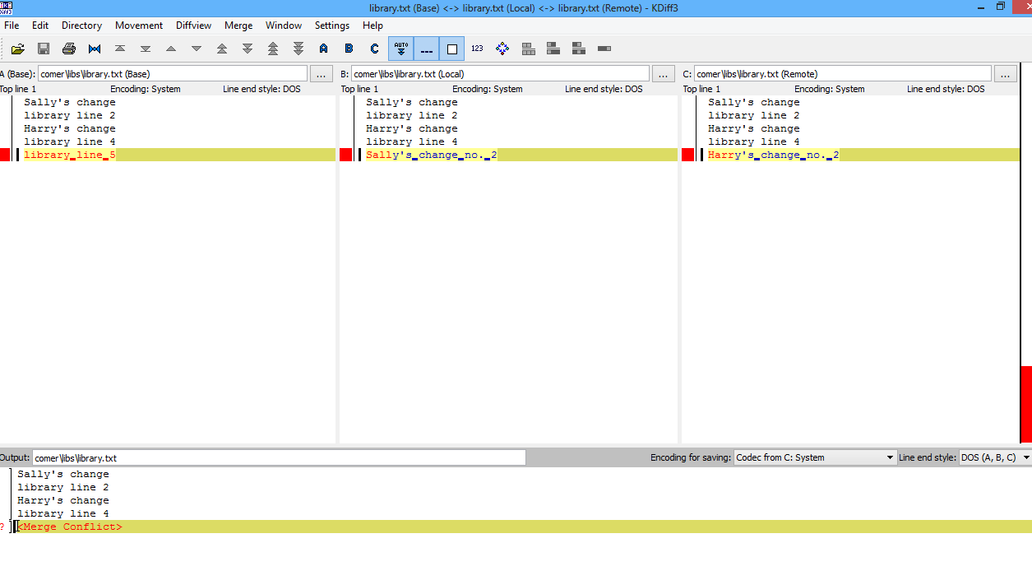

Commit the resolved file/s

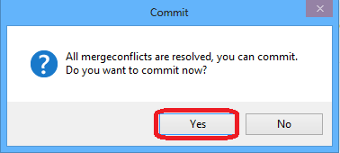

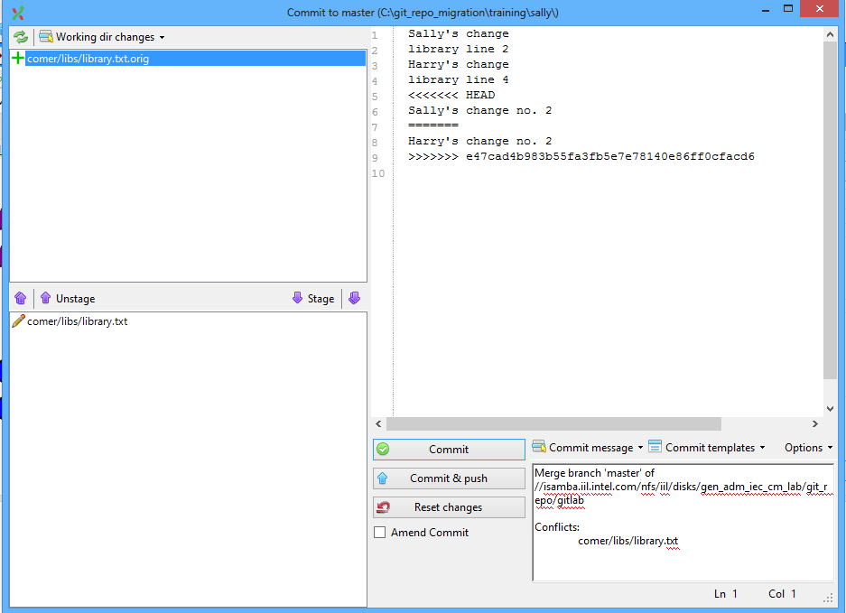

**Exercise V: Tagging**

Create tag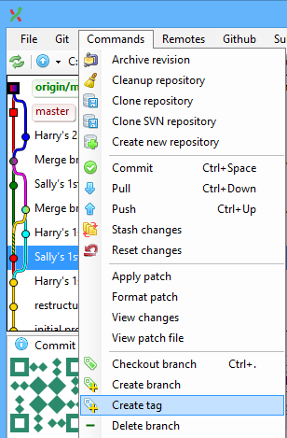 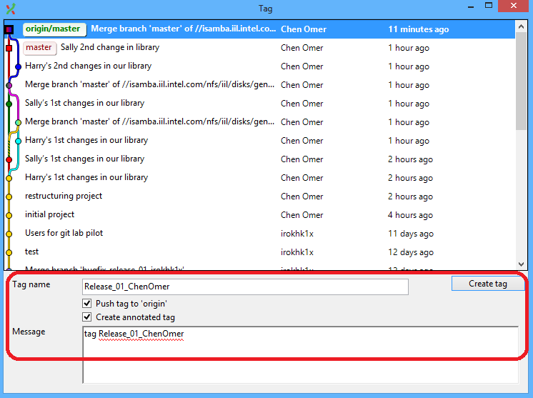

View the tag

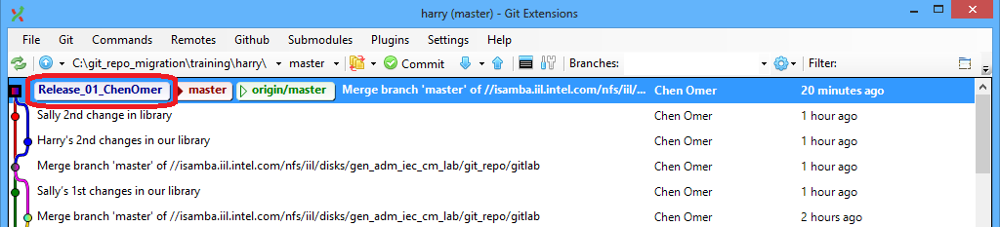

**Exercise VI: Branching**

Create branch

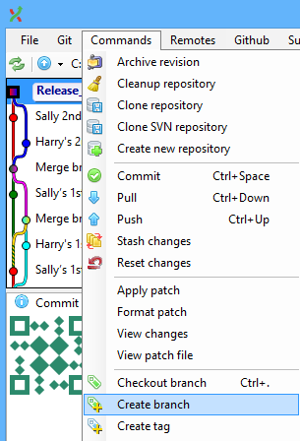 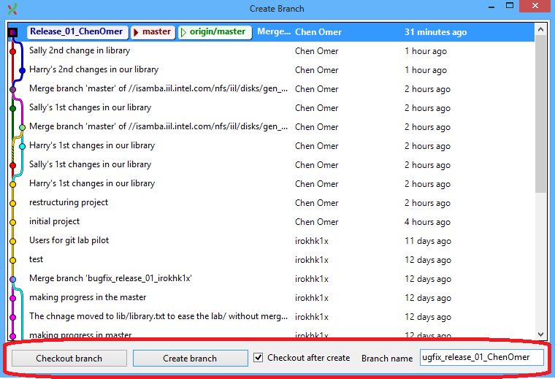

Checkout branch

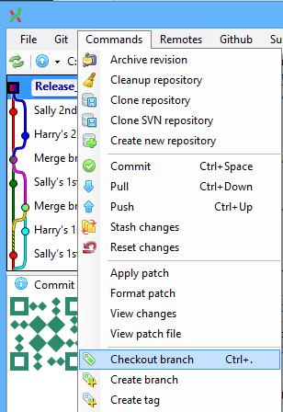 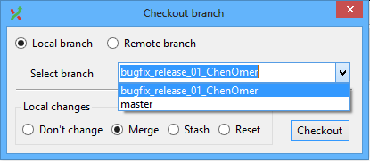

Push a branch

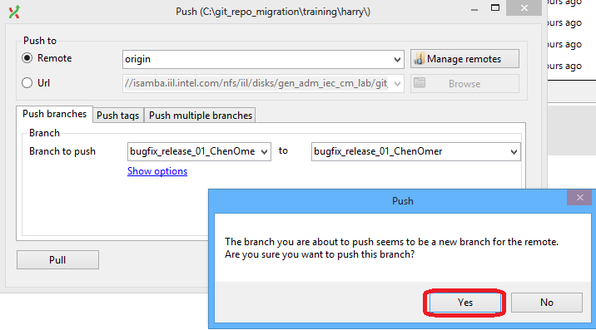

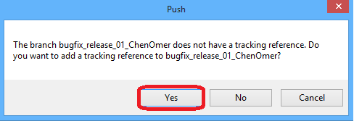

**Exercise VII: Merging**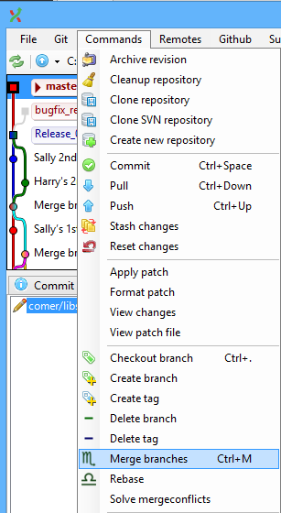 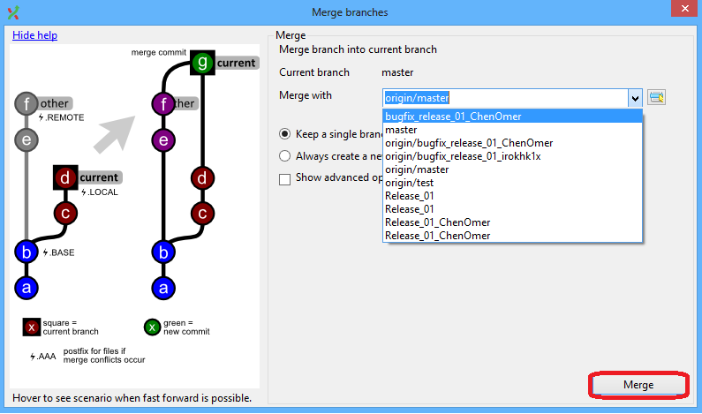

**SVN Lab helper (Command line):**

**Exercise I: Adding Files**

Check out trunk from: [https://subversion.iil.intel.com/it/pec/ec/svnlab/<YOUR_USER_NAME>/trunk](https://subversion.iil.intel.com/it/pec/ec/svnlab/%3cYOUR_USER_NAME%3e/trunk)  
$ **svn co** [https://subversion.iil.intel.com/it/pec/ec/svnlab/<YOUR_USER_NAME>/trunk](https://subversion.iil.intel.com/it/pec/ec/svnlab/%3cYOUR_USER_NAME%3e/trunk) **harry**  
  
SVN Add  
$ **svn add** *  
  
SVN Commit  
$ **svn commit -m “initial project”**

**Exercise II: restructuring files**

Rename a versioned file  
$ **svn mv main_e.txt main.txt**

Move versioned file  
$ **svn mv library.txt libs**

**Exercise III: teamwork**

SVN Update  
$ **svn up**

**Exercise IV: conflicts**Edit conflicts, reconciling the conflict lines, and then save the file  
after the file is correct, need to sign it as Resolved to commit it

[irokhk1x@icsl2000 libs]$ **svn up**  
Conflict discovered in 'library.txt'.  
Select: (p) postpone, (df) diff-full, (e) edit,  
 (mc) mine-conflict, (tc) theirs-conflict,  
 (s) show all options: p  
C library.txt  
$ ls  
library.txt library.txt.mine library.txt.r13 library.txt.r14  
$ **tkdiff -conflict library.txt**  
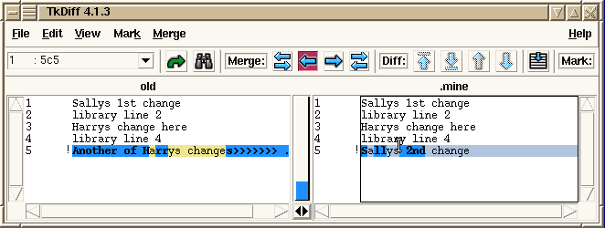

$ **kdiff3 library.txt.r13 library.txt.mine library.txt.r14 -o library.txt**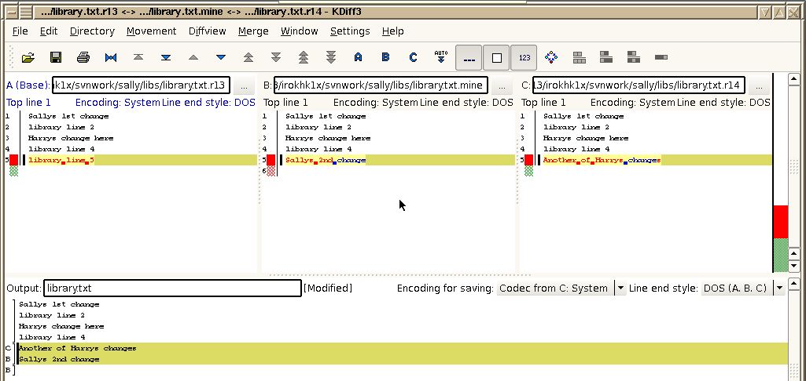

$ **svn resolved library.txt**  
Resolved conflicted state of 'library.txt'

**Exercise V: optimistic locking**Lock the main.txt in harry‘s workingcopy   
$ **svn lock main.txt**

Revert sallys changes  
$ **svn revert main.txt**

**Exercise VI: pessimistic locking**

$ **svn propset svn:needs-lock 1 main.txt**   
property 'svn:needs-lock' set on 'main.txt'

$ **svn propdel svn:needs-lock main.txt**  
property 'svn:needs-lock' deleted from 'main.txt'.

**Exercise VII: tagging**  
Copy command is used to create tags and **branches**  
sally]$ **svn cp -m "mk tag after locking" .** [https://subversion.iil.intel.com/it/pec/ec/svnlab/<YOUR_USER_NAME>/tags/release_01](https://subversion.iil.intel.com/it/pec/ec/svnlab/%3cYOUR_USER_NAME%3e/tags/release_01)  
 **Exercise VIII: branching**  
To create branch use **svn cp** command, see previous excersise  
Switch Working Copysally]$ **svn sw** [https://subversion.iil.intel.com/it/pec/ec/svnlab/<YOUR_USER_NAME>/branches/bugfix_release_01](https://subversion.iil.intel.com/it/pec/ec/svnlab/%3cYOUR_USER_NAME%3e/branches/bugfix_release_01) **.**

**Exercise IX: merging**  
Merge the appropriate revision(s) from /branches/bugfix_release_01 into Sally’s working copy  
Merge sally’s WC (trunk) from branches/bugfix_release_01  
sally]$ **svn merge** [https://subversion.iil.intel.com/it/pec/ec/svnlab/<YOUR_USER_NAME>/branches/bugfix_release_01](https://subversion.iil.intel.com/it/pec/ec/svnlab/%3cYOUR_USER_NAME%3e/branches/bugfix_release_01) **.**

See the log with merge history  
sally]$ **svn log -g**