20. You are also to write SQL to generate two queries which must meet the following requirements.

a. A summary report that employs table and column aliases and minimially at least one filter, two INNER JOINS, one SQL Aggregate, GROUP BY functions. In the design of your report, you need to specify your target audience or role and how you envisage the report would be used by the target audience.

*Target audience requests for sales report of a particular customer to confirm the Quantity of Voucher and Type purchased as a black and white.*

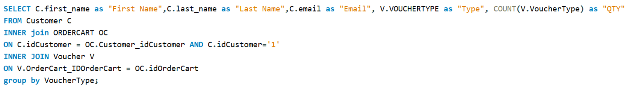

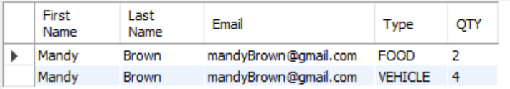

b. A daily list of orders placed by customers providing details of the orders including order date, customer email, order number and details of each voucher in terms of the email of the voucher’s recipient, type of voucher and the voucher’s value. The list is to be sorted by voucher type and voucher ID.

