**Measuring Cups (group project)**

Adil Zhumgalbekov, Dastan Asanov, Kairat Kypchakbaev, Ilias Iangurazov

This is a 3d model of measuring cups.

Providing a consistent dining experience depends on creating a consistent product, and the only way to guarantee that is by following a precise recipe each and every time. Measuring cups are one quintessential tool that gives chefs the ability to replicate their signature dishes from batch to batch, and when it comes to shopping for a new set, you have the choice between several materials, each of which have their own benefits and drawbacks.

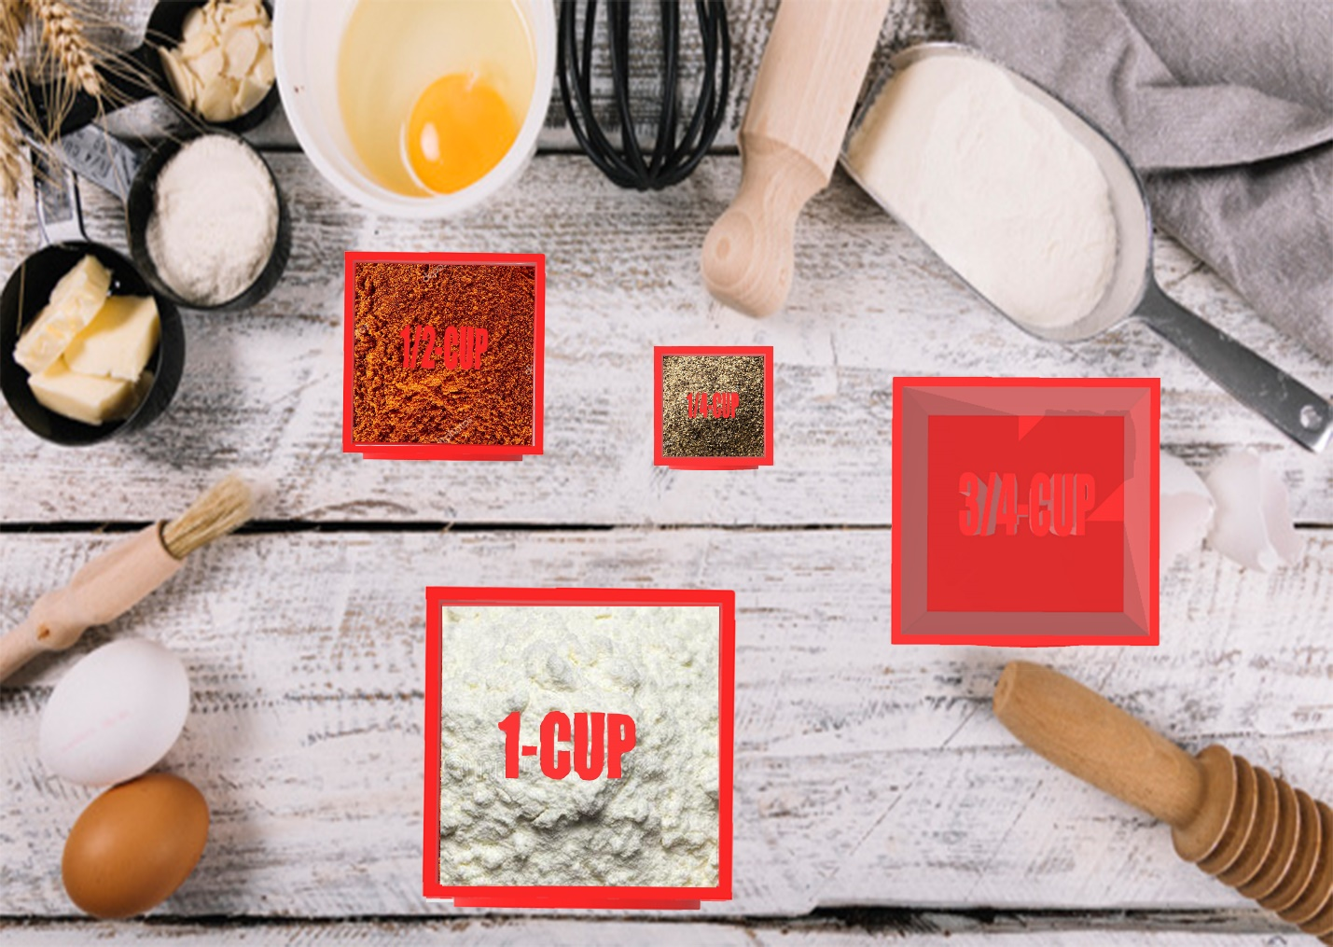

1 cup:



¾ cup:



½ cup



¼ cup

