QUESTION BANK

PROJECT REPORT

Submitted by

ILYAS BABU (Reg No : AZASSCS002)
ILYAS BABU (Reg No : AZASSCS002)
ILYAS BABU (Reg No : AZASSCS002)
ILYAS BABU (Reg No : AZASSCS002)

For the award of the Degree of

Bachelor of science (B.Sc.)

In Computer Science

(University of Calicut)



AMAL COLLEGE OF ADVANCED STUDIES, NILAMBUR

(Affiliated to the University of Calicut)

Santhigramam,Myladi

Eranhimangad P.O

Nilambur,Kerala 679329

MARCH - 2021

1

ACKNOWLEDGMENT

First of all, I thank the ALMIGHTY GOD for showering his immense blessing and giving strength to complete my project work successfully. I wish to express my sincere gratitude to Dr. Zacaria TV, Principal for providing us adequate facilities to do this work. I am grateful to Mrs. Swapna, Assistant Professor on contract, Department of Computer Science, for the guidance offered and Mrs. Jashira P, Head of the Department of Computer Science in bringing this report to a successful completion. .Last but not the least, I express my sincere thanks to all of the staffs in Department of Computer Science, all of my friends and my parents who have patiently extended all sorts of help for accomplishing this undertaking

Date:

HIBA SHIRIN P

RINSHA K A

HIBA A

MANUSHA C

2

DECLARATION

We, here by declare that this submission is my own work and that, to the best of my knowledge and belief, it contains no material previously published or written by another person or material which has been accepted for the award of any other degree or diploma of the university or other institute of higher learning, except where due acknowledgment has been made in the text

Place: NILAMBUR

Signature:

Date:

Name: HIBA SHIRIN P

(Reg No: AZASSCS002)

RINSHA K A

(Reg No: AZASSCS003)

HIBA A

(Reg No: AZASSCS011)

MANUSHA C

(Reg No: AZASSCS020)

3

CERTIFICATE

This is to certify that the project report entitled MENTOR AND MENTEE submitted by HIBA SHIRIN P (Register Number: AZASSCS002 ), RINSHA K A (Register Number: AZASSCS003 ), HIBA A (Register Number: AZASSCS011 ), MANUSHA C (Register Number: AZASSCS020 ) to University of Calicut for the award of the degree of Bachelor of Science (B.Sc.) in Computer Science is a bonafide record of the project work carried out by him/her under my supervision and guidance. The content of the report, in full or parts have not been submitted to any other Institute or University for the award of any other degree or diploma.

Signature

Signature

Mrs. Swapna

Mrs. Jashira P

Assistant professor on contract

Head of the department

Department of computer science

Amal college of advanced studies

Myladi, Nilambur

Place:

Date:

(Office seal)

Certified that the candidate was examined by us in the Project Viva Voce Examination held

on........................................... and his/her Register Number is .....................................

Examiners:

1.

2.

4

CONTENTS

Page No

ABSTRACT……………………………………………………………. | 7
LIST OF FIGURES……………………………………………………. | 8
LIST OF TABLES……………………………………………………… | 9
1.INDRODUCTION……………………………………………………. | 10
2.PROBLEM DEFINITION AND METHONODOLOGY………….. | 11
2.1 PROBLEM DEFINITION……………………………………. | 11
2.2 PROJECT OVERVIEW……………………………………… | 11
2.3 METHODOLOGY…………………………………………… | 12
2.4 PURPOSE…………………………………………………….. | 13
2.5 SCOPE……………………………………………………… .. | 13
3.REQUIREMENT ANALYSIS AND SPECIFICATION………….. | 14
3.1 EXISTING SYSTEM………………………………………… | 14
3.2 PROPOSED SYSTEM……………………………………….. | 14
3.3 FEASIBILITY STUDY………………………………………. | 15
3.3.1 ECONOMIC FEASIBILITY………………………… | 15
3.3.2 TECHNICAL FEASIBILITY………………………... | 15
3.3.3 OPERATIONAL FEASIBILITY……………………. | 15
3.3.4 BEHAVIOURAL FEASIBILITY……………………. | 16
3.4 REQUIREMENT SPECIFICATION…………………………. | 16
3.4.1 FUNCTIONAL REQUIREMENTS………………….. | 17
3.4.2 NON FUNCTIONAL REQUIREMENTS…………… | 17
3.5 ENVIRONMENT DETAILS…………………………………. | 17
3.5.1 HARDWARE SPECIFICATION……………………. | 17
3.5.2 SOFTWARE SPECIFICATION……………………... | 18
5

3.5.3 SOFTWARE DESCRIPTION……………………….. | 18
4. SYSTEM DESIGN…………………………………………………… | 24
4.1 USERS OF THE SYSTEM…………………………………… | 24
4.2 ARCHITECTURAL DESIGN………………………………… | 25
4.2.1 DATABASE DESIGN………………………………... | 26
4.3 LOGICAL DESIGN…………………………………………… | 28
4.3.1 DATA FLOW DIAGRAM…………………………… | 28
5. IMPLEMENTATION………………………………………………… | 38
5.1 SYSTEM DEVELOPMENT………………………………….. | 39
6. SYSTEM TESTING…………………………………………………. | 40
6.1 SMOKE TESTING…………………………………………… | 40
6.2 FUNCTIONAL TESTING…………………………………… | 40
6.3 UNIT TESTING……………………………………………… | 40
6.4 INTEGRATION TESTING………………………………….. | 41
6.5 PERFORMANCE TESTING………………………………… | 41
6.6 TEST PLAN………………………………………………….. | 41
6.7 CHARACTERISTICS OF GOOD TESTING……………….. | 41
6.8 TEST CASE………………………………………………….. | 42

- SOFTWARE MAINTENANCE…………………………………….43

- CONCLUTION………………………………………………………44

- BIBLIOGRAPHY……………………………………………………45

APPENDIX……………………………………………………………… | 46
SCREENSHOTS………………………………………………….. | 46

6

Abstract

‘MENTOR AND MENTEE’ is an android application which is used to interact between mentor and mentee. It allows mentor to collect all information of mentee. includes cultural activities, social behavior , qualification etc .An admin can add and remove mentor and a mentor can remove mentee .A super admin can view mentor , mentee ,feedback .And a super admin can add and remove admin .It provide a notification when mentee can request mentor and also provide a platform for feedback section .Which is useful for better interaction with mentee and add a good mentor.

Key feature of the application

- Trustable mentor and mentee informations.

- Mentor can easy to access mentee.

- Mentor and mentee chat with a single platform.

7

List of figures

NO | FIGURE | PAGE NO
1 | DFD LEVEL 0 | 29
2 | DFD LEVEL 1.1 | 30
3 | DFD LEVEL 1.2 | 31
4 | DFD LEVEL 1.3 | 32
5 | DFD LEVEL 1.4 | 33
6 | DFD LEVEL 2.1.1 | 34
7 | DFD LEVEL 2.2.1 | 34
8 | DFD LEVEL 2.3.1 | 35
9 | DFD LEVEL 2.3.2 | 35
10 | DFD LEVEL 2.3.4 | 36
11 | DFD LEVEL 2.4.3 | 36
12 | DFD LEVEL 2.4.4 | 37
13 | DFD LEVEL 2.4.5 | 37

8

List of Tables

NO | TABLE NAME | PAGE NO
1 | admin_tb | 26
2 | chat_tb | 26
3 | feedback_tb | 26
4 | login_tb | 26
5 | mentee_tb | 27
6 | mentor_tb | 27
7 | request_tb | 27

9

CHAPTER 1

INTRODUCTION

This project is an android application, Which is used to strengthen the interaction between mentor and mentee. It allows mentor to collect all information of mentee. includes cultural activities, social behavior , qualification etc .An admin can add and remove mentor and a mentor can remove mentee .A super admin can view mentor , mentee ,feedback .And a super admin can add and remove admin.It provide a notification when mentee can request mentor and also provide a platform for feedback section .Which is useful for better interaction with mentee and add a good mentor. One of the main advantage of this application is trustable mentor mentee informations. Mentor can easy to access mentee. Mentor and mentee chat with single platform.

The application acts as an interface between mentor and mentee who can strengthen their bonds. Mentor can understand the level of mentee and treat his or her according to that.

10

CHAPTER 2

PROBLEM DEFINITION AND METHODOLOGY

2.1 Problem Definition

The aim to design and develop this program is to produce an android app inorder to strengthen the bond between mentor and mentee. Like this pandemic situation the interaction between mentor and mentee is poor. So the education of students are in struggle. On a common class mentor can’t get attention of each and every student. So they can’t taught according to their level. By using this app mentor got attention of every student and taught according to their convenience. So this application is helpful for them to overcome all the crisis and strengthen the interactions.

2.2 Project Overview

‘MENTOR AND MENTEE’ is an android application which is used to interact between mentor and mentee. It allows mentor to collect all information of mentee. includes cultural activities, social behavior , qualification etc .An admin can add and remove mentor and a mentor can remove mentee .A super admin can view mentor , mentee ,feedback .And a super admin can add and remove .It provide a notification when mentee can request mentor and also provide a platform for feedback section .Which is useful for better interaction with mentee and add a good mentor. It is easier method for efficient interaction between student and mentor.The conventional method is time consuming and often prove inefficient. This system manages time more effectively.It bridges the gap between mentor and the student. It encourages doubts and hence enhances the knowledge level of student.

11

2.3 Methodology

AGILE methodology is a practice that promotes continuous iteration of development and testing throughout the software development lifecycle of the project. Both development and testing activities are concurrent unlike the Waterfall model. The agile software development emphasizes on four core values.

- Individual and team interactions over processes and tools .

- Working software over comprehensive documentation.

- Customer collaboration over contract negotiation Responding to change over following a plan.

Phases of Agile Model:

- Requirements gathering: In this phase, you must define the requirements. You should explain business opportunities and plan the time and effort needed to build the project. Based on this information, you can evaluate technical and economic feasibility.

- Design the requirements: When you have identified the project, work with stakeholders to define requirements. You can use the user flow diagram or the high level UML diagram to show the work of new features and show how it will apply to your existing system.

- Construction/ iteration: When the team defines the requirements, the work begins. Designers and developers start working on their project, which aims to deploy a working product. The product will undergo various stages of improvement, so it includes simple, minimal functionality.

- Testing: In this phase, the Quality Assurance team examines the product's performance and looks for the bug.

- Deployment: In this phase, the team issues a product for the user's work environment.

  - Feedback: After releasing the product, the last step is feedback. In this, the team receives feedback about the product and works through the feedback.

12

2.4 Purpose

The application ‘MENTOR AND MENTEE’ can be used for collecting the knowledge using the proper guidance of mentors to the mentees and also can accrue knowledge whether if it’s from out of syllabus also.In this pandemic situation of COVID-19 the best option in the educational field is conducting classes virtually. The app gives freedom for students to select their best mentors who were allocated for the students .

2.5 Scope

During this COVID-19 pandemic, the necessity of services based online platforms are high. The majority of our society is always depends on online classes and also we are proposing the systemic support to a broad range of our society and future of students. This online platform aimed to reduce the risk factors in the pandemic situation by avoiding unnecessary visits and aimed to develop a proper tutoring for students who were suffering the problem in studies . And it is a perfect solution for knowing proper mentorship details and usages for who fails to understand it in English. Native language is convenient for all age groups. Various educational updates and instructions from educational field will be provided exclusively and it is necessary in this condition.

13

CHAPTER 3

REQUIREMENT ANALYSIS AND SPECIFICATION

Conventional method of sending course-ware through postal systems. E-mail services wherein the sender and receiver can communicate if they know each other’s e-mail ids. Conventional systems leave a huge gap in interactions among faculty/trainers and students. In the present system of mailing questions and answer it is required that the sender requires knowing the mail id of the receiver. Conventional systems require the mentor and the student to be physically present at the same place at the same time.

Limitations

- Conventional systems leave a huge gap in interactions among faculty/trainers and students.

- In the present system of mailing questions and answer it is required that the sender requires to know the mail id of the receiver.

- Conventional systems require the mentor and the student to be physically present at the same place at the same time.

2.3 Proposed System

It is an online interaction between mentor and student. The teacher can chat with students. Thus we can improve the student’s academic performance. It is easier method for efficient interaction between student and mentor.

Advantages

- It is easier method for efficient interaction between student and mentor.

- The conventional method is time consuming and often prove inefficient.

- This system manages time more effectively.

- It bridges the gap between mentor and the student.

- It encourages doubts and hence enhances the knowledge level of student.

14

3.3 Feasibility Study

Now a day’s application is an unavoidable part of our day to life. The implementation of modern technology in ‘MENTOR AND MENTEE’ application will help the different students and parents compulsory . This application will be more relevant in our society. The easy availability of information makes the application more popular among them. In this feasibility we test the economic, technical, operational and behavioral feasibility of the system. It is done by investigation the existing system and generating idea about new system. There are four consideration involved in feasibility study.

3.3.1 Economic Feasibility

The developing system must be justified by cost and benefit. Criteria to ensure that effort is concentrated on project, which will give best, return at the earliest. One of the factors which effect the development of a new system is the cost it would require. Since the system developed as part of project work, there is no manually cost to spend for the proposed system. Also all the recourses are already available, it give an indication of the system is economically possible for development.

3.3.2 Technical Feasibility

The developing system must be evaluating with the technical capability. The project is feasible within the limits of current technology. The technology we used here is website technology, which is one of the widely used. We can easily provide the complete services provided by this application with available technology resource constraints. We don’t need any external hardware component to serve this service. The latest visual studio code platform and Android

- php and other framework technologies are used which will work in common system. So the proposed system is technically feasible.

3.3.3 Operational feasibility

The application provides effective and reliable way to utilize the online education. The website is highly accurate and efficient. The simple user interface provides easily manageable user experience, flexibility, accuracy to user. The server provides fast experience to the all the users all operations on the system is extremely fast.

15

3.3.4 Behavioral Feasibility

Normal human psychology of human beings indicates that people are resistant to change and computers are known to facilitate change. The project mainly focused on informing correct and accurate educational information and proper mentorship information to the society. The users can trust the application and simply look through various informations in teaching. This application can provide a good user experience. So we expect that the society will accept the project with their open heart.

3.4 Requirement Specification

The aim of the project is to create a web site using Android PHP. It is connected to MySQL Server for database information.

Software requirement specification involves the study of the platform being used in detailed and in this case the platform being used is Android PHP. It also involves the detailed study of the various operations performed by the system and their relation-ship within and outside the system.

Android is an application software with back end PHP , which is robust and easy to understand. It follows a model-view-controller design pattern. Android reuses the existing components of different frameworks which helps in creating a Android app. The Android application thus designed is more structured and pragmatic. Android offers a rich set of API’s which incorporates the basic features of PHP and other programming languages like Ruby on Rails. Laravel has a very rich set of features which will boost the speed of web development.

The html is a standard markup language for creating webpage and web application, with cascading style sheet (CSS) and java script. Its designers also leveraged may tried – and – true approaches proven to work in the wireless world. It’s true that many of these features appear in existing in proprietary platform. Web browser receives html document from a web server or from a local storage and the document into multimedia web pages. HTML describes the structure of a web page semantically and originally includes cues for the appearance of document.

16

3.4.1 Functional Requirements

- Super admin Login : In this app super admin can view,add,delete admin .view student and feedback ,view mentor details.

- Admin: In this app admin can view,add,delete mentors,view students feedback.

- Mentor Login : In this app mentor can view,add,delete,chat with mentee.view student feedback and gives reply.

- Mentee registration : In this app mentee can view,chat with mentor and can also add feedback.

3.4.2 Non – functional requirements

- Usability : The information are well arranged. So anyone can operate easily.

- Efficiency: Even at low end devices this application can work flawlessly.

3.5 Environmental Details

Environmental requirements for the installation and smooth functioning of this product could be configured based on the requirement needed by the component of the operating environment that works as front – end system. Here we suggest minimum configuration for both hardware and software components

3.5.1 Hardware Specification

The following are the hardware used for development of the application.

- Processor : Intel Core i3

- RAM:4GB

- Hard disk : 1 TB

- Input Device : Mouse ,Keyboard

- Output Device : Monitor

- Operating system : windows 10

17

3.5.2 Software Specification

The following are the software needed for the development of the application

- IDE : Sublime Text, Android Studio

- Frond End : Android, xml

- Framework: Bootstrap

- Back End : PHP, MySql

- Coding Language: HTML, CSS, JavaScript

- Operating System : Windows 10

- Web Server : Localhost

3.5.3 Software Description

Android

Android is an open source platform. Neither developers nor handset manufacturers pay royalties or license fees to develop for the platform .The underlying operating system of Android is licensed under GNU General Public License Version 2 (GPLv2), a strong \copy left" license where any third-party improvements must continue to fall under the open source licensing agreement terms. The Android framework is distributed under the Apache Software License (ASL/Apache2), which allows for the distribution of both open and closed source derivations of the source code. Commercial developers (handset manufacturers especially) can choose to enhance the platform without having to provide their improvements to the open source community. Instead, developers can profit from enhancements such as handset-specific improvements and redistribute their work under whatever licensing they want. Android application developers have the ability to distribute their applications under whatever licensing scheme they prefer. Developers can write open source freeware or traditional licensed applications for profit and everything in between. Android is an operating system and a software platform upon which applications are developed. A core set of applications for everyday tasks, such as Web browsing and email, are included on Android handsets. As a product of the Open Handset Alliance's vision for a robust and open source development environment for wireless, Android is an emerging mobile development platform. The platform was designed for the sole purpose of encouraging a free and open market that all mobile applications phone users might want to have and software developers might want to develop.

18

Android Application Environment

Each Android application runs in a separate process, with its own instance of the Dalvik virtual machine (VM). Based on the Java VM, the Dalvik design has been optimized for mobile devices. The Dalvik VM has a small memory footprint and multiple instances of the Dalvik VM can run concurrently on the handset.

XML

XML stands for Extensible Mark-up Language. It is a text-based mark-up language derived from Standard Generalized Mark-up Language (SGML).XML tags identify the data and are used to store and organize the data, rather than specifying how to display it like HTML tags, which are used to display the data. XML is not going to replace HTML in the near future, but it introduces new possibilities by adopting many successful features of HTML. There are three important characteristics of XML that make it useful in a variety of systems and solutions:

- XML is extensible: XML allows you to create your own self-descriptive tags or language that suits your application.

- XML carries the data, does not present it: XML allows you to store the data irrespective of how it will be presented.

- XML is a public standard: XML was developed by an organization called the World Wide Web Consortium (W3C) and is available as an open standard.

Java

Java programming language was originally developed by Sun Microsystems which was initiated by James Gosling and released in 1995 as core component of Sun Microsystems' Java platform (Java 1.0 [J2SE]). The latest release of the Java Standard Edition is Java SE 8. With the advancement of Java and its widespread popularity, multiple configurations were built to suit various types of platforms. For example: J2EE for Enterprise Applications, J2ME for Mobile Applications. The new J2 versions were renamed as Java SE, Java EE, and Java ME respectively. Java is guaranteed to be Write Once, Run Anywhere. Java is: 5

19

- Object Oriented: In Java, everything is an Object. Java can be easily extended since it is based on the Object model.

- Platform Independent: Unlike many other programming languages including C and C++, when Java is compiled, it is not compiled into platform specific machine, rather into platform independent byte code. This byte code is distributed over the web and interpreted by the Virtual Machine (JVM) on whichever platform it is being run on.

- Simple: Java is designed to be easy to learn. If you understand the basic concept of OOP Java, it would be easy to master.

- Secure: With Java's secure feature it enables to develop virus-free, tamper-free systems. Authentication techniques are based on public-key encryption.

- Architecture-neutral: Java compiler generates an architecture-neutral object file format, which makes the compiled code executable on many processors, with the presence of Java runtime system.

- Portable: Being architecture-neutral and having no implementation dependent aspects of the specification makes Java portable. Compiler in Java is written in ANSI C with a clean portability boundary, which is a POSIX subset.

- Robust: Java makes an effort to eliminate error prone situations by emphasizing mainly on compile time error checking and runtime checking.

- Multithreaded: With Java's multithreaded feature it is possible to write programs that can perform many tasks simultaneously. This design feature allows the developers to construct interactive applications that can run smoothly.

- Interpreted: Java byte code is translated on the to native machine instructions and is not stored anywhere. The development process is more rapid and analytical since the linking is an incremental and light-weight process.

- High Performance: With the use of Just-In-Time compilers, Java enables high performance.

20

PHP

PHP Hypertext Preprocessor (or simply PHP) is a general-purpose programming language originally designed for web development. It was originally created by Rasmus Lerdorf in 1994; the PHP reference implementation is now produced by The PHP Group. PHP originally stood for Personal Home Page, but it now stands for the recursive initialism PHP: Hypertext Preprocessor. PHP code may be executed with a command line interface (CLI), embedded into HTML code, or it can be used in combination with various web template systems, web content management systems, and web frameworks. PHP code is usually processed by a PHP interpreter implemented as a module in a web server or as a Common Gateway Interface (CGI) executable. The web server combines the results of the interpreted and executed PHP code, which may be any type of data, including images, with the generated web page. PHP can be used for many programming tasks outside of the web context, such as standalone graphical applications and robotic drone control.

HTML

Hypertext Markup Language (HTML) is the standard markup language for documents designed to be displayed in a web browser. It can be assisted by technologies such as Cascading Style Sheets (CSS) and scripting languages such as JavaScript.

Web browsers receive HTML documents from a web server or from local storage and render the documents into multimedia web pages. HTML describes the structure of a web page semantically and originally included cues for the appearance of the document.

HTML elements are the building blocks of HTML pages. With HTML constructs, images and other objects such as interactive forms may be embedded into the rendered page. HTML provides a means to create structured documents by denoting structural semantics for text such as headings, paragraphs, lists, links, quotes and other items. HTML elements are delineated by tags, written using angle brackets. Tags such as directly introduce content into the page. Other tags such as surround and provide information about document text and may include other tags as sub-elements. Browsers do not display the HTML tags, but use them to interpret the content of the page.

HTML can embed programs written in a scripting language such as JavaScript, which affects the behavior and content of web pages.Inclusion of CSS defines the look and layout of content. The World Wide Web Consortium (W3C), former maintainer of the HTML and current

21

maintainer of the CSS standards, has encouraged the use of CSS over explicit presentational HTML since 1997.

CSS

Cascading Style Sheets (CSS) is a style sheet language used for describing the presentation of a document written in a markup language like HTML. CSS is a cornerstone technology of the World Wide Web, alongside HTML and JavaScript.

CSS is designed to enable the separation of presentation and content, including layout, colors, and fonts. This separation can improve content accessibility, provide more flexibility and control in the specification of presentation characteristics, enable multiple web pages to share formatting by specifying the relevant CSS in a separate .css file, and reduce complexity and repetition in the structural content.

Separation of formatting and content also makes it feasible to present the same markup page in different styles for different rendering methods, such as on-screen, in print, by voice (via speech based browser or screen reader), and on Braille-based tactile devices. CSS also has rules for alternate formatting if the content is accessed on a mobile device.[4]

The name cascading comes from the specified priority scheme to determine which style rule applies if more than one rule matches a particular element. This cascading priority scheme is predictable.

The CSS specifications are maintained by the World Wide Web Consortium (W3C). Internet media type (MIME type) is registered for use with CSS by RFC 2318 (March 1998). The W3C operates a free CSS validation service for CSS documents.[5]

In addition to HTML, other markup languages support the use of CSS including XHTML, plain XML, SVG, and XUL.

Java Script

JavaScript often abbreviated as JS, is a programming language that conforms to the ECMA Script specification. JavaScript is high-level, often just-in-time compiled, and multi-paradigm. It has curly-bracket syntax, dynamic typing, prototype-based object-orientation, and first-class functions.

22

Alongside HTML and CSS, JavaScript is one of the core technologies of the World Wide Web.

- JavaScript enables interactive web pages and is an essential part of web applications. The vast majority of websites use it for client-side page behavior,[9] and all major web browsers have a dedicated JavaScript engine to execute it. As a multi-paradigm language, JavaScript supports event-driven, functional, and imperative programming styles. It has application programming interfaces (APIs) for working with text, dates, regular expressions, standard data

structures, and the Document Object Model (DOM). However, the language itself does not include any input/output (I/O), such as networking, storage, or graphics facilities, as the host environment (usually a web browser) provides those APIs.

Originally used only in web browsers, JavaScript engines are also now embedded in server side website deployments and non-browser applications. Although there are similarities between JavaScript and Java, including language name, syntax, and respective standard libraries, the two languages are distinct and differ greatly in design.

MySQL

MySQL is an open-source relational database management system (RDBMS). Its name is a combination of “My”, the name of co-founders Michael Widenius's daughter, and "SQL", the abbreviation for Structured Query Language

23

CHAPTER 4

SYSTEM DESIGN

4.1 User of the system

The main users of the system are:

- Super admin

- Admin

- Mentor

- Mentee

Super admin:

This module will have the provision to do the following after the login process:

- Manage Admin

- View Mentor Details

- View Mentee Details

- View Feedback

Admin:

This module will have the provision to do the following after the login process:

- Manage Mentor

- View Mentee

- View Feedback

Mentor:

This module will have the provision to do the following after the login process:

- Manage Mentee

- Chat Mentee

- View Feedback

- Give Reply

- Accept and Reject Request

24

Mentee:

This module will have the provision to do the following after the login process:

- View Mentor

- Chat Mentor

- Give Feedback

- Send Request

4.2 Architectural Design

The software architecture of a computing system is the structure of the system, which comprise application components, the externally visible properties of those components, and the relationships between them. The term also refers to documentation of a system's software architecture. Documenting software architecture facilitates communication between stakeholders, documents early decisions about high-level design, and allows reuse of design components and patterns between projects. Architecture is commonly defined in terms of components and connectors. Components are identified and assigned responsibilities that client components interact with through "contracted" interfaces. Component interconnections specify communication and control mechanisms, and support all component interactions needed to accomplish system behavior.

25

4.2.1 Database Design

Database name: mentor_mentee_db

Table Name: admin_tb

NAME | TYPE | CONSTRAINTS
admin_id | Int | Primary key
Name | varchar
Email | varchar
Phone_number | varchar
Department | varchar
login_id | Int | Foreign key

Table Name: chat_tb

NAME | TYPE | CONSTRAINTS
chat_id | int | Primary key
mentor_login_id | int | Foreign key
mentee_login_id | int | Foreign key
message | varchar
reply | varchar

Table Name: feedback_tb

NAME | TYPE | CONSTRAINTS
feedback_id | int | Primary key
mentee_login_id | int | Foreign key
mentor_login_id | int | Foreign key
feedback | varchar
reply | varchar
Table Name: login_tb
NAME | TYPE | CONSTRAINTS
login_id | int | Primary key
username | varchar
password | varchar
Role | varchar

26

Table Name: mentee_tb

NAME | TYPE | CONSTRAINTS
mentee_id | int | Primary key
Name | varchar
Email | varchar
Department | varchar
Phone_number | varchar
Address | varchar
Gender | varchar
Age | varchar
Religion | varchar
Caste | varchar
Qualification | varchar
Cultural_Activities | varchar
Family_background | varchar
Gardian_name | varchar
Gardian_phonenumber | varchar
file | varchar
login_id | int | Foreign key
Table Name: mentor_tb
NAME | TYPE | CONSTRAINTS
mentor_id | int | Primary key
Name | varchar
Email | varchar
Phone_number | varchar
Department | varchar
file | varchar
login_id | int | Foreign key
Table Name: request_tb
NAME | TYPE | CONSTRAINTS
request_id | int | Primary key
mentor_login_id | int | Foreign key
mentee_login_id | int | Foreign key
status | varchar
ment_status | varchar

27

4.3 Logical Design

It defines the relationship between major structural elements of the program. This modular framework of a computer program can be derived from the analysis models and the interaction of the subsystems within the analysis model. The primary objective is to develop a modular program structure and represent a relationship between the modules. In addition the logical design methods program structure and data structure, defining interface that enables data to flow throughout the program. The logical design of various modules in the CDAS is described using Data Flow Diagram.

4.3.1 Data Flow Diagram (DFD)

A data flow diagram (DFD) is a graphical representation of the "flow" of data through an information system. A data flow diagram can also be used for the visualization of data processing (structured design). It is common practice for a designer to draw a context-level DFD first which shows the interaction between the system and outside entities. This context level DFD is then "exploded" to show more detail of the system being modeled.

Data Flow Diagram Notations

We can use different types of notations on Data Flow Diagram. In Media Management system we use Yourdon & Coad. There are four basic symbols in this notation


- Process


• Data store

28

• Data flow

- External entity

DFD Level 0

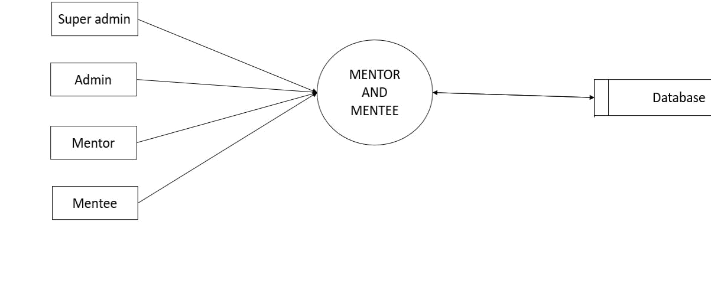

Fig:4.3.1.1

29

DFD Level 1.1

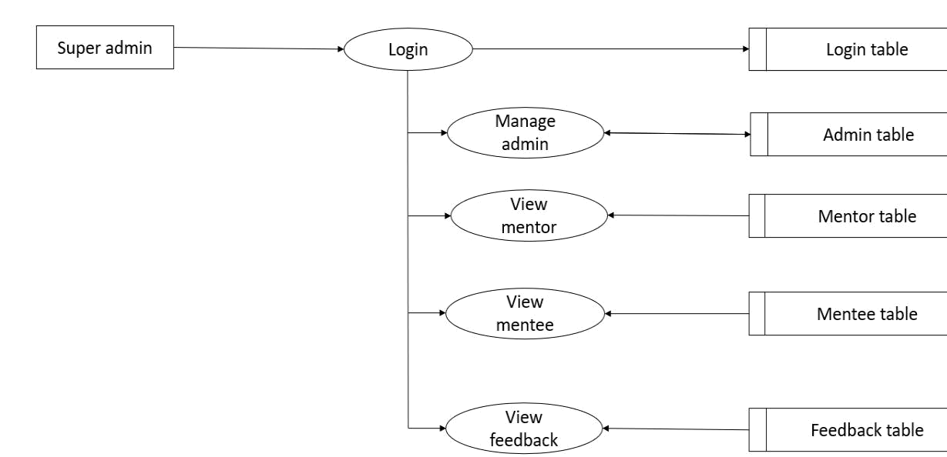

Fig:4.3.1.2

30

DFD Level 1.2

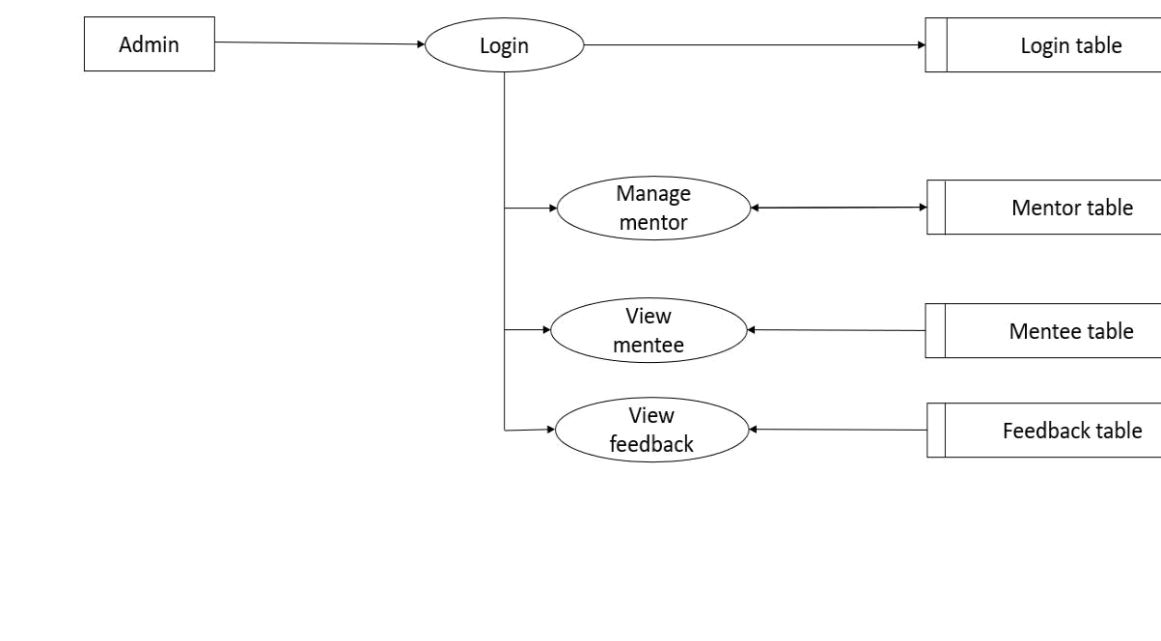

Fig:4.3.1.3

31

DFD Level 1.3

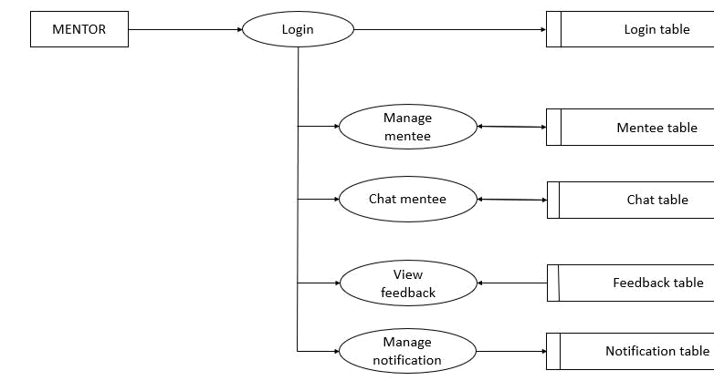

Fig:4.3.1.4

32

DFD Level 1.4

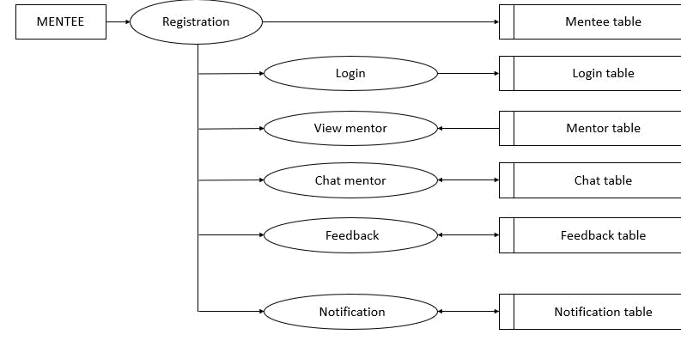

Fig:4.3.1.4

33

DFD Level 2.1.1

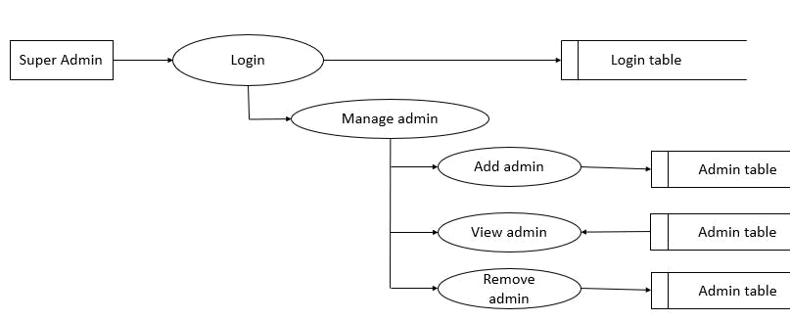

Fig:4.3.1.5

DFD Level 2.2.1

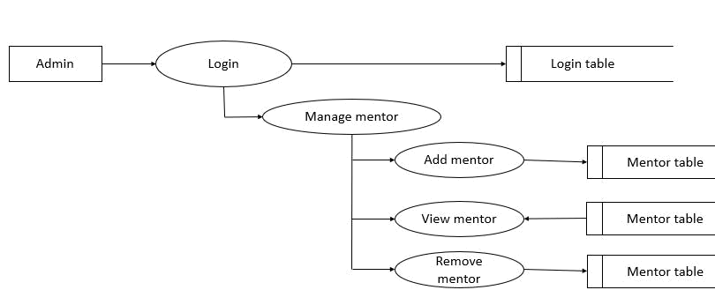

Fig:4.3.1.6

34

DFD Level 2.3.1

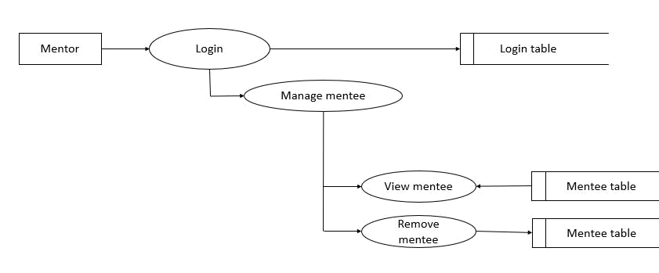

Fig:4.3.1.7

DFD Level 2.3.2

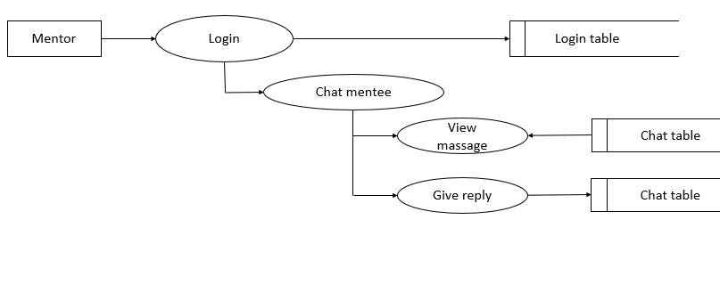

Fig:4.3.1.8

35

DFD Level 2.3.4

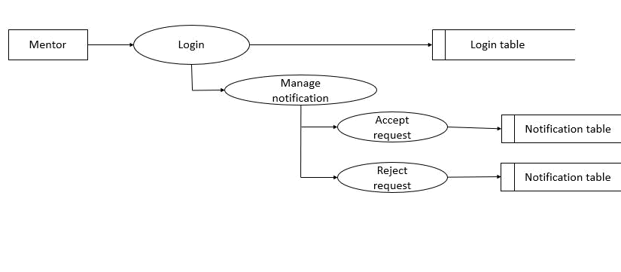

Fig:4.3.1.9

DFD Level 2.4.3

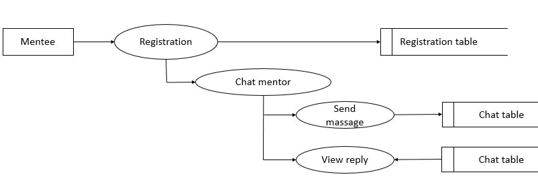

Fig:4.3.1.10

36

DFD Level 2.4.4

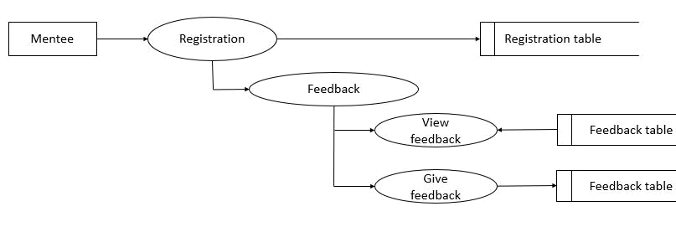

Fig:4.3.1.11

DFD Level 2.4.5

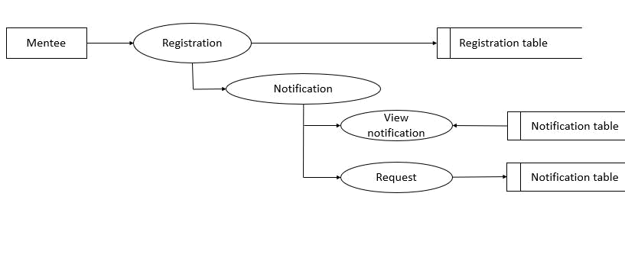

Fig:4.3.1.12

37

CHAPTER 5

IMPLEMENTATION

The implementation is the important phase. It involves user training, system testing and successful running of the developed proposed system. The user tests the developed systems and changes are made according to their needs.

The implementation phase of software development involves translating of design specification into source code, and debugging, documenting and unit testing the source code. Implementation is the process of converting a new or a revised system design in to an operational one. Conversion means changing from one system to another. The objective is to put the system into operation while holding costs, risks and personnel irritation to minimum. It involves

- Creating computer compatible files.

- Training the operating staff.

- Installing terminals and hardware.

MENTOR AND MENTEE is a Android based application system, so it requires some space in server. To implement the new system, it has to be deployed in the local host. It is also possible to run the system in the local network. First up all build the website, then publish website. After publishing the project, the files will be integrated into a package. These files and database will be published into the online server. Then it is possible to access the functionalities just by using the url. Only a web browser is required to perform the operation. The project is developed in a framework, but the client system doesn’t require any framework to be installed. This method also offers the greatest security.

For the implementation of the system we want to introduce the project in society. The admin should login into the web home page after entering the username and password. Then he/she can manage all details.

38

5.1 SYSTEM DEVELOPMENT

The development phase of the software design consists of different task to be done sequentially for obtaining the desired results. Here we do not implement parallel; instead we first implement admin and then the warden module. The different phases are:

Creating the database :

A database is created, in which all the tables are defined which required to do the different operations such as storage and retrieval of information. Database is designed in such a way it can handle the different database queries. Users and admin can retrieve required details from the system on clicking on the links and buttons.

- Creating graphical user interface :

Graphical user interface is created in Visual Studio Code, Laravel for a user friendly interface. It is intended for two purposes. First is to create a user friendly interface for the application. Having a good user interface make it easier for the user to use and understand the different functionalities of the application. Secondly, the user interface hides the end users from the complexities in the working of the application. So the user is made unaware of how a task is performed when he chooses to perform it.

- Creating system environment :

For the intended project to work on, we need to implement its required hardware and

software requirements. This system is build using Visual Studio Code, Laravel and based on Windows Operating System. Memory and Hard disk should confirm according to hardware mentioned.

39

CHAPTER 6

SYSTEM TESTING

Testing is the process of examining the application to compare the actual behavior with that of the excepted behavior. The major goal of software testing is to demonstrate that faults are not present. In order to achieve this goal the tester executes the program with the intent offending errors. Though testing cannot show absence of errors but by not showing their presence it is considered that these are not present. The following method of testing are carried out to assure the correctness and reliability of MENTOR AND MENTEE.

6.1 Smoke Testing

Smoke testing is the most cost effective method for identifying and fixing defects in application. It is a preliminary to further testing, intended to reveal simple failures severe enough to reject a prospective application release. In this case the smoke is metaphorical. A subset of test cases that cover the most important functionality of a component or system are selected and run, to ascertain if the most crucial functions of a program work correctly. The purpose is to determine whether the application is so badly broken that further testing is unnecessary. Smoke tests can either be performed manually or using an automated tool. In Event Mate application system smoke tests are performed by manually. Smoke tests can be broadly categorized as functional tests or unit tests.

6.2 Functional testing

Functional tests exercise the complete program with various inputs. Functional tests may be a scripted series of program inputs, possibly even with an automated mechanism for controlling mouse movements. It ensures that the program physically works the way it was intended and all required menu options are present. It also ensures that the program conforms to the industry standards relevant to that environment.

6.3 Unit testing

Unit testing is carried out in parallel to coding. Functionality of each of the individual modules we have developed is tested using test cases. Unit testing is done according to the test plans prepared for each of the module. Test plan prepared have covered all functional areas, actual

40

input and expected outputs. Modules are tested using different test cases. Actual outputs are compared with expected outputs. The results are also recorded.

6.4 Integration Testing

The major concerns of integration testing are developing incremental strategies that will the complexity of entire actions among components as they are added to the system. Though each program works individually; they should work after linking them together. This is also referred to as interfacing. Data may be lost across interface and one module can have adverse effect on another. Integration testing is a systematic technique for constructing program structure while at the same time, conducting test to uncover errors associated with the interface. In the testing, the programs are constructed and tested in small segments.

6.5 Performance Testing

Performance Testing is designed to test the runtime performance of the integrated system.

CDAS can process large number of data with minimum memory and time is tested here.

6.6 Test Plan

A test plan is a systematic approach to testing a system. The plan typically contains a detailed understanding of what the eventual workflow will be. Normally, testing of any large systems will be in two parts.

- The functional verification and validation against the requirement specification.

- Performance evaluation against the indicated requirements.

Testing activity is involved right from the beginning of the project. At the very first stage of testing, the goals and objectives are set. This simplifies the limits or borders of testing process. Before testing, the tester should plan what kind of data he is giving for test. Give data inputs as functional, boundary, stress, performance, usability values etc.

6.7 Characteristics of a Good Test

- Tests are likely to catch bugs

- No redundancy

- Not too simple or too complex

41

6.8 Test Cases

Specific set of steps and data along with expected results for a particular test objective. A test case should only test one limited subset of a feature or functionality. Test case documents for each functionality/testing area will be written, reviewed and maintained separately in Excel Sheet. In system testing, test data should cover the possible values of each parameter based on the requirements. Since testing every value is impractical, a few values should be chosen from each equivalence class. An equivalence class is a set of values that should all be treated the same. Ideally, test cases that check error conditions are written separately from the functional test cases and should have steps to verify the error messages and logs. Realistically, if error test cases are not yet written, it is OK for testers to check for error conditions when performing normal functional test cases. It should be clear which test data, if any, is expected to trigger errors.

Example

Test | Test Conditions | Test Data | Execution Setup | Expected Result | Pass/Fail
Cases
1 | Admin Login | User name and | Click on login | Admin home | Pass
 |  | password | button | page should be
 |  |  |  | displayed
2 | Mentor Login | User name and | Click on login | Mentor home | Pass
 |  | password | button | page should be
 |  |  |  | displayed
 |  | Table 6.8.1

42

CHAPTER 7

SOFTWARE MAINTENANCE

Software maintenance is a part of the Software Development Life Cycle. Its primary goal is to modify and update software application after delivery to correct errors and to improve performance. Software is a model of the real world. When the real world changes, the software require alteration wherever possible.

Software Maintenance is an inclusive activity that includes error corrections, enhancement of capabilities, deletion of obsolete capabilities, and optimization.

Need for Maintenance

- Correct errors .

- Change in user requirement with time.

- Changing hardware/software requirements.

- To improve system efficiency.

- To optimize the code to run faster.

- To modify the components.

- To reduce any unwanted side effects.

For the maintenance of MENTOR AND MENTEE we have some future visions and from the next development cycle onwards the application will be modified as per these points.

- The website converted to an android application.

- Implement a punching system so that the doctors can easily mark their attendance by

using a fingerprint scanner to reduce login time in the busy routine.

- Improve ambulance services.

43

CHAPTER 8

CONCLUSION

MENTOR AND MENTEE, the Android application which is a perfect assistance for students educational growth. The project enables us to handle various services and informations in our finger tips. This is 100 percent beneficial for those who constantly prefer students as their first choice. Some services can be accessed without any restrictions. Super admin can add Admin ,Admin can add Mentors ,they can teach the students. Students have the whole freedom to select the best mentor . The program for caring out the various activities have been run and tested successfully to ensure that the software development will meet the needs satisfactory. As a whole we could conclude that this website has met all its objectives of being user friendly.

44

BIBLIOGRPHY

WEBSITE BIBLIOGRAPHY

- FOR WEB LINKING https://www.w3schools.com/php/func_filesystem_link.asp

- FOR SQL https://www.php.net/manual/en/book.mysqli.php

- FOR PHP https://www.w3schools.com/php/

- FOR AJAX https://www.guru99.com/php-ajax.html

REFERENCES

- Learning PHP. MySQLi, AJAX and CSS:A step-by-step guide to creating Dynamic websites –by Robin Nixon

- Learning PHP, MySQLi and AJAX with query. CSS and HTML5- by Oreilly

- PHP and MySQLi for Dynamic website: Visual QuickPro guide by Larry Ullman

- Bootstrap reference guide : Quickly references all classes and common code snippets(Bootstrap 4 tutorial Book2)[Print Replica]Kindle Edition

45

APPENDIX

Screen Shots

User lognin page

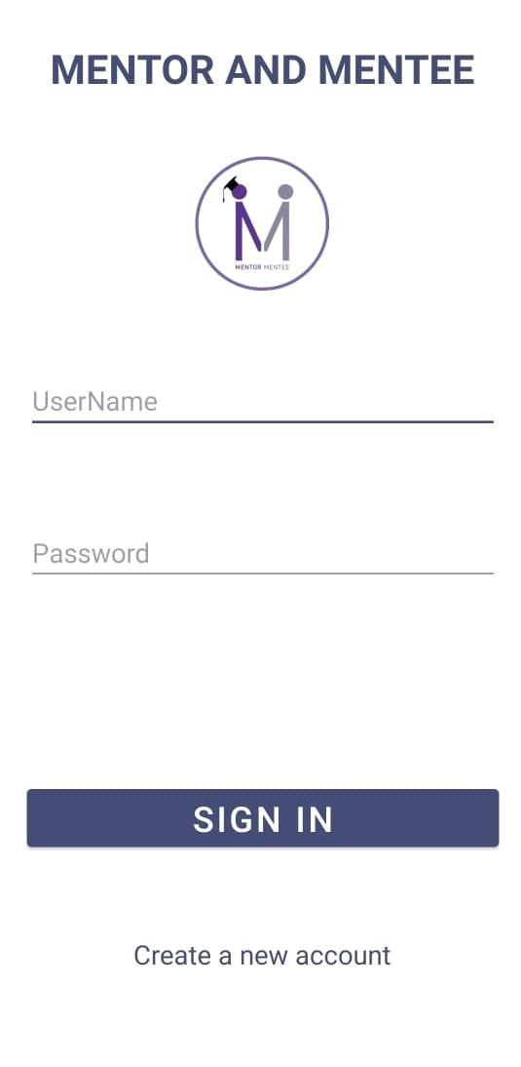

46

Mentor home page

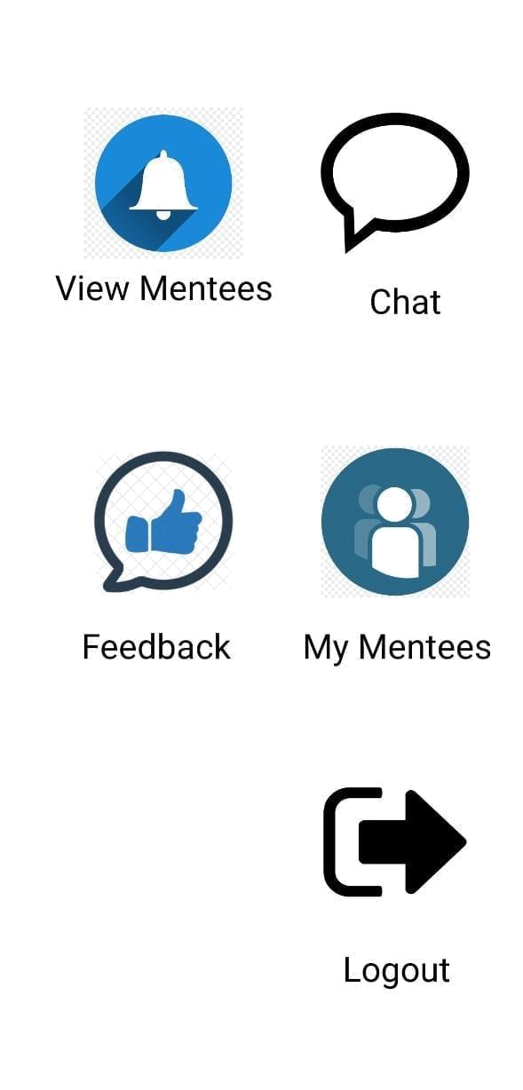

47

Mentee home page

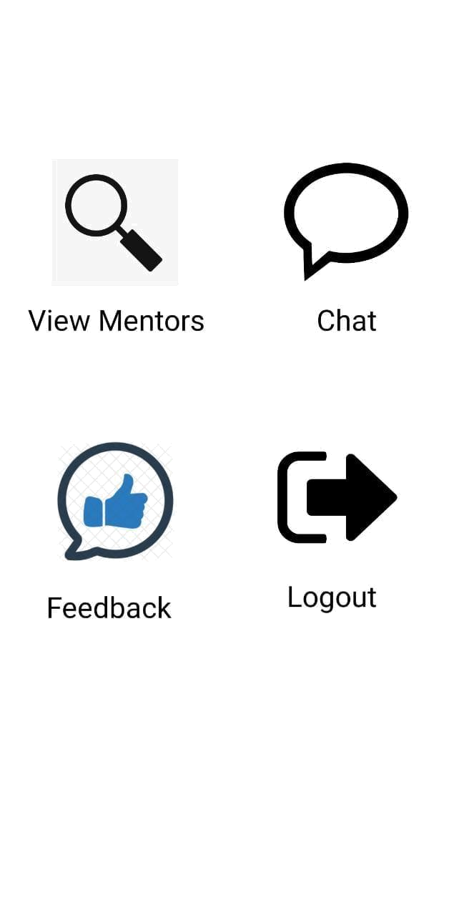

48

Admins login page

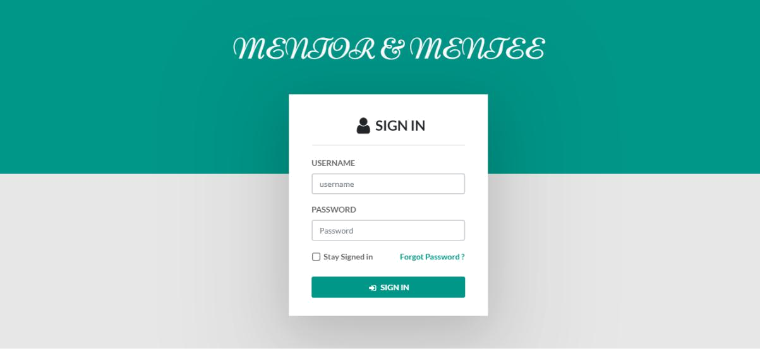

Super admin home page

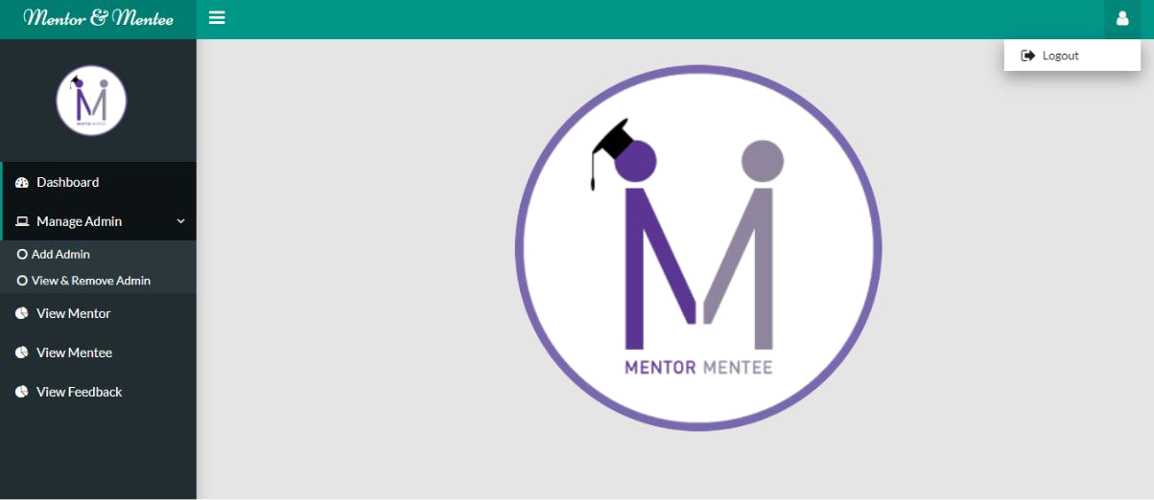

49

Admin home page

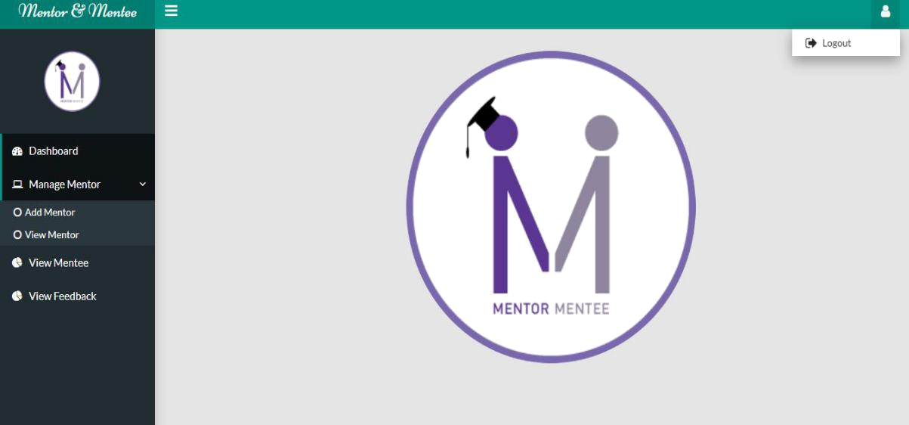

50

