1. Buat vagrant virtual box dan buat user ‘awan’ dengan password ‘buayakecil’.

Error

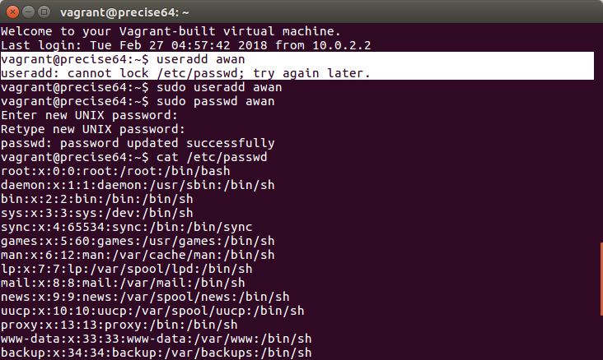

Cara buat

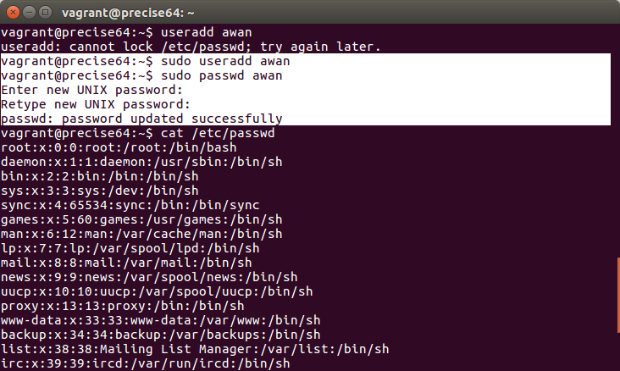

Cara cek

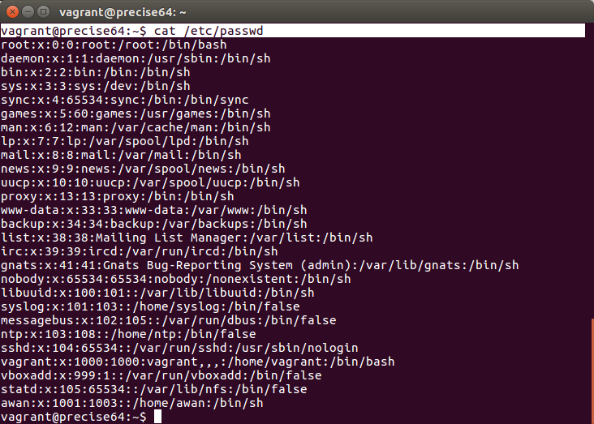

Berhasil

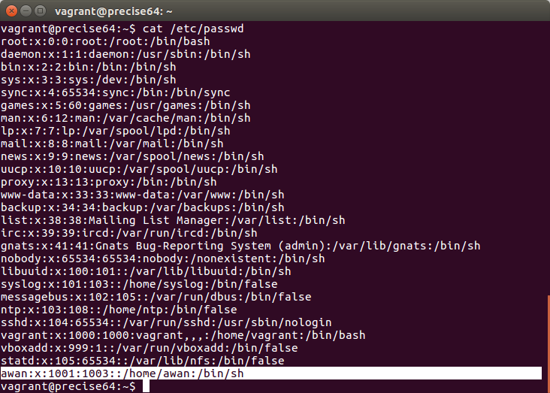

error login harus pake sudo

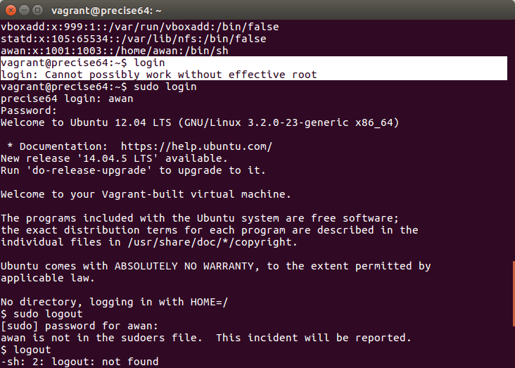

login

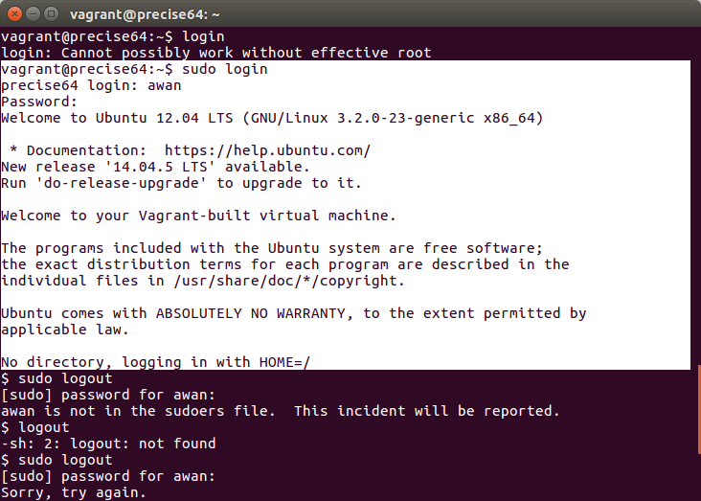

erro logout

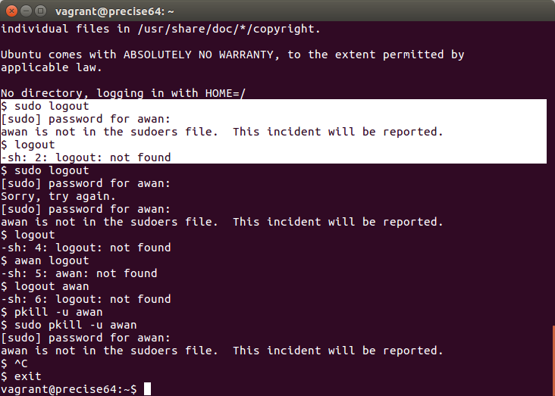

logout



2.

file provision

wget https://packages.erlang-solutions.com/erlang-solutions_1.0_all.deb && dpkg -i erlang-solutions_1.0_all.deb

apt-get update

apt-get install -y esl-erlang

apt-get install -y elixir

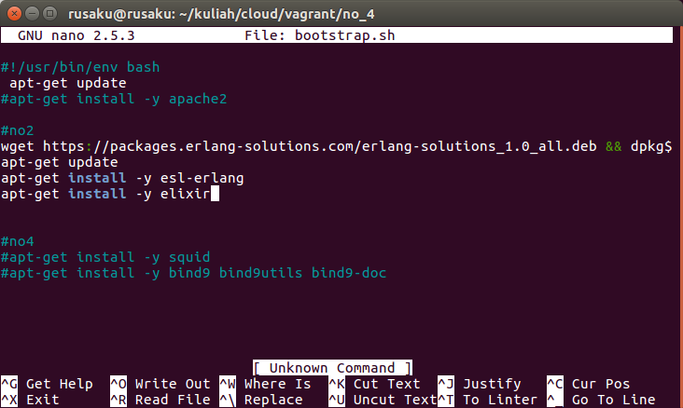

nunjukin phoenix udah diinstall dan versinya

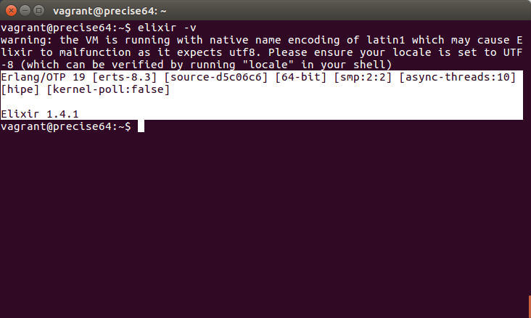

3.

isi provision file

#install mysql

debconf-set-selections <<< 'mysql-server mysql-server/root_password password 12345678'

debconf-set-selections <<< 'mysql-server mysql-server/root_password_again password 12345678'

apt-get update

apt-get install -y mysql-server

#install php

#php 5

apt-get update

apt-get install php5 curl -y

#php 7

#apt-get update

#apt-get install -y python-software-properties software-properties-common

#LC_ALL=C.UTF-8 add-apt-repository ppa:ondrej/php -y

#add-apt-repository "deb http://kambing.ui.ac.id/ubuntu/ precise main restricted universe multiverse" -y

#add-apt-repository "deb http://kambing.ui.ac.id/ubuntu/ precise-updates main restricted universe multiverse" -y

#add-apt-repository "deb http://kambing.ui.ac.id/ubuntu/ precise-security main restricted universe multiverse" -y

#add-apt-repository "deb http://kambing.ui.ac.id/ubuntu/ precise-backports main restricted universe multiverse"

#apt-get update

#apt-get install -y php7.1 curl

#install composer

apt-get update

curl -sS https://getcomposer.org/installer | php

sudo mv composer.phar /usr/local/bin/composer

#install nginx

apt-get update

apt-get install -y nginx

nunjukin mysql udah diinstal dan versinya

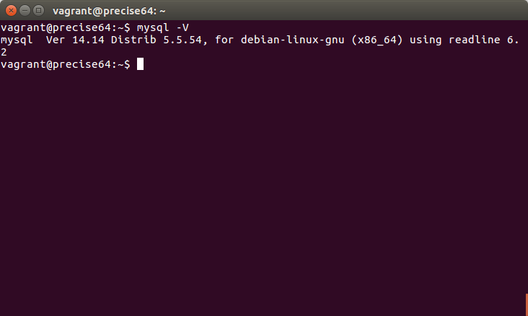

nunjukin php udah diinstal dan versinya

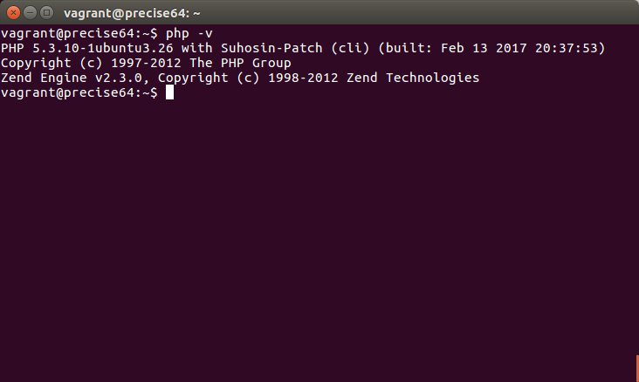

nunjukin composer udah diiinstal dan versinya

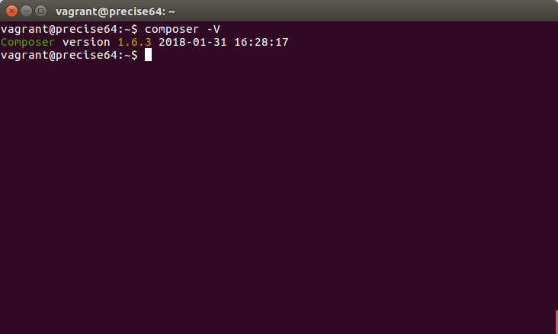

nunjukin engine x dan versinya

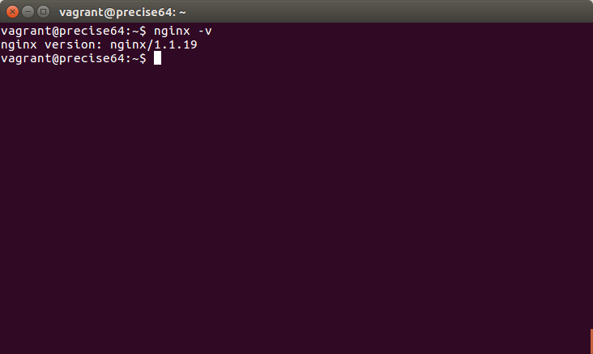

kendala:

-install laravel yang membutuhkan php 7

-install php7 di ubuntu 12. kesulitan mencari repository yang menyediakan php 7 untuk ubuntu 12

sehingga tidak bisa mengerjakan yang setelahnya

4.

file provision

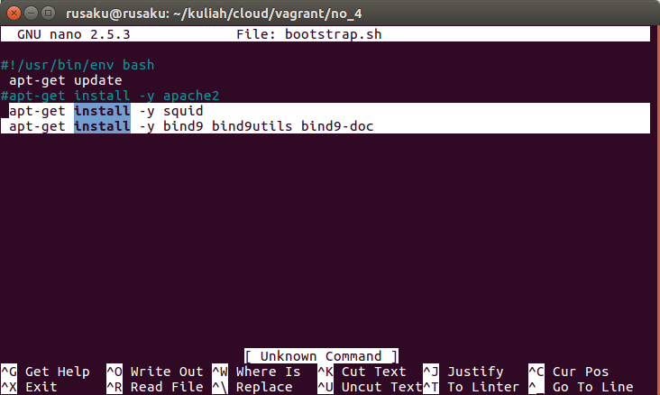

nunjukin squid udah diinstal dan versinya

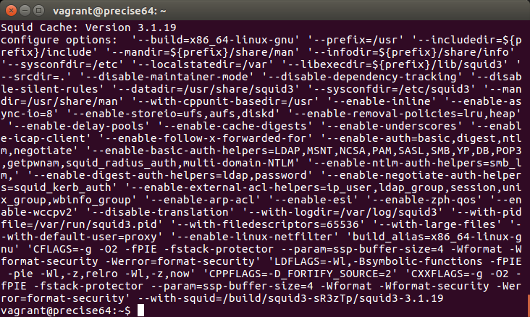

nunjukin bind9 udah diinstal dan versinya

