Figure 1:

1. Register, Login and Contact Us should be on right side.
2. Home is missing
3. Home and About Us should be on left side
4. Hover color change with bold on each menu item should be there
5. Image change option in admin panel for Home page is still not available

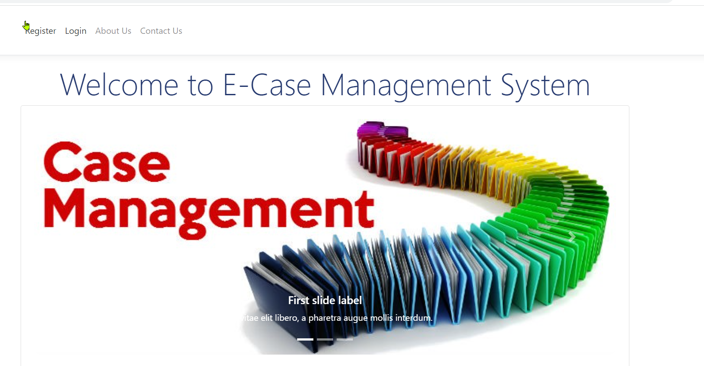

Figure 2:

Kindly add the provided Icon on each screen/page

Correct the Gender options radio buttons position and alignment

Password policy still missing.

User can still register with same email id. duplication on email and mobile number should be there

Provide the option in admin panel to configure messages for term of use and privacy policy

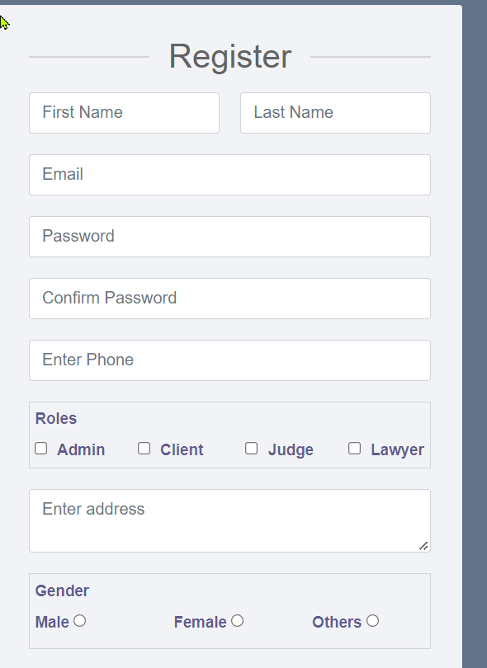

Figure 3:

User profile image is missing for current login user and not aligned at right corner

Link to edit profile is missing

Logout is missing

Case No. should be alphanumeric field.

FIR No. is correct title

FIR Year is correct title

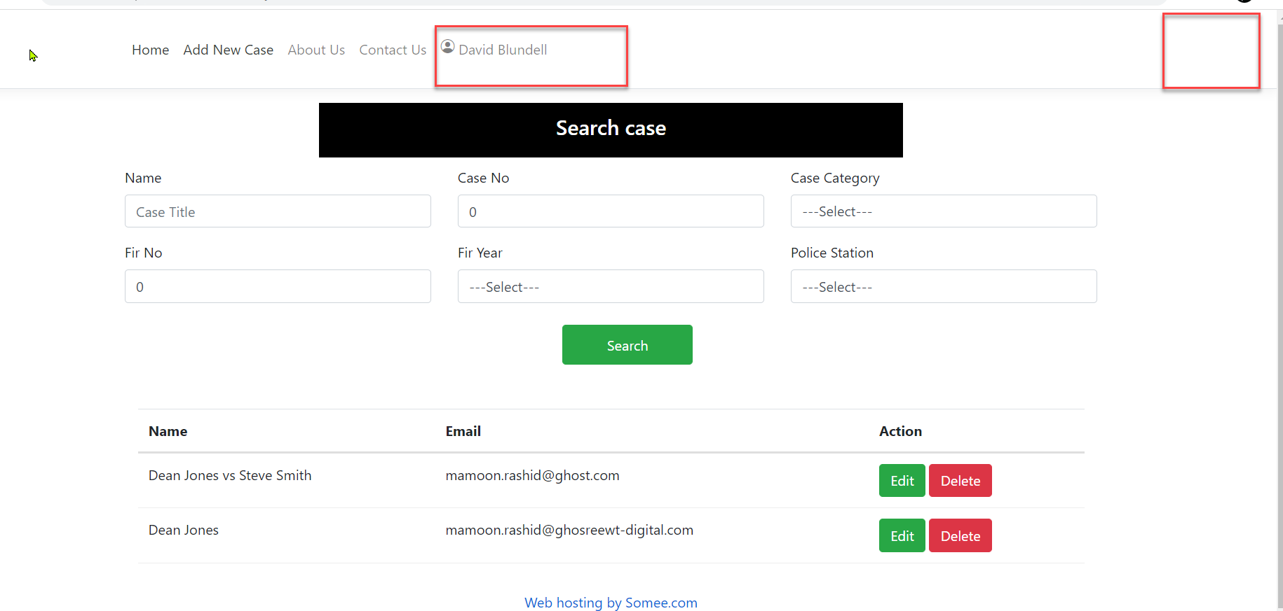

Search section should be like below image and all thesec8 fields should be available in Add case page along with other fields

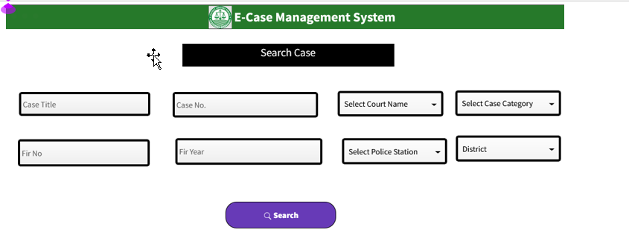

This below list section should look like in the image shown below with table layout

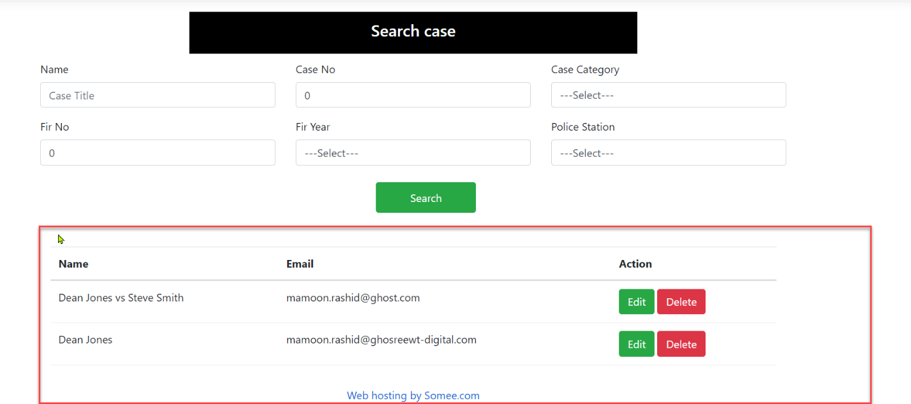

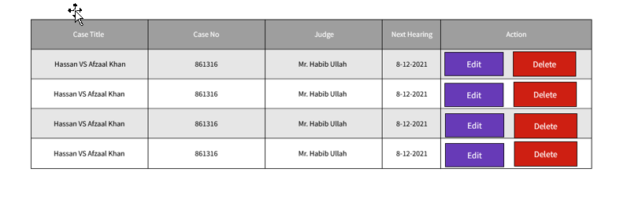

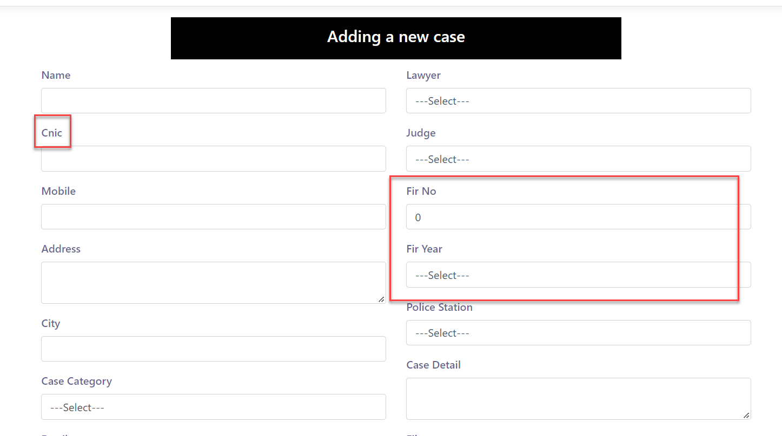

1. FIR No. and FIR Year should be in same row.
2. CNIC No. is correct title
3. Add CNIC number format in the field like 12352-8556289-9
4. FIR No. should be alphanumeric field
5. Expand case detail section
6. Show document upload and document name field in the section and cover un one box
7. Show document uploading progress
8. Mobile number should be numeric field
9. Upon downloading the document, it should prompt the browse option to save on particular path// not allowed by the browser
10. Configure a path in admin module to save all the documents by default