Software verification and validation(V&V)
E-Commerce Order Management System

Submitted to:
Ma’am Jawaria Ramzan
Submitted by:
Humaira Ilyas
Minhail Amir
Hiba Ali
Roll No:
(Fa-2023/BS SE/167)
(Fa-2023/BS SE/042)
(Fa-2023/BS SE/177)

Session 2023-2027
Department of software engineering

1. INTRODUCTION
This Software Requirements Specification document details the operational, functional, and behavioral requirements of the E-Commerce Order Management System. The platform acts as an automated bridge between client-side purchase flows and administrative inventory management. It provides deterministic state tracking, algorithmic stock deduction, and real-time execution constraints to minimize transaction anomalies.
2. CORE SYSTEM OBJECTIVES
- Transaction Integrity: Execute concurrent checkout flows without state corruption or race conditions.
- Algorithmic Inventory Deductions: Automatically adjust quantities synchronously upon valid order validation.
- Lifecycle Control: Restrict order cancellations to precise, pre-fulfillment operational windows.
- State Traceability: Keep clear delivery steps visible to stakeholders through distinct order states.
- Failure Prevention: Prevent invalid user actions at the validation layer before they hit the database.
3. ARCHITECTURAL SCOPE
The OMS handles backend logic for micro-to-small online retail businesses. It manages data from the moment an item is placed in a cart to final parcel delivery.
- In-Scope: Subsystem synchronization, status state-machine transitions, ID creation, and inventory boundary validations.
- Out-of-Scope: Third-party gateway billing APIs, content management systems (CMS), and logistics fleet routing algorithms.
4. SYSTEM BOUNDARIES & STATE DIAGRAM
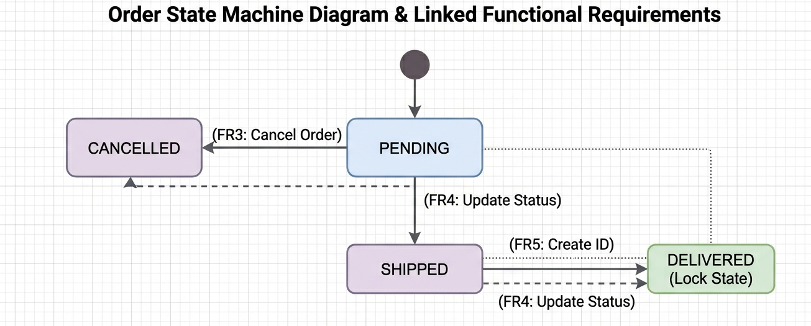
5. FUNCTIONAL REQUIREMENTS (FR) & VERIFICATION METRICS
FR ID | Requirement | Description | Validation Method | Pass Criteria
FR1 | Place Order | User can select items and place an order. | Black-box testing | Order is created successfully with details.
FR2 | Update Inventory | Stock decreases after order is placed. | Database testing | Stock is updated correctly after order.
FR3 | Cancel Order | User can cancel only pending orders. | State testing | Cancel fails for shipped/delivered orders.
FR4 | Update Status | Admin can change order status. | Role testing | Only admin can update status.
FR5 | Unique Order ID | Each order has a unique ID. | Database test | No duplicate IDs in system.
6. NON-FUNCTIONAL REQUIREMENTS (NFR) & QUANTIFIABLE METRICS
Metric Category | Definitive Quality Attribute Standard | Measurement Method
Security | RBAC validation matrices must secure every API endpoint. Data-at-rest requires AES-256 bit encryption algorithms. | Static Application Security Testing (SAST) & Penetration Audits.
Reliability | The transaction processing layer must maintain a minimum uptime of 99.95% over any calendar month. | Continuous uptime synthetic monitoring tools.
Performance | The server must return an API response within 2000 milliseconds under a concurrent load of 150 requests per second. | JMeter automated spike and volume load testing scripts.
Consistency | The platform must implement ACID-compliant transaction blocks across the inventory and order tables. | Intentional connection loss testing during active database writes.
7. SYSTEM BUSINESS CONSTRAINTS & DATA VALIDATION RULES
BC ID | Constraint | Description | Validation Method | Pass Criteria
BC1 | Immutability | Delivered orders cannot be changed or deleted. | State testing | System blocks any update or delete on delivered orders.
BC2 | Stock Limit | Stock cannot go below zero. | Boundary testing | Orders fail if stock becomes negative.
BC3 | Unique Order ID | Each order must have a unique ID (Primary Key). | Database constraint test | No duplicate order IDs allowed.
8. USE CASE DIAGRAM
