Electricity Consumption Analysis
Ilyas Mammadov
Regression
All potential predictors are t (linear trend), Mon–Sat day-of-week dummies (Sunday is baseline), average temperature on day t.
Train = first 10 months (304 days), Test = last 2 months (61 days).
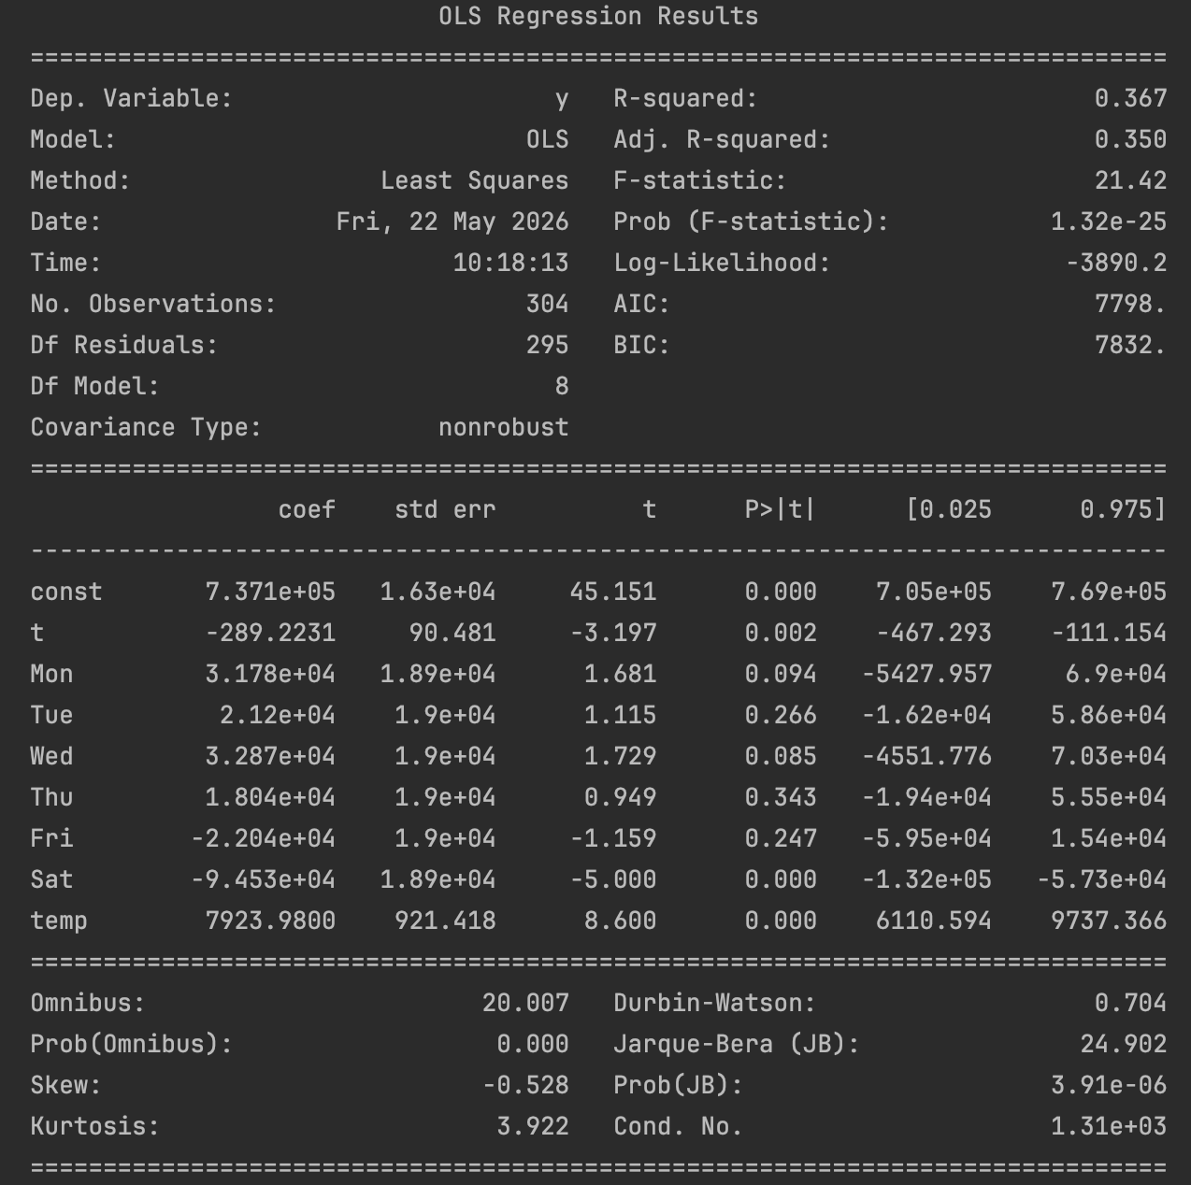
All the dummies, except for Saturday are statistically insignificant, linear trend and temperature are statistically significant. P value of regression shows that regression is statistically significant. R squared is 0.367 so 8 predictors explain about 37% of variation in daily consumption which is a moderate fit.
OLS - training MSE= 7,630,039,644 RMSE= 87,350.10 MAPE= 8.880%
The error performance for training data is also not bad as 8.88 MAPE is a good result.
OLS - training MSE= 7,630,039,644 RMSE= 87,350.10 MAPE= 8.880%
OLS - test MSE=16,922,002,158 RMSE=130,084.60 MAPE=13.186%
There are significant changes in the values of these error metrics,especially test RMSE 49% higher than train, which worsen for test data, which seems as overfitting. (linear trend negative coefficient of -289 plays role as actually in November, December, consumption rises again due to most probably winter heating)
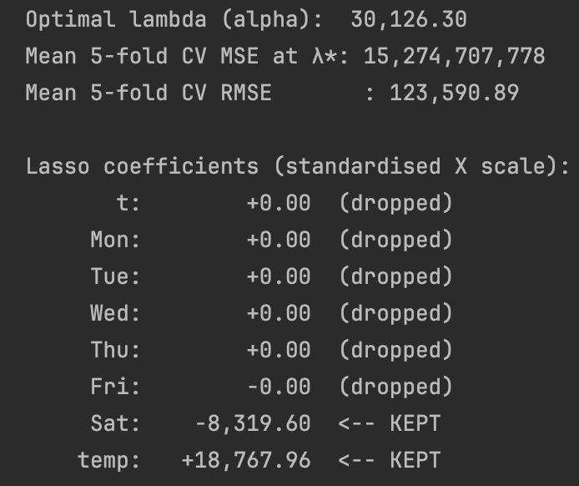
Only 2 predictors are kept – temperature and Saturday dummy, all others are dropped.
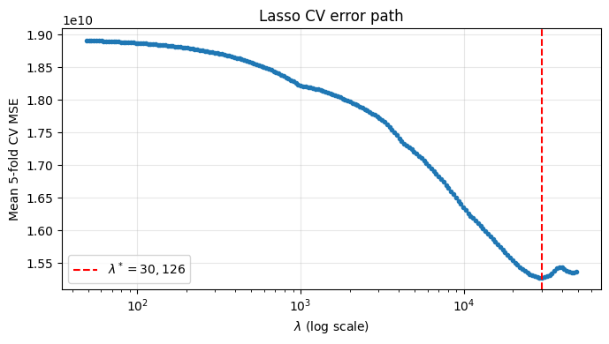
Lasso-selected predictors: ['Sat', 'temp']
Lasso (penalised) - train MSE=10,005,291,249 RMSE=100,026.45 MAPE= 9.888%
Lasso (penalised) - test MSE= 5,898,326,541 RMSE= 76,800.56 MAPE= 7.902%
Reduced OLS (Sat, temp) - train MSE= 8,208,191,571 RMSE= 90,599.07 MAPE= 9.186%
Reduced OLS (Sat, temp) - test MSE= 6,616,080,966 RMSE= 81,339.30 MAPE= 8.530%

Reduced OLS performs worse for training data, but better for test data when comparing with initial OLS.
I solved by enumerating all C(8,5) = 56 candidate subsets and by picking the one with minimum training MSE.
Optimal 5-predictor subset: ['t', 'Wed', 'Fri', 'Sat', 'temp']
Training MSE of this subset = 7,705,823,006 (RMSE = 87,782.82)
5-predictor BIP - train MSE= 7,705,823,006 RMSE= 87,782.82 MAPE= 8.932%
5-predictor BIP - test MSE=16,921,057,237 RMSE=130,080.96 MAPE=13.215%
Lasso (which can drop any number of predictors) outperforms a fixed-size best subset of this problem.
Trees/Forests
Tree depth : 19
Tree leaves : 304
Tree (un-pruned) - train MSE= 0 RMSE= 0.00 MAPE= 0.000%
Tree (un-pruned) - test MSE=23,016,656,092 RMSE=151,712.41 MAPE=16.277%

The un-pruned tree memorises the training data (train MSE = 0) and so overfits massively. I use it as a starting point — random forests will provide regularisation.
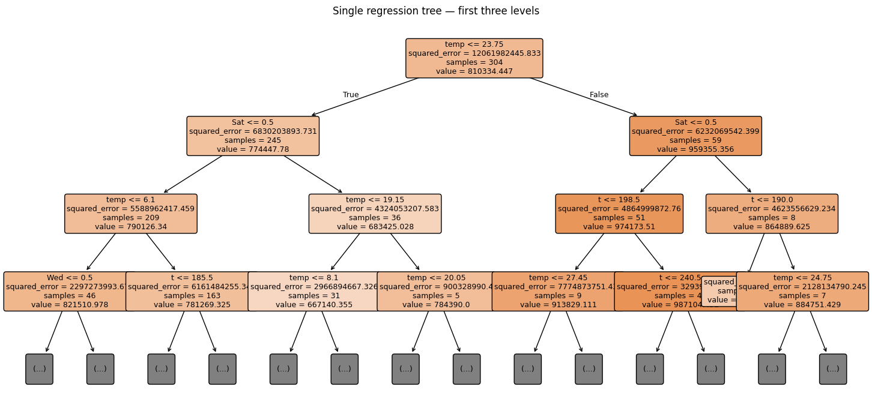
The root split is on temperature — exactly the variable was most statistically significant. The next-level splits are on Saturday and then temperature again, with trend depending on the procedure . After that, it is combination of trend, temperature and even Wednesday dummy once on that level. This agrees with the regression as only significant were trend, temperature and Saturday dummy.
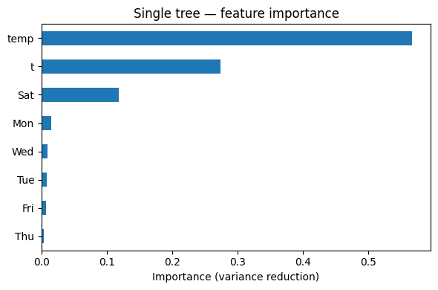
For OLS, Temperature, Saturday, trend, Wednesday,Monday,Friday, Tuesday, Thursday
So, mostly they are similar.
Tree - train MSE= 0 RMSE= 0.00 MAPE= 0.000%
Tree - test MSE=23,016,656,092 RMSE=151,712.41 MAPE=16.277%
The single tree is the worst model on the test set: train MSE = 0 but test RMSE ≈ 152000 which shows “textbook overfitting”.
Best value for maximum depth: 15
Best value for features: 4
Best 5-fold CV MSE : 4,019,642,926
Best 5-fold CV RMSE : 63,400.65
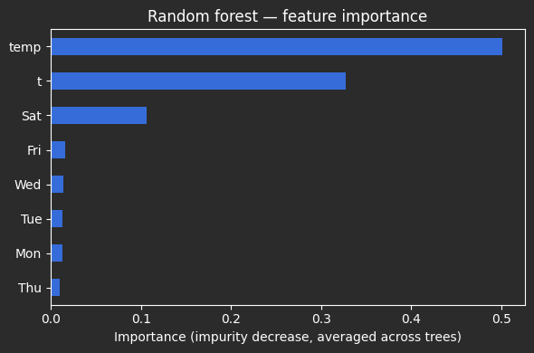
The forest gives almost the same ranking —temperature ≫ trend > Saturday — confirming the picture from the single tree. Day-of-week effects other than Saturday are essentially noise.
For OLS, Temperature, Saturday, trend, Wednesday,Monday,Friday, Tuesday, Thursday
So, mostly they are similar.
RF (best CV params) - train MSE= 589,697,501 RMSE= 24,283.69 MAPE= 2.396%
RF (best CV params) - test MSE= 8,112,003,560 RMSE= 90,066.66 MAPE= 9.408%
The random forest reduces test RMSE from ≈152k (single tree) to ≈90k. It still overfits somewhat (train MSE far below test MSE), but generalises substantially better than the single tree.
Neural Nets
Both X and y were standardised before training (otherwise the MLP collapsed to a near-constant prediction). Search grid: activation ∈ {ReLU, sigmoid}, batch ∈ {16, 32}, epochs ∈ {500–2500}.

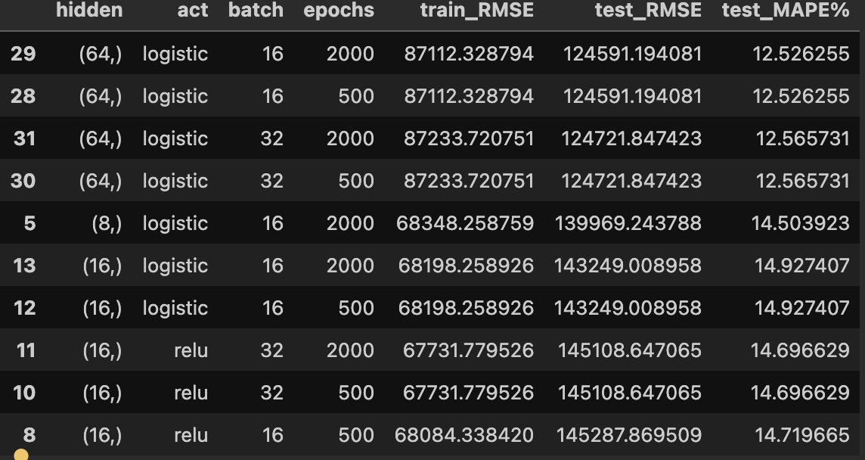
Best fit: hidden layer (64,) logistic (sigmoid), 2000 epochs (error performance is same with 500 epochs), batch size of 16.
Best 1-layer MLP - train MSE= 7,588,557,828 RMSE= 87,112.33 MAPE= 8.827%
Best 1-layer MLP - test MSE=15,522,965,642 RMSE=124,591.19 MAPE=12.526%
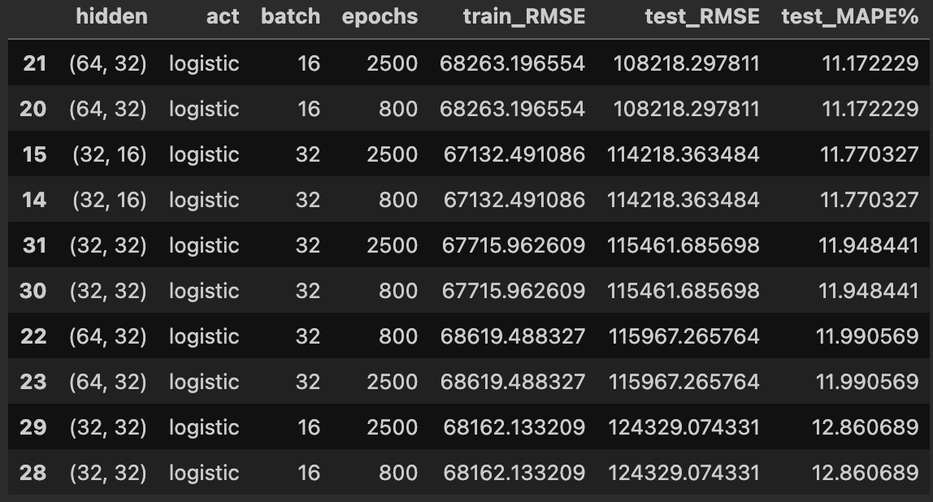

Best two-hidden config: {'hidden': (64, 32), 'act': 'logistic', 'batch': 16, 'epochs': 2500}
Best 2-layer MLP - train MSE= 4,659,864,004 RMSE= 68,263.20 MAPE= 6.625%
Best 2-layer MLP - test MSE=11,711,199,981 RMSE=108,218.30 MAPE=11.172%
Second layer brings modest improvement (test RMSE 125k → 108k) but still loses to Lasso.

Summary Report:

Rank | Model | Train RMSE | Test RMSE | Test MAPE
1 | Lasso (Sat, temp) — penalised | 100,026 | 76,801 | 7.90%
2 | Reduced OLS (Sat, temp) | 90,599 | 81,339 | 8.53%
3 | Random forest (depth 12, mf 4) | 24,284 | 90,067 | 9.41%
4 | Best 2-hidden MLP (64,32) sigmoid | 68,263 | 108,218 | 11.17%
5 | Best 1-hidden MLP (64,) sigmoid | 87,112 | 124,591 | 12.53%
6 | BIP best-5 (t,Wed,Fri,Sat,temp) | 87,783 | 130,081 | 13.21%
7 | Full OLS (8 predictors) | 87,350 | 130,085 | 13.19%
8 | Single regression tree | 0 | 151,712 | 16.28%
Best methods:
Lasso (5-fold CV): most accurate on test data.
Reduced OLS on (Sat, temp): nearly as good and fully interpretable.
Random forest: best non-linear model.
Methods to avoid:
Single un-pruned regression tree — train MSE = 0, worst test RMSE.
Full 8-predictor OLS and BIP best-5 — both keep the trend t, which extrapolates poorly into Nov–Dec.
MLPs: with only 304 training rows their flexibility is not justified; even the tuned 2-layer net is beaten by 2-predictor Lasso.

