MAP524
Mobile App Development – Android
Winter 2015
Assignment #2
Prof. John Selmys
Due: April 13, 2015
Submitted April 13, 2015
Name: Ilyas Mohamed
Student No.: 015716137

Summary of Species at Risk

Species at Risk is an open application used to observe and analyze data from wildlife species that are at risk of becoming extinct. These include all species groups including mammals, fishes, reptiles, and also vascular plants. The data is observed by studying the Canadian Environmental Sustainability Indicators (CESI) status of risk levels. These levels are interpreted by the number of species groups that are either at higher risk, lower risk, and the number of species groups whose risk levels did not change. The data used for this application is fairly accurate and up to date as it was published during 2014.

App Description

Species At Risk is a simple application that lets you view and record the numbers of species that are at risk in Canada. As you first start the application, you are introduced by a main view which contains a spinner where you could choose from all the different species. Once you choose a specie, you with be provided with the status of their risk level. For more information on the specie, you can click on the MORE! Button to take you to a wikipedia page for that specie. Is also has a menu bar with an About, Contact, and a Help dialog message.
The application does ot have a social integration as first proposed. It does not have a picture gallery, a click-to-call function, or push notifications.
The app does in fact include data connections, it is fast and efficient, a drop down menu, and offline capabilities. It is also safe and secure and has no memory leakage. That app does not perform queries since I am not using a SQL database.

Features that work
- Drop down menu
- Contact information
- offline capabilities
- fast, efficient
- data connection
- security

Features that are not included
- social media integration
- picture gallery
- click-to-call
- tell-a-friend
- push notifications
- perform queries
- multi-view

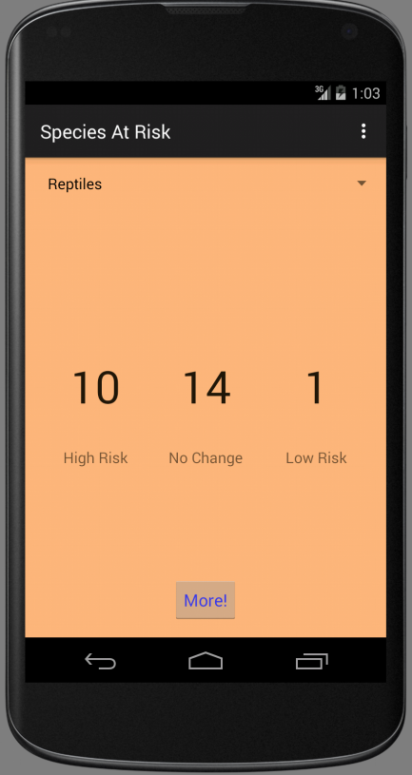
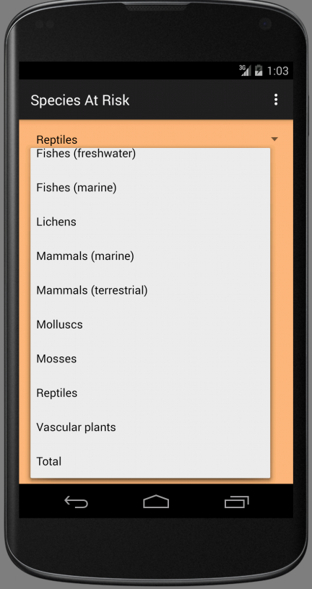
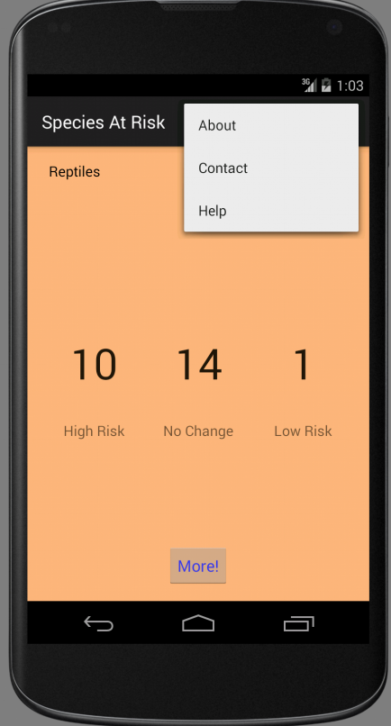
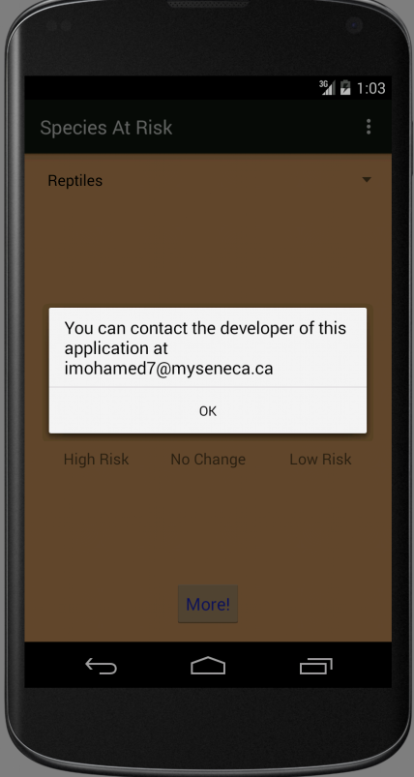

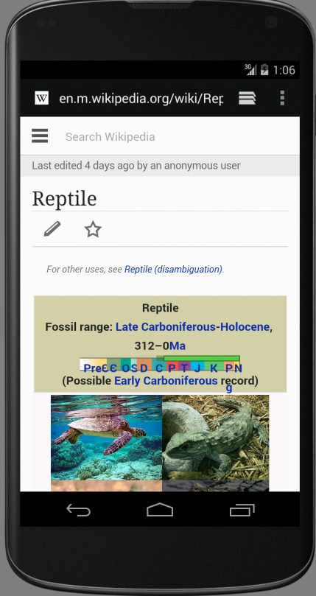


Conclusion

Some of the features that were initially proposed were not added to the application because of the complexity of creating them and/or not enough time left to add those features such as the social media integration which was challenging because I would need to integrate and study the Facebook API into my project.

A feature that was added to the application was a Webview which allows you to learn more about a specie by reading more through a link to wikipedia.

If I had more time, I would definitely add a social media integration so people can share the status info to their friends. I would also add a picture gallery for each specie.

I am overall impressed with my application. It is not as sophisticated as other apps but it definitely provides enough info to make it a usefule app that actual people can you and benefit from.

