How to use Facemap and then analyse the data :

1) Open a terminal and type “conda activate facemap_gpu”

This will open an environment that allows to use facemap with the good versions of the packages to use the GPU (Quadro K2200)

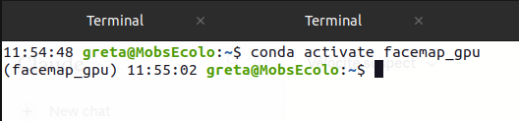
2) Type “python -m facemap” to launch it :
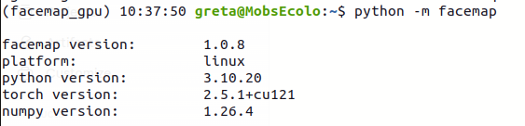
3) This page will appear, it’s the Facemap interface
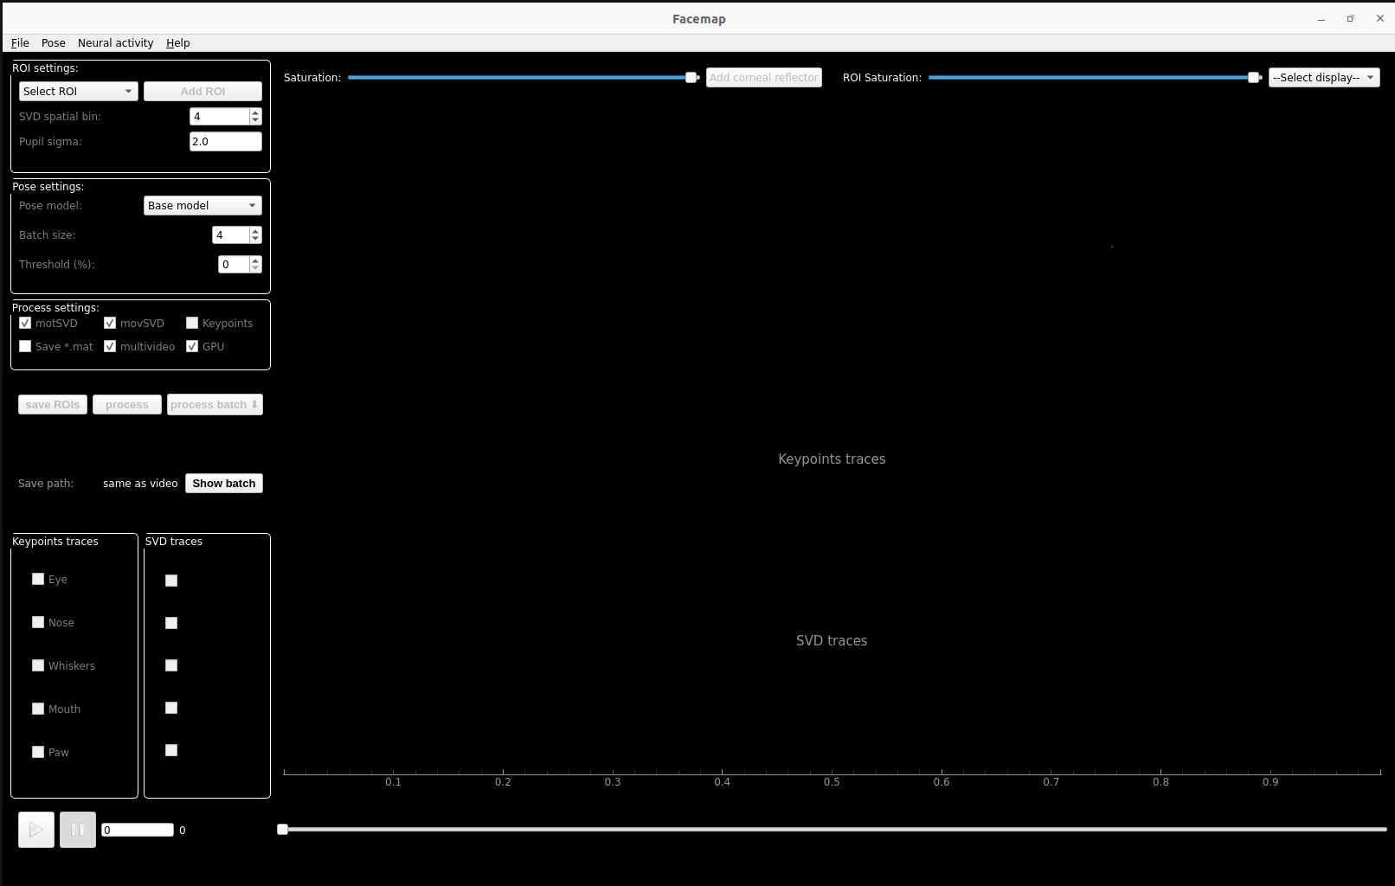

4) On this page when clicking on “file” you can load the .avi of the video that you want to process.

Warning 1 : You have to load one .avi after another the “load multiple videos” feature doesn’t work
Warning 2 :Figure F The “load _proc.npy” is also a feature that doesn’t work because it asks you to reposition the Face ROI for each videos and this forces to be at the computer

NB : If the video you took has already a .h5 or .npy in the same file the keypoints will appear in facemap
► The processing WILL replace the actual data

5) If you want to go to the NAS you have to select : Computer ► / ►media ► nas8-2 ►ProjectCardioSense ►…

6) Once the video is loaded you will see this :
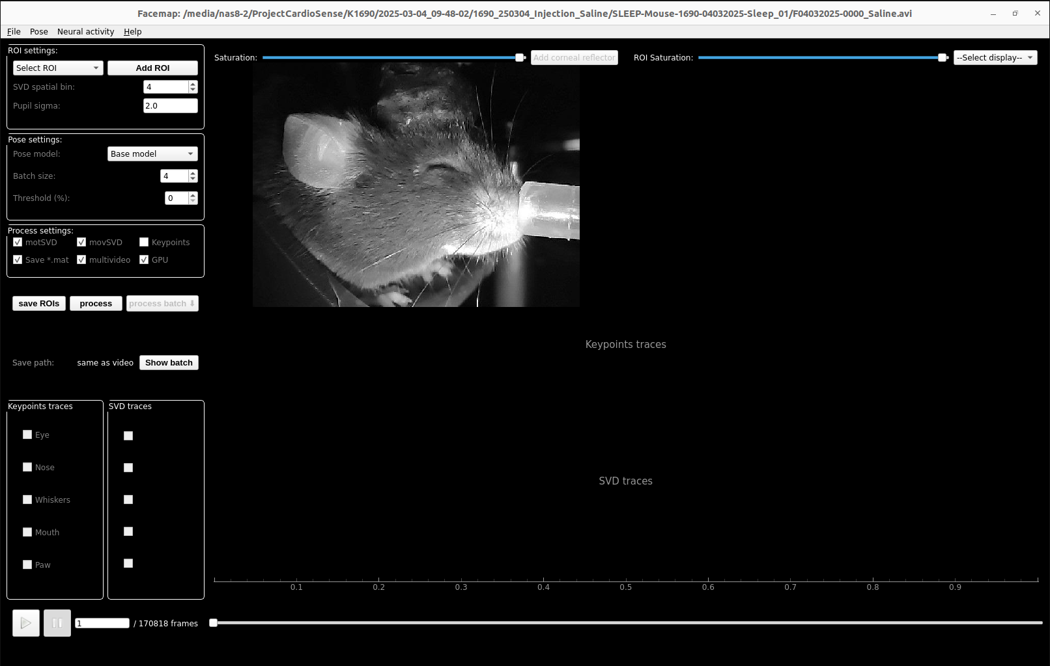
7) You have to change some settings to have these four selected :
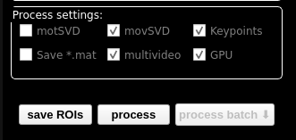
8) Then you also have to chose a batch size that is equal to the number of videos you want to process at once (you can do it after posing the ROIs on all the videos)
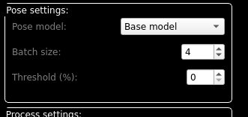
9) Now you have to position the 2 ROIs

First the Face ROI : “Select ROI” ► “Face (pose)” ►”Add ROI”
Then you position the rectangle like this :

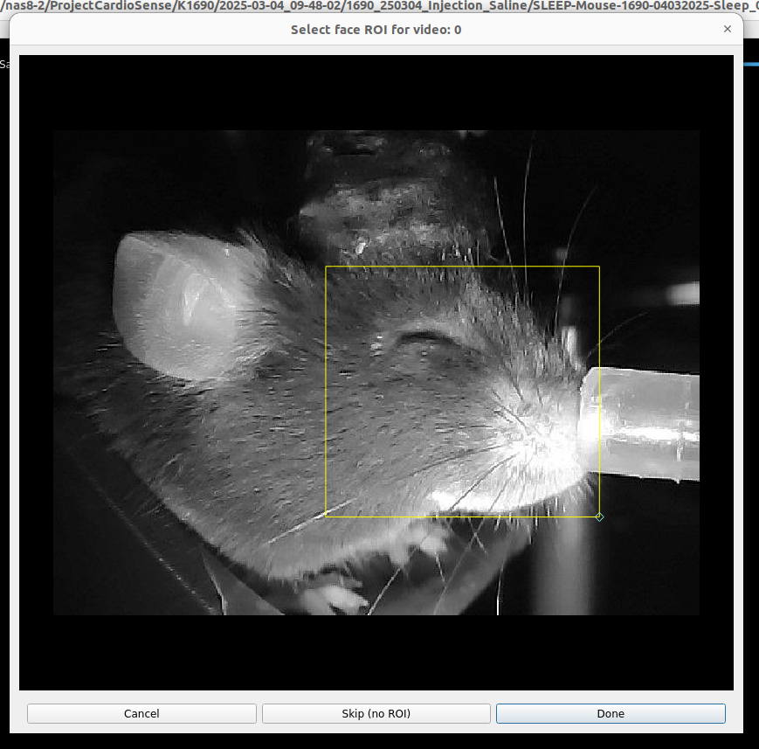
What’s important here is to :
►Avoid the ears (white is sometimes detected ad whiskers)
►Don’t take too much of the respiratory apparatus
►The base of the whiskers, the eye and the mouth must be in the rectangle

Then the pupil ROI : You zoom on the eye and then you find a frame where the pupil is visible. Then you set the saturation in order to see only the pupil, the other structure must appear in white

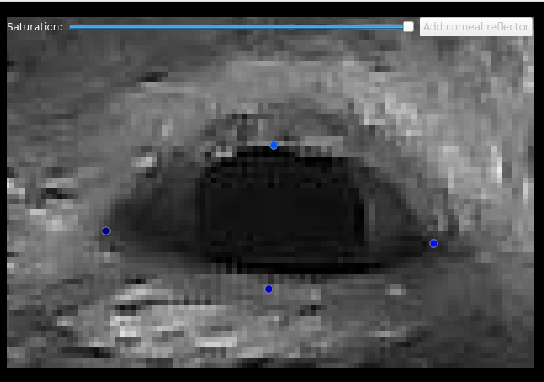
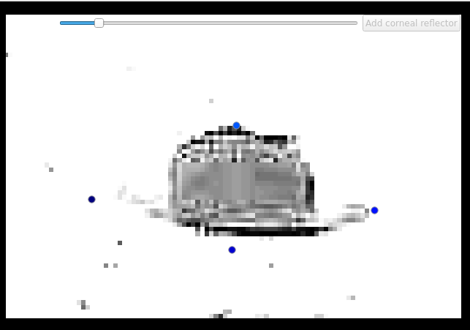
►

We can now easely understand why the eyelid could be a problem in the detection of the pupil area (it could add pixels)
► We have to avoid it as much as possible in the ROI
►Normally Facemap only counts the pixels around the center of mass of the pupil but it’s important to think about the impact of the eyelids when the mouse closes the eyes during a long time (cf : K1712 Ivabradine 20mg)

Then you have to add the ellipse around this pupil : “Select ROI” ► “Pupil” ► “Add ROI”

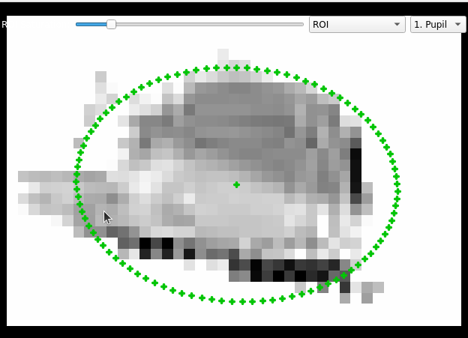
IMPORTANT PART : You can see on the right a zoomed image of the selected ROI you will have to modify the saturation of this window in order to take as much as possible only the pupil and not the eyelid.
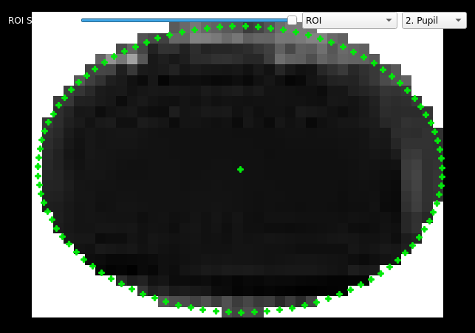

►
NB : You can switch between the different ROI by clicking on the box next “ROI”

Once the pupil ROI is placed you will have to check if it contains the whole pupil during all the frames, you can travel 100 frames per 100 frames with the right arrow on the keyboard.

If the pupil moves or gains volume, you have to adjust it in order to take every pixel even if it takes more eyelid on the other frames

Important things :
► If the pupil is tiny like in Ivabradine videos and the ellipse takes the eyelid, try to moove the ROI to avoid the eyelid to take only the pupil even if it doesn’t fit the first frames anymore where the pupil is bigger
► If the eyelid is not too saturated you can try to change the saturation to make it disapear

10) The corneal reflector :

Facemap does include an option to hide the reflection of the lamps on the cornea because it could artificially decrease the number of pixels in the pupil
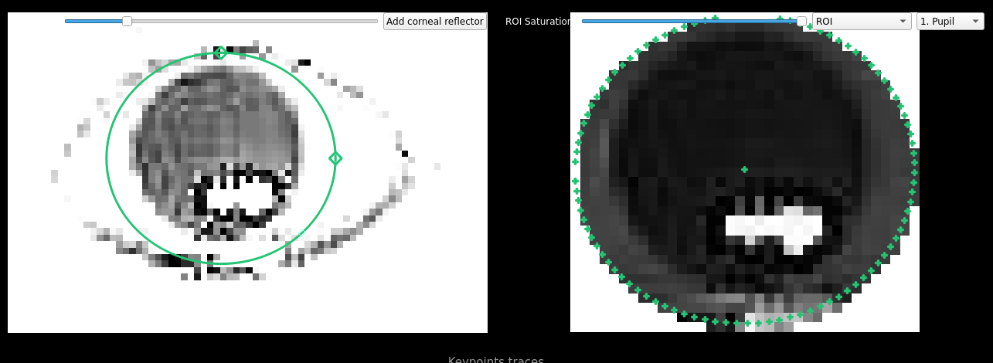
To use it you have to find a frame where the reflection is complete (the mask is immobile) and click on “Add corneal reflector”

It’ll put the mask on the right screen, you can then adjust the size and the position when you travel the frames

- Look at the video “Why the mask is a problem”; we can see that the frames in the mask doesn’t correspond to the arounding saturation and it makes often the area of the ROI pupil way bigger than it actually is

- Look at the video “When could the mask help”; maybe the mask could help only if the conditions to set the mask aren’t just “presence of corneal reflection” but also “the corneal reflection is the majority of the film on the pupil”

Films where it could work :
►K1712 F01042025 P
►K1712 F02042025 Iva
►K1712 F02042025 P
►
►
►
►

Piece of advice : If you try to hard to put the corneal mask on the whole reflection you take the risk to make the pupil bigger when the corneal mask isn’t integrated in the pupil, so it’s better to remain conservative by putting a smaller mask
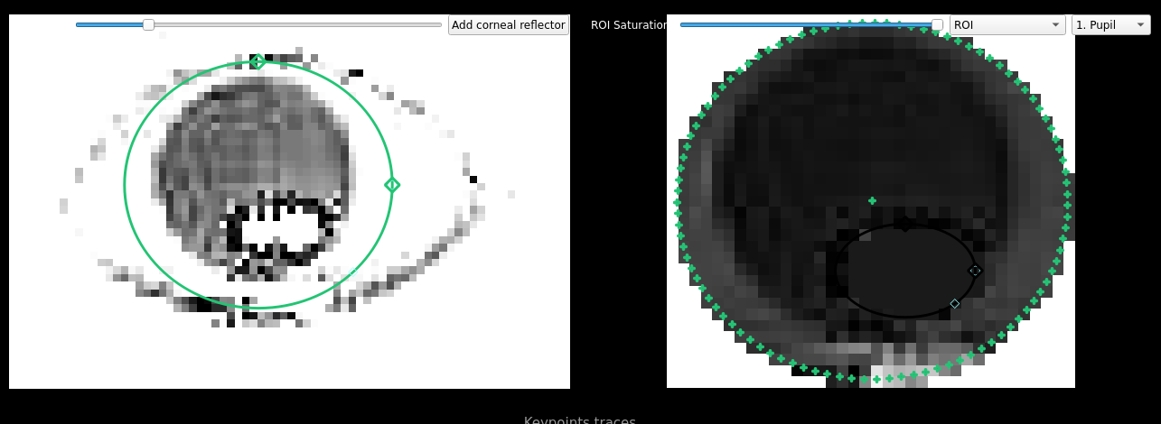
NB 1 : It’s possible that this mask does create outliers, we will investigate this issue
NB 2 : It’s possible to ignore those frames because the coordinated of the mask are in the .pkl, this is useful to make a threshold on the luminosity without taking either the mask neither the reflection in the calculus

11) Once all the ROIs are placed, verify again the settings and click on “save ROIs” this will create a “*_proc.npy”

You can then verify if you clicked correctly by clicking on “show batch”

NB : If the batch is too big the “Show batch” window will not appear compelitely you can then use “Crtl + A” and the copy the text in a text editor to verify if all the wanted videos are in the batch and if some are in double

► If you double clicked on “save ROIs” you cannot remove on of the videos from the batch (at least I didn’t find how” so either you shut down Facemap and put the ROIs again on all the video either you accept that this video will be processed 2 times (1 video is approxymately processed in 4-6 hours so I advice just to reprocess everything again)

IMPORTANT WARNING : Facemap has a known bug that all the “.h5” and “.npy” and “metadata.pkl” will be created in the same folder (usually the folder which contains the last video you processed but not every time”

So it’s very important that 2 .avi don’t have the same name even if they’re in different folders

I also advice to always process the videos of the same mouse in one Facemap window, so for example if you want to process the videos of 3 mice
► Open 3 Facemap windows in the 3 different terminals
► Put all the ROIs in the three windows BEFORE starting to process a batch
► Start the processing of the batchs in the 3 windows AT THE SAME TIME

To reorganize it we created a python code “OrganizerFaceMap.py”, you will have to use it when the processing ended :
► Type “conda activate facemap_gpu”
► Type “python OrganizerFaceMap.py”
► Click on enter
► Give the pathway of the parent folder that contains all the videos of the same mouse (e.g. /home/greta/Documents/Ilyass/Data/K1712)
► The code shows the modification he made

Added feature : If you chose the wrong parent folder, it’s possible that all the files are wrongly disposed
► You just have to type again “python OrganizerFaceMap.py”
► The following message will appear : Type 'undo' to cancel the last storing and 'Enter' to launch a new storing :
►type “undo”

12) You clicked on “Process Batch” you can verify the advancing by looking on the terminal

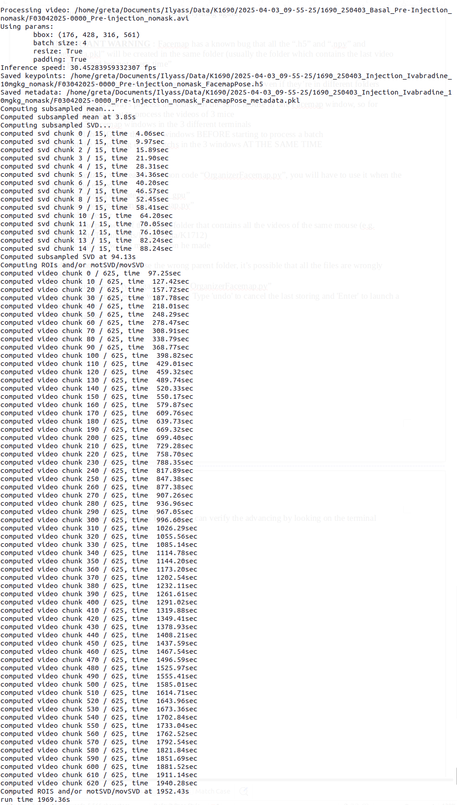
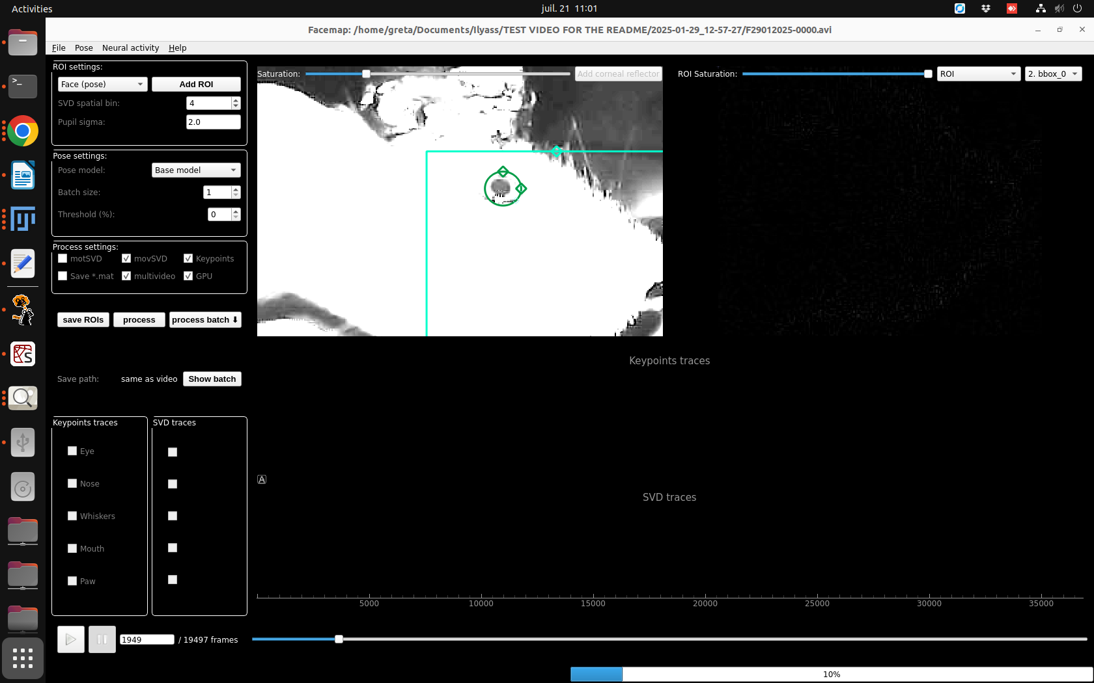
First step : Second step :
► You can see the progression bar on the bottom right
► If the windows crashes and show “Facemap is not responding”, it’s normal you just have to wait, it will take maximum 8 hours for a 3h video
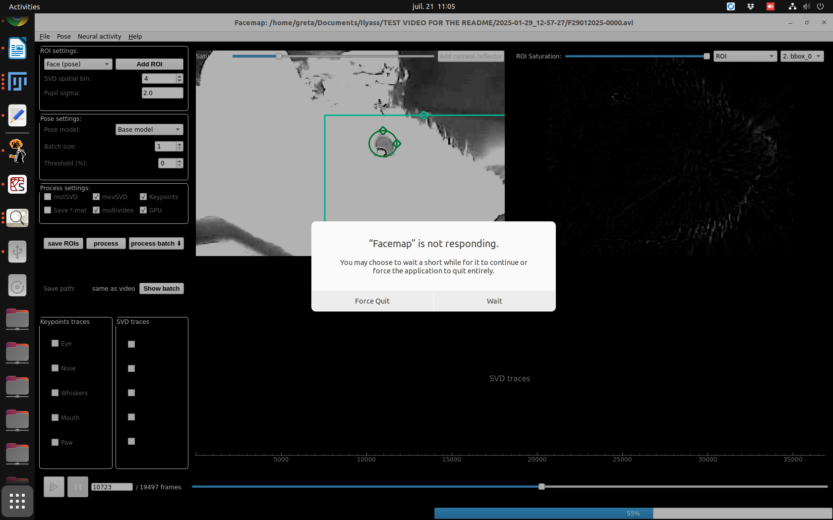

NB : Sometimes Facemap spams a message in the terminal, but it still function normally, you can either ignore it or restart the software
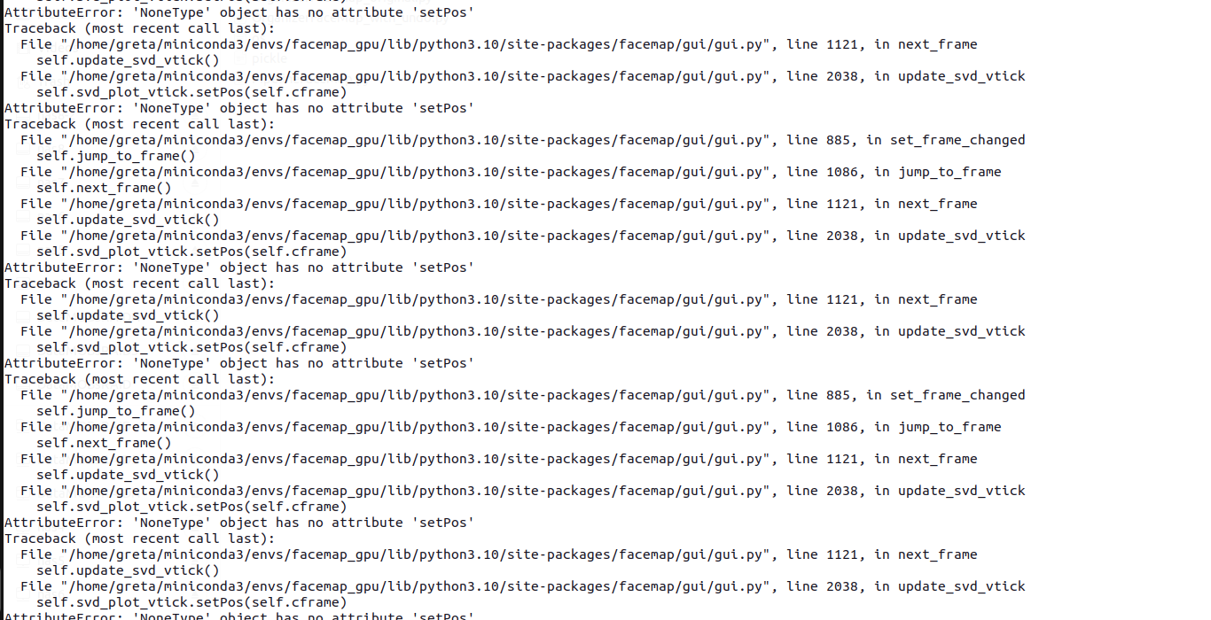
13) Once the processing is finished and you used “OrganizerFaceMap.py” you will have a folder that contains :
►The “behavResources.mat” file
►The “*.avi” file
►The “*FacemapPose_metadata.pkl” file
►The “*_proc.npy” file
►The “*_FacemapPose.h5” file

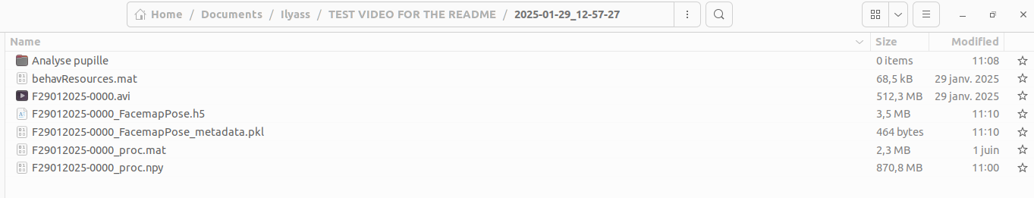
►PS : The “*_proc.mat” is not important

14) You have now to analyse the data by typing in a terminal “python AnalyseFaceMap.py” and then you put the parent folder either of a single video or of the parent folder with all the .h5

NB : Sometimes the code bugs and it doesn’t analyse some .h5 when they’re in a batch; I changed the code to make a warning message and just continue to the next .h5 file
► You will have to analyse those video alone, in order to do it you can launch a lot of analyse at the same time in different terminals

The first step of the analysis is to set a scale in the .pkl, to do so I coded a GUI that appear you just have to place two extremity points (= diameter) of the respiratory apparatus that are aligned, like this :
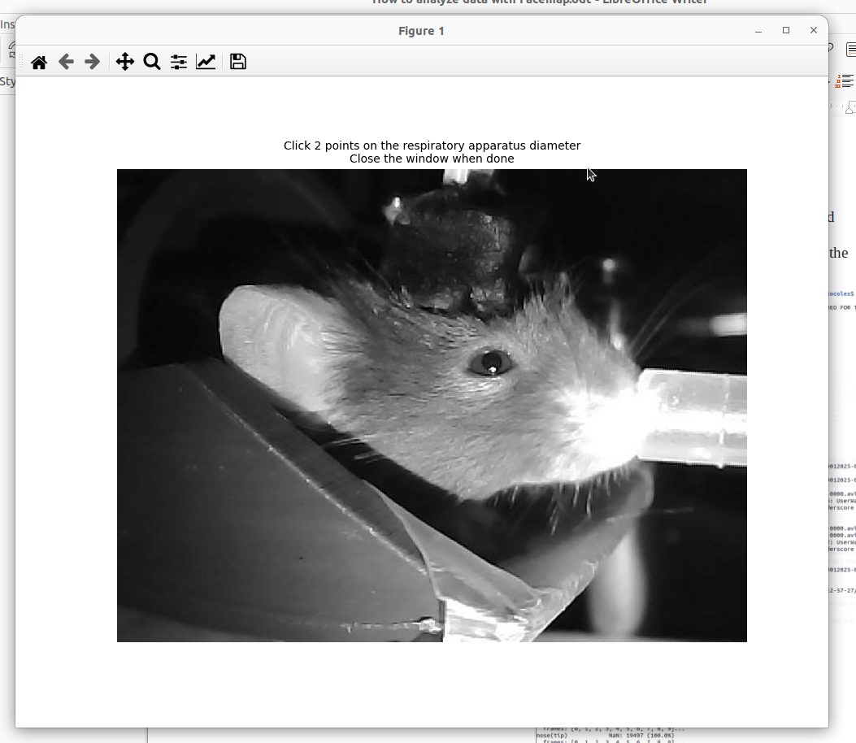
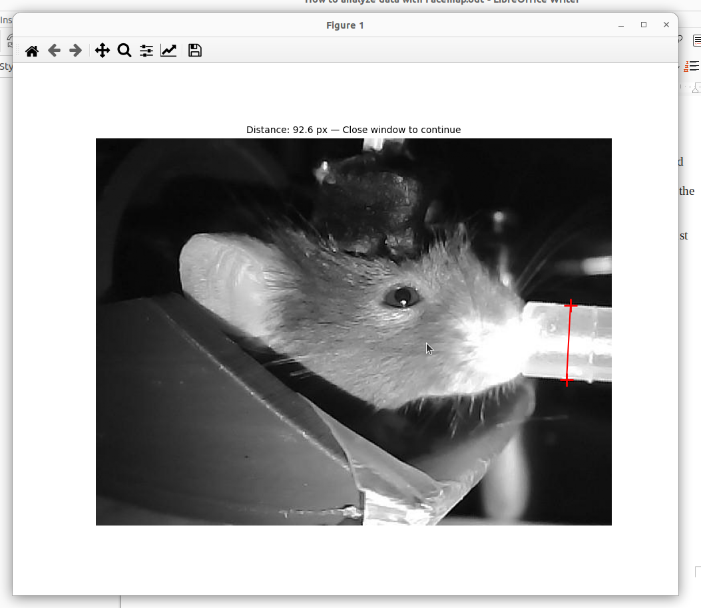
►

Then you just have to close the window and to type the real size of this apparatus in milimeters (usually it’s 7 mm, but this step allows to change it if necessary without changing the code)

PS : If you miss a click you can just right click to go back

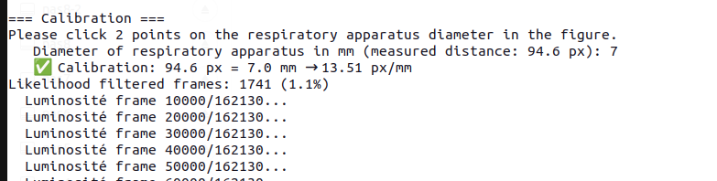

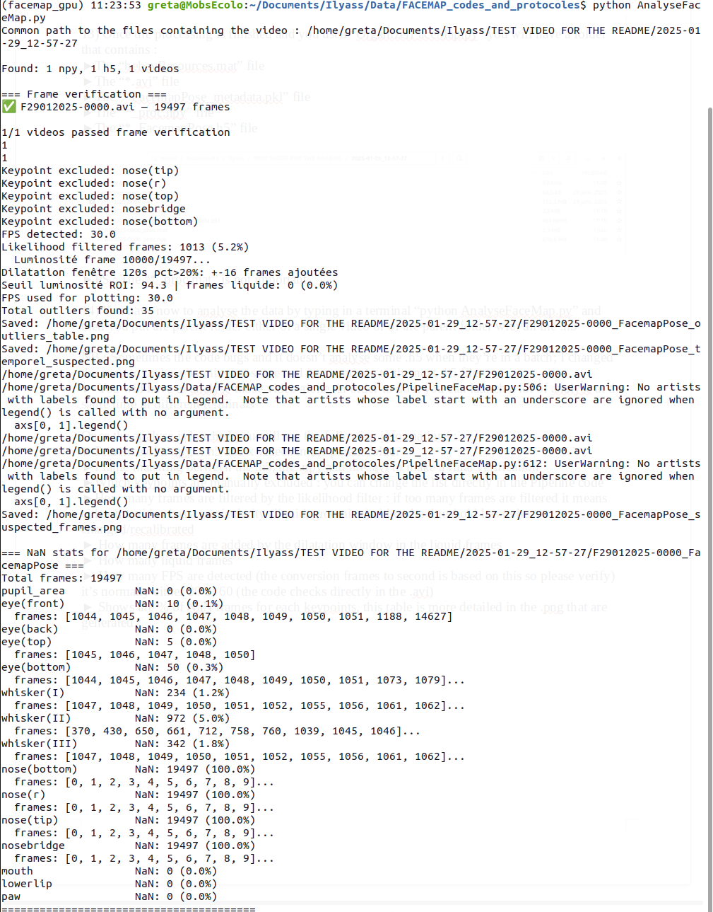
Once the analyse is lauched you will see the following informations :
►Presence of x npy, x h5 and x videos in the parent folder
►Frame matching between the .h5, the .npy and the .avi to make a final verification
►Which keypoints are manually excluded : you can change the list directly in the Pipeline code
►How many frames are filtered by the likelihood filter : if too many frames are filtered it means either the video has a particularity (liquid, grooming) either the threshold has to be changed/recalibrated
► How many frames are added by the dilatation window in the liquid frames
► How many liquid frames
► How many FPS are detected (the conversion frames to second is based on this so please verify) it’s normally either 30 or 60 (the code checks directly in the .avi)
► Shows the % of NaN frames for each keypoints, this table is more detailed in the .png that are generated

15) This analyse will create the following files that you have to stock in a folder that is named “VF1” and this folder has to be in the “Analyse pupille” folder; this precise pathway will be used by the “ComparaisonFaceMap.py” code :
►The “*_FacemapPose.pkl”file that is the table with all the data after the filters are applied
►The “*__FacemapPose_distri_et_spatial.html” and the “*__FacemapPose_temporel.html” which are figures that allow to have more details in the analysis
►The “*__FacemapPose_distri_et_spatial.png” and the “*__FacemapPose_suspected_frames.png” which are the spatial figures (the 2nd figure contains the raw data)
►The “*__FacemapPose_temporel.png” and the “*__FacemapPose_temporel_suspected.png” which are the temporal figures (the 2nd figure contains raw data)
►The “*__FacemapPose_outliers_table.png” is a table with the 99.99% most variable frames postfilter; that allow us to check manually what happens at those frames to see if they’re outliers or interesting frames

NB : In the temporal figure the green dots show the frames filtered because of luminosity and the red dots shows the frames filtered because of the likelihood filter

16) Now that the .pkl is in a VF1 folder you have to post-process the video :
► Type “python PostProcessingGUI.py”
► First it asks the folder pathway THAT CONTAINS the VF1, so not the VF1 folder but for example the “Analyse pupille” folder
► Then it asks you if you simply want to copy the temporal segments of another post-processing, it allows to go faster when you post-process the same video again for example with a corneal mask because the post processing is on the raw video
► Then it opens a window where you see several information
► The pupil velocity temporal curve allows to be careful on the frames with rapid movement that could sign either a physiological movement or when the mouse closes the eye
►The pupil area temporal curve allows to be careful when it’s goes way too high or when it’s near 0 that could mean that liquid appeared or that the mouse closed the eye
► The mark START and END button allows to define the timepoint to place a segment that’ll be set to NaN

IMPORTANT THING : Before placing a segment choose whether it’s a segment with liquid or a segment where the eye is closed by clicking on the circles in the rectangle

►It’s important because the liquid frames are completely out filtered even the whiskers keypoints but the eye closed frame only outfilter the pupil area and velocity value because the other are still accurate

► START INJECTION is important when the video doesn’t start right after the injection, this button will outfilter everything that’s behind the timepoint and it will set this timepoint as t = 0 in the comparison figures

► To know when the injection has been done, you can either go in the file that registered the mouse during the experiment or simply find the frame where the experimentator opened the box (everything become dark in the video so the pupil velocity goes up)
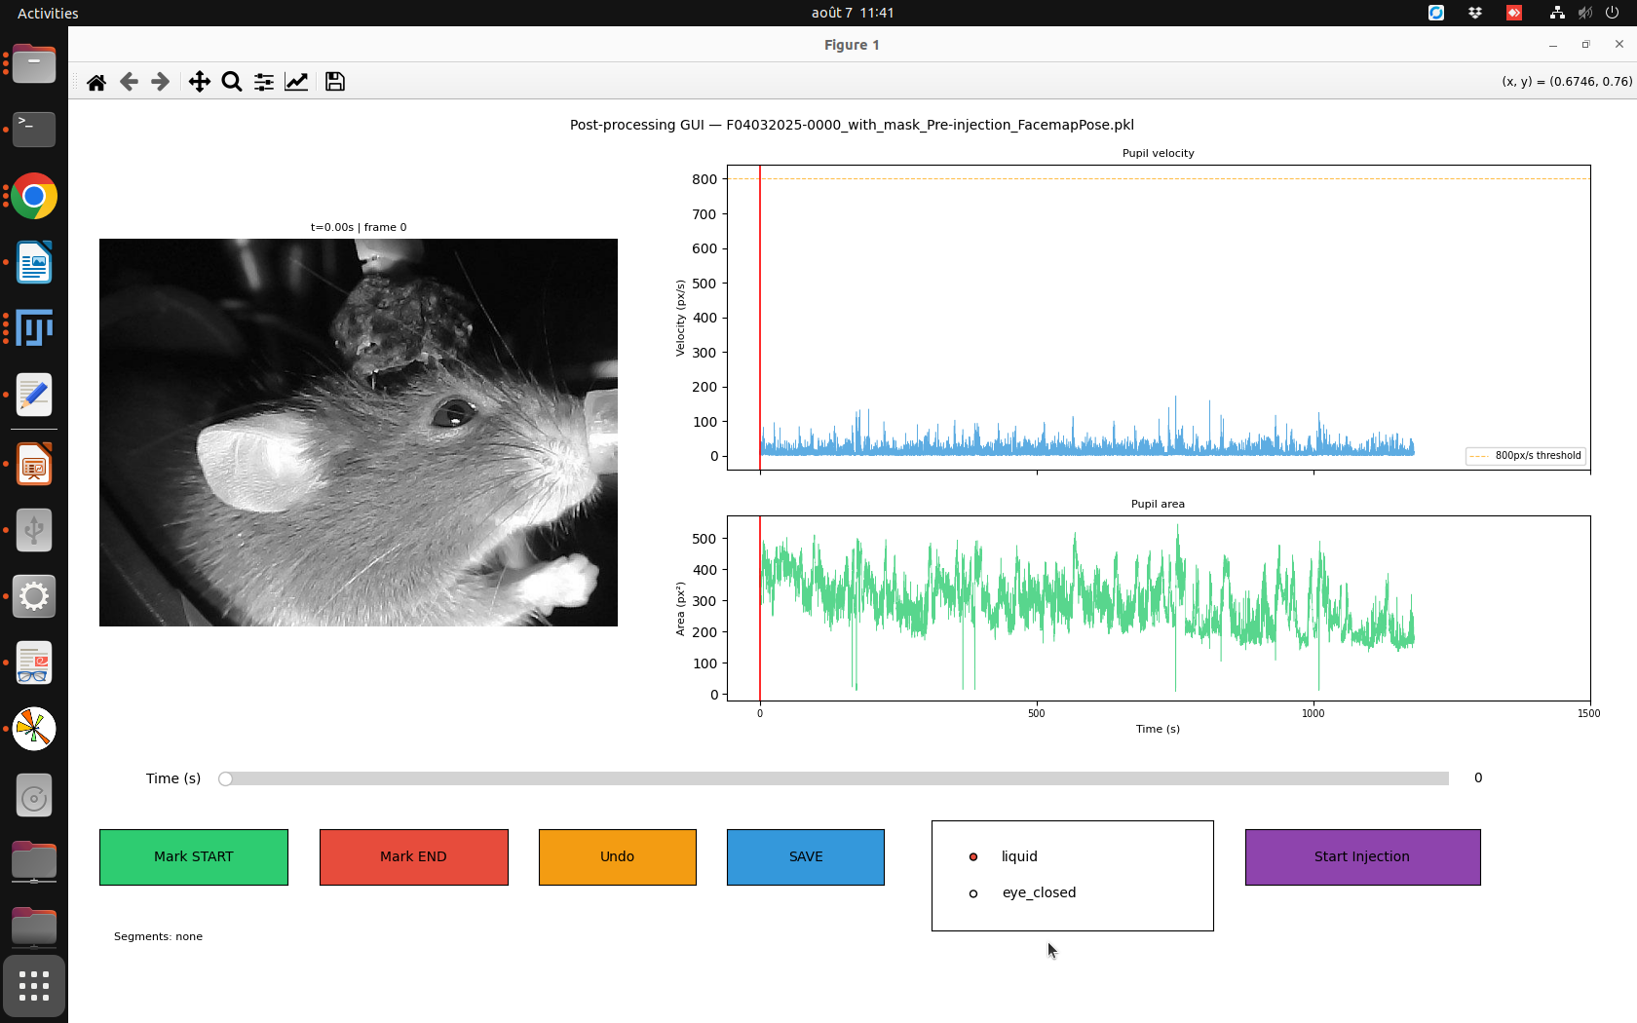

17) How to decide whether a frame has to be outfiltered ?

What’s important to understand is that we use the median so if one frame is very high or low it isn’t problematic because there’s no “weight difference” between a frame that has a pupil at 0 px² and a frame where’s the pupil is a 200 px²

In this case what’s important to exclude are the segments where the eye is closed for a long time or when liquid appears.

To do so, I use the right arrow that make a displacement of 10 seconds, if I find the eye closed 2 clicks in a row, it means the eye has been closed for 20 seconds so I go back to the first frame where the eye was closed and then I seek the first frame where the eye is reopened and I set the END time point.
IMPORTANT point : Verify if the frame after the reopening isn’t also a closed eye frame, because in this case it’s better to exclude everything

18) Some special situations :
► When the liquid is around the pupil but the whole pupil is visible and the area curve doesn’t drop, you can keep the frames
►When the liquid is just on one part of the pupil and it affects the area pupil, outfilter everything, it can drag all the median to lower values if you keep it
►When the eye is semi closed, but when you de-zoom you still can see the pupil, do not outfilter, it happens a lot but the literature says that if the eye is semi-closed the pupil is constricted so even if the quantification isn’t perfect in those frame the tendancy is right

NB 1: The Undo button and the right click do the same thing, it allows to suppress your last segment if you miss clicked or if you selected the wrong category

NB 2 : If you save without putting any segment, no pkl is created, so please write in the gsheet that you post-processed the video but that no problem has been detected
► As a backup you can also verify on the .png normally it should say “No segment have been placed”
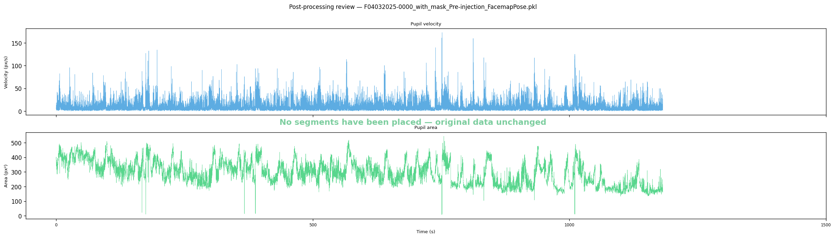

19) After you saved the post-processing, you will have 2 new files in VF1 :
►The “*_post_processing_FacemapPose.pkl”, it’s the new .pkl that’ll be used for the comparison the other pkl is kept to make the Raw vs Post-processed figure
►The *__post_processing_FacemapPose_control.png” that allows to verify which segment have been placed for a given video (you can find the exact timepoint in the pkl)

20) Once all the .pkl are generated, we can launch “python ComparaisonFaceMap.py” that’ll make the different figures to compare the conditions and the mice and will prioritize the post-processed .pkl

NB : The code search all the .pkl that are in a folder : \Analyse pupille\VF1
► Name correctly these folders

21) IMPORTANT : Once a new mouse is added to the quantification you have to add the pathway to the pkl in the code “path_for_expe_facemap.py”

=== HOW TO ADD A NEW MOUSE ===
1. Add the mouse ID to MICE list: MICE = ['K1690', 'K1711', 'K1712', 'KXXXX']

2. Add a unique color to MOUSE_COLORS: MOUSE_COLORS = { ... 'KXXXX': '#hex_color', }

3. Add its sessions to EXPERIMENTS (see HOW TO ADD A NEW SESSION above) That's it — the mouse will automatically appear in all figures and analyses.

Then you have to add the sessions :
== HOW TO ADD A NEW SESSION TO EXPERIMENTS ===

Each condition in EXPERIMENTS is a list of tuples: (mouse_id, relative_path)
- mouse_id: e.g. 'K1690', 'K2010'
- relative_path: path relative to BASE (/media/nas8-2/ProjectCardioSense)

Examples:
Old structure (K1690/K1711/K1712):
('K1690', '2025-03-12_10-56-54/1690_250312_Injection_Ivabradine_10mgkg')

New structure (Data_for_Ilyass):
('K2010', 'Data_for_Ilyass/K2010/20260716-HeadFixed-Mouse-2010-Ivabradine_00')

find_pkl() searches recursively for *_FacemapPose.pkl in any subfolder.
Priority: split post_processing pkl > regular post_processing pkl > regular pkl.

For new sessions with Pre-injection + Injection in the same video:
1. Run PostProcessingGUI.py on the video
2. Click 'Start Injection' at the injection timepoint
3. Save → creates 2 pkl:
- *_Pre-injection_post_processing_FacemapPose.pkl → Basal_Pre_Injection
- *_Injection_post_processing_FacemapPose.pkl → Injection_Ivabradine_10mgkg
4. Add the session to BOTH conditions in EXPERIMENTS.

Let’s take an example with this video : /media/nas8-2/ProjectCardioSense/Data_for_Ilyass/K2010/20260716-HeadFixed-Mouse-2010-Ivabradine_00/F20260716-0000.avi

This video contains the pre-injection segment and the injection segment, so once is has been post-processed, 2 pkl will be in VF1 :
- One for the pre-injection
- One for the Injection so here it’s Ivabradine (but it could be Saline or Heart stimulations)
Once those are created you add them in the function EXPERIMENTS in “path_for_expe_facemap.py” like this :
1- You add the mouse in right category so here’s its Basal_Pre_Injection AND Ivabradine 10mgkg
2- Then you add the pathway to find the folder that contains the .avi and VF1, here because the BASE is “/media/nas8-2/ProjectCardioSense” you just have to write : “Data_for_Ilyass/K2010/20260716-HeadFixed-Mouse-2010-Ivabradine_00”

You have to do this manually for each new condition, in the same way you can by modifying this folder decide what you want to include in the quantification
