1. Introduction
2. Literature review
3. Problem description and formulations
4. Special Cases and Analytical results
5. Experiments
6. Proposed Solution

3. Problem description and formulations
3.1 Environment
Creating hardware processor requires a lot of computational resources and time. Additionally when several projects like this are running in parallel. A system is built, in order to share between compute resources, for different task in different projects. Specifically we are interested in scheduling tasks for costly resources called emulators.
Each emulator has five boards. A task sent by user can request one or more boards, the boards must be occupied in sequential order. For example if our current state is that we have a task that runs on emulator on board 3,
Board 1
Board 2
Board 3 – Task A
Board 4
Board 5

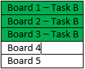
and a new task comes in, that need 3 boards, it cannot run in the same emulator unit as the previous task, because of the constraint that all boards must be occupied sequentially. So we will use two emulators.
Board 1
Board 2
Board 3 – Task A
Board 4
Board 5

A task can require more than five boards, in this case the board of the next closest emulator will be occupied. Because of this property we can model the problem as a long ordered line of boards, ignoring the existence of emulators.
A user of the system can make three different request types:
- Provide possible time window for the task and its size.
- Provide exact start time of the task he wants to run.
- Request extension to already running task.
After a user make a request, the system tries to schedule the new request, and reply the user whether it was able to do so.
When doing the scheduling there are three types of tasks:
- Task at progress, this tasks are already running, they occupy specific boards, due time is known. When doing re-scheduling this tasks will remain fixed.
- Tasks that are promised to run in time window. For this tasks we know the earliest time they can start running, and the latest due date. When doing re-schedule if there is a need to, we can change their start time or boards being used, as long as we meet promised due date.
- Tasks that are coming from new user request. For this tasks we know their availability, due date, and number of needed boards. There is a need to schedule in the given due date.

3.2 Goal
To create correct scheduling we followed guidelines as given by the business need:
- Complete as most tasks as possible in their due date is the most important
- For all jobs that cannot complete before or at their due date, it is preferable that:
  - That total jobs lateness will be as small as possible.
  - Lateness will be evenly distributed between them.
- For all jobs that can meet their due date it is preferable that:
  - Their earliness will be evenly distributed among them.
When scheduling two jobs, we have three possible schedules: both of the jobs will meet their due date; only one of the jobs will meet due date; none of the jobs will meet due date. Since first guideline is to prefer as most task as possible to be completed before their due date, we will always prefer first case over second, and the second over the third. For example, if we have two jobs which we can schedule in two alternative ways, both jobs with small latency, or we can make a schedule where one of the jobs will finish on time, while the other one will have a bigger latency. We will prefer alternative where we have at least one completed task.

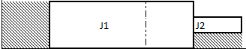
Alternative 1, not jobs completes on due date. The dashed line is due date of both of the jobs.

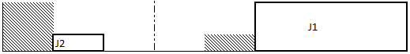
Alternative 2, one job completes on due date. The dashed line is due date of both of the jobs.
If both of the jobs are not going to meet their schedule, our alternatives look like: (1) both jobs end at the same time, and their total latency is t_{s}; (2) jobs complete on different times and their total latency is smaller than t_{s}; (3) jobs complete on different times and their total latency is bigger than t_{s};(4) jobs complete on different times and their total latency is equal t_{s}; According to second guideline we would prefer alternative (2) over all others, then alternative (1), afterwards alternative (4) and at the end alternative (3).

3.3 Mathematical modeling
Let M = {M₁, M₂, …, M_{m}} be a set of distinct processors (processors and boards are used interchangeably) that can execute only one job at a time. Processors reside along a straight line were processor M₂ is located immediately after M₁, processor M₃ immediately after M₂ and so forth. Let J = {J₁, J₂, …, J_{n}} be a set of jobs that are needed to be scheduled on the processors. Each job is defined by: p_{j} – processing time of job j; r_{j} – ready time of job j; d_{j} – due date of job j; s_{j} – size of job j, number of needed sequential processors.
We present three different formulations where each formulation has the following parameters:
$$T-Maximum time for which our model will try to find optimality. T=\max_{j}\left\{d_{j}\right\}$$
$S-Maximum size, equal the number of boards. S=\left|M\right|$
$$w_{u}-Weight for unit penalty, if the job is not completed on time.$$
$$w_{t}-Weight for tardiness.$$

And below decision variables, are common to all:
$$c_{j}-completion time of job j.$$
$$U_{j}-Unit penalty. Equals 0 if job j completes on time, 1 otherwise.$$
$$T_{j}-Tardiness of job j.$$

3.3.1 MIP Formulation 1
This is a relative formulation taken from [Guan, 2004], in our case all weights are equal 1. Model parameters are the same as in formulation 1.
Decision Variables:
$$u_{j}-processing start time of job j$$
$$v_{j}-starting board occupied by job j$$
$$σ_{ji}=\left\{\begin{aligned}1, if job j starts, before job i, and they do not overlapp \\ \\ 0, otherwise; \end{aligned}\right.$$
$δ_{ji}=\left\{\begin{aligned}1, if job's j starting board is before starting board of job i \\ and they do not overlapp \\ 0, otherwise; \end{aligned}\right.$

$min \left\{w_{u}×\sum{U_{j}}+w_{t}×\sum{T_{j}} \right\}$ (1)
Subject to:
$U_{j}×T≥c_{j}-d_{j}$ $∀j$ (2)
$u_{j}-u_{i}-p_{i}-{(σ}_{ij}-1)T≥0$ $∀i,j$ (3)
$v_{j}-v_{i}-s_{i}-\left(δ_{ij}-1\right)S≥0$ $∀i,j$ (4)
$σ_{ij}+σ_{ji}+δ_{ij}+δ_{ji}≥1$ $∀i,j$ (5)
$σ_{ij}+σ_{ji}≤1$ $∀i,j$ (6)
$δ_{ij}+δ_{ji}≤1$ $∀i,j$ (7)
${ p}_{j}+u_{j}=c_{j}$ $∀j$ (8)
$r_{j}≤u_{j}$ $∀j$ (9)
$u_{j}≤T-p_{j}$ $∀j$ (10)
$v_{j}≤S-s_{j}$ $∀j$ (11)
$T_{j}≥0$ $∀j$ (13)
$T_{j}≥c_{j}-d_{j}$ $∀j$ (14)
$σ_{ji}∈\left\{0,1\right\}, δ_{ji}∈\left\{0,1\right\}$ $∀j,i$ (15)

3.3.2 MIP Formulation 2
This formulation is also relative formulation, taken from [Heragu].
Decision variables:
$$x_{j}-point of half time job j$$
$$y_{j}-point of half size job j$$

$min \left\{w_{u}×\sum{U_{j}}+w_{t}×\sum{T_{j}}\right\}$ (1)
Subject to:
$U_{j}×T≥c_{j}-d_{j}$ $∀j$ (16)
$p_{j}+x_{j}=c_{j}$ $∀j$ (17)
$\left|x_{j}-x_{i}\right|+T×z_{ji}≥0.5×\left(p_{j}+p_{i}\right)$ $∀j,i$ (18)
$\left|y_{j}-y_{i}\right|+S×(1-z_{ji})≥0.5×\left(s_{j}+s_{i}\right)$ $∀j,i$ (19)
$x_{i}+0.5p_{j}≤d_{j}$ $∀j$ (20)
$y_{i}+0.5s_{j}≤S$ $∀j$ (21)
$x_{j}≥ r_{j}+0.5p_{j}$ $∀j$ (22)
$y_{j}≥0.5s_{j}$ $∀j$ (23)
$T_{j}≥0$ $∀j$ (13)
$T_{j}≥c_{j}-d_{j}$ $∀j$ (14)

3.3.3 MIP Formulation 3
Decision Variables:
$$x_{jmt}- Equals 1 if job j starts the process on machine m, at time t, 0 otherwise. t=1..T$$

$min \left\{w_{u}×\sum{U_{j}}+w_{t}×\sum{T_{j}} \right\}$ (1)
Subject to:
$\sum_{m}{\sum_{t}{x_{jmt}=1}}$ $∀j$ (24)
$\sum_{j}{\sum_{t^{'}=t}^{min\left\{T,t+p_{j}-1\right\}}{\sum_{m^{'}=m}^{min⁡\{M,m+{size}_{j}\}}{x_{jmt}≤1}}}$ $∀t,m,j$ (25)
$\sum_{t}{{t×x}_{jmt}≥r_{j}}$ $∀j, m$ (26)
$p_{j}+\sum_{m}{\sum_{t}{{t×x}_{jmt}=c_{j}}}$ $∀j$ (27)
$T×U_{j}≥c_{j}-d_{j}$ $∀j$ (28)
$T_{j}≥0$ $∀j$ (13)
$T_{j}≥c_{j}-d_{j}$ $∀j$ (14)

Constraint (2) forces that all the jobs will start process at some period of time. (3) Enforces that at time t, and on board m only one job j can run. (4) Ensures that all jobs will not start running before their availability time. (5) Assign the completion time of job j to variable$c_{j}$. (6) Calculates unit penalty, if job is late $U_{j}$ will equal 1 otherwise 0.

3.3.4 CP Formulation
Our second approach was to create a constraint programming formulation for the problem.
Defined parameters:
$$A- A set of valid tuples for scheduling job j on machine m.$$

Decision Variables:
$$U_{j}-Unit penalty. Equals 0 if job j completes on time, 1 otherwise.$$
$$T_{j}-Tardiness of job j.$$
$$tialt_{a}-Interval type. Present if alternative a is used 0 otherwise. a ∈A, a=(j,m)$$
$$tijobs_{j}-Interval type. Describes the running interval for job j.$$

Formulation:
$min \left\{w_{u}×\sum{U_{j}}+w_{t}×\sum{T_{j}} \right\}$ (1)
Subject to:
$startOf\left(tijob_{j}\right)≥r_{j}$ $∀j$ (29)
$alternative(tijob_{j},\left\{tialt_{a}:j∈a\right\})$ $∀j$ (30)
$\sum_{a∈A:m≥a.m ∧a.m+s_{j}>m }{pulse\left(tialts\left(a\right),1\right)≤1}$ $∀m$ (31)
$T_{j}=max⁡(0,endOf\left(tijob_{j}\right)-d_{j}$) $∀j$ (32)
$if endOf\left(tijob_{j}\right)>d_{j}=>U_{j}=1 else U_{j}=0$ $∀j$ (33)

Constraint (29) ensures that all jobs will start only after their ready time, (30) enforces that for each job only one alternative can exist. Constraint (31) enforces that at each period of time, only one job use board m. (32) finds tardiness, (33) assign penalty variable.

4. Special Cases and Analytical results
5. Experiments
6. Proposed Solution

5. 1 General Description of the experiments

5.2 Compare performance in small to medium sized problems
In this experiment a comparative analysis of Guan’s and TBased2 formulations is being made. The objectives of the experiment are:
- Analyze which parameters affect the solution time for each of the formulations.
- Compare the two formulations, performance as problem resolutions grows.

5.2.1 Experimental design
A factorial design was chosen to achieve the objectives, factors for this experiment are summarized in <Table:6>, there are three 2 level factors and one 4 level factor. A randomly generated problem for this experiment is generated in the following manner: firstly number of machines and number of jobs are being set by the factors; then for each job a process time,${ p}_{i}$, is drawn from discrete uniform distribution $U(\frac{p_{max}}{5},p_{max})$, then the size of the job,${ s}_{i}$, is drawn from discrete uniform distribution $U(1,M)$, and finally a due date value, $d_{i}$ is drawn from discrete uniform distribution $U(p_{i},p_{i}+d_{max})$. The distribution of process time is $U(\frac{p_{max}}{5},p_{max})$, so the values will be drawn from $U\left(1,5\right)$ or $U(2,10)$ etc., this allows to look at problems with different process times as similar problems but with different time resolution. For each combination of the factors 10 random problems are generated. There are 32 different factors ($2×2×2× 4)$, and 10 problems for each factor so in total 320 problems are generated.
<Table:6> Factors summary.
Factor | Set of possible values
M – Number of machines | {15,25}
$n$ – Number of jobs | {15,25}
$d_{max}$ – Max. due date | {15,25}
$p_{max}$ – Max. Process time | {5,10,20,40}

Each of the 320 problems will be tested with Guan’s formulation, and with TBased2, so in total 640 responses are received.

5.2.2 Results and Analysis
Three ANOVA tests conducted on three different responses, time received by Guan’s formulation, time received from TBased2 formulation and the difference between them. All models were found significant, with significance level of 0.05. Guan’s most influencing factor is number of jobs, as the number of jobs growth the time it takes to solve the problem also growth with it, this is expected as it is the only factor that affects number of integer variables, further analysis is provided in section 5.2.2.1. For TBased2 all factors has influence on the problem solution time, this is because all the factors has impact on number of integer variables, further analysis is provided in section 5.2.2.2
Summary of solution results shown in <Table:1>, in total TBased2 solved all problems faster than Guan. Despite this, in almost $\frac{2}{3}$ of the problems, 204, Guan had better solution time. Comparing only optimally solved problems, by both of the models, Guan solved the problems faster, on average Guan solved each problem in 114.6 sec (SD = 298.3), and for TBased2 it took 130.5 sec. (SD = 306.5) per problem. In both formulations the standard deviations of problems that are optimally solved for both of them, are bigger than the mean, this shows that there is a big variation in solution time.

<Table:1> Summary of solution time
 | Guan | TBased2
Average solution time | 430.74 sec. (SD = 710.7) | 219.2 sec. (SD = 490.4)
Average solution time optimal only | 114.6 sec (SD = 298.3) | 130.5 sec. (SD = 306.5)
Average solution time mutual optimality | 161.2 sec. (SD = 366.4) | 171.5 sec. (SD = 368.6)
Median solution time | 7.1 sec. | 24.7 sec.
Median solution time optimal only | 1.6 sec. | 19.1 sec.
Median solution time mutual optimality | 4.63 | 26.2
Better solution time | 204 | 116
Optimality proved | 260 | 303
Exclusive Optimality | 9 | 52
Mutual optimality | 251 | 251
Better solution value | 8 | 3

TBased2 has a little bit more optimally proved problems than Guan, 303 vs. 260, but despite that Guan formulation resulted 8 times in a better solution than TBased2, while TBased2 had only 3 results that are better than Guan. Additionally <TableId:1> shows that for each formulation there is a small set of problems that only it, was able to proof optimality, 9 for Guan, and 52 for TBased2, it indicates that the factors are affect differently on each of the formulation. <Figure:22> shows that TBased2 has more problems solved under 400 seconds, and that both of the formulations solved most of the problems in less than 100 seconds.
As explained in section 5.2.1 above, the data set is also constructed in a way that it is possible to compare what is happening to each formulation when the time resolution changes, i.e. solving the same problem but once when a time unit is hour, and then when the time unit is half an hour, etc.. From <Figure:7>, it is seen that as the resolution is high, for example hours, TBased2 is better in solving the problems, and when moving to a more granular time units, for example quarter hours, TBased2 performs slower than Guan formulation, since Guan’s solution time is not impacted by this factor.
<Figure:7>

<Figure:22> Histogram of solution time for each of the formulations.

5.2.2.1 Analysis of Guan formulation
To analyze results, and understand which factors are most influencing solution time of a problem, ANOVA test was used.

<Table:2> ANOVA results for Guan formulation
Source | Sum of  Squares | df | Mean  Square | F  Value | p-value  Prob > F
Model | 73135611.84 | 28 | 2611986.14 | 8.593679145 | < 0.0001
A-Machines | 35157.86483 | 1 | 35157.8648 | 0.11567267 | 0.7340
B-Jobs | 58832059.11 | 1 | 58832059 | 193.5629873 | < 0.0001
C-Duedate | 412600.084 | 1 | 412600.084 | 1.357492939 | 0.2449
D-ProcessTime | 4434096.521 | 3 | 1478032 | 4.862864349 | 0.0026
AB | 38533.11604 | 1 | 38533.116 | 0.126777562 | 0.7221
AC | 43200.95242 | 1 | 43200.9524 | 0.142135182 | 0.7064
AD | 787903.964 | 3 | 262634.655 | 0.864092624 | 0.4601
BC | 421638.0767 | 1 | 421638.077 | 1.387228782 | 0.2398
BD | 4410127.211 | 3 | 1470042 | 4.836577257 | 0.0027
CD | 561078.6572 | 3 | 187026.219 | 0.615333786 | 0.6056
ABC | 41308.34629 | 1 | 41308.3463 | 0.13590833 | 0.7127
ABD | 784518.9688 | 3 | 261506.323 | 0.860380307 | 0.4620
ACD | 1776569.042 | 3 | 592189.681 | 1.94835954 | 0.1219
BCD | 556819.9249 | 3 | 185606.642 | 0.610663243 | 0.6086
Residual | 88447328.91 | 291 | 303942.711
Lack of Fit | 1752652.179 | 3 | 584217.393 | 1.940772093 | 0.1231
Pure Error | 86694676.73 | 288 | 301023.183
Cor Total | 161582940.7 | 319

<Table:2> shows received ANOVA results for testing Guan’s solution time dependent variable. There are two significant factor for guan solution time, number of jobs with $F=193.56, p<0.0001$, indicating that as number of jobs is growing the time it takes to solve the problem is increasing, and a second factor, process time, with $F=4.86, p=0.002$. As can be seen from <Figure:12>, process time does not impact the solution time in any specific direction, it is not expected that process time will be significant factor, since it does not have a relation to the number of integer variables in Guan’s formulation. On the other hand number of jobs has a visible impact, <Figure:2>, on solution time, this result is expected since the amount of integer variables in Guan’s formulation is being affected by the number of jobs in the problem, and as the number of jobs is bigger, the number of integer variables is growing and the time for solving a problem is increasing drastically. Additionally <Figure:14> shows the significant interaction between number of jobs and process time factors.

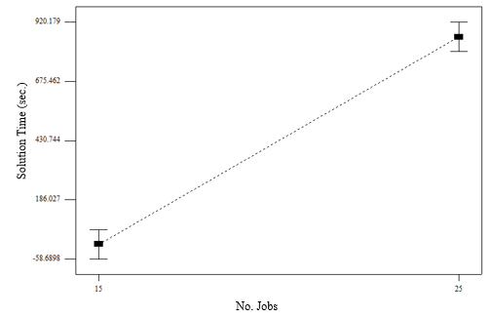 <Figure:2>. Solution time as a function of number of jobs.

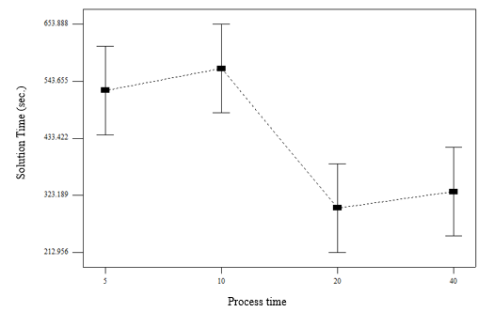<Figure:12>. Solution time as a function of process time.

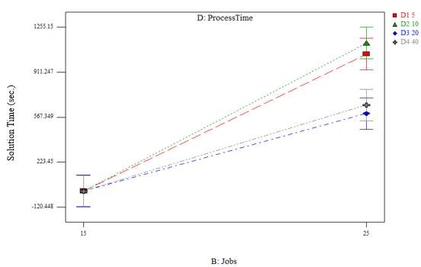<Figure:14> Interaction between Number of jobs and process time.

5.2.2.2 Analysis of TBased2 formulation
<Table:3> summarizes the ANOVA results. All factors except due date are affecting the time that will be needed to solve the problem.
Machines factor is significant with $F=49.28, p<0.0001$, indicating that increase in the number of machines will cause increase in solution time. Jobs factor is significant with $F=97.92, p<0.0001$ indicating that increase in number of jobs will cause increase in solution time. Process time factor is significant with $F=59.90, p<0.0001$ indicating that increase in average process time for a job will increase problem solution time. <Figure:4>, <Figure:5>,<Figure:6> visualize the change in solution time, as the factor changes. It is trivial to understand why number of jobs and number of machines affect the solution time, as they directly impact the number of integer variables that a formulation will have. Process time is a little bit different, in TBased2 formulation, time horizon is the third factor, besides number of jobs and machines, that impact on the number of integer variables, in conducted tests time horizon was set as $\sum_{i}{p_{i}}$, thus increase in average process time would increase time horizon and hence increase the number of integer variables. Additionally any interaction between the three significant factors is also significant, figures 16-18 show this. The general pattern for the interactions is that a higher factor values are a lot more influencing other high factor values. As an example interaction between machines and jobs is studied, in <Figure:16> it is clearly seen, that the influence of jobs with value 25 is higher than for value 15, the gradient is significantly bigger.

<Table:3> ANOVA results for TBased2 formulation
Source | Sum of  Squares | df | Mean  Square | F  Value | p-value  Prob > F
Model | 47950911.1 | 28 | 1712532.539 | 19.63976379 | < 0.0001
A-Machines | 4297085.8 | 1 | 4297085.8 | 49.28008558 | < 0.0001
B-Jobs | 8538712.222 | 1 | 8538712.222 | 97.92414874 | < 0.0001
C-Duedate | 86735.51317 | 1 | 86735.51317 | 0.994705182 | 0.3194
D-ProcessTime | 15670574.19 | 3 | 5223524.73 | 59.90472559 | < 0.0001
AB | 2941744.137 | 1 | 2941744.137 | 33.73667866 | < 0.0001
AC | 51335.29805 | 1 | 51335.29805 | 0.588726406 | 0.4435
AD | 5161309.207 | 3 | 1720436.402 | 19.73040732 | < 0.0001
BC | 9001.842718 | 1 | 9001.842718 | 0.103235448 | 0.7482
BD | 6844355.28 | 3 | 2281451.76 | 26.16427579 | < 0.0001
CD | 562836.3656 | 3 | 187612.1219 | 2.151584085 | 0.0939
ABC | 48205.0549 | 1 | 48205.0549 | 0.552827973 | 0.4578
ABD | 3379308.686 | 3 | 1126436.229 | 12.9182605 | < 0.0001
ACD | 206469.9197 | 3 | 68823.30656 | 0.789283388 | 0.5007
BCD | 153237.5867 | 3 | 51079.19557 | 0.585789357 | 0.6248
Residual | 25374387.1 | 291 | 87197.20653
Lack of Fit | 225312.7603 | 3 | 75104.25342 | 0.86007241 | 0.4622
Pure Error | 25149074.34 | 288 | 87323.17479
Cor Total | 73325298.2 | 319

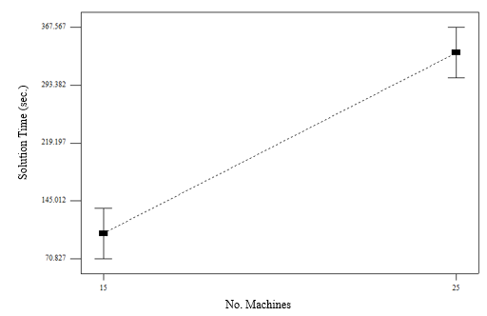<Figure:4>. Solution time vs number of machines

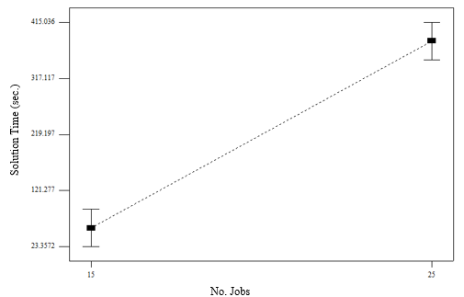<Figure:5>. Solution time vs number of jobs

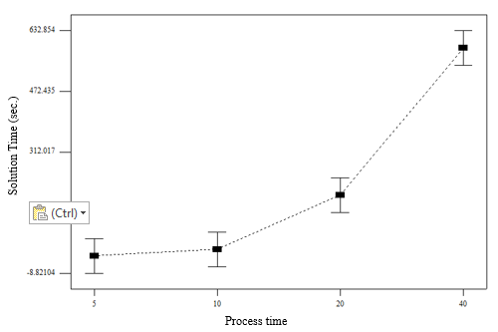<Figure:6>. Solution time vs max job process time

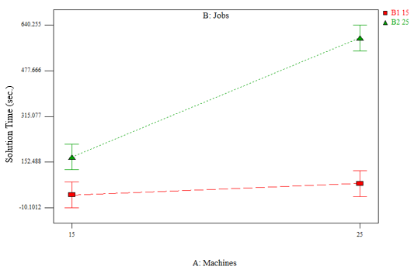<Figure:16>. Solution time as function of interaction between jobs and machines

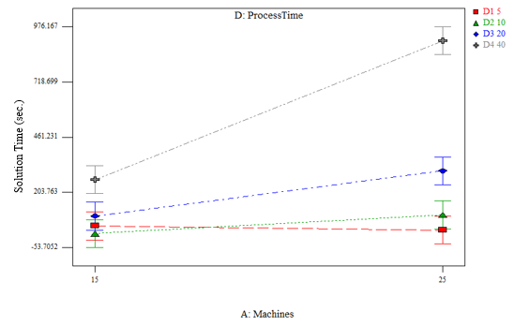 <Figure:17>. Solution time as function of interaction between machines and process time
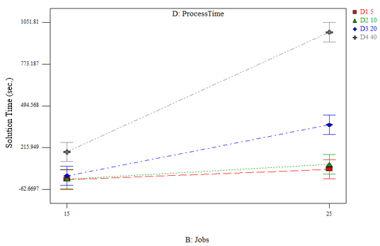<Figure:18>. Solution time as function of interaction between jobs and process time

5.2.2.3 Analysis of solution time difference between the two formulations
Third dependent variable that is tested is the difference of solution time between TBased2 and Guan. All factors except due date, has a significant impact on the difference between the two formulations. Machines factor is significant with factor $F=11.18, p<0.0009$, indicating that as the number of machines is growing the difference changes from negative (meaning TBased2 is faster), to positive (meaning Guan is faster), <Figure:9> visualize this.

<Table:4>. ANOVA results for time difference test.
Source | Sum of  Squares | df | Mean  Square | F  Value | p-value  Prob > F
Model | 100624176.2 | 28 | 3593720.577 | 11.3020842 | < 0.0001
A-Machines | 3554872.809 | 1 | 3554872.809 | 11.17990978 | 0.0009
B-Jobs | 22544438.79 | 1 | 22544438.79 | 70.90121228 | < 0.0001
C-Duedate | 120986.129 | 1 | 120986.129 | 0.380495753 | 0.5378
D-ProcessTime | 31955398.22 | 3 | 10651799.41 | 33.4994141 | < 0.0001
AB | 2306913.85 | 1 | 2306913.85 | 7.255136846 | 0.0075
AC | 350.6089199 | 1 | 350.6089199 | 0.001102649 | 0.9735
AD | 9178406.382 | 3 | 3059468.794 | 9.621887172 | < 0.0001
BC | 553855.4972 | 1 | 553855.4972 | 1.741849799 | 0.1879
BD | 19594600.37 | 3 | 6531533.457 | 20.54136918 | < 0.0001
CD | 1396846.574 | 3 | 465615.5248 | 1.464339187 | 0.2244
ABC | 266.0796445 | 1 | 266.0796445 | 0.000836808 | 0.9769
ABD | 6784042.471 | 3 | 2261347.49 | 7.111832764 | 0.0001
ACD | 1579608.785 | 3 | 526536.2615 | 1.655932072 | 0.1767
BCD | 1053589.592 | 3 | 351196.5305 | 1.104496767 | 0.3476
Residual | 92529189.25 | 291 | 317969.7225
Lack of Fit | 1561050.107 | 3 | 520350.0355 | 1.647398877 | 0.1786
Pure Error | 90968139.14 | 288 | 315861.5942
Cor Total | 193153365.4 | 319

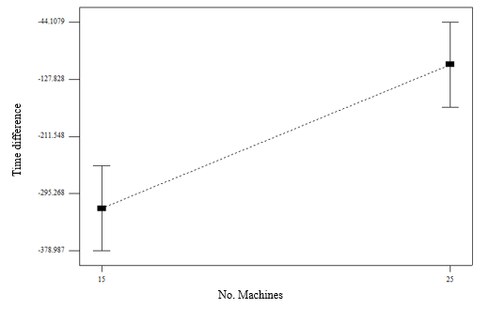<Figure:9>. Time difference between TBased2 and Guan formulation, as number of machines changes.
Number of jobs is significant factor with $F=70.09, p<0.0001$. This factor impacts the opposite way from previous one, as number of jobs is growing difference value is degrading, which means that in cases where we have many jobs, TBased2 is better performing than Guan, <Figure:10> shows this. 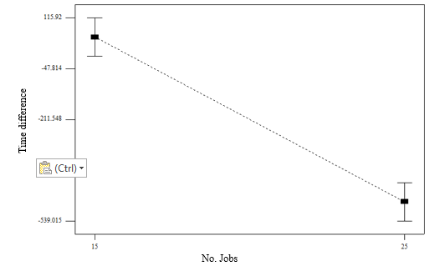<Figure:10>. Time difference between TBased2 and Guan formulation, as number of jobs changes.
Last significant factor is the process time, with $F=33.50, p<0.0001$, indicating that as the process time is getting bigger, Guan will have better solution time, <Figure:11> show the difference change. Summary of other ANOVA analysis is provided in <Table:4>. A correlation between the difference and number of machines or process time is expected, because both of the factors have a significant effect on the solution time, only in TBased2 formulation. Number of jobs has inverse correlation, which means that Guan’s performance degrades more rapidly as the number of jobs is being increased, than TBased2 formulation. So for problems with relative big number of jobs TBased2 has more potential of getting better result.
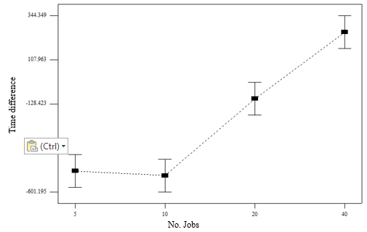<Figure:11>. Time difference between TBased2 and Guan formulation, process time changes.
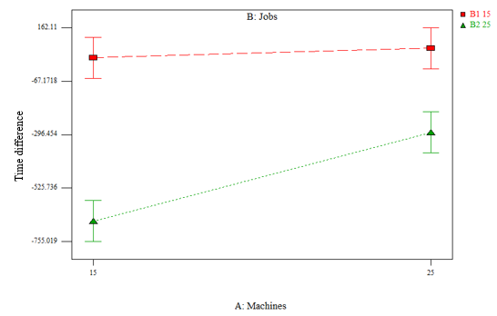<Figure:19> Solution time difference as a function of interaction between Jobs and Machines.
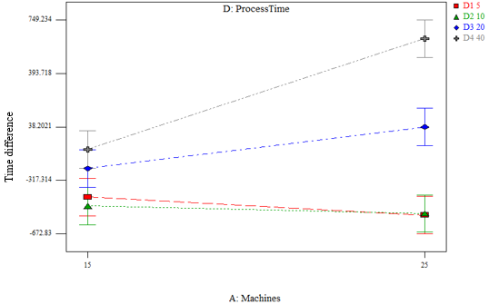<Figure:20>. Solution time difference as a function of interaction between Machines and Process time.

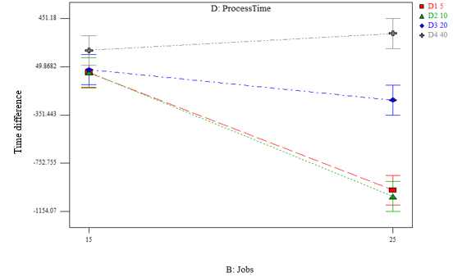<Figure:21>. Solution time difference as a function of interaction between jobs and process time.

5.3 Compare solution quality on large problems
In this experiment a comparative analysis of Guan’s and TBased2 formulations is being made. The objectives of the experiment are:
- Compare the two formulations, by solution quality.
- Analyze which parameters affect mostly on solution quality in each formulation

5.3.1 Experimental design
A factorial design was chosen to achieve the objectives, factors for this experiment are summarized in <Table:6>, there is one two level factor, one three level and one four level. A randomly generated problem for this experiment is generated in the following manner: firstly number of machines and number of jobs are being set by the factors; then for each job a process time,${ p}_{i}$, is drawn from discrete uniform distribution $U(\frac{p_{max}}{5},p_{max})$, then the size of the job,${ s}_{i}$, is drawn from discrete uniform distribution $U(1,M)$, and finally a due date value, $d_{i}$ is drawn from discrete uniform distribution $U(p_{i},p_{i}+d_{max})$. The distribution of process time is $U(\frac{p_{max}}{5},p_{max})$, as described above. For each combination of the factors 10 random problems are generated. There are 24 different factors ($2×3×2)$, and 10 problems for each factor so in total 120 problems are generated.

<Table:7> Factors summary.
Factor | Set of possible values
M – Number of machines | {15,25}
$n$ – Number of jobs | {30,40,50}
$p_{max}$ – Max. Process time | {20,40}
Each of the 120 problems will be tested with Guan’s formulation, and with TBased2, so in total 240 responses are received.

5.3.2 Results and Analysis

<Table:5>. Summary results for experiment 2.
 | Guan | TBased2
Optimally solved | 17 | 42
Mutual Optimality | 11 | 11
Exclusive Optimality | 6 | 31
Better solution value | 59 | 13
Better Solution value, for problems solved mutually not optimal. | 55 | 3
Avg Gap | 0.213 (SD = 0.13) | 0.337 (SD = 0.43)
Avg. Gap mutually not optimal | 0.263 (SD = 0.10) | 0.526 (SD = 0.44)

5.3.2.1 Analysis of Guan formulation
As in previous analysis we use ANOVA to understand which factors impacts the gap. Similar to Guan’s previous results, when tested for solution time, jobs and process time found to have significant impact on the gap value. Jobs factor is significant with $F=84.87, p<0.0001$, indicating that as number of jobs increases the assumed gap between the optimal solution is higher, this can be seen in <Figure:23> . Process time factor was significant also with $F=19.15, p<0.0001$, <Figure:24>, shows that as the process time is increasing the gap between optimal solution is lower, as in previous results regarding Guan’s formulation and process time, this is something not expected, and no good explanation could be found.

<Table:8>. ANOVA results for gap for Guan formulation.
Source | Sum of  Squares | df | Mean  Square | F  Value | p-value  Prob > F
Model | 1.372218192 | 11 | 0.124747108 | 17.88240997 | < 0.0001
A-Machines | 1.48702E-08 | 1 | 1.48702E-08 | 2.13163E-06 | 0.9988
B-Jobs | 1.184154069 | 2 | 0.592077034 | 84.87382517 | < 0.0001
C-Process Time | 0.133601293 | 1 | 0.133601293 | 19.15165103 | < 0.0001
AB | 0.004367244 | 2 | 0.002183622 | 0.313020666 | 0.7319
AC | 0.005493765 | 1 | 0.005493765 | 0.787527399 | 0.3768
BC | 0.024954208 | 2 | 0.012477104 | 1.788584031 | 0.1721
ABC | 0.019647599 | 2 | 0.009823799 | 1.408234716 | 0.2490
Pure Error | 0.753404475 | 108 | 0.006975967
Cor Total | 2.125622667 | 119

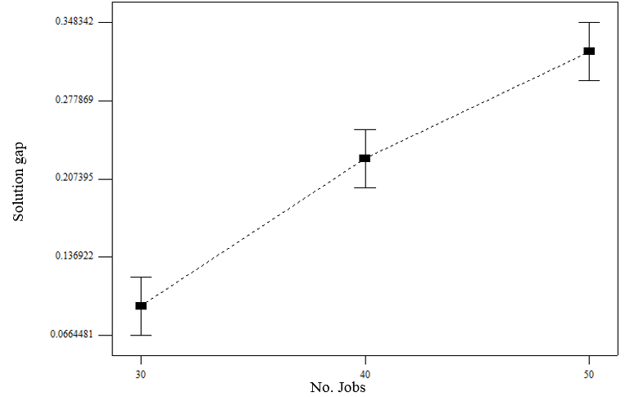<Figure:23>. Solution gap of Guan’s formulation as a function of Number of jobs.

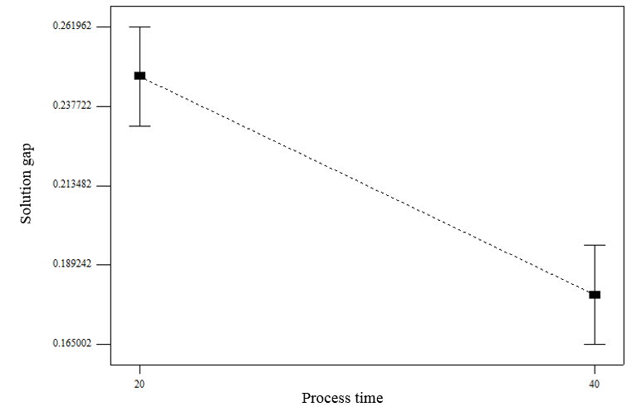<Figure:24>. Solution gap of Guan’s formulation as a function of Process time.

5.3.2.2 Analysis of TBased2 formulation
ANOVA test was used to analyze the gap for TBased2 formulation. Summary of the results presented in <Table:9>. Similar to what happened when analyzing problem solution time, factors of: machines, jobs and process time; were found significant, additionally all the interactions between this factors also found to be significant. Machines factor is significant with $F=27.1, p<0.0001$, indicating that when number of machines is growing, solution gap is growing also, <Figure:25> shows the gap rise. Jobs factor is significant with $F=24.81, p<0.0001$, indicating that as number of jobs is growing the gap is also growing, <Figure:25> shows the gap increase. In <Figure:25> the gap curve has positive decreasing derivative, which means that the gap increases more slowly as the number of jobs is rising, we can assume that this behavior would be the same if we would continue to increase number of jobs, this can be explained by the fact that gap values can be between 0 and 1, and every additional job we add, has less and less impact on the gap value. Process time factor is significant with $F=153.07, p<0.0001$, indicating that as the maximum process time value is growing, the solution gap is also growing, <Figure:26> shows this. All the three factors are significant and this result is expected as these factors determine the number of integer variables in the formulation, and similar as with solution time, as number of integer variables is increasing it is harder to solve the problem, and the gap between the optimal solution is higher.

<Table:9>. ANOVA results for gap for TBased2 formulation.
Source | Sum of  Squares | df | Mean  Square | F  Value | p-value  Prob > F
Model | 16.520836 | 11 | 1.5018942 | 25.899319 | < 0.0001
A-Machines | 1.5715659 | 1 | 1.5715659 | 27.10077 | < 0.0001
B-Jobs | 2.8776294 | 2 | 1.4388147 | 24.81155 | < 0.0001
C-Process Time | 8.8765066 | 1 | 8.8765066 | 153.07036 | < 0.0001
AB | 0.4438406 | 2 | 0.2219203 | 3.8268906 | 0.0248
AC | 1.3971195 | 1 | 1.3971195 | 24.092539 | < 0.0001
BC | 1.2977202 | 2 | 0.6488601 | 11.189227 | < 0.0001
ABC | 0.0564534 | 2 | 0.0282267 | 0.4867537 | 0.6160
Pure Error | 6.2628893 | 108 | 0.0579897
Cor Total | 22.783725 | 119

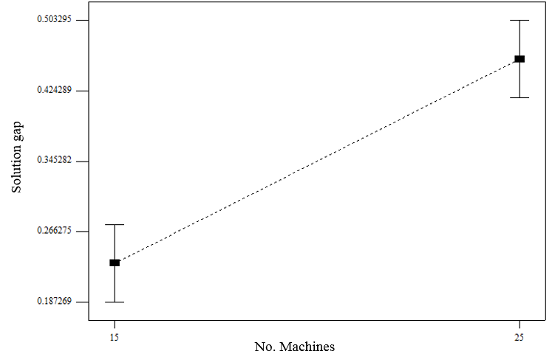<Figure:25>. Solution gap of Tbased2 formulation as a function of number of machines

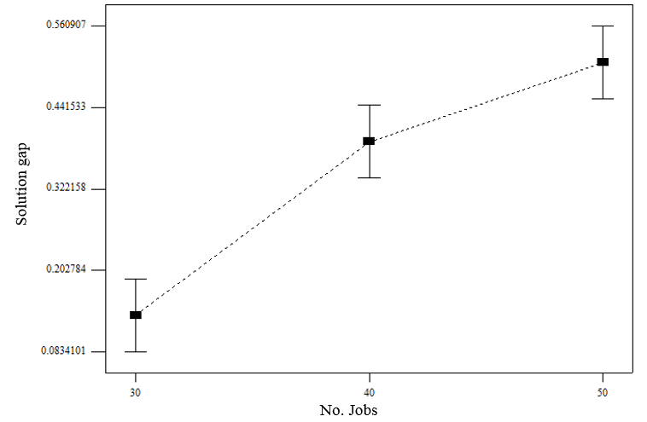<Figure:25>. Solution gap of TBased2 formulation as a function of number of jobs.

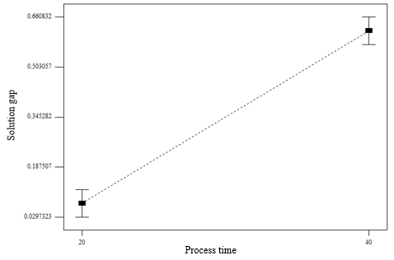<Figure:26>. Solution gap of TBased2 formulation as a function of number of process time.

Analysis also showed that all the interaction between the factors are also significant, as shown in <Figure:27>-<Figure:29>, a key learning is that a combination of higher factor values leads, in most cases, to a more radical increase in gap value.

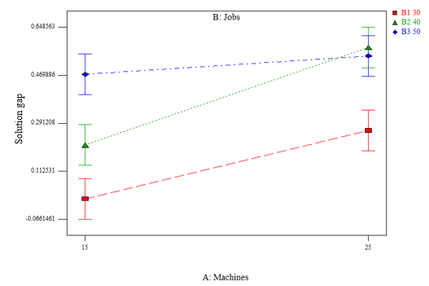<Figure:27>. Solution gap for TBased2 formulation, as a function of interaction between jobs and machines

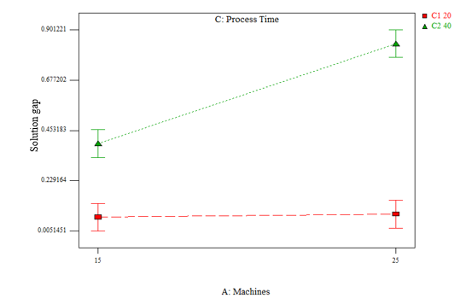<Figure:28>. Solution gap for TBased2 formulation, as a function of interaction between process time and machines

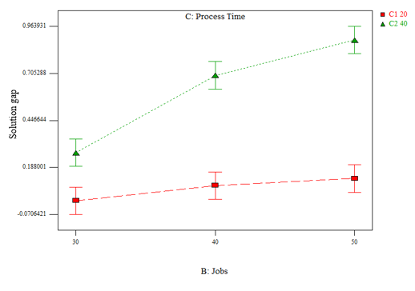<Figure:29>. Solution gap for TBased2 formulation, as a function of interaction between process time and jobs

5.3.2.3 Analysis of Gap difference between formulations
ANOVA test was used to analyze the gap difference between the two solutions. Summary of the results presented in <Table:10>. Two factors were found significant, machines is significant with $F=23.27, p<0.0001$, indicating that as number of machines is growing the gap difference is also growing, <Figure:30> shows this. Growth in the difference means that the value of gap for TBased2 is increasing more rapidly than it is increasing for Guan as number of machines is growing. In fact since number of machines was not significant factor Guan formulation in section 5.3.2.1, it means that the gap value for Guan is staying the same, while this value for TBased2 is growing fast. Process time is significant with $F=165.66, p<0.0001$, indicating that as the process time is increasing the difference between the gap is also increasing, <Figure:31> shows this. In previous sections, it was shown that for Guan, as process time is increasing, the gap is decreasing, and for TBased2 as process time grew the gap also grew, the difference is increasing as the process time is increasing, meaning that the impact for TBased2 formulation is higher than on Guan formulation.

<Table:10>. ANOVA results for gap difference between TBased2 and Guan formulations.
Source | Sum of  Squares | df | Mean  Square | F  Value | p-value  Prob > F
Model | 16.87780395 | 11 | 1.534345813 | 22.7199555 | < 0.0001
A-Machines | 1.571871689 | 1 | 1.571871689 | 23.27562309 | < 0.0001
B-Jobs | 0.384793913 | 2 | 0.192396957 | 2.84893422 | 0.0623
C-Process Time | 11.18810033 | 1 | 11.18810033 | 165.6687426 | < 0.0001
AB | 0.452331861 | 2 | 0.226165931 | 3.348971162 | 0.0388
AC | 1.577832529 | 1 | 1.577832529 | 23.36388872 | < 0.0001
BC | 1.682225498 | 2 | 0.841112749 | 12.45484823 | < 0.0001
ABC | 0.020648126 | 2 | 0.010324063 | 0.152874439 | 0.8584
Pure Error | 7.293559525 | 108 | 0.067532959
Cor Total | 24.17136347 | 119

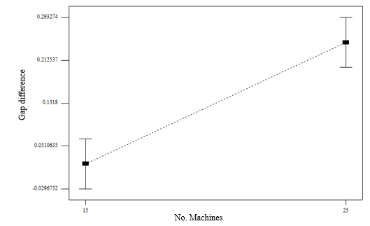<Figure:30>. Gap difference between TBased2 as a function of number of machines

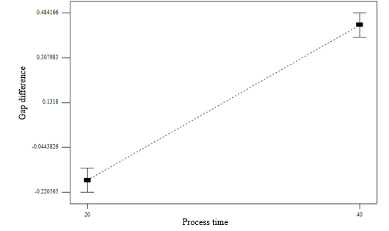<Figure:31>. Gap difference between TBased2 as a function of process time

Additionally all interactions between any two factors are also significant. This is shown in <Figure:32> - <Figure:34>.

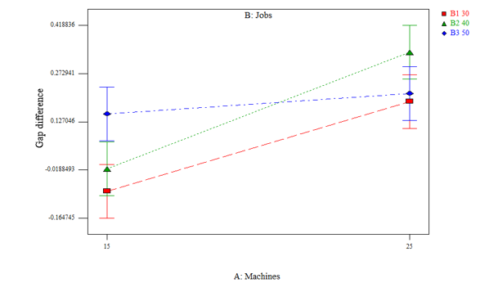<Figure:32>. Gap difference between TBased2 and Guan as a function of interaction between machines and jobs.

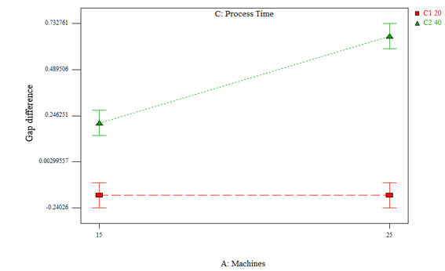<Figure:33>. Gap difference between TBased2 and Guan as a function of interaction between machines and process time.

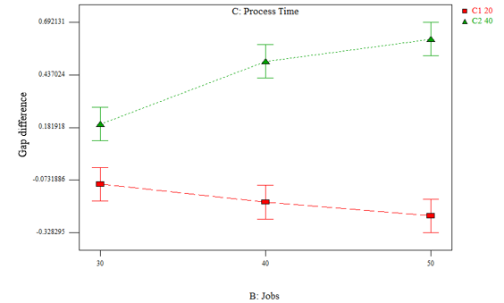<Figure:34>. Gap difference between TBased2 and Guan as a function of interaction between jobs and process time.

5.3.2.3 Analysis of CP formulation
On the same set of problems a CP formulation was tested with time limit of 10 seconds. As CP is not good in proving optimality and the time limit is very strict, not even one solution proved to be optimal.

<Table:11> Results summary for CP formulation.
 | Guan | TBased2
Average difference | 0.8 | -2.8
Average diff. by percentage | 3.3% | -5.5
Median difference | 1 | 0
CP has better solution value | 4 | 53
Other formulation has better value | 79 | 53

ANOVA test was used to compare CP results versus two previous formulations. Average and average by percentage was as comparative metrics.
<Table:12> Anova results for difference between guan and CP
Source |  | Sum of  Squares | df | Mean  Square | F  Value | p-value  Prob > F
Model |  | 29.45 | 9 | 3.272222 | 5.261064 | < 0.0001
A-Machines |  | 8.533333 | 1 | 8.533333 | 13.71985 | 0.0003
B-Jobs |  | 0.116667 | 2 | 0.058333 | 0.093788 | 0.9105
C-Process Time |  | 17.63333 | 1 | 17.63333 | 28.35079 | < 0.0001
AB | 1.516667 |  | 2 | 0.758333 | 1.219245 | 0.2994
AC | 0.833333 |  | 1 | 0.833333 | 1.339829 | 0.2496
BC | 0.816667 |  | 2 | 0.408333 | 0.656516 | 0.5207
Residual | 68.41667 |  | 110 | 0.62197
Lack of Fit | 0.616667 |  | 2 | 0.308333 | 0.49115 | 0.6133
Pure Error | 67.8 |  | 108 | 0.627778
Cor Total | 97.86667 |  | 119

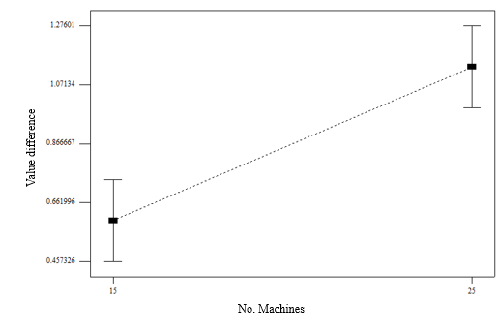<Figure:35>

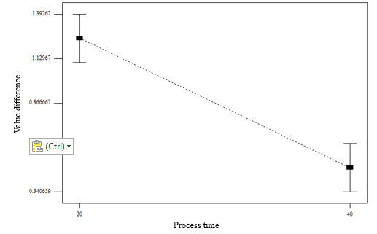<Figure:36>

Source | Sum of  Squares | df | Mean  Square | F  Value | p-value  Prob > F
Model | 1918.625 | 9 | 213.1806 | 24.55054383 | < 0.0001
A-Machines | 35.20833 | 1 | 35.20833 | 4.054702495 | 0.0465
B-Jobs | 376.4667 | 2 | 188.2333 | 21.67754319 | < 0.0001
C-Process Time | 1209.675 | 1 | 1209.675 | 139.3099808 | < 0.0001
AB | 98.06667 | 2 | 49.03333 | 5.646833013 | 0.0046
AC | 69.00833 | 1 | 69.00833 | 7.947216891 | 0.0057
BC | 130.2 | 2 | 65.1 | 7.497120921 | 0.0009
Residual | 955.1667 | 110 | 8.683333
Lack of Fit | 33.26667 | 2 | 16.63333 | 1.948584445 | 0.1475
Pure Error | 921.9 | 108 | 8.536111
Cor Total | 2873.792 | 119

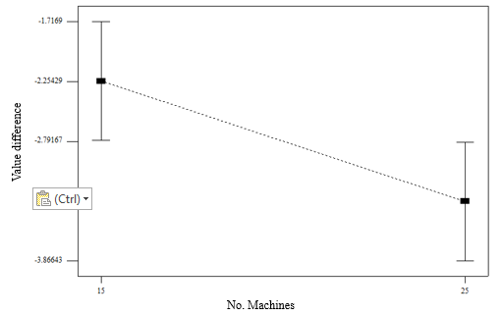<Figure:37>

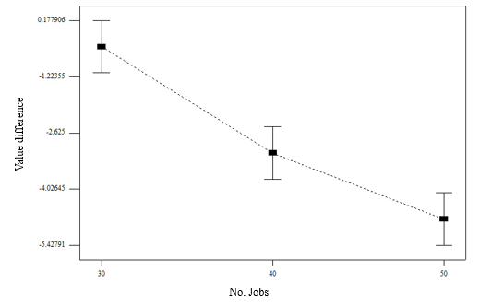<Figure:38>

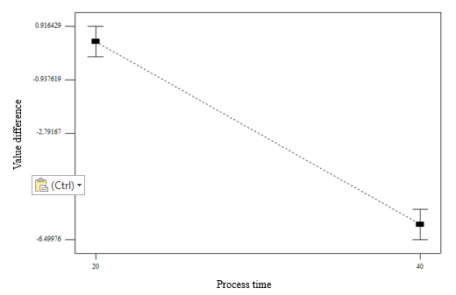<Figure:39>

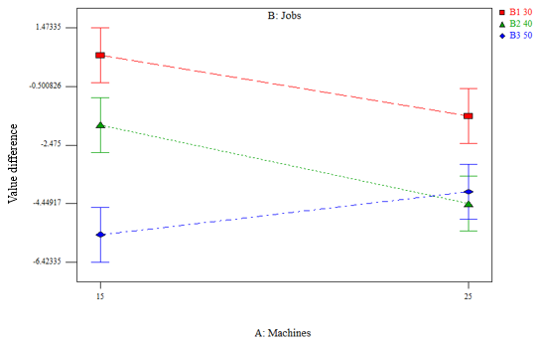<Figure:40>

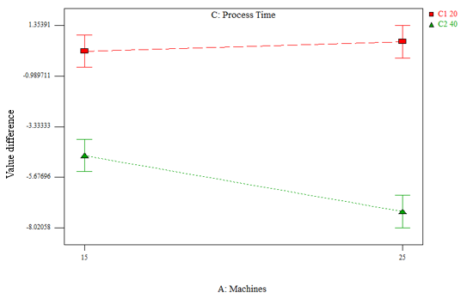<Figure:41>

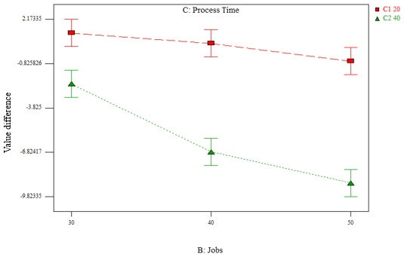<Figure:42>

