1. Introduction
   1. Backgroud

Paris is the most visited capital in the world. About 50 million tourists visited Paris in 2018. The city is known for its monuments, as well as for its gastronomy.

A huge number of visitors and residents of Paris take advantage of the multitude of restaurants, shops and activities that the city offers. The city is also known for its ethnic, cultural diversity which allows a cultural richness.

Thanks to this wealth, Paris has seen the emergence of many different restaurants such as Asian restaurants, Italian restaurants, etc…

* 1. Problem

Paris offers many restaurants. Suppose I want to open a Japanese restaurant. I need to know where is the best place to open my restaurant. That is to say analyze the restaurant in each borough and look at the proportion of Japanese restaurant, also take into account the data on the population (age, young people, median income), the price for the rental of the room

* 1. Interest

The interest of this project is that I will be able to make the best choice to open my restaurant while minimizing competition, by providing a targeted service in relation to the population of the neighborhood, so I will be able to adapt my offers and be competitive.

1. Data

Based on definition of our problem, factors that will influence our decision are:

* + - **Number of Japanese restaurants in Borough**
    - **Characteristic of people in Borough**
    - **Price for the rental**

So the following will be needed to solve the probleme :

* + - 1. https://fr.wikipedia.org/wiki/Liste_des_quartiers_administratifs_de_Paris contains the informations of the name and the different neighbordhood in each borough

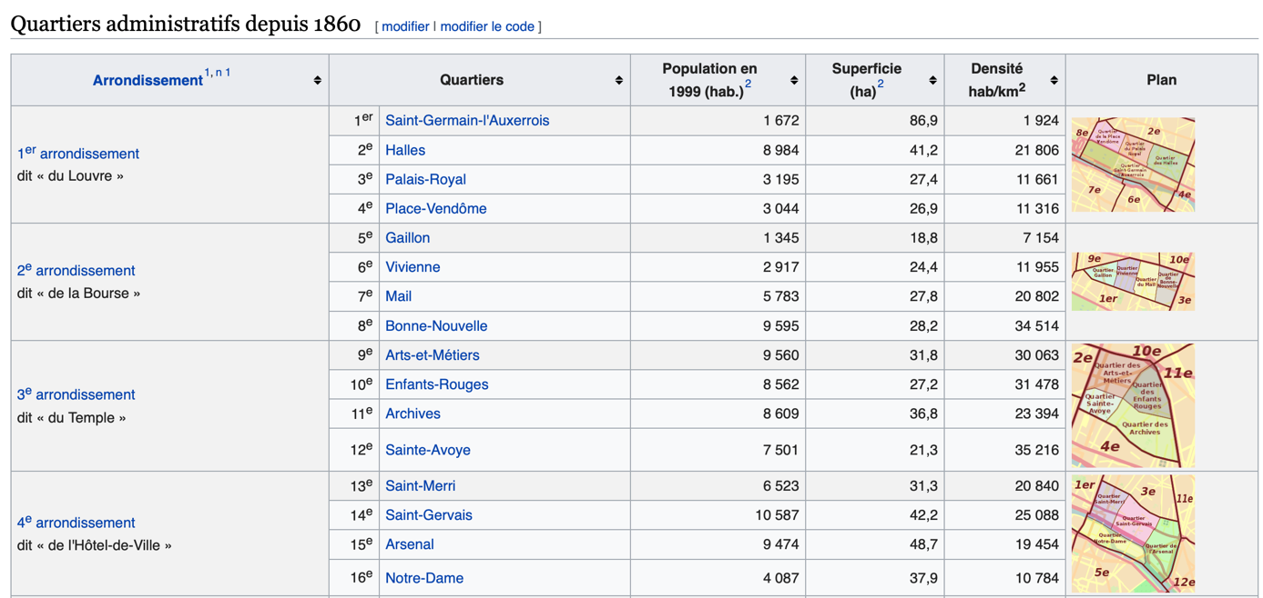

* + - 1. <https://www.apur.org/dataviz/portraits-metropole-grand-paris-donnees/?fbclid=IwAR13J2vJTTG6ZDpsGJgicSaOkJN1EILnH-GGtyiEDD6yUtypq9cqIC50l7k>

Characteristic of people in each borough. We choose only certain informations and put in a csv

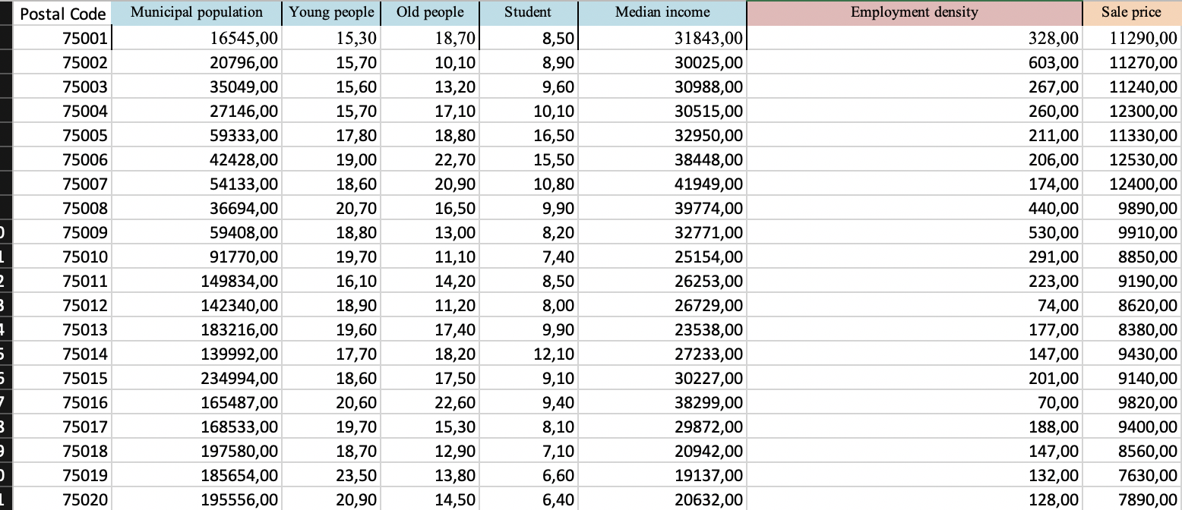

I choose to keep : Number of people, the proportion of young people, old people and student. The median income to analyze if the borough is rich. The employment density to see if there are lot of worker in the borough and finaly, the sale price for the rental.

* + - 1. Foursquare API to find the restaurant in each Borough
      2. Geopy to find the location of each borough.